Daniel James Lewis
1702173

Fine Art: Studio, Site and Context

Ways of Perceiving

Ryan Moule
ADAD4019

Exhibition Curation

Word count: 1636

The tortured artist

There is an expectation for creative minds to turn their pain into art (Banymadhub, 2018). The relationship between pain and art is a topic I find myself repeatedly returning to as an artist myself. Mental and physical pain plays a major role in the creation of, and observation of art, granting new means of perspective where others would find limited.

Taking the theme of pain and art into account, site of exhibition is essential consider to best convey the concept. A blank slate type of setting becomes most suitable, whilst trying to convey specific tones of the selected artworks, with no distraction from the art itself. For this reason, Swansea’s Mission Gallery exhibition space becomes a suitable candidate.

Coming into this concept of developing and curating a hypothetical exhibition, I was immediately drawn to the idea of the ‘tortured artist’. The term tortured artist is a theory based on the idea that pain is the essential ingredient in art. The term is more specifically used regarding mental illness found in artists, but I want to stretch this into physical pain and trauma as I believe these oftentimes can go hand in hand. Artists are physical people, when this physical ability is taken away, it creates a detriment to the mental state of the artist. When an artist reaches a severe point of mental illness, the ability of creativity is also wounded. (Lejsted, 2006)

I believe mental and physical pain is an important topic to be discussed in general, let alone the art world. With mental and physical wellbeing being a major topic in today’s culture and society, people want to and should learn more. I imagine having a visual stimulant like this proposed exhibition would open new conversations and perspectives, putting the audience in the artist’s mind whilst still obtaining freedom of interpretation. Oftentimes art that depicts the pain of the artist can often be referred to as some of the most powerful. The art creates a discomfort, push and pull relationship with the viewer – our instinct of curiosity makes us want to know more, which in turn creating a cycle that enforces the tortured artist theory between creator and viewer.

Pain looks different in nearly every individual’s case, which may be one reason we look to artists during this discussion. Artists have a unique position that differs to the norm, as they have the capability to portray pain in ways that others don’t have the means to do, making pain seem more prevalent in artists. Though, art that falls under the umbrella of ‘the tortured artist’ doesn’t always follow a specific type of visual language and can range throughout all mediums of creativity.

Many of the most notable artists throughout time fall victim to the concept of mentally unstable, artistic genius. Mental illness and suffering are almost celebrated in artists, we see it in many artists throughout time; Vincent Van Gogh, Edvard Munch, Louis Wain, some of the biggest names in art celebrated for their works whilst being at their lowest mentally. (Waugh, 2020). This is a title that has been pushed onto the likes of contemporary artist Tracey Emin.

Tracey Emin, the contemporary artist known for her intense and graphic honesty, oftentimes putting her own life experience into the forefront of her art, such as her experiences with depression, grief, sexual assault, traumatic abortion experiences amongst other things.
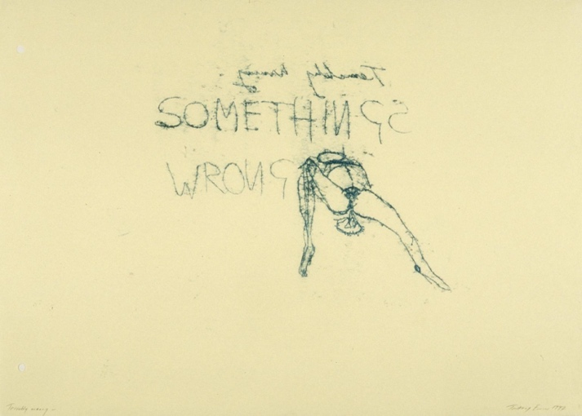
Fig 1. Terribly Wrong, 1997, Tracey Emin
582 × 811 mm

Many of Emin’s artworks could be suitable to an exhibition of this sort, following the theme of the tortured artist. The selected piece chosen for exhibition has a very direct portrayal of pain, creating a direct story for the audience to understand. The piece depicts Emin’s traumatic experience with and aftermath of abortion, throughout a ‘week from hell’ in 1994. (Manchester, 2000). Emin experienced a combination of physical and emotional pain from the pain of major dentistry work, the end of a romantic relationship and a traumatic abortion. The accumulation of painful events resulted in a series of works titled ‘A Week From Hell’ first shown in 1995, and was then revisited as shown in fig.1.

In an interview with Stuart Morgan, Emin states “Much of my work has been about memory, for example, but memories of violence and pain… Being an artist isn't just about making nice things, or people patting you on the back; it's some kind of communication, a message.” (Morgan, 1997). This statement alluding to an understanding of the importance that through recounting the traumatic experiences from her life through her art, Emin has created a way to rebuild her own damage while also communicating with her audience on an open and honest level.

The tortured artist theory leaks through into all aspects of creativity, literature being a prominent format. Through writing of painful experience in poem and novel formats, thus taking away a visual stimulant, a different level of relatability is created between creator and audience. In conversations of literature and pain, Sylvia Plath is a prominent figure of discussion.

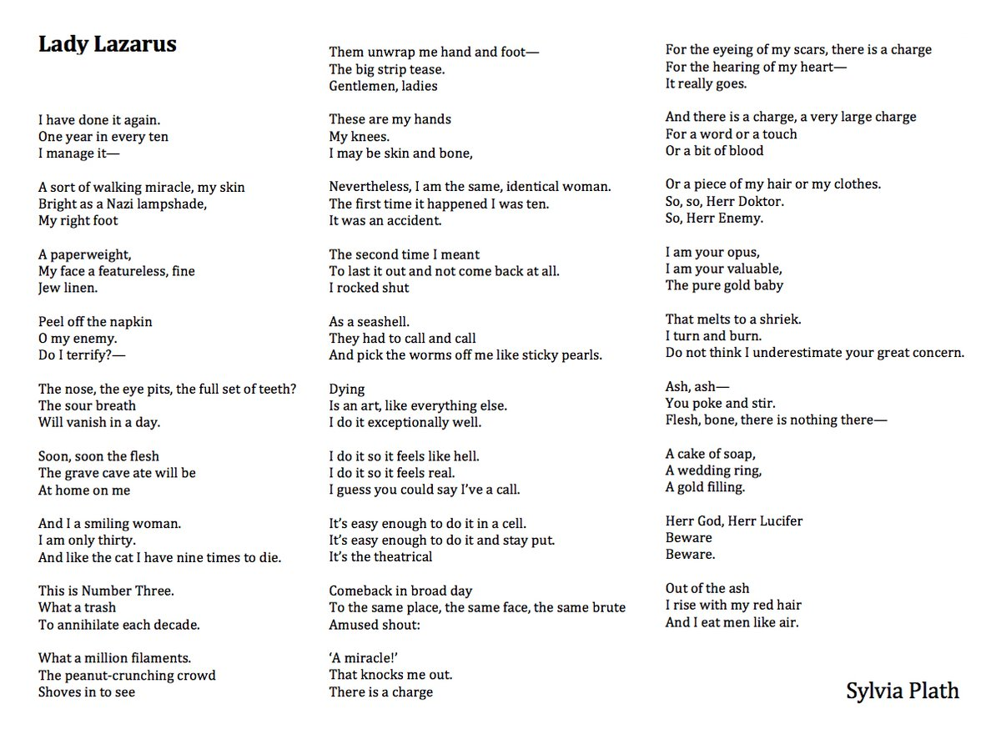
Fig.2 Lady Lazarus, 1962, published 1965, Sylvia Plath

Lady Lazarus, one of many poems created in the few months prior to her suicide in 1963, that explicitly captured her experience in suffering and was eventually published 2 years following her passing in the poem book ‘Ariel’.
The title refers to the biblical figure Lazarus, resurrected from the dead by Jesus, building a comparison to the figure, she takes on the persona of Lady Lazarus as a way to convey the story of her own encounters with death. (Ford, 2016) The poem details her failed suicide attempts of which she was ‘resurrected’ from, making comparisons to the nine lives of a cat, she had more to die. She states that there would only be further attempts, but she again would be resurrected, “Out of the ash I rise with my red hair And I eat men like air.” (Lines 82-84) In the closing stanza of Lady Lazarus (Plath and Hughes, 1981). The predicted further attempt would be her last, passing away just months later.

Lady Lazarus quickly became one of Plath’s most famous works for its honest themes of death, depression, pain and power. (Lady Lazarus Analysis - Literary devices and Poetic devices, n.d.). Though the author was undeniably talented, it raises the question of whether the notes of pain at the core of this poem was essential in order to reach its acclaim, as it statistically surpasses the less intensely painful poems of the author.

Though the tortured artist theory is more referenced regarding mental illness, I believe physical pain can go hand in hand with this theory. Frida Kahlo is one of many artists that suffered from physical and mental trauma yet persisted in creating art despite setback.
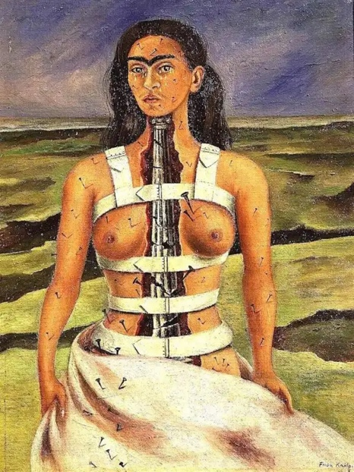
Fig.3 The Broken Column,1944, Frida Kahlo
39.8 cm × 30.6 cm (15.7 in × 12.0 in)

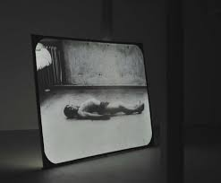
“Injured badly at the age of eighteen in a traffic accident, the self-portraits of Frida Kahlo often focus on physical and psychological suffering.” (The Broken Column by Frida Kahlo, Kahlo.org, n.d.). Kahlo produced the painting shortly after undergoing one of many spinal surgeries following said accident, none of which were successful, if not made her condition more painful. The physical pain she experiences becomes clear in the painting; the column, a symbol of strength now crumbling apart to represent the damaged spine, metal nails piercing her exposed nude body, held together by a medical corset. As much as the piece captures her physical turmoil, her emotional torment is hinted at too. The self-portrait shows Kahlo standing alone in front of an empty background, believed to be alluding to the ongoing affairs of husband Diego Rivers of when the portrait would’ve been created (The Broken Column by Frida Kahlo, Kahlo.org, n.d.). In the self-portrait, a teary-eyed Kahlo stares straightforward as if at the audience, challenging not only herself but the audience, to face her situation too. (The Broken Column, 1944 by Frida Kahlo, n.d.)
Fig. 4. 10ms-1, 1994, Douglas Gordon
Unconfirmed: 2295 × 3060 mm
Duration: 20 min., 57 sec.
Video, back projection, black and white

Pain depicted in art often challenges the audience, this piece by Douglas Gordon undoubtedly accomplishes that. Showcasing the torment of an unidentified man, in turn creating discomfort for the viewer. The Projection shows pre-existing footage captured during WWI, roughly 40 years prior to the birth of the artist. The film documents what appears to be a physically fit, but psychologically injured man, repeatedly attempt and fail to stand up and walk (Mclean-Ferris, 2009). Gordan edited the footage into an endless loop, not only “locking the injured man into a constant replay of his private struggle with his body” (Manchester, 2000), but keeping the audience stuck with him in a state of discomfort. The piece doesn’t directly centre on the suffering of the artist but suffering still sits at the forefront of the piece. The piece becomes effective through depicting the torment of another, which all artworks discussed in consideration for the proposed exhibition have in common.

To conclude the curation of an exhibition, research of the topic at hand enforces the idea art and pain do often go hand in hand, thus enforcing the tortured artist myth. Art is a medium of storytelling, pain will naturally find its way into that, be that pain Is one of the most basic yet complicated emotions to convey (Wong, 2013). The selected artworks from the discussed artists are some of their most known works, and all share a one common theme – suffering.
Art evokes a response in most cases, pain being a universal emotion at some level gives the impression that the theme shows a lot of potential. An exhibition of this sort may not be appealing to the at first glance but may be powerful if came to fruition.

Proposed exhibition

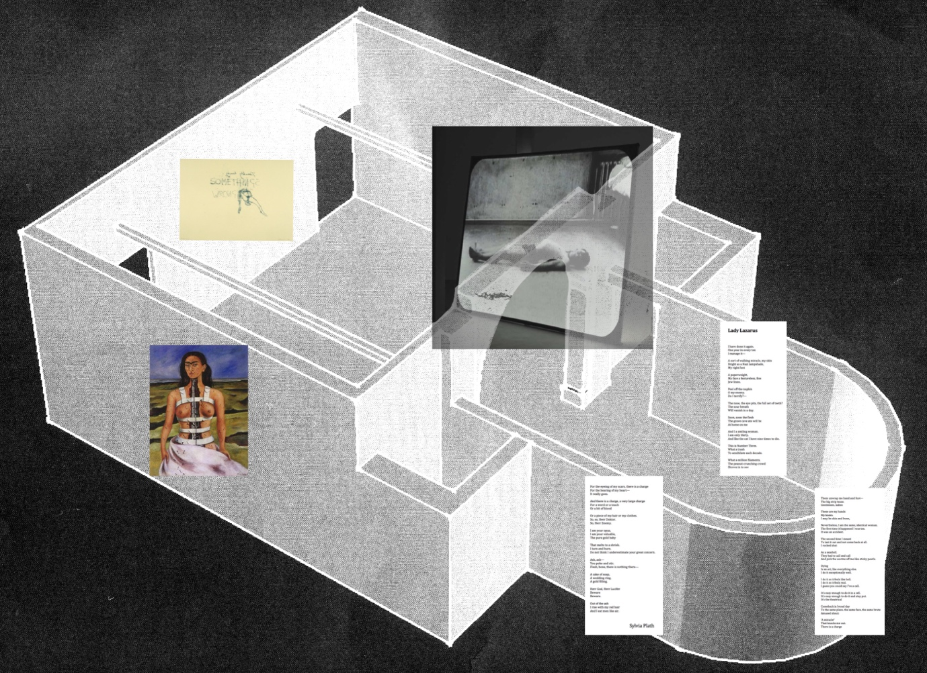
Mission Gallery, Swansea, floorplan

Fig.1 Standalone piece displayed on wall, complimenting minimal aesthetic of piece.
Fig.2 Displayed as text on wall, reading left to right on curved wall of floorplan – as metaphor for resurrection/return theme of piece – always coming back.
Fig.3.Displayed immediately at entrance/exit, challenging audience to face the self-portrait as alluded to in essay text.
Fig.4 Displayed at an outwards angle from corner of wall, allowing space for mechanisms of piece to exist.

Bibliography

Books

Plath, S. and Hughes, T., 1981. Lady Lazarus from Collected poems (Plath, Sylvia). London: Faber and Faber.

Interviews

Morgan, S., 1997. The Story of I: An interview with Tracey Emin. [online] Frieze.
Available at: https://www.frieze.com/article/story-i [Accessed March 2022].

Websites

Banymadhub, Y., 2018. 'The tortured artist is a dangerous myth – it must be stopped'. [online] The Independent. Available at: https://www.independent.co.uk/voices/world-mental-health-day-tortured-artist-dangerous-myth-pain-art-depression-suicide-a8576971.html?r=41266 [Accessed March 2022].

Ford, M., 2016. ‘Lady Lazarus’ by Sylvia Plath: a close reading. [online] British Library. Available at: https://www.bl.uk/20th-century-literature/articles/a-close-reading-of-lady-lazarus [Accessed March 2022].

Literary Devices. n.d. Lady Lazarus Analysis - Literary devices and Poetic devices. [online] Available at: https://literarydevices.net/lady-lazarus/
[Accessed March 2022].

Lejsted, M., 2006. Essay: Art created by psychiatric patients. [online] The Lancet. Available at: https://www.thelancet.com/pdfs/journals/lancet/PIIS0140673606699066.pdf [Accessed March 2022].

Manchester, E., 2000. Terribly Wrong, 1997, Tracey Emin. [online] Tate. Available at: https://www.tate.org.uk/art/artworks/emin-terribly-wrong-p11565 [Accessed March 2022].

Manchester, E., 2000. 10ms-1. [online] Tate. Available at: https://www.tate.org.uk/art/artworks/gordon-10ms-1-t07276 [Accessed March 2022].

Mclean-Ferris, L., 2009. 10 ms-1 - Douglas Gordon - Google Arts & Culture. [online] Google Arts & Culture. Available at: https://artsandculture.google.com/asset/10-ms-1-douglas-gordon/SAHwx3ZljS9kIQ?hl=en [Accessed March 2022].

Kahlo.org. n.d. The Broken Column by Frida Kahlo. [online] Available at: https://www.kahlo.org/broken-column/ [Accessed March 2022].

Fridakahlo.org. n.d. The Broken Column, 1944 by Frida Kahlo. [online] Available at: https://www.fridakahlo.org/the-broken-column.jsp [Accessed March 2022].

Waugh, R., 2020. The enduring connection between art and mental health. [online] Artuk.org. Available at: https://artuk.org/discover/stories/the-enduring-connection-between-art-and-mental-health# [Accessed March 2022].

Wong, C., 2013. What’s Pain Got to Do with It? In Art, It’s Everything — EYES-WIDE.com. [online] Eyes-wide.com. Available at: http://eyes-wide.com/whats-pain-got-to-do-with-it-in-art-its-everything-no-pain-no-pleasure-no-art-no-brain/ [Accessed March 2022].

List of figures

Fig. 1. Terribly Wrong, 1997, Tracey Emin

Fig. 2. Lady Lazarus, 19

Fig. 3. The Broken Column, 1944, Frida Kahlo

Fig. 4. 10ms-1, 1994, Douglas Gordon

