Wheel of Life

How it works...
This wheel contains eight sections that, together, represent one way of describing a whole life. The structure is up to you. The exercise measures your level of satisfaction in these areas on the day you work through this exercise. It is not a picture of how it has been in the past or what you want it to be in the future. It is a snapshot taken in the moment. It is not a report card on how well you have performed or what you have achieved. The emphasis is on your level of satisfaction in each area you choose to place on the wheel. The Wheel of Life provides a unique coaching model for clients. The wheel shows you what balance in your life looks like.
Instructions
- Select the 8 categories or priorities you wish to place on the wheel. For example you may select Family, Relationships, Health, Career, Finances, Hobbies, Travel etc. This is just an example so please choose areas that most reflect your life.
- Rate your level of satisfaction in each of the areas with zero meaning not satisfied and 10 meaning highly satisfied.
- Connect the lines to form an inner wheel. Counting from the centre of the wheel outwards. Note: This is not about getting 10’s in every area its about improving balance and achieving a smoother ride. ‘If the wheel were a tyre on your car, how bumpy would the ride be?’

Here is an example.

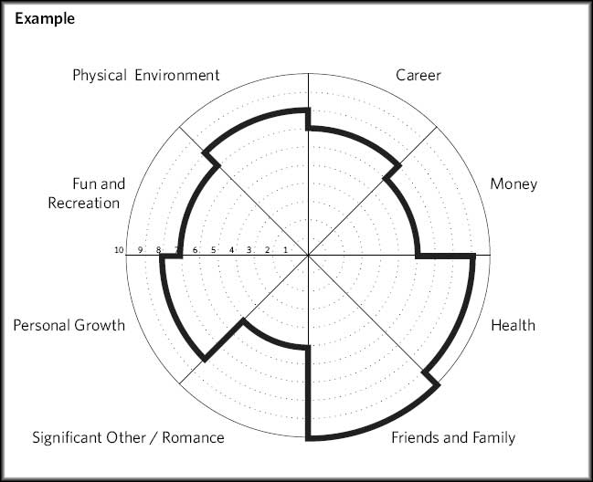

- Looking at your picture now, think about which area you would like coaching on or which area you are ready to make changes in.
- For this area, ask yourself what would you want to be happening for it to score a 10/10? Try to visualise this moment. Where are you? Who are you with? How are you feeling? How do you know you have achieved it?

Well done you are on the road to setting your first goal!

