
The gateway to employment  Module code. BMLC5005. | Student name; Denise jones  Student Number: 2405845

Table of Contents

Placement hours log 2
First 40 hours; A Reflection 3
Overall reflection 5
Specific questions 7
Reference list and AI reference list 8
Appendices…………………………………………………………………………………………………… 9
End Page………………………………………………………………………………………………………. 10

Placement hours log
In this section, please record your placement hours, including dates and the amount of hours completed on each day. Please note that this should also be signed by your placement provider to confirm that the recorded hours are correct.

Date | Hours completed
01.01.2026 | 5
22.01.2026 | 6
04.02.2026 | 6
05.02.2026 | 6
09.02.2026 | 6
16.02.2026 | 6
18.02.2026 | 6
23.02.2026 | 6
04.03.2026 | 7
05.03.2026 | 7
16.03.2026 | 6
01.04.2026 | 8
02.04.2026 | 3
16.04.2026 | 5
TOTAL HOURS COMPLETED | 83 HOURS



Confirmation of hours completed.
Placement provider signature.
Date signed;

First 40 hours; A Reflection

This reflective account documents my 40-hour voluntary placement at Thrive Women's Aid, an organisation that provides trauma-informed support to both women, men and children who have experienced domestic abuse. To structure my reflection, I have applied Gibbs' Reflective Cycle (Gibbs, 1988), exploring my experience across its six stages: description, feelings, evaluation, analysis, conclusion, and action plan.

1. Description
During my time at Thrive, I attended and helped support several wellbeing activities, including the weekly choir, coffee morning, and craft group, which provided a safe space for women to connect and access emotional support (Mushogna, 2026). In addition, I further helped with practical needs such as accessing food vouchers and finding clothing for important occasions.
There are two situations that stood out during my first 40-hours of placement, the first involved helping a woman access a food voucher when she was experiencing financial difficulty, while the second involved supporting a woman who needed suitable clothing for a formal ball. As I was still learning the organisation’s procedures, both situations required me to communicate professionally, listen carefully, and seek guidance from experienced staff. These experiences challenged me to apply trauma-informed practice in real-life situations and highlighted the importance of practical support in empowering women (Fuller 2023), while also creating a calm and positive atmosphere, as informed by (Skolinik and Skolinik 2024).
2. Feelings
At the beginning of my placement, I felt both excited and nervous. I was looking forward to gaining experience in a supportive organisation, but I was also aware that many of the women and men accessing the service had experienced domestic abuse and trauma ( Robinson and Spilsbury).This made me anxious about saying the wrong thing which could trigger or upset any of the woman (Clark and Beck, 2023). For example, when a woman asked me about a food voucher, I felt uncertain because I did not yet fully understand the process. I worried that I might provide incorrect information or appear unprofessional. I also felt pressure because her need was urgent, and I wanted to help quickly. I addressed this by approaching my manager. After receiving the voucher, I supported her calmly and discreetly to avoid any embarrassment (UK Home Office, 2022).
Similarly, when the woman asked about clothing for the chief’s civics charity ball, I felt unsure about what resources were available. However, I also felt motivated to help because attending the event was important to her confidence and sense of normality (Cohen 2022).
With staff support, we were able to provide suitable outfits, from outside sources, which helped the ladies enjoy and the ball raised over £10,000 for the charity. Over time, I gradually felt more confident and reassured that asking for guidance was the correct approach.
3. Evaluation
Overall, these experiences were positive learning opportunities, (Illeris 2003) A strength was that I remained calm and approachable, listening carefully and treating both individuals with respect and empathy. I also recognised my limitations and sought guidance from staff rather than guessing or giving incorrect information, ensuring appropriate support was provided which is an important part of the process (Taylor Baser and Wilkie 2006).
A limitation was my initial lack of confidence and unfamiliarity with procedures, which slowed my response and affected my confidence in the moment. Despite this, both situations had positive outcomes, and I gained valuable experience.
4. Analysis
These experiences highlighted the importance of trauma-informed practice, which focuses on safety, trust, choice, collaboration, and empowerment for individuals affected by trauma (Wright and Laurent 2021)
The food voucher request demonstrated how financial hardship can continue after leaving an abusive situation, and how practical support can restore dignity and stability. Similarly, supporting access to clothing for the ball showed how practical assistance can promote confidence and emotional wellbeing. These experiences reinforced the importance of working in a professional and ethical way, including recognising when to seek help and maintaining appropriate boundaries.
5. Conclusion
This experience taught me that volunteering with Women’s Aid involves far more than practical assistance, it requires sensitivity, active listening, and an understanding of how trauma can affect all areas of a person’s life.
I also learned that confidence develops over time and through learning experiences (Currie 2008) Initially, I saw uncertainty as a weakness, but I now understand that asking questions and seeking support is a key part of professional practice.
6. Action Plan
In future placements, I will familiarise myself with organisational procedures earlier so I can respond more confidently to requests for support. I will also continue to develop my understanding of trauma-informed practice through further reading and training (Carello and Bulter 2015). Finally, I will continue to develop my communication skills by observing experienced staff, reflecting on my practice, and using reflective models such as Gibbs’ cycle to improve my future practice (Gibbs 2025).

Overall reflection

1. Description
During my placement, I completed a total of 80 hours, supporting women in a domestic abuse support service (Gilbert 2020), continued to take part in the range of wellbeing activities including craft groups, coffee mornings, and choir sessions, which provided a safe and supportive environment for service users. In addition, I attended monthly organisational meetings where staff discussed fundraising, upcoming events, and budgeting. External organisations such as Clybiau Cymru delivered sessions on substance misuse and exploitation among young people, and the vulnerable, which included activities identifying drugs and understanding online communication trends.
A key highlight of my placement was helping prepare and distribute Easter donations. I sorted and labelled Easter eggs and assisted in delivering them to families, contributing to help give the ladies and children a positive and enjoyable Easter.
I attended a local refuge supporting women and children who had left abusive or unsafe home environments. Refuge-based support services are essential in providing immediate safety, stability, and structured recovery pathways for survivors (Callaghan and Alexander 2014). I assisted in preparing a bedroom for a new resident and helped create a welcome pack containing essential personal items, which was incredibly rewarding.

2. Feelings
At the beginning of my placement, I felt excited but also uncertain about my role. I was aware that many service users had experienced trauma, which initially made me anxious about how to respond appropriately. This reflects common emotional responses among student practitioners entering trauma-informed environments for the first time (Knight, 2018).
As I progressed through my placement, I became more confident and comfortable interacting with service users. I particularly enjoyed group sessions, as they helped me build rapport and feel more engaged. During the refuge visit, I felt more emotionally aware of the vulnerability of service users entering emergency accommodation. This experience reinforced the emotional demands of support work and the importance of maintaining professional boundaries while showing empathy (Watson et al, 2025)

3. Evaluation
There were several positive aspects of my placement. Which I really enjoyed. A particularly positive experience was supporting the Easter donation distribution, which contributed to improving wellbeing and creating positive experiences for families. Community-based interventions such as this are shown to support emotional recovery and resilience in vulnerable populations (Scott, et al 2025).
However, a limitation was my initial misunderstanding of the nature of the role. I expected more crisis led intervention work, a more hands on approach, whereas much of the service is focused on ongoing structured support and recovery. This highlights the importance of understanding service models before entering placement settings. Despite this, I adapted well and developed a broader understanding of the sector.

4. Analysis
This placement highlighted the importance of structured support services in helping survivors rebuild stability and independence. Group-based interventions have been shown to improve confidence, reduce isolation, and support emotional regulation in survivors of domestic abuse.
The refuge experience demonstrated the importance of trauma-informed environments, particularly in ensuring safety, dignity, and emotional reassurance for individuals in crisis. Trauma-informed approaches are widely recognised as essential in domestic abuse services due to the complex psychological impact of abuse experiences (Fellin et al 2019).
The involvement of external organisations such as Clybiau Cymru also highlighted the importance of multi-agency collaboration in addressing broader safeguarding issues, including exploitation and substance misuse. Multi-agency working is considered a key factor in effective safeguarding practice (Shorrock mc manus and Kirby 2020). Overall, this experience helped me understand that support work is not only about immediate intervention but also long-term recovery, prevention, and system-wide collaboration.

5. Conclusion
This placement helped me understand that working in Women’s Aid services involves structured, ongoing support rather than solely crisis intervention. While I initially expected more emergency-based work, I now recognise the importance of long-term recovery support in helping survivors rebuild their lives.
I have also learned that I enjoy working in supportive environments and building relationships with service users. However, I feel my interests may be more aligned with frontline safeguarding or emergency intervention work.

6. Action Plan
In future, I aim to gain experience in frontline safeguarding environments, such as police or social services, particularly in roles linked to early intervention and exploitation prevention, while developing my understanding of safeguarding practice, trauma-informed approaches, and multi-agency working through both academic study and voluntary experience (Close 2026).
I would like to continue some volunteering work in these areas, and over the next year my plan is to complete my dissertation research into county lines exploitation, focusing on how young people become involved in criminal networks and how early intervention can reduce harm, and hopefully find work in this area.

Specific questions

- Explain a situation during your placement where you demonstrated resilience.

During my placement, I found that I demonstrated resilience when supporting a woman who needed a food voucher for herself and her child. She was visibly distressed and embarrassed when she approached me, and although I felt unsure at first, I stayed calm and reassured her that I would help. I spoke with the manager to explain the situation and was able to get the voucher approved.
Through using trauma-informed communication, as suggested by (Leonce 2025). I took her into a private room, so she felt respected and not exposed or embarrassed in front of others. Once we were away from the group, she became more relaxed and thanked me for handling the situation sensitively. This moment showed me how important it is to stay steady and compassionate, even when I feel unsure and anxious.
This experience strengthened my confidence in managing unexpected challenges, it showed me that resilience is not about being unaffected, but about staying calm, purposeful, and supportive when someone needs help (Klaas 2020), learned that even when I doubt myself, I can still act professionally and make a positive difference to others.

- Explain a situation during your placement where you were required to be honest and open.

During my placement, I also needed to be honest and open when helping several women choose clothing for a charity ball. This was an important fundraising event, and many of the women could not afford formal outfits. Thrive arranged donations from local organisations, similar to the support described by (ravens croft 2017) who report that clothing assistance can increase confidence and wellbeing. One coffee morning, we sorted through the donated dresses and accessories. I supported the women by giving honest, kind, and practical feedback about what suited their shape, style, and comfort. This helped them feel confident and excited about attending the event, research by (Ryan 2020), suggests that positive appearance-related support can improve self-esteem, which I saw reflected in their reactions.
I also demonstrated openness during a monthly meeting, where I shared my honest opinions and contributed ideas to help raise funds for the charity, including suggesting a sponsored silence or a charity walk. Being open in these discussions helped me feel more involved and showed that my contributions were valued.

- How did you demonstrate professionalism during your placement?

During my placement, I demonstrated professionalism by always turning up when expected and on time, being reliable, consistent, and approachable during the choir, coffee mornings, and craft sessions. These activities required me to create a safe and welcoming environment, which is important in trauma-informed settings (Erickson Harvey 2023). Furthermore, I maintained appropriate boundaries, treated everyone with respect, and paid attention to safeguarding concerns, especially when someone appeared withdrawn or isolated. I balanced friendliness with responsibility, making sure each woman felt included and valued.
Over time, I noticed my own confidence growing, as well as the trust the women placed in me. I felt increasingly accepted within the group, which made my overall experience a very positive one.

Reference list

Callaghan, J. and Alexander, J., (2014). Providing shelter and housing for victims of domestic violence.
Carello, J. and Butler, L.D., (2015). Practicing what we teach: Trauma-informed educational practice. Journal of Teaching in Social Work, 35(3), pp.262-278.
Clark, D.A. and Beck, A.T., (2023). Anxiety and worry workbook. Guilford Publications.
Close, R., (2026). How is a ‘Trauma-Informed’approach experienced and perceived by staff and survivors in a Domestic Abuse service? (Doctoral dissertation, University of Lancashire).
Close, R., (2026). How is a ‘Trauma-Informed’approach experienced and perceived by staff and survivors in a Domestic Abuse service? (Doctoral dissertation, University of Lancashire).
Cohen, G.L., (2022). Belonging: The science of creating connection and bridging divides. WW Norton & Company.
Erickson, M. and Harvey, T., (2023). A framework for a structured approach for formulating a trauma-informed environment. Journal of Education, 203(3), pp.6
Fuller, G., (2023). On becoming trauma informed: Exploring the narratives of female survivors of intimate partner violence (Doctoral dissertation, University of Essex).
Gilbert, B., (2020). Exploring the experiences of domestic abuse survivors working in the field of domestic abuse support: assisting recovery or re-victimisation revisited?. Journal of gender-based violence, 4(1), pp.73-87.
Illeris, K., (2003). Adult education as experienced by the learners. International journal of lifelong education, 22(1), pp.13-23.
Klaas, N.C., (2020). Resilience Enhancement Through Establishing Self-Help Groups for Vulnerable Women in the Eastern Cape (Buffalo City) (Doctoral dissertation, University of South Africa (South Africa)).
Knight, C. (2018) Trauma-informed social work practice.
Mushonga, M., (2026). Recovering and Rebuilding the Lives of Women with Disabilities Who Are Survivors of Intimate Partner Violence. In Using Women's Economic Empowerment to Combat Intimate Partner Violence (pp. 197-207). Routledge.
Ravenscroft, C., (2017). Facing Forward: How Small and Medium Charities can Adapt to Survive.
Shorrock, S., McManus, M.M. and Kirby, S., (2020). Practitioner perspectives of multi-agency safeguarding hubs (MASH). The journal of adult protection, 22(1), pp.9-20.
Skolnik, S. and Skolnik, L., (2024). Developing a Safe Space. A Handbook of Contemporary Group Work Practice: Promoting Resilience and Empowerment in a Complex World, p.251.
Watson, T., Waters, R., Watts, L. and Hodgson, D., (2025). Exploring the challenges of empathy in a therapeutic context: An interpretative phenomenological analysis. Qualitative Health Research, p.10497323251331460.

AI reference list

I acknowledge the use of Grammarly (https://www.grammarly.com/) on 10 May 2026 to check my work using the prompt(s): 1. Please check the following text for readability, grammar and spelling. I confirm that I have not presented any AI generated text as my own work. I confirm I have copies of my drafts, notes, and other resources I used before, and after the use of AI tools which I may be asked to provide in evidence.

I acknowledge the use of Zotero a referencing tool (Zotero | Your personal research assistant) on 6 February 2026 to check my work using the prompt(s): 1. Please check the following text for referencing layout. I confirm that I have not presented any AI generated text as my own work. I confirm I have copies of my drafts, notes, and other resources I used before, and after the use of AI tools which I may be asked to provide in evidence.

Appendices

Appendix 1 – Choir Practice
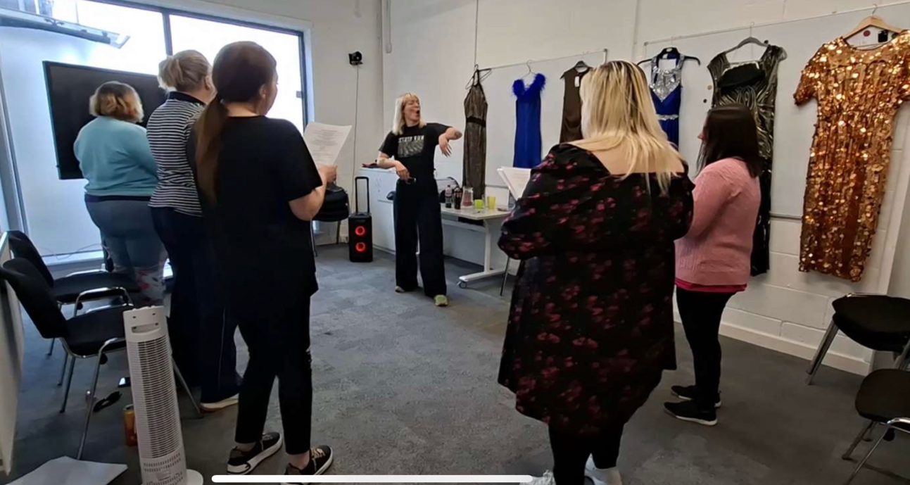

Appendix 2 – Ball, Dress selection
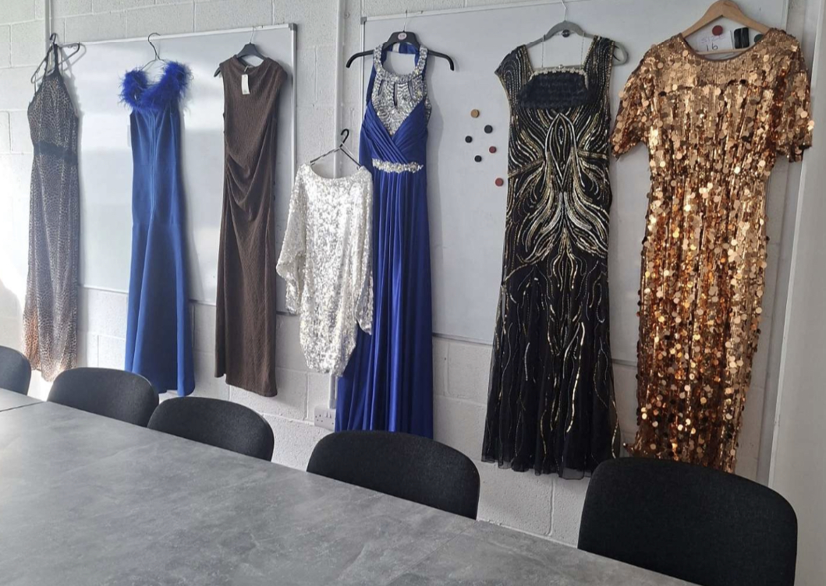

Appendix 3 – Craft Work
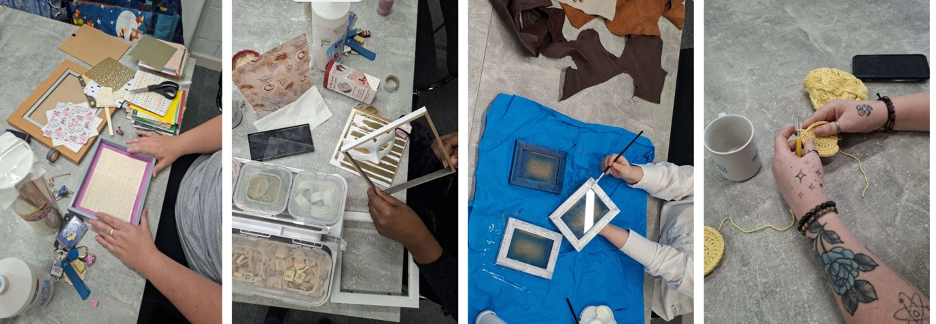

End Page

