

Course Title: MBA - International Business
Term 1

Student Name: VISHAL BHALALA
Student ID: 2509170

Module Name: Marketing Management
Module Code: LCMB7024

Lecturer’s Name: Dr Laila Maazouz (London)
Word Count: 2496/2500

Strategic Analysis of Macro-Environmental Forces and Competitive Responses: A Netflix-Centred Evaluation of the Global Digital Streaming Industry

Table of Contents
1. Introduction 2
1.1 Purpose of the Report 2
1.2 Importance of Macro Environment Analysis 2
1.3 Scope and Structure of the Report 2
2. Task 1: Critical Analysis of the Macro Marketing Environment 2
2.1 Overview of the Macro Marketing Environment 2
2.2 Selection of Two External Macro Marketing Actors 3
2.3 Critical Analysis of Each Actor 3
3. Task 2: Strategic Responses of Pioneering and Follower Organisations 5
3.1 Strategic Responses of Pioneering Organisations (Netflix) 5
3.2 Strategic Responses of Follower Organisations 7
4. Conclusion 8
References 10
Appendix 11

1. Introduction

1.1 Purpose of the Report
The current report is directed at the discussion of the role of the external macro marketing environment on strategic marketing management as well as the organisations within the digital streaming industry. The report will focus on how the macro-environmental forces have an impact on the competitive behaviour and strategic decision-making (Paramadita, Purnomo and Rumangkit, 2024). The discussion evaluates how pioneers and follower organisations absorb external pressures and opportunities on board through strategic marketing frameworks through the case of Netflix as the pioneer organisation.

1.2 Importance of Macro Environment Analysis
The macro environment analysis is a critical component of strategic marketing management because it enables business to anticipate external changes, understand how to alleviate risks and what will be presented due to growth. This analysis can be systematized with the help of such models as PESTEL and consideration of political, economic, social, technological, environmental, and legal forces that impose the driving forces of the market dynamics (Paramadita, Purnomo and Rumangkit, 2024).

1.3 Scope and Structure of the Report
In this report, I have subdivided the report into two key tasks. The critical assessment of the macro marketing environment in Task 1 will be done through the selection of two significant external actors and the way they affect the players of the industry. Task 2 discusses the strategic activities of creative organisations like Netflix, the follower firms and applies models like the Growth Matrix of Ansoff and the Generic Strategies of Porter (Morris, 2022). The report concludes with the summary of some of the key findings along with the reiteration of the importance of environmental scanning and adaptive strategic marketing.

2. Task 1: Critical Analysis of the Macro Marketing Environment

2.1 Overview of the Macro Marketing Environment
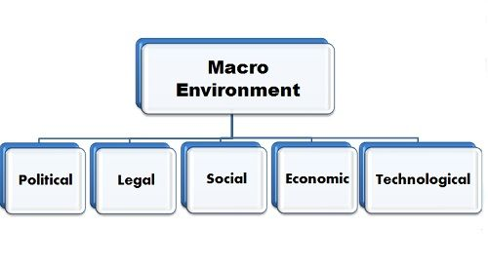
Figure: Macro Marketing Environment
Source: (Morris, 2022)
The macro marketing environment is a group of external forces that organisations cannot control yet they need to be keen of such forces in order to formulate effective marketing strategies. These forces help to dictate consumer behaviour, the competitive forces as well as dictating the overall direction of an industry (Morris, 2022). The change of the macro environment in firms dealing in dynamic industries as is the case in digital entertainment can alter the market opportunities and threats in a short period. In such a way, strategic decision-making requires continuous scanning because preparations to act before any changes may occur and predict them. PESTEL framework is an evaluation instrument that is widely used and assists organisations to scrutinize Political, Economic, Social, Technological, Environmental, and Legal factors. It also helps in environmental scanning by giving a systematized prism within which companies are able to measure the long term trends and uncertainties (Morris, 2022).

2.2 Selection of Two External Macro Marketing Actors
There are two macro-actors that have been selected in this analysis; Technological Environment and Economic Environment. The reason why such actors have been chosen is due to their massive and immediate influence on streaming websites over the internet. The streaming business is based on the technological environment, and AI-based recommendation systems, data analytics, and content delivery systems are the elements that can be used as the subject of platform competition (Khan et al., 2023). As recent reports in the industry have claimed, algorithmic suggestions concerning how the viewers are selected in large streaming platforms are over 70 percent and this on the one hand highlights the importance of technological capability (Khan et al., 2023).

2.3 Critical Analysis of Each Actor
Technological Environment
a. Impact on Pioneering Organisation (Netflix)
The opportunities and challenges that come with technological advancement are present in the case of Netflix. The use of algorithmic personalisation and content investment using data adopted early by Netflix gave it a colossal customer engagement lead as an early adopter. It can use its sophisticated AI systems to make personal recommendations and success models of prediction content (Viter, 2021). However, the accelerated technological growth assumes the continuous investment into the advancement of the quality of streaming, cybersecurity, and platform improvement.
b. Impact on Follower Organisations
Technological imitation is heavily relying on the subsidiary companies such as Disney+, Amazon Prime Video and Hulu to remain competitive. As they adopt better algorithms and better streaming infrastructure they will most likely face the challenges that involve higher R and D costs, later roll out and decreased access to historical data (Viter, 2021). Amazon Prime video has an opportunity to solve this problem by its large e-commerce data-ecosystem, and Disney + can leverage the popularity of the brand to offset technological weaknesses. However, the customisation needed to replicate Netflix is a challenge to most of the followers.
Economic Environment
a. Impact on Pioneering Organisation (Netflix)
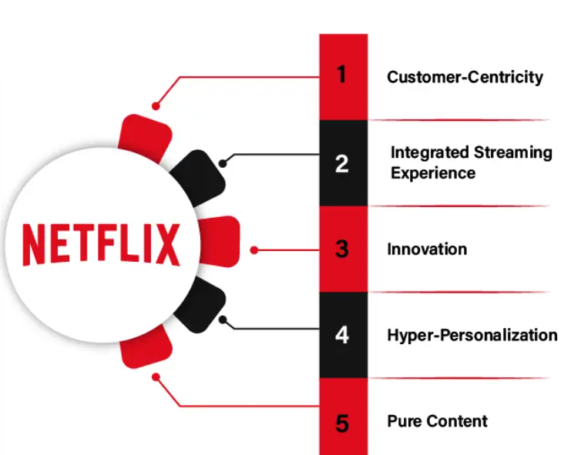
Figure: Impact on Pioneering Organisation
Source: (Iordache, Raats and Mombaerts, 2022)
Economic instability affects Netflix as this affects retention of subscription and international growth strategies. Threats to Netflix are spending power of the subscribers and augmented operation cost during times of inflation. This has forced Netflix to adopt elastic pricing strategies including lower advertisement plans. Economic demands are also encouraging diversification of their modes of games and live events to diversify their revenues (Iordache, Raats and Mombaerts, 2022).
b. Impact on Follower Organisations
Follower bases are also more prone to economic variations as they do not have strong subscription bases. The Disney + and Apple TV+ retaliation is founded on offerings of the offers of bundled services that are affordable but add value. The good thing about Amazon Prime Video is that it is combined with the Prime membership platform and therefore it is not prone to pure subscription losses (Iordache, Raats and Mombaerts, 2022).
c. Strategic Implications
The economy forces demand powerful pricing models, diversification of the source of revenue, and the market segmentation strategies. To remain competitive, pioneers and followers must adopt cost effective business practices and value based marketing practices. In a situation where there is uncertainty in the economy, the aspect of possessing flexibility is pertinent and hence the need to continuously scan the environment (Iordache, Raats and Mombaerts, 2022).

3. Task 2: Strategic Responses of Pioneering and Follower Organisations

3.1 Strategic Responses of Pioneering Organisations (Netflix)
Overview of Netflix’s Strategic Positioning
Netflix is the pioneer streaming organisation in the global streaming sector, with the adoption of innovative technology, original content and customer focus, the company has been in a position to shape the competitive environment. The macro-environment forces discussed in Task 1, in particular, the advances in technology and economic demands, compel Netflix to continuously dislike its marketing practices and to be creative in line with the demands of consumers and the general market situation around the world (Challa and Jena, 2024).
Netflix’s Responses Using Ansoff’s Growth Matrix
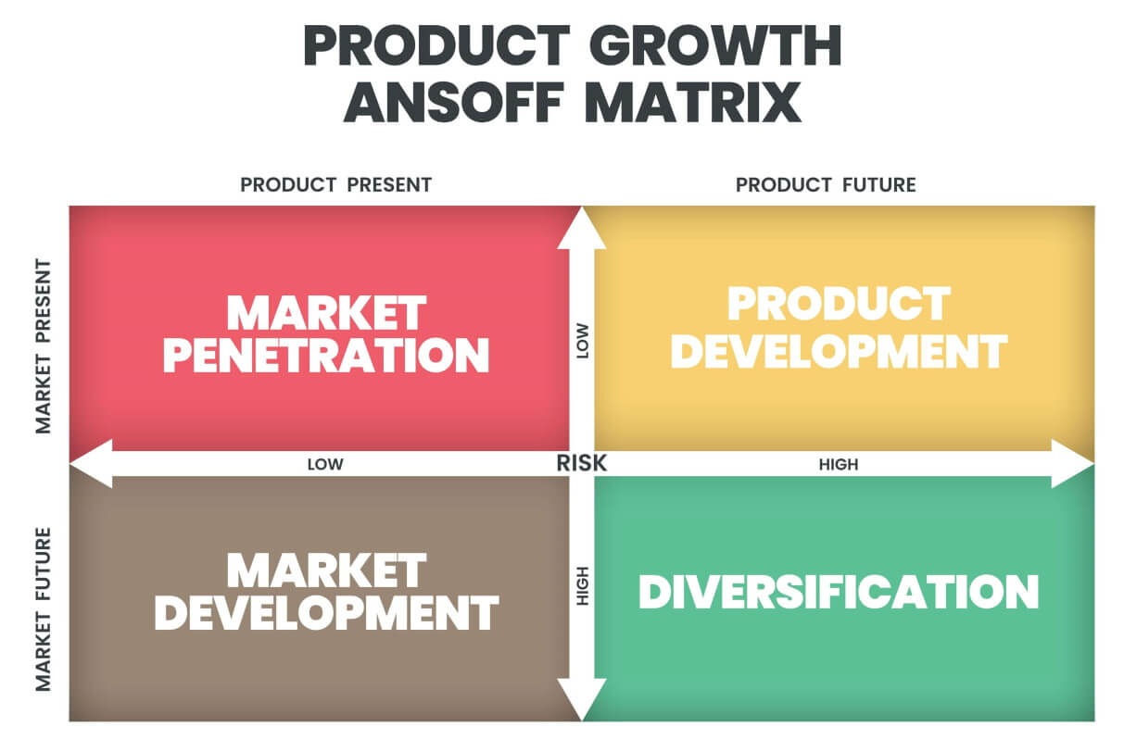
Figure: Ansoff’s Growth Matrix
Source: (Challa and Jena, 2024)
Market Penetration
Netflix augments the penetration by increasing its subscriptions in the already established markets through low prices and superior value propositions. The ad-supported level that was launched in different markets during the economic low seasons is a pointer of a strategic move to reach price sensitive clients as well as reduce subscription cancellation (Challa and Jena, 2024).
Market Development
Netflix has been aggressive in its internationalization to other geographical markets particularly Asia-Pacific, Africa and Middle East. An effective method through which Netflix can tap into the new segments of the customer base is localisation of the content, investment in region-specific content (e.g., Money Heist Korea, Sacred Games in India) and partnership with the local telecom providers. This plan takes place on the opportunities presented by the rise in internet penetration and the growing demand of the digital entertainment in the world (Heinz, Hunke and Breitschopf, 2021).
Product Development
Netflix is a business that tends to add new content formats and functions to their platform with a very high frequency. The interactive storytelling as the development of the product such as the Black Mirror: Bandersnatch is proven by the fact that interactive stories are introduced, which are aimed at making the user more engaged through the unknown experience (Heinz, Hunke and Breitschopf, 2021).
Diversification
The two approaches that Netflix has pursued as part of their diversification plan include exploration of live-streaming (e.g. stand-up comedy specials, sports-related documentaries) and partnership with merchandise. Through these programs, Netflix will have an opportunity to generate additional sources of revenue other than streaming and establish brands in other locations. The Reactions of Netflix according to the Porters generic strategies (Hsiao, 2024).
Netflix’s Responses Using Porter’s Generic Strategies
Differentiation Strategy
The significant differentiation strategy of Netflix, Netflix Originals, personalised suggestions, and user-friendly interface, constitute a significant part of the Netflix strategy. Stranger Things, The Crown and Wednesday among other successful shows not only reinforce the brand image but also reduce the necessity to rely on third parties to launch their productions which give Netflix more strategic advantages (Hsiao, 2024). The reason is due to its algorithmic personalisation that offers a highly curated experience, which its followers have failed to duplicate due to the shallow nature of the data.
Cost Leadership (Selective Application)
Though Netflix is not a pure cost leader, selective implementation of cost-reducing initiatives, such as the ad-supported plan and the improvement of cloud and content delivery efficiency, can help to manage the prices of the operations and offer the competitive price at the sensitive markets. This kind of hybrid cost-differentiation one of it, which help Netflix to stay afloat in the chaos of the economic turbulence (ALEONG and TÜRKTARHAN, 2022).
Strategic Implications for Netflix
The actions of being highly innovational, internationalizing, and the importance of innovation as well as balanced pricing are reflected in the strategic reactions of Netflix. The first-mover advantage of the company is promoted with the help of its company strengths that help the company to launch data-driven insights at every stage of its strategy, including the content development and pricing (ALEONG and TÜRKTARHAN, 2022). However, to sustain the leadership, the company needs a continuous investment in technology and diversification services to minimize the rising competition and economic volatility.

3.2 Strategic Responses of Follower Organisations
Overview of Follower Firm Strategies
The first-mover activity by Netflix puts the competitor organisations such as Disney+, Amazon Prime Video, Hulu, and Apple TV+ in a competitive space. Differentiating content- maximizing price, forming strategic alliances, applying brand ecosystems are some of the ways these companies respond to the macro-environment forces strategically (Ahmed et al., 2022). Their approaches can also be measured using Ansoff Growth Matrix and Porters Generic Strategies.
Followers’ Responses Using Ansoff’s Growth Matrix
Market Penetration
The followers streaming sites apply various market penetration strategies to increase their penetration in the existing markets. Disney+ leverages the family focus brand name by offering an exclusive access to the globally recognised brands such as Marvel, Star Wars, and Pixar that appeals to the following audiences and long term audiences (Dahan and Levi-Bliech, 2025).
Market Development
The other approach employed by the follower organisations is the market development strategy, which involves the expansion of their products and services into new markets with culturally aware products and pricing mechanisms that are culturally appropriate to the region. Live sports, and more specifically the entertainment content of the sport of cricket has been a great success of Disney+ Hotstar in India since it aligns with the local viewing habits and ensures mass adoption (Dahan and Levi-Bliech, 2025). Similarly, the size of Amazon logistics, funds at their disposal, and clientele base make Amazon Prime Video fast in expanding in other nations.
Product Development
The follower sites are also making efforts to match with Netflix with product development including new features and exclusive content. Under Disney+, the number of original series based on the franchise is continually growing as the company connects more emotionally and nostalgically with the audience of the world (Arazzi et al., 2023). Prime is on the path of technological evolution, developing high-level AI-based search and recommendation services, improving the user experience and content collection.
Diversification
Diversification is another strategic choice that is significant among the follower firms. Another strength of Disney+ is the fact that it benefits from an extended business model of entertainment that encompasses theme parks, merchandise, television broadcasts as well as theatrical releases that allow the corporation to be able to create connected entertainment experiences (Arazzi et al., 2023). This kind of synergy increases brand loyalty and causes consumers to go through multiple touchpoints.
Followers’ Responses Using Porter’s Generic Strategies
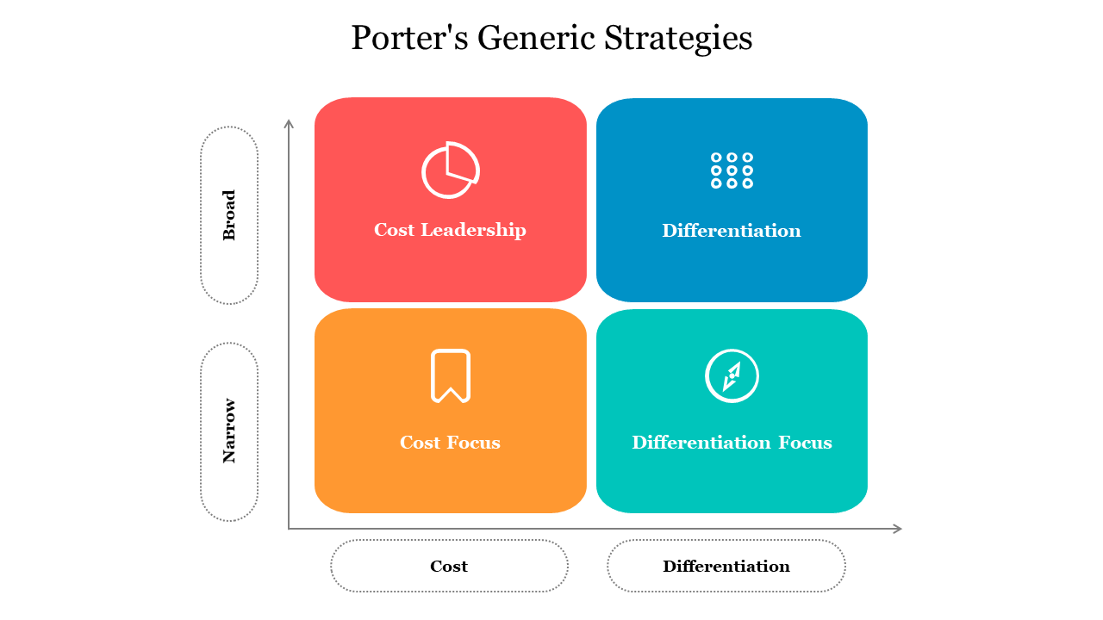
Figure: Porter’s Generic Strategies
Source: (Obi, Eze and Balogun, 2023)
The follower organisations rely on the generic Strategies created by Porter to strengthen their positions in the market against Netflix. The differentiation concept is already widespread, and Disney+ benefits on its exclusive brands and family-oriented content, whereas Apple TV+ concentrates on high-quality and prestige productions (Obi, Eze and Balogun, 2023). Hulu is also characterized by the access to the contents, streaming television the next day, which is attractive to the customer who desires to get the content in real-time.
Strategic Implications for Follower Firms
The follower organisations are required to remain competitive in the streaming industry in the long run, in that the ecosystem integration, strong brand equity, exclusive franchise content, and competitive bundling is critical to the organisations. Although the follower companies tend to imitate the technological advances of Netflix, they build their competitive advantages through the assistance of special resources that Netflix does not possess e.g. the deep intellectual property base of Disney and the diversified e-commerce platform of Amazon (Obi, Eze and Balogun, 2023).

4. Conclusion
The comparison of the strategies applied by the initiator and the follower organisations of the global streaming industry suggests the dynamism and competitiveness of the digital entertainment environment. As a pioneering firm, Netflix has consistently employed innovativeness, data-driven personalisation, and internationalisation of the content as its income in maintaining the top position. Netflix possesses high market penetration, product development and diversification capabilities which are reflected in the Growth Matrix devised by Ansoff in its ad-supported subscriptions, interactive content and investments in foreign content productions. The Porters assignation of Generic Strategies also illustrates the way in which the complexity of the Netflix focus on differentiation in the form of original content and highly-developed algorithms continues to fuel the competitive advantage of the company against the growing market saturation and the slide in consumer demand.
Ansoff Matrix is employed on these platforms to gain a targeted expansion in the market, multi-service diversification, and franchise products development as a method of consolidating the market. Porters Generic Strategies illustrate how the followers incorporate the two forms of differentiation, exclusive intellectual property and high quality originals, and cost leadership especially through bundled service, to attract and retain different forms of audience. Overall, the strategic behaviors of the innovators and the imitators demonstrate that the emerging streaming business is dictated by innovation, integration within the ecosystem, and consumer-driven value creation. The skill of the organisations to find the right balance in the evolution of technology, content diversity and sustainable business model in an increasingly globalised and fragmented market environment will become a long-term success as the competition increases.

References
Ahmed, W., Fenton, A., Hardey, M. and Das, R. (2022). Binge Watching and the Role of Social Media Virality towards promoting Netflix’s Squid Game. IIM Kozhikode Society & Management Review, [online] 11(2), p.227797522210833. doi: https://doi.org/10.1177/22779752221083351.
ALEONG, D.S. and TÜRKTARHAN, G. (2022). COMPANIES WITH VISIONARY LEADERS POSITIONED FOR FUTURISTIC TECHNOLOGY: SIX CASE STUDIES OF BENCHMARKS FOR SURVIVAL. Kafkas Üniversitesi İktisadi ve İdari Bilimler Fakültesi Dergisi, 13(25), pp.267–299. doi: https://doi.org/10.36543/kauiibfd.2022.012.
Arazzi, M., Ferretti, M., Nicolazzo, S. and Nocera, A. (2023). The role of social media on the evolution of companies: A Twitter analysis of Streaming Service Providers. Online Social Networks and Media, [online] 36, p.100251. doi: https://doi.org/10.1016/j.osnem.2023.100251.
Challa, S.D. and Jena, L.K. (2024). Navigating change and adversity: A case study of netflix’s journey. Business Perspectives and Research, [online] 12(3). doi: https://doi.org/10.1177/22785337241233035.
Dahan, G. and Levi-Bliech, M. (2025). Israel as a startup nation: assessing the role of artificial intelligence as a mediator in the relationship between pioneering orientation and new product creativity. Israel Affairs, pp.1–17. doi: https://doi.org/10.1080/13537121.2025.2469442.
Heinz, D., Hunke, F. and Breitschopf, G.F. (2021). Organizing for Digital Innovation and Transformation: Bridging Between Organizational Resilience and Innovation Management. Lecture Notes in Information Systems and Organisation, pp.548–564. doi: https://doi.org/10.1007/978-3-030-86797-3_36.
Hsiao, Y.-H. (2024). The Business Strategy Analysis of Netflix. Transactions on Social Science Education and Humanities Research, [online] 11(2960-1770), pp.760–767. doi: https://pdfs.semanticscholar.org/0418/cdfee079cdbf834abd369556b64f1fc6fb43.pdf.
Iordache, C., Raats, T. and Mombaerts, S. (2022). The Netflix Original documentary, explained: global investment patterns in documentary films and series. Studies in Documentary Film, 17(2), pp.1–21. doi: https://doi.org/10.1080/17503280.2022.2109099.
Khan, U., Ali, Y., Petrillo, A. and Felice, F.D. (2023). Macro-environmental factors and their impact on startups from the perspective of developing countries. International Journal of Sustainable Engineering, 16(1), pp.166–183. doi: https://www.tandfonline.com/doi/abs/10.1080/19397038.2023.2238754.
Morris, K. (2022). Netflix Strategic Business Analysis Netflix Strategic Business Analysis. [online] Available at: https://scholarworks.umt.edu/cgi/viewcontent.cgi?article=1425&context=utpp.
Obi, P., Eze, K. and Balogun, R. (2023). Competition in Marketing: A Deep Dive into Advertising Rivalries. Fusion of Multidisciplinary Research, An International Journal, [online] 4(2), pp.471–482. doi: https://fusionproceedings.com/fmr/1/article/view/55.
Paramadita, S., Purnomo, L. and Rumangkit, S. (2024). Macro-Environmental Analysis Throughout Covid-19 Pandemic Using Pestel Framework: A Study in Indonesian Multi-Industry. eCo-Buss, [online] 7(1), pp.271–282. doi: https://doi.org/10.32877/eb.v7i1.1446.
Viter, L. (2021). An investigation into disruptive innovation in the entertainment industry. Business. [online] doi: https://arc.cct.ie/business/18/.

Appendix

