Information Engineering – Practical Examination

The following document contains four documents in total a Context Diagram, Level 0 DFD, Level 1 DFD and an Entity Relationship Diagram also known as an ERD.

  - Context Diagram

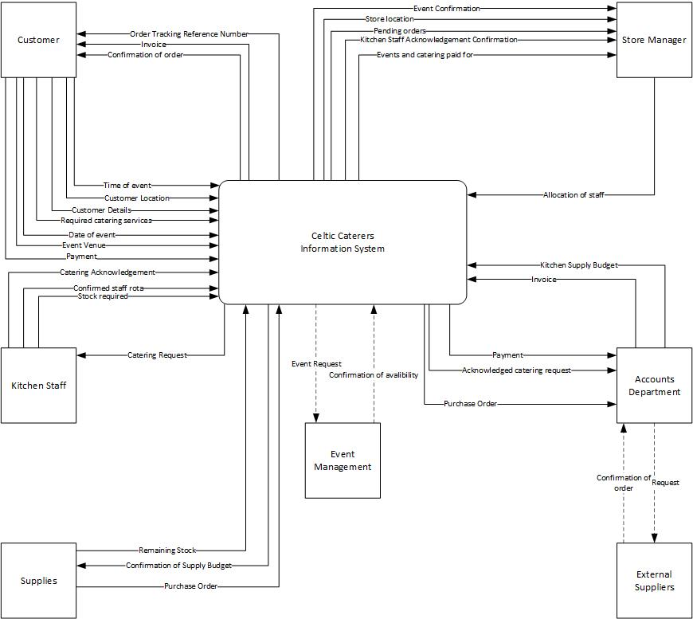

  - Level 0 DFD
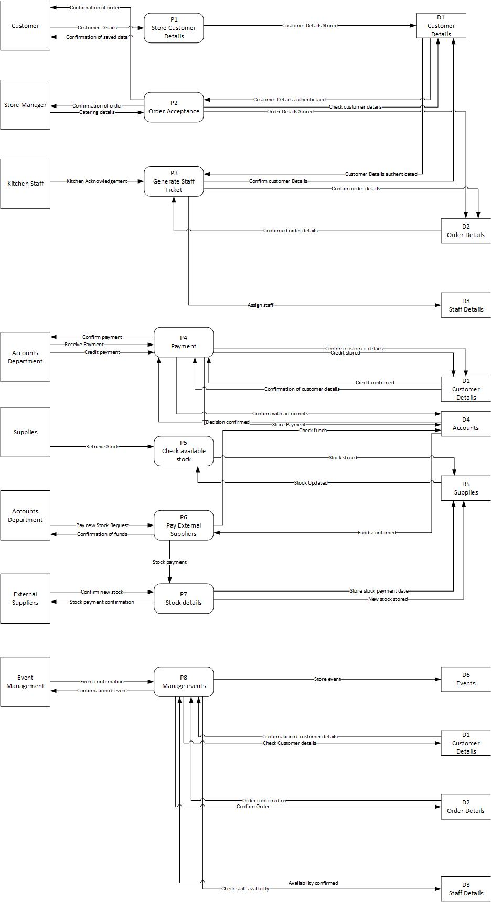

  - Level 1 DFD
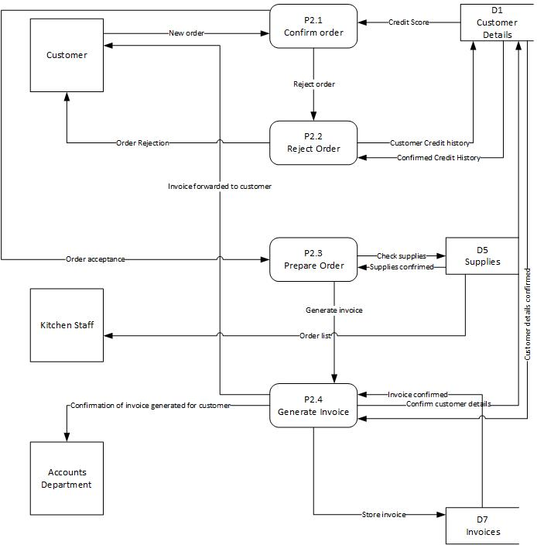

  - Entity Relationship Diagram


