
BUSINESS SKILLS FOR INTERNATIONAL HOTEL INDUSTRY

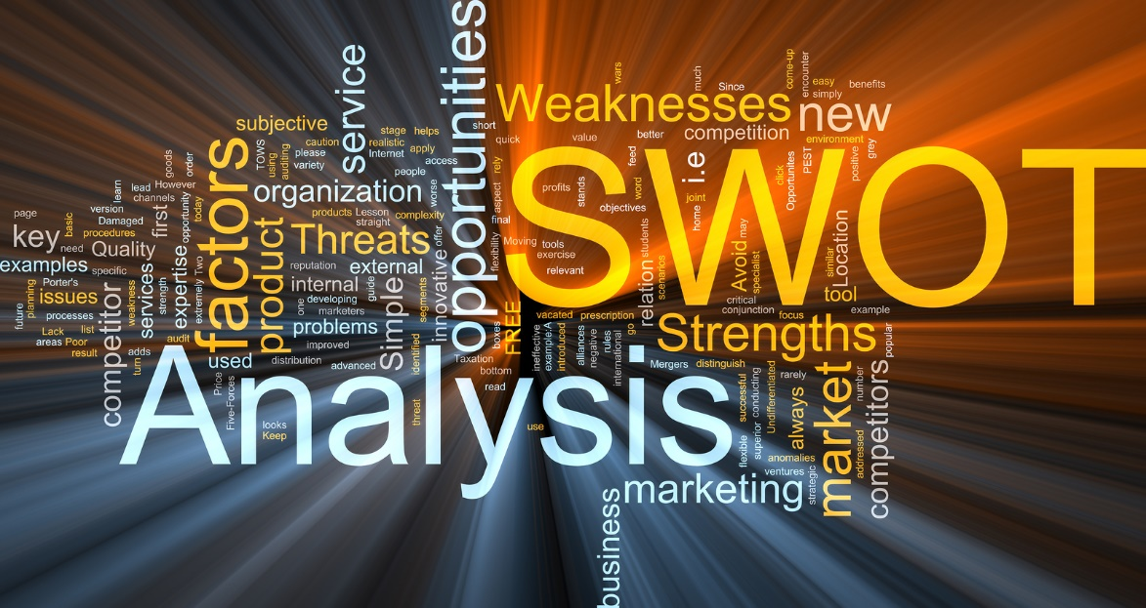

MODULE CODE: BAX 01917
STUDENT: Andreea Sandru 1815220
LECTURER: DALE CLARK
Content

1. Introduction…………………………………………………………………. 3
2. SWOT………………………………………………………………………. 4
3. PDP…………………………………………………………………………. 6
4. Academic skills……………………………………………………………. 7
5. Employability skills………………………………………………………… 8
6. Conclusion………………………………………………………………… 10
7. References………………………………………………………………… 11

Introduction

Before I start creating my SWOT, I would like to provide a definition of the term as it is quite crucial to understand what it means and how it is important to every business that wants to succeed. SWOT represents a study conducted by a company, in order to identify the strengths and weaknesses it holds. These might be focused on internal, but also on external opportunities and threats. This report can be performed for an organization, to find out their strengths, weaknesses, opportunities, and threats.

Creating a SWOT is really simple: you can start by addressing what you want to analyze, after that you can begin with identifying the strengths, note the weaknesses, think about the opportunities and finish with limiting the threats. In this way, you can improve your strengths, discover new opportunities and deal with the risks.

Having performed a SWOT brings advantages also, both for you and for your organization. Some of these advantages are: it is a source of information for strategic planning, builds an organization's strengths, reverses its weaknesses, maximizes its response to opportunities, overcomes organizations threats. It also helps in identifying the core competencies of the firm and in the setting of objectives for strategic planning.

The purpose of this assignment it is to analyze my Academic and Employability skills by pointing out my strengths, weaknesses, opportunities and threats, my personal development plan and how I intend to use this skill to find employment in the hotel and hospitality industry.

SWOT

Strengths

Strengths are tasks/actions that I perform at a higher level. These actions can refer to knowledge, proficiencies, skills, and talents. Some of them are:

⦁ Ambitious – I push myself to the limit in order to obtain the desired result;
⦁ Communicative - improved communication skills throughout the years by working in the hospitality industry;
⦁ Flexible - constantly adapting and improving;
⦁ High-pressure ninja - I choose to stay calm, focused and accept the situation;
⦁ Reliable - I like to honor my word and keep my promises;
⦁ Good computer skills - proficient in using a personal computer and the Microsoft Office suite;
⦁ Organizational skills - combining a personal life with a career requires a lot of planning and timetables;
⦁ Sociable - I can fit into any collective;
⦁ Open-minded - open to new challenges and situations;

Weaknesses

Weaknesses are actions that I'm not particularly brilliant at. Some of them are:

⦁ Intermediate English – my English level is not as advanced and as I'd wish;
⦁ Stubborn - I like being right in most of the situations but I accept a good argument;
⦁ Focusing on small details - sometimes I lack the bigger picture and prefer to point out the needle in the hay;
⦁ Risk-taker - going full-in without analyzing all there is to process beforehand;
⦁ Perfectionist - I strive for the best results and actions, even though that could prove unhealthy at some point;

Opportunities

Opportunities are different circumstances, which at some point provide a positive result if taken advantage of. Some of my opportunities are:

⦁ Learning English - I would love to reach an advanced level;
⦁ Meet new people - meeting someone new means getting to know yet another perspective;
⦁ New projects - getting involved in new and exciting situations;

Threats

⦁ Illness - if something might affect me physically, I might be very difficult to recover everything that I lost in the time I was sick;
⦁ 0 finances - if I wouldn't receive the student finance support anymore, I would not be able to pay my studies.

Personal Development Plan

According to James Smith (2011), “personal development planning is the process of creating an action plan based on awareness, values, reflection, goal-setting, and planning for personal development within the context of a career, education, relationship or for self-improvement.”

In a personal development plan, two parts can be found: your short-term and long-term goals. Both are equally important because in order to achieve my long terms goals, first I must achieve my short-term goals.

Some of my short-term goals are:
⦁ Starting writing in a foreign language. I will start by taking language courses, writing more at home and learning new words.
⦁ Creating a timetable and trying to write more than 500 words on my assignments on a weekly basis.
⦁ Submitting my assignments on time, also pass my exams.
⦁ Have a good attitude - I can’t control everything that it is happening in my life, but I can adapt.

Some of my long-term goals are:

⦁ Graduate university and get my degree in hospitality.
⦁ Enroll in a master program - learn even more about hospitality and obtain a higher position in this domain.
⦁ Have a good job – I want to work hard and try my best and offer my family everything they deserve.
⦁ Move to another city/ country to work in the hospitality domain.
For me, the benefits of creating my PDP helps me learn how to value myself, how to become more self-reliant and aware of my own potential, and how to manage my strengths and weaknesses for my own benefit.

Academic skills

In my opinion, academic skills are acquired by getting involved in university assessments. These skills can help us become a more effective learner, by developing the research and study skills that will help us now but, in the future, also. By developing this skill, we can achieve academic success that reflects our full potential.

Some of my academic skills are:

⦁ Research abilities - when I look up information, I have the patience to search, read and extract the essence from what I found.
⦁ Taking notes skills - I consider myself a good listener but I can also be selective with the information.
⦁ Time management - managing my time for learning, to make it easy for my family and for myself.

An academic skill that I must develop and find it pretty vital: Oral communication.

According to Chandler (2011), oral communication means “Human interaction through the use of speech or spoken messages”. As a manager, I must communicate a lot, in meetings, presentations, or interviews. This is the main reason I desire to learn English especially since it is not my first language. I would like to participate in English courses, to improve and boost my confidence, and to finally be able to speak in front of numerous people.

Employability skills

Employability skills can be defined as the transferable skills needed by an individual to make them employable. In The Conference Board of Canada (1999) it was said that “In today’s world teamwork skills are employability skills”. It is a very good point because this is one of the most important skills that an employee must display. Some other important skills are: positive attitude, communication, self-management, willingness to learn, and the list can continue.

In the past, I worked seven for years in a restaurant as a chef, waitress, bartender and front desk. All these years I have developed my skills by learning how to treat a customer, how to cook, and much more. Also, the manager taught me some things about managing a hotel.
Some of my current employability skills are:
⦁ I have a positive attitude
⦁ I am an excellent team player
⦁ I am motivated, organized and devoted
⦁ I connect very good with customers and colleagues
⦁ I can complete all the tasks.
⦁ I am flexible and adaptable.
⦁ I can follow directions.
⦁ I work calmly in busy environments.

Some employability skills that I must develop are:
⦁ Exceptional verbal skills
⦁ Languages skills (learning another language)
⦁ Financial skills
⦁ Management skills
⦁ Logistical skills

Conclusion

In this assignment, I created my own SWOT and PDP for the occupation of a post in hospitality. I also talked about academic skills and employability skills that I currently have but also pointed out those that need to be developed in the future. Given that my goal is to work as a manager in the hotel, I currently do not have all the necessary skills for this job. But by the time I'm done with university, and receive my manager's degree, I'll have time to develop them. My job skills are quite decent but not enough to get a top position in the hotel. The first thing that I must do is improve my English.
Now that I created my SWOT and PDP, I know my strengths, weaknesses, threats and opportunities and I understood what skills I must develop in the future as a good manager in a hotel.
Eugene S. Wilson (1978) said about working in hospitality that “Only the curious will learn and only the resolute overcome the obstacles to learning. The quest quotient has always exited me and more than the intelligence quotient.”

References

⦁ Chandler, D., and R. Munday. "Oral Communication." A Dictionary of Media and Communication (2011): A Dictionary of Media and Communication. Web.
⦁ Eugene S. Wilson, (1978) Former Dean of Admission at Amherst College.
⦁ James Smith (2011) “Personal Development Plan”. Samford, Australia; Tebbo
⦁ Personal Development eBook. (2006). my-skills.
⦁ Philpot, S., Curnick, L., Soars, L. and Soars, J. (2011). Academic skills. Oxford: Oxford University Press.
⦁ Understanding Employability Skills. (1999). Ottawa: The Conference Board of Canada.
- https://www.managementstudyguide.com/swot-analysis.htm [ accessed 15/07/2019]

