

MSc Data and Artificial Intelligence

Data Security, Governance and Compliance

Student name :Rohan Mendapara
Student id :2520811
Professor Name: Vijeyananthan Thayananthan
Module Code: ACCA7028

Executive Summary
This report examines the cybersecurity, governance and compliance challenges faced by AeroLink Logistics (ALL) due to its reliance on cloud computing, IoT, AI and third-party services. Key risks include third-party security, remote access, IoT vulnerabilities and governance gaps. The report evaluates the NIST Cybersecurity Framework, ISO/IEC 27001, COBIT 2019 and ITIL Security Management, recommending an integrated governance approach to strengthen risk management, regulatory compliance, vendor governance, business continuity and operational resilience in response to evolving cyber threats.
Table of Contents
1. Introduction 5
2. Analysis of Current Security Challenges at ALL 5
2.1 Cloud and Third-Party Security Risks 5
2.2 IoT and AI Security Vulnerabilities 6
2.3 Remote Access and BYOD Risks 6
2.4 Governance and Compliance Gaps 7
3. Critical Evaluation of Security Frameworks and Models 8
3.1 NIST Cybersecurity Framework 8
3.2 ISO/IEC 27001 9
3.3 COBIT 2019 10
3.4 ITIL Security Management 11
3.5 Comparative Framework Analysis 11
4. Proposed Integrated Security Governance Framework for ALL 13
4.1 Proposed Security Governance Architecture 13
4.2 Integrated Framework Design 14
4.3 Risk Management Strategy 14
4.4 Security Controls and Protection Mechanisms 16
4.5 Vendor Governance and SLA Management 17
4.6 Business Continuity and Incident Response 17
5. Critical Discussion: Importance of Continuous Regulatory and Security Updates 18
5.1 Emerging Technology Risks 18
5.2 Evolving Global Compliance Demands 19
5.3 Importance of Continuous Security Adaptation 19
6. Recommendations 20
7. Conclusion 20
8. Reference List 22

1. Introduction
AeroLink Logistics (ALL) relies on cloud platforms, AI analytics and IoT technologies to support global logistics operations. While these technologies improve efficiency, they also increase cybersecurity, governance and compliance risks. This report evaluates these challenges and recommends an integrated security governance framework.

2. Analysis of Current Security Challenges at ALL

2.1 Cloud and Third-Party Security Risks
There is a significant reliance on infrastructure services provided by third parties, with around 88% of ALL outsourcing going through IaaS and SaaS. Lack of sufficient security measures could cause the organisation to be hampered in its operations, damage its good reputation, and possibly incur regulatory fines.
Additionally, poor vendor management could result in cloud environments that are misconfigured, have insecure APIs, and expose a medium of unauthorised data. Not having specific Service Level Agreements (SLAs) and vendor security audits could also hinder ALL's capacity to hold vendors accountable during security incidents [2]. Lack of sufficient security measures could cause the organisation to be hampered in its operations, damage its good reputation, and possibly incur regulatory fines.
Table 1: Major Cloud and Third-Party Risks at ALL
Risk Area | Organisational Impact
Cloud misconfiguration | Exposure of customer and shipment data
Weak vendor accountability | Delayed incident response and unclear liability
Insecure APIs | Increased risk of unauthorised system access
Cross-border data processing | GDPR and compliance complications
Limited vendor monitoring | Reduced visibility into third-party security posture

2.2 IoT and AI Security Vulnerabilities
The use of tracking devices, IoT technologies, and artificial intelligence-driven analysis of data increases the attack surface. IOT devices often have very few built-in security controls, which is why there are opportunities for device hijacking, spoofing attacks and intercepting or stealing data [3]. An environment of logistics can have the possibility of corrupting shipment tracking information, introduction of supply chain visibility and restriction of trust in the environment of operation.
Similarly, with AI-backed analysis systems, data poisoning, algorithm manipulation and contaminated training data pose potential threats. If AI models’ responses are reliant on logistics data and the data used for changes is incorrect, this can generate inaccurate operational forecasts and make decisions in the strategic planning phase vulnerable to data errors [4].

2.3 Remote Access and BYOD Risks
Working remotely has allowed staff, suppliers and logistics partners to connect organisations' systems from remote locations, from any number of geographical regions, on unmanaged devices [5]. This helps provide some continuity to the operation but significantly reduces the strength of endpoint security and identity management controls.
Besides, it may be difficult to monitor and detect incidents in different time zones with remote connectivity. If there are no robust authentication and monitoring over these systems, it is possible for the attackers to use stolen credentials and still have enough time to establish a persistent entry into the organisation's sensitive systems.

2.4 Governance and Compliance Gaps
There is currently no centralised security framework, formalised risk management process and regular compliance auditing with recognised standards (GDPR, ISO/IEC 27001) for ALL.
Another negative impact that may occur is a lack of clear business continuity planning and incident response policies affecting incident response and business continuity efforts respectively [6]. At the same time, the world of data protection is ever-changing, and organisations must maintain ongoing compliance monitoring and flexible governance of their security programs.
Table 2: Governance and Compliance Weaknesses at ALL
Governance Gap | Strategic Consequence
No unified security framework | Inconsistent security implementation
Lack of compliance audits | Increased regulatory exposure
Weak risk governance | Poor threat prioritisation
Unclear security responsibilities | Reduced accountability
Limited business continuity planning | Operational disruption during incidents

3. Critical Evaluation of Security Frameworks and Models

3.1 NIST Cybersecurity Framework
The NIST Cybersecurity Framework (NIST CSF), which was developed by the NIST, is a risk-based structure made up of five different functions: Identify, Protect, Detect, Respond, and Recover, these functions are aimed at enhancing cybersecurity resilience of organisations [7].

Figure 1: Flow diagram for the NIST framework
(Source: Self-developed)
The NIST framework provides a great deal of benefit for ALL, due to the ongoing identification of risk and management of operations. The introduction of Information Security Policy has become an essential part of the NIST framework for improving AI governance and reduce data breach conditions. Functions such as "Identify" and "Protect" could help the organisation identify potential weaknesses in the cloud infrastructure, hardware devices or remote access programs [8]. Likewise, the “Detect” and “Respond” functions enhance incident management by facilitating the ability to monitor activity singly and promptly quarantine threats [9].
However, although there are some limitations, NIST is not a complete listing of compliance certification processes such as ISO/IEC 27001. This can lead to organisations being required to have additional governance to deal with legal and compliance issues if they operate in multiple jurisdictions.
Table 3: Evaluation of NIST CSF for ALL
Strengths | Limitations
Flexible risk-based approach | Limited compliance certification support
Strong incident response guidance | Requires organisational security maturity
Effective for continuous monitoring | Complex implementation across outsourced systems
Suitable for cloud security management | Heavy dependence on internal coordination

3.2 ISO/IEC 27001
ISO/IEC 27001 is an international standard which is dedicated to information security governance, risk management and continual improvement [10]. The framework includes formally defined requirements about control and audit arrangements and establishes ways to generate evidence for organisations to demonstrate compliance with regulation and structured security governance. The ALL administration can also devise adequate Risk management policies involved with ISO/IEC 27001 framework for identifying and evaluating information related different cyber security threats that can lower digital infrastructure productivity.
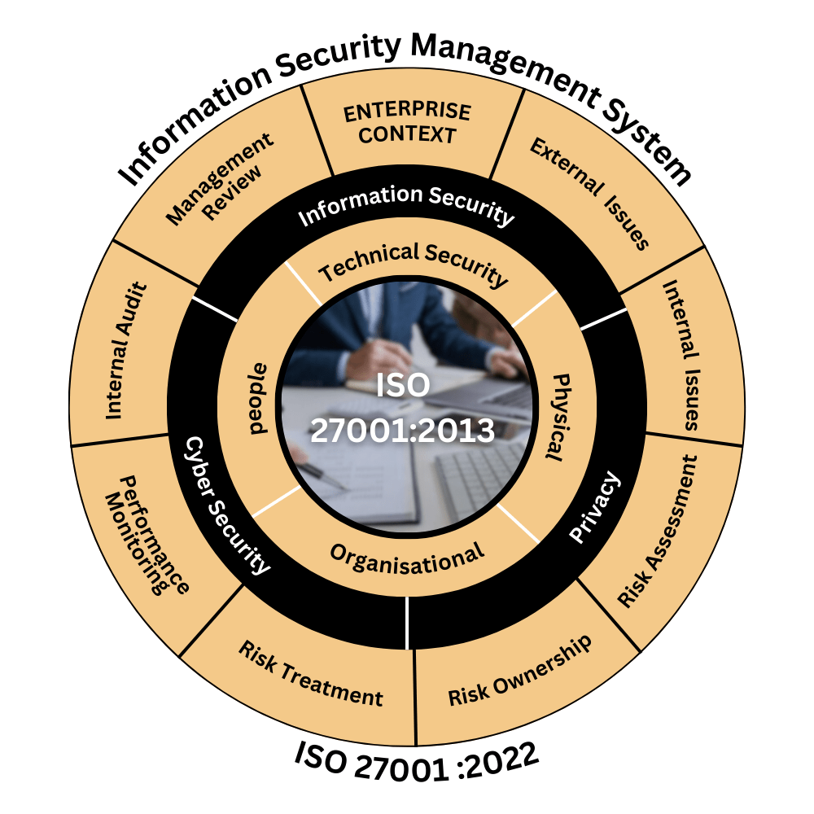
Figure 2: ISO/IEC 27001
(Source: 19)
All is specifically useful in this context due to the ISO/IEC 27001 laying down clear responsibilities and formal governance procedures with respect to security [11]. The framework could enhance the uniformity of policies, accountability of vendors, and protection of data in the global scale.
However, implementing ISO/IEC 27001 can be complex, open resource demands, and necessitates admin effort [12]. Documentation needs, ongoing audit responsibility and change management can be challenging issues in smaller operating units of ALL. Further, ISO standards offer governance provisions with somewhat little guidance towards the real-time detection and response to cyber threats.

3.3 COBIT 2019
COBIT 2019 is a governance framework and management which has a target to harmonise IT operation to organisational objectives [13]. COBIT is not a technical cybersecurity framework but a more governance, structure accountability and Performance Management one.
When it comes to ALL, COBIT 2019 can provide a significant governance advantage since there is a lack of a central security leader and poor security accountability in the current organisation [14]. The ALL leadership can also consider the use of Align, Plan, and Organize (APO) policy included in the COBIT 2019 Framework for addressing future AI policies that compromise organisational data security.
Unfortunately, COBIT is also broad in orientation in the governance, which can restrict the usefulness if applied to operational cybersecurity management without the appropriate context [15]. No detailed information on technical controls for detecting incidents, defending endpoints, or implementing cloud-specific security exists in the framework.

3.4 ITIL Security Management
Information Technology Infrastructure Library (ITIL) is a data system technology that focuses on the management of data system and business continuity [16]. Beyond logistics, ITIL security management practices have a significant role to play in logging in incidents, maintaining the availability of services, and assuring business continuity in contexts where digital processes are important [17].
Successful implementation of ITIL can bring about operational resilience in ALL due to the following optimisations: internal resource optimisation of incident escalation procedures, coordination of disaster recovery and optimisation/restructuring of service restoring operations. Structured service management procedure can help minimise the likelihood of operations being disrupted due to a cyber security incident as logistics activities require systems be readily available.
While all these are benefits of ITIL, it is focused mainly on service management and not on extensive cybersecurity governance. With that said, the structure can be inadequate for dealing with advanced cyber dangers, the administration of cloud resources or administrative prerequisites [18]. Moreover, if relying too heavily on procedural service management, it can have a negative impact on the agility of organisations in the event of a rapidly changing cyber incident.

3.5 Comparative Framework Analysis
There are no comprehensive or universal solution that cover all of ALL's security, governance and compliance rules and obligations. Instead, it is every framework that brings its different strategic and operational capacities. Hence, because of the multi-dimensional nature of cybersecurity issues, an integrated cybersecurity governance would be more suitable to be utilised in this organisation's governance. In the instance of quantitative aspect, the use of risk calculations with some graphs can prove to be useful for identifying the latest security threats for ALL administration.
Table 4: Cybersecurity Framework
Framework | Primary Focus | Key Strength | Key Limitation | Suitability for ALL
NIST CSF | Operational cybersecurity | Risk-based threat management | Limited compliance focus | High
ISO/IEC 27001 | Governance and compliance | Formal ISMS and auditing | Resource-intensive implementation | High
COBIT 2019 | IT governance | Strategic alignment and accountability | Limited operational controls | Moderate to High
ITIL | Service management | Incident and continuity management | Weak cybersecurity depth | Moderate

4. Proposed Integrated Security Governance Framework for ALL

4.1 Proposed Security Governance Architecture

Figure 3: Hierarchical governance structure
(Source: Self-developed)
The governance structure proposed is both centralised in terms of accountability and cross-departmental in terms of coordination for dealing with the current weaknesses in governance that exist in ALL. Executive leadership for cybersecurity strategy should be delivered by a governance team in separate operational teams such as risk management, compliance controls, incident response and vendor governance teams.
Table 5: Proposed Governance Structure for ALL
Governance Function | Key Responsibility
Security Governance Board | Strategic security oversight and policy approval
Security Operations Centre (SOC) | Continuous monitoring and incident detection
Risk Management Team | Threat assessment and risk prioritisation
Compliance and Audit Unit | GDPR and ISO compliance monitoring
Vendor Governance Team | Third-party risk assessment and SLA enforcement
Incident Response Team | Security incident containment and recovery

4.2 Integrated Framework Design
The proposed integrated framework leverages more of the operational best practices people can find in NIST and the governance and compliance aspects in ISO/IEC 27001, COBIT 2019, and ITIL. The frameworks cover separate aspects of the organisation's needs but wholeheartedly contribute to the wider cyber security maturity.
Since the one thing NIST CSF has in common with the organisation is the need to be continuously monitored, respond to incidents when they occur, and detect threats, it should serve as the organisation's operational cybersecurity model. The ISO/IEC 27001 should define the Information Security Management System (ISMS) to set the base for the standardised framework of Information Security governance policies and compliance auditing [13]. The benefits of COBIT 2019 can be to benefit the alignment of the strategic goals, objectives and cybersecurity intent of the business or organisation with its cybersecurity policies and practices; and the benefits of ITIL to provide service continuity and operational resilience.

4.3 Risk Management Strategy
Risk ID | Risk Description | Likelihood (1–5) | Impact (1–5) | Risk Score | Recommended Mitigation Control | Risk Owner
R1 | Cloud infrastructure misconfiguration leading to data exposure | 5 | 5 | 25 | Continuous cloud monitoring, configuration audits, and Zero Trust implementation | Cloud Security Team
R2 | Unauthorised access through compromised remote credentials | 5 | 5 | 25 | MFA, IAM systems, phishing awareness training | Security Operations Centre (SOC)
R3 | An IoT device compromise is affecting shipment tracking systems | 4 | 5 | 20 | IoT encryption, network segmentation, and device authentication | Infrastructure Security Team
R4 | Third-party vendor security failure causing a data breach | 5 | 5 | 25 | Third-party risk assessments, compliance-based SLAs | Vendor Governance Team
R5 | Ransomware attack disrupting logistics operations | 4 | 5 | 20 | Backup redundancy, endpoint protection, and incident response planning | Incident Response Team
R6 | AI analytics manipulation through compromised datasets | 3 | 5 | 15 | Dataset validation, anomaly detection, secure AI model governance | Data Governance Team
R7 | Regulatory non-compliance with GDPR and data protection laws | 4 | 5 | 20 | ISO/IEC 27001 implementation, regular compliance reviews | Compliance and Audit Unit
R8 | Insider threats are causing unauthorised data disclosure | 3 | 4 | 12 | RBAC, user behaviour monitoring, and least privilege access | HR and IT Security Team
R9 | Distributed Denial-of-Service (DDoS) attacks on operational platforms | 3 | 4 | 12 | DDoS mitigation tools, network traffic monitoring | Network Security Team
R10 | Failure of disaster recovery systems during cyber incidents | 3 | 5 | 15 | Geographically distributed backups, continuity simulations | Business Continuity Team
The above table showcases the effectiveness of continuous Cloud monitoring systems for overcoming data Misconfiguration for ALL and its IT division. However, the increased data breach concerns can prove to be a serious issue for ALL while using Cloud monitoring processes for effective data management. On the other hand, the IoT security networks are more prone to ransomware attacks that can lower the ability of ALL to maintain continuous IT operations.
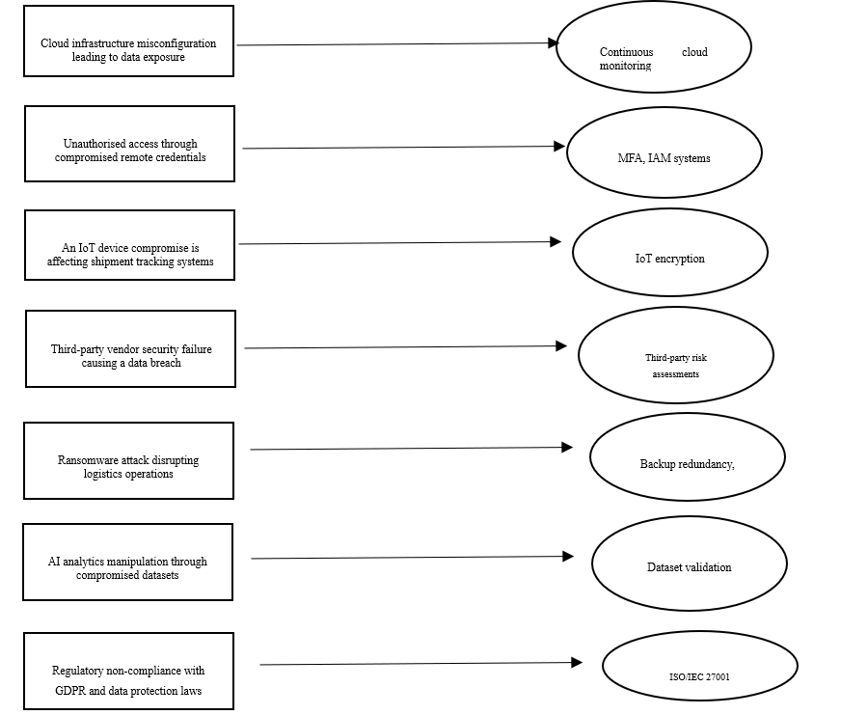
Figure 4: Flowchart demonstrating different solutions
(Source: Self-designed)

4.4 Security Controls and Protection Mechanisms
ALL should deploy layered security controls that match up with the principles of Zero Trust security to enhance cybersecurity resilience. It is operating where no perimeter security models can be applied and using unmanaged devices to access the organisation's network remotely.

Figure 4: Zero Trust security
(Source: Self-designed)

4.5 Vendor Governance and SLA Management
Vendors are a key part of ALL's "extended" enterprise, and vendor governance is a key aspect of organisational security management. Poor procedures at the vendor level can result in data breaches, non-compliance and operational problems [11].
ALL should develop its own risk assessment protocols and subsequent contingencies with third parties and create an SLA that deals with security. It is important that vendors are held accountable to security standards, including ISO/IEC 27001 and practice to regularly audit their security. In addition, there are timelines for breach notification, incident response obligations, and regulatory compliance requirements that are key elements of SLAs.

4.6 Business Continuity and Incident Response
Business continuity is necessary along with incident response planning because ALL logistics operations are dependent on continuous addresses and keeping track of incidents in real time. At present, the organisation's restricted continuity plan has added to operational risks in the event of a cyber-attack.

Figure 5: NIST-style incident response
(Source: Self-designed)
The suggested actions for a framework should then include a formality incident response lifecycle, including preparation, detection, containment, eradication, recovery, and post-incident review. Backup systems and disaster recovery sites should also be located geographically in different areas to minimise disruption should a ransomware attack occur or when a cloud-based service experiences an outage.

5. Critical Discussion: Importance of Continuous Regulatory and Security Updates

5.1 Emerging Technology challenges
Cloud Computing, Internet of Things (IoT) systems and artificial intelligence (AI)-assisted analysis have helped organisations operate so much more efficiently, however, there seems to be an array of security vulnerabilities [3]. The machine-to-machine communications technology used for the Internet of Things (IoT) is often less secure than one might expect, making it easily accessible for hackers to hijack and alter the information used at the targeted supply chain activity, or to slow it down. Similarly, AI algorithms can be biased and tampered with by malicious parties who will manipulate and use incomplete data for training purposes, thereby producing substandard decision making.

5.2 Evolving Global Compliance Demands and subsequent challenges
The regulatory environment is always evolving from rising data privacy, cross-border data transfers, and digital accountability are on the rise. Requirements such as General Data Protection Regulation (GDPR) have specific provisions regarding the way the data are to be processed, how any breach will be communicated and the protections afforded the data's owner privacy. When operations are global (multinational organisations), like ALL, compliance complexity becomes more complex.
Table 6: Impact of Continuous Regulatory Updates
Regulatory Area | Organisational Importance
Data protection laws | Protection of customer information
Breach notification requirements | Faster incident transparency
Third-party compliance obligations | Improved vendor accountability
Cross-border data regulations | Stronger international governance
Security auditing standards | Continuous compliance readiness

5.3 Importance of Continuous Security Adaptation
This is the reason for constant adaptation to meet the changing threats from cyberspace and the faster-paced threats compared to traditional governance structures. It can also help future students towards better identify potential security risks in AI-based systems for preventing cyberattacks. An outdated policy or static controls or a policy that is not audited often can give organisations a false sense of security in terms of security maturity as to the type of attack techniques being utilised on the network [7]. Adaptive governance models that move to incorporate real-time monitoring, threat intelligence, and continual auditing are gaining popularity by the day. As a Future IT leader, the deployment of IT security drills is critical for demonstrating potential AI-based solutions to employees for maximising internal security and adhering to the GDPR regulations.

6. Recommendations
Recommendation 1: an integrated governance framework combining NIST CSF, ISO/IEC 27001, COBIT 2019, and ITIL
First, a combined governance framework (NIST CSF, ISO/IEC 27001, COBIT 2019 and ITIL framework) should be implemented at the first level of governance in ALL. It would allow the organisation to risk manage, adhere to compliance frameworks, align and integrate them into business strategies, and maintain business continuity in a single security platform.
Recommendation 2: Strengthen third-party governance through comprehensive vendor risk management procedures
Secondly, the organisation's third-party governance should be more robustly developed via extensive vendor risk management processes. To minimise the risks of relying on IaaS and SaaS vendors, a Security Based Service Levels Agreement (SLAs), a mandatory compliance audit, and regular monitoring of vendors should be implemented. It is also beneficial for the vendors to adhere to known security standards, as that will lead to secured supply chain ecosystem.
Recommendation 3: Adopt Zero Trust security principles
Thirdly, in the interest of averting vulnerabilities caused by remote employees and unmanaged Bring Your Own Devices (BYOD) use, ALL must adopt Zero Trust security concepts. Multi-factor authentication, endpoint protection, Identity and Access Management (IAM) and continuous authentication should be implemented to minimize risk due to unauthorised access. Besides, need for encryption and segmentation aspects for IoT devices and Logistics Infrastructure also need to be highlighted.

7. Conclusion
The evaluation showed that no single framework can fully meet the operational, governance and regulatory requirements of ALL. The analysis identified key risks, including third-party dependence, remote access vulnerabilities, governance weaknesses and compliance challenges. An integrated governance framework combining NIST CSF, ISO/IEC 27001, COBIT 2019 and ITIL provides the most effective solution by improving cybersecurity, governance, compliance and operational resilience. This integrated approach also enhances risk management, strengthens vendor oversight, supports business continuity and enables the organisation to respond more effectively to evolving cyber threats and regulatory requirements.

8. Reference List
[1] N. H. Anh, “Hybrid cloud migration strategies: Balancing flexibility, security, and cost in a multi-cloud environment,” Transactions on Machine Learning, Artificial Intelligence, and Advanced Intelligent Systems, vol. 14, no. 10, pp. 14–26, 2024. [Online].
[2] M. Y. M. Haq, S. Anand, L. J. M. Nieuwenhuis, and A. Abhishta, “Cloud outsourcing risk management for cloud consumers: A systematic literature review,” ACM Computing Surveys, vol. 58, no. 12, Art. no. 297, pp. 1–36, 2026, doi: 10.1145/3808691.
[3] M. Shafiq, Z. Gu, O. Cheikhrouhou, W. Alhakami, and H. Hamam, “The rise of Internet of Things: Review and open research issues related to detection and prevention of IoT-based security attacks,” Wireless Communications and Mobile Computing, vol. 2022, Art. no. 8669348, 2022, doi: 10.1155/2022/8669348.
[4] P. K. Sadhu, V. P. Yanambaka, and A. Abdelgawad, “Internet of Things: Security and solutions survey,” Sensors, vol. 22, no. 19, Art. no. 7433, 2022, doi: 10.3390/s22197433.
[5] A. Nand, A. Sohal, I. Fridman, S. Hussain, and M. Wallace, “An exploratory study of organisational and industry drivers for the implementation of emerging technologies in logistics,” Industrial Management & Data Systems, vol. 123, no. 5, pp. 1418–1439, 2023, doi: 10.1108/IMDS-08-2022-0467.
[6] F. Osman and H. Rahman, “Planning for cybersecurity incidents and recovery: Methods for ensuring business continuity and maintaining information assurance,” Algorithms, Computational Theory, Optimisation Techniques, and Applications in Research Quarterly, vol. 14, no. 9, pp. 1–17, 2024. [Online].
[7] D. P. Möller, “NIST cybersecurity framework and MITRE cybersecurity criteria,” in Guide to Cybersecurity in Digital Transformation: Trends, Methods, Technologies, Applications and Best Practices. Cham, Switzerland: Springer Nature, 2023, pp. 231–271, doi: 10.1007/978-3-031-26845-8_5.
[8] A. D. Khaleefah and H. M. Al-Mashhadi, “Methodologies, requirements, and challenges of cybersecurity frameworks: A review,” Iraqi Journal of Science, vol. 65, no. 1, pp. 468–486, Jan. 2024, doi: 10.24996/ijs.2024.65.1.38.
[9] R. Rohan, B. Papasratorn, W. Chutimaskul, J. Hautamäki, S. Funilkul, and D. Pal, “Enhancing cybersecurity resilience: A comprehensive analysis of human factors and security practices aligned with the NIST cybersecurity framework,” in Proc. 13th International Conference on Advances in Information Technology (IAIT 2023), Dec. 2023, pp. 1–16, doi: 10.1145/3628454.3629472.
[10] F. Kitsios, E. Chatzidimitriou, and M. Kamariotou, “The ISO/IEC 27001 information security management standard: How to extract value from data in the IT sector,” Sustainability, vol. 15, no. 7, Art. no. 5828, 2023, doi: 10.3390/su15075828.
[11] S. Meitarice, L. Febyana, A. Fitriansyah, R. Kurniawan, and R. A. Nugroho, “Risk management analysis of information security in an academic information system at a public university in Indonesia: Implementation of ISO/IEC 27005:2018 and ISO/IEC 27001:2013 security controls,” Journal of Information Technology and Cyber Security, vol. 2, no. 2, pp. 58–75, 2024, doi: 10.30996/jitcs.12099.
[12] J. Jevelin and A. Faza, “Evaluation the information security management system: A path towards ISO 27001 certification,” Journal of Information Systems and Informatics, vol. 5, no. 4, pp. 1240–1256, 2023, doi: 10.51519/journalisi.v5i4.572.
[13] B. V. Tulus and A. R. Tanaamah, “Design of information technology governance in educational institutions using COBIT 2019 framework,” Journal of Information Systems and Informatics, vol. 5, no. 1, pp. 31–43, 2023, doi: 10.51519/journalisi.v5i1.408.
[14] B. Metin, S. B. Sevim, and M. Wynn, “Cybersecurity strategy development: Towards an integrated approach based on COBIT and ISO 27000 series standards,” Standards, vol. 5, no. 4, Art. no. 33, 2025, doi: 10.3390/standards5040033.
[15] H. M. Melaku, “A dynamic and adaptive cybersecurity governance framework,” Journal of Cybersecurity and Privacy, vol. 3, no. 3, pp. 327–350, 2023, doi: 10.3390/jcp3030017.
[16] M. C. Pontoan, J. I. Sihotang, and E. Lompoliu, “Information security analysis of online education management system using information technology infrastructure library version 3,” MATRIK: Jurnal Manajemen, Teknik Informatika dan Rekayasa Komputer, vol. 22, no. 2, pp. 207–216, 2023, doi: 10.30812/matrik.v22i2.2474.
[17] A. Harjanto and R. F. Aji, “Improving IT assets management with ITIL 4 framework,” Jurnal Ilmu Komputer dan Informasi, vol. 17, no. 2, pp. 127–143, 2024, doi: 10.21609/jiki.v17i2.1195.
[18] D. Dzemydienė, S. Turskienė, and I. Šileikienė, “Development of ICT infrastructure management services for the optimisation of the administration of educational institution activities by using ITIL v4,” Baltic Journal of Modern Computing, vol. 11, no. 4, pp. 558–579, 2023, doi: 10.22364/bjmc.2023.11.4.03.
[19] Trojan Hunt India, “ISO 27001:2022 Information Security Management System,” 2024. [Online].

