Name : Patel Komalben Babubhai
Student id : 2211067
Module : Marketing Management
Module code : LCMB7001
Lecturer : Tushara balendran

Table of Contents
Introduction 3
Discussion 3
Conducting the environmental marketing analysis by considering the vital external influencing driver along with an analysis of the internal environment 3
The role marketing plays in the company 6
Recommendation for the future 7
Conclusion 7
References 9

Introduction
As per the view of Krizanova et al. (2019), marketing plays an important role in managing the performance of the company. Businesses have been turning to adapt marketing tools for promoting their products & services in the competitive world. It has been examined that the businesses in the United Kingdom have been focused on their consumer by developing customer-facing interfaces digitally, while other businesses improve their data integration for “end-to-end” customer tracking, the main objective of the marketing (Statista, 2022a). In this report, the UK-based grocery company Morrisons has been considered and the impact of the external market on their operation has also been explored. It is the fourth largest chains of supermarket having its headquarter in the UK (Plc, 2022).
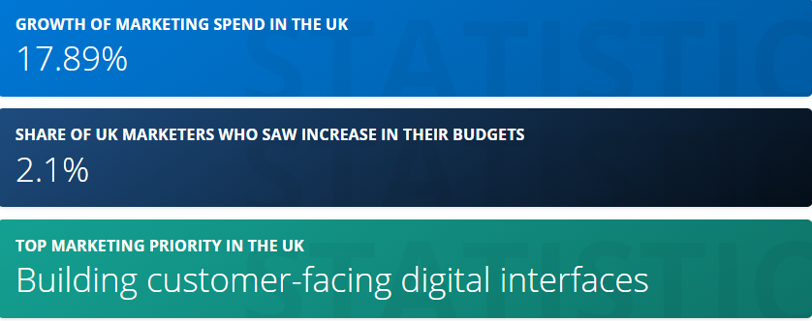
Figure 1: The role of marketing in the business
(Source: Statista, 2022a)

Discussion

Conducting the environmental marketing analysis by considering the vital external influencing driver along with an analysis of the internal environment
The company across the globe has been operating in the ever-changing business world. Thus, external factors can have an impact on the success of the company (BBC, 2022a). In addition, the impact of external factors can be negative or positive for the business. It is possible for an organization to manage their internal operations based on the requirement of the market. However, it is very difficult for the company to control external factors such as the Covid-19 pandemic. This has immensely affected the overall operations of the company and their sustainability has been a challenge. It is also necessary for the brand to understand the customer and their satisfaction level.

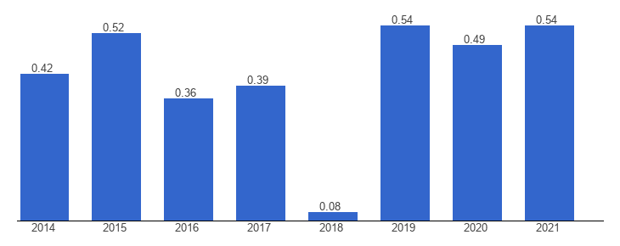
Figure 2: Political stability of the company
(Source: Theglobaleconomy, 2022)
The political stability index falls between -2.5 which means weak and 2.5 means strong (Theglobaleconomy, 2022). Based on figure 2, the United Kingdom is a politically stable nation which allows businesses to perform well and sustain their operation. Therefore, the strong political stability of the UK allows Morrisons to perform well and manage their operations effectively. However, the outbreak of the Covid-19 pandemic has affected the overall performance of the company because the economic condition of the UK has been affected badly. Due to the extreme competition from the external environment, the company has focused on improving its price list and product specification, packaging as well as merchandising of the favourite items of the customers (Morrisons-corporate, 2022a). The home delivery services that have been offered by the company may affect their rivals to integrate the same approach or the approach better than Morrisons in their services. The same-day delivery approach of Morrisons is effective and helps the business to grow and expand. This can be done by the brand by managing their internal operation and manage the operation which can help them to grow.
The ban on plastic has become a mandatory requirement imposed by the government. This has been effective for Morrisons because their competitors would not be able to adopt this strategy faster than Morrisons. Moreover, the company has introduced new carrier bags that have been made of the new paper, thus, the reduced use of plastic bags can have a positive impact on the environment. On the other hand, the advancement of digital technology has been effective for the brand to growth. As per the view of Lambert et al. (2019), they have been using digital technology to offer increasingly accessible, convenient and easy services for customers. The brand has also been digitizing the shopping trips of the customers and helping colleagues continue to work and having the purpose to reduce wasted effort. It has been examined that Morrisons has started the new “Scan and Go” app that can enable the customer & to check out quickly. However, during the initial phase of the pandemic, the company increased the contactless payment to around £45. In addition, they have also invested in automation as well as robotics for grading and production line technology. Thus, it can help to improve the yield of raw materials and product flow by removing the manual tasks repetitive. On the other hand, the use of technology has been effective for the brand because it can improve pallets as well as reduces packaging and transport utilization.
According to the opinion of the author Morrison and Marcotte (2019), technological advancement can be effective for the growth and stability of the company. They have been providing discounts and offers on their products to attract the attention of the customers. This is the key to the growth and stability of their business in the long run. Morrisons' partnership with Amazon has been for the brand as E-commerce can be helpful in soaring sales during the pandemic or the disruption in the external environment. According to the agreement, more than 100 products of Morrisons would be available on Amazon Prime & Amazon Pantry Consumers (Morrisons-Corporate, 2022b). The company would be providing wholesale supply services to the brand Amazon. Thereby, it can allow the customer of Amazon to get access to the frozen, fresh and ambient products of Amazon. It has been examined that the opportunity that can be effective to develop the supermarket strong is based on the essential priorities. In continuation, the wholesale supply can enable the growth volume and also leverage the distribution, and manufacturing capability of the company.
The investment of the company in machine learning has been focused to optimize its long-life and ambient products which are around 26,000 SKUs (Yonder, 2017). This investment has been effective in bringing down the shelf gaps to approximately 30 percent & reducing the grocery stock in the warehouses. According to the view of Yonder (2017), advanced technology has been effective for Morrisons to replenish automation and demand optimization which is the “brainchild” of machine learning and artificial intelligence. The demands and the requirement of the consumers change very frequently which makes it difficult for the staff members to take appropriate action, the advanced technology can automate around 13 million decisions regularly, competing KPIs so as to enhance the availability and reduces waste. It is the key to the efficiency of the supermarket but machine learning is also helpful in freeing the time of their valuable staff by focusing on enhancing the consumer experience. Being a recognized brand in the UK, Morrisons has been facing fierce competition from other discounters such as Lidl and Aldi (BBC, 2022b).
The demand for home delivery services has been increasing at a fast pace as people have less time to visit stores and buy groceries or other food items. They also prefer to buy products in the comfort of their home. Thus, the company has done a partnership with Amazon which would deliver their shopping basket. According to the database, the discounters have been trying hard to enhance their sales but the profit margin achieved by them is very less. In addition, Aldi has reported growth in its overall sales increasing while the profit has fallen at a sharp rate because of the price war among the brands. The latest sales of the company have been 13.5% in the year 2016 and the profit margin dropped to 17 percent (BBC, 2022c). On the other hand, the premium range of Lidl & Aldi does not rank well.
The importance and demand for social networking sites have been increasing at a fast pace. This is responsible for the growth and demands of the business. However, the company has been focusing to marketing its product or services through the traditional marketing approach. According to Morrisons, social media is not a platform used for selling (Hobbs, 2016). As per the view of Hobbs (2016), the social media is a platform through which the brand can reach out to the customers and develop a strong relationship with them. However, it cannot assure that the customers will buy the products.

The role marketing plays in the company
Marketing plays an important role in enhancing the brand value and reputation in the market. It is also crucial to develop or make consumers aware of the products and the services offered by the company. Thus, Morrisons has been focusing to market their products and services through the use of media. Indeed, they create as well as implement the plans related to price and develop an understanding to their customer. It has been examined that Morrisons focus on marketing the products through different ways such as PR, Pricing, Trade Planning, Customer Insights and Communications (Morrisons, 2022a). The marketing team of the retail chain has been spending it’s time to protect and build the reputation of the company through the use of media. Indeed, they have been dealing with the national and local media enquiries. Moreover, they inform the media about the launch of new products and services of the company. Further, the company has been delivering more than 100 radio ads, 200 TV advertisement, 20 publications, 400 press advertisement, direct mails, leaflets and other traditional ads for a week (Morrisons, 2022). This requires them to spend around £35m budget which drives the advertisement of products and services offered by the company (Morrisons, 2022). Additionally, the price team of the company has been focusing to research the overall market and cut the cost of the products based on the price quoted by their competitors. This is effective in enhancing the sales of the company. However, the profit margin may vary depending upon the price of the product. On the other hand, the Customer Insight denote the voice of the customer and the marketing team carefully listen around 30,000 customers per week (Morissons, 2022).

Recommendation for the future
It is recommended that the company can consider satisfying the needs of its customers. This is vital for the success and stability of an organization. The company need to keep products which are demanding and attract the attention of the present generation such as vegan food products, less sweet products and other demanding food items. Thus, the company is required to follow the 3 Cs of consumer satisfaction can be consistency, consistency and consistency.
It can also be recommended to the company focus on reducing the emission of carbon footprints so that they can be able to attract customers. This is because consumers in the present era have been cautious about the environment and the carbon footprints can deplete the ozone layer of the atmosphere.
It may also be recommended that the company can also introduce a feedback system. This can be effective and help the company to understand the shopping experience of the customers. Based on their feedback, the brand can consider an update to update its stock and services accordingly.
It may also be recommended that Morrisons can consider marketing its product through the social networking sites. This is because the total number of social media user in the UK is around 57.6 million which is approximately 84.3% of the people in the UK (Statista, 2022b). This means the company can get the opportunity to expand its presence in the wider market.

Conclusion
It can be concluded from the above analysis that marketing plays an important role in managing the performance of the company. Businesses have been turning to adapt marketing tools for promoting their products & services in the competitive world. It has also been discussed that the company has control over the internal factors and the external factors cannot be controlled by the firm. Instead, they have to make an appropriate decision to deal with the external factors which are affecting their operations. It has also been concluded that the brand is making use of various factors that can enhance customer loyalty. Moreover, understanding customer satisfaction can help the brand to provide the products as per their needs and requirements. Adapting the sustainable approach can be effective for the company to satisfy the expectation of the customers.

References
Bbc, 2022a. External factors - External factors - National 5 Business management Revision - BBC Bitesize (2022). Available at: https://www.bbc.co.uk/bitesize/guides/zgfrpbk/revision/1 (Accessed: 23 December 2022).
Bbc, 2022b. Morrisons notches up more sales growth (2022). Available at: https://www.bbc.com/news/business-41842375 (Accessed: 24 December 2022).
Hobbs, T. (2016) Morrisons' marketing boss: 'brands using social media to sell are making a mistake', Marketing Week. Marketing Week. Available at: https://www.marketingweek.com/morrisons-marketing-boss-brands-using-social-media-to-sell-are-making-a-mistake/ (Accessed: December 24, 2022).
Krizanova, A., Lăzăroiu, G., Gajanova, L., Kliestikova, J., Nadanyiova, M. and Moravcikova, D., 2019. The effectiveness of marketing communication and importance of its evaluation in an online environment. Sustainability, 11(24), p.7016.
Lambert, S.D., Ould Brahim, L., Morrison, M., Girgis, A., Yaffe, M., Belzile, E., Clayberg, K., Robinson, J., Thorne, S., Bottorff, J.L. and Duggleby, W., 2019. Priorities for caregiver research in cancer care: an international Delphi survey of caregivers, clinicians, managers, and researchers. Supportive Care in Cancer, 27(3), pp.805-817.
Morrison, G. and Marcotte, D., 2019. Looking to the future of commerce: Retail transformation as connected consumers embrace smart homes and smart stores. Journal of Brand Strategy, 8(3), pp.241-249.

Morrisons, 2022. Customer & Marketing | Morrisons Careers (2022). Available at: https://www.morrisons.jobs/our-teams/teams-head-office/marketing#:~:text=While%20our%20stores%20are%20the,that%20talks%20directly%20to%20them. (Accessed: 24 December 2022).

Morrisons-corporate, (2022a) Morrisons-corporate.com. Available at: https://www.morrisons-corporate.com/globalassets/2020_21-morrisons-annual-report.pdf (Accessed: 23 December 2022).

Morrisons-corporate, 2022b. PLC, M.Morrisons to enter supply arrangement with Amazon, Morrisons. Available at: https://www.morrisons-corporate.com/media-centre/corporate-news/morrisons-to-enter-supply-arrangement-with-amazon/ (Accessed: 24 December 2022).
PLC, M. (2022) About Us - Morrisons Corporate, Morrisons. Available at: https://www.morrisons-corporate.com/about-us/ (Accessed: 23 December 2022).
Statista, 2022a. Topic: Marketing in the United Kingdom (2022). Available at: https://www.statista.com/topics/9016/marketing-in-the-united-kingdom/#topicHeader__wrapper (Accessed: 21 December 2022).
Statista, 2022b. Social media penetration UK 2022 | Statista (2022). Available at: https://www.statista.com/statistics/507405/uk-active-social-media-and-mobile-social-media-users/ (Accessed: 24 December 2022).
Theglobaleconomy, 2022. United Kingdom Political stability - data, chart | TheGlobalEconomy.com (2022). Available at: https://www.theglobaleconomy.com/United-Kingdom/wb_political_stability/ (Accessed: 23 December 2022).

Yonder, B. et al. (2017) How Morrisons is innovating around customers, Retail Week. Available at: https://www.retail-week.com/retail-voice/how-morrisons-is-innovating-around-customers/7019809.article?authent=1 (Accessed: 24 December 2022).

