

Assessment 1
PART 1
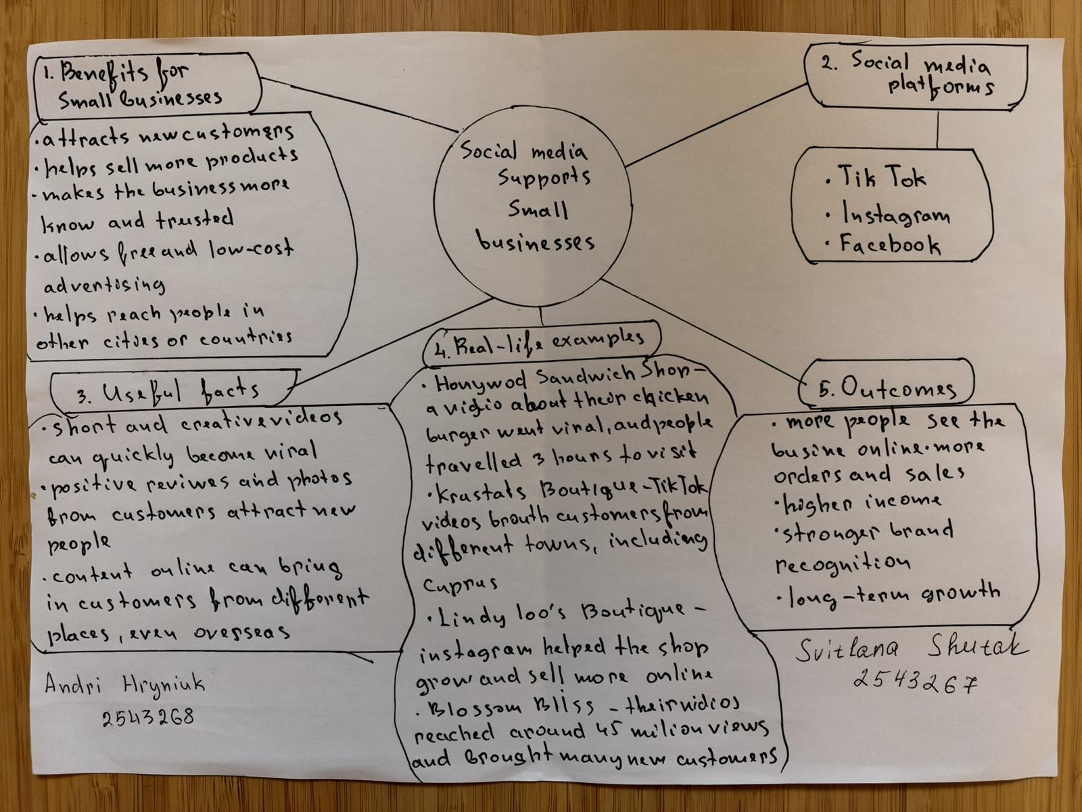

PART 2:

- What is the main idea of the whole text?

The main idea is that social media helps small businesses get more customers and sell more products. Videos on TikTok and Instagram can make a business popular.

- What is one key point that supports the main idea, and which specific example from the text shows this?

One key point is that social media can bring customers from far away. For example, people travelled for three hours to Honywood Sandwich Shop to buy a chicken burger.

- What is a different key point that supports the main idea, and which specific example from the text shows this?

Another key point is that funny videos can help a shop sell clothes. For example, Krystalls Boutique became popular because its funny videos got millions of views.

- Which part of the text do you think is most important, and why?

I think the story about Honywood Sandwich Shop is the most important. It shows that social media can bring real customers to a small business.

Reflection:
- What did you find difficult in this task (including in-class components), and why was it difficult?

For me, the most difficult part was choosing the most important information from the text. Sometimes different details can be important, and it is not always easy to decide what to include. I think everyone can understand a text in a different way, and this is part of learning.

- What helped you with this difficulty, and how did it help you?

Reading the text carefully and thinking about its meaning helped me. I learned that it is important to understand the main message and choose details that support it. I also think that sharing ideas with other students can help us see things in different ways and learn from each other.

