Data Handling and Business Intelligence LCBB5000
Data Analysis and Visualization

Student name:Constantin Somodi
Student ID:2123844
Module code:LCBB5000
Lecturer name:Xavier Matieni

Contents
Introduction 3
Part 1 3
Average Price of Room Based on Room Type 5
Average Lead Time in Each Year 6
Average Price Of Rooms In Different Market Place 7
Pivot Table to Understand The Price Of Room Type Reserved For Each Market Type 8
Part 2 10
How Many Students Are Male and Female 10
Student Qualifies and Does Not Qualify For Reduced/Free Lunch 10
Mean And Median of Student that Qualifies and Does Not Qualify For Reduced/Free Lunch 10
Mean And Median Differences of Students Pre-Test and Post-Test Scores 11
Most Common Data Mining Methods 11
Most Common Text Mining Methods 12
Advantages and Disadvantages of Using SPSS and Excel 14
Conclusion 15
Reference 16
Appendix 19
Pivot Table 19
If Function 19
Average Price of Rooms in Different Market Place 19
Average Lead Time 19
Average Price of Rooms Yearly 20
Average Price of Rooms based on Room Types 20

Introduction
Understanding trends, patterns, and insights that direct decision-making in diverse disciplines depends critically on data analysis (Bag et al, 2020). This assignment addresses a variety of data analysis topics, including pricing variations for hotel rooms, data mining methods, and the benefits and drawbacks of using SPSS and Excel. Each assignment component offers insightful information on the dynamics of data interpretation and its real-world applications for modern enterprises.

Part 1
Decline Or Increase in Average Room Reservation Price
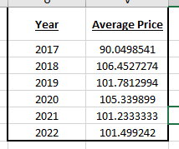
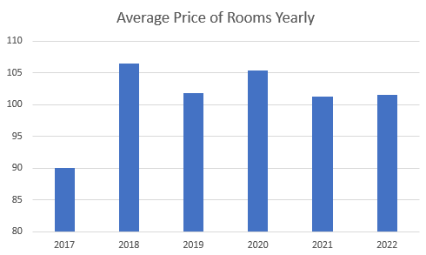
Over the past six years, there has been a large fluctuation in the average hotel room pricing, exhibiting intriguing trends that show the dynamics of the hospitality business. Based on the aforementioned data, it is evident that there is a distinct pattern in the average hotel room pricing, which has increased and decreased over time (Park et al, 2020).
Beginning in January 2017, hotel rooms cost £90.05 per night. This rather low number serves as the fundamental foundation for the comparison for the next year. Prices have risen in 2018, with the average cost rising to £106.45. This was an increase of 18% from the prior year, pointing to prospective industry expansion that may be brought on by a rise in travel demand or a rise in economic growth. Nevertheless, the average price fell to £101.78 in 2019, suggesting that the trend may be changing. Although this decrease wasn't as dramatic as the one from the previous year, it nevertheless showed that the market needed to adjust. A unanticipated disruption—the worldwide pandemic—arrived in 2020 (Saputro and Nanang, 2021). Average costs were steady at £105.34 despite travel limitations and a decline in travelers' desire to travel, which may be ascribed to a complicated interaction between diminished demand and changed supply chains. Despite the difficulties the epidemic brought about, the average cost dropped somewhat to £101.23 in 2021. It is obvious that the epidemic continues to have an effect on traveler behavior and the sector (Jiang, 2022). The average price increased somewhat to £101.50 in 2022 as travel restrictions loosened, suggesting a likely slow recovery.
The six-year investigation shows that the typical hotel room cost varies. Following a year of strong expansion, 2019 may have seen corrections brought on by market dynamics and world events. The pandemic's destructive effects are more apparent now that data indicate a slow comeback. These changes show how susceptible to outside influences and how flexible the hotel sector is to shifting conditions.

Average Price of Room Based on Room Type
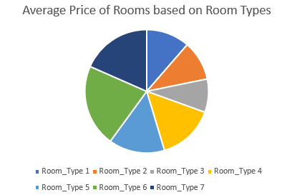
It's interesting to see how average hotel charges vary depending on the type of room, which gives us a better understanding of the industry's complex pricing structure. The data presented suggests a variety of room kinds, each with their own characteristics, amenities and thus pricing ranges. These numbers exhibit recognizable rising and falling patterns that represent market trends and consumer preferences.
The average cost starts at Room Type 1, which is £95.92. As a result, a comparison can be made. For Room Type 2, the average price is slightly lower at £87.85. This equates to a decrease of about 8%, suggesting that Room Type 2 may offer fewer amenities, or a more affordable experience compared to Room Type 1. The average cost for Room Type 3 is even lower, coming in at £73.68. With this price, travelers on a budget are likely to receive amenities that are significantly different from those in his previous two room types (Saputro and Nanang, 2021).
However, if Room Type 4 and Room Type 5 are scrutinized appropriately it would show that the trend changes suddenly where the average price increases £125.29 and £123.73 successively. This sudden increase is roughly about 35% and 33% successively compared to Room Type 1, which suggests that Room Type 4 and Room Type 5 are comparatively more luxurious and spacious. Another sudden increase in price is seen in Room Type 6, where the average price is £182.21. This sudden increase in price signifies that it is the most premium and luxurious room with additional services and exclusive features (Chalupa and Petricek, 2022). However, Room Type 7 is comparatively cheaper, £155.20, and due to its price, it is expected that it is a premium room but less premium than Room Type 6. While making such an assumption it is taken as a fact that the pricier a room type is the more luxurious and exclusive services will be.

Average Lead Time in Each Year
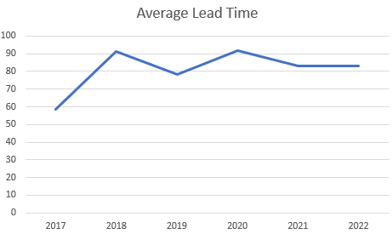
The average lead time in hotel reservations provides a comprehensive insight regarding the changes in hotel room booking as well as the behavior of customers. Lead time can be considered as the amount of time that is in between actually staying in a hotel and booking a hotel room, and it shows how precocious a traveler is regarding their plan (Bag et al, 2020). The scatter diagram presented above shows the fluctuating pattern in customer preferences by judging their average lead time.
In 2017 the average lead time is 58.62 days which will be considered as the benchmark for comparison. However, in 2018 the average lead time increased to 91.16 days. This giant gap represents a dramatic change in the booking habits of customers, with where customers are planning their vacation almost 3 months before their trip and 1.5 months ahead of the previous year. This change can also represent that tourists are more aware of their surroundings and the availability of early booking promotions (Saputro and Nanang, 2021).
However, the opposite trend can be seen in 2019 where the average lead time has decreased to 78.53 days. This drop signifies that customers prefer last-minute bookings or changes in customer preferences, mostly because of the economic factor and or travel trends. In 2020, an approximate increase is seen where the average lead time is 91.85 days. This suggests the previous booking pattern had emerged, mostly because of stable economic conditions (Kim, Chua and Han, 2021). Also in 2021, the average lead time decreased to 83.19 days, compared to the previous year. This change in trend indicates that the market is evolving, where customers have to adjust their booking behavior for the purpose of responding to various economic factors such as digital transformation. In 2022, the average lead time reached 82.95 days, which maintained a comparatively stable trend that suggests customers have become predictable and matured in the tourism industry where customers automatically plan their trips ahead of time.
Basically, the analysis of average lead time shows the view of customers regarding their booking habits and behavior over the course of 6 years. Initially, the average lead time was fluctuating but after a few years, the customers have become more mature and predictable to the degree that the hotel can expect that customers will plan their trips ahead and shows the lead time will be substantially big (Huang and Zheng, 2023). In such circumstances, the hotel can provide more benefits to the individual that will have shorter lead time and to increase the lead time the hotel can provide more promotional benefits for early bookings.

Average Price Of Rooms In Different Market Place
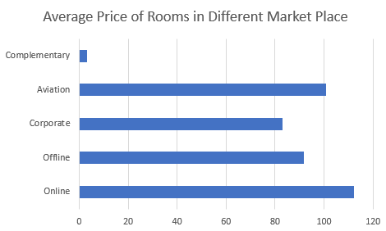
An in-depth understanding of how pricing strategies cater to various client segments may be obtained by examining the average cost of hotel rooms by market type. The data presented demonstrates compelling pricing dynamics patterns that illuminate the industry's reaction to various market segments (Yu, 2021).
Starting with the online marketplace type, the average price is £112.26. This serves as a starting point for comparison. It's possible that the higher average prices for the online category are due to the inclusion of online booking platforms, which commonly offer services and add-ons that can be justified by the premium.
The average price for the offline market type is £91.63, in contrast. This is substantially less than the internet market, which is probably due to a clientele with less resources and a preference for conventional booking procedures. The decrease shows that offline clients would be willing to forgo some convenience in favor of a more economical choice.
The average cost of a Market Type Enterprise is £82.91. This cheaper pricing is consistent with the notion that business travel-driven corporate reservations may prioritize price while still offering the space required for work-related holidays and employment (Lv, 2021).
With an average price of £100.70, the airline market type illustrates the affordable prices that are likely to draw tourists interested in the aviation industry. It can be crew members or commuters seeking comfort and convenience.
With an average price of £3.14, the extra market category is unmistakably a unique good. This may be a benefit of a loyalty program, a promotional offer, or other circumstances when rooms are provided as a component of a bigger deal.

Pivot Table to Understand The Price Of Room Type Reserved For Each Market Type
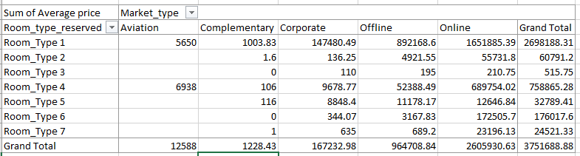
An in-depth understanding of how pricing methods are appropriate for various client groups may be obtained by using a PivotTable to comprehend the price distribution of room kinds particular to each market type. The information shown in the table demonstrates a variety of price patterns that emphasize variances in average costs across various room kinds and market types (Huang and Zheng, 2023).
Across all market categories, Room Type 1 appears to have the highest overall sales, with the largest percentage coming from the internet market. This shows that Room Type 1 is well-liked by those making online reservations, possibly implying that many consumers find it appealing as it offers a well-balanced mix of comfort and cost.
With a wide range of customers, the Enterprise and Offline sectors considerably contribute to Room Type 2's income. However, it also appears that a sizeable amount of its overall earnings comes from the internet sector. This could demonstrate Room Type 2's potential as a versatile option for both business and leisure tourists.
Sales of Room Type 3 in the enterprise, offline, and online marketplaces have been comparatively steady. The reasonably constant distribution may indicate that Room Type 3 draws specialized clients from several market groups, despite the Supplements market not showing any income.
The revenue for the Online and Enterprise division is mostly made up of Room Type 4. This implies that customers making business or internet reservations are likely to prefer this sort of lodging.
The distribution of revenue across market types is balanced for Room Type 5, with a sizeable portion coming from the Enterprise and Online categories. This may imply that Room Type 5 is suitable for a variety of passengers, including corporate clients and people making internet reservations.
There are varying income distributions among market kinds in Room Types 6 and 7. Notably, Room Type 6 appears to generate a sizable amount of its revenue from both offline and online markets, which would indicate that it appeals to a broad range of customers.

Part 2

How Many Students Are Male and Female
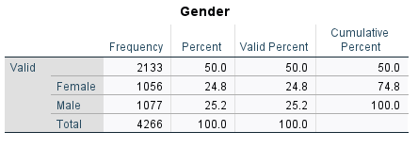

Student Qualifies and Does Not Qualify For Reduced/Free Lunch
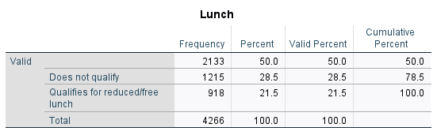

Mean And Median of Student that Qualifies and Does Not Qualify For Reduced/Free Lunch
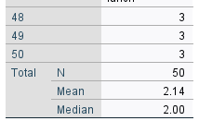

Mean And Median Differences of Students Pre-Test and Post-Test Scores
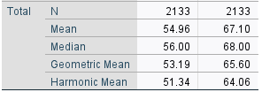

Most Common Data Mining Methods
Data mining techniques play a key role in converting unstructured data into knowledge that is useful for business decisions and competitive advantage. Let's examine the five most popular data mining techniques in more detail and examine actual business contexts where they are used.
Classification Analysis: Businesses frequently use categorization analysis to improve consumer experiences in today's data-driven environment. This technique, for instance, may be used by a music streaming service to categorize customers into genres based on their listening preferences (Mazzilli et al, 2021). The service may suggest customized playlists and new releases that are catered to individual interests by examining trends in user song preference data. This focused strategy not only keeps consumers interested but also motivates them to stick with the site.
Association Rule Learning: Association rule learning is used by retail behemoths like Amazon to enhance their product suggestions. Amazon can find commonly co-purchased products by looking into the shopping histories of millions of individuals. For instance, the system may recommend the camera bag to consumers who purchase cameras if customers routinely buy both a camera and a camera bag (Li and Sheu, 2022). Cross-selling is more likely to occur, and sales are likely to rise with this strategy.
Anomaly Detection: The ability to recognize anomalies is now essential in the field of cybersecurity. Modern companies are highly dependent on digital platforms and networks, which leaves them open to cyber assaults (Mishra et al, 2021). To find unexpected trends in transactions that might point to fraud, financial institutions use anomaly detection algorithms. Businesses may protect their assets and uphold consumer trust by quickly identifying and correcting irregularities.
Cluster Analysis: Cluster analysis aids hotels in adjusting their offerings to diverse clientele groups in the hospitality sector. Hotels may group visitors into groups including leisure tourists, business travelers, and families by examining booking habits, preferences, and comments (Khater, Nabi and Hamarneh, 2020). This gives businesses the ability to tailor services, room arrangements, and promotional offers to meet the requirements of each cluster.
Regression Analysis: Making data-driven forecasts and trend predictions requires the use of regression analysis. Regression analysis is used by airlines, for instance, in the transportation industry to improve ticket pricing based on historical booking data, seasonal trends, and outside variables like fuel prices (Paisanwarakiat, Na-udom and Rungrattanaubol, 2022). Airlines may increase income while assuring competitive pricing for consumers by precisely forecasting demand and modifying prices accordingly.
These data mining methods offer tangible benefits across industries:
Retail: To provide frictionless purchasing experiences, e-commerce systems like Amazon use categorization and association rule learning. These systems provide recommendations for goods that are catered to specific interests by looking at users' browsing histories and purchasing patterns (Kumar, Venkatesh and Rahman, 2021). For instance, depending on a customer's product interactions, Amazon's recommendation engine makes suggestions for related items, successfully cross-selling and boosting user engagement.
Manufacturing: In the industrial sector, cluster analysis is used to group related goods or parts. By combining car models with comparable assembly procedures, this technique can assist streamline production lines in the automobile industry (Khater, Nabi and Hamarneh, 2020). By streamlining manufacturing, effectively allocating resources, and ensuring constant product quality, firms may.

Most Common Text Mining Methods
Businesses may find patterns, trends, and important information that can guide decision-making and strategic planning by using text mining techniques, which are crucial in sifting through huge volumes of textual data and extracting insightful information. Let's investigate the practical uses of each of the five most popular text mining techniques in modern corporate environments.
Information Extraction: In the world of news media, information extraction techniques are used to condense vast amounts of news items and extract important details like the title, the date, the place, and any significant events that are covered. For instance, information extraction may be used by a news aggregator app to give consumers succinct summaries of the day's top news headlines, improving their browsing experience (Olivetti et al, 2020).
Information Retrieval: One of the main functions of internet search engines is information retrieval. Imagine a situation when a consumer uses an e-commerce site to look for a certain product. According to the user's query, the platform's information retrieval technology quickly offers pertinent product listings, facilitating effective product discovery and purchase selections (Abbasiantaeb and Momtazi, 2021).
Clustering: Clustering algorithms may be used to group comparable customer evaluations or comments in the context of customer feedback analysis. This makes it possible for businesses to recognize recurrent themes, feelings, and pain spots among many goods and services (Tao, Yang and Feng, 2020). Clustering might be used by a chain of hotels to organize customer evaluations and target enhancements based on recurring themes.
Categorization: In content management systems, categorization is commonly used. For instance, a media outlet can classify news pieces into categories like politics, sports, entertainment, and technology automatically (Greco and Polli, 2020). By streamlining content distribution, readers will find it simpler to obtain articles that interest them.
Visualization: Tools for text visualization are essential for sentiment analysis in social media. Word clouds or sentiment histograms are two tools that brands may use to visualize customer sentiment. With the aid of this graphical display, marketers can swiftly understand current sentiment patterns and make educated changes to their communication tactics (Greco and Polli, 2020).
In contemporary businesses:
Healthcare: Information extraction techniques help to summarize and arrange patient records, ensuring that healthcare professionals have quick access to vital medical data.
E-commerce: Based on their browsing and purchasing habits, clustering can assist online merchants in identifying unique client categories, enabling focused marketing efforts and individualized suggestions (Abbasiantaeb and Momtazi, 2021).
Legal Services: Legal researchers may swiftly find pertinent case law, legislation, and legal opinions thanks to information retrieval, which is essential for legal research platforms.

Advantages and Disadvantages of Using SPSS and Excel
Following is the advantages of SPSS and Excel,
Advantages | SPSS | Excel
Ease of Use | Provides a simple point-and-click user interface. | Common spreadsheet user interface for simple operations.
Statistical Power | Capable of carrying out sophisticated statistical analysis (Babbie et al, 2022). | Only basic statistical functions are available.
Data Handling | Efficiently handles bigger datasets. | Suitable for smaller datasets.
Advanced Analytics | Enables sophisticated analytics, such as factor analysis, etc. | A lack of sophisticated statistical tools (Dunbar, 2020).
Graphical Representation | Different graph types are offered for data visualization. | Limited ability to graph.

Following are the disadvantages of SPSS and Excel,
Disadvantages | SPSS | Excel
Cost | The cost of licensed software varies. | Easily accessible and economical (Moolman, 2021).
Big Data Analysis | Unsuitable for large-scale dataset analysis. | Limited ability to handle large amounts of data.
Data Manipulation | May call for further data preparation activities. | Less options for data processing than SPSS.
Complexity | Analysis of complex statistical data may call for training (Babbie et al, 2022). | Support for complex statistical ideas is limited.
Specialized Use Cases | Less appropriate for fields with large amounts of data. | Though generally adaptable, analytics are not its intended use.

Conclusion
In conclusion, this assignment offers a comprehensive investigation of data analysis and its uses in a variety of fields. The assignment highlights the crucial role that data interpretation plays in decision-making for modern enterprises by analyzing variations in hotel room costs, revealing insights using data mining techniques, and weighing the benefits and drawbacks of analytical tools. Businesses and people may equip themselves with the resources necessary to successfully traverse complicated marketplaces, customize tactics, and make wise decisions by analyzing data trends, comprehending student demographics, and embracing modern data mining techniques. The assignment highlights the revolutionary impact of data analysis as a cornerstone of sound decision-making in today's data-driven world throughout this trip.

Reference

Abbasiantaeb, Z. and Momtazi, S., 2021. Text‐based question answering from information retrieval and deep neural network perspectives: A survey. Wiley Interdisciplinary Reviews: Data Mining and Knowledge Discovery, 11(6), p.e1412.
Babbie, E., Wagner III, W.E. and Zaino, J., 2022. Adventures in social research: Data analysis using IBM SPSS statistics. Sage Publications.
Chalupa, S. and Petricek, M., 2022. Understanding customer's online booking intentions using hotel big data analysis. Journal of Vacation Marketing, p.13567667221122107.
Greco, F. and Polli, A., 2020. Emotional Text Mining: Customer profiling in brand management. International Journal of Information Management, 51, p.101934.
Huang, L. and Zheng, W., 2023. Hotel demand forecasting: a comprehensive literature review. Tourism Review, 78(1), pp.218-244.
Jiang, H., 2022. Research on hotel management based on internet of things and big data analysis. International Journal of Reliability, Quality and Safety Engineering, 29(05), p.2240004.
Khater, I.M., Nabi, I.R. and Hamarneh, G., 2020. A review of super-resolution single-molecule localization microscopy cluster analysis and quantification methods. Patterns, 1(3).
Kim, J.J., Chua, B.L. and Han, H., 2021. Mobile hotel reservations and customer behavior: Channel familiarity and channel type. Journal of Vacation Marketing, 27(1), pp.82-102.
Kumar, M.R., Venkatesh, J. and Rahman, A.M.Z., 2021. Data mining and machine learning in retail business: developing efficiencies for better customer retention. Journal of Ambient Intelligence and Humanized Computing, pp.1-13.
Li, H. and Sheu, P.C.Y., 2022. A scalable association rule learning and recommendation algorithm for large-scale microarray datasets. Journal of Big Data, 9(1), p.35.
Lv, X., 2021, March. Analysis and Optimization Strategy of Travel Hotel Website Reservation Behavior Based on Collaborative Filtering. In 2021 International Conference on Intelligent Transportation, Big Data & Smart City (ICITBS) (pp. 362-365). IEEE.
Mishra, S., Sagban, R., Yakoob, A. and Gandhi, N., 2021. Swarm intelligence in anomaly detection systems: an overview. International Journal of Computers and Applications, 43(2), pp.109-118.
Moolman, W.H., 2021. Using Excel and R for Teaching Statistics and Data Analysis. In Book of Abstracts (p. 228).
Olivetti, E.A., Cole, J.M., Kim, E., Kononova, O., Ceder, G., Han, T.Y.J. and Hiszpanski, A.M., 2020. Data-driven materials research enabled by natural language processing and information extraction. Applied Physics Reviews, 7(4).
Pallant, J., 2020. SPSS survival manual: A step by step guide to data analysis using IBM SPSS. McGraw-hill education (UK).
Park, E., Kang, J., Choi, D. and Han, J., 2020. Understanding customers' hotel revisiting behaviour: a sentiment analysis of online feedback reviews. Current Issues in Tourism, 23(5), pp.605-611.
Sabanci, K., Aslan, M.F., Ropelewska, E. and Unlersen, M.F., 2022. A convolutional neural network‐based comparative study for pepper seed classification: Analysis of selected deep features with support vector machine. Journal of Food Process Engineering, 45(6), p.e13955.
Saputro, P.H. and Nanang, H., 2021. Exploratory data analysis & booking cancelation prediction on hotel booking demands datasets. Journal of Applied Data Sciences, 2(1), pp.40-56.
Yu, Y., 2021, April. Design and implementation of hotel network management information system in the era of big data. In Journal of Physics: Conference Series (Vol. 1881, No. 2, p. 022068). IOP Publishing.

Appendix

Pivot Table
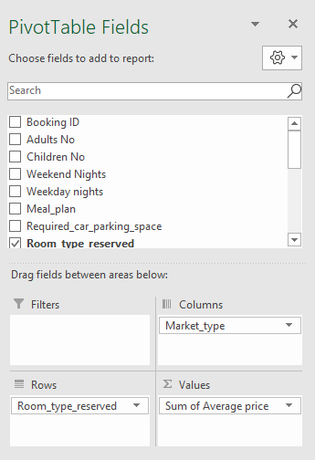

If Function

Average Price of Rooms in Different Market Place
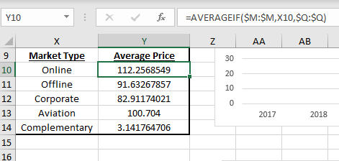

Average Lead Time
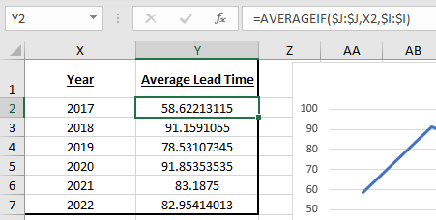

Average Price of Rooms Yearly
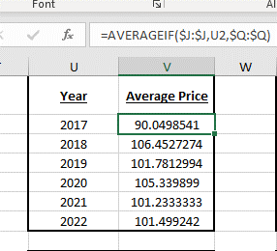

Average Price of Rooms based on Room Types


