
The Business of Sport Template
Assignment 1

Cody Peacey

240220

Sporting structures and delivery

3000

Task A – Definition 1 (Plus 2+ Academic References) (Circa 400 words)

Impact of marketing on the Women's Rugby World Cup
The Women's Rugby World Cup's (WRWC) commercial value, cultural significance, and visibility have all been significantly shaped by marketing. Women's sports have historically suffered from a lack of media attention, insufficient funding, and gendered presumptions about audience interest. But over the past ten years, strategic marketing campaigns have started to overcome these obstacles, boosting women's rugby's participation, viewership, and international recognition.
The increase in media visibility has been a major effect of marketing. It is commonly acknowledged that media coverage is a major factor in the legitimacy and financial expansion of sports (Fink, 2015). To reposition women's rugby as an elite, high-performance event rather than a niche activity, campaigns surrounding recent WRWC tournaments have increasingly emphasised athlete stories, competitive narratives, and national pride. This change is consistent with research by Litchfield and Kavanagh (2019), who claim that athlete-centred marketing and storytelling are essential for attracting new fans to women's sports.
This visibility has been further accelerated by digital marketing. By avoiding the usual media gatekeepers, social media platforms enable athletes, fans, and governing bodies to interact directly. Targeted digital campaigns that advertise match highlights, behind-the-scenes material, and engaging fan experiences have helped the WRWC. Pegoraro and Jinnah (2012) claim that by managing their own narratives on social media, female athletes and organisations can challenge gender stereotypes and establish brand equity. In rugby, where physicality and athleticism have traditionally been viewed through a male lens this had a particularly significant impact due to the stereotypes of the public.
Another area where marketing has made a discernible difference is commercial investment. As companies realise how important it is to align with women's sport, diversity, and empowerment messaging, sponsorship deals for women's rugby have increased. The WRWC is a desirable platform for corporate partners because marketing campaigns that highlight social progress and inclusivity resonate strongly with modern audiences. This is in line with larger patterns noted by Cunningham et al. (2021), who observe that when it comes to investing in sports, brands are becoming more driven by social responsibility and gender equity.
However, marketing's effects are not always favourable. The marketing resources provided to the men's and women's Rugby World Cups continue to differ despite advancements. Budget constraints may limit the scope and reach of marketing initiative leading to already-existing disparities. Women's sports continue to receive disproportionately less media attention than men's sports according to Cooky et al. (2021), which can reduce the impact of marketing initiatives. The WRWC runs the risk of reaching a plateau in its growth trajectory in the absence of consistent investment.

Task A – Definition 2 (Plus 2+ Academic References) (Circa 400 words)

Importance of recruitment and retention of employees in the NFL

For the National Football League (NFL) to sustain long-term strategic success effective recruitment and retention are essential. The NFL depends on luring top talent, both players and non-playing staff, and making sure that these people stay dedicated, driven, and in line with the organization's objectives as a high-performance sporting organization. This means that recruitment and retention serve as competitive mechanisms that influence team culture, performance results, and financial sustainability in addition to being HR functions.
Because of the NFL's high-performance environment, salary cap rules, and the scrutiny of player selection, recruitment in the league is particularly complicated. The goal of the NFL Draft, free agency, and scouting programs is to find people who possess extraordinary tactical, psychological, and physical skills. Recruiting effectively guarantees that teams get players who align with their long-term development plans, cultural values, and tactical systems. According to research, strategic hiring improves team cohesiveness and aids in succession planning in elite sports (Taylor et al., 2008). Recruitment quality directly affects competitive advantage in the NFL, where season outcomes can be determined by marginal gains.
Retention is just as important. High turnover can damage team cohesiveness, erode organisational culture, and raise operating expenses, whether it comes from players, coaches, or support personnel. Maintaining key personnel promotes consistency in performance routines, playbook systems, and coaching philosophies. Stability in sports organisations fosters shared leadership, communication, and trust all of which are critical in high-stress settings like the NFL, according to Chelladurai and Kerwin (2018). Additionally, retention lessens the cost of ongoing hiring, onboarding, and training.
Contract structures, organisational culture, leadership calibre, career development opportunities, and player welfare provisions are some of the factors that affect NFL employee retention. The NFL has been under pressure to enhance its duty of care due to growing awareness of issues like concussions, mental health, and post-career transitions. Improving welfare assistance is a tactical retention tactic in addition to being morally significant. According to studies, athletes are more likely to stick with companies that place a high priority on long-term career support and holistic wellbeing (Wylleman & Lavallee, 2004).
Additionally, the NFL’s ability to retain diverse talent both on and off the field has become a central organisational priority. The goal of programs like the Rooney Rule is to increase representation in leadership and coaching positions. Organisational reliability, creativity, and decision-making quality are all strengthened by effective diversity recruitment and retention strategies (Cunningham, 2019). Long-term sustainability in a league with a diverse athlete population and a global audience depends on the inclusivity of the HR strategies.

Task A – Definition 3 (Plus 2+ Academic References) (Circa 400 words)

2 Examples of leaders within swport who take the role of a manager
Sir Alex Ferguson and Eddie Jones are widely recognised as leaders in sport who also operate as highly effective managers, using structured planning, cultural control and system-wide oversight to sustain elite performance. Ferguson’s managerial approach at Manchester United is frequently cited as an example of transformational leadership, characterised by his ability to shape culture, enforce discipline and develop long-term organisational systems (Elberse & Dye, 2012). Rather than focusing solely on coaching, Ferguson managed the entire performance environment, overseeing recruitment, youth development, sports science integration and staff coordination. His leadership style emphasised “smart control” and “balanced delegation,” enabling him to maintain authority while empowering staff and players to contribute to the club’s long-term success (Elberse & Dye, 2012). Scholars argue that Ferguson’s success stemmed from his capacity to manage change, maintain high standards and create a culture of continuous improvement, demonstrating the managerial dimension of leadership in high-performance sport (Crust & Lawrence, 2006). Similarly, Eddie Jones exemplifies managerial leadership within rugby union through his strategic planning, meticulous preparation and coordination of large multidisciplinary support teams. Jones is known for implementing detailed performance systems, managing analysts, medical staff and assistant coaches to create a unified organisational structure (Blackett et al., 2017). His leadership extends beyond match-day tactics, involving long-term planning of training cycles, player workload management and cultural restructuring—behaviours aligned with managerial leadership rather than purely motivational coaching. Research on elite rugby coaching highlights Jones’s ability to rapidly transform team cultures, introduce new systems and maintain high levels of discipline and professionalism, reinforcing his reputation as a leader who manages complex organisational processes (Blackett et al., 2017). Together, Ferguson and Jones illustrate how leaders in sport often function as managers responsible for strategic oversight, culture building, staff coordination and long-term organisational planning. Their careers demonstrate that success at the highest level requires more than inspirational leadership; it demands structured management, system thinking and the ability to guide entire organisations through periods of change and high pressure. Both figures show that leadership and management in sport are deeply interconnected, and that the most successful leaders are those who can integrate motivational influence with organisational control.

Task B – Stakeholder Diagram (with appropriate communication channels selected for each stakeholder) and referenced material detailing role, emphasis, funding and performance of organisation (Internal and External) – Diagram + Circa 600 Words (References 5+)

Internal Stakeholders in Babolat
Owners / Family Leadership — Babolat remains a family-owned company, meaning strategic direction and long-term brand identity is shaped internally by the Babolat family (Babolat, 2024).
Executive Management Team — Senior leaders such as the CEO and directors oversee global operations, product strategy and financial performance, ensuring the company remains competitive in the global tennis and sports-equipment market (Babolat, 2024)
Employees (Head Office & Global Offices) — Staff working across marketing, finance, HR, logistics and international sales contribute to daily operations and organisational growth (Smith & Stewart, 2015).
Research & Development (R&D) Team — Engineers and designers responsible for racquet technology, strings and footwear innovation play a central role in maintaining Babolat’s reputation for high-performance equipment (Babolat, 2024).
Production & Manufacturing Staff — Teams involved in string production, racquet assembly and quality control ensure product consistency and reliability, which is essential in the sports-equipment industry (Smith & Stewart, 2015).
Sales Teams — National and international sales representatives work with retailers, clubs and distributors, acting as key internal stakeholders who drive revenue and market expansion (Babolat, 2024).
Marketing & Brand Teams — Staff responsible for athlete partnerships, digital marketing and product launches help maintain Babolat’s global brand presence (Smith & Stewart, 2015).
Sponsored Athletes (as internal partners) — Although not employees, top players such as Rafael Nadal function as internal strategic partners because they influence product development and brand direction (Babolat, 2024).
Customer Service & After-Sales Teams — These teams support retailers and consumers with technical issues, warranties and product queries, contributing to customer satisfaction and brand loyalty (Smith & Stewart, 2015).
Logistics & Supply Chain Teams — Employees managing warehousing, distribution and global inventory ensure products reach markets efficiently (Babolat, 2024).
Retail Store Staff — Staff working in Babolat managed retail spaces represent the brand directly to consumers and provide product expertise (Smith & Stewart, 2015).
External Stakeholders in Babolat
Professional Athletes (External Brand Ambassadors) — Players such as Rafael Nadal and Carlos Alcaraz influence product reputation, consumer trust and global brand visibility (Babolat, 2024).

Sports Clubs and Academies — Tennis clubs, coaching academies and training centres rely on Babolat equipment and provide essential feedback that shapes product development and sales strategies (Smith & Stewart, 2015).
Retailers and Distributors — Sports shops, online retailers and international distributors are key partners who sell Babolat products worldwide, directly affecting revenue and market reach (Babolat, 2024).
International Sports Federations — Organisations such as the ITF, ATP and WTA regulate equipment standards and approve products for professional use, influencing Babolat’s design and compliance requirements (Smith & Stewart, 2015).
Event Organisers and Tournaments — Major tournaments (e.g., Roland-Garros) collaborate with Babolat for official equipment partnerships, boosting brand exposure and commercial opportunities (Babolat, 2024).
Suppliers and Manufacturers — External suppliers provide raw materials and components used in racquets, strings and footwear, making them essential to production quality and supply chain stability (Smith & Stewart, 2015)
Consumers and Recreational Players — Everyday players purchasing racquets, shoes and accessories form the largest customer base and influence product demand and brand reputation (Babolat, 2024).
Media and Sports Journalists — External media outlets shape public perception through product reviews, athlete coverage and brand storytelling (Smith & Stewart, 2015).
Technology Partners — Companies collaborating on connected equipment (e.g., smart racquets) contribute to innovation and product development (Babolat, 2024).
Sponsorship Partners — External brands and organisations that co-sponsor athletes or events help expand Babolat’s marketing reach and commercial influence (Smith & Stewart, 2015).
Stakeholder diagram
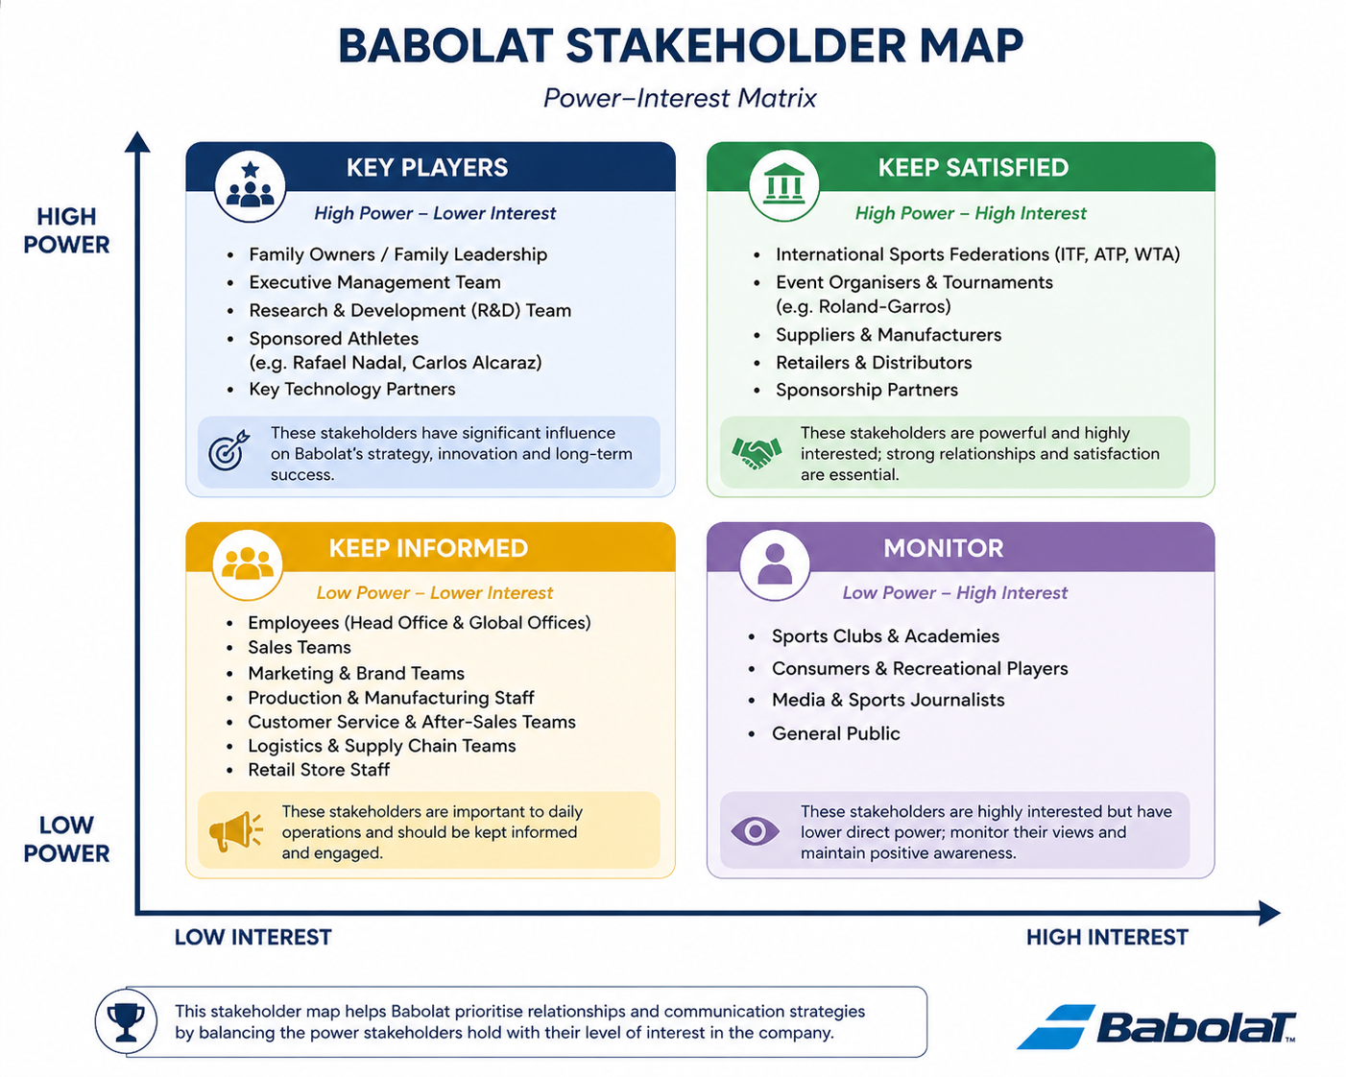

Task C – Complete Operational Planning Document for your Event (Fill, 2006) (1200 words)

Title of Event | Sunny 6’s, 6 a side football tournament
Event Purpose Link to Case study and (Fill, 2006)  Think Why? | To promote physical activity and social inclusion through a fun competitive environment. Creating a platform for inexperienced amateur players to play in a tournament structure whilst raising awareness of grassroots football. The event supports Fill (2006) by the mission to encourage local participation in sports.
Event Description  Think What?  What is your USP? | One day outdoor football tournaments featuring football teams made up of 6 players competing in a realistic tournament competition with group and knockout stages. There will be 24 teams in total each team guaranteed to play 3 games each.  The USP is that unlike the usual football tournaments, Sunny 6’s will have all day live entertainment, places to eat food, and a place where you can learn different skills from qualified coaches. This creates a festival style atmosphere which would appeal to the whole family not just the players.
Overall Funding Required (Financial Statement) | The Case study Organisation gives a Fixed grant of £10,000.  Income  Team entry fees= £2400  Food and drink vendor fees= £1000  Sponsorship= £2000  Sales= £600  Total income= £16,000  Expenditure:  Venue hire= £2500  Trophies and medals and other equipment = £1,200  Insurance and permits= £800  Entertainment and catering = £1,500  Marketing and promotion= £1,500  Staff and officials= £3,000  Contingency= £500  Expenditure= £11,000  Forecasted Profit/ Loss = £5000 profit
Partners | Sport Wales  Local council  Local leisure centres  Local businesses (sponsorship)
Strategic Impacts (Government, Local Authority, NGB’s) | This event would align with the national and local strategies for promoting health and wellbeing and would contribute to Swansea Councils active communities' initiative
Venue/ Facility (Justify) | Swansea University pitches, high quality 3g pitches with a high spectator capacity and the location will offer easy access for public transport and plenty of parking on site.
Marketing Plan (Segmentation, Competition, Media, Sponsorship and Promotional Activities) | Segmentation- Primary: Amateur footballers aged 16-35  Secondary: Families and spectators  Competition- Smaller local 6 a side tournaments and leagues  Media- social media such as TikTok and Instagram for promotion  Posters in schools, gyms and sports clubs.  Promotional activities:  - Early bird team registrations get a discount  - Social media player profiles from each team  - Community outreach through schools and youth clubs  - Post match highlights of different games to build recognition
Staffing Requirements (Duties, Technical Certificates etc.) | Event manager to oversee all operations and ensure the running goes smoothly  Qualified FAW referees  Volunteers- Crowd management, registration.  Medical staff  Security staff- Ensure safety
Equipment Required | Football goals  Match balls  PA system and microphone  Trophies and medals
Key Legislation | Health and Safety at Work Act (1974) – ensures safe working conditions  Equality Act (2010) – guarantees inclusive participation  Data Protection Act (2018) – protects participant information  Safeguarding Vulnerable Groups Act (2006) – ensures child protection  Licensing Act (2003) – regulates food and entertainment vendors
Health and Safety Risks | Slips and trips on wet surfaces  Heat exhaustion  Crowd congestion  Injuries whilst playing
Economic and Operational Considerations | Economic:  Local spending through food vendors, sponsorship visibility will enhance the businesses reputations  Operational:  Efficient scheduling and planning are vital for the event to run smoothly

Financial Statement / Profit and Loss Forecast Accounts (Insert from Excel) (Adapt version on Moodle based on your event which considers Revenue, Expenditure, Anticipated Profit or Loss

Gantt Chart (Insert from Excel)

Eventbrite Page for your event (Screenshot from Website page and insert into table below)

Survey Monkey Audit of relevant questions, consider grouping questions to ask into 3 categories - before, during and after the event. (Screenshot from Website page and insert into table below)

Event Floorplan (Screenshot from PC or Picture Drag and Drop into table below)

Event Poster (Screenshot from PC or Picture Drag and Drop into table below)

Reference List and Bibliography

Babolat (2024) About Us. Available at: https://www.babolat.com.
Blackett, A.D., Evans, A.B. & Piggott, D. (2017) Why people coach: A qualitative investigation of rugby union coaches’ motivations and behaviours. International Journal of Sports Science & Coaching, 12(2), pp. 216–226.
Chelladurai, P., & Kerwin, S. (2018). Human Resource Management in Sport and Recreation. Human Kinetics.
Cooky, C., Council, L., Mears, M. and Messner, M. (2021) ‘One and done: The Long Eclipse of Women’s Televised Sports, 1989–2019’, Communication & Sport, 9(3), pp. 347–371.
Crust, L. & Lawrence, I. (2006). A review of leadership in sport: Implications for football management. Athletic Insight, 8(4), pp. 28–48.
Cunningham, G. (2019). Diversity and inclusion in sport organisations. Routledge Handbook of Sport Management.
Cunningham, G.B., Fink, J.S. and Doherty, A. (2021). Routledge handbook of theory in sport management. London: Routledge.
Elberse, A. & Dye, S. (2012). Sir Alex Ferguson: Managing Manchester United. Harvard Business School Case Study 513-051. Harvard Business Publishing
Fink, J.S. (2015) ‘Female athletes, women’s sport, and the sport media commercial complex: Have we really “come a long way, baby”?’, Sport Management Review, 18(3), pp. 331–342.
Litchfield, C. and Kavanagh, E. (2019) ‘Twitter, Team GB and the London Olympics: Gender, media and digital culture’, International Review for the Sociology of Sport, 54(2), pp. 208–224.
Pegoraro, A. and Jinnah, N. (2012) ‘Tweet ‘em and reap ‘em: The impact of professional athletes’ use of Twitter on current and potential sponsorship opportunities’, Journal of Brand Strategy, 1(1), pp. 85–97.
Smith, A. & Stewart, B. (2015). Introduction to Sport Management. London: Routledge.
Taylor, M., Doherty, A., & McGraw, P. (2008). Managing People in Sport Organizations. Routledge.
Wylleman, P., & Lavallee, D. (2004). A developmental perspective on transitions faced by athletes. Developmental Sport and Exercise Psychology.
Wolfe, R., Weick, K., Usher, J., et al. (2005). Sport and organisational studies: Exploring synergy. Journal of Management Inquiry, 14(2), 182–210.

Appendix (Add Screenshot evidence here of any online costings etc.)

1st place trophy. 1st, 2nd and 3rd Place Trophies | Trophy Store
2nd place trophy.
Participation medals.Amazon.co.uk : 250 medals

Appendix (Add Screenshot evidence here of any online costings etc.)

Goals for the games. Net World Sports | Shop The Best Sports Equipment & Gear



UWTSD SPORT

