How does Sydney Opera House reflect the ambitions, tensions, and contradictions of post 1945 architecture?
-A critical examination

By Tyler David

Introduction
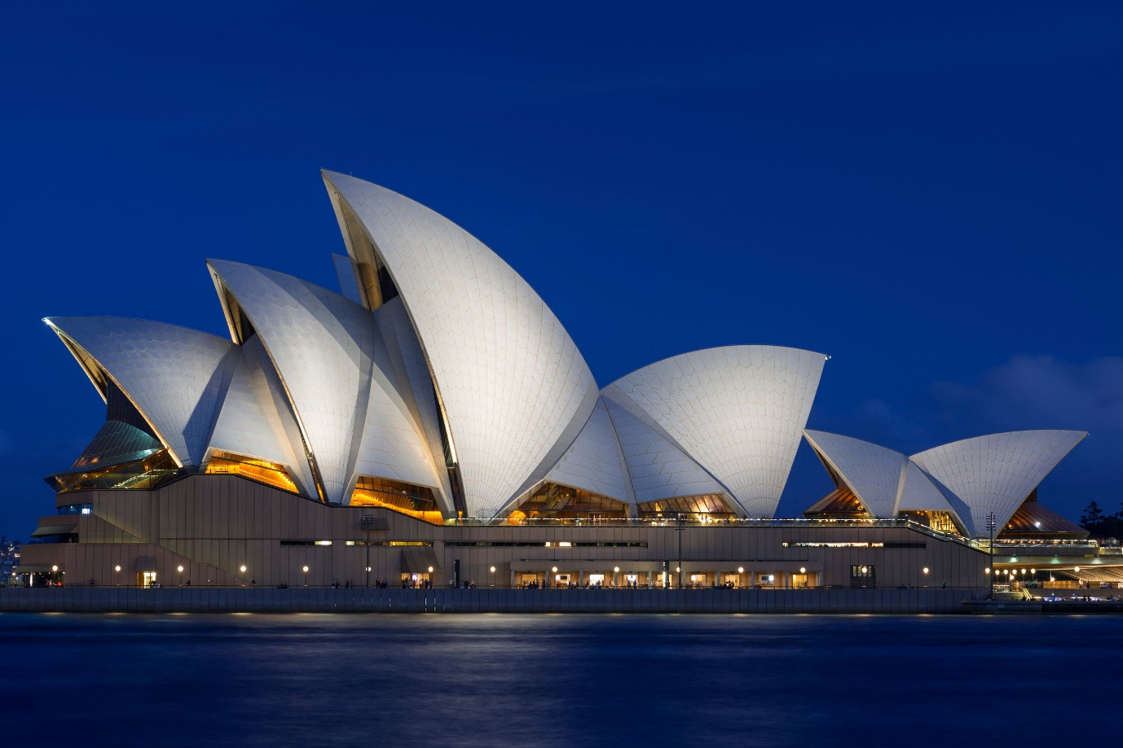
Figure 1: Night time view of Sydney Opera house overlooking Sydney harbour (Price, G, 2023)
The Sydney Opera House is viewed as one of the most iconic buildings of the twentieth century, not only in Australia but globally. Recognised for its bold form and commanding presence on Sydney Harbour, the building emerged from post-war ambition to reposition Sydney as a global capital (Heritage action plan, 2022). However, this status as an international icon has possibly obscured the contested history that produced it.
Designed by Jorn Utzon, construction began in 1959 and was completed in 1973. Over the course of said 14 years, the erection of the Opera house faced intense political dispute, technical boundaries, and conflict over function, cost, and authorship (State Government, 2026).
This essay argues that the Sydney Opera House is significant not only as a masterpiece of modern innovation, but as a revealing example of the contradictions of post 1945 architecture.

Historical and architectural context
The Sydney Opera House must be understood within the broader context following the war, a period of rapid growth for modernism and the emergence of new national identities. In Australia, this era was characterised by a desire to reposition the nation on a global stage, moving beyond its colonial past (State Government, 2026). The commission of a desired cultural landmark was therefore both a political and cultural notion, intended to set forth Australia’s maturity as a modern society. Through post-war optimism a project aimed at creating a globally recognised leading venue for the performing arts was born (Heritage action plan, 2022). Construction of such a building would reinforce the importance of culture within public life while elevating Sydney’s international status.
In 1956 the New South Wales Government called upon an international design competition which attracted over 200 entries, reflecting the ambition for such a project nationally and globally. The commission of Danish architect Jorn Utzon was unexpected, particularly due to his lack of experience and absence of any engineering advice (UNESCO, 2006). However, its rudimentary design and visionary qualities aligned with the broader ambitions of post-war architecture, which sought to embrace minimalism and reject ornamentation (Science and media museum, 2021). According to UNESCO ‘The Sydney Opera House represents one of the most demanding and innovative structures in modern architecture’. Not simply for its innovations during construction but also due to its function as a staple of the country. It anchored the harbour and transformed Australia’s modern identity; it defined the spirit of the country as much as the Eiffel tower did so for France.
Therefore, the Sydney Opera House is of historical importance not simply due to it being one of the indisputable masterpieces of human creativity’, but as an indicative example of the struggle between architectural ambition and the realities of delivering such a large-scale operation even in todays standards (Heritage action plan, 2022).

Location, Landscape, and setting
Sydney Opera House is situated upon Bennelong Point, a fundamental to its architectural meaning. The structure presides over the site as both an object with demanding presence and one with a sense of belonging to the landscape of Sydney Harbour. Projecting into the harbour between Sydney Cove and Farm Cove, the site is exposed and highly visible, allowing the building to project outward into the surrounding context (Tubowgule, 2026). This prominent positioning within the landscape transforms the Opera House into a ‘great urban sculpture carefully set in a remarkable waterscape’ emphasising its role not only as a functioning building but as a national landmark, fully realising the ambitions and intentions of the initial goal (Croker, A, 2017). The relationship to water is particularly significant ‘The white sail-like forms of the shell vaults relate as naturally to the harbour as the sails of its yachts’. The shells are in fact derived from a single sphere; this consistent geometric radius creates a sense of natural growth just as a wave has fluid curves. In addition, the ceramic tiles draped over the shell vault catches the light from the water mimicking the sparkle of waves under the sun, truly embracing and integrating itself into the surrounding landscape (Croker, A, 2017).


Figure 2: Evolution and demonstration of the sphere in which the sails were conceived from (Leeuwen. R. V, 2017)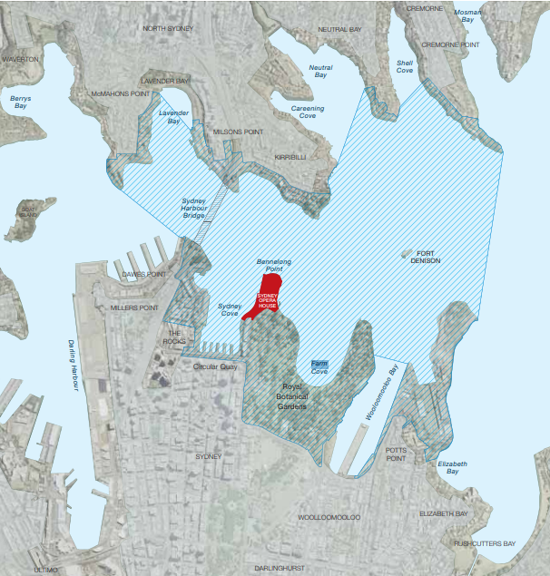
Figure 3: Sydney Opera house location wihtin the context of the surrounding landscape (Croker, A, 2017)
The approach to the structure is orchestrated through use of a raised podium to dominate its urban context and elevate the building above the waterline. As Rome, China and the Mayans once did with its monumental structures, the use of a high raised podium directs the eye and mind to a grand awe (Sear, F, 1998). This platform not only separates the building from its immediate surrounding context but also frames it against the horizon, enhancing its visibility within the skyline. The shell forms, rising from this podium, recalling the relationship between a wave, with its geometry echoing maritime imagery while capturing the light across the day. Large glazed openings frame views toward the harbour, reinforcing a continuous relation to its setting, ‘implicit visual relationship with the harbour surrounding them’, dissolving between interior and exterior (Peter Hall, 2026). The Opera house went through significant evolution in its choice of glass, eventually landing on laminated glass. Utilising it to its maximum, using laminated glass, eliminated the need for heavy steel beams thus breathing conformity into the structure (Zunz, J, 1973). This reduction in visual clutter preserved the ‘sail’ metaphor ensuring no visual obstruction with the Opera house’s relationship with the harbour surrounding it.
The building is deeply rooted in its context, responding to topography, water, and movement, acting as a focal point within the harbour landscape. Yet its monumental scale and audacious form assert a presence that arguably overwhelms the site. The Opera House functions as a simultaneous response to post-war global ambition and the physical landscape, serving as a precedent for the union of architecture and place.

Jorn Utzon and the design philosophy
Danish architect Jørn Utzon armed with his design philosophy challenged conventional modern architecture of the time. Utzon’s approach was shaped by a range of influences, including natural forms such as waves, non-Western precedents such as Roman and Mayan monuments, and an interest in architectural phenomenology which centres around form following experience (Stanford,2003). He became infatuated with Chinese and Mayan architecture, where elevated platforms created a feeling of firmness and security, it was a quality he held dear, a fixation that controlled the Opera House’s image (Ruan, X, 2017). At the same time his engagement while under Finnish architect Alvar Aalto, encouraged an architecture that combined erratic form, light, space, and atmosphere into a unified whole, Aalto prioritised this environmental harmony (Britannica, 2026). These principles throughout his work were expressed through a sculptural design process, most notably in the shell vaults derived from a single sphere, where the geometric radius provided as aforementioned and a means of construction. Utzon was not simply producing an eccentric roof form but rethinking how public architecture could be experienced and how movement, light and space could shape the user’s perception. However, this ambition also revealed significant contradictions. While the design embodied a desire to move beyond the functionalism approach of earlier modernism, its expressive form throughout created an abundance of technical and practical challenges, requiring unprecedented engineering solutions and prolonged experimentation primarily with glass (RIBA, 2026). The prioritisation of form over conventional planning led to tensions within the building’s interior, where pragmatic functional requirements for performance spaces and acoustics were difficult to nest within the geometry of the roof sculpture, ‘very sketchy and did not really attack the problems of acoustics’, the vision however outweighed the facts (V.L.Jordan, 1973).
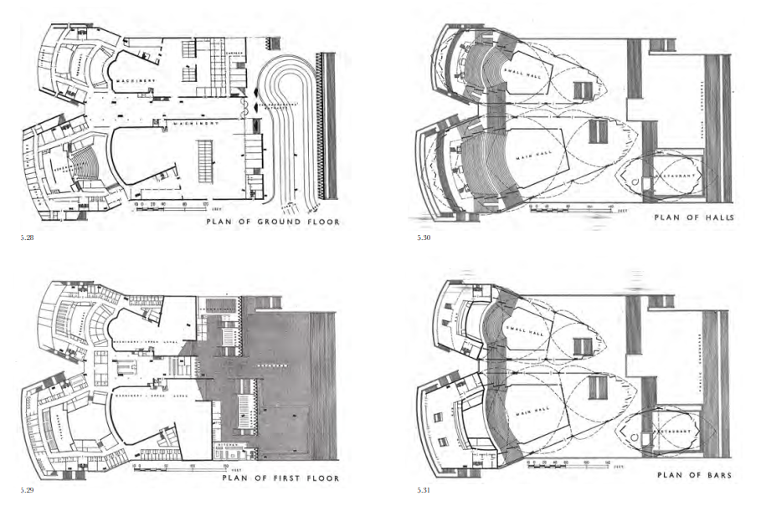
Figure 4: Floor plans of Sydney Opera House (Croker, A, 2017)
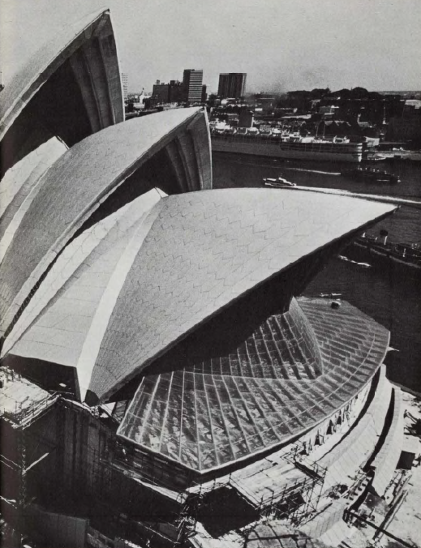
Figure 5: Image to showcase the complexities of the glass design of Sydney Opera House (Zunz, J, 1973)
Furthermore, the project exposed a broader conflict between artistic vision and political control, as rapidly escalating cost estimates that reached up to £24.7 million and delays intensified the reviews into Utzon’s methods (Croker, A, 2017). These pressures ultimately undermined the extensive collaborative process between architect, engineers, and government which helped evolve modern architecture, contributing to Utzon’s resignation in February of 1966 before the building’s completion (Croker, A, 2017). It is evident that the Opera House reflects not only the ambitions of post-war architecture to create expressive aspirational public monuments, but also its clear contradictions, where visionary design, technical feasibility, and functional requirements collide, revealing the complex nature of architectural production in the post 1945 period.

Client, user, and function
The New South Wales Government commissioned the Opera House, representing an ambition to establish a major performing arts venue that would serve the nation and wider civic population. The project was intended not only to provide functional theatre spaces but to act as a cultural landmark that could serve as the face of Australia and elevate Sydney’s global identity ‘for its unique architectural character and for being revered by people the world over.’ (UNESCO,2006). The building is a public institution, hosting a wide range of performances across multiple venues, including opera, theatre, and concerts, while also functioning as a tourist hotspot. (Sydney Opera House, 2026). However, accommodating these diverse range of experiences exposed significant tensions between architectural ambition and function. The exterior’s geometric, radical form evidently achieved extraordinary visual awe, but the internal planning has frequently been criticised for being so superficial. Each hall with distinct acoustic and spatial requirements, proved difficult to accommodate inside the geometry imposed by the shell structures. Criticism focused particularly on these limitations, issues that required later modification and adaptation (V.L.Jordan, 1973). These issues highlighted a disconnect between initial design intentions and realised use in line with Utzon’s philosophy. Furthermore, the evolution of the project during construction, under political and financial pressures intensified these contradictions, as the need to these requirements and present a functioning building conflicted with the desire to preserve its iconic form. The result is a structure that achieves its goal as a cultural landmark but reveals tensions between the spectacle and usability. The Opera House reflects not just the ambitions of post war architecture, but also the contradictions, where the desire for an audacious form can undermine functionality, exposing the demands placed upon architecture in the post 1945.

Planning & controversy
The planning and construction of the Sydney Opera House reveal that architecture is not solely revolved around design but is evidently shaped by politics and economics. From its conception the project was strongly backed by the New South Wales Government, which promoted it in hopes of it becoming a symbol of cultural ambition and national evolution ‘it represents Australia's rising post-war self-confidence.’ (Bryant, N, 2023). This support from the government was delivered with increased scrutiny as the realities of the elaborate construction began. The complexity of Utzon’s shell structures, which required the development of entirely new construction techniques. The project faced this throughout including the numerous experiments with glass to accommodate for the size and flexibility, significant delays were made and uncertainty within the project began to muster (Zunz, J, 1973). The shells met an eventual solution by deriving the shells from a single geometric sphere which enabled structural consistency and a clearer sense of form and growth (Rey-Rey, J, 2022). The breakthrough came after years of experimentation which contributed to the escalating costs that saw the estimations rise significantly every year and thus frustration among government officials additionally rose (Croker, A, 2017). Originally no limits were placed on the estimate during the design competition and when construction kicked off the estimated sum was relatively modest at £4.8 million, however the final cost rose dramatically to an immense £24 million as aforementioned. The costs intensified the public and political criticism ran rampant, transforming the project into a subject of national debate (Flyvbjerg, B, 2005)
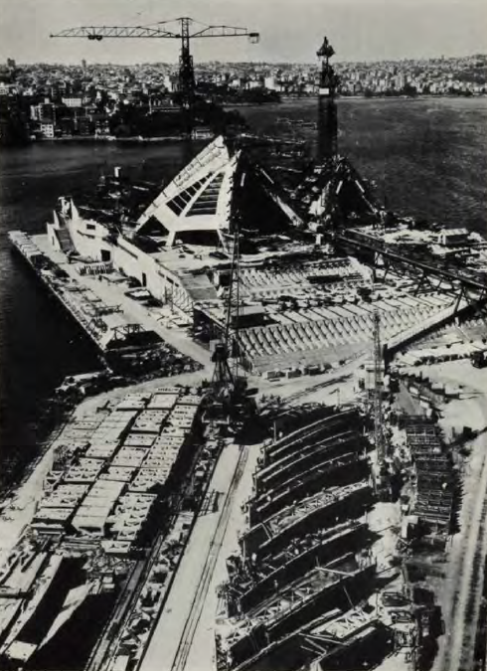
Figure 6: Precasting yard and the site (Zunz, J, 1973)
As the construction of the Opera house progressed, tensions between Utzon and the New South Wales Government became increasingly proverbial, particularly regarding control over design decisions and expenditure as made clear. The government’s demand for greater accountability and detailed drawings conflicted with Utzon’s more exploratory design process working more like a sculpturer, this birthed light to a fundamental clash that spun for years. A pivotal moment came when Utzon, after all the conflict that culminated, resigned and exposing the somewhat fragility of the architect’s authority (Croker, A, 2017). The building was completed under the direction of Australian architect Peter Hall, whose role primarily involved adapting the interiors to meet functional and budgetary constraints. Hall however still attempted to follow and make sense of Utzon’s vision of the Opera house. (Sydney Opera House, 2026). This transition is clear evidence of the project becoming shaped by governmental forces rather than a singular architectural vision.
The Opera House was additionally subjected to planning considerations and heritage constraints, primarily due to its prominent harbour setting. The project had to respond to concerns regarding cost, public accountability, and its impact on the urban and cultural landscape (Heritage, 2026). Public anxiety surrounding the project accumulated from the excessive expenditure and led questioning whether such an ambitious design was now appropriate in consideration. Thus, the Opera House became a site of tension, where innovation intersected with politics, limitations, and public opinion.
This complex history reveals how architecture operates within systems of power, where visionary design must contend with structures and reality. In doing so, the building reflects the contradictions of post 1945 architecture, where the desire for expressive, innovative forms is frequently challenged by the countless constraints.

Reception & significance
Sydney Opera House’s status has shifted significantly over time, reflecting the change in architectural values over the decades. The structure was framed as an example of architectural excess, where radical form would override functionality and financial responsibility as aforementioned. Renowned architect Frank Lloyd Wright was fairly critical of the project, describing it as a ‘circus tent’ and ‘an inorganic fantasy’ (Jackson, D, 2026). However, its eventual completion in 1973, led way to a gradual celebration as one of the defining works of twentieth-century architecture. Its reputation within architectural journals grew as attitudes toward modernism shifted and evolved to see more comfort in expressive and sculptural forms. The building’s eventual listing as a UNESCO World Heritage Site in 2007 cemented its status as a global icon (UNESCO, 2006). Its influence can be seen across the globe particularly in the work of architects such as Frank Gehry, whose designs similarly explore complex geometries ‘(it) changed the image of an entire country’ (Architectural tour, 2026).
The Opera House’s bow recognisable image has as some would argue, overshadowed its tension filled history particularly in its performance halls. The building’s radical ethereal image is evident without question, but its greatness may lie as much in the story of its making and should be just as recognisable. The tensions between vision, ambition and constraint contribute to its relevance as shadowed as it is.

Conclusion
The Sydney Opera House stands as one of the most powerful architectural structure posts 1945, not only for its innovation but for the narrative sown within. The building evidently reflects the ambitions of the post war optimism, is cemented in technological progress, and a true example of the wants of national identity, this all is embedded in its radical, flowing design. The building’s form essentially redefined architecture and spatial experience through its complication and hurdles the team behind the astonishment jumped over. Furthermore, the escalating costs, and political intervention highlight how architecture is shaped not only by design but by governments, economics, and the public.
It has been made evidently clear the Opera House reveals a contradiction of post 1945 architecture. The desire for bold, expressive forms often carries with tension revolving feasibility and function. The structure on the one hand has achieved global recognition as not just an architectural icon but a worldwide one. However, its iconography obscures the complex processes and boundaries that plagued the construction that gave way to the sensation today. Its significance, particularly in the architecture world lies in the exposure of the realities of architectural production that it highlighted and should be a narrative all students should consider researching. In conclusion, the Sydney Opera House reflects the ambitions, tensions, and contradictions of post 1945 architecture as a collective that can define both a building and the era.

Word count: roughly 2707

Reference List
Britannica, 2026. Jørn Utzon. Britannica. Available at: https://www.britannica.com/biography/Jorn-Utzon (Accessed at: 15 March 2026).
Bryant, N, 2023. The Sydney Opera House: The monument that represents Australia. BBC. Available at: https://www.bbc.co.uk/travel/article/20231102-the-sydney-opera-house-the-monument-that-represents-australia#:~:text=The%20Sydney%20Opera%20House%20is%20a%20significant,much%20of%20the%20manpower%20for%20its%20construction. (Accessed at: 24 March 2026)
Croker, A, 2017. Respecting the Vision: Sydney Opera House - a Conservation Management Plan. Sydney Opera House. Available at: https://www.sydneyoperahouse.com/sites/default/files/collaborodam_assets/soh-cmp-interactive-1.pdf (Accessed at: 2 March 2026).
Flyvbjerg, B, 2005. Design by deception. Harvard design magazine. Available at: file:///C:/Users/tjd23/Downloads/Flyvbjerg05DesignByDeceptionThePoliticsOfMegaprojectApproval.pdf (Accessed at: 24 March 2026)
Heritage NSW, 2026. Sydney Opera House. State Government. Available at: https://www.hms.heritage.nsw.gov.au/App/Item/ViewItem?itemId=5054880 (Accessed at: 2 March 2026).
Jackson, D, 2026. Frank Lloyd Wright’s bridge. Walsh Bay. Available at: https://walshbayhistory.net/stories/frank-lloyd-wrights-bridge#:~:text=Frank%20Lloyd%20Wright%20(1867-1959)%20was%20an%20American,"A%20circus%20tent"%20*%20"An%20inorganic%20fantasy (Accessed at: 27 March 2026)
Leeuwen. R. V, 2017. Sydney Opera House. Structural engineering blog. Available at: https://robbievanleeuwen.github.io/engineering%20journalism/sydney-opera-house/ (Accessed at: 27 March 2026)
Matarese, L, 2022. Heritage action plan FINAL 2022. Sydney Opera House. Available at: https://www.sydneyoperahouse.com/sites/default/files/collaborodam_assets/heritage-action-plan-2022-e-text.pdf (Accessed at: 2 March 2026).
Rey-Rey, J, 2022. Nature as a Source of Inspiration for the Structure of the Sydney Opera House. National library of medicine. Available at: https://pmc.ncbi.nlm.nih.gov/articles/PMC8883984/ (Accessed at: 24 March 2026)
RIBA, 2026. Modernism. RIBA. Available at: https://www.riba.org/explore/riba-collections/architectural-styles/modernism-movement/ (Accessed at: 15 March 2026).
Ruan, X, 2017. Platforms and Plateaus: on the Chinese & Mayan influences on Sydney’s famous opera house. Available at: https://www.citymonitor.ai/analysis/platforms-and-plateaus-chinese-mayan-influences-sydney-s-famous-opera-house-2805/?cf-view (Accessed at: 15 March 2026).
Science and media museum, 2021. Houses of the future: British post-war architecture from modernism to futurism. Science and media museum. Available at: https://www.scienceandmediamuseum.org.uk/objects-and-stories/british-post-war-architecture-modernism-futurism (Accessed at: 2 March 2026).
Sear, F, 1998. Roman architecture. Routledge London. Available at: 10.4324_9780203019153_previewpdf (1).pdf (Accessed at: 9 March 2026).
Stanford, 2003. Phenomenology. Stanford encyclopaedia of philosophy. Available at: https://plato.stanford.edu/entries/phenomenology/ (Accessed at: 15 March 2026).
Sydney Opera House, 2026. Architectural tour. Sydney Opera House. Available at: https://www.sydneyoperahouse.com/tours/architectural-tour#:~:text=Journey%20into%20the%20minds%20of,each%20time%20due%20to%20availability. (Accessed at: 27 March 2026)
Sydney Opera House, 2026. Heritage action plan. Sydney Opera House. Available at: https://www.sydneyoperahouse.com/sites/default/files/collaborodam_assets/heritage-action-plan-june-1.pdf?_gl=1*18ydtsw*_gcl_au*MTgzNjc3MzcyNy4xNzc0Mzg5MTA2*_ga*NjIxODY4MDUyLjE3NzQzODkxMDc.*_ga_H98KVDQDSG*czE3NzQ2NDg2NDQkbzEwJGcwJHQxNzc0NjQ4NjQ1JGo1OSRsMCRoMA.. (Accessed at: 27 March 2026)
Sydney Opera House, 2026. Our story. Sydney Opera House. Available at: https://www.sydneyoperahouse.com/our-story (Accessed at: 15 March 2026).
Sydney Opera House, 2026. Peter Hall and the completion of the Opera House. Sydney Opera House. Available at: https://www.sydneyoperahouse.com/our-story/peter-hall-and-completion-opera-house (Accessed at: 9 March 2026).
Sydney Opera House, 2026. Peter Hall and the completion of the Opera house. Sydney Opera House. Available at: https://www.sydneyoperahouse.com/our-story/peter-hall-and-completion-opera-house (Accessed at: 27 March 2026)
Sydney Opera House, 2026. Tubowgule. Sydney Opera House. Available at: https://www.sydneyoperahouse.com/our-story/tubowgule (Accessed at: 7 March 2026).
UNESCO, 2006. Sydney Opera House nomination for world heritage listing. UNESCO. Available at: https://whc.unesco.org/uploads/nominations/166rev.pdf (Accessed at: 2: March 2026).
V. L. Jordan, 1973. Acoustical Design Considerations of the Sydney Opera House. The Royal Society of New South Wales. Available at: https://www.royalsoc.org.au/wp-content/uploads/2024/09/106_12_jordan.pdf (Accessed at: 20 March 2026).
Zunz, J, 1973. The Arup Journal. Ove Arup Partnership. Available at: the-arup-journal-1973-issue-3.pdf (Accessed at: 9 March 2026).

