Task 1: Locating Sources
Identify and locate three different sources (a report, a journal article, and a website) related to the question
“What employability skills do business graduates need to succeed in the modern workplace?”
Show how you used keywords, search terms, and Boolean operators to find them, and explain how you know which type of source each one is and why it is appropriate for the research question.

Source Type & Why It Is Appropriate | URL/DOI | What search engine did you use? Google/Online Library/Library AI Assistant | Keywords/Boolean Operators Used

Task 2: Evaluating Information (CRAAP Test)

Your colleague has forwarded you a source from a peer reviewed journal, and they are not sure whether it is appropriate to use and has asked for your help. Your task is to evaluate the source by using the CRAAP Test to assess its appropriateness.

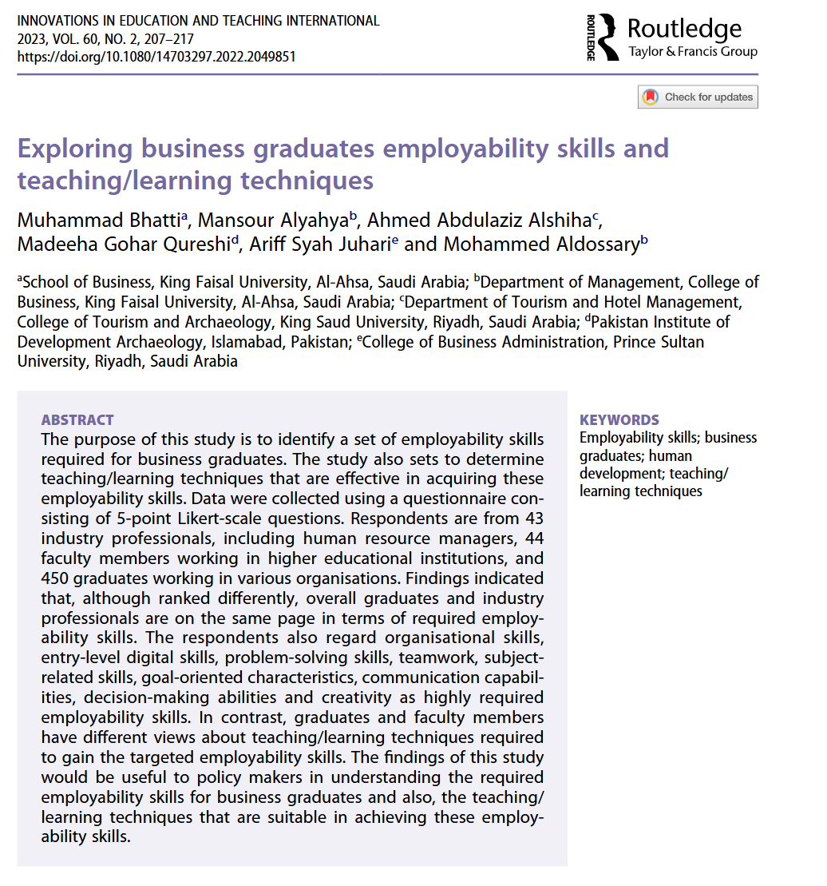
https://www-tandfonline-com.uwtsd.idm.oclc.org/doi/full/10.1080/14703297.2022.2049851

CRAAP Test
Currency

Relevance

Authority
Accuracy
Purpose

Task 3: Source Analysis
Your manager has provided you with a short extract from a source and has asked you to analyse the source by Identifying one strength, one weakness, and providing a brief explanation of the strength and weakness identified.
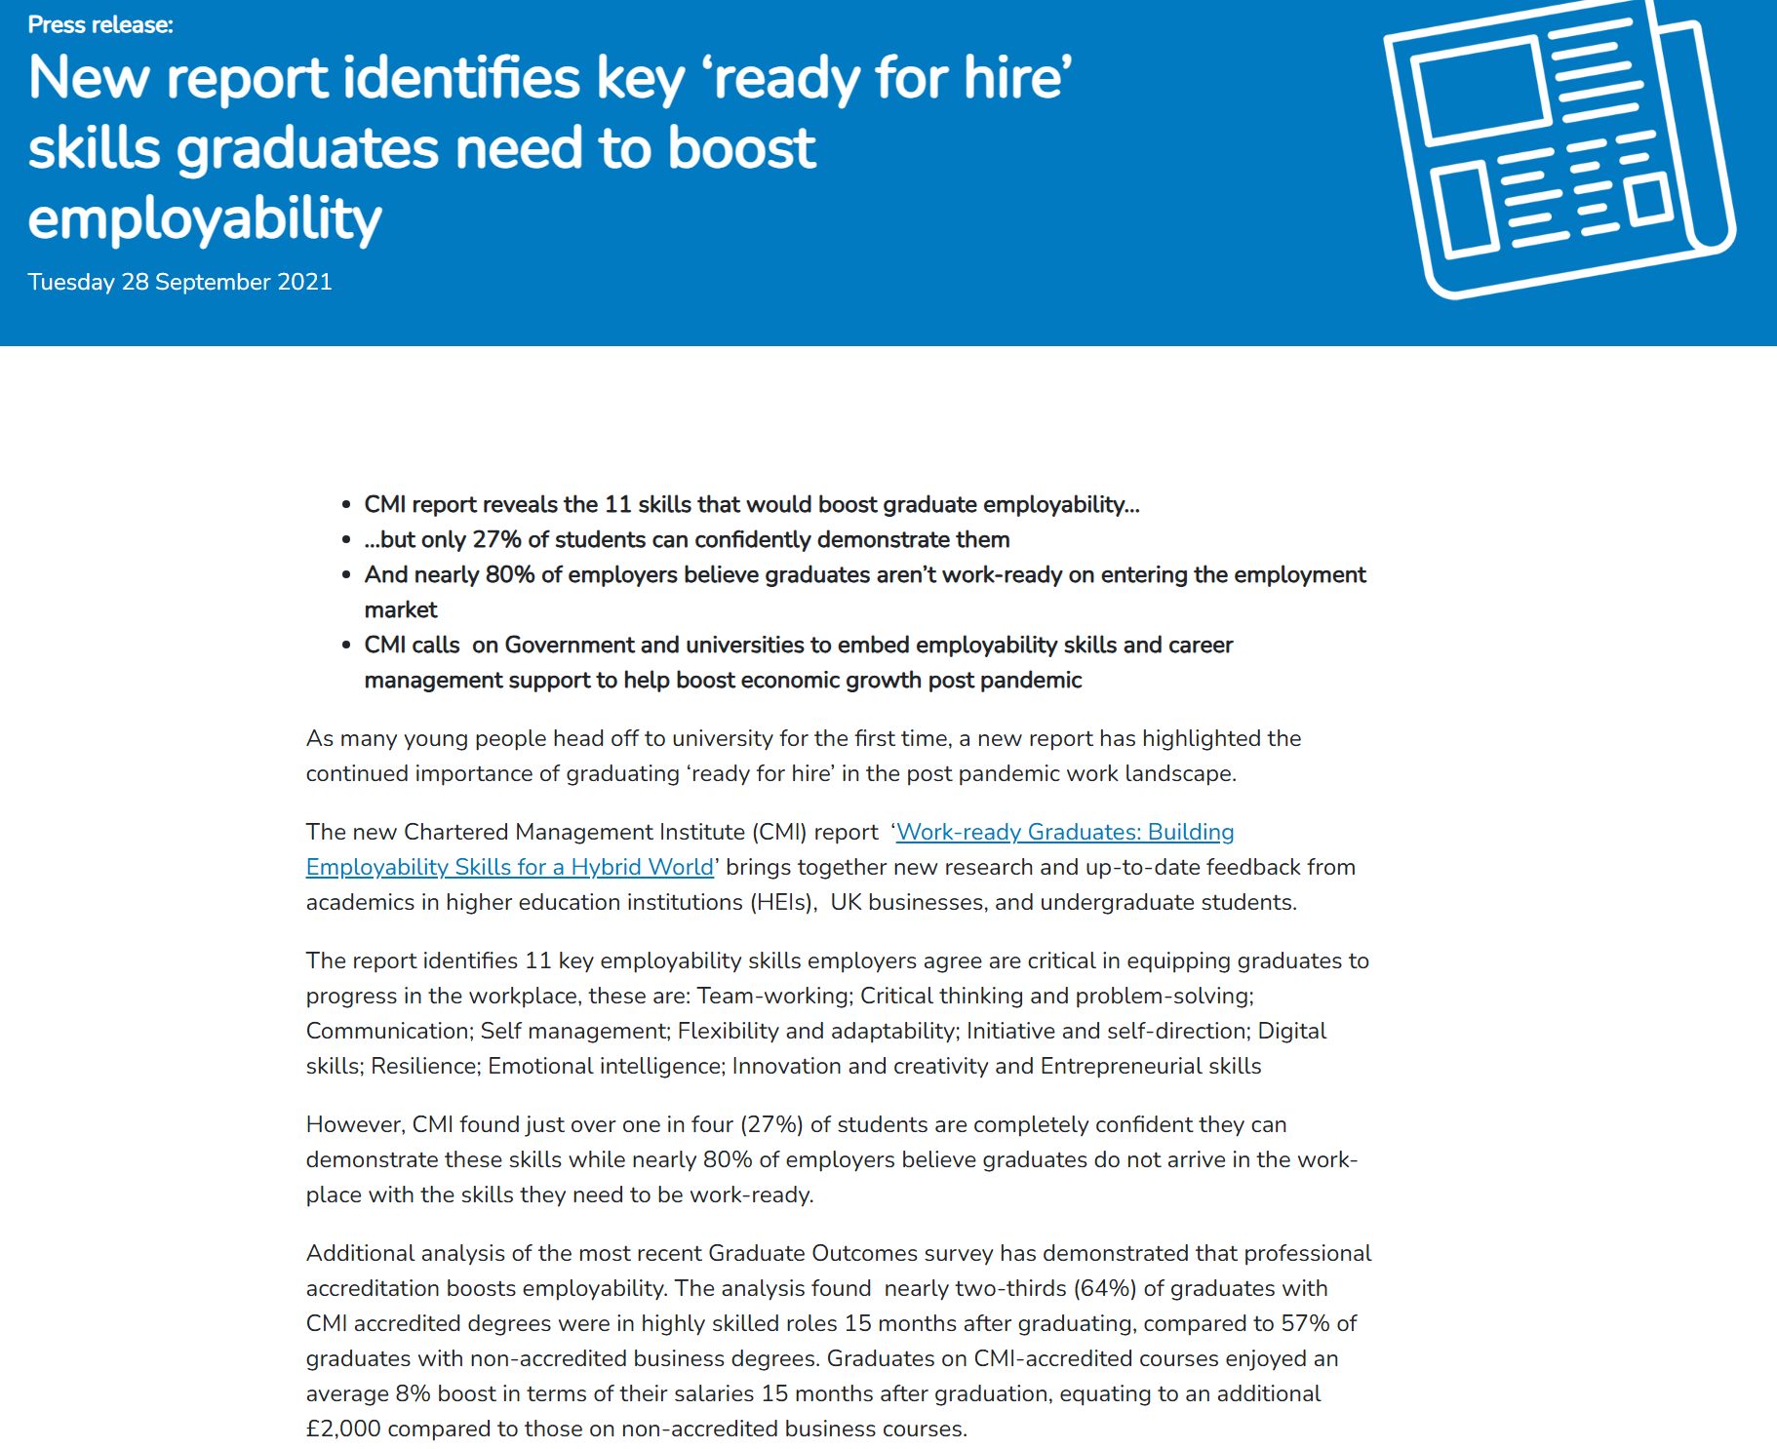

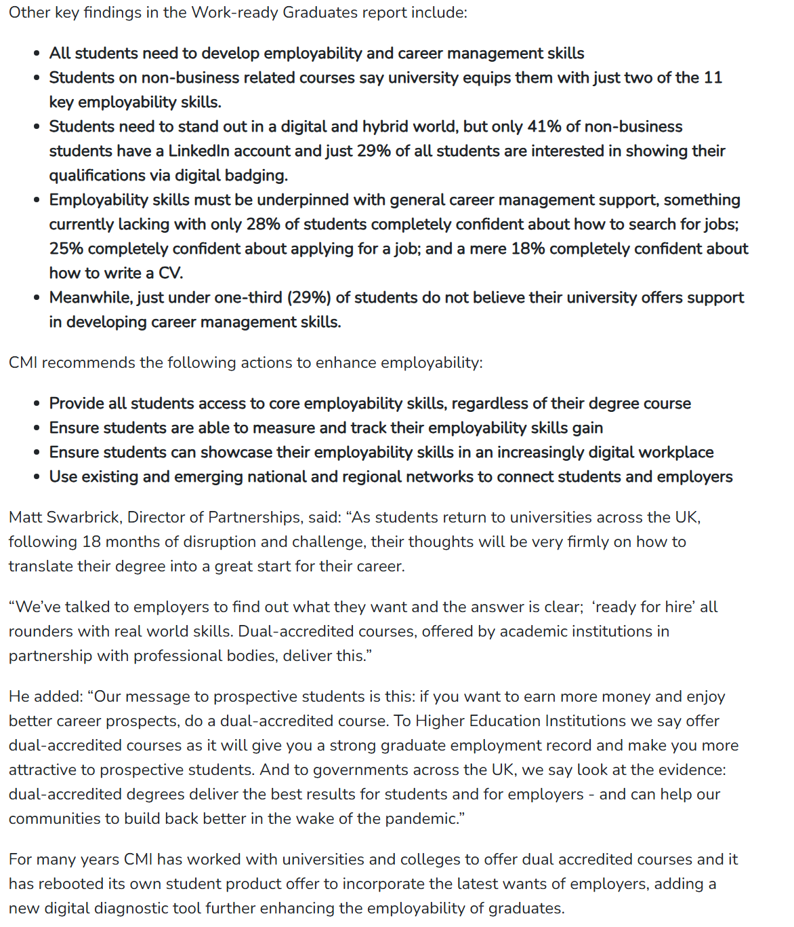
New report identifies key ‘ready for hire’ skills graduates need to boost employability - CMI
Strength of the Source:

Weakness of the Source:

