Course Title | Entrepreneurship
Module Code | LCBB5001
Tutor | Laila Maazouz
Student Name | Diana Gabriela Bucataru
Student ID | 2122807

Coursework: Business Plan

Table of Contents
BUSINESS DESCRIPTION / MARKET OPPORTUNITY 3
INDUSTRY ANALYSIS 4
OPERATIONS AND MANAGEMENT TEAM 7
MARKETING 9
FINANCIALS 10
MARKET RESEARCH 11
References 12

BUSINESS DESCRIPTION / MARKET OPPORTUNITY
I have always been thinking about starting a new business. Finally I have decided to start a personalized online gift shop business in the name of “Clarissa”. Clarissa will be offering various gift products which can be customized or personalized as per the desire of the customers. There will be verities of products including customized mugs, engraved accessories, customized photo albums, custom-made jewellery, and others. Customers will be able to use their preferable picture, name, letter, or any sign on the products. Clarissa will be providing several offers such as buy one get one, instant discounts, discounts on next purchase etc. on special occasion including Christmas, Valentine’s Day, and mothers/father’s day and so on. Clarissa will also include delivery services for the customers. They can have home delivery of their ordered products. They can even send surprise parcel to another location instead of informing the person receiving the gift. Clarissa will ensure the confidentiality and privacy of the customer’s personal information.
- Mission: The mission of Clarissa is to achieve a standard sales record within next six months and then enhancing the sales rate by 5% within 1 year.
- Intellectual property rights: The business name “Clarissa” should be registered for getting a trademark so that no one can use this name and sell fraud products for misleading the customers.
- Ownership structure: Clarissa is a sole proprietorship business which will be run by me. There will be a management body which will manage the business operation.
- Legal consideration: The forming of a sole proprietorship business is very simple and easy for which no complex legal procedures need to be followed. I will take all of the responsibilities of all kinds of legal issues that will occur in the upcoming days.

INDUSTRY ANALYSIS
The personalized gift shop market is becoming wider gradually due to huge demand for personalized gift products. It is estimated that the global personalized gift shop market was worth USD 30676.3 million in 2022 which will be expanding at a CAGR of 8.77% in the upcoming period and will be worth USD 50803.43 million by 2028 (Li et al., 2022). The more the new companies are entering into the market, the more it is becoming competitive. The competitiveness of the UK personalized gift shop market can be analysed through the analysis of porter’s five forces analysis.
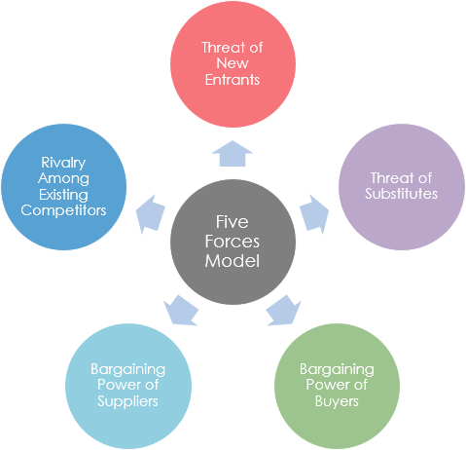
Figure01: Porter’s five forces analysis.
Threat of new entry: A moderate level of entry barriers might be prevailing in the personalized gift shop market of United Kingdom. Initial investment in product development, marketing, technology and etc. is required for setting up a business (Su et al., 2021). But the amount of investment would be smaller for SME businesses. There are already lots of established players in the gift shop market who have already gained recognition and might create challenges for the new entrants.
Threat of substitutes: There are moderate level of threats of substitute products in the UK personalized gift shop market. New companies are now offering unique products by adding sentimental values but the customers are still interested in purchasing traditional products, generic gifts which contain authenticity. By adding emotional values in the products, gift shop can keep the customers attracted for a long time and can mitigate the threats of substitute products.
Bargaining power of customers: There are significant level of bargaining power of the customers in the gift shop market in United Kingdom (Eggert et al., 2019). Since gifts are sentimental products, customers can be picky. Besides, they can switch into several brands for having new experience whenever they purchase anything. There are lots of brands that are offering similar products. Some customers can be picky to particular brand while some can switch into different brands due to the low switching cost.
Bargaining power of suppliers: The suppliers of the personalized gift shop market are the manufacturers of customizable products, different items used in making gifts, packaging items, crockeries items as well as other items. If most of the suppliers provide similar products then they will have lower bargaining power but when they will be offering differentiated products their bargaining power will be increasing.
Competitive Rivalry: The UK personalized gift shop market is becoming competitive day by day as new companies are entering into the market (Wang, 2021). Some of the companies have already become popular by offering unique and quality products to the customers including “You Name It UK”, Shop Personalised Gifts, Getting Personal and so on. These are the biggest competitor of “Clarissa”
Name of competitor | Differentiation
You Name It UK | Our products are valuable since customers can purchase from us according to their requirements. But the products are not rare. Competitors can imitate our products. The products are very organized which will be prepared with great care.
Shop Personalised Gifts | The personalization policy of Clarissa is very valuable which will allow the customers to send personalized gift box to their loved one without even informing the receivers. This policy is kind of rare. But other competitor can yet imitate such policy. The implementation of the policy will be handled in an organized way.
Getting Personal | Clarissa will be offering discounts on a particular range of sales which will be given to anyone including both regular and irregular customers. This will be adding value in the company’s overall sales. The offers will be organized on every occasion for the customers so that more people can purchase. Customer’s will get 5% extra discount on purchasing from app.

OPERATIONS AND MANAGEMENT TEAM
OPERATIONS
Clarissa will be operated from a warehouse in London where the products will be produced and from where the products will be dispatched for the customer’s location. There will be staffs who will be working full day. The management team of 5 members including myself will be planning, organizing, monitoring and controlling the operations. I will be taking most of the decisions by taking suggestions from other team members since Clarissa is a sole proprietorship business. Sole tradership is the most appropriate legal structure for a SME business like Clarissa.
Clarissa will be following the upgrading techniques for generating revenue. Improving the quality of our products and enhancing the usefulness of each and every products will be our technique of upgrading. Each and every products will be prepared by using quality supplies so that the usefulness and effectiveness of the products increase and the customers become satisfied. Whenever it comes to gifting someone, customers always prefer quality so that the gift means a lot to the receiver. Quality is attracts customers while purchasing gift items. Our strategy is to maintain best quality in all of the products. We will be trying to maintain the same quality of a particular product even after many years. By the use of new technology as well as better supplies the usefulness of the products will be increased in the upcoming days.
We will be trying to maintain consistency in the sales rate every months so that a consistent revenue can be earned. For maintaining the consistency in sales, different offers will be provided to the customers so that customers become interested in purchasing from Clarissa. This will help us in selling the least number of products every month for preventing loss of revenues. The marketing team will be working productively for attracting the customers so that they come to purchase from us.
MANAGEMENT TEAM
Name | Skills | What do they bring to the firm
Jonathon | Leadership skill | He can lead the fellow employees for working hard for increasing productivity and efficiency. Helps in aligning employee’s work with organizational mission.
Emily | Planning and managing skills | Helps in planning and managing the business operations smoothly.
Noah | Human resource management | Keep the employee motivated all of the time by recognizing their hard work and allowing them to share their ideas and thoughts.
Arthur | Monitoring and controlling | Helps in monitoring all of the activities so that everything goes well and takes effective steps if anything is not going as expected.

MARKETING
The 4Ps of marketing mix of Clarissa will be discussed in the below.
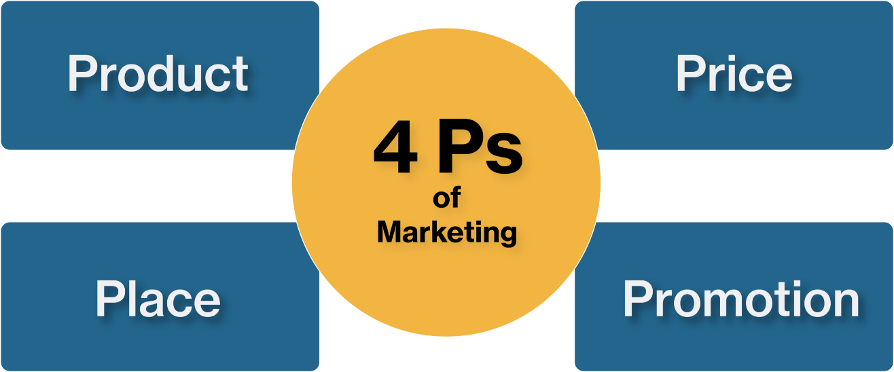
Figure02: Marketing mix.
Product: Clarissa will be providing customized gift items for the customers. Customers can select items for a gift box according to their preferences. We will be offering customized mug, engraved accessories, customized photo albums, custom-made jewellery as well as other products as per customer’s demand. They will be provided home delivery services. They can also avail surprise hole delivery services for sending gift to a location without notifying the receivers. We will be protecting customer’s privacy by all means.
Price: We will be following a competitive pricing strategy so that we can stay competitive. We will be selecting the price of each items after the analysis of the price of the competitors. This will helps us in surviving the competition. We have planning for following a premium pricing strategy when we will be able to secure a strong position in the competitive market.
Promotional mix: Promotion is very important for a start-up company. We will be promoting our brand “Clarissa” through digital marketing. We will be continuously posting on social media account such as Facebook, instagram, Twitter, YouTube so that people using those sites can see our brand all of the time and feel the urge of purchasing from us one day. We will instantly reply to the queries of the customers for enhancing customer engagement.
Place: Initially, there will be no physical location from where customers can purchase their products but a warehouse will be there from where we will be delivering our products to the customer’s location. We will be thinking about opening physical store when a strong customer base will be created. Until then customers will have to purchase from online store just by clicking the “order” option on our website and mobile app.

FINANCIALS
For starting “Clarissa” approximately £100,000 pound will be required initially. I will be using my personal savings which is not going to cover the overall capital requirement. I will need to collect loans from bank. I will be taking both short term loan and long term loan from banks for financing the business. The collected capital will be used for both the fixed and variable costs of the business. In the beginning, the sales rate is expected to be lower since it will take time for the customers to learn about Clarissa. The effective marketing will influence the customers to purchase from Clarissa. When customers will be well-aware of the existence of Clarissa they will continue purchasing from us which will help us in achieving financial stability.
Use of funds
 | Month 1 | Month 2 | Month 3 | Month 4 | Month 5 | Month 6
Revenue | £10,000 | £12,000 | £12,000 | £15,000 | £16,000 | £18,000
Fixed Costs
Lease | £10,000 | - | - | - | - | -
Vehicle | £20,000 | - | - | - | - | -
Equipment | £30,000 | - | - | - | - | -
Computer | £10,000 | - | - | - | - | -
Variable Costs
Wages | £200 | £200 | £200 | £200 | £200 | £200
Salary | £1200 | £1200 | £1200 | £1200 | £1200 | £1200
Utilities | £500 | £600 | £800 | £1000 | £1200 | £1500
Interest | £300 | £300 | £300 | £300 | £300 | £300
Marketing | £2000 | £2000 | £2000 | £2000 | £2000 | £2000
Insurance | £400 | £400 | £400 | £400 | £400 | £400
Total cost | £74,600 | £4700 | £4900 | £5100 | £5300 | £5600
Profit | (£64,600) | £7300 | £7100 | £9900 | £10700 | £12400

MARKET RESEARCH
The size of UK Personalized Gifts Market is expected to increase by USD 898.1 million (Stata et al., 2022). This is also estimated to grow 9.61% CAGR by 2027. Market growth has been driven by the increasing popularity of the private level brands. Customers are more interested in purchasing from the private level personalized gift shops. The macro environmental factor such as political, economic, social, environmental, technological and legal factor have significant impact on the personalized gift shop market in UK. Political stability helps in business growth while the economic instability refrain customers from purchasing gift products. But customers are becoming more sincere and considering to offer gifts to their loved ones on special occasion. Technology provides huge opportunity for the gift shop companies for expanding their business operations into new markets by promoting their business using digital promotional strategy.

References
- Barringer, B., Ireland, D., (2019) Entrepreneurship: Successfully Launching New Ventures. Sixth edition; Global edition. Harlow, England: Pearson.
- Bplans (2020) Sample Business Plans. Assessed on 21st November 2020. Available at: https://www.bplans.com/downloads/business-plan-template/ ​
- Eggert, A., Steinhoff, L. and Witte, C., 2019. Gift purchases as catalysts for strengthening customer–brand relationships. Journal of marketing, 83(5), pp.115-132.
- Falahuddin, F., Fuadi, F., Munandar, M., Juanda, R. and Ilham, R.N., 2022. Increasing Business Supporting Capacity In Msmes Business Group Tempe Bungong Nanggroe Kerupuk In Syamtalira Aron District, Utara Aceh Regency. Irpitage Journal, 2(2), pp.65-68.
- Lahtinen, V., Dietrich, T. and Rundle-Thiele, S., 2020. Long live the marketing mix. Testing the effectiveness of the commercial marketing mix in a social marketing context. Journal of Social Marketing, 10(3), pp.357-375.
- Li, L., Kang, K., Feng, Y. and Zhao, A., 2022. Factors affecting online consumers’ cultural presence and cultural immersion experiences in live streaming shopping. Journal of Marketing Analytics, pp.1-14.
- Stata, W., Press, S. and Shop, G., 2022 UK Stata Conference 8–9 September| London.
- Su, D.N., Duong, T.H., Dinh, M.T.T., Nguyen-Phuoc, D.Q. and Johnson, L.W., 2021. Behavior towards shopping at retailers practicing sustainable grocery packaging: The influences of intra-personal and retailer-based contextual factors. Journal of Cleaner Production, 279, p.123683.
- Wang, C.L., 2021. New frontiers and future directions in interactive marketing: inaugural Editorial. Journal of Research in Interactive Marketing, 15(1), pp.1-9.
- Ye, L., Gai, L., Youssef, E. and Jiang, T., 2019. Love consumption at the digital age: Online consumer reviews and romantic gift giving. Journal of Global Marketing, 32(5), pp.335-355.

