

Student Name : HARDIK SAI GADDIPATI
Student Number : 2215797
Module Name : Data base systems (ACCA7002)

Abstract

This report provides a detailed comparison of different types of NoSQL databases and an investigation into the alternatives for Abertawe Entertainment, a business based in Swansea. The report also contains a debate of when to use a NoSQL database.

Table of Contents

1. Introduction 3
2. Types of NoSQL Databases 3
2.1. Document-oriented databases 3
2.2. Key-value stores 4
2.3. Wide-column databases 4
2.4. Graph databases 4
3. Uses of NoSQL Database 4
References 5

Introduction

Abertawe Entertainment is a business in Swansea, they sell various short stories. These are available in text, digital and audio. Since Abertawe Entertainment is looking to expand in Wales, they need a new platform for the customer to browse and make the purchase. This report explores various databases and critically analyze them and suggest which type of database works best for them.

There are two types of databases used relational and non-relational databases, also known as SQL and NoSQL. Firstly, Relational databases like PostgreSQL and MySQL store data in tables that is represented in rows and columns. These type databases use a structured query language (SQL) to retrieve and manipulate data within the database. Secondly Non-relational databases such as MongoDB and Redis store data in a non-tabular format and use a various data models and query languages to access the database.

Types of NoSQL Databases

Document-oriented databases
Document databases are semi-structured databases that use a key-value pair format. These databases allow the value associated with a key to be another key, creating a hierarchical data structure. However, document databases are not limited to just key-value pairs and can also support more complex data models like arrays and nested objects. Document-type databases generate documents sequentially, making them suitable for storing data with high level of variability and complexity. Document databases use a flexible schema, which makes them highly adaptable to changing data structures and suitable for storing large, unstructured data with faster query times. However, the query time may depend on factors such as the size and complexity of the data and the nature of the queries being executed. The data is stored in a similar way to an array, making it horizontally scalable.

Key-value stores
In key-value stores, databases only store one key and one value for each key. Here, each value is assigned a unique key, and the value can store strings, numbers, objects, lists, arrays, binary objects, etc. This database is suitable for managing, caching, session storage, and sorting unstructured data. The database has a simple structure, which makes it easy to scale over time, and it can perform queries faster compared to other database types.

Wide-column databases
Wide column is a type of NoSQL database, which contains tables, and each table has a key and a column family. The keys are unique, and each row can contain one or many columns which may vary from other rows. In wide column table we can store multiple versions of the same value which is marked by a timestamp, this facilitates to query older values of the same row. Wide column databases usually use a complex model with flexible schema, they can scale horizontally.

Graph databases
Graph databases are designed mostly to store and navigate multiple relationships. The emphasis is placed on the relationships between data rather than the data itself. Nodes represent data entities in this type of database, while edges represent the relationships between nodes which makes them ideal for complex data structures. Each edge contains information such as a start node, end node, direction and type. The relationships stored on edges can vary widely and relate to the nodes in various ways. Graph databases can be spread out over different nodes, which helps them scale horizontally as more data is added.

Uses of NoSQL Database

The advantages of the no SQL databases are that they can handle large amounts of both structured and unstructured data. NoSQL databases are perfect form large unstructured data which needs to be scalable. Schemas are flexible enough to change data structure of the database. Usually suitable for maintaining real time applications where entries and reading the data need to be fast. Various factors to consider using a NoSQL database:

- Depending on the data structure and its complexity we can choose a suitable type of database. For instance, if the database needs to update a multiple times column and retains the ability to access its previous data entries a wide colour database would be a wise choice.

- NoSQL databases are known for its scalability as they are primarily used to handle unstructured data and it is easy to alter the database structure. NoSQL databases are typically better suited for scaling horizontally, while relational databases are typically better suited for scaling vertically.

- Performance: Consider the performance requirements of your application. If you need fast read and write speeds, a NoSQL database might be a better option. On the other hand, if you need complex queries that require joins and aggregations, a relational database might be a better fit.

- Cost: Consider the cost of the database software and any associated hardware and infrastructure. NoSQL databases are often open source and free, but may require more hardware and infrastructure to support.

- Security: Consider the security requirements of your application. Relational databases typically offer more robust security features, such as role-based access control and encryption, but NoSQL databases can also provide strong security measures.

- Availability and reliability: Consider the level of availability and reliability required for your application. Both relational and NoSQL databases can provide high availability and reliability, but the specific features and configurations required may differ.

- Development and maintenance: Consider the ease of development and maintenance for the chosen database. NoSQL databases typically have a more flexible schema, making them easier to develop and maintain, while relational databases require more upfront planning and design.

Solution
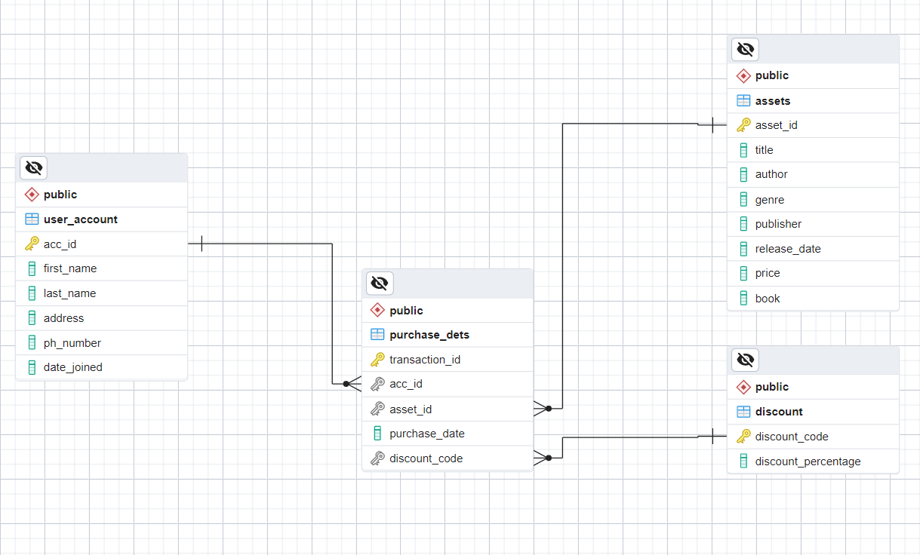

Above figure is an entity relationship diagram of the database which meets the Abertawe Entertainment requirements.

References
Types Of NoSQL Databases | MongoDB
NoSQL Vs SQL Databases | MongoDB

