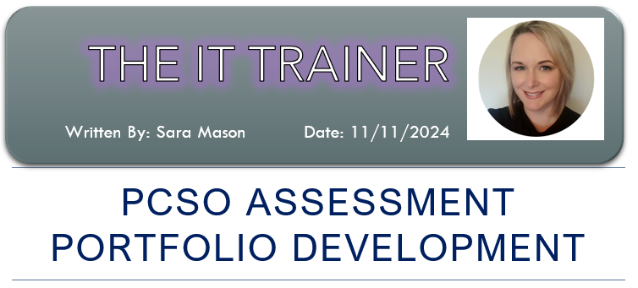

Assessment… this can be a scary prospect, especially when your career relies heavily on the outcome of a final assessment following an intense training programme. Before the last two Police Community Support Officer (PCSO) cohorts, I recognised that there was no formal assessment in place for PCSOs like there is for Police Officers. CSOs were given a piece of paper with a ‘checklist’ on it, where they had to ‘tick off’ their day-to-day activities such as ‘attend a call’, ‘book in lost property’ and ‘update the control room using their radio’, the same list I had to fill in to complete my PCSO probation ten years earlier! Once completed, it was expected that the PCSO’s tutor and Sergeant would sign the paper, and then keep it on file, and because of this they were rarely completed. This could be an issue, as if a ‘complaint’ came into the Learning and Development Department about the actions of an officer, we could only evidence what they were like in training and not out in the community after. I was very concerned about this, especially because the actions of the PCSOs following training heavily reflected on my own teaching practice and knowledge, I felt that it was vital to have an assessment process in place following the initial training phase that I was responsible for.
I mentioned to my training colleague how this needed to change, and she agreed. We researched what practices the Police Officer trainers were using for assessment and found that they were already using a programme called LASER Learning, which is an online portfolio system, it can be found here at Laser Learning Ltd.
I already had some basic knowledge of the LASER system as it was used to evidence my training for the Level 3 Award in Education, but it did take a little getting used to from an assessor’s point of view. Together my colleague and I devised a mock-up portfolio which included all the evidence that we felt was more appropriate to include, (for example, ‘evidence an occasion where you have had to manage conflict’, ‘evidence the process where you have dealt with an investigation, such as what enquires were made’, and ‘Provide an example of when you have offered emotional support to a victim or witness’), and covered a vast range of evidence requirements that would show that the PCSOs were capable of doing their role and dealing with the public. We spoke to the training Sergeant and Inspector and explained the importance of developing a substantial assessment programme for PCSOs that also involved an input from the Neighbourhood Sergeants, and explained that not only would it benefit the Learning and Development Department by putting the onus on Neighbourhood teams but would also provide on-going support following the initial training for PCSOs and their supervisors which was not done before. Thankfully they fully supported the idea, and soon enough I was placed on another course, the Level 3 Award in Assessing Vocationally Related Achievement.
During the initial training for the first PCSO cohort who would be using the LASER system, we ensured that all our students were set up and arranged for one of the Crime Assessors to do an input on how to upload evidence to the system. I also designed a guidebook for students with step-by-step guidance on uploading evidence and how to present their evidence in the best way possible. As well as this process being used for summative assessment, it also encouraged better formative assessment by using a ‘Holistic Assessment’ approach;
https://www.bing.com/videos/riverview/relatedvideo?q=holistic+assessment+in+education&&mid=4919C4646D336E86E4B24919C4646D336E86E4B2&&mmscn=stvo&FORM=VRDGAR
I explained how a lot of the criteria could be marked off by evidencing one incident correctly, this encouraged the students to engage with us more often, ask more questions, and submit more ideas - which got them to think more freely. I explained to the students that once they dealt with an incident that fit the evidence criteria, we needed them to make sure that, firstly, they were allocated to the STORM log and linked as an attending officer on NICHE, and secondly, the importance of writing full updates on these systems to evidence all the hard work they were doing as part of their enquires, as well as submitting their body camera footage. Once they understood the process, we were ready to begin.
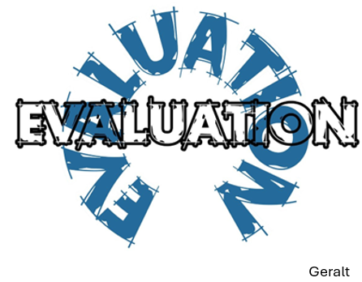
My colleague and I divided the twenty portfolios between us, and we began sifting through all the evidence that was uploaded. At first we found that some of the students were putting anything in just so that they had uploaded something to the system, so there were a few messages back and forth telling them that we needed additional evidence and giving them pointers on what they should be including. We agreed that this process would take fifteen weeks to complete, and much of our time was spent viewing body camera footage and reading logs to check that the students had evidenced the criteria and provided the best examples. Many of the students completed their portfolios in good time, and some took longer than the allocated fifteen weeks. It was agreed that two of the outcomes required might not be able to be completed during this timeframe, such as issuing a Fixed Penalty Notice for littering or dog fouling, but in order to evidence the reporting process, we performed recorded professional discussions which we later uploaded to the portfolios ourselves to be able to complete the signing off process. By doing these discussions, we were able to speak to the PCSOs and gauge their confidence to ensure that they were ready for independent patrol.
The portfolios worked well, and it gave us a chance to also engage with the Neighbourhood Sergeants and discuss any issues that a portfolio highlighted. It did take a lot of prompting to make sure that it was completed, because as this was a new system PCSOs who had joined previously did not understand the requirement, so was likely telling the students that they were a waste of time and that ‘they did not need to do them’. In order to reduce the stigma of this, we held PCSO Tutor sessions with more experienced PCSOs to explain the importance of completing the portfolios and the repercussions of not doing so (which was that a student would have to go onto an Action Plan, which could result in them not being able to go out on independent patrol, and it could have an impact on the application process should they decide to apply to become a Police Officer).
Thankfully, everyone completed their portfolios, and all the officers were fit for independent patrol. As far as I am aware, there has not been any complaints about the PCSOs as the portfolios clearly evidence that they are capable of doing to role professionally. There is another intake of PCSOs in March 2025, which I have been allocated to assist with, and I look forward to using the system again.

References:
Laser Learning (2024) https://www.laserlearning.co.uk/ (Accessed: 11th November 2024)
Brooks and Kirk Assessor Training (2024) What is Holistic Assessment? A Short Guide and Example. Available at: https://www.bing.com/videos/riverview/relatedvideo?q=holistic+assessment+in+education&&mid=4919C4646D336E86E4B24919C4646D336E86E4B2&&mmscn=stvo&FORM=VRDGAR (Accessed: 11th November 2024)
Image 1 retrieved from: Scott Graham. Available at: https://unsplash.com/s/photos/portfolio (https://unsplash.com/@homajob) (Accessed: 22nd November 2024)
Image 2 retrieved from: Geralt. Available at: https://pixabay.com/illustrations/circle-evaluation-judgement-1264717/ (https://pixabay.com/users/geralt-9301/) (Accessed: 22nd November 2024)

(1160 words)

