MODULE: Fundamentals of Construction Technology

MODULE CODE: ACBA4001

STUDENT NUMBER 1910146

1

Contents

- Proposed Restaurant and Ice Cream Parlour Site Investigation on Swansea Foreshore.................................................................................................pg 3
- Current Description of Site.......................................................................pg 3
- Bedrock Geology......................................................................................pg 4
- Historical Background of Proposed Site...................................................pg 4
- Loco Sheds...............................................................................................pg 4
Loco Sheds Continued..................................................................pg 5
- Civic Centre Build.....................................................................................pg 5
- Recommendations...................................................................................pg 6
- Codes of Practice.....................................................................................pg 7
- Building Services......................................................................................pg 7
Plumbing and Heating..................................................................pg 7
Drainage and Sewage...................................................................pg 7
Electricity......................................................................................pg 8
Telecommunications....................................................................pg 8
- Foundation..............................................................................................pg 8
- Drawing Plan……………………………………………………………………………………….pg 9
- Drawing Elavation……………………………………………………………………………….pg 10
- References...............................................................................................pg 11

2

Proposed restaurant and ice cream parlour site investigation on Swansea foreshore.

The purpose of this paper is to provide and initiate a full site investigation concerning the proposed site for the new restaurant and ice cream parlour, which is to be situated between the Marriott hotel and County Hall Swansea (sa1 3sn). The following investigation will outline the history of the site, it will also identify an investigation concerning the surrounding area and any possible issues that may occur. Once this has been achieved the paper will then look to include recommendations for a full site investigation based upon my findings throughout the investigation.

Current description of site
The land upon which the building is to be situated is currently split over the car parks of both the Marriott hotel and County Hall/Civic Centre, which is situated on the beach front. Between each car park there is greenery, trees, possible vegetation, as a result the area is uneven. It has been identified that there is a seated patio area for customers of the hotel which is situated where the proposed restaurant and ice cream parlour would be located. Further, to the side of the patio there is a brick building and metal containers, through an investigation with the Marriott hotel it has not been identified what the purpose of the brick building and the metal containers are, further the Marriott Hotel has not claimed any rights to these building. With this in mind, going forward it is essential to establish who owns the rights to the building and the metal containers. The investigation has also identified a cycle path which also goes through the land where the proposed building is to be built, this is another issue that will need to be investigated further.

3
Bedrock Geology
According to the British Geological Survey (BGS) website, the bedrock geology at the site is made up of mudstone, siltstone and sandstone. Sedimentary Bedrock was formed approximately 310 to 318 million years ago. The local environment was supposedly previously dominated by swamps, estuaries and deltas.
Also, according to the BGS the sedimentary rocks are fluvial, palustrine and shallow-marine. The form they show reflects the channels, floodplains and deltas of a river in a coastal setting.
Historical background of proposed site
In February 1941, during the second world war, the proposed site according to Robins, (1994) was a target for bombing by the Luftwaffe. However, there does not appear to be any evidence to suggest that the Luftwaffe were successful in their attempt. Even though there has been no suggested evidence that the proposed site was bombed, consideration must be given to the possibility of an unexploded bomb possibly being located around the proposed development site.
Loco sheds
Swansea Victoria (SS652923) on south side of line west of station, demolished 1966 - site now occupied by a modern hotel and County Hall. Swansea Victoria (Paxton Street) 87K six-track shed (closed 1959).
SS6592 : Swansea Paxton Street Locomotive Depot: an 0-8-4T

taken 73 years ago, near to Swansea/Abertawe, Great Britain
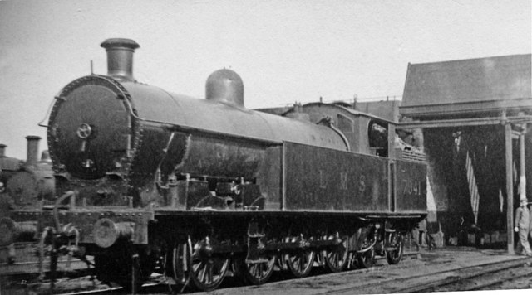 This image was taken by (Brooksbank, 1946)
4

The land was later bought from the British rail by the County Borough in the 1970s, it was also during the 1970s that the area was divided into two; City of Swansea and West Glamorgan.
Further research carried out at Swansea Civic Centre archives, having obtained ordnance survey maps, have resulted in the identification of canister works and a timber yard situated in the vicinity of the proposed site, these findings will also need further consideration going forward.

Civic centre build
As the new restaurant and ice cream parlour would be situated on the same site as the Civic centre, searches in this area would be very beneficial in order to obtain a better understanding of the site exploration and the building materials used in order to complete.
According to Porch, (2011/2012) work started on site in 1979 when piling began for foundations which went down some 18 metres (54 ft) to find the base rock. According to the project architect for Swansea’s Civic centre, Mr Charles Quick had stated that as they did so they went through a layer of peat some two metres thick.
This wasn’t the only time peat has been found in the surrounding area during excavation works for builds. According to Porch (2011/2012) when the foundations for the former gas works were being created, they encountered a layer of peat too. The presence of this peat suggests that within the last 10,000 years (no time at all in geological terms) Swansea was covered by forest. As a result, the trees may have sat in what is called a raised bog and these are found in places where topography is flat, for example; on plains or Valley floors of the kind the City Centre rests on now. It could well be that the forest stretched out across Swansea and out into the Bristol channel.
The Civic centre building was constructed of concrete which was the ideal material for the surroundings and the structure itself. According to Porch (2011/2012) Swansea’s then County Architect J.S. Webb was quoted as saying;

‘Concrete was chosen for a number of reasons brickwork would have been much to domestic for a building of this size and nature and might have given rise to problems of efflorescence so close as we are to the sea. Then there was all important question of sheep which we could not have attained in brickwork, but for which concrete of course was the ideal material. My concept also had in mind the proud style and strength of old Portland stone buildings’.

5

Recommendations
Following on from the preliminary desk top study findings and the historical background of the site, a full on-site investigation is required. To start, it may be suggested that the engineer carries out a visual inspection of the proposed site and surrounding area, looking at any vegetation that could possibly be there which could give an indication of any sub soil to be found. It may also be recommended to investigate any nearby buildings for any potential cracks which in turn could possibly show signs of settlement, this is especially important as the land is close to the sea which could possibly change the moisture content of the soils, causing clays and silts to be softened thus causing settlement.
Following on from the visual inspection and gathering as much information as possible, the next phase would be to make several test bore holes. The purpose of such tests at the proposed site which would allow for collecting of any disturbed and undisturbed soil samples from varying depths to visually check and as such be sent off for further analysis. To proceed with this recommendation, it may be argued to recommend bore holes around the perimeter and from the centre of the site. Depending on how uniform these samples comeback will then depend if further bore holes will be required. The depth of the bore holes should go deep enough to the area that will be affected by the new building construction and that it can be adequately tested for its qualities such as strength and rigidity. Although through the desktop study we know it will roughly be 18m to base rock, it would still also be recommended to obtain at least one bore hole to the base rock, the purpose of which to prove the base rock, as such it would be suggested coring into it to a depth of at least 3m.
Due to the history of the site and the fact that it used to house an engine shed, canister works, a timber yard and bearing in mind it is on the sea front, it is further recommended that as well as bore holes, to excavate a trial pit in order to assess the ground and the ground water in order to ascertain if there are anthropogenic ground and/or contamination from the previous uses of the site.
The bore holes and trial pits are to be carried out in accordance with Standard Rules SR2015 No 36.
As the proposed site is to be proposed to be built over two car parks there is a requirement to look in to how the build will affect the buildings around it and also the effect on the users of the car park and the disruption that may be caused.
The roads leading to the site are very busy throughout the day especially during peak rush hour times, as such, this needs to be taken into consideration when planning deliveries to the site of materials especially if large delivery vehicles are required.

6

Codes of Practice
BS5930:2015 along with the new revised BS EN 1997-1 and BS EN 1997-2. To comply with site investigation, design and construction of the build. Also regarding environmental factors and guidance on geotechnical investigations.
BS 8004:2015. Recommendations for foundations.
SR2015 No 36. Installing and using site investigation bore holes
Once the ground investigation is complete and all the necessary findings have been gathered; the next phase of the site investigation would be to look at the services that will be required for the building itself.
Building services
Plumbing and Heating – To establish where the main cold-water service is running underground in conjunction with the build itself and that whether it can be accessed and connected. Thus, ensuring that it is connected on to a large enough bore of pipe for adequate water flow/pressure and that it does not affect the connected buildings or charges for the connection of the water.
To find out which source of gas is available for heating at the site, i.e; whether it is natural gas, LPG or oil, this information will be needed in order to plan what heating system would be required. If it is natural gas, it will need to be established the depth of the pipe, the pipes size and gas pressure to determine if there is enough to handle extra demand required for the new building. It will also need to be identified as to the costing of installation. Further, to look at renewable energy options such as ground source heat pumps and solar.
Drainage and sewage - To locate the sewage pipes to ensure they are suitable to be added on to for the new building and that there is enough capacity for the added waste/water.
It will also need to be established whether there are separate foul and storm drains or if they are combined. Due to the fact the facility will be serving food and drink there will also be a need to look in to solid waste disposal to ensure where the new building is to be erected that it isn't covering any inspection chambers and that when digging for foundations that any services are not damaged. Again, there is a requirement to find out charges for the connections.

7
Electricity – To locate the existing electrical supply for the site, the voltage available and if it is capable of handling the extra demand required. There is a need to also establish the charges for installation.

For all the above services it is required to find out the names of the supplying authorities and the regulations that need to be adhered to.

Telecommunications – To establish the location of existing phone lines, any requirements that need to be fulfilled according to the telephone agency and the charges for installation.

Foundation
From the preliminary report and investigation, it is suggested the building itself would benefit from the use of pile foundations due to the location of the site, where it is susceptible to high wind conditions and heavy rainfall and the fact that it is on the sea front. By using the pile foundation method, it will prevent settlement of foundations and possible uplift caused by heavy wind. Also due to the fact peat has been found in this area the method of pile foundation will go well below this level for a firm solid structure.

8

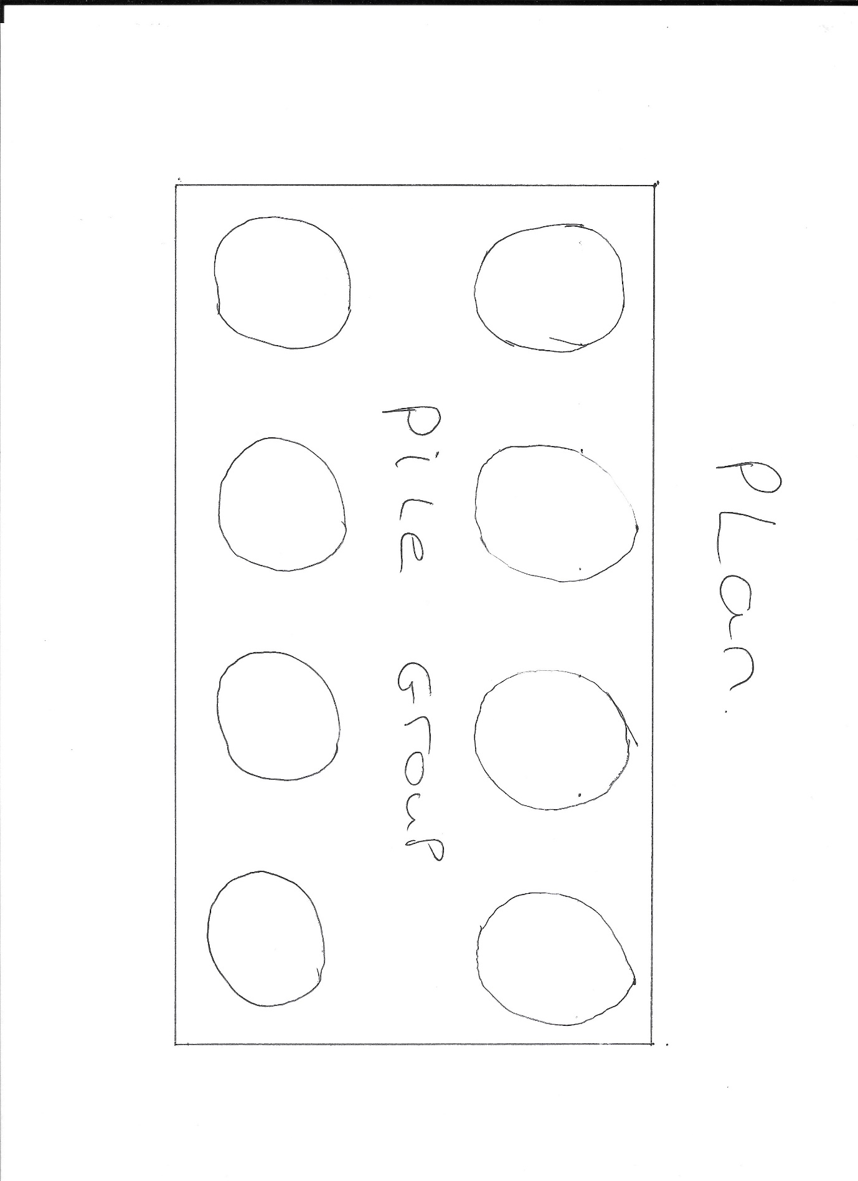

9

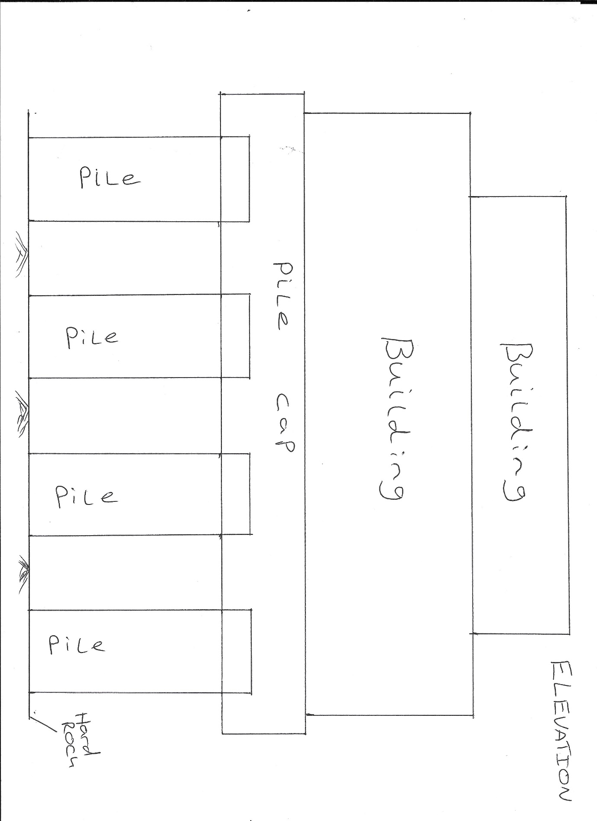

10

References

Brooksbank, B. (2010) Swansea Paxton Street Locomotive Depot: an 0-8-4T. Available at:https://www.geograph.org.uk/photo/2210749 (Accessed on 7 November 2019).
Environment Agency The Environmental Permitting (England and Wales) Regulations 2016 (SR2015 No 36) Available at: https://assets.publishing.service.gov.uk/government/uploads/system/uploads/attachment_data/file/823472/Standard-Rule-2015-No-36.pdf (Accessed on 19 November 2019)
Porch, R. (2011/2012) ‘The Civic Centre/County Hall: an example of seafront Modernism’ The Swansea History Journal, Minerva, 19, pp 20.
Porch, R. (2011/2012) ‘The Civic Centre/County Hall: an example of seafront Modernism’, The Swansea History Journal, Minerva, 19, pp 22.
Porch, R. (2011/2012) ‘The Civic Centre/County Hall: an example of seafront Modernism’ The Swansea History Journal, Minerva, 19, pp 28.
Robins, N. 1994. Eye of the eagle. 1st ed. Tawe history publishing.
Natural Environment Research Council. Available at: http://mapapps.bgs.ac.uk/geologyofbritain/home.html. (Accessed 9 December 2019).

11

