Database and application development
  - The Smile Factory Case Study

ABSTRACT
This report contains the evidence of me creating the Smile Factory database. This database was created by only using SQL code.

By Harry Morris

Table of Contents
Introduction 2
Performance Tuning 2
Distributed Database Solution 5
Conclusion 6
References 6
Bibliography 7

Introduction
The purpose of this document is to show the steps which I took when developing The Smile Factory database. Each section of the database had content based on what I believed a database needed. I used all SQL code to develop the database, this posed challenges during the development process. I will include some screenshots of the SQL code that I have used with the database. This document will also include the some of the improvements that I added in order to improve the performance of the database. I will also include a solution to the distribution problem that The Smile Factory has. A well as a conclusion to conclude this assignment and this document.

Performance Tuning
This section of the document is dedicated to the performance of the database. I will be including my EDR in this section as I believe that a good ERD improves the overall performance of the database. In the database I used three performance tuning techniques these included; CHECK constraints, queries and secondary indexes to improve the performance.
ERD
Before I stated to create the database, I had to plan what I wanted the database to look like. Therefore, I went to Lucidchart to build a ERD that was to my liking. Once I created this, I could then move on to building the tables.
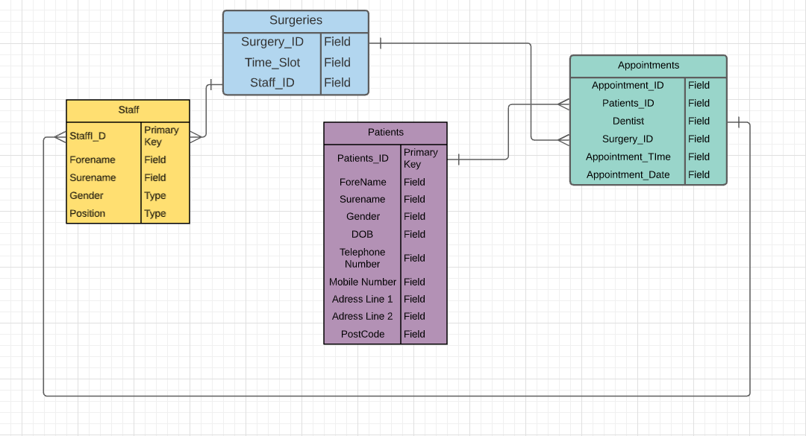
CHECK Constrains
The purpose of the CHECK [1]’ to limit the value range that can be placed in a column’. (direct quote) This was the reason why I used it when I created the tables. In total I used 3 CHECK constrains these includes; gender limiting to only allow male and female to be entered (M or F), a time constraint only allowing people to enter times between 8am and 4pm, the final constraint was used to limited the charters that a user can enter.
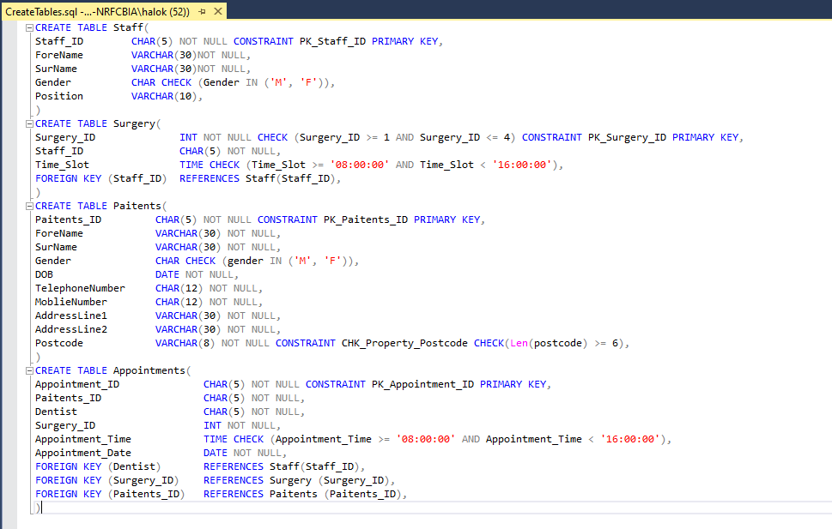
Queries
Another technique I used when developing was queries. In total I created 5 queries all with different purposes. The purpose of adding queries to the database was to [2] ‘pull the information from various tables and assemble it for display in the form or report.’ (direct quote) An example, one of the queries that I created filter out any patients that didn’t have an L or J at the beginning of their first name.
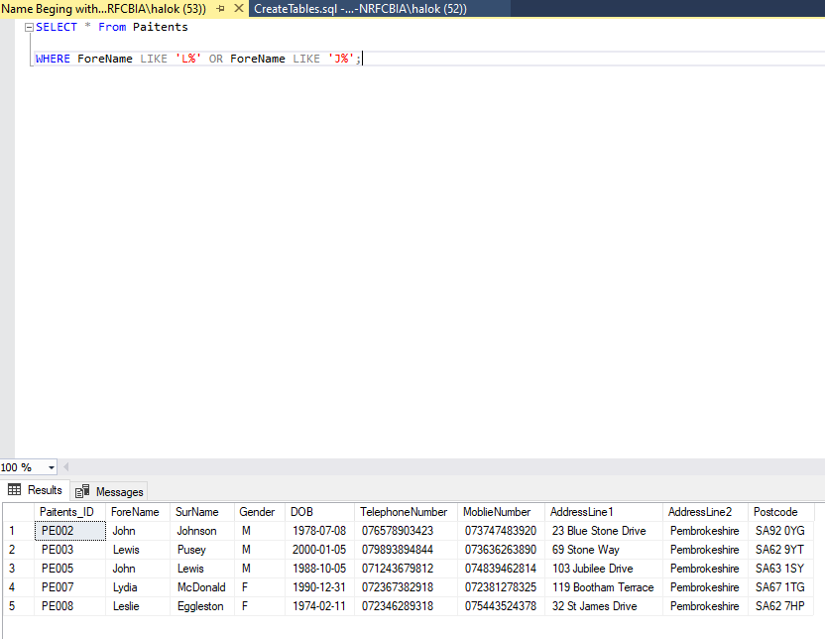
Secondary Indexes
The final performance technique I used was secondary indexing. Indexing is an effective performance technique as it allows user to pull key information quickly. Another benefit of index is that [3] ‘users cannot see the indexes, they are just used to speed up searches/queries.’ (direct quote) In total I used three indexes the screenshot below shows the all the indexes and secondary index.
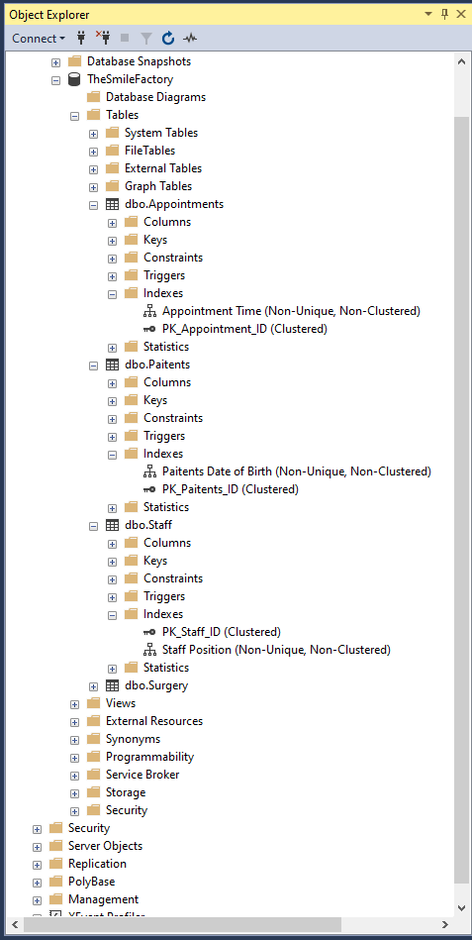

Distributed Database Solution
Fragmentation
Fragmentation is used to divides the tables into smaller chunks, all of the becomes fragments. In total there are three different types of fragmentation and I will be talking about it in this section. Fragments should be done so [4] ‘the original table can be reconstructed from the fragments.’ (direct quote).
Positive
- Once fragmented the data close to the site of usage. This then makes the database more efficient.
- Local queries are optimised as most of the queries are stored locally.
- Another benefit isn’t available at the sites, this also means that the security and the privacy are easily maintained.
Negative
- Depending on the on the type of fragmentation the time it takes to be fragmented can vairy.
- If recursive fragmentation was used to fragment the database then the reconstruction can be expensive.
- A lack of backup copies might make the database ineffective.
Horizontal Fragmentation
When it comes to horizontal fragmentation groups the tuples of a table to the values of the one or more fields within the tables. When it comes to horizontal fragmentation the main rule is that all of the columns of the original database are needed.
Vertical Fragmentation
Vertical fragmentation both the fields or columns of tables are grouped together in fragments. If the user wanted to reconstruct their data then each fragment should contain the primary key fields, because of this vertical can be used to enforce the privacy of data.
Mixed Fragmentation
The mixed or hybrid fragmentation is a combination of both vertical and horizontal techniques. This happens because it creates the fragments by using a small amount of information form the database. But mix fragmentation does come at a cost as the reconstruction of these database tables can be an expensive task.
The One I Have Chosen
Smile Factory asked me to choose a Distributed Database Solution fragmentation. The fragmentation which I chosen is mixed, the reason why I have chosen this is because it uses both methods of fragmentation. Even though it might have some drawback like the cost of recreating tables. I personally believe that all the tables should be fragmented in order to keep the information safe and secure from external threats.

Conclusion
In conclusion, I believe that this assignment went ok. At the beginning I had some issues with sequel server being installed on my PC, I had spent most of this assignment trying to find fixes to allow me to install it. Eventually I did fix the issues and I was able to develop my database using SQL. Even though these issues occurred I still feel like I developed a functional database, however there are some feature left to be desired in order to improve my database as a whole. Things, like customer payment deals and a rollover should have been added into this database but due to the lack of time that I had these feature were not added. If I was to do this assignment again, I would add some more feature to improve the database, I would also manage my time better as I wouldn’t have the installation problem which held me back during the assigned time.

References

[1] | W3school, "SQL CHECK Constraint," W3schools, [Online]. Available: https://www.w3schools.com/sql/sql_check.asp#:~:text=The%20CHECK%20constraint%20is%20used,be%20placed%20in%20a%20column.&text=If%20you%20define%20a%20CHECK%20constraint%20on%20a%20table%20it,other%20columns%20in%20the%20row.. [Accessed 7 February 2021].
[2] | Microsoft, "Introduction to queries," Microsoft, [Online]. Available: https://support.microsoft.com/en-us/office/introduction-to-queries-a9739a09-d3ff-4f36-8ac3-5760249fb65c#:~:text=Queries%20help%20you%20find%20and%20work%20with%20your%20data,-In%20a%20well&text=A%20query%20can%20either%20be,delete%20data%20from%20a%20data. [Accessed 7 February 2021].
[3] | W3schools, "SQL CREATE INDEX Statement," W3schools, [Online]. Available: https://www.w3schools.com/sql/sql_create_index.asp#:~:text=Indexes%20are%20used%20to%20retrieve,indexes%20also%20need%20an%20update).. [Accessed 7 February 2021].
[4] | tutorialspoint, "Distributed DBMS - Design Strategies," tutorialspoint, [Online]. Available: https://www.tutorialspoint.com/distributed_dbms/distributed_dbms_design_strategies.htm. [Accessed 7 February 2021].

Bibliography

[1] | W3school, "SQL CHECK Constraint," W3schools, [Online]. Available: https://www.w3schools.com/sql/sql_check.asp#:~:text=The%20CHECK%20constraint%20is%20used,be%20placed%20in%20a%20column.&text=If%20you%20define%20a%20CHECK%20constraint%20on%20a%20table%20it,other%20columns%20in%20the%20row.. [Accessed 7 February 2021].
[2] | Microsoft, "Introduction to queries," Microsoft, [Online]. Available: https://support.microsoft.com/en-us/office/introduction-to-queries-a9739a09-d3ff-4f36-8ac3-5760249fb65c#:~:text=Queries%20help%20you%20find%20and%20work%20with%20your%20data,-In%20a%20well&text=A%20query%20can%20either%20be,delete%20data%20from%20a%20data. [Accessed 7 February 2021].
[3] | W3schools, "SQL CREATE INDEX Statement," W3schools, [Online]. Available: https://www.w3schools.com/sql/sql_create_index.asp#:~:text=Indexes%20are%20used%20to%20retrieve,indexes%20also%20need%20an%20update).. [Accessed 7 February 2021].
[4] | tutorialspoint, "Distributed DBMS - Design Strategies," tutorialspoint, [Online]. Available: https://www.tutorialspoint.com/distributed_dbms/distributed_dbms_design_strategies.htm. [Accessed 7 February 2021].

