Financial Management for the Hotel Industry

Contents
Introduction 3
Task 1: Prepared Budget for Grand Hotel 4
Task 2: Report for Budgeting for Grand Hotel 5
Analysis of Prepared Budget 5
Importance of Budgeting in a Business 6
Four Types of Budgeting Techniques 7
Significance of Budgetary Control for Sustainability 9
Conclusion 10
Reference 11
Appendix 12

Introduction
Budgeting is key part of any firm’s financial management. Companies prepare budget so that they may keep tabs on spending and stick to a budget, establishing a budget helps with timely bill payment, saving for unexpected costs, and other large purchases. In this report an annual budget is prepared for Grand Hotel situated in London. The report will also discus and analysis different budgeting techniques.

Task 1: Prepared Budget for Grand Hotel
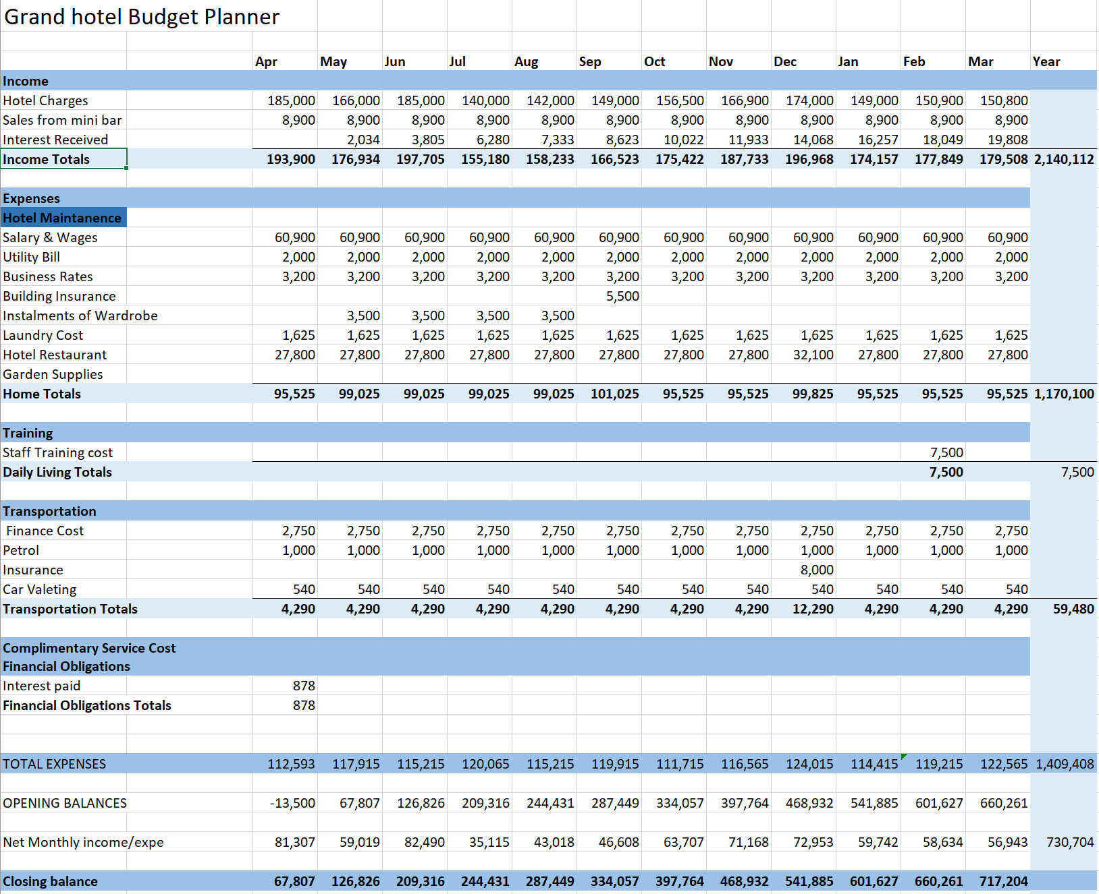
Figure 1: Budget for Grand Hotel of London for the year 2022-23. Source: Self-created

Task 2: Report for Budgeting for Grand Hotel

Analysis of Prepared Budget
The budget is prepared for Grand Hotel is mainly cash-budget on monthly basis from April of 2022 to March of 2023. As the budget is prepared based on the previous experience of the hotel management and its future prediction, the budget is prepared by using incremental technique.
The projected income from hotel reservations varies across the months, with the first three months bringing in an average of £178,667, which is much greater than the income from the final nine months, which was just £153,233. Another significant source of income comes from the sales made at the small bar, which total around £8,900 every single month. According to the projection, the revenues generated by the hotel are sufficient to pay all of its operating expenditures.
The hotel's primary ongoing expense is the payment of employee salaries, which come to a total of £60,900 each month when overtime is taken into account. Although other costs are predicted at a set rate, actual costs may vary depending on how they are used. As a result of the fact that some costs, such as insurance premiums, magazine subscriptions, and in-room beverages, are incurred on a yearly, quarterly, or bi-monthly basis, rather than every single month, cash flow would be negatively affected. This results in a fluctuation in the overall cost from one month to the next.
Due to the fact that the hotel had a credit balance in the bank during the month of April that came before it, the interest charge was only levied in the first month. After then, the hotel began to earn a percentage of the bank's interest income depending on the amount that was left in the account at the end of each preceding month.
The budgeted net annual revenue of the hotel during 2022-23 period is £730,704 and the closing cash balance for the hotel is £717,204. The hotel management must adjust and take controlling measures to achieve this budgeted figure if any deviation occurs.

Importance of Budgeting in a Business
For financial stability over a certain time frame, it is necessary to create and stick to a spending plan; this is what is meant by "budgeting." The ability to plan and stick to a budget is crucial for successfully completing tasks and reaching one's objectives (Heisinger and Hoyle, 2022). No matter how basic the budget, it always boils down to an estimate of income and expenses for a certain time frame. To avoid going into the red, it is important to reduce planned expenses from planned profits before devoting any leftover funds to future endeavours. The accuracy of future projections might be clarified by looking at how past budgets stacked up against actual financial allocation and performance.
Controlling Spending: Without proper budget management may find it difficult to set the amount of spending necessary to achieve certain amount of income or to avoid overspending. Budget sets the limit how much management can spend or if the management overspend, it can identify the area where it can take controlling measure (Martin, 2018).
Preparation for Emergency: To prepare for the unforeseen is essential. Having a budget in place can prevent the hotel from having to take money from one area of business to cover the costs of another in the case of an unexpected incident.
Setting Internal Goals: In addition to allocating funds for the next accounting period, budgeting also involves forecasting revenue needs to ensure the achievement of organizational objectives. Using a budget, management can establish financial targets for the entire organization or for specific teams (Chadwick, 2017). This is most noticeable with activity-based budgeting, although it helps regardless of the hotel's spending methodology.
Prioritizing Projects: Prioritizing projects and activities is an inevitable result of creating a budget. Investment returns, alignment with business values, and impact on financial goals should all be considered when determining the order of priority for projects. Hotels could benefit from the value proposition budgeting approach, which encourages managers to define and justify the worth of each budget line item in order to better prioritize tasks and large-scale initiatives.

Four Types of Budgeting Techniques
Incremental budgeting
When using incremental budgeting, one takes the actual figures from the prior year and either add to them or subtract a certain percentage in order to arrive at your budget for the current year. This budgeting technique is the most common since it is simple and clear to use. Incremental budgeting may be helpful if firm’s primary spending drivers are stable from year to year (Brewer, 2018). This method is most effective for well-established hotels that have both financial data and customer feedback to provide. It's perfect for companies who wish to increase the worth of their departments, streamline their budgeting procedures, and meet their predictable and constant monetary needs.
But with incremental budgeting, the current budget is based on the totals from the preceding year; hence, if a department uses up all of its assigned cash from the previous year, the company would give additional money to that department even if it doesn't truly need it. There is a possibility that this may result in additional costs. When developing a budget on an incremental basis, you run the risk of ignoring factors that are beyond your control, such as fluctuations in the market and inflation.
Activity-based budgeting
When an organization employs activity-based budgeting, the quantity of inputs that are needed to support the goals or outputs that were stated by the organization are determined using a top-down approach. The leadership of the company has to figure out first what needs to be done in order to attain the sales target, and then they need to evaluate the expenses associated with making that objective a reality. Businesses that are going through significant changes and have substantial budgets and income streams, in addition to new businesses that are trying to get off to a good start, are both good candidates for the services offered by ABB (Hansen and Mowen, 2019).
If the Grand Hotel uses ABB, it might be more expensive and time-consuming to implement than more standard budgeting strategies. For the company to know what it does and how much it costs, it needs an analytical group. After that, they must provide each department a fair share of the total budget.
Zero-based budgeting
The assumption that all departmental budgets start out at zero and have to be generated from scratch makes zero-based budgeting unique methodology. The management of the corporation requires a reason for every single dollar that is spent. In a budget that is based on zero, there is very little wiggle space, and the primary objective is to spend just what is required to keep the company operating at a profit (Mowen, 2022). The bottom-up budgeting method is an effective instrument for "shifting things up." Companies of any size might stand to gain from using zero-based budgeting since it enables them to concentrate their efforts on a select group of important goals for the next financial year.
But it takes a lot of time because of the constant requirement to review and revise budgets. That's why most businesses only resort to this strategy infrequently.
Value proposition budgeting
The value proposition strategy is an alternative to traditional budgeting that combines the best features of zero-based and incremental methods. Each purchase is evaluated to see whether it contributes to the overall savings goal. Every expense in a budget with a value proposition is picked out with one goal in mind: growing the business. Value proposition budgeting aims to save costs by repurposing resources rather than wasting them, but it is not as laser-focused on that objective as our previous budgeting technique, zero-based budgeting (Platt and W. Hilton, 2018). This kind of financial planning is useful for businesses that wish to save money without resorting to zero-based budgeting.
However, value is not something that can be easily put into price tags. If the management don't know what the product or service worth, management more likely to make hasty choices that set you back from your goals. The social, political, economic, and technical contexts in which things are valued also have a role in how and when those values shift through time.
After analysis four major budgeting methods, if Grand Hotel wants to maintain an easy-to-use budgeting technique, then it should follow incremental method. However, if the hotel management wants to justify its expenses according to its perceived value, then the firm should follow value proposition model. It will ensure that the hotel is allotting its resources based on the value the expense will provide.

Significance of Budgetary Control for Sustainability
Budgetary control is a cost-management strategy that involves setting financial goals, allocating resources, monitoring performance, and responding to variances in order to maximize profits. When it comes to managing money for sustainable growth and prosperity, budgeting is crucial. Budgeting also helps keep the company's money and resources working as efficiently as possible. A solid budgeting system should have mechanisms for both planning and controlling, as well as coordinating, for maximum efficiency. In any case, the time spent planning and controlling are lost if they aren't coordinated well. The budgetary control system identifies potential information sources for use in developing economic and financial strategies (Alexander, 2020). Finally, financial control provides an explanation of budgets and performance measures as communication tools, allowing for proactive thinking beyond traditional planning.
As the budgetary control focuses on efficient use of resources so that the firm can use the resource for long-time, it is the key tool for a company’s sustainability strategy. To ensuring that limited resources are preserved for future generations is central to the concept of sustainability in economics and public policy. With budgetary control a business tries to prevent any unnecessary loss of resources without hampering business profitability (Brewer, 2018). Therefore, sustainability of both businesses and our environment requires budgetary control to be effectively implemented in every business organisation.

Conclusion
Hotel or even for any type of business budgeting is a must tool to be used to maintain financial control over the organisation. Budgeting empowers the management to set the parameters for the employees to maintain in the organisation and also take corrective measures if any parameter is not maintained. This ensures efficiency in the business organisation and leads sustainable growth for the business.

Reference
Alexander, J., 2020. Financial Planning & Analysis and Performance Management. Hoboken, New Jersey: Wiley.
Brewer, P., 2018. Introduction to managerial accounting. New York: McGraw-Hill/Irwin.
Chadwick, L., 2017. Essential management accounting for managers. Harlow, England: Financial Times/Pearson Education.
Hansen, D. and Mowen, M., 2019. Management accounting. Mason, Ohio: South-Western.
Heisinger, K. and Hoyle, J., 2022. Managerial Accounting. Washington, DC: Saylor Academy.
Martin, V., 2018. Accounting for managers. New York: American Management Association, Extension Institute.
MOWEN, M., 2022. MANAGERIAL ACCOUNTING. Boston: CENGAGE LEARNING.
Platt, D. and W. Hilton, R., 2018. ISE MANAGERIAL ACCOUNTING. New York: MCGRAW-HILL EDUCATION.
S. Warren, C., M. Reeve, J. and Duchac, J., 2022. Financial & Managerial Accounting. Boston: Cengage Learning,.

Appendix


