

Utilizing Web and Mobile Applications for Language Acquisition
by
Saeed Mohamed

Supervisor: Tim Bashford

Project submitted as part of the requirements for the award of UNIVERSITY OF WALES -TRINITY SAINT DAVID.

MSc software engineering (web development)
February 2023

Declaration.
I affirm that this work is solely my own, and I have duly acknowledged and referenced all information obtained from external sources. This dissertation is presented as part of the fulfilment for the master’s in software engineering with a focus on web development at the University of Wales Trinity Saint David.

Supervisor- Tim Bashford

Signed- Saeed Mohamed 05/02/24.

Abstract.

This report encompasses the evolution of the Internet and the World Wide Web (WWW). It delves into the progression of language learning, exploring its theories and their evolution over time. Additionally, the report presents a thorough review of a conducted study, examining the influence and impact of mobile and web applications, as well as technology in general, on language learning.

Furthermore, the report scrutinizes existing web and mobile language learning applications, categorizing them based on their functionalities. A significant portion of the report is dedicated to the assessment of a prototype designed to facilitate Arabic alphabet learning for students. It elaborates on the software design and utilizes rapid application development as the chosen methodology for prototype development.

Towards the conclusion, the report provides an evaluation of the prototype, highlighting discovered limitations, and offers suggestions for future enhancements. A conclusive segment summarizes the overall progress of the research project, explores future directions for language learning theories, and discusses their impact on the development of web and mobile applications tailored for language learning purposes.

Acknowledgment

I extend my sincere gratitude and thanks to Allah (God) for bestowing upon me the ability, motivation, and guidance to embark on and complete this research project and the associated degree. My heartfelt appreciation goes to my mother and family, whose upbringing, care, support, and motivation instilled in me a deep love for education and a commitment to pursuing it to the highest degree possible.
I am profoundly thankful to the DVLA for granting me the opportunity to participate in this remarkable apprenticeship. Their exceptional support and guidance went above and beyond, enabling me to conduct and complete this research project successfully.
Lastly, I express my appreciation to Tim and other lecturers who have provided invaluable assistance and support when needed throughout my academic journey at the university.

Table of contents.
Table of Contents
Declaration. 2
Abstract. 3
Acknowledgment 4
Table of contents. 5
Introduction 7
Motivation 8
Aims: 10
Objectives: 10
The review of literature 11
Connection between culture and speech 13
Theoretical frameworks for language learning 16
Current existing learning languages application. 19
Education application. 21
Software methodology 28
RAD- Rapid application development. 29
Key features of RAD include: 30
Arabic 2 u application. 32
(Home page) 32
Stage 1– The learning pages. 34
stage -2 35
Stage 3 36
Quiz page 38
result page. 44
Research. 50
Evaluation. 55
Limitations: 55
Future Directions: 55
Conclusion. 56
Code and work. 57
References. 81

Introduction

Communication, a fundamental life skill, has been a pivotal factor in the survival and continuity of humanity throughout history. It serves as a means for expressing emotions, sharing ideas, and connecting with others. Given the innate human inclination for socialization, various methods, including visual and verbal exchanges, facilitate communication (Corporate Finance Institute, 2024).

Among these forms, verbal communication stands out as the most intricate, involving the use of languages. The ability to speak and learn multiple languages is considered a profound sign within the Muslim faith, as stated in the Quran (30:22), emphasizing the diversity of languages as a divine manifestation.

Communication's positive impact extends across various life domains such as work, education, social interactions, and entertainment. Effective communication, for instance, significantly contributes to organizational success in the workplace, as evidenced by Owen Hargie's research, which highlights increased productivity, improved service and product quality, enhanced trust, engagement, and creativity, among other benefits (Hargie, 2016).

Recognizing the pivotal role of language in communication, parents and guardians play a crucial role in teaching their children their mother tongue and other languages. Educational institutions further emphasize the importance of acquiring language skills, including universal languages like English and regional languages. In this context, modern technology, specifically the World Wide Web and mobile applications, has revolutionized access to a vast array of educational resources. Language learning applications offer opportunities for individuals to learn, practice, and apply language skills effectively (Rosell-Aguilar, 2018).

This research project aims to review and evaluate language learning applications, exploring their impact on language acquisition. Additionally, the project endeavours to develop a prototype specifically designed to teach the Arabic alphabet, contributing to the broader landscape of language learning applications.

Motivation

The impetus behind undertaking this research project is deeply rooted in my fervour for language learning, particularly my decade-long dedication to mastering the Arabic language. Throughout these years, my exploration has extended into the intricacies of Arabic grammar, morphology, eloquence, and literature. The more I delve into the complexities of the Arabic language, the more my admiration for it grows. Complementing my personal studies, I have voluntarily taken on the role of teaching Arabic during evenings and weekends for the past five years.

The teaching experience has emerged as a primary motivating factor for this research. Observing the struggles of students learning to read the Arabic alphabet and witnessing their challenges in retention has fuelled my quest for effective teaching methods. Through experimentation, I discovered that a combination of repetition and quizzes proved highly beneficial in helping students memorize the alphabet. Inspired by these insights, I envisioned creating a prototype that allows students to click on each letter, listen to its pronunciation as many times as needed, and engage in quizzes to reinforce their knowledge.

Recognizing the potential impact of such a tool, I envision its broader utility beyond the confines of my teaching sessions. Providing students with access to this prototype outside of regular lessons has the potential to significantly enhance their comprehension and proficiency in reading, memorizing, and recalling the Arabic alphabet. This project is fuelled by the belief that leveraging technology in language learning can empower students to independently reinforce their language skills, contributing to a more effective and accessible educational experience.

Aims:

The primary aim of this project is to develop a prototype that assists students in mastering the Arabic alphabet, particularly targeting those who encounter challenges in this aspect of language learning. In pursuit of this goal, the research will delve into various facets, including language learning theories, the evolution of the internet, and the utilization of mobile and web applications for language learning. Additionally, the project aims to assess the impact of web and mobile applications on enhancing language education, while also undertaking a comprehensive review of existing mobile language learning applications.

Objectives:

To achieve the overarching aim, the specific objectives of this research project are as follows:

1. Conduct a thorough and critical review of academic literature related to:
a. The evolution of the Internet.
b. Language learning theories and their advancements.
c. The use of web applications in language learning and their impact.
d. Existing language learning apps in the current market.

2. Design and develop a prototype specifically tailored to aid students in mastering the Arabic alphabet. This involves incorporating features that facilitate effective learning through methods such as repetition and quizzes.

3. Conclude the research by synthesizing and evaluating the gathered findings. This includes assessing the impact of web and mobile applications on language learning, critically analysing the effectiveness of the prototype, and drawing insightful conclusions from the research outcomes.

The review of literature

The Internet is a vast global network of interconnected computers and devices that facilitates communication, information sharing, and collaboration across geographical distances. It is a decentralized network, meaning that there is no central authority governing its operation. Instead, it comprises a multitude of interconnected networks, including private, public, academic, government, and commercial networks.

At its core, the Internet operates on a set of standardized protocols, such as TCP/IP (Transmission Control Protocol/Internet Protocol), which enable devices to communicate with each other. These protocols define the rules and conventions for data transmission, routing, and addressing, ensuring that information can be exchanged reliably and efficiently.

The Internet enables a wide range of services and activities, including:

1. Communication: The Internet provides various communication tools, such as email, instant messaging, voice and video calls, and social media platforms, allowing individuals to connect and interact with others around the world in real-time.

2. Information Sharing: The Internet serves as a vast repository of information, encompassing websites, online databases, digital libraries, and multimedia content. Users can access a wealth of information on virtually any topic, ranging from news and entertainment to academic research and educational resources.

3. E-Commerce: The Internet has revolutionized commerce by enabling online shopping, electronic payments, and digital transactions. E-commerce platforms allow businesses to sell products and services to customers globally, facilitating convenient and secure transactions.

4. Entertainment: The Internet offers a multitude of entertainment options, including streaming services for music, movies, TV shows, and video games. Users can access a diverse range of entertainment content anytime, anywhere, using various devices.

5. Collaboration and Productivity: The Internet facilitates collaboration and productivity through tools such as cloud computing, online project management platforms, and collaborative document editing software. These tools enable individuals and teams to work together remotely, share resources, and coordinate tasks effectively.

Overall, the Internet has become an indispensable tool for communication, commerce, education, entertainment, and countless other activities, shaping the way we live, work, and interact in the digital age. Its widespread adoption and accessibility have transformed society, economy, and culture on a global scale.

Connection between culture and speech

The connection between language and culture is deeply intertwined, with each influencing the other in significant ways. Language serves as a means of expressing and sharing cultural values, beliefs, and traditions.

Culture is embedded within language through vocabulary, phrases, and grammar structures that reflect the collective identity and experiences of a community. For example, languages often contain words or expressions that capture cultural concepts or customs unique to a particular society.

Conversely, culture influences language usage, shaping linguistic norms, polite expressions, and communication styles. Social structures, gender roles, and societal expectations are often reflected in language conventions and interactions.

The interplay between language and culture extends beyond communication to impact how individuals perceive and understand the world around them. Different languages may shape thought patterns and perspectives, influencing how people interpret their surroundings.

Language also serves as a marker of cultural identity, connecting individuals to their heritage and community. Preserving indigenous languages, for example, is crucial for maintaining cultural heritage and identity.

In summary, the relationship between language and culture is complex and multifaceted, shaping individual and collective identities, communication patterns, and societal norms. Understanding this relationship is vital for fostering cross-cultural understanding and appreciation.

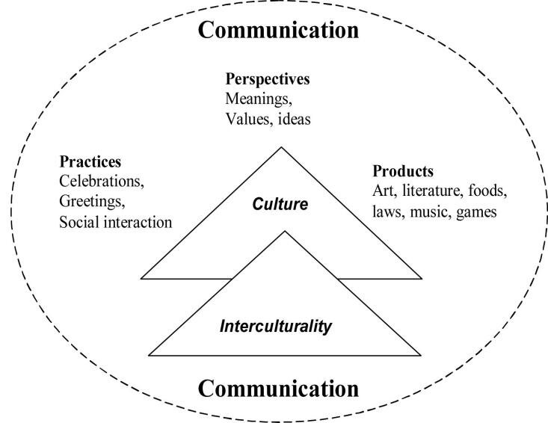

One simplified model illustrating the links between language and culture is the "Language-Culture Connection" model. This model outlines how language and culture are closely intertwined through several key aspects:

1. Expression: Language is a primary way people express cultural values and beliefs. Through words, phrases, and sentence structures, individuals convey cultural ideas and customs in their communication.

2. Cultural Influence: Culture shapes the content and context of language. Cultural practices and traditions influence the topics and themes discussed in language use, as well as the symbols and expressions employed.

3. Social Variation: Different social factors, such as social class, ethnicity, and age, affect language use within specific cultural groups. These variations, such as accents or dialects, reflect cultural identities and social affiliations.

4. Understanding Differences: Cultural competence involves being aware of and respecting cultural differences in language and communication styles. It's important for effective communication across cultures.

5. Cross-Cultural Communication: When people from different cultures interact, understanding cultural norms and linguistic cues is crucial for successful communication. By recognizing the connection between language and culture, individuals can navigate cultural diversity more effectively.

This simplified model emphasizes how language and culture are interconnected and influence each other in various social and communicative contexts.
Each of these five focal points possesses unique and defining characteristics. Communication serves as the foundational cornerstone and primary goal of language learning. When acquiring a foreign language, understanding it within its cultural context and comparing it to one's native language promotes an open-minded perspective and enhances tolerance towards diverse cultures. Additionally, learners gain insights into the intricate connections between their native language and the foreign language.
Connection provides learners with varied perspectives on the foreign language, offering access to diverse details and insights. Comparison facilitates a deeper understanding of the language's components and cultural nuances by drawing parallels between the foreign language and the learner's native tongue.

Community fosters an atmosphere conducive to language practice in a global environment beyond the classroom setting. By immersing themselves in an international community, learners engage with the language authentically and refine their skills in real-world contexts (Chen and Yang, 2014).

Theoretical frameworks for language learning

Theoretical perspectives on language learning encompass various frameworks aimed at comprehending the cognitive, social, and psychological processes involved in acquiring a new language. These perspectives offer insights into how learners develop linguistic proficiency and competence over time.

One notable theoretical viewpoint is the Behaviourist approach, which emphasizes the importance of environmental stimuli and reinforcement in language acquisition. According to behaviourist theory, language learning occurs through imitation, repetition, and conditioning, with learners acquiring language through exposure to linguistic input and positive reinforcement for correct responses.

In contrast, the Innatist approach, proposed by linguist Noam Chomsky, suggests that humans have an inherent biological predisposition to language acquisition through innate cognitive mechanisms. Chomsky's Universal Grammar theory posits that humans are born with an innate linguistic capacity, allowing them to internalize the grammatical rules and structures of language through exposure to linguistic input.

Another influential theoretical perspective is the Sociocultural approach, advocated by psychologist Lev Vygotsky, which underscores the role of social and cultural context in language learning. According to this approach, language development is shaped by social interactions and cultural practices, with learners acquiring language through collaborative activities, scaffolding, and participation in meaningful communication within their social environment.

Moreover, the Cognitive approach highlights the significance of cognitive processes such as memory, attention, and problem-solving in language acquisition. This perspective views language learning as a cognitive skill involving the processing and manipulation of linguistic information in the mind, with learners actively engaging in cognitive tasks to understand and produce language.

Additionally, the Interactionist approach integrates elements of behaviourism, innatism, sociocultural theory, and cognitive psychology to elucidate language learning as a dynamic and multifaceted process. Interactionist theorists emphasize the importance of both individual cognitive processes and social interactions in language development, emphasizing the reciprocal relationship between internal cognitive mechanisms and external environmental factors in shaping language acquisition.

In summary, theoretical perspectives on language learning provide diverse insights into how learners acquire language and develop linguistic competence. By examining the cognitive, social, and psychological aspects of language acquisition, these theoretical frameworks contribute to our understanding of the complex processes involved in learning a new language.

In recent years, researchers specializing in this field have identified several modern theoretical approaches to language learning. These include:

1. Universal Grammar
2. Autonomous Induction
3. Associative-Cognitive CREED
4. Skill Acquisition
5. Input Processing
6. Processability
7. Concept-Oriented Approach
8. Interaction Framework
9. Vygotskian Sociocultural Theory

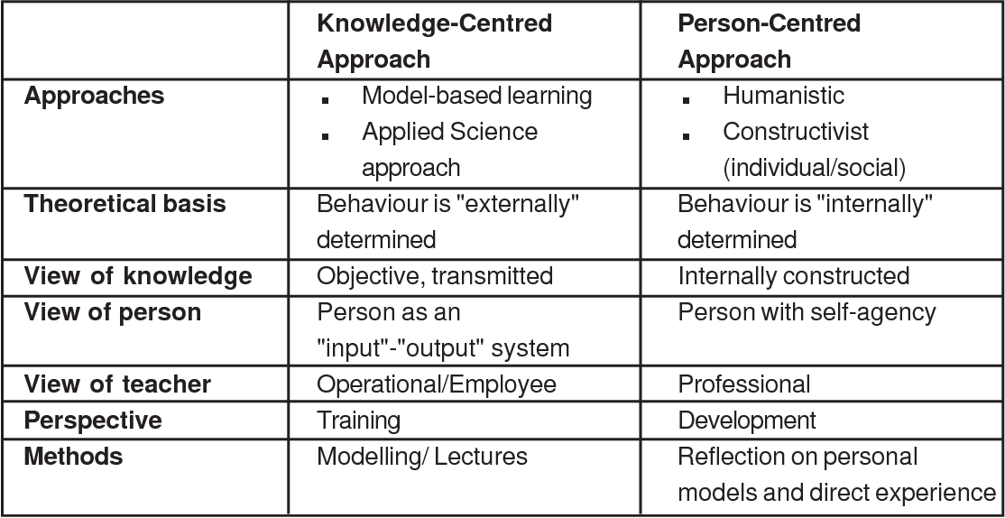
These theoretical perspectives offer diverse insights into language acquisition and contribute significantly to our understanding of the cognitive, social, and psychological aspects involved in learning a new language (VanPatten and Williams, 2008; Moeller and Theresa Catalano, 2015).

Current existing learning languages application.
"Review of Existing Language Learning Applications" entails examining and analysing the current landscape of language learning apps available in the market. This process involves assessing various aspects of these applications, such as their features, effectiveness, user interface, content quality, and suitability for different language learners. The aim is to provide an overview of the strengths and weaknesses of these apps, as well as to identify any gaps or areas for improvement in the existing offerings.
The use of language learning in mobile applications simply refers to how language learning methods and materials are incorporated into apps designed for smartphones or tablets. These apps allow users to learn languages conveniently on their mobile devices, offering features like lessons, vocabulary exercises, and interactive activities. They make language learning easier and more accessible, allowing users to practice wherever and whenever they want. These apps often include fun features to keep users engaged and motivated as they learn. Overall, they've made language learning more convenient and enjoyable for many people.
I selected this paper for a couple of reasons. Firstly, it offers an exhaustive examination of the language learning apps currently available in the market, providing valuable insights into which applications are best suited for different types of users. Secondly, I was drawn to this paper because of the limited amount of research conducted on this specific topic with such thoroughness and attention to detail.
Classification of Mobile Applications" involves organizing mobile apps into distinct categories or groups based on their characteristics, features, or intended use. This categorization helps users navigate through the vast array of available apps more effectively by grouping similar apps together.
- For example, common categories for mobile apps include:
- Productivity: Apps designed to help users manage tasks, organize schedules, or enhance productivity.
- Entertainment: Apps for streaming music, movies, or games, providing entertainment and leisure activities.
- Social Networking: Apps that facilitate communication and interaction with others, such as social media platforms.
- Education: Apps focused on learning and skill development, including language learning, academic courses, or educational games.
- Lifestyle: Apps catering to various aspects of daily life, such as fitness tracking, cooking, or personal finance management.
- Utilities: Apps offering tools and functionalities to assist with specific tasks, like weather forecasting, file management, or device optimization.
- Additionally, apps can be classified based on their platform (iOS, Android, etc.), pricing model (free, freemium, paid), or target audience (children, professionals, seniors).
By classifying mobile apps, users can easily browse and discover new apps within categories that align with their interests or needs. Developers also benefit from this classification as it helps them understand market trends and user preferences, enabling them to create apps that cater to specific demographics or niches.

Education application.
Education apps are designed to facilitate learning and skill development across various subjects and age groups. These apps offer a wide range of educational content and tools, making learning more interactive, accessible, and engaging. Here are some key features and examples of education apps:

1. Learning Materials: Education apps provide access to a diverse range of learning materials, including textbooks, videos, interactive lessons, quizzes, and assessments. These resources cover various subjects such as math, science, languages, history, and more.

2. Personalized Learning: Many education apps offer personalized learning experiences tailored to individual preferences, learning styles, and skill levels. They use algorithms and user data to provide customized recommendations, adaptive learning paths, and targeted practice exercises.

3. Gamification: To make learning more fun and motivating, education apps often incorporate gamification elements such as points, badges, levels, and rewards. Gamified activities encourage users to stay engaged, track their progress, and strive for mastery.

4. Interactive Features: Education apps leverage interactive features like simulations, virtual labs, multimedia presentations, and augmented reality to enhance understanding and retention of complex concepts. These interactive experiences allow users to explore, experiment, and learn in immersive ways.

5. Collaboration and Communication: Some education apps facilitate collaboration and communication among students, teachers, and peers. They offer features like discussion forums, group projects, live chat, and video conferencing to foster collaboration, peer-to-peer learning, and social interaction.

Examples of education apps include:

- Duolingo: A language learning app that offers interactive lessons, quizzes, and games to help users learn languages like English, Spanish, French, and more.
- Khan Academy: An online learning platform offering educational videos, practice exercises, and personalized learning journeys across subjects like math, science, economics, and humanities.
- Quizlet: A study tool that enables users to create, share, and study digital flashcards, quizzes, and games on various topics and subjects.
- Photomath: A math learning app that allows users to scan math problems with their camera and receive step-by-step solutions, explanations, and interactive graphs.
- Google Classroom: A virtual classroom platform that enables teachers to create and distribute assignments, manage coursework, and communicate with students online.

Overall, education apps play a crucial role in supplementing traditional learning methods, providing learners with flexible, interactive, and accessible resources to support their educational goals.

During my research, I discovered that educational mobile applications are typically categorized into three main groups: primary, secondary, and tertiary. Each category has a different approach to learning, tailored to the age and educational level of the users.

- Primary education apps: These are designed for young learners in elementary or primary school. They focus on foundational skills in subjects like math, science, language arts, and social studies. These apps often use colorful graphics, interactive activities, and simple language to engage young children and make learning fun and accessible.

- Secondary education apps: These target students in middle school and high school. They offer more advanced content and activities that align with the curriculum for these grade levels. Secondary education apps may include interactive lessons, practice quizzes, study tools, and resources for exam preparation.

- Tertiary education apps: These are geared towards college or university students and adult learners. They provide content and resources for higher-level courses and specialized subjects. Tertiary education apps may include lecture videos, reading materials, research tools, and collaboration platforms for academic projects.

Overall, each category of educational mobile apps is tailored to meet the specific learning needs and objectives of students at different stages of their academic journey.

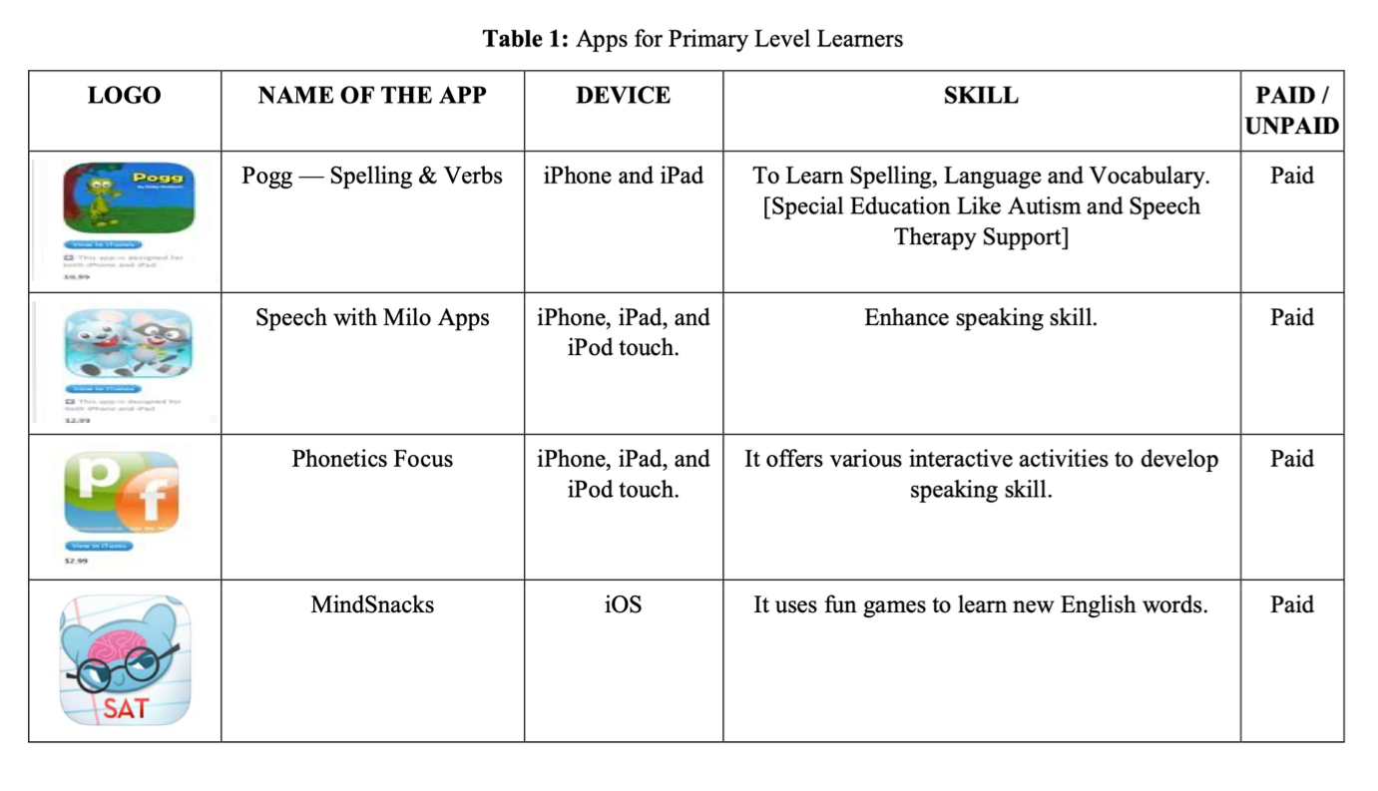
(Primary stage)
Mobile apps made for primary school students aim to provide fun and educational content suited to their age group and learning level. These apps cover subjects like math, science, language arts, and social studies, offering interactive lessons, games, quizzes, and stories to engage young learners. They use colourful visuals, animations, and simple language to make learning enjoyable and easy to understand. These apps help kids learn while having fun, supporting their academic development in a playful way.

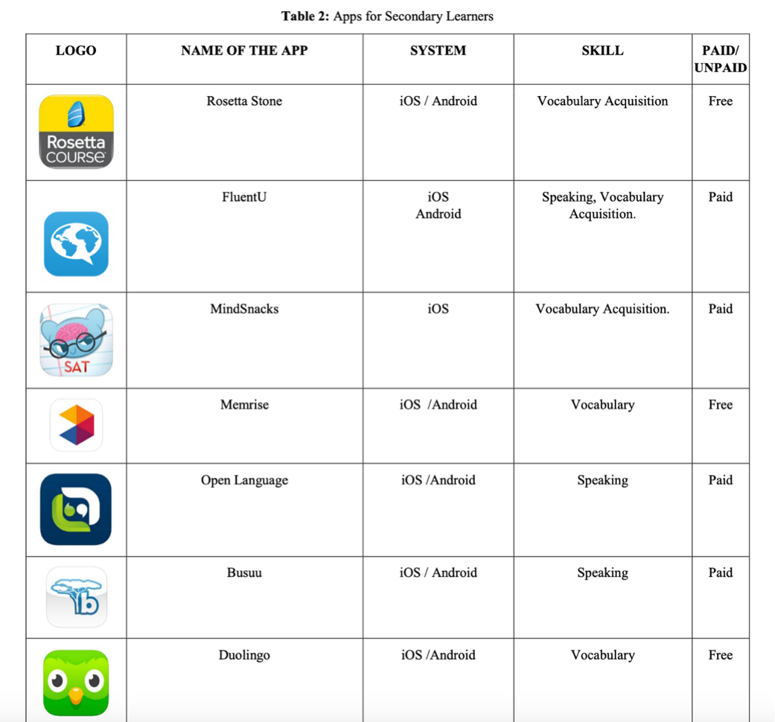
(Secondary mobile education)

Mobile applications in secondary education are designed to support students in middle school and high school by providing educational resources, tools, and assistance with their coursework. These apps cater to the unique needs of secondary students and offer a variety of features to enhance learning experiences. Here are some common elements found in mobile applications for secondary education:

1. Study Tools: Secondary education apps often include study tools such as flashcards, quizzes, and practice tests to help students review and reinforce their knowledge in various subjects.
2. Homework Help: Many apps offer homework help by providing explanations, solutions, and examples for textbook problems and assignments across different subjects.
3. Subject-specific Resources: Apps may provide subject-specific resources such as interactive lessons, videos, tutorials, and reference materials to support learning in subjects like math, science, language arts, and social studies.
4. Exam Preparation: Secondary education apps may offer resources and strategies for exam preparation, including tips for studying, time management, and test-taking strategies for standardized tests like SAT, ACT, and AP exams.
5. Collaboration and Communication: Some apps facilitate collaboration and communication among students and teachers, allowing for group discussions, project sharing, and feedback on assignments.
6. Progress Tracking: Many apps include features for tracking student progress, such as gradebooks, performance analytics, and personalized learning paths to monitor and improve academic performance.
Overall, mobile applications in secondary education aim to supplement classroom learning, provide additional support outside of school hours, and empower students to succeed academically in middle and high school.

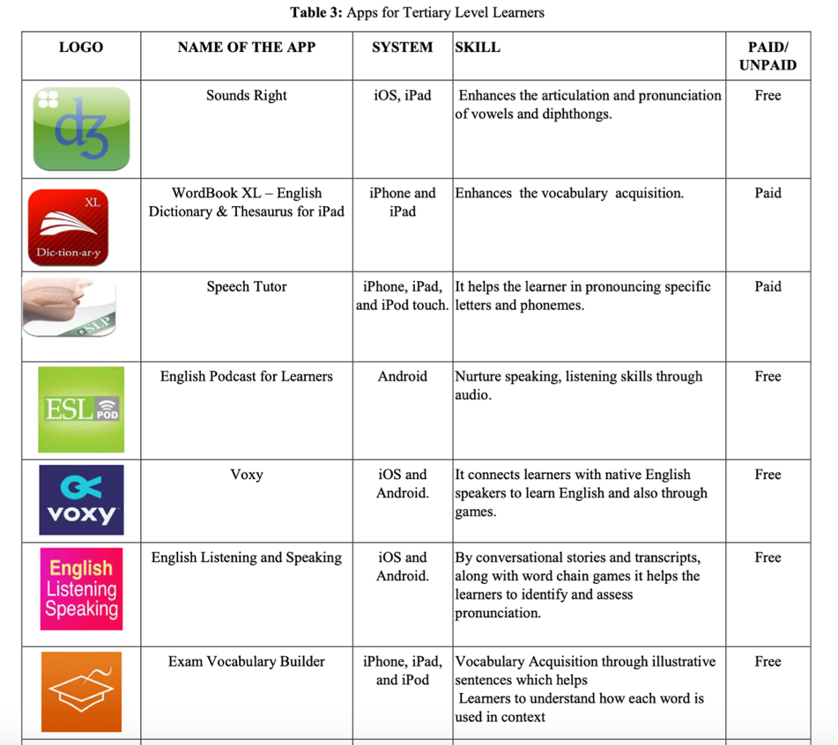
(Tertiary education application)
Mobile education apps for tertiary learners are designed to support college and university students in their academic pursuits. These apps offer a range of features to assist tertiary learners in their studies, research, and overall academic experience. Here are some common elements found in mobile education apps for tertiary learners:

1. Lecture Materials: Apps may provide access to lecture notes, slides, recordings, and other course materials to help students review and supplement their learning outside of the classroom.
2. Study Aids: Tertiary education apps often include study aids such as flashcards, practice quizzes, and interactive learning modules to help students reinforce their understanding of course concepts and prepare for exams.
3. Research Tools: Many apps offer research tools and resources such as access to academic journals, databases, citation generators, and literature review guides to support students in their research projects and assignments.

4. Collaboration Platforms: Some apps facilitate collaboration and communication among students and professors, allowing for group discussions, project sharing, and feedback on academic work.
5. Time Management and Organization: Tertiary education apps may include features for time management, scheduling, and task organization to help students stay on top of their coursework and deadlines.
6. Career Development: Apps may offer resources and guidance for career development, such as resume builders, job search tools, internship opportunities, and networking opportunities with alumni and industry professionals.
Overall, mobile education apps for tertiary learners aim to enhance the academic experience, provide additional support and resources, and empower students to succeed in their higher education journey.

Software methodology
For my research project, I decided to create a prototype to help beginners learn the Arabic alphabet more effectively. To start, I investigated the Software Development Lifecycle (SDLC) and various software methods. This helped me plan how to turn my idea into a working prototype.

The SDLC is a structured approach used by software organizations to manage projects. It lays out the steps for developing, maintaining, replacing, and improving software. The goal is to deliver high-quality software that meets customer expectations on time and within budget.
During my exploration of the SDLC concept, I encountered several widely recognized SDLC models, including:
• Waterfall Model
• Iterative Model
• Spiral Model
• V-Model
• Big Bang Model (Source: SDLC - Software Development Life Cycle)
In addition to those, I discovered alternative methodologies like the Rapid Application Development (RAD) model and Agile Model. Upon careful examination of each, I determined that the RAD model aligns best with my project's needs, especially considering the time limitations.

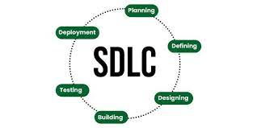

RAD- Rapid application development.
The Rapid Application Development (RAD) model is a software development approach emphasizing quick prototyping and iterative development. Unlike traditional methods that follow a linear sequence of stages, RAD prioritizes flexibility and adaptability to changing requirements.
RAD divides the development process into small modules or prototypes, developed concurrently. These prototypes are swiftly assembled and tested to gather stakeholder feedback. Based on this input, the prototypes are refined iteratively, with additional features incorporated.

Key features of RAD include:
1. Iterative Development: The project is broken into multiple iterations, each focusing on specific features or functionalities. This iterative approach allows for rapid development and frequent delivery of functional software increments.
2. Prototyping: Rapid prototyping is central to RAD. Prototypes quickly visualize user requirements, enabling early feedback and adjustments.
3. User Involvement: Stakeholder participation and user feedback are vital. Users actively engage in prototyping and testing phases, ensuring the final product aligns with their needs.
4. Time-boxed Development: RAD projects are time-bound, with strict deadlines for each iteration. Time-boxing maintains focus, prioritizes tasks, and ensures timely milestone completion.
5. Incremental Delivery: RAD emphasizes delivering functional software increments at the end of each iteration. This approach allows for early feature validation and keeps the project on track.
In summary, RAD suits projects with evolving requirements, necessitating rapid development and software delivery. It fosters collaboration, flexibility, and responsiveness to user feedback throughout the development lifecycle.
RAD has become popular due to the competitive software market and the increasing demand for new applications. James Martin introduced RAD in 1991, recognizing that software could be updated and changed endlessly using design development models. RAD's emergence paved the way for agile methodologies adopted by companies seeking flexible approaches to meet client needs and adapt to rapid business growth.

By emphasizing rapid prototyping, RAD allows for iterations and release cycles guided by user feedback, reducing the need for extensive planning that can lead to high costs, particularly if clients are unhappy with the final product. The rise of RAD has led to the development of low code/no code platforms, making software development faster and more efficient.
The RAD cycle begins with clients and the development team collaborating to define project requirements. Stakeholders discuss aims, project duration, pricing, and budget to ensure alignment and prevent costly mistakes. Despite setting initial requirements, RAD allows for flexibility to adjust as needed during prototype development.
Once project requirements are agreed upon, developers, designers, and clients work together to quickly create a working prototype that meets established requirements. The prototype may undergo multiple iterations until clients are satisfied. RAD involves user testing and feedback on live prototypes, enabling continuous improvement until requirements are met and clients are happy. This stage facilitates efficient communication among stakeholders and early detection and resolution of errors and bugs.
The next stage focuses on rapid construction and feedback gathering, where the prototype is developed further and tested in various forms. This stage transforms the prototype into functional software, with most issues addressed during prototyping. Clients provide suggestions and address any issues that arise.
The final stage involves developers addressing technical debt and optimizing the software for stability in preparation for launch. The software undergoes rigorous testing to identify any remaining bugs before being moved to a live production environment. Detailed documentation is compiled, and any remaining tasks are completed before the final product is delivered to the client.
Due to time constraints, I completed the RAD cycle up to the prototype stage. However, I aim to continue through the subsequent stages to create a fully functional application that benefits many users.

Arabic 2 u application.
In this segment, I will evaluate and provide insights into the prototype named "Arabic 2 U," which I developed utilizing HTML, CSS, Bootstrap, and JavaScript.

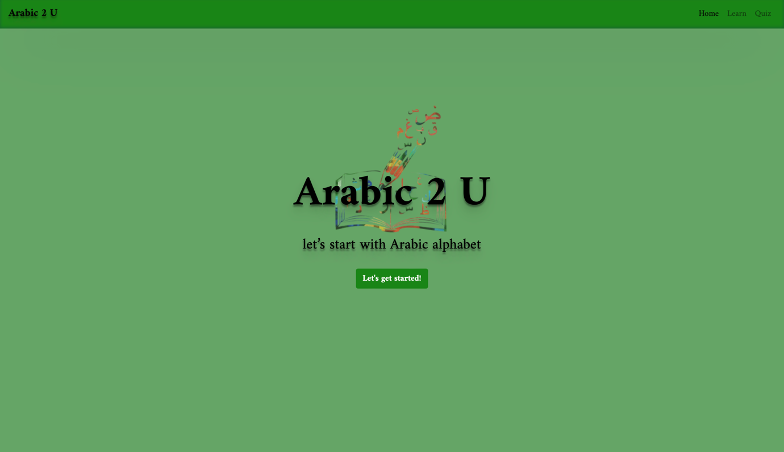
(Home page)
The prototype's name "Arabic 2 U" is prominently displayed at the centre. I chose this name to signify the application's goal of catering to a diverse audience and adapting to individual learning styles, thus ensuring user satisfaction and a personalized experience. Additionally, to enhance user engagement, I included a compelling question, "lets start with the Arabic alphabet? This prompts users to contemplate their interest in learning Arabic and encourages them to explore further. For those inclined to begin their Arabic learning journey, a clear directive is provided with the message including a "Let’s get started!" button, guiding users to the next page. The background photo was carefully selected to evoke a vibrant and colourful imagery associated with learning Arabic, capturing users' attention and improving their overall experience. Recognizing the significance of the homepage as the initial point of interaction, I prioritized user experience (UX) considerations. A well-designed UX offers several benefits, including increased customer acquisition and loyalty, enhanced revenue opportunities, optimized resource utilization, deeper insights from user engagement, and reduced troubleshooting and associated costs.
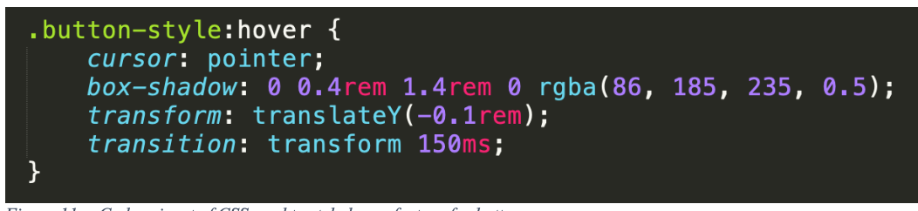
I will outline various features that I incorporated throughout the different phases of this project to ensure accessibility for users and enhance their overall experience.

Another feature integrated into the prototype is the hover effect. When users hover over a button, a faded highlight appears behind it, enhancing visual feedback and improving user interaction. This feature serves to capture users' attention, thereby enhancing the overall user interface (UI) and user experience (UX).
Consistency in colours, fonts, and themes has been maintained throughout the application. This consistency is crucial as it contributes to improved usability and learnability. When similar elements have a consistent appearance and behaviour, users find it easier to navigate and understand the interface.
I've also integrated the active class into the navbar. This feature will prove especially handy as the app expands with more pages in later stages of development. It enables users to easily identify the current page they're on, thereby streamlining navigation throughout the app and enhancing both the user interface (UI) and user experience (UX).

Stage 1– The learning pages.
Crafting the learn page to achieve maximum user-friendliness and effectiveness posed a significant challenge during the prototype development process, requiring multiple design iterations to refine.

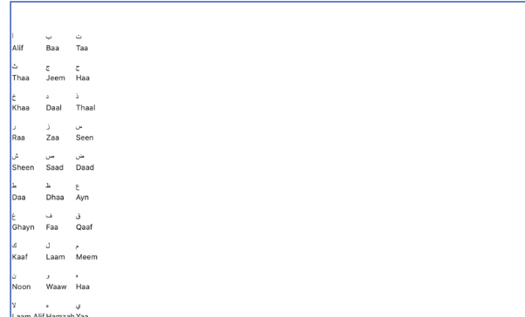

I decided to showcase the Arabic alphabet letters on the learn page using a borderless table format, along with transliterations underneath each letter to aid students in pronunciation. However, the absence of styling on the page detracts from the overall theme consistency of the app.

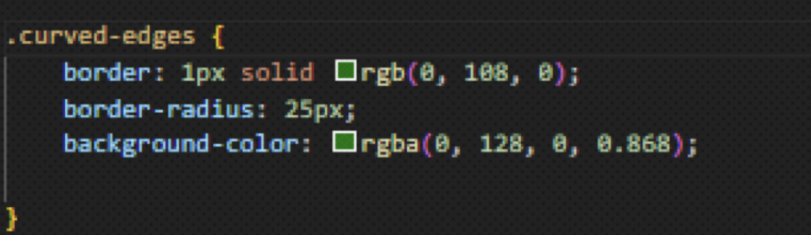
stage -2

Then, I began styling the learn page by centring the table and ensuring that each letter adhered to the app's overall theme. This entailed enlarging the letters, creating grey tiles with rounded edges, and placing each letter of the Arabic alphabet within its respective tile. To achieve this, I developed a CSS class specifically tailored for the desired styling.
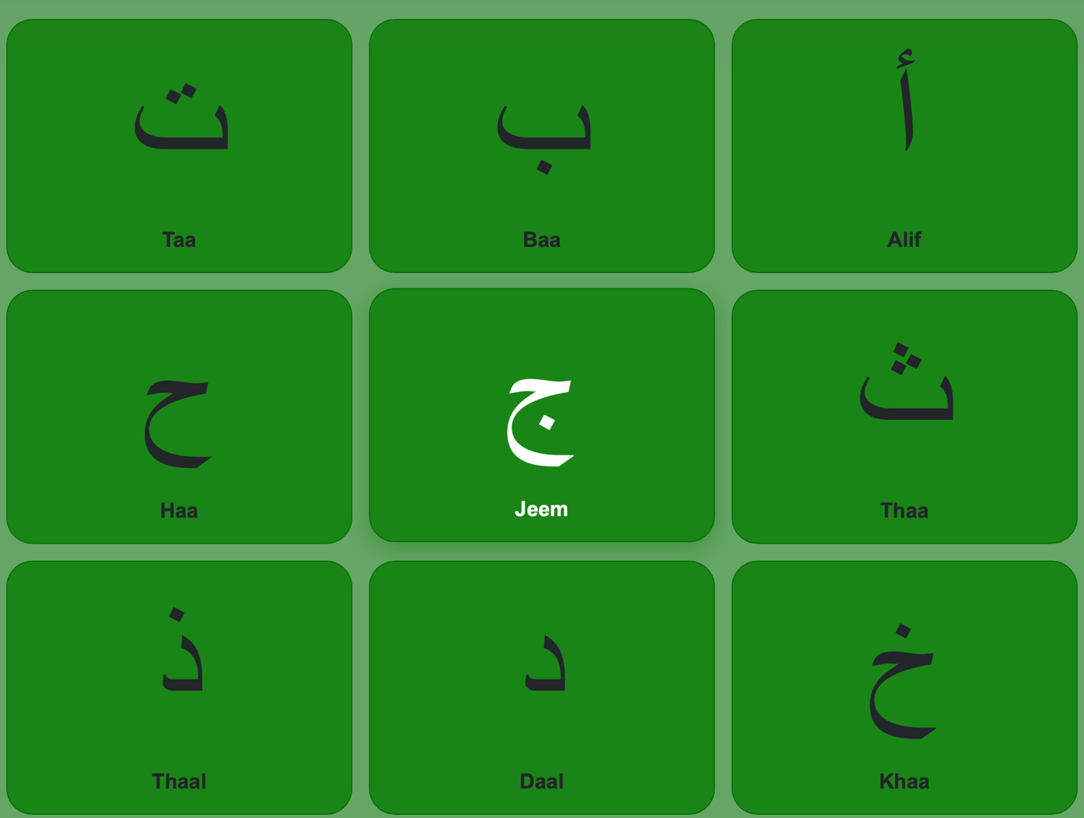

This marks the final iteration of the learn prototype, where I introduced styling and a green background colour. The addition of the green colour serves to draw attention and typically signifies success or completion, hinting that consistent practice leads to progress and success.

Stage 3
Upon completing the second stage, I encountered a common issue observed among students, particularly when learning the Arabic alphabet. Many students tend to forget the pronunciation of letters when they review at home after class, despite the presence of transliterations beneath each letter. Recognizing this challenge, I decided to address it in the subsequent phase of the project. In this next stage, I introduced a feature allowing users to hear the pronunciation of each letter by clicking on it. To achieve this, I utilized the HTML audio element and created a folder named "sounds" containing all the pronunciation files. Each audio file was given a unique ID attribute, which was then accessed in the JavaScript functionality. I implemented a JavaScript function named "play ()" to handle the audio playback. When a user clicks on a letter tile, the corresponding audio file is played, thanks to the onclick attribute set on each tile. This interactive feature aims to enhance the learning experience and help users retain the pronunciation of Arabic letters more effectively.
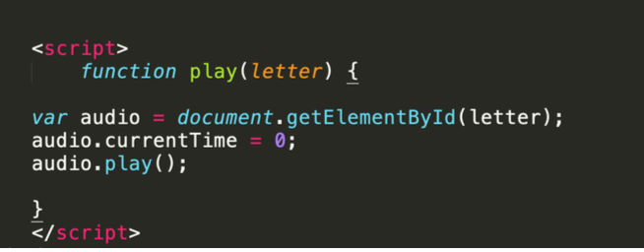

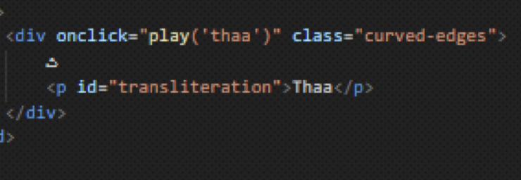

In the subsequent stage, I noticed an issue where users experienced delays when clicking on letter tiles repeatedly to hear the pronunciation again. Recognizing that this delay could negatively impact the user experience, I took steps to resolve it. I implemented a solution by resetting the current time of the audio variable to zero. This adjustment ensures that users can repeat the pronunciation of the letter as many times as they like without encountering any delays. By addressing this issue, our goal is to enhance both the user interface and user experience of the application.

Quiz page

Once students have utilized the learn page and reached a level where they feel confident in their grasp of the Arabic alphabet, I integrated a quiz game feature into the prototype to test their knowledge. The quiz game comprises a home page where users can commence the game by clicking the play button. To offer a unique experience, I chose contrasting colours from the app's general theme, signalling a transition to a new section within the application.
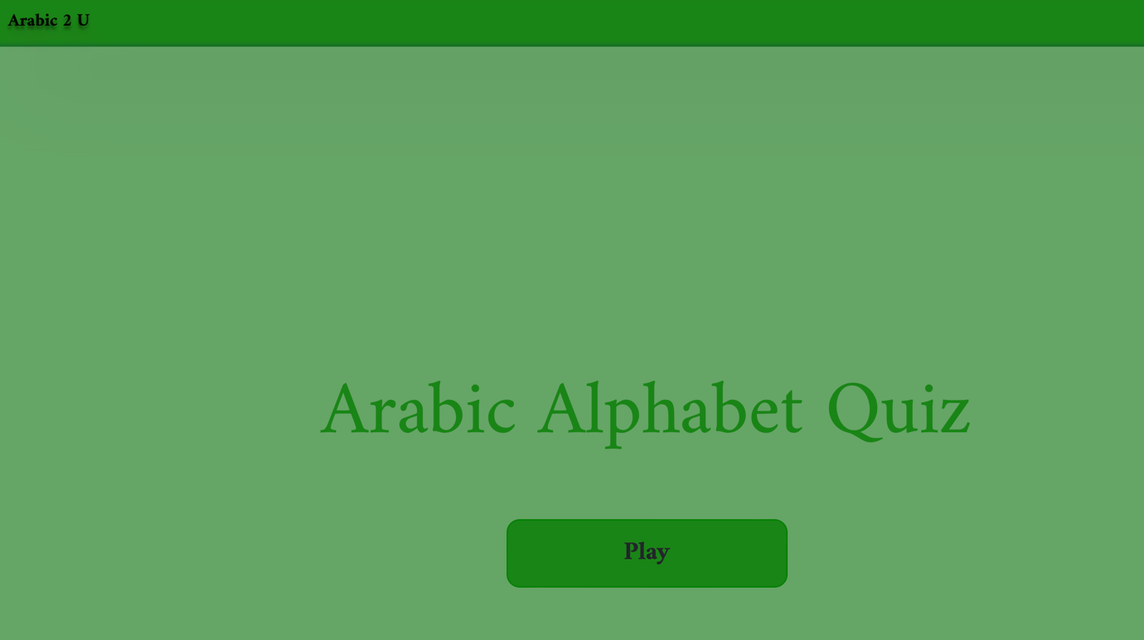

After selecting "play," users are redirected to a specially designated quiz page. Here, users carefully listen to a letter being vocalized and then choose from among four provided options. Correct selections are highlighted in green, earning them 10 points, while incorrect ones are marked in red, resulting in zero points. The quiz comprises ten questions displayed one after another in a random order. To encourage active learning and memory recall, I deliberately removed the navigation bar, prompting users to rely solely on their memory. This approach mirrors the effective teaching method used in my Arabic reading classes, where students quickly grasp the alphabet. Despite obtaining low scores initially, users have the option to replay the quiz until they achieve a perfect score.

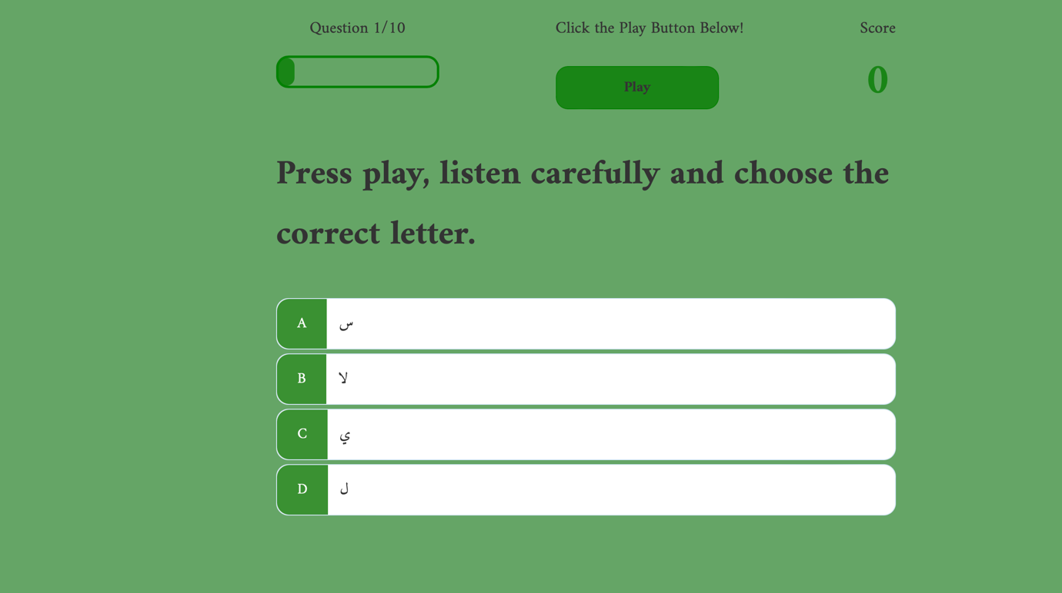

I've chosen to utilize the CSS flexbox layout method to centre all elements on the screen. This approach ensures that regardless of the screen size, everything remains centrally aligned, providing a consistent layout and improving user experience.

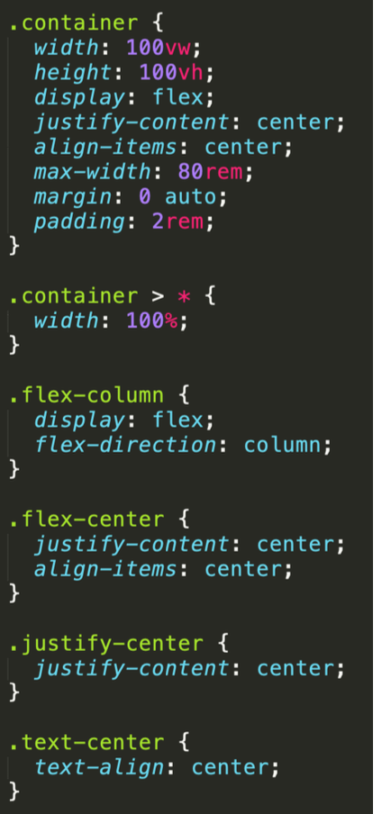
I've organized each question on the quiz page along with four options labelled A-D. This layout is created using nested div containers, each styled with its unique CSS class. Furthermore, every choice is furnished with a data attribute, aiding in identifying the correct answer within the JavaScript code. Additionally, I've integrated a hover effect using CSS for each option, enhancing user engagement by visually indicating the selected answer.

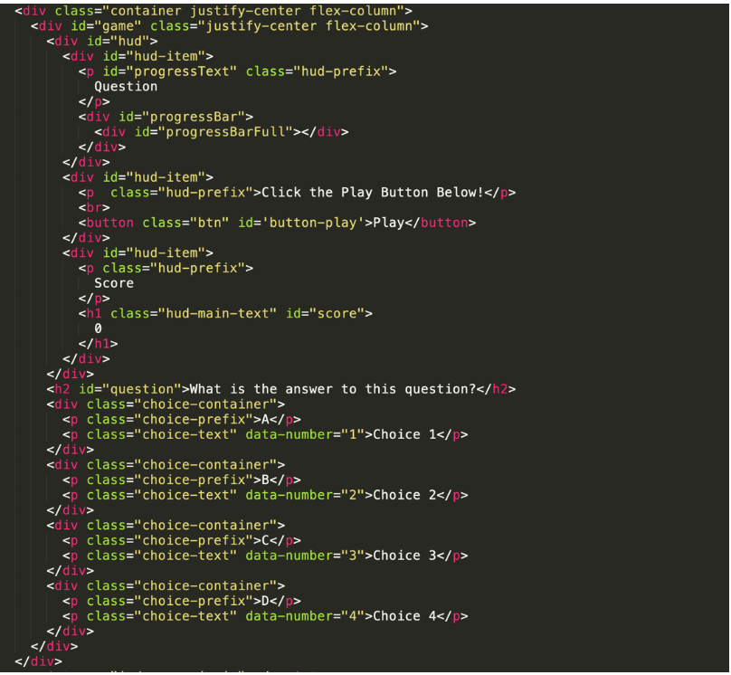

The questions featured on the webpage are stored within an array of objects termed as "questions." Each object within this array includes four answer options, the correct answer, and its corresponding sound file.
I ensured that the questions appear randomly by incorporating an additional array named "availableQuestions." Initially, this array encompasses all objects from the "questions" array, facilitated by the spread operator. This operator takes all elements from the "questions" array, disseminates them, and appends them to the "availableQuestions" array. As the user progresses through the quiz, each answered question is eliminated from the "availableQuestions" array, ensuring that only unanswered questions are presented. This mechanism prevents the recurrence of previously answered questions, thus enhancing the randomness and integrity of the quiz.
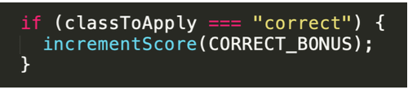
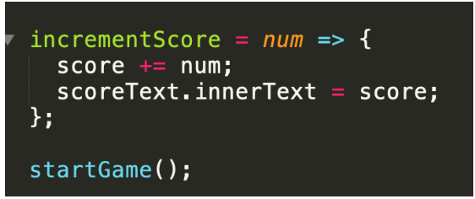
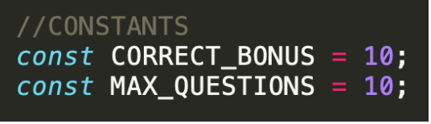
The assessment comprises ten questions, with each correct answer earning the user ten points. Conversely, selecting the wrong option results in zero points.

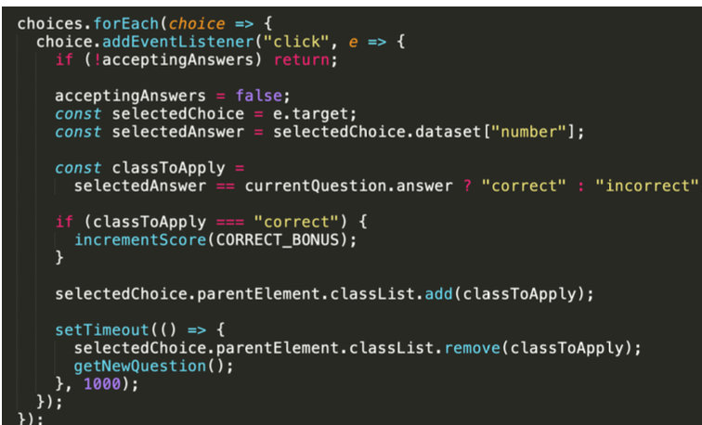
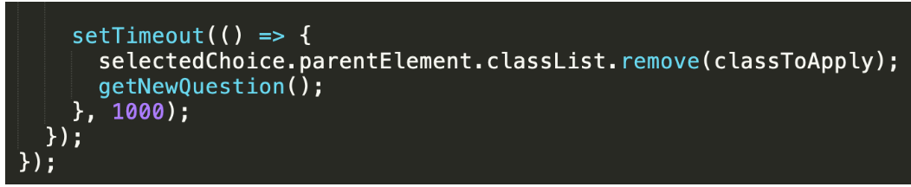
The system highlights the correct answer in green and marks the incorrect one in red. This visual feedback is achieved using two CSS classes: "correct" and "incorrect", each defining a distinct background colour corresponding to the user's response. JavaScript dynamically applies these classes based on the user's selection. Furthermore, a brief delay is incorporated after the user's response before presenting the next question, allowing them ample time to process their answer.

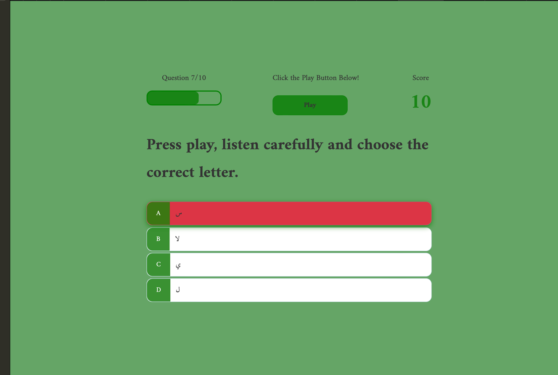
I've integrated a progress bar at the upper left corner of the interface, providing users with a visual indicator of their advancement as they proceed through the quiz. With each question answered, the progress bar gradually fills up, offering learners a clear sense of their progress in real-time. This addition aims to motivate users by illustrating their journey through the quiz and encouraging them to continue until completion.

result page.

In addition to the quiz and its functionalities, I have integrated a final page into the prototype, serving as a comprehensive results summary. This page offers users a detailed breakdown of their performance throughout the quiz, providing valuable insights into their understanding of the Arabic alphabet. It displays the total number of questions answered correctly and incorrectly, offering users a clear overview of their accuracy. Moreover, the page showcases the points earned for each correct answer, with each question being worth 10 points. This scoring system not only incentivizes users to strive for accuracy but also allows them to gauge their progress based on their accumulated points. Furthermore, the results page determines whether the user has passed or failed the quiz, providing them with actionable feedback on their performance. By highlighting areas of strength and areas needing improvement, users can identify specific areas to focus on for future learning endeavours. Ultimately, the final page serves as a valuable tool for users to assess their Arabic alphabet proficiency and track their learning progress over time.

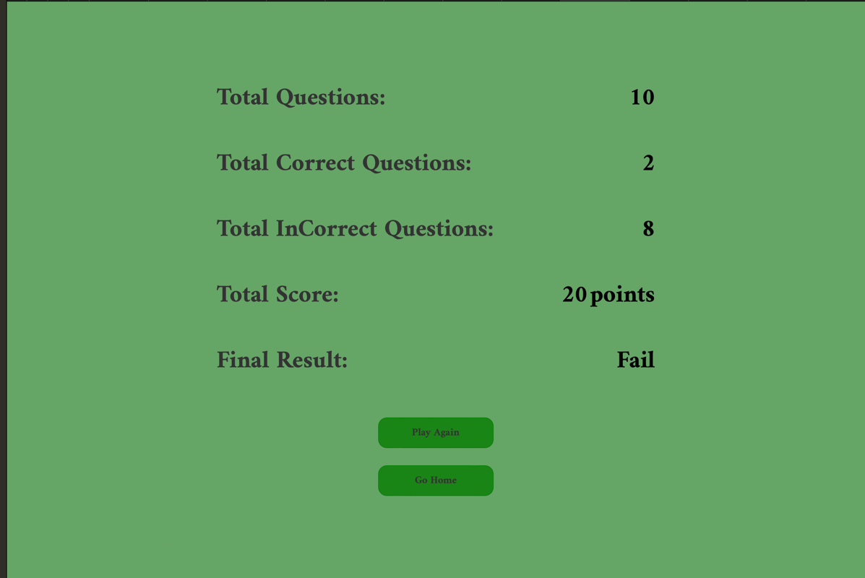

End .html
Document Type Declaration and HTML Opening Tag:
- <!DOCTYPE html>: Specifies the document type and version of HTML.
- <html lang="en">: The opening tag for the HTML document with the "en" attribute indicating the English language.
- Head Section:
- <head>: Contains meta information about the document.
- <meta charset="UTF-8" />: Specifies the character encoding for the document as UTF-8.
- <meta name="viewport" content="width=device-width, initial-scale=1.0" />: Sets the viewport properties for responsive design.
- <meta http-equiv="X-UA-Compatible" content="ie=edge" />: Defines the compatibility mode for Internet Explorer.
- <title>Congrats!</title>: Sets the title of the document.
- Font imports from Google Fonts and links to CSS files.
- Body Section:
- <body>: Contains the content of the HTML document.
- <div class="container">: A container div to structure the content.
- <div id="end" class="flex-center flex-column">: A div with the id "end" and flex-center/flex-column classes, indicating a centered and vertically aligned column layout.
- HUD Sections:
- Multiple sections containing HUD items.
- <div id="hud" style="display: flex; justify-content:space-between; width:100%;">: HUD section with a flex display, space-between justification, and 100% width.
- <div id="hud-item"><h2>Total Questions:</h2></div>: Displays "Total Questions" in an HUD item.
- <div id="hud-item"><h2 class="result-text" id="">10</h2></div>: Displays the total number of questions (10) in an HUD item.
- Similar sections for "Total Correct Questions," "Total Incorrect Questions," "Total Score," and "Final Result."
- Buttons:
- <a class="btn" href="game.html">Play Again</a>: A button with the class "btn" that links to the "game.html" page.
- <a class="btn" href="home.html">Go Home</a>: A button with the class "btn" that links to the "home.html" page.
- JavaScript Script:
- <script src="js/end.js"></script>: Links to an external JavaScript file named "end.js," indicating that there is additional scripting logic for the "end.html" page.
End.js
Getting Elements by ID:
- const finalScore = document.getElementById('finalScore');: Retrieves the HTML element with the ID 'finalScore' and stores it in the finalScore variable.
- const totalCorrect = document.getElementById("CorrectQuestions"): Retrieves the HTML element with the ID 'CorrectQuestions' and stores it in the totalCorrect variable.
- const totalInCorrect = document.getElementById("IncorrectQuestions"): Retrieves the HTML element with the ID 'IncorrectQuestions' and stores it in the totalInCorrect variable.
- const finalResult = document.getElementById("finalResult"): Retrieves the HTML element with the ID 'finalResult' and stores it in the finalResult variable.
- Retrieving Most Recent Score:
- const mostRecentScore = localStorage.getItem('mostRecentScore');: Retrieves the most recent score from the local storage and stores it in the mostRecentScore variable.
- Displaying Most Recent Score:
- finalScore.innerText = mostRecentScore;: Sets the inner text of the 'finalScore' element to the value of the most recent score, effectively displaying it on the page.
- Calculating and Displaying Total Correct Questions:
- const totalCorrectQuestion = mostRecentScore/10: Calculates the total number of correct questions by dividing the most recent score by 10 (assuming 10 questions).
- totalCorrect.innerText = totalCorrectQuestion: Sets the inner text of the 'CorrectQuestions' element to the calculated total number of correct questions.
- Calculating and Displaying Total Incorrect Questions:
- const totalInCorrectQuestion = 10 - totalCorrectQuestion: Calculates the total number of incorrect questions by subtracting the total correct questions from the total number of questions (10).
- totalInCorrect.innerText = totalInCorrectQuestion: Sets the inner text of the 'IncorrectQuestions' element to the calculated total number of incorrect questions.
- Determining and Displaying Final Result:
- const reslut = totalCorrectQuestion > 6 ? "Pass" : "Fail": Determines the final result based on whether the total correct questions are greater than 6. If true, the result is "Pass"; otherwise, it's "Fail."
- finalResult.innerText = reslut: Sets the inner text of the 'finalResult' element to the determined final result, displaying it on the page.

Research.

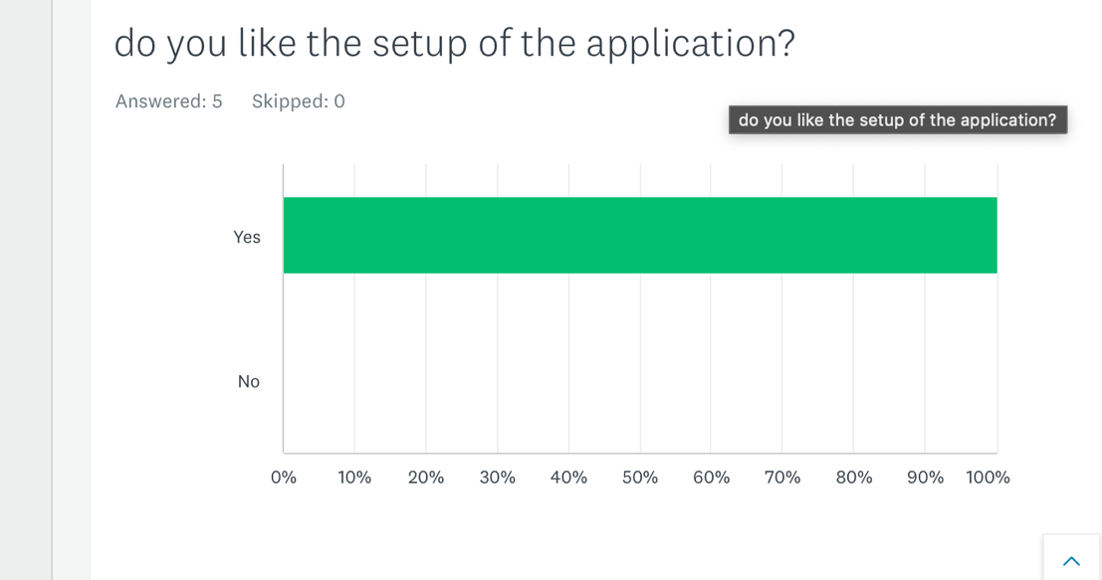

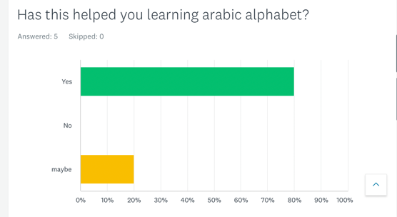

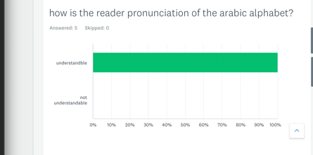

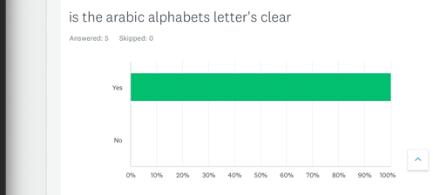

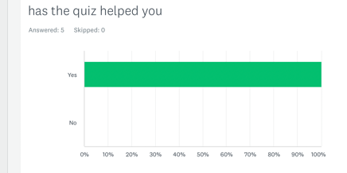

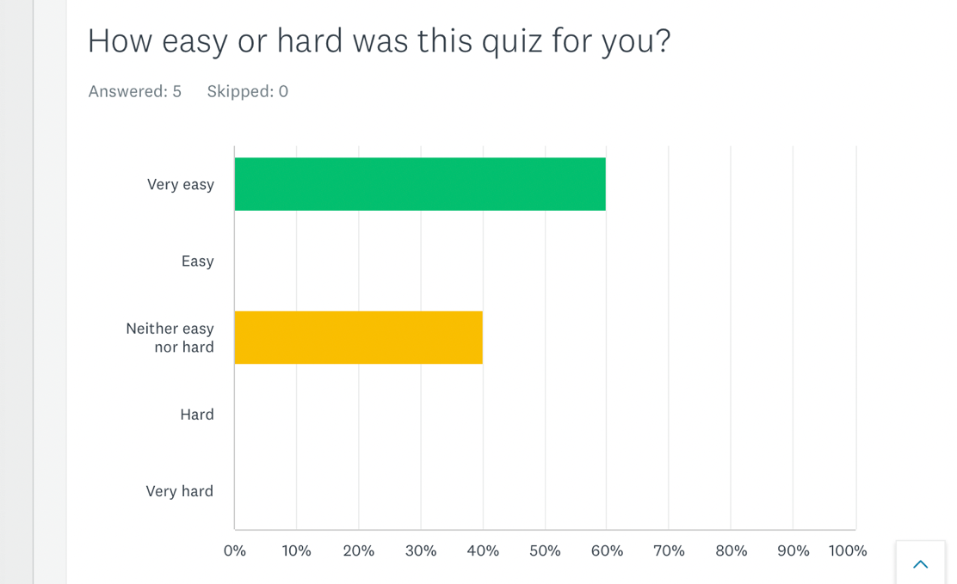

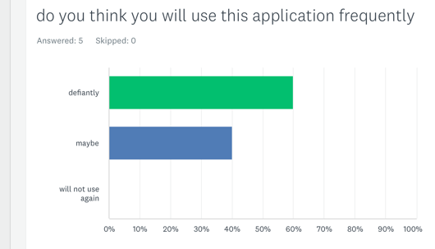

Based on my research, I developed a questionnaire tailored to individuals within my target audience, encompassing a diverse range of ages and gender identities. To administer the questionnaire, I opted to use SurveyMonkey, distributing the link to potential respondents. The questionnaire was crafted to elicit feedback at a professional level, ensuring that respondents' opinions were valued as integral to improving my application.
Upon receiving responses, I gained valuable insights into users' perceptions of my application. I was pleased to find that most of the feedback was positive, affirming the strengths of my project. However, it's important to note that this research had its limitations, primarily due to time constraints and a smaller-than-expected response rate. In hindsight, I recognize the value of conducting surveys in person to reach a broader audience and gather more diverse perspectives.

Evaluation.

Limitations:
Upon thorough reflection on the research project, it becomes evident that several limitations need acknowledgment. Chief among them is the restricted analysis scope, which primarily focuses on the prototype itself without delving into crucial aspects such as testing procedures, feedback from volunteer testers, and the comprehensive data gleaned from questionnaires administered to assess user experience. A more robust analysis incorporating these elements would have yielded deeper insights into the prototype's efficacy in enhancing the Arabic alphabet learning process. Moreover, it could have shed light on the broader implications for web and mobile applications in language learning. The main hindrance to such a comprehensive analysis stem from time constraints, as the project had to be completed within a limited timeframe. Thus, while the current analysis provides valuable insights, a more expansive examination would have provided a more nuanced understanding of the prototype's impact.

Future Directions:

While the current project has achieved its goals, there are several areas where it can be further refined and expanded in future iterations. One key aspect for improvement lies in enhancing the validation process within the quiz game. Presently, when users select an incorrect answer, there's no immediate indication of the correct option. To rectify this, implementing a feature that highlights both the incorrect and correct options simultaneously would offer users immediate feedback on their choices, facilitating their learning process.

Moreover, there is room to enhance the presentation of questions within the app. Currently, questions, options, correct answers, and audio files are hardcoded and stored in an array. This approach may result in question repetition as users engage with the quiz repeatedly. Leveraging the fetch API to dynamically retrieve a broader range of questions and randomly select them for display would introduce variety and maintain user interest over time.
Additionally, integrating a feature to store and showcase high scores could introduce a competitive element to the app. Allowing users to monitor their progress and compare their scores with others would incentivize them to strive for improvement, thereby enhancing their engagement with the learning process.
Expanding the range of activities and quizzes within the app would also enrich the user experience. Introducing new games and exercises that assess students' comprehension from various angles would provide a more comprehensive learning environment. For example, incorporating AI-driven exercises where a virtual teacher evaluates pronunciation or interactive tasks where users can practice writing letters would deepen user engagement and facilitate better learning outcomes. Continuously innovating and diversifying the app's content will ensure its ongoing relevance and effectiveness in supporting language learners.

Conclusion.
In summary, this research project has effectively met its objectives, emphasizing the significant role of web applications in facilitating language learning. It underscores the increasing importance of technology in educational settings and the ongoing development of innovative web and mobile applications for language acquisition.
Nevertheless, the research also highlights the challenges associated with utilizing web and mobile apps for language learning, prompting experts to seek solutions to address these issues. Through a comprehensive review of existing literature, valuable insights have been gained to deepen our understanding of this domain.
Furthermore, the creation and assessment of a prototype have yielded valuable insights into its strengths, weaknesses, and potential areas for improvement. This evaluation provides a foundation for future enhancements to the prototype, should the project progress further.

Code and work.

HTML (home.html):
1. DOCTYPE Declaration: Specifies the document type and version of HTML.
2. HTML Tag: The root element of the HTML document.
3. Head Section:
- External CSS Libraries: Links to external CSS libraries (animate.css and Bootstrap) and Google Fonts.
- External JavaScript Libraries: Links to external JavaScript libraries (jQuery and Bootstrap).
- Meta Tag: Specifies the character set for the document.
- Title Tag: Sets the title of the web page.
- Internal CSS: Defines some styles for the body and creates a background using a pseudo-element (::after).

4. Body Section:
- Navbar: Bootstrap navigation bar with a brand logo ("Arabic 2 U") and navigation links for Home, Learn, and Quiz.
- Content Section: Animated content with a title ("Arabic 2 U"), a subheading, and a button that links to the "learn.html" page.

CSS (index.css):
1. Google Fonts Import: Imports multiple font families from Google Fonts.
2. Body Styles:
- Sets the position, z-index, and font family for the body.
- Uses a pseudo-element (::after) to add a background image with opacity.

3. Global Styles:
- Sets the width, height, and text color for the entire HTML document.
- Defines a navigation bar style with a green background, box shadow, and a special style for the brand logo.

4. Navbar Styles:
- Adjusts the font weight and adds a text shadow for the navbar brand and links.
- Changes link color on hover.

5. Content Styles:
- Styles for the main content section, including padding, text alignment, and text shadow.

6. Button Styles:
- Styles for the button, including background color, font weight, and margin.
- Adds a hover effect with a box shadow and a slight transformation.

Index.html
index.css

HTML (learn.html):
- DOCTYPE Declaration: Specifies the document type and version of HTML.
- HTML Tag: The root element of the HTML document.
- Head Section:
- External CSS Libraries: Links to external CSS libraries (Bootstrap and Google Fonts).
- External JavaScript Libraries: Links to external JavaScript libraries (jQuery and Bootstrap).
- Meta Tag: Specifies the character set for the document.
- Title Tag: Sets the title of the web page.
- Internal CSS: Links to the internal CSS file specific to the "learn.html" page.
- Body Section:
- Navbar: Similar to the one in "home.html" with navigation links for Home, Learn, and Quiz.
- Audio Elements: Each Arabic letter has an associated audio file loaded using the <audio> element.
- Table with Arabic Letters:
- The table displays Arabic letters as clickable elements, each associated with a specific pronunciation (transliteration).
- The play function in the embedded JavaScript is triggered when a letter is clicked, playing the associated audio file.
- Content Section:
- Contains a heading ("put your Arabic alphabet to test") and a button linking to the "quiz.html" page.
- Embedded JavaScript:
- Defines a play function that plays the audio corresponding to a clicked letter.
CSS (learn.css):
- Google Fonts Import: Imports multiple font families from Google Fonts.
- Body Styles:
- Sets the background color for the body.
- Table Styles:
- Styles for the Arabic letters table, including font size, fixed table layout, and right-to-left direction.
- Each table cell (td) has specific styling like text alignment, padding, and a curved border.
- Curved-Edges Styles:
- Defines styling for the clickable curved-edges div elements inside the table, changing color and adding a shadow on hover.
- Content Styles:
- Styles for the content section, including padding, text alignment, and text shadow.
- Button Styles:
- Styles for the button, including background color, font weight, and margin.
- Adds a hover effect with a box shadow and a slight transformation.
- Navbar Styles:
- Similar to "home.css", it defines styles for the navigation bar, brand, and links.
HTML (quiz.html):
- DOCTYPE Declaration: Specifies the document type and version of HTML.
- HTML Tag: The root element of the HTML document.
- Head Section:
- External CSS Libraries: Links to external CSS libraries (Bootstrap and Google Fonts).
- Meta Tag: Specifies the character set for the document.
- Title Tag: Sets the title of the web page.
- Internal CSS: Links to the internal CSS file specific to the "quiz.html" page.
- Body Section:
- Navbar: Similar to the one in other pages, providing navigation links for Home, Learn, and Quiz.
- Container Div:
- Contains a flex-centered div with an h1 heading ("Arabic Alphabet Quiz") and a play button.
- The button triggers a redirect to the "game.html" page when clicked.
CSS (quiz.css):
- Google Fonts Import: Imports multiple font families from Google Fonts.
- Body Styles:
- Sets the background color for the body.
- Uses a pseudo-element (body::after) to overlay a background image with opacity, creating a visual effect.
- Navbar Styles:
- Similar to previous pages, it defines styles for the navigation bar, brand, and links.
- Heading Styles:
- Styles for various heading levels (h1, h2, h3, h4).
- Specific styles for the h1 element, making it large, bold, and with a margin.
- Utilities:
- Utility classes for flexbox-based layout, text centering, hiding elements, and button styling.
- These utility classes make it easy to apply common styles across different elements.
- Button Styles:
- Styles for buttons, specifying font size, padding, width, border, border-radius, background color, and font weight.
- Adds a hover effect with color change, box shadow, and a slight transformation.
- There's a specific styling for disabled buttons when hovered.
- Form Styles:
- Styles for forms, including width, flex layout, and styling for input fields.
- Placeholder text is styled with a specific color.
- HUD (Heads-Up Display) Styles:
- Styles for the HUD section, which includes the main text and prefix.
- Displayed in a flex container with space-between alignment.

Game.html
- Document Type Declaration (<!DOCTYPE html>):
- Specifies the document type and version of HTML being used.
- HTML Document Structure:
- <html lang="en" xmlns="http://www.w3.org/1999/xhtml">: Declares the HTML root element with the language set to English. The xmlns attribute is not necessary for HTML5, but it might be included for compatibility.
- Head Section (<head>):
- Meta tags:
- <meta charset="UTF-8" />: Sets the character set to UTF-8 for proper encoding of characters.
- <meta name="viewport" content="width=device-width, initial-scale=1.0" />: Configures the viewport for responsive design.
- <meta http-equiv="X-UA-Compatible" content="ie=edge" />: Ensures compatibility with the latest version of Internet Explorer.
- Title: <title>Quiz - Play</title>: Sets the title of the webpage.
- External Stylesheets (<link>):
- Links to external stylesheets from Google Fonts for custom font styles.
- <link rel="stylesheet" href="css/quiz.css" />: Links to a stylesheet for quiz-specific styles.
- <link rel="stylesheet" href="css/game.css" />: Links to a stylesheet for game-specific styles.
- Body Section (<body>):
- <audio id="answer-audio"></audio>: Creates an HTML audio element with the ID "answer-audio," likely intended for playing the audio associated with quiz questions.
- Container and Game Elements:
- <div class="container justify-center flex-column">: Creates a container div with flex properties for centering its content vertically.
- <div id="game" class="justify-center flex-column">: Creates a div for the game content with flex properties for centering its content vertically.
- HUD (Heads Up Display):
- <div id="hud">: Represents the heads-up display containing information like question progress, a play button, and the player's score.
- <div id="hud-item">: Each HUD item contains specific information, such as question progress, a play button, or the player's score.
- Question Display:
- <h2 id="question">What is the answer to this question?</h2>: Displays the current quiz question.
- Choice Containers: Each choice is displayed in a separate container with a prefix ("A," "B," etc.) and the choice text.
- Script:
- <script src="js/game-quiz.js"></script>: Links to an external JavaScript file (game-quiz.js) to provide the logic and functionality for the quiz.
Game .css
Font Imports:
- @import url('https://fonts.googleapis.com/css2?family=Amiri:wght@400;700&family=Nunito:wght@400;500;600;700&family=Poppins:wght@300;400;500;600;700&family=Red+Hat+Display:wght@400;500;600;700;800&display=swap');: Imports font styles from Google Fonts, providing various font weights for the 'Amiri,' 'Nunito,' 'Poppins,' and 'Red Hat Display' typefaces.
- Root Font Size:
- :root { font-size: 62.5%; }: Sets the base font size to 62.5% of the default size. This is often done to make it easier to work with rem units, where 1 rem is equal to the root font size (10 pixels in this case).
- Universal Styles (* Selector):
- * { ... }: Applies styles to all elements on the page.
- box-sizing: border-box;: Ensures that padding and border are included in the element's total width and height.
- font-family: Arial, Helvetica, sans-serif;: Specifies a fallback font family if the primary fonts are not available.
- margin: 0; padding: 0;: Removes default margin and padding from all elements.
- color: #333;: Sets the default text color to a dark gray.
- font-family: 'Amiri', serif;: Overrides the earlier font-family declaration, setting the default font for the page.
- Choice Container Styles:
- .choice-container { ... }: Styles for the container of each answer choice.
- display: flex;: Makes the container a flex container.
- margin-bottom: 0.5rem;: Adds a small margin at the bottom of each choice.
- width: 100%;: Makes the container take up the full width.
- font-size: 1.8rem;: Sets the font size for the choices.
- border: 0.1rem solid rgb(86, 165, 235, 0.25);: Adds a light border to the choices.
- border-radius: 15px;: Rounds the corners of the container.
- background-color: white;: Sets the background color to white.
- justify-content: center;: Centers the content horizontally.
- Choice Container Hover Styles:
- .choice-container:hover { ... }: Styles applied when hovering over a choice container.
- cursor: pointer;: Changes the cursor to a pointer.
- box-shadow: ...;: Adds a subtle box-shadow effect.
- transform: ...;: Applies a slight vertical translation.
- transition: ...;: Specifies a smooth transition effect.
- Choice Prefix Styles:
- .choice-prefix { ... }: Styles for the prefix section (e.g., "A," "B") of each choice.
- padding: 1.5rem 2.5rem;: Sets padding for the prefix.
- background-color: rgba(0, 128, 0, 0.868);: Sets the background color to a green shade.
- color: white;: Sets the text color to white.
- border-bottom-left-radius: 15px; border-top-left-radius: 15px;: Rounds the left corners.
- Choice Text Styles:
- .choice-text { ... }: Styles for the text content of each choice.
- padding: 1.5rem; width: 100%;: Adds padding and makes the text take up the full width.
- Correct and Incorrect Styles:
- .correct { ... } and .incorrect { ... }: Styles for correct and incorrect choices.
- background-color: #28a745; and background-color: #dc3545;: Sets background colors for correct and incorrect choices, respectively.
- HUD (Heads Up Display) Styles:
- #hud { ... }: Styles for the heads-up display section.
- display: flex; justify-content: space-between;: Makes it a flex container with space-between alignment.
- font-size: 16px !important;: Sets the font size for HUD items, with !important for specificity.
- HUD Item Styles:
- .hud-prefix and .hud-main-text: Styles for the prefix and main text within the HUD.
- text-align: center;: Centers the text.
- Progress Bar Styles:
- #progressBar { ... } and #progressBarFull { ... }: Styles for the progress bar and its filled portion.
- width: ...; height: ...; border: ...; border-radius: ...; margin-top: ...;: Sets dimensions, border, border-radius, and margin.
- background-color: rgba(0, 128, 0, 0.868);: Sets the background color for the filled portion.
- Result Text Styles:
- .result-text { color: #000; }: Styles for result text, setting the color to black.

Game Quiz javascript
- Variable Declarations:
- question, audio, choices, progressText, scoreText, progressBarFull, and playButton are all variables storing references to various HTML elements.
- Several variables like currentQuestion, acceptingAnswers, score, questionCounter, availableQuestions, correctAnswers, and incorrectAnswers are used to manage the state of the quiz.
- Questions Array:
- An array named questions contains objects, each representing a quiz question.
- Each question has properties such as question (the question text), choice1 through choice4 (the answer choices), answer (the correct choice), and source (the audio file for the question).
- Constants:
- Constants like CORRECT_BONUS (bonus points for correct answers) and MAX_QUESTIONS (maximum number of questions in the quiz) are defined.
- Functions:
- startGame: Initializes the game by resetting counters, scores, and available questions. Calls getNewQuestion to display the first question.
- getNewQuestion: Updates the question, choices, and progress bar. Plays the audio for the current question when the "Play" button is clicked.
- incrementScore: Increments the score based on the provided bonus points. Determines if the selected answer is correct or incorrect and updates the score accordingly.
- Event Listeners:
- Event listener on each choice (click event) checks if the answer is correct or incorrect. Updates the UI with the correct/incorrect class and triggers the next question after a delay.
- Initialization:
- The startGame function is called to initiate the quiz when the page loads.
- Local Storage:
- The correct and incorrect answers are stored in local storage (localStorage.setItem) for future reference.
- End of Quiz:
- When there are no more available questions or the maximum question limit is reached, the script redirects the user to the end page (window.location.assign('end.html')).
The script uses a combination of HTML elements, audio playback, and event handling to create a quiz experience where users can listen to Arabic alphabet pronunciations and select the correct corresponding letter. The quiz also keeps track of the user's score and displays the result at the end of the quiz.

End .html
Document Type Declaration and HTML Opening Tag:
- <!DOCTYPE html>: Specifies the document type and version of HTML.
- <html lang="en">: The opening tag for the HTML document with the "en" attribute indicating the English language.
- Head Section:
- <head>: Contains meta information about the document.
- <meta charset="UTF-8" />: Specifies the character encoding for the document as UTF-8.
- <meta name="viewport" content="width=device-width, initial-scale=1.0" />: Sets the viewport properties for responsive design.
- <meta http-equiv="X-UA-Compatible" content="ie=edge" />: Defines the compatibility mode for Internet Explorer.
- <title>Congrats!</title>: Sets the title of the document.
- Font imports from Google Fonts and links to CSS files.
- Body Section:
- <body>: Contains the content of the HTML document.
- <div class="container">: A container div to structure the content.
- <div id="end" class="flex-center flex-column">: A div with the id "end" and flex-center/flex-column classes, indicating a centered and vertically aligned column layout.
- HUD Sections:
- Multiple sections containing HUD items.
- <div id="hud" style="display: flex; justify-content:space-between; width:100%;">: HUD section with a flex display, space-between justification, and 100% width.
- <div id="hud-item"><h2>Total Questions:</h2></div>: Displays "Total Questions" in an HUD item.
- <div id="hud-item"><h2 class="result-text" id="">10</h2></div>: Displays the total number of questions (10) in an HUD item.
- Similar sections for "Total Correct Questions," "Total Incorrect Questions," "Total Score," and "Final Result."
- Buttons:
- <a class="btn" href="game.html">Play Again</a>: A button with the class "btn" that links to the "game.html" page.
- <a class="btn" href="home.html">Go Home</a>: A button with the class "btn" that links to the "home.html" page.
- JavaScript Script:
- <script src="js/end.js"></script>: Links to an external JavaScript file named "end.js," indicating that there is additional scripting logic for the "end.html" page.
End.js
Getting Elements by ID:
- const finalScore = document.getElementById('finalScore');: Retrieves the HTML element with the ID 'finalScore' and stores it in the finalScore variable.
- const totalCorrect = document.getElementById("CorrectQuestions"): Retrieves the HTML element with the ID 'CorrectQuestions' and stores it in the totalCorrect variable.
- const totalInCorrect = document.getElementById("IncorrectQuestions"): Retrieves the HTML element with the ID 'IncorrectQuestions' and stores it in the totalInCorrect variable.
- const finalResult = document.getElementById("finalResult"): Retrieves the HTML element with the ID 'finalResult' and stores it in the finalResult variable.
- Retrieving Most Recent Score:
- const mostRecentScore = localStorage.getItem('mostRecentScore');: Retrieves the most recent score from the local storage and stores it in the mostRecentScore variable.
- Displaying Most Recent Score:
- finalScore.innerText = mostRecentScore;: Sets the inner text of the 'finalScore' element to the value of the most recent score, effectively displaying it on the page.
- Calculating and Displaying Total Correct Questions:
- const totalCorrectQuestion = mostRecentScore/10: Calculates the total number of correct questions by dividing the most recent score by 10 (assuming 10 questions).
- totalCorrect.innerText = totalCorrectQuestion: Sets the inner text of the 'CorrectQuestions' element to the calculated total number of correct questions.
- Calculating and Displaying Total Incorrect Questions:
- const totalInCorrectQuestion = 10 - totalCorrectQuestion: Calculates the total number of incorrect questions by subtracting the total correct questions from the total number of questions (10).
- totalInCorrect.innerText = totalInCorrectQuestion: Sets the inner text of the 'IncorrectQuestions' element to the calculated total number of incorrect questions.
- Determining and Displaying Final Result:
- const reslut = totalCorrectQuestion > 6 ? "Pass" : "Fail": Determines the final result based on whether the total correct questions are greater than 6. If true, the result is "Pass"; otherwise, it's "Fail."
- finalResult.innerText = reslut: Sets the inner text of the 'finalResult' element to the determined final result, displaying it on the page.

References.

- Oracle, 2023. Java Tutorials. [online] Oracle. Available at: https://docs.oracle.com/javase/tutorial/ [Accessed 5 February 2024].
- Here are the Harvard references for the provided links with their order swapped:

- VanPatten, B., Williams, J. (Ed.)

- Long, M.H. (1985) 'Input and second language acquisition theory.' In: Gass, S., Madden, C. (Eds.), *Input in Second Language Acquisition.* Newbury House, Rowley, MA, pp. 377–393.

- Chomsky, N. and Skinner, B.F. (1959) *Verbal behavior.* *Language*, 35, pp. 26-58.

- Byram, M. (1997) *Teaching and assessing intercultural communicative competence.* Clevedon, UK: Multilingual Matters.

- Kramsch, C. (1998) *Language and culture.* Oxford, UK: Oxford University Press.

- Byram, M., Gribkova, B., & Starkey, H. (2002) *Developing the intercultural dimension in language teaching: A practical introduction for teachers.* Strasbourg, France: Council of Europe Publishing, Language Policy Division.

- ACTFL (1996) *Standards for foreign language learning: Preparing for the 21st Century.* Lawrence, KS: Allen.

- Chen, J. and Yang, S. (2014) 'Fostering Foreign Language Learning Through Technology-Enhanced intercultural Projects.' *Language Learning & Technology*, 18(1), pp. 57-75.

- Qur’an 30:22 (2007). Translated by Dr. Muhammad Muhsin Khan, Dr Muhammad Taqi-ud-din Al-Hilail. Riyadh, Kingdom of Saudi Arabia: DARUSSALAM Publishers and Distributors.

- Brainscape Academy (2021) 'What is Active Recall? How to use it to ace your exams.' Brainscape Academy. Available at: <https://www.brainscape.com/academy/active-recall-definition-studying/> [Accessed 11 November 2024].

- OXO Solutions® (2021) 'What is Inline Javascript: How to Inline and Benefits of Using it?' OXO Solutions®. Available at: <https://oxosolutions.com/inline-small-javascript/> [Accessed 10 November 2024].

- Nikolov, A. (2017) 'Design principle: Consistency.' Medium. Available at: <https://uxdesign.cc/design-principle-consistency-6b0cf7e7339f> [Accessed 5 November 2024].

- Bootstrap (2021) 'Bootstrap.' Available at: <https://getbootstrap.com/> [Accessed 5 November 2024].

- FAHM Technology Partners (2021) '5 Benefits of integrating UI/UX Design to your process - FAHM Technology Partners.' Available at: <https://www.fahmpartners.com/5-benefits-of-integrating-ui-ux-design-to-your-process/> [Accessed 5 November 2024].

- JavaTpoint (2021) 'SDLC - Software Development Life Cycle.' Available at: <https://www.javatpoint.com/software-engineering-software-development-life-cycle> [Accessed 3 November 2024].

- Rosell-Aguilar, F. (2018) 'Autonomous language learning through a mobile application: a user evaluation of the busuu app.' Language Learning and Technology, 31(8), pp. 854-881.

- Hargie, O. (2016) 'The Importance of Communication for Organisational Effectiveness.' Corporate Finance Institute. Available at: <https://corporatefinanceinstitute.com/resources/careers/soft-skills/communication/> [Accessed 5 November 2024].

- Chien, C. (2024) 'What is Rapid Application Development (RAD)?' Codebots. Available at: <https://codebots.com/app-development/what-is-rapid-application-development-rad> [Accessed 3 November 2024].

