University of Wales Trinity Saint David

Marketing fundamentals
LCBB4004

Zee Zook

Mariya Mitreva
2011903

Assessment 2

Table of Contents
Introduction 1
Critical anlysis and evaluation of Marketing's position in generating value for consumers 2
Definition of marketing concept 2
How marketing concept add value to amazon customers 3
Advantages and disadvantages 3
Definition of branding 4
Advantages of branding to customer 4
Ansoff matrix- the current amazon strategies 4
Stakeholders’ engagement and their impact on the marketing activities of Amazon 6
Definition stakeholder 6
Mendelow matrix 7
Amazon communication with stakeholders 8
How stakeholders impact on marketing activity 9
Conclusion 10
References 10

Introduction

For its importance to marketing theory and practice in the 1990s, the historical marketing management function, based on the microeconomic maximization framework, should be critically analyzed. A modern marketing paradigm will focus on managing strategic relationships and placing the company in the supply chain between suppliers and consumers, with the aim of providing superior value to customers. Customer partnerships can be seen as the company's most important competitive resource (Frederick & Webster, 1992).
Defining value entails identifying and prioritizing stakeholders, comprehending how individuals relate to the organization's mission and policy, and determining how to manage their particular interests and aspirations. Effective stakeholder involvement encourages a variety of views from various stakeholders to advice on the topics that are most important to the business's competitiveness and its long-term sustainability is crucial. Meaningful interaction with core stakeholders improves awareness of the positive and negative effects of doing business, and thereby informs a constant appraisal of the material problems informing policy and its execution by business model practices. The method of determining meaning through engagement often aids in identifying places of confusion. The method of identifying meaning by interaction often aids in revealing places of misalignment and trade-off. As a result, it is critical to consider and communicate how various stakeholders' short-term aspirations can affect long-term decisions and prospects. This serves as the foundation for communicating how short-, mid-, and long-term trade-offs are handled (Colgate & Danaher, 2000).
This study will include a critical overview and assessment of the role of marketing in generating value for consumers and stakeholder participation, as well as their effect on an organization's marketing activities. It will be carried out some appropriate academic theory, and for industry references to help the debate, Amazon as an organization will be included. This work will consist of four parts. It will start with an introduction, following up with a critical analysis and evaluation of marketing concept for creating a customer value. For this purpose it will be stated definition of marketing concept, how marketing concept add value to the customers, some advantages and disadvantages, as well as definition, advantages and disadvantages of branding and using Ansof matrix and analyze current Amazon strategies. Next part will consist of stakeholder analysis and their impact on marketing activities. For that purpose it will be used Mendelow matrix.

Critical anlysis and evaluation of Marketing's position in generating value for consumers
The value chain analysis theory is based on the idea that businesses exist to generate value for their consumers. Amazon chose from the start to build its own warehouses in order to boost the speed and efficiency of its online order distribution. Amazon has attempted to incorporate value in its distribution and shipping operations, seeing this as a key competency (Amit & Zott, 2001).
However, the investment in new facilities needed to service new customers or have a significant increase in capability has been crippling, and Amazon has closed many facilities where capacity has been underutilised. More recently, Amazon has taken a more open approach, serving as a platform for other vendors that offer products and services in addition to its own, even though they are rivals providing cheaper costs than other manufacturers on products it sells. Of addition, with more research and experience in these industries, it has been discovered that, in order to serve demand markets, there has been both decentralisation and preventing formation. Businesses such as Amazon have had to implement modern logistics capabilities that have become much more costly than conventional models (Comai & Tena, 2007).

Definition of marketing concept
Marketing should be considered an operational activity as well as a collection of mechanisms for expressing meaning to consumers. The key term is often attributed to Philip Kotler, who is credited with being the originator of the more recent advances in the area. Marketing may be characterized in a variety of ways, depending on the function of the marketed. It may also play a strategic part in the firm's strategic positioning. It may also play a strategic role in placing the company within its business strategic role. Marketing is the connection between a society's material demands and the needs and desires of its consumers (Kotler, 1972).
Marketing concept Marketing strategy encompasses all of a company's marketing objectives. The first step in developing a market strategy is to conduct market research to identify needs of individual customers. There is also an evaluation of market conditions, action plans, budgets, pricing strategies, approaches, and income reports. The marketing concept helps to develop revenues through client satisfaction rather than maximise profitable sales volumes. Marketing is used to define product categories in the marketing concept. To meet the needs of its target markets, the marketing mix is used to develop a strategy. The marketing strategy of Amazon is intended to strengthen the Amazon brand, increase customer traffic to Amazon Web sites, build customer loyalty, increase the sales, and improve accumulative service and product business opportunities. The vision continues to evaluate how the core Amazon strategic marketing brand value is tried to communicate all on-site and offline. Of course, customer satisfaction and increased sales have been critical to Amazon's achievement. Many dot-coms failed because they achieved understanding but not loyalty (Kotler, 1982).

How marketing concept add value to amazon customers
Amazon adds value to customers by providing satisfying services and controlling business outlets with effective use of technology. Amazon's service quality is its strength, and it allows managers compete effectively and improve firm performance. Amazon.com generates value to the customer by providing a wide range of products of each on their website and guaranteeing availability of the products to demonstrate a strong commitment to their customers and employees. Amazon began to establish its own storage facilities in various countries to ensure quick and correct shipment to their clients (Amazon, 2021).

Advantages and disadvantages
Based on firm decisions, the marketing concept has both benefits and drawbacks, and many businesses are now struggling to find the best way to use it. The ordinary company owner or marketer is unaware of the risks and threats involved. The field is still in this condition. It is so new that evaluating the credentials of social media "experts" who sell their services online is challenging. So, before an organization enters the area of social media marketing, it must do extensive research on social media activities. To succeed in the world of social media marketing, a company must learn the fundamental concepts and strategies of using social media as an effective weapon. A company's or organizations main objectives must be to engage clients, maintain the company's image, and deliver services. A company's or organizations main priorities should be to engage consumers, maintain the company's integrity, provide customers with high-quality products and services, and meet consumer needs (Borges, 2009).

Definition of branding
The marketing process of designing a name, emblem, or design that distinguishes and differentiates a product or service from other products or services is described as branding. If executed effectively, branding helps to create a large and differentiated footprint within a market that draws and maintains loyal buyers, while ensuring a constant flow of sales. In addition, a brand also seeks to inform customers of what they should expect from a company's goods and services. The core of a company is usually an emblem, and can also be used on an organization's website, advertising, and advertising materials (Kotler & Keller, 2015).

Advantages of branding to customer
Brand benefits can be seen in a variety of areas. The more 'difficult' the position that users are in, the more 'advantages' would become apparent. Consumers can achieve 'brand benefits' in a variety of ways (Farquhar, 1989).
Amazon engages in events that increase brand visibility. Building brand equity is critical to assisting the organization in reaching new customer markets and increasing exposure. Increased Amazon brand recognition contributes to increased brand recall, which is vital for purchasing decisions. As a result, growing brand recognition is critical for increasing sales and accelerating success in new markets (Amazon, 2021).

Ansoff matrix- the current amazon strategies
The Ansoff matrix is a marketing method designed to aid and direct companies in making growth-related decisions. Businesses can use the Ansoff matrix to select one of four strategic options: marketing strategy, business expansion, process improvement, or diversifying. An organisation or business must select one of these four strategies, or a combination of them – deepening on various interdisciplinary topics. External factors often include facets of an area's social stability and environment, while internal influences might have talent acquisition and capital abilities. Companies choose various business models based on an interpretation of internal and external variables, which can be broadly described by the Ansoff matrix (Ansoff, 1957).
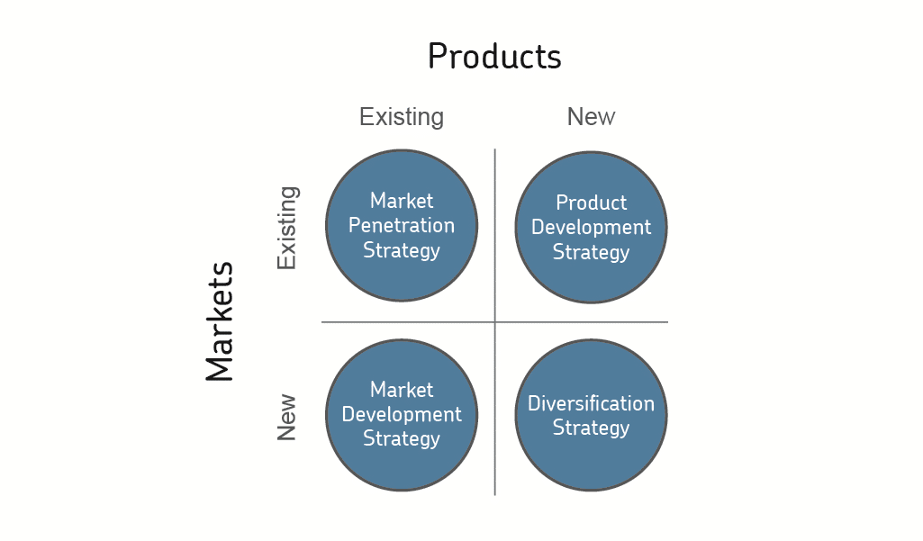
Fig.1 Ansoff matrix

Source: Ansoff, 1957
Based on its key development decisions and choices, Amazon has been effective in its worldwide operations and business. These expansion actions and routes have differed for various regions and at various times – depending on internal and external organisational factors. However, Amazon has constantly used the Ansoff matrix to be one of the world's top beverage conglomerates. The following are some of the techniques that Amazon.com Inc has proven successful using the Ansoff matrix and classifications. Market penetration Businesses that want to grow their existing services in marketplaces where their brand names also now exist and are implementation use the market development strategy. With enhanced manufacturing capacity, Amazon will be able to reach more clients inside the same market. Improved manufacturing capacity also would result in greater efficiency, particularly in terms of controlling overhead costs. Regulated operational expenses would result in competitive pricing, appealing to customers in same market. Improved desirability and better rates within that market will lead to increased purchases as well as consumption – and thus greater brand recognition (Martinet, 2010). Amazon may also invest more money in marketing and promotional actions in order to improve market share. Amazon should strive to create and specification participating interaction useful content to its various markets. Participating in correspondence and investing in marketing and sales will enable Amazon to achieve more purchasers inside the same market. Amazon will be able to gain market expansion in current businesses for current products with increased advertising budget. Amazon can experiment with unique and modern distribution platforms. Amazon can also look into new technologies for their products. New and improved distributors and approaches will enable Amazon to reach new customer segment and consumer advocates in the same market that were previously unavailable. Increased suppliers and distribution networks may result in higher prices. Amazon may implement competitive rates and cost reductions in effort to expand the attraction of its goods. Market competition will provide the better customer experience and will lead to increased consumer engagement with the product. Simultaneously, market competition will increase Amazon's sales and result in increased stimulation. Amazon will cut overhead costs in order to maximise sustainable pricing. Amazon's increased market size and usage would be aided by competitive rates. Lower operating expenses would result in less costs being passed on to customers, making Amazon's goods more attractive and reasonable. Higher availability and usability would aid Amazon in expanding the business (Kipley & Lewis, 2011).
Amazon could boost its sales potential by bringing existing brands into new markets using market expansion techniques. The company will develop software systems and capabilities, as well as enter new business segments for existing devices. It may also test new customer segments for its brands in the same market. The company's international expansion would allow it to gain access to new markets (Amazon, 2021).

Stakeholders’ engagement and their impact on the marketing activities of Amazon

Definition stakeholder
According to R. Edward Freeman, the (grand) father of stakeholder theory, a stakeholder is "any community or entity who may or may not be motivated by the accomplishment of the company's objectives." Freeman (2010) defines formal Stakeholders may be divided into several categories: internal, connected and external stakeholders. The way of identifying stakeholders is through stakeholder analysis. This acknowledges stakeholder desires and power, allowing business owners to consider government priorities (Freeman, 2010).
Amazon's stakeholders include administrators, executives, corporate investors, staff, clients, and the world, with consumers and the community being most important at the moment. In response to environmental challenges, Amazon is more likely to be impacted by social responsibility and would need to mold its business policy to expose its carbon emissions and go green in order to meet the expectations of its conscientious consumers (Amazon, 2021).

Mendelow matrix

Fig.1 Mendelow matrix - Power and interest
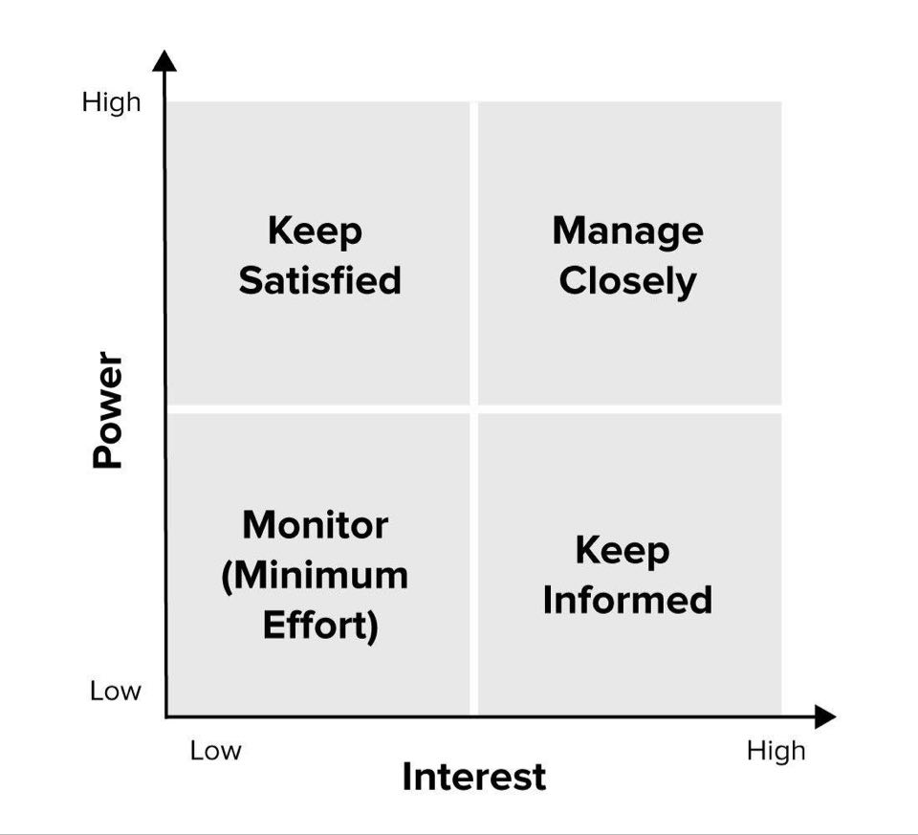
Source: Mendelow, 1991 cited in Johnson, Scholes, and Whittington, 2006
It should be noted that not all participants are equal in terms of power and meaning. Organizations may also create a range of engagement mechanisms depending on their members' influence and involvement. Indeed, stakeholder involvement supports companies in a variety of areas. A stakeholder analysis may help businesses identify the most and least important stakeholders. They can also identify adverse actors and their potential negative impacts on the project by analysis. Different groups have opposing viewpoints on one another. Shareholders, for instance, care about earnings per share, while executives care about healthcare, high wages, and progression. The local people would most probably be involved in the company's job prospects. This is needed for businesses to understand stakeholders and their goals. Perceptions of stakeholders always collide. Stakeholder analysis is indeed very beneficial to all organizations. It encourages identifying and managing risk to classify, assess, and priorities decision makers based on their relevance, influence, and significance. Understanding stakeholder expectations and initiative engagement levels is crucial to the effective implementation of the stakeholder planning and implementation plan (Rahman, 2017).

Amazon communication with stakeholders
As part of Amazon's internalization approach, Amazon develops its partnership expertise through a great network interaction with customers, which will produce innovative, exclusive, unusual, and non-substitutable products and goods that are expected to ensure sustainable competitive advantage in world markets. Amazon, as a massive corporation, must satisfy a variety of underlying stakeholders (Saunders, 2001). Amazon's primary owners include the executive board, creditors, executives, clients, corporate partners, and suppliers. Each stakeholder is influenced by the company's results, but also by the corporation's strategy and planning (Amazon, 2021).
The executive board and creditors hope that the company will develop and benefit even more. The directors anticipate that business innovation will strengthen and that cost savings will be implemented in the organization model, raising the number of profits earned (Spector, 2000). Employees expect to retain their employment, earn more money, and see the company thrive, which will enable them to succeed in their employment (Saunders, 2001). Strategic partners and sellers, on the other hand, want the business to thrive and grow so that they can benefit from better prices for their products, higher returns from the enterprise, and the benefits of brand association with the group. Customers expect retailers to stock greater products at fair prices. They want secure downloads and the opportunity to order easily, and they want their information to be kept private. They also want the company to serve them equally at all periods and to respond promptly to their complaints with the products. The publics concerned with personal well-being and human progress are related to as the community (Spector, 2000). On the stakeholder index, the group has low interest and control. Nonetheless, Amazon is accountable for its carbon footprint, especially in terms of the equipment used and discarded in the packaging of goods sold to customers. Amazon is also recognizing the impact that being environmentally conscious is important for the company's viability in light of consumers' increasing eco-buying desires. As a consequence, considering the current situation, community is a key stakeholder with significant influence and a high level of concern for cautious purchasers. When designing strategies, Amazon prioritizes local and environmental issues. However, critics and average citizens have raised significant concerns about Amazon's environmental impact in the creation of the Kindle, and the packaging. Specialists and the wider community, however, have raised significant concerns about Amazon's carbon emissions in the development of the Kindle, as well as the processing and sale of products bought online from Amazon e-store. It is concerning that Amazon has yet to publish its environmental impact results. Such concerns are casting a false light on Amazon in the eyes of "responsible" consumers, resulting in a negative public image for the company. Amazon would be required to write a CSR study in order to reveal the environmental implications in order to prevent extenuating situations. This necessitates considering the company's carbon footprint and becoming "green." As a result, while CSR does not directly impact the firm, the company has found itself in a situation where it would have to form its strategies around CSR concerns in response to public pressure (Godelnik, 2011).

How stakeholders impact on marketing activity
Consumer orientation is important for businesses who want to make long-term contributions to nurturing customer connections through consistency, support, and creativity. Customer orientation, according to Narver and Slater (1990), is a behavioral aspect of business orientation. Such consumer attention results in pleased consumers who want to purchase from the company and spread positive word of mouth to new customers... The importance of consumer orientation to key marketing results and company success cannot be overstated. It is important for a company to consider its potential consumers in order to have superior service to them (Narver & Slater, 1990).
Employees are "the driving force behind the success of an organization." As per studies, they play a significant role in growing customer interest to the business. A high level of client recognition increases the customer's willingness to pay, thus increasing financial performance. The level to which employees identify with a company is equal to the degree to which customers identify with it company (Hartline & Ferrell, 1996).
A well-performing partnership occurs because both the supplier and the company are comfortable with the relationship's efficacy and performance. Collaboration between a company and its suppliers has been described as a firm's machine ability that improves efficiency and competitive advantages. Failure to meet a supplier's needs, for example, may have a negative impact on a firm. Failure to meet a supplier's needs, for example, may have a detrimental impact on a company when suppliers can avoid delivering a critical input. The firm's partnerships with its suppliers will also help it boost its efficiency (Hill & Jones, 1992).
Firms commit it to their owners to increase their wealth Shareholders in a company as they believe the company can produce higher returns on their money (Day & Fahey, 1988).
Amazon may need to respond to the interests of customers by implementing a robust corporate social responsibility (CSR) policy. Amazon must strengthen its efforts to meet the changing goals and needs of investors in the global e-commerce market as its CSR services and policies change. Customers are prioritized in Amazon's corporate social responsibility approach. Customers are the most important determinant of an e-commerce company's growth. The importance of fair pricing, ease of operation, and online protection when transacting with the firm cannot be overstated. Amazon addresses all of these desires by emphasizing quality and innovations. For safe purchases and reliable procurement and distribution systems, the firm employs cutting-edge information and communication technology (Amazon, 2021).

Conclusion
Having reviewed theory and company practices it can be conclude that Amazon is the supply chain. Constant creativity to disrupt the current state and conventional market practices. Stakeholder marketing necessitates the formation of common beliefs and partnerships with a variety of organizations. Marketers might need to understand that their company is a member of an interconnected network of social relationships. The word "society at large" is not expressly used in this concept of stakeholder marketing because it is difficult to operationalize (Hunt, 2007).

References

Amazon, 2021. Amazon. [Online]
Available at: https://www.aboutamazon.com/
[Accessed 15 04 2021].
Amit, R. & Zott, C., 2001. Value creation in E‐business. Strategic management journal, 22(6/7), pp. 493-520.
Ansoff, H., 1957. Strategies for diversification. Harvard business review, 35(5), pp. 113-124.
Borges, B., 2009. Marketing 2.0 Bridging the Gape between Seller and Buyer through Social Media Marketing. 1st ed. Tucson, Arizona: Wheatmark..
Colgate, M. R. & Danaher, P. J., 2000. Implementing a customerrelationship strategy: The asymmetric impact of poor versus excellent execution. Journal of the Academy of Marketing Science, 28(3), pp. 345-387.
Comai, A. & Tena, J., 2007. Early warning systems for your competitive landscape. Society of Competitive Intelligence Professionals, 10(3).
Day, G. S. & Fahey, L., 1988. Valuing market strategies. Journal ofMarketing, 52(3), pp. 45-57.
Farquhar, P. H., 1989. Managing brand equity. Marketing Research, Volume 1, pp. 24-33.
Frederick, E. & Webster, J., 1992. The Changing Role of Marketing in the Corporation. Journal of Marketing, 56(4), pp. 1-17.
Freeman, R., 2010. Strategic Management: A Stakeholder Approach.. Cambridge: Cambridge University Press.
Godelnik, R., 2011. Why Amazon Needs to Come Clean about its Carbon Footprint.. London: Triple.
Hartline, M. D. & Ferrell, O. C., 1996. The management ofcustomer-contact service employees: An empirical investigation.. Journal of Marketing, 60(4), pp. 52-70.
Hill, C. W. L. & Jones, T. M., 1992. Stakeholder-agency theory.. Journal of Management Studies, 29(2), pp. 131-154.
Hunt, S. D., 2007. A responsibilities framework for marketing as a professional discipline.. Journal of Public Policy & Marketing, 26(2), pp. 277-283.
Kipley, D. & Lewis, A., 2011. Strategic Management: Incorporating Ansoff. New York: Pearson.. New York: Pearson.
Kotler & Keller, 2015. Marketing Management. USA: American Marketing Association (AMA).
Kotler, P., 1972. A generic concept of marketing. Journal of Marketing , 36(2), pp. 46-54.
Kotler, P., 1982. Marketing for nonprofit organizations. 2nd ed. New Jersey: Prentice hall.
Martinet, A., 2010. Strategic planning, strategic management, strategic foresight: The seminal work of H. Igor Ansoff.. Martinet, A., 2010. Strategic planning, strategic management, strategicTechnological Forecasting and Social Change, 77(9), pp. 1485-1487.
Narver, J. C. & Slater, S. F., 1990. The effect of a market orientationb on business profitability. Journal of Marketing, 54(4), pp. 20-35.
Rahman, M., 2017. Stakeholder mapping – stakeholder analysis.. [Online]
Available at: https://www.howandwhat.net/stakeholder-mapping-stakeholder-analysis/
[Accessed 10 4 2021].
Saunders, R., 2001. Business: The Amazon.com.. s.l.:Capstone Publishing Limited.
Spector, R., 2000. Amazon.com: Get Big Fast. New York: Harper Collins.

