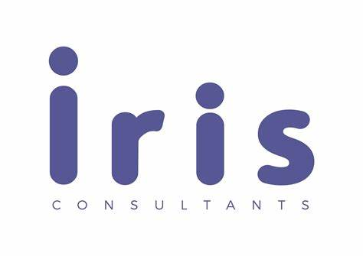

Sheraton Grand Chicago Riverwalk
Housekeeping and Facilities Department
Student name: Madalina Andreea Iordache
Student ID Number: 2119156
Iris Consultants Company
Date: 20.02.2024

Contents List:

Executive Summary.................................................................................................3-8
Introduction.............................................................................................................9-10
Analysis......................................................................................................................11
Issues Identified.................................................................................................11-14
Steeple Analysis......................................................................................................14
Steeple Analysis for Sheraton Grand Chicago Riverwalk Hotel.........................14-16
Soar Analysis..........................................................................................................17
Soar Analysis for Sheraton Grand Chicago Riverwalk Hotel.............................18-19
Tows Analysis.........................................................................................................19
Tows Analysis for Sheraton Grand Chicago Riverwalk Hotel............................20-21
Tows Strategies.................................................................................................21-22
Recommendation and Change Management............................................................22
Recommendation...............................................................................................22-23
Implementation of the suggested measures...........................................................23
Managing the changing suggested....................................................................23-24
Review and Measurement of Impact/Success Rates.............................................24
Change Management Strategies for a Seamless Transition.............................25-26
Potential Hotel Benefits by Implementing Recommended Strategies................26-27
Cost Associated with the Result of Implementing Recommended Strategies.........27
Action Plan.................................................................................................................28
Conclusion..................................................................................................................29
Appendix....................................................................................................................30
References............................................................................................................31-36

Executive Summary

Sheraton Grand Chicago Hotel stands as a beacon of luxury and sophistication, offering guests a lavish retreat during the bustling cityscape. Boasting elegant accommodations, world-class amenities, and breathtaking views of the iconic Chicago River and Lake Michigan, this esteemed hotel exudes a sense of opulence and refinement. With a reputation for impeccable service, exquisite dining options, and a host of upscale facilities, the Sheraton Grand Chicago Hotel sets the standard for hospitality excellence. Whether you seek a tranquil escape or a vibrant urban experience, this distinguished hotel promises a memorable stay that encapsulates the essence of luxury living (sheratongrandchicagoinfo, 2024).
When it comes to divine reviews, the Sheraton Grand Chicago Hotel sparkles like a gem on platforms like TripAdvisor, Trivago, or Expedia. Guests sing praises of its luxurious accommodations, impeccable service, and stunning views, painting a picture of a heavenly stay. However, amidst the radiant reviews, shadows of discontent loom with some negative feedback casting a pall over the hotel's reputation and highlighting some areas of concern (Expedia, 2024).
Guests have expressed dissatisfaction with issues such as inconsistent housekeeping standards, slow response times to guest requests, and subpar maintenance of facilities. These criticisms point to a need for the hotel to enhance its service delivery, operational efficiency, and overall guest experience to address the concerns raised by its patrons (Trip, 2024).
As a result of these blemishes in its reviews, an in-depth consultancy report is required to illuminate and address the underlying problems plaguing this otherwise esteemed establishment.
To analyse the problem and provide effective solutions, this report will utilize various frameworks and theories. The STEEPLE framework will be used to assess the external factors that influence the Housekeeping and Facilities Department, such as social, technological, economic, environmental, political, legal, ethical, and demographic aspects. The SOAR framework will be employed to identify the department's strengths, opportunities, aspirations, and results. Lastly, the TOWS matrix will be utilized to develop strategies by aligning the department's weaknesses and threats with its strengths and opportunities (Databox, 2022).

Issues identified:

- Room interior concerns by not providing kitchenette facilities.
- Cleanliness issues destroying the hotel's luxury image.
- Inadequate delivery of housekeeping services resulting in visitor complaints.
- Staff shortages impacting room service.
- Insufficient parking availability, and limited capacity (Tripadvisor, 2024).

STEEPLE Analysis for Sheraton Grand Chicago Riverwalk Hotel

 | Room Interior Concerns - Lack of Kitchenette Facilities: | Cleanliness Issues Impacting Luxury Image: | Inadequate Delivery of Housekeeping Services and Visitor Complaints: | Staff Shortages Impacting Room Service: | Insufficient Parking Availability and Limited Capacity:
Social Factors: | Guest preferences for convenience and flexibility in-room amenities. | Guest perceptions of cleanliness affect reputation and brand image. | Guest expectations of prompt and efficient housekeeping services. | Impact on guest satisfaction and staff morale due to service delays. | Guest convenience and accessibility are influenced by parking availability.
Technological Factors: | Integration of smart kitchen appliances for enhanced guest experience. | Implementation of advanced cleaning technologies for efficiency. | Implementation of housekeeping management systems for efficiency. | Staff scheduling tools for optimized allocation. | Parking management systems for improved efficiency.
Economic Factors: | Cost implications of adding kitchenette facilities and potential revenue impact. | Investment in cleaning resources to uphold luxury standards. | Cost-effective staffing solutions for improved service delivery. | Investment in recruitment, training, and retention to address shortages. | Cost considerations for expanding parking capacity.
Environmental  Factors: | Incorporation of sustainable kitchenette designs and eco-friendly practices. | Adoption of green cleaning practices for sustainability. | Sustainable housekeeping practices for environmental initiatives. | Staff efficiency for resource optimization | Sustainable parking solutions for environmental alignment.
Political Factors: | Compliance with health and safety regulations for guest room food preparation areas. | Compliance with health and sanitation regulations for guest safety. | Compliance with labour laws in housekeeping staffing. | Compliance with labour laws in staff management. | Compliance with parking regulations and legal requirements.
Legal Factors: | Contractual considerations with suppliers for kitchenette installations. | Risk management for cleanliness-related incidents and guest complaints. | Contractual obligations with service providers and liability considerations. | Employment contracts and liability considerations in service disruptions. | Liability considerations in parking management.
Ethical Factors: | Providing kitchenette facilities aligns with ethical guest-centric service. | Upholding ethical standards of cleanliness for guest trust. | Ethical treatment of staff and service quality standards. | Fair treatment of staff and transparency in communication. | Guest convenience and ethical parking practices.

SOAR Analysis for Sheraton Grand Chicago Riverwalk Hotel

Strengths:  1. Prime Location: Situated along the Chicago Riverwalk, offering scenic views and convenient access to attractions.  2. Brand Reputation: Being part of the Sheraton brand, known for luxury and exceptional hospitality standards.  3. Luxurious Amenities: High-quality facilities including spa, fitness centre, and upscale dining options.  4. Professional Staff: Well-trained and courteous personnel providing top-notch service to guests.  5. Event Spaces: Versatile meeting and event venues suitable for corporate gatherings and special occasions (FourWeekMBA, 2020). | Opportunities:  1. Market Expansion: Explore partnerships or collaborations to attract new market segments.  2. Technology Integration: Implement innovative tech solutions to enhance guest experiences and streamline operations.  3. Sustainability Initiatives: Embrace eco-friendly practices to appeal to environmentally conscious travellers.  4. Enhanced Culinary Offerings: Introduce unique dining experiences or partnerships with renowned chefs.  5. Local Community Engagement: Foster relationships with local businesses and organizations for mutual benefits (Mindtools, 2023).
Aspirations:  1. Service Excellence: Strive for service excellence by exceeding guest expectations and personalizing experiences.  2. Employee Development: Invest in training and development programs to empower staff and enhance skills.  3. Guest Loyalty: Build strong guest loyalty through rewards programs, personalized services, and special offers.  4. Innovative Offerings: Constantly innovate in services, amenities, and guest engagement strategies.  5. Industry Recognition: Aim for industry awards and accolades to showcase excellence in hospitality (Soaranalysis, 2021). | Results:  1. Increased Revenue: Achieve revenue growth through strategic pricing, upselling, and attracting high-value guests.  2. Positive Guest Feedback: Garner positive reviews and ratings on review platforms and social media.  3. Employee Satisfaction: Boost staff morale and retention rates through recognition programs and supportive work culture.  4. Community Impact: Contribute positively to the local community through sustainable practices and partnerships.  5. Competitive Edge: Maintain a competitive edge in the market by consistently delivering exceptional experiences and services (Team, 2023)

TOWS Analysis for Sheraton Grand Chicago Riverwalk Hotel

Strengths (S)  1. Prime Location along Chicago Riverwalk  2. Luxurious Amenities and Facilities  3. Strong Brand Reputation as part of Sheraton  4. Professional and Well-Trained Staff  5. Versatile Event Spaces for Meetings and Events | Weaknesses (W)  1. Limited Local Engagement and Partnerships  2. Potential Overreliance on Brand Name  3. High Competition in the Chicago Hospitality Market  4. Room for Improvement in Sustainability Practices  5. Room for Innovation in Culinary Offerings
Opportunities (O)  1. Market Expansion to Attract New Segments  2. Technology Integration for Enhanced Guest Experiences  3. Sustainability Initiatives to Attract Eco-Conscious Travelers  4. Enhanced Culinary Offerings through Partnerships  5. Local Community Engagement for Mutual Benefits | Threats (T)  1. External Economic Factors Impacting Travel Industry  2. Intense Competition from Other Luxury Hotels in Chicago  3. Changing Consumer Preferences and Expectations  4. Potential Disruption from Sharing Economy Platforms  5. Negative Impact of Environmental Issues on Tourism
(VisualParadigm, 2024).

Action Plan

Number | Problem | Solution | Desired outcome | Time Scale | Completion Date | Planned Budget
1 | Room interior lacks kitchenette facilities | Renovate a portion of rooms to include kitchenette facilities | Improved guest satisfaction and longer stays | 6 months | End of the renovation period | £50,000
2 | Cleanliness issues affecting the hotel's luxury image | Implement stricter cleaning protocols and staff training | Enhanced cleanliness standards and positive guest reviews | Ongoing | Continuous improvement | £15,000 for training and equipment upgrades
3 | Inadequate delivery of housekeeping services leading to visitor complaints | Increase housekeeping staff and streamline processes | Timely and efficient housekeeping services | 3 months | Implementation within 3 months | £15,000 for hiring and training
4 | Staff shortages impacting room service | Cross-train existing staff and hire additional personnel | Improved room service efficiency | 2 months | Staff training within 2 months | £15,000 for training and recruitment
5 | Insufficient parking availability and limited capacity | Expand parking facilities or establish partnerships with nearby parking garages | Increased parking capacity for guests | 1 year | Implementation within 1 year | £20,000 for expansion or partnerships
(Michael Z, 2024).

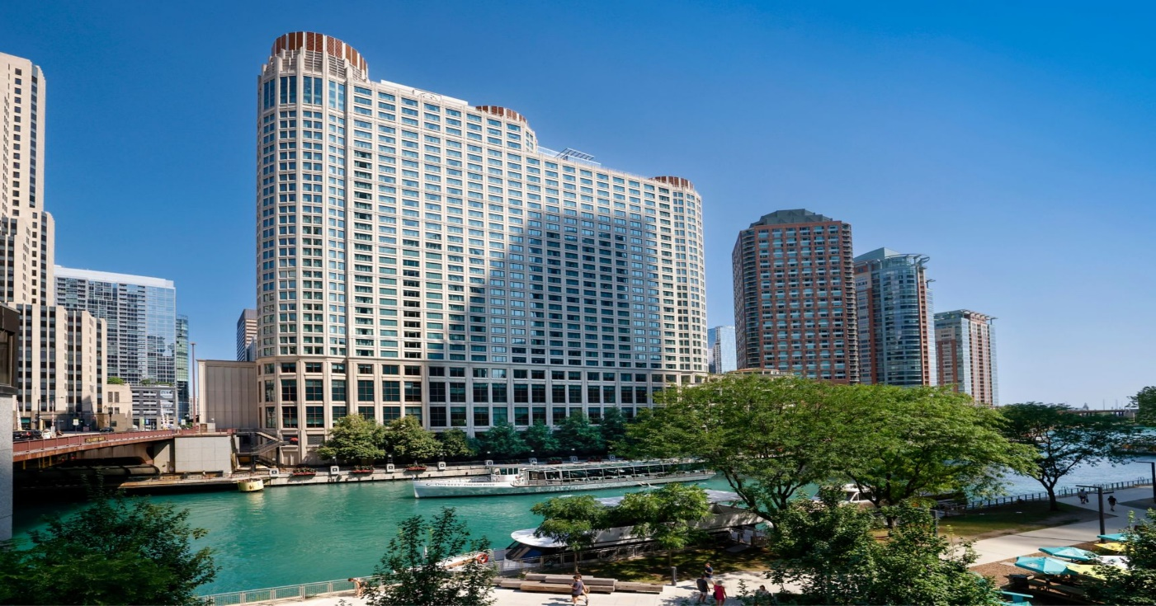
Figure-1 Sheraton Grand Chicago Riverwalk Hotel (Marriott, 2024).

Introduction:

Sheraton Hotels & Resorts is a global hotel brand that was founded in 1937 and became part of Starwood Hotels & Resorts Worldwide, Inc. in 1998. In 2016, Sheraton merged with Marriott International and became part of the world's largest hotel company (Sheraton Hotels & Resorts, 2019).
Sheraton Grand Chicago Riverwalk is a renowned hotel located in the heart of the river North district in Chicago, Illinois, known for its luxurious accommodations and excellent services. The hotel has been in operation for several years and is well-established in the hospitality industry. It offers a range of amenities and services to cater to the needs of its guests (Marriott, 2024).

The hotel has 1,218 guestrooms and suites inspired by the Riverwalk and vessels that navigate the nearby Chicago River. All guestrooms and suites feature high-speed internet access, a desk area, and a personal safe (Marriott, 2024).
Sheraton Grand Chicago offers a range of room prices to cater to the diverse needs and preferences of its guests. The hotel offers various room types, including standard rooms, deluxe rooms, suites, and executive rooms, each with its own unique features and amenities (Marriott, 2024).
The room prices are influenced by factors such as the room type, the seasonality of the demand, the duration of stay, and any additional services or packages requested by the guests. The hotel follows a dynamic pricing strategy, which means that room rates may vary based on factors like availability, demand, and special events happening in the city.
To provide a general idea of the room prices at Sheraton Grand Chicago, the starting rates for standard rooms typically range from £150 to £300 per night. Deluxe rooms, which offer additional space and upgraded amenities, may start from £250 to £400 per night. Suites, providing more luxurious accommodations and extra living space, can range from £400 to £800 per night. Executive rooms, designed for business travelers and offering exclusive access to executive lounges and additional services, may start from £300 to £500 per night (Sheratongrandchicagoinfo, 2024).
The hotel offers a variety of on-property restaurants that cater to different preferences such as Shula's Steak House, Riverside Café, Link Café, CHI Bar, A La Carte, and Chicago Burger Company (Seasonal).
The Housekeeping and Facilities Department plays a crucial role in maintaining the cleanliness and functionality of the hotel (Triviago, 2019).
Recent issues in these departments have impacted overall guest satisfaction and operational efficiency. This consultancy report aims to identify the key challenges faced by these departments and provide recommendations for improvement.

To analyse the problem and provide effective solutions, this report will utilize various frameworks and theories. The STEEPLE framework will be used to assess the external factors that influence the Housekeeping and Facilities Department, such as social, technological, economic, environmental, political, legal, ethical, and demographic aspects. The SOAR framework will be employed to identify the department's strengths, opportunities, aspirations, and results. Lastly, the TOWS matrix will be utilized to develop strategies by aligning the department's weaknesses and threats with its strengths and opportunities (Databox, 2022).
Iris Consultants, the consultancy firm responsible for this report, is renowned for its expertise in the hospitality industry. With years of experience and a track record of successful projects, Iris Consultants brings a wealth of knowledge to address the challenges faced by the Housekeeping and Facilities Department at Sheraton Grand Chicago Riverwalk. Our team of consultants will employ their industry insights, analytical skills, and best practices to deliver practical recommendations for improvement (Consultancy, 2024).

Analysis:

Sheraton Grand Chicago Riverwalk Hotel stands as a beacon of luxury and sophistication, offering guests a lavish retreat during the bustling cityscape. Boasting elegant accommodations, world-class amenities, and breathtaking views of the iconic Chicago River and Lake Michigan, this esteemed hotel exudes a sense of opulence and refinement. With a reputation for impeccable service, exquisite dining options, and a host of upscale facilities, the Sheraton Grand Chicago Hotel sets the standard for hospitality excellence. Whether you seek a tranquil escape or a vibrant urban experience, this distinguished hotel promises a memorable stay that encapsulates the essence of luxury living (sheratongrandchicagoinfo, 2024).
When it comes to divine reviews, the Sheraton Grand Chicago Hotel sparkles like a gem on platforms like TripAdvisor, Trivago, or Expedia. Guests sing praises of its luxurious accommodations, impeccable service, and stunning views, painting a picture of a heavenly stay. However, amidst the radiant reviews, shadows of discontent loom with some negative feedback casting a pall over the hotel's reputation and highlighting some areas of concern (Expedia, 2024).
Guests have expressed dissatisfaction with issues such as inconsistent housekeeping standards, slow response times to guest requests, and subpar maintenance of facilities. These criticisms point to a need for the hotel to enhance its service delivery, operational efficiency, and overall guest experience to address the concerns raised by its patrons (Trip, 2024).
As a result of these blemishes in its reviews, an in-depth consultancy report is required to illuminate and address the underlying problems plaguing this otherwise esteemed establishment.

Issues identified:

- Room interior concerns by not providing kitchenette facilities.
- Cleanliness issues destroying the hotel's luxury image.
- Inadequate delivery of housekeeping services resulting in visitor complaints.
- Staff shortages impacting room service.
- Insufficient parking availability, limited capacity (Tripadvisor, 2024).

1. Room interior concerns by not providing kitchenette facilities:
Impact on the hotel:
This issue can negatively impact guest satisfaction and lead to complaints. Guests who prefer the convenience of having kitchenette facilities may choose to stay at other hotels that offer this amenity.
Possible causes:
The hotel may have opted to prioritize other amenities or may have limited space to accommodate kitchenette facilities. It could also be a cost-saving measure to reduce expenses related to the maintenance and cleaning of kitchenette areas (EHL Insights, 2023).
2. Cleanliness issues destroying the hotel's luxury image:
Impact on the hotel:
Cleanliness issues can significantly damage a hotel's reputation, especially if it is marketed as a luxury establishment. Guests may leave negative reviews, resulting in a decline in bookings and potential loss of revenue (Kamburov-Niepewna, 2021).
Possible causes:
Inadequate training of housekeeping staff, lack of proper cleaning procedures, or insufficient resources allocated to maintain cleanliness standards could be contributing factors (Brown, 2022).
3. Inadequate delivery of housekeeping services resulting in visitor complaints:

Impact on the hotel:

Guest satisfaction and overall experience can be severely affected by subpar housekeeping services. Frequent complaints may lead to a decline in guest loyalty and negative word-of-mouth, impacting the hotel's reputation (Quora, 2019).
Possible causes:
Insufficient staffing, lack of proper training or supervision of housekeeping staff, high turnover rate, or inadequate communication channels between guests and housekeeping department can contribute to this issue (guesttouch, 2022).
4. Staff shortages impacting room service:
Impact on the hotel:
Staff shortages can result in delayed or inefficient room service, leading to guest dissatisfaction. This can affect the hotel's reputation and result in negative reviews and a decline in repeat business.
Possible causes:
Inadequate staffing levels, high turnover rate, poor scheduling, or unexpected absences can all contribute to staff shortages in the room service department (McKinsey, 2022).
5. Insufficient parking availability, limited capacity:
Impact on the hotel:
Limited parking capacity can inconvenience guests who require parking, potentially leading to frustration and negative reviews. It may also deter potential guests from choosing the hotel, impacting bookings and revenue (Hotelchantelle, 2023).
Possible causes:
Limited physical space for parking, inadequate planning or design of the parking area, or an increase in the number of guests with vehicles without a corresponding increase in parking capacity can all contribute to this issue (STR, 2021).
Feedback:
Feedback is crucial in identifying and addressing these issues. Guest feedback can provide valuable insights into areas that need improvement, allowing the hotel management to take corrective actions (Cloudbeds, 2022).
Reputation:
All the mentioned issues can impact the hotel's reputation. Negative reviews, complaints, and poor guest experiences can tarnish the hotel's image and make it less desirable for potential guests (Petrilli, 2023).
Income:
Issues such as cleanliness concerns, inadequate housekeeping services, and insufficient parking availability can lead to a decline in bookings and revenue. Dissatisfied guests may choose alternative accommodations, resulting in a loss of income for the hotel (Glavonjić, 2023).
Scope:
The scope of these issues extends beyond individual guest experiences. They can have a ripple effect, impacting the overall reputation and financial performance of the hotel. It is important for the hotel management to address these issues promptly and effectively to mitigate their impact (Indeed Career Guide, 2023).

STEEPLE Analysis:

A STEEPLE analysis in is a strategic management tool that evaluates various external factors impacting the industry. The acronym STEEPLE stands for:
1. Social: Refers to societal trends, demographics, cultural norms, and consumer behaviours that influence the hospitality sector. This includes factors such as changing guest preferences, lifestyle patterns, and social expectations related to service quality and experiences (Frue, 2020).
2. Technological: Encompasses advancements in technology that can create opportunities or challenges for hotels. This includes innovations in guest services, property management systems, online booking platforms, smart room technology, and digital marketing strategies (Masterclass, 2022).
3. Economic: Focuses on economic factors that affect the hospitality industry, such as global economic trends, exchange rates, inflation rates, and consumer spending patterns. Economic factors can impact travel demand, pricing strategies, and investment decisions in the hotel sector (Kenique, 2022).
4. Environmental: Considers environmental sustainability, eco-friendly practices, and green initiatives within the hospitality industry. This includes energy efficiency, waste management, water conservation, and sustainable development practices that hotels can adopt to reduce their environmental footprint (Frue, 2020).
5. Political: Involves governmental regulations, policies, and political stability that influence the operations of hotels. This includes labour laws, taxation policies, safety regulations, zoning laws, and government initiatives that impact the hospitality sector (Kenique, 2022).
6. Legal: Focuses on legal considerations and regulatory requirements that hotels must adhere to in their operations. This includes licensing requirements, health and safety regulations, employment laws, data protection regulations, and contractual obligations with suppliers and partners (Masterclass, 2022).
7. Ethical: Addresses ethical considerations and corporate social responsibility in the hospitality industry. This includes ethical business practices, fair treatment of employees, diversity and inclusion initiatives, community engagement, and transparency in operations (Frue, 2020).

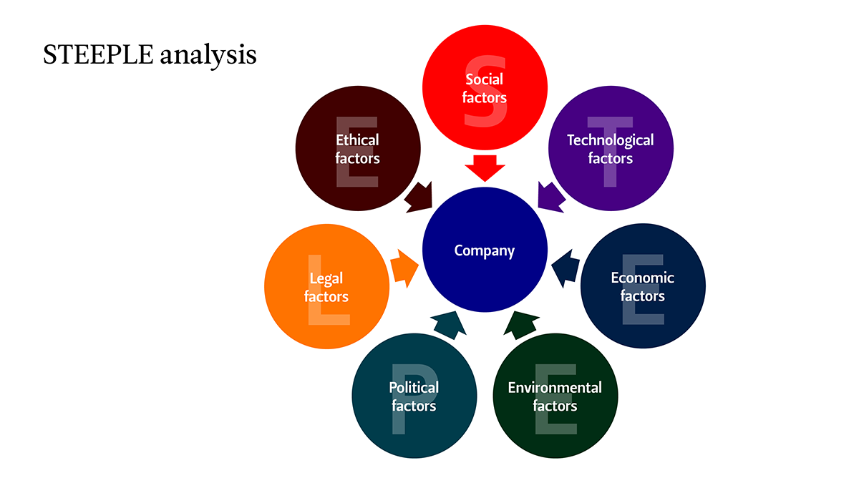
Figure-3 STEEPLE Analysis (Bollig, 2021).

STEEPLE Analysis for Sheraton Grand Chicago Riverwalk Hotel

 | Room Interior Concerns - Lack of Kitchenette Facilities: | Cleanliness Issues Impacting Luxury Image: | Inadequate Delivery of Housekeeping Services and Visitor Complaints: | Staff Shortages Impacting Room Service: | Insufficient Parking Availability and Limited Capacity:
Social Factors: | Guest preferences for convenience and flexibility in room amenities. | Guest perceptions of cleanliness affecting reputation and brand image. | Guest expectations of prompt and efficient housekeeping services. | Impact on guest satisfaction and staff morale due to service delays. | Guest convenience and accessibility influenced by parking availability.
Technological Factors: | Integration of smart kitchen appliances for enhanced guest experience. | Implementation of advanced cleaning technologies for efficiency. | Implementation of housekeeping management systems for efficiency. | Staff scheduling tools for optimized allocation. | Parking management systems for improved efficiency.
Economic Factors: | Cost implications of adding kitchenette facilities and potential revenue impact. | Investment in cleaning resources to uphold luxury standards. | Cost-effective staffing solutions for improved service delivery. | Investment in recruitment, training, and retention to address shortages. | Cost considerations for expanding parking capacity.
Environmental  Factors: | Incorporation of sustainable kitchenette designs and eco-friendly practices. | Adoption of green cleaning practices for sustainability. | Sustainable housekeeping practices for environmental initiatives. | Staff efficiency for resource optimization | Sustainable parking solutions for environmental alignment.
Political Factors: | Compliance with health and safety regulations for guest room food preparation areas. | Compliance with health and sanitation regulations for guest safety. | Compliance with labour laws in housekeeping staffing. | Compliance with labour laws in staff management. | Compliance with parking regulations and legal requirements.
Legal Factors: | Contractual considerations with suppliers for kitchenette installations. | Risk management for cleanliness-related incidents and guest complaints. | Contractual obligations with service providers and liability considerations. | Employment contracts and liability considerations in service disruptions. | Liability considerations in parking management.
Ethical Factors: | Providing kitchenette facilities aligns with ethical guest-centric service. | Upholding ethical standards of cleanliness for guest trust. | Ethical treatment of staff and service quality standards. | Fair treatment of staff and transparency in communication. | Guest convenience and ethical parking practices.

SOAR analysis:

A SOAR analysis is a strategic planning tool that focuses on the organization's strengths, opportunities, aspirations, and results. It is a positive and future-oriented approach that helps organizations identify and leverage their internal capabilities and external opportunities to achieve their desired outcomes. Here is a brief overview of each component of a SOAR analysis:
1. Strengths: This involves identifying the internal strengths and advantages that the organization possesses. These can include resources, capabilities, expertise, reputation, and other factors that give the organization a competitive edge (Team, 2023).
2. Opportunities: This refers to external factors and situations that the organization can capitalize on to achieve its goals. Opportunities can arise from market trends, technological advancements, industry developments, partnerships, and other favorable circumstances (Momin, 2023).
3. Aspirations: Aspirations are the organization's ambitious goals and objectives that it aims to achieve in the future. These can be related to growth, innovation, customer satisfaction, employee development, sustainability, or any other strategic priorities (Momin, 2023).
4. Results: Results are the measurable outcomes that the organization seeks to attain by leveraging its strengths, capitalizing on opportunities, and pursuing its aspirations. These outcomes can include financial performance, customer satisfaction, employee engagement, market share growth, and other key metrics of success (Team, 2023).

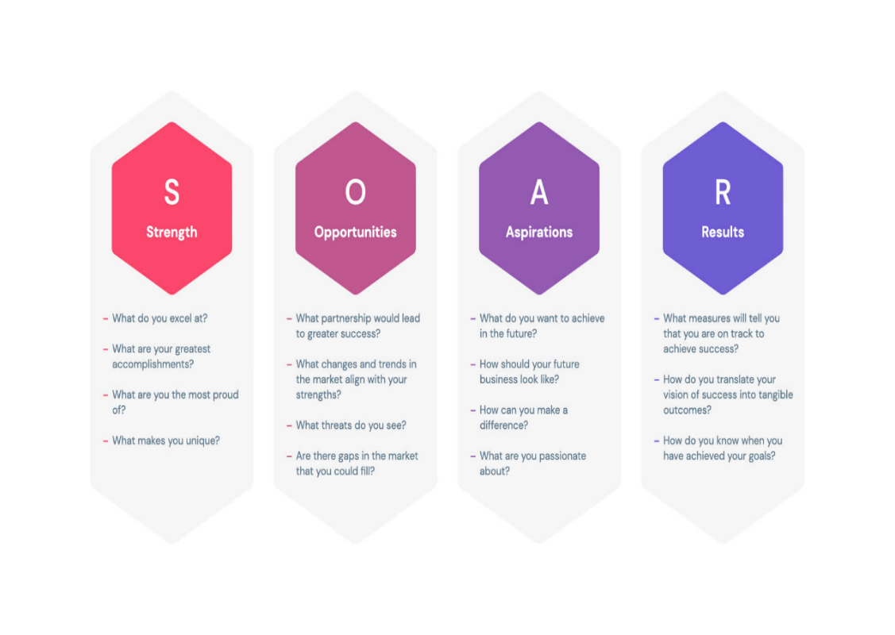
Figure-4 SOAR Analysis (Slideegg, 2024).

SOAR Analysis for Sheraton Grand Chicago Riverwalk Hotel

Strengths:  1. Prime Location: Situated along the Chicago Riverwalk, offering scenic views and convenient access to attractions.  2. Brand Reputation: Being part of the Sheraton brand, known for luxury and exceptional hospitality standards.  3. Luxurious Amenities: High-quality facilities including spa, fitness center, and upscale dining options.  4. Professional Staff: Well-trained and courteous personnel providing top-notch service to guests.  5. Event Spaces: Versatile meeting and event venues suitable for corporate gatherings and special occasions (FourWeekMBA, 2020). | Opportunities:  1. Market Expansion: Explore partnerships or collaborations to attract new market segments.  2. Technology Integration: Implement innovative tech solutions to enhance guest experiences and streamline operations.  3. Sustainability Initiatives: Embrace eco-friendly practices to appeal to environmentally conscious travelers.  4. Enhanced Culinary Offerings: Introduce unique dining experiences or partnerships with renowned chefs.  5. Local Community Engagement: Foster relationships with local businesses and organizations for mutual benefits (Mindtools, 2023).
Aspirations:  1. Service Excellence: Strive for service excellence by exceeding guest expectations and personalizing experiences.  2. Employee Development: Invest in training and development programs to empower staff and enhance skills.  3. Guest Loyalty: Build strong guest loyalty through rewards programs, personalized services, and special offers.  4. Innovative Offerings: Constantly innovate in services, amenities, and guest engagement strategies.  5. Industry Recognition: Aim for industry awards and accolades to showcase excellence in hospitality (Soaranalysis, 2021). | Results:  1. Increased Revenue: Achieve revenue growth through strategic pricing, upselling, and attracting high-value guests.  2. Positive Guest Feedback: Garner positive reviews and ratings on review platforms and social media.  3. Employee Satisfaction: Boost staff morale and retention rates through recognition programs and supportive work culture.  4. Community Impact: Contribute positively to the local community through sustainable practices and partnerships.  5. Competitive Edge: Maintain a competitive edge in the market by consistently delivering exceptional  experience. (Team, 2023)

TOWS Analysis

A TOWS analysis is a strategic planning tool that stands for Threats, Opportunities, Weaknesses, and Strengths. It is a framework used to analyse the internal and external factors affecting an organization and develop strategic responses to capitalize on opportunities, mitigate threats, leverage strengths, and address weaknesses. The TOWS analysis involves identifying the relationship between these four elements to create strategies that align with the organization's objectives and competitive environment. By conducting a TOWS analysis, organizations can develop actionable strategies that leverage their strengths to capitalize on opportunities, mitigate weaknesses to address threats, and ultimately achieve their strategic goals (Wallbridge, 2022).

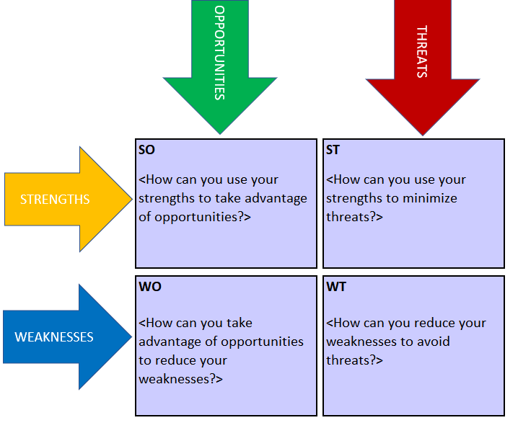
Figure-5 TOWS Analysis (Stakeholdermap, 2024).

TOWS Analysis for Sheraton Grand Chicago Riverwalk Hotel

Strengths (S)  1. Prime Location along the Chicago Riverwalk  2. Luxurious Amenities and Facilities  3. Strong Brand Reputation as part of Sheraton  4. Professional and Well-Trained Staff  5. Versatile Event Spaces for Meetings and Events | Weaknesses (W)  1. Limited Local Engagement and Partnerships  2. Potential Overreliance on Brand Name  3. High Competition in the Chicago Hospitality Market  4. Room for Improvement in Sustainability Practices  5. Room for Innovation in Culinary Offerings
Opportunities (O)  1. Market Expansion to Attract New Segments  2. Technology Integration for Enhanced Guest Experiences  3. Sustainability Initiatives to Attract Eco-Conscious Travelers  4. Enhanced Culinary Offerings through Partnerships  5. Local Community Engagement for Mutual Benefits | Threats (T)  1. External Economic Factors Impacting Travel Industry  2. Intense Competition from Other Luxury Hotels in Chicago  3. Changing Consumer Preferences and Expectations  4. Potential Disruption from Sharing Economy Platforms  5. Negative Impact of Environmental Issues on Tourism
(VisualParadigm, 2024).

TOWS Strategies:

SO Strategies (Maximize Strengths to Exploit Opportunities)  1. Utilize Prime Location and Brand Reputation to Expand into New Markets.  2. Enhance Technological Integration to Improve Guest Experiences and Attract Tech-Savvy Travelers.  3. Leverage Luxurious Amenities and Sustainability Initiatives to Appeal to Eco-Conscious Guests.  4. Capitalize on Professional Staff and Event Spaces for Enhanced Culinary Offerings and Partnerships.  5. Foster Local Community Engagement to Enhance Reputation and Drive Business Growth (Learnleansigma, 2023). | WO Strategies (Overcome Weaknesses by Exploiting Opportunities)  1. Address Limited Local Engagement by Leveraging Opportunities for Community Partnerships.  2. Mitigate Overreliance on Brand Name by Innovating Culinary Offerings through Partnerships.  3. Use Sustainability Initiatives to Overcome Weaknesses in Environmental Practices.  4. Enhance Innovation in Culinary Offerings to Stand Out in Competitive Market.  5. Collaborate with Technology Partners to Improve Guest Experiences and Offset Weaknesses in Tech Integration (DeBruin, 2019).
ST Strategies (Maximize Strengths to Counter Threats)  1. Leverage Prime Location and Strong Brand Reputation to Counter External Economic Factors.  2. Utilize Luxurious Amenities and Professional Staff to Compete Effectively with Other Luxury Hotels.  3. Enhance Event Spaces and Culinary Offerings to Adapt to Changing Consumer Preferences.  4. Utilize Professional Staff and Brand Reputation to Differentiate from Sharing Economy Platforms.  5. Implement Sustainability Initiatives to Address the Negative Impact of Environmental Issues (Professionalacademy, 2024). | WT Strategies (Minimize Weaknesses and Avoid Threats)  1. Address Weaknesses in Local Engagement to Mitigate Threats from Intense Competition.  2. Diversify Offerings and Innovate Culinary Options to Overcome Threats from Changing Consumer Preferences.  3. Improve Sustainability Practices to Counter Potential Disruption from Environmental Issues.  4. Enhance Innovation in Culinary Offerings to Mitigate Threats from Sharing Economy Platforms.  5. Collaborate with Technology Partners to Address Threats from External Economic Factors.  (Phantran, 2021).

Recommendations and Change Management

Recommendations:
1. Room interior concerns by not providing kitchenette facilities:
- Conduct a feasibility study to assess the space and cost implications of adding kitchenette facilities to some rooms.
- Identify the target market segments that value kitchenette facilities and prioritize the implementation in those room categories.
- Communicate the availability of kitchenette facilities on the hotel's website and other booking platforms to attract guests who specifically require this amenity.
2. Cleanliness issues destroying the hotel's luxury image:
- Review and revise the cleaning procedures and protocols to ensure consistent and high-quality cleaning standards are maintained.
- Invest in staff training to improve cleaning techniques and emphasize the importance of attention to detail.
- Implement regular inspections and audits to monitor cleanliness standards and address any issues promptly (APM, 2019).
3. Inadequate delivery of housekeeping services resulting in visitor complaints:
- Conduct a thorough analysis of the housekeeping department's workload and staffing requirements.
- Adjust staffing levels and schedules to ensure adequate coverage and minimize the chances of service delays.
- Improve communication channels between guests and housekeeping to address any specific requests or concerns promptly.
4. Staff shortages impacting room service:
- Evaluate the staffing needs of the room service department and adjust accordingly.
- Explore the possibility of cross-training existing staff members to handle room service duties during peak periods.
- Implement a system for efficient scheduling and shift management to optimize staff utilization (George, 2023).
5. Insufficient parking availability, limited capacity:
- Explore options for expanding the parking capacity, such as utilizing nearby parking lots or partnering with nearby establishments for shared parking arrangements.
- Implement a reservation system or prioritize parking spaces for guests based on their needs and length of stay.
- Provide alternative transportation options for guests, such as shuttle services or partnerships with local transportation providers (Dana and Cassie 2021).
Implementation of the suggested measures:
1. Assign a dedicated project team to oversee the implementation of each recommendation.
2. Develop a detailed action plan with specific timelines and responsibilities for each recommendation.
3. Allocate the necessary resources, including budget, staff, and technology, to support the implementation process.
4. Conduct regular progress reviews and address any obstacles or challenges that arise during the implementation phase.
5. Communicate the changes and improvements to both staff and guests to ensure a smooth transition and manage expectations (Trepanier, 2021).

Managing the changes suggested:
1. Provide comprehensive training and guidance to all staff members involved in the implementation process to ensure a common understanding of the changes and their objectives.
2. Establish clear communication channels for staff to provide feedback and address any concerns or questions they may have.
3. Monitor the impact of the changes on guest satisfaction, revenue, and other relevant performance indicators.
4. Continuously evaluate and refine the implemented measures based on feedback and performance data.
5. Maintain open lines of communication with guests to gather feedback and address any issues or suggestions they may have (S.A.R. Macau, 2015).

Review and Measurement of Impact/Success Rates:
1. Guest Satisfaction Surveys: Conduct regular guest satisfaction surveys to measure improvements in cleanliness, housekeeping services, room service, and parking availability. Compare feedback before and after implementing the recommended strategies.
2. Online Reviews and Ratings: Monitor online review platforms to track changes in the hotel's reputation and ratings. Positive reviews and increased ratings can indicate the success of the implemented measures.
3. Revenue and Booking Data: Analyse revenue trends and booking patterns to assess the impact of the strategies on occupancy rates, average room rates, and overall financial performance.
4. Staff Feedback and Turnover Rates: Measure staff satisfaction levels and turnover rates to gauge the effectiveness of staffing adjustments and training programs in improving service delivery (Researchgate, 2017).

Change Management Strategies for a Seamless Transition:

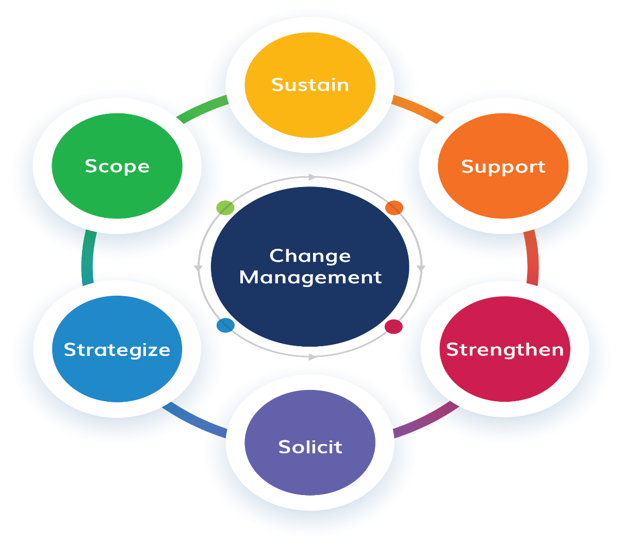
Figure-6 Change Management (Iso, 2023).

1. Clear Communication:
Communicate the reasons for change, the benefits it will bring, and how it aligns with the hotel's goals. Ensure all staff members understand the purpose and expected outcomes of the recommended strategies.
2. Stakeholder Engagement:
Involve key stakeholders, including staff members, department heads, and guests, in the change process. Seek their input, address concerns, and encourage participation to build a sense of ownership and commitment.
3. Training and Development:
Provide comprehensive training and development programs to equip staff with the necessary skills and knowledge to implement the recommended strategies effectively. Offer ongoing support and resources to facilitate learning and adaptation.
4. Change Champions:
Identify and empower change champions within the organization who can advocate for the recommended strategies, motivate their peers, and drive positive change. Recognize and reward their efforts to inspire others.
5. Incremental Implementation:
Break down the implementation of the strategies into manageable phases or steps to avoid overwhelming staff and guests. Gradual changes allow for smoother adaptation and reduce resistance to change.
6. Feedback Mechanisms:
Establish feedback mechanisms, such as suggestion boxes, regular meetings, and surveys, to gather input from staff and guests throughout the transition process. Use feedback to address concerns, adjust, and ensure continuous improvement.
7. Celebrate Successes:
Acknowledge and celebrate milestones and achievements reached during the transition period. Recognize individual and team efforts, share success stories, and highlight positive outcomes to boost morale and motivation.
8. Flexibility and Adaptability:
Remain flexible and adaptable to unforeseen challenges or obstacles that may arise during the transition. Encourage a culture of openness to change, creativity, and innovation to facilitate a smooth and successful transition (Bryson, 2018).

Potential Hotel Benefits by Implementing Recommended Strategies:
1. Improved Guest Satisfaction:
Enhanced cleanliness, housekeeping services, room service efficiency, and parking availability can lead to higher guest satisfaction levels and positive word-of-mouth recommendations.
2. Enhanced Reputation:
Addressing the identified issues can help restore and strengthen the hotel's luxury image, leading to increased brand recognition and loyalty among guests.
3. Increased Revenue:
Satisfied guests are more likely to return and recommend the hotel to others, resulting in higher occupancy rates, improved room rates, and overall revenue growth.
4. Competitive Advantage:
By offering kitchenette facilities, superior cleanliness, efficient housekeeping services, and adequate parking, the hotel can differentiate itself from competitors and attract a wider range of guests (Jaaron et all, 2022).
Cost Associated with the Result of Implementing Recommended Strategies:
Initial Investment:
- Renovation for kitchenette facilities: £50,000
- Training programs for staff: £25,000
- Cleaning equipment and supplies upgrade: £5,000
- Parking expansion and enhancement: £20,000
Ongoing Costs:
- Staffing adjustments and additional hires: £15,000 per month
- Maintenance and upkeep of new facilities: £2,000 per month
- Marketing and communication expenses: £5,000 per quarter
Total Cost for Implementation:
Initial Investment: £100,000
Annual Ongoing Costs: £222,000
While the initial investment and ongoing costs may seem significant, the potential benefits of improved guest satisfaction, reputation, and revenue generation implement the recommended strategies a worthwhile investment for the hotel in the long run.

Action Plan

Number | Problem | Solution | Desired outcome | Time Scale | Completion Date | Planned Budget
1 | Room interior lacks kitchenette facilities | Renovate a portion of rooms to include kitchenette facilities | Improved guest satisfaction and longer stays | 6 months | End of the renovation period | £50,000
2 | Cleanliness issues affecting the hotel's luxury image | Implement stricter cleaning protocols and staff training | Enhanced cleanliness standards and positive guest reviews | Ongoing | Continuous improvement | £15,000 for training and equipment upgrades
3 | Inadequate delivery of housekeeping services leading to visitor complaints | Increase housekeeping staff and streamline processes | Timely and efficient housekeeping services | 3 months | Implementation within 3 months | £15,000 for hiring and training
4 | Staff shortages impacting room service | Cross-train existing staff and hire additional personnel | Improved room service efficiency | 2 months | Staff training within 2 months | £15,000 for training and recruitment
5 | Insufficient parking availability and limited capacity | Expand parking facilities or establish partnerships with nearby parking garages | Increased parking capacity for guests | 1 year | Implementation within 1 year | £20,000 for expansion or partnerships
(Michael Z, 2024).

Conclusion

The comprehensive consultancy report prepared for Sheraton Grand Chicago Riverwalk Hotel has identified crucial issues affecting the hotel's operations and guest experience. Through detailed STEEPLE, TOWS, and SOAR analyses, key insights have been gleaned to address room interior concerns, cleanliness issues, housekeeping service deficiencies, staff shortages, parking availability, and limited capacity.
The recommendations and change management strategies outlined in the report aim to drive positive transformation and sustainable improvements across various facets of the hotel's operations. By implementing these recommendations, the hotel can enhance its luxury image, elevate service standards, and overcome operational challenges to meet guest expectations effectively.
The action plan provided offers a roadmap for the hotel to implement changes systematically and strategically, ensuring a smooth transition towards a more efficient and guest-centric approach. With a focus on continuous improvement and innovation, Sheraton Grand Chicago Riverwalk Hotel can position itself as a prominent player in the competitive hospitality industry, delivering exceptional experiences and maintaining a strong market presence.
Iris Consultants Company is committed to assisting the hotel in meeting its objectives and driving success through customised solutions and collaborative efforts. Together, we can overcome obstacles, seize opportunities, and realise Sheraton Grand Chicago Riverwalk Hotel's full potential for long-term growth and excellence.
Iris Consultants Company would like to thank the Sheraton Grand Chicago Riverwalk Hotel for considering collaborating with us on a consultancy report. We are confident that our expertise, insights, and innovative solutions will significantly benefit the hotel's operations and strategic initiatives. We believe that by collaborating, we can drive success, improve performance, and achieve mutual growth in the rapidly evolving hospitality industry. We look forward to the opportunity to collaborate with the Sheraton Grand Chicago Riverwalk Hotel.

Appendix

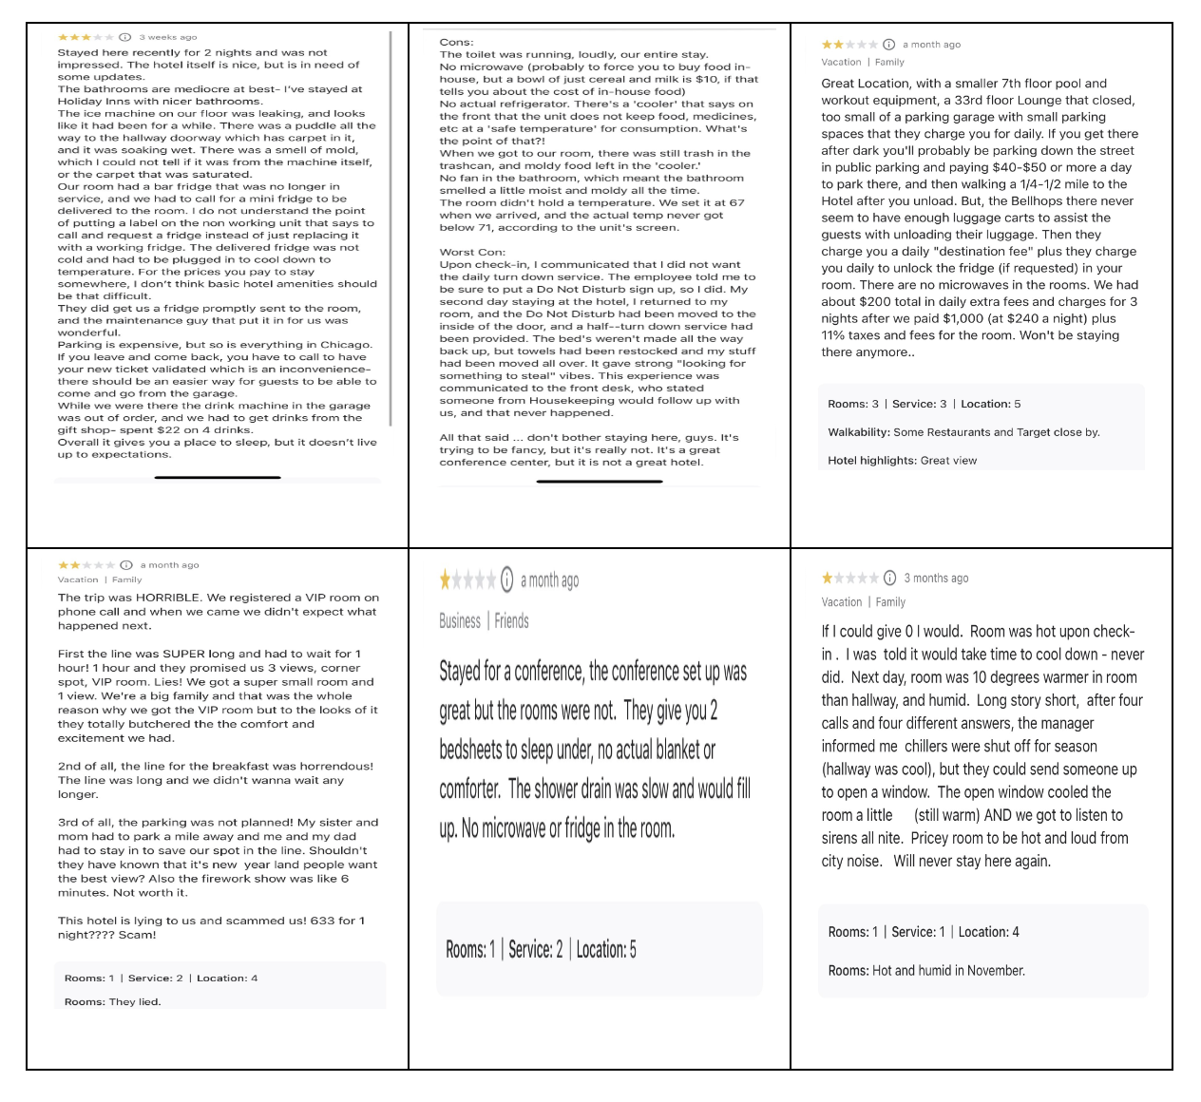
Figure-2 Tripadvisor reviews, Sheraton Grand Chicago Hotel (Tripadvisor, 2024).

References

APM (2019). What is change management and organisational change? Available at: https://www.apm.org.uk/resources/what-is-project-management/what-is-change-management/. (Accessed 21 Feb. 2024).

Bollig, M. (2021). Situation Analysis in Marketing. Available at: https://svaerm.com/en/blog/situation-analysis/. (Accessed 20 Feb. 2024).

Bryson, J.M., 2018. Strategic Planning for Public and Nonprofit Organizations: A Guide to Strengthening and Sustaining Organizational Achievement. John Wiley & Sons.

Brown, A. (2022). How to Improve Performance Management Through Training. Available at: https://www.northpass.com/blog/how-to-improve-performance-management-through-training. (Accessed 21 Feb. 2024).

Cloudbeds (2022). Guest feedback: Why it matters and how to use it. Available at: https://www.cloudbeds.com/articles/guest-feedback/. (Accessed 20 Feb. 2024).

De Bruin, L. (2019). SWOT Analysis (and TOWS Matrix) EXPLAINED with EXAMPLES Available at: https://www.business-to-you.com/swot-analysis/. (Accessed 23 Feb. 2024).

Expedia (2024). Sheraton Grand Chicago Riverwalk Hotel. Available at: Sheraton Grand Chicago Riverwalk Reviews | Expedia (Accessed 23 Feb. 2024).

Consultancy (2023). What is consulting? Available at: https://www.consultancy.uk/career/what-is-consulting. (Accessed 22 Feb. 2024).

Databox. (2022). How to Write a Great Business Consulting Report: Best Practices and Report Examples. Available at: https://databox.com/business-consulting-report. (Accessed 22 Feb. 2024).

EHL Insights (2023). 2023 Top Hospitality Industry Trends. Available at: https://hospitalityinsights.ehl.edu/hospitality-industry-trends. (Accessed 21 Feb. 2024).

FourWeekMBA. (2020). What Is A SOAR Analysis And How To Use It? Available at: https://fourweekmba.com/soar-analysis/. (Accessed 20 Feb. 2024).

Frue, K. (2020). STEEPLED Analysis: What is it with Examples. Available at: https://pestleanalysis.com/steepled-analysis/. (Accessed 20 Feb. 2024).

George, S. (2023). CIPD | Change Management. Available at: https://www.cipd.org/uk/knowledge/factsheets/change-management-factsheet/. (Accessed 21 Feb. 2024).

Glavonjić, M. (2023). 5 Key Reasons Why Hotel Revenue Decreases and Solutions. Available at: https://otasync.me/blog/5-key-reasons-why-hotel-revenue-decreases-and-solutions/ (Accessed 23 Feb. 2024).

Guesttouch (2023). How to Respond to Hotel Reviews Regarding Cleanliness During COVID-19. Available at: guesttouch.com/blog/how-to-respond-to-hotel-reviews-regarding-cleanliness-during-covid-19-use-cases (Accessed 23 Feb. 2024).

Gratiela, B., 2014. ADKAR Model vs Quality Management Change. Ann. Dunarea Jos
Univ.

Guestreservations (2022). Sheraton Grand Chicago - Guest Reservations. Available at: https://www.guestreservations.com/sheraton-chicago/booking?msclkid=fd915ffd19931ea559ee3a28506b75c7 (Accessed 21 Feb. 2024).

Hotelchantelle, (2023). Why Parking is Critical for Hotels: A Comprehensive Guide - Hotel Chantelle. Available at: https://hotelchantelle.com/why-is-parking-important-in-hotels/. (Accessed 22 Feb. 2024).

Hussain, M., Reynolds, P., Zahid, U., Khan, J., Tariq, R., Maqbool, N., 2020. Relationship Between Total Quality Management Practices And Profitability: Case Of Small Hotel Sector London (UK).

Indeed Career Guide. (2023). What Is Hotel Management? Definition and Duties Available at: https://www.indeed.com/career-advice/finding-a-job/hotel-management. (Accessed 22 Feb. 2024).

Iso.hkust.edu.hk. (2023). Change Management | Information Systems Office - The Hong Kong University of Science and Technology. Available at: https://iso.hkust.edu.hk/is-governance/change-management. (Accessed 21 Feb. 2024).

Jaaron, A.A.M., Hijazi, I.H., Musleh, K.I.Y., 2022. A conceptual model for adoption of BIM in construction projects: ADKAR as an integrative model of change management. Technol. Anal. Strateg. Manag. 34, 655– 667. https://doi.org/10.1080/09537325.2021.1915975

Kamburov-Niepewna, U. (2021). 7 Reasons Why Customer Feedback Is Important To Your Business. Available at: https://www.startquestion.com/blog/7-reasons-why-customer-feedback-is-important-to-your-business/#:~:text=Customer%20feedback%20is%20information%20clients. (Accessed 23 Feb. 2024).

Kenique, (2022). STEEPLE Analysis Explained - Business Chronicler. Available at: https://businesschronicler.com/business-strategy/steeple-analysis-explained/. (Accessed 21 Feb. 2024).

learnleansigma (2023). Guide: TOWS Matrix - Learn Lean Sigma. Available at: https://www.learnleansigma.com/guides/tows-matrix/. (Accessed 21 Feb. 2024).

Marriott (2024). Explore Our Brands. [online] Available at: https://www.marriott.com/marriott-brands/explore-our-brands.mi. (Accessed 23 Feb. 2024).

Masterclass, (2022). How to conduct a Steeple Analysis. Available at: STEEPLE Analysis: How to Conduct a STEEPLE Analysis - 2024 - MasterClass (Accessed 22 Feb. 2024).
Mckinsey (2022). Hotel staffing shortages | McKinsey. Available at: https://www.mckinsey.com/industries/travel-logistics-and-infrastructure/our-insights/three-innovations-to-solve-hotel-staffing-shortages. (Accessed 21 Feb. 2024).

Michael Z, (2024). Consulting Report Template (For Any Type Of Consultant). Available at: https://www.consultingsuccess.com/consulting-report-template. (Accessed 21 Feb. 2024).

Mindtools (2023). MindTools. Available at: https://www.mindtools.com/a0atsgq/soar-analysis. (Accessed 22 Feb. 2024).

Miranda, D. and Bottorff, C. (2021). The Four Principles Of Change Management. Available at: https://www.forbes.com/advisor/business/principles-of-change-management/. (Accessed 22 Feb. 2024).

Momin, A. (2023). What is SOAR Analysis: Template, Example, Comparison with SWOT analysis. Available at: https://pestleanalysis.com/soar-analysis/. (Accessed 21 Feb. 2024).

Petrilli, A. (2023). Hospitality Reputation Management: Benefits of ORM in the Hospitality Industry. Available at: https://www.onlinereputation.com/hospitality-reputation-management/ (Accessed 23 Feb. 2024).
Phantran (2021). The SWOT Matrix. Available at: https://phantran.net/the-swot-matrix/ (Accessed 24 Feb. 2024).

Professionalacademy (2024). An Introduction to the TOWS matrix: Putting SWOT into action. Available at: https://www.professionalacademy.com/blogs/an-introduction-to-the-tows-matrix-putting-swot-into-action/. (Accessed 21 Feb. 2024).
Quora. (2019). How would you handle a guest complaint on the delay of room cleaning? Available at: https://www.quora.com/How-would-you-handle-a-guest-complaint-on-the-delay-of-room-cleaning (Accessed 23 Feb. 2024).
ResearchGate. (2017). (PDF) The impact of hotel employee satisfaction on hospitability performance. Available at: https://www.researchgate.net/publication/316726796_The_impact_of_hotel_employee_satisfaction_on_hospitability_performance. (Accessed 20 Feb. 2024).

Sawagvudcharee, O., Limpabandhu, B., 2019. Understanding the Multifaceted Dynamics of Organizational Change within the Hospitality Industry. ABAC J. Vol39 No1 January-March 2019 Pp 34-56

S.A.R. Macau (2015). The Importance of Change Management in Hotel Rebranding Projects. Available at: https://projectmanagers.org/management-free/the-importance-of-change-management-in-hotel-rebranding-projects/. (Accessed 24 Feb. 2024).

Sheratongrandchicagoinfo (2023). HOME - Sheraton Grand Chicago Info. Available at: https://www.sheratongrandchicagoinfo.com/. (Accessed 20 Feb. 2024).

Sheraton Hotels & Resorts. (2019). Sheraton Hotels & Resorts. Available at: https://sheraton.marriott.com/about-us/. (Accessed 21 Feb. 2024).

Slideegg. (2021). SOAR Analysis PowerPoint Template nd Google Slides. Available at: https://www.slideegg.com/soar-analysis-template-ppt-slide (Accessed 23 Feb. 2024).

Soaranalysis, (2021). How is a SOAR Analysis useful? - SOAR ANALYSIS FRAMEWORK. Available at: https://soaranalysis.com/how-to-conduct-a-soar-analysis/. (Accessed 21 Feb. 2024).

Stakeholdermap (2022). How to Conduct a TOWS Analysis with Free Template. Available at: https://www.stakeholdermap.com/business-templates/tows-analysis-excel-template.html. (Accessed 20 Feb. 2024).

STR. (2021). The definitive guide to hotel parking counts. Available at: https://str.com/data-insights-blog/definitive-guide-hotel-parking-counts (Accessed 23 Feb. 2024).

Team, C. (2023). SOAR Analysis: What It Is & Step-By-Step Guide (2023). Available at: https://www.cascade.app/blog/soar-analysis-guide. (Accessed 22 Feb. 2024).

Trépanier, S. (2021). Change management in the Hospitality industry. Available at: https://hotello.com/en/change-management-hospitality-industry/. (Accessed 21 Feb. 2024).

Trip (2024) Verified Sheraton Grand Chicago Reviews Reviews from Real Guests Available at: https://www.trip.com/hot/hotel-review/sheraton-grand-chicago-reviews.html
(Accessed 23 Feb. 2024).

Tripadvisor. (2024). SHERATON GRAND CHICAGO RIVERWALK - Updated 2024 (IL). Available at: https://www.tripadvisor.co.uk/Hotel_Review-g35805-d87638-Reviews-Sheraton_Grand_Chicago_Riverwalk-Chicago_Illinois.html
(Accessed 23 Feb. 2024).

Trivago (2019). Trivago. Available at: https://www.trivago.co.uk/. (Accessed 21 Feb. 2024).

Visualparadigm (2024). TOWS Analysis: A Comprehensive Guide. Available at: https://online.visual-paradigm.com/knowledge/strategic-analysis/tows-analysis-guide/. (Accessed 21 Feb. 2024).

Wallbridge, A. (2022). The TOWS Matrix – A Guide For Leaders And Managers. Available at: https://www.tsw.co.uk/blog/leadership-and-management/the-tows-matrix/. (Accessed 22 Feb. 2024).

