

Postgraduate/Distance Learning
Assignment coversheet & feedback form

THIS SHEET MUST BE THE FIRST PAGE OF THE ASSIGNMENT YOU ARE SUBMITTING (DO NOT SEND AS A SEPARATE FILE)

For completion by the student:
Student Name: Christine Allen

Student University Email: 2008524@student.uwtsd.ac.uk
Module code: HPCA7028  Module title: Sacred Skies | Student ID number:  2008524 |  |  | Educational support needs:  Yes

Assignment title: ASSIGNMENT 2: A Critical Examination of the Sky in Relation to Material Culture – A Measurement Based on a Physical Site

Assignment due date: 4th May 2023
This assignment is for the 4th module of the degree
I confirm that this is my original work and that I have adhered to the University policy on plagiarism.
Signed …………Christine Allen…………………………………………………
Email submission:if you are submitting this form via email, please tick this box □x
(as a substitute for your signature) to confirm that you agree to the above declaration.
Assignment Mark
1st Marker’s Provisional mark
2nd Marker’s/Moderator’s provisional mark
External Examiner’s mark (if relevant)
Final Mark

NB. All marks are provisional until confirmed by the Final Examination Board.

ALL COMMENTS ARE ON THE PDF OF YOUR PAPER IN TURNITIN

For completion by Marker 1 :
Comments:

Marker’s signature: |  |  | Date:
For completion by Marker 2/Moderator:

Comments:

Marker’s Signature: |  | Date:
External Examiner’s comments (if relevant)

External Examiner’s Signature: |  | Date:

ASSIGNMENT 2:
A Critical Examination of the Sky in Relation to Material Culture – A Measurement Based on a Physical Site
Word Count 4860

Introduction
Churches in England are often assumed to have been constructed along specific alignments. Monastic life in medieval times revolved around daily ritual and the holy days of the liturgical calendar and a deep understanding of astronomical cycles ensured religious observances were practised at the correct time. Researchers have questioned whether ecclesiastical structures were built in ways that physically embodied their astronomical knowledge and beliefs. From a rocky hilltop above Morecambe Bay, St Patrick’s Chapel in Heysham has been looking out towards the distant horizon for over a thousand years. By taking the eye upward from the land and the sea, to embrace, also, a study of ‘the heavens and the celestial bodies’, Silva suggested it is possible to gain a deeper understanding of the role that the sky played in the lives of those who walked the land before us. This essay describes fieldwork undertaken at St Patrick’s Chapel in Heysham and explores whether the orientation of the building suggests any intentional celestial alignment. This study questions whether the chapel was orientated towards sunrise on the equinox (Hinton, 2010; Caval, 2018), or orientation towards sunset (Brady, Gunzburg and Silva, 2021) and whether it aligns to any liturgically significant day.

Literature Review
Silva wrote that, ‘the sky was an important resource and an equally significant component of their world-views and social lives’ for past societies. Defining archaeoastronomy as ‘the study of how people have understood, conceptualized and used the phenomena in the sky and what role the sky played in their cultures, by analysing their material remains,’ he suggests it offers insights into the way people embraced the sky in their beliefs and daily lives. McCluskey (2015) noted that medieval monastic life depended on knowledge of the movement of the sky’s objects in order to identify the precise times for prayer and ritual. Medieval monastics may also have created physical manifestations of that relationship with the heavens as medieval churches appear to have been constructed along specific axial alignments (Hoare and Sweet, 2000; Hinton, 2010; McCluskey, 2015; Caval, 2018; Moskvina, 2020), suggesting that monastic life was embracing the sky in significant ways, as Silva suggested.

Medieval churches are believed to orientate east. Various studies have sought to verify this assumption (e.g., Hinton, 2010; Caval, 2018). The tradition of orientating sacred buildings towards the east in Europe can be traced back to ancient times, and in AD 325 the Ecumenical Council of Nicaea formalised the practice within Christianity by decreeing that churches should face east. In his work Etymologiae, Isidore of Seville, AD 560 -636, suggested that altars be positioned towards the east and entrances be placed in the west in churches. Isidore was writing shortly before the construction of St Patrick’s Chapel, so it raises questions about whether the builders of St Patrick’s Chapel orientated the building according to Isidore’s suggestions.

While much research has focused on churches’ alignment with sunrise, Brady, Gunzburg and Silva’s research into Cistercian abbeys found possible significant alignments with sunset. In particular, they identified notable numbers of the abbeys appeared to align with Michaelmas and/or the equinox on their western entrance. Their findings were echoed by Caval’s study of medieval churches in Slovenia. Caval investigated alignments with calendar and natural festivals and found a number of churches combined alignment towards both the liturgical calendar in its east-facing orientation and the natural, celestial cycles of the equinox on the west-facing orientation. As Caval noted, ‘These churches exemplify eternal calendars, i.e. astronomical cycles in real time as well as official time reckoning, i.e. Julian calendar.’ The suggestion of west-facing orientations may be relevant to St Patrick’s Chapel as it overlooks the western coastline, hinting that the western-facing end of the church might have a significant alignment.

Other studies, such as Hinton (2006), have explored the significance of patronal saints in the sunrise orientation of churches. However, McCluskey largely dismissed the idea that medieval builders oriented their church towards the sunrise on the day of their patronal saints because he believes that (i) medieval texts do not mention such alignments and (ii) the evidence of measurements in surviving medieval churches would show a very wide range of orientations reflecting the diversity of patron saints. Nevertheless, despite his reservations, McCluskey’s own data found that churches dedicated to All Saints were prominent in his findings and appeared to be linked to equinoctial orientation – a link he believed might be associated with the theme of universality, i.e. the universality of the concept of al All Saints dedication and the universality of the vernal equinox.

Noting the challenges of investigating potential alignments of material remains, Ruggles advised caution when assigning meaning to astronomical data gathered at very old sites because a lack of empirically-sound records from that period or location can mean it is not possible to fully understand the significance of the information collected. This may be true of St Patrick’s Chapel as records of early medieval culture in the area are sparse and even the building itself cannot be accurately dated (see Background below). The orientation of St Patrick’s Chapel has been surveyed previously. Moskvina survey revealed the chapel appears to have axial alignment but may not follow common Anglo-Saxon axial alignment patterns and may be more significantly aligned with the site’s rock-cut graves.

This study will seek to establish whether the chapel was constructed according to Isidore’s decree with the altar facing east and the entrance to the west, and whether the westward orientation appears to have been significant (Brady, Gunzburg and Silva, 2021). While seeking to avoid making assumptions about structural alignments that may emerge and recognising such alignments may have been unintentional (Ruggles, 2015), this study will also measure the orientations of the chapel with the rock-cut graves (Moskvina, 2020). The next section examines the history of St Patrick’s Chapel.

Background

Location
St Patrick’s Chapel sits on the Heysham rocks overlooking the mouth of Morecambe Bay on the north Lancashire coast. Morecambe lies north of Heysham, beyond which, the eye is drawn to the rounded hills of Furness and, behind them, to the rugged fells of the Lake District.

Site
The site comprises two church buildings – the ruins of St Patrick’s Chapel on the rocks above the sea and, nestled into a wooded hollow below the chapel, St Peter’s Church. Only three walls remain of the chapel, the sea-facing side now being completely open to the elements. The Chapel has no windows, but it does have an arched doorway on the south-facing wall. Nearby lie six rock-hewn graves and accompanying post holes. Two more rock-cut graves lie further off.

Unlike the chapel, St Peter’s Church is still in use. Its graveyard contains the shaft of a carved stone cross, known as the Churchyard Cross, believed to come from the chapel site, and stores an ornately carved Viking hogback stone, brought in from the graveyard for preservation purposes. While providing a fascinating backdrop to the study of St Patrick’s Chapel, St Peter’s Church and its stone artefacts lie beyond the scope of this project.

Chronology
The site has clearly been a significant place for hundreds of years but there is no precise dating for the chapel or the graves. The site’s National Trust’s noticeboards date St Patrick’s Chapel to the eighth century (see Figure One).

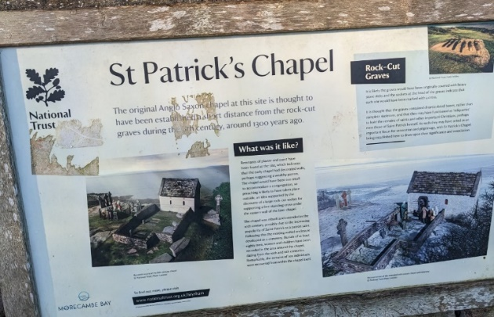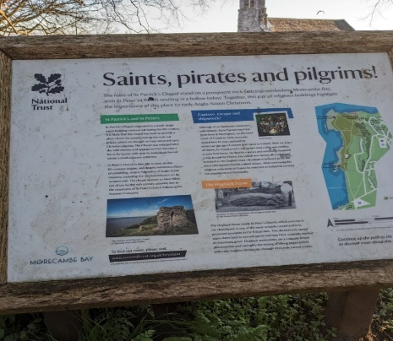
Figure One. National Trust Noticeboards at St Patrick’s Chapel. Photographs C Allen 2023.

The chapel is believed to have been extended in the 10th century (see Figure One). Nowell cites Potter and Andrews’ 1977 partial excavation of the site, noting their suggestion that the rock-cut graves were the initial constructions on the site, followed by the construction of the chapel. Moskvina acknowledges that the chapel is not well-documented, but she suggested the chapel dates from the seventh to eighth century. She also noted that, although there is no mention of St Peter’s in the Doomsday book, it is documented in the records of a grant made by Roger of Pitou to the Normandy Abbey of Sees in 1094. The first rector of St Peter’s Church appearing in records was Ralph, dated ca 1190.

Medieval Heysham
Moskvina highlights the contradictions in our understanding of early medieval Heysham – namely, the lack of records prior to 1094 suggests the village was a small, insignificant place, yet the high-quality stone-carved material remains suggest it was a place of some wealth and importance.

Popular folklore highlights links with St Patrick - as the National Trust noticeboard explains, it is believed that Patrick was captured from Cumbria and taken to Ireland as a slave, before making his escape six years later by boat. After being blown off course, it is said he came ashore at Heysham.

Methodology

Fieldwork
Fieldwork was conducted at the site on two occasions in April 2023. On my first visit, a rough line-drawing was made of the remains of the chapel site, with each corner allocated a letter (A, B, C, etc.). A table was created in my notebook, listing all the possible lines of measurements, for example, A to B, D to C, etc. then measurements were entered into the table as I worked around the site. On the second visit, a much-reduced drawing was made, labelling only A/B and D/C axis-lines and approximate window of visibility (Silva, 2014).

Azimuth readings were calculated by measuring the orientations of the chapel ruins and stone graves and recorded in my journal. Azimuth readings are the angular distances between True North and the object being studied. The measurements produced are in degrees between 0° and 360°.Orientation was measured with a Proster Compass, model TL150, which has an accuracy of 1° or less, according to the compass’ information sheet. Because the compass could not guarantee 100% accuracy and as allowance had to be made for human error, the field measurements were compared to measurements taken virtually, using Google Earth Pro (see Virtual Surveys below).

Measurements were not taken by holding the compass against the chapel walls, as has been the method in other studies (Hoare and Sweet, 2000), as Brady Gunzburg and Silva (2017) noted its unreliability, as factors like uneven walls affect the reliability of results. Just for interest, however, I did take two wall measurements by holding the compass against the wall C-D, that is, facing east. This gave a reading of 90°, due east. However, taking a longer line of sight along the C-D line gave a different reading. Photographs were also taken from around the site.

Landscape
Measurements were taken of the horizon altitude of the land around the chapel. Horizon altitude is the degree of elevation above sea level of the surrounding landscape, which can affect the visibility of certain celestial objects from the site. For example, orienting a church towards an elevated eastern horizon must account for the fact that the sun will be seen on that horizon slightly later and slightly further along that horizon than it would be over flat land. The Proster Compass contains an integrated clinometer which was used for altitude measurements.
Westward, the chapel has no horizon obstructions as it overlooks the sea. Eastern horizon measurements were more difficult to obtain as the view was obstructed by trees. This research, therefore, relied on virtual altitude measurements (see below).

Magnetic North
During fieldwork, the orientation of the chapel was checked by measuring the walls from both sides, i.e. from A to B and from B to A, to minimise the risk of magnetic anomalies arising from either the building itself or the surrounding land. The difference between magnetic bearings and true bearing was checked using the online resource National Geophysical Data Centre’s calculator. Adjustments were made for the difference my readings and the true bearings. However, as the only readings obtained at the site were my own and not therefore checked against readings from other surveyors to achieve an agreed mean reading, this project decided to use readings obtained from Google Earth Pro which uses true bearings and are, therefore, probably more accurate than my fieldwork readings.

Virtual Surveys

Google Earth Pro
First, latitude and longitude were calculated by using the coordinates from the Ordnance Survey Explorer map for Lancaster, Morecambe and Fleetwood. The coordinates, SD 409616, were then entered into the latitude/longitude conversion calculator on the online resource https://www.movable-type.co.uk/scripts/latlong-os-gridref.html which gave a reading of 54.04 north and 002.904 west. A search for Heysham was then entered into the Google Earth Pro app, which located the chapel. The axial orientations of the chapel were then measured using the website’s ruler tools and then the azimuth measurements were entered into my table. As Google Earth Pro measures true bearings, there was no need to make allowance for magnetic anomalies. Latitude and longitude calculations were also checked against the readings in Google Earth Pro, along with the altitude readings.

HeyWhatsThat
Fieldwork horizon altitude measurements were checked using the website, www.HeyWhatsThat.com. Azimuth readings were found on the site’s altitude graph for Heysham, and that data was entered into my table.

Stellarium
Stellarium app can recreate the sky on a given day at a given place, so it was used to recreate the sky on two of the solar declination dates to explore what was happening in the sky at this time.

Date
While the date of St Patrick’s Chapel is uncertain, this project took a date of 750 AD as the assumed date of construction - the rationale being that the construction date range lies between the 7th and 8th century, so the year 750 lies at the conservative end of that date range.

Declination and Calendar Conversion
Declination figures were achieved by entering azimuth, altitude and latitude measurements into a table which converts the reading to equatorial coordinates. Before checking the daily sunrise and sunset declinations, the results had to take account of the calendar drift between the Julian and Gregorian calendars (Brady, Gunzburg and Silva, 2017; Hinton 2006). This adjustment was calculated using another online resource which suggested an adjustment of four days. The adjusted declination readings were then checked against Silva’s ‘Change in Solar Declination through the year’ to give a possible date for the sunrise and sunset orientations of St Patrick’s Chapel. Allowing for margins of error, the solar declination dates were checked against medieval liturgical calendars, using a margin of three days either side of the dates shown in the solar declination tables, to find possible matches with days that may have religious significance for the monastic community of eighth century Heysham.

Window of Visibility
Fabio Silva describes window of visibility as,
the region of the horizon that, given the structure’s corridor and entrance geometry, can be seen from within its chamber. This amounts to a range of azimuth bearings between a minimum and a maximum value defined by the diagonals of the corridor/passage and chamber entrances
Initially, only the straight line from the middle of the east wall was measured (giving an azimuth of 270°, due west). After reflecting on Silva’s window of visibility technique, it became clear that the diagonal measurements looking out of the chapel would be useful, so a second trip to Heysham took place. However, without a second surveyor to hold a ranging pole, and with visitors at the site obstructing the view, these measurements left too much room for error and measurements were taken on Google Earth Pro instead.

Findings and Discussion

Landscape
Altitude of surrounding landscape can affect where the sun is seen at sunrise. As the chapel sits atop rocks overlooking the sea on the westward side, and on higher ground than the village of Heysham and St Peter’s Church on the eastward side, the altitude did not appear to significantly affect orientation of sunrise or sunset measurements. Looking west, the inbuilt clinometer in my compass, showed 0 degrees altitude. This was confirmed by checking the azimuth and location on the website, www.HeyWhatsThat.com . Figure Two shows the altitude of St Patrick’s Chapel facing westward calculated by HeyWhatsThat.

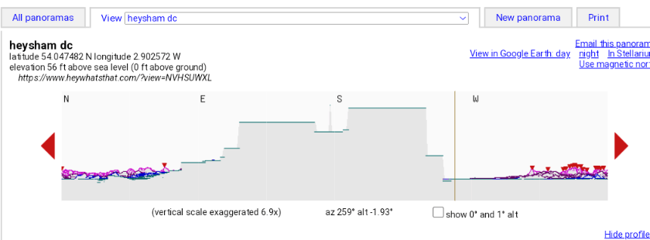
Figure Two: Graph showing the westward horizon www.HeyWhatsThat.com

During fieldwork visits, it was more difficult to ascertain the eastward altitude of the surrounding landscape as the area is wooded with very large trees. The only reliable measurement, therefore, was the calculation made in HeyWhatsThat, see Figure Three. This study found that neither the sunrise nor the sunset orientations were affected by the surrounding landscape.

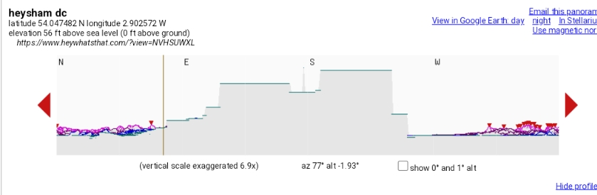
Figure Three: Graph showing the eastward horizon from www.HeyWhatsThat.com

Orientation
Although the directions of all the chapel walls were measured, this essay focuses only on the east-west axis, the chapel’s possible relationship with the six rock graves, and the westward window of visibility readings (as suggested by Silva). Figure Four shows a drawing that was made at the site.

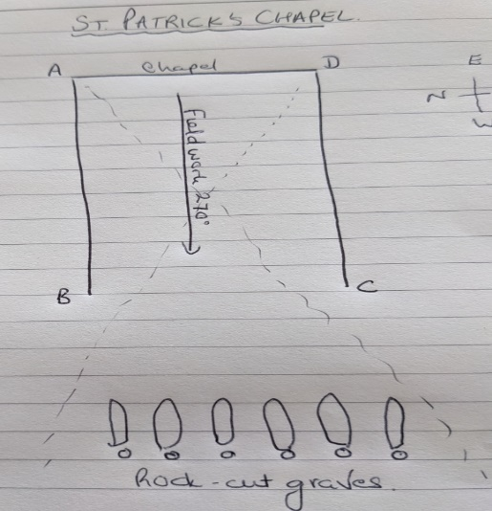
Figure Four: Plan from my journal.

Sunrise
Sunrise orientations were explored along the BA and DC axis-lines. Table One shows the results. As the C-D-axis wall is believed to have been altered around the tenth century, this study focused on the B-A axis, which was found to point north of east.

Axis | Azimuth | Altitude | Latitude | Declination | Possible Dates*
BA | 77° | -1.93 | -2.9 | 13.08 | 20th April or 13th August
CD | 81° | -1.93 | -2.9 | 9.08 | 9th April or 25th August
*The dates have made allowance for the Julian calendar, for the year 750 AD, by subtracting four days from the Gregorian readings.
Table One: Orientation Measurements for Sunrise.

Hoare and Sweet found that ‘liturgically-correct alignment was regarded as desirable’ by medieval church builders and that their true east alignments were largely successful. Allowing for a 10° tolerance, Hoare and Sweet suggested that existing townscapes might have affected orientation at the time of construction. However, in Heysham, the chapel was built on the rocks overlooking the sea, whereas the village itself sits down in a hollow a distance from the chapel, so pre-existing townscapes were unlikely to have been the reason that it is not facing true east. Even though the azimuth appears not be exactly true east, these measurements are only a few degrees out, so, assuming the altar was set against the back wall of the chapel opposite the entrance, the findings do suggest that the altar of the chapel is oriented east, as advised by Isidore of Seville, and the entrance (assumed to be where the wall is missing) lay on the west.

In terms of being aligned with special feast days, the B-A axis suggests a possible alignment with the feast of Ælfheah of Canterbury on 19th April, however, as he was not canonised until after the date of construction of the chapel, this seems an unlikely alignment. In early medieval England, the Marian Day of Assumption was widely observed on 15th August, which is quite close to the 13th August orientation that this study found. McCluskey noted that orienting churches towards the feast-days of patronal saints would result in a range of different orientations, which would, therefore, violate the instruction from church leaders to align churches with true east. Hoare and Sweet also dismissed the theory that medieval churches were aligned with the feast-days of their patronal saint and Hinton decided to omit Mary dedications from his discussions of his findings because there are several possible feast-days dedicated to her every year. Hinton’s data nevertheless suggested a significant number of churches are dedicated to St Mary and appear to orient towards a Marion festival. On a blogpost on the Catholic Culture website, Father Francis Weiser explains that the observation of Mary’s Assumption on 15th August, one of the oldest Mary festivals, can be traced back to Palestine to 529, so it is not unreasonable to suppose that the monastic community in early medieval Heysham might have observed this festival. In the village where my parents lived in northern Italy, Zorzino, the Ferragosto (Assumption) festival takes place on the 15^{th of} August and is one of the most important festivals in the church’s calendar, observed by the whole community. Ferragosto is a bank holiday in Italy whereas Good Friday is not, which reveals how significant a feast-day this is can be for practitioners. It is possible, then, that the monastic community which planned the construction of St Patrick’s Chapel did intend to orient their altar towards the liturgically important festival of the Assumption on 15th August.

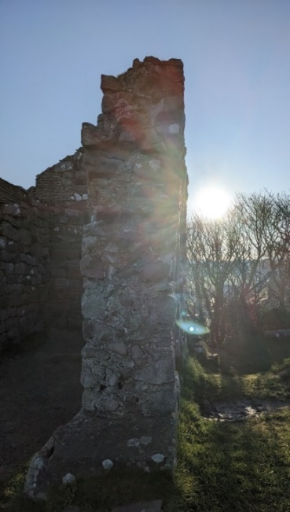
Figure Five: Sun rising along the C-D wall. Photograph C Allen, April 2023.

Sunset
The following table shows the declination dates for the westward orientation of the chapel. Both walls orient west, although not true west, unlike the measurement gained when the compass was used to measure the view outward to the sea from the middle of the chapel interior (270°).

Axis | Azimuth | Altitude | Latitude | Declination | Possible Dates*
AB | 259 | 0 | 54.04 | -6.43 | 29th February or 5th October
DC | 263 | 0 | 54.04 | -4.10 | 5th March or 30th September
*The dates have made allowance for the Julian calendar, for the year 750 AD, by subtracting four days from the Gregorian readings.
Table Two: Orientation Measurements for Sunset.

The D-C axis’ declination suggests a date that is close to the autumnal equinox, but, perhaps just as significantly, the date is very close to the festival of Michael the Archangel on the 29th September, a widely-celebrated feast-day in medieval England. This echoes the findings of Brady, Gunzburg and Silva’s 2021 research into the Cistercian abbeys of the United Kingdom, which found that a significant number of Cistercian abbeys surveyed were oriented towards sunset on the Feast of St Michael, 29th September. They noted Michael’s strong connection to Mary, whose soul was entrusted to the protection of Michael. This link between Mary and Michael might be significant for St Patrick’s Chapel as the east wall is oriented toward the feast of the Assumption. Is it possible that the builders of St Patrick’s Chapel intentionally oriented towards sunrise on the Feast of the Assumption and towards sunset on Michaelmas?

Michaelmas is close to the autumnal equinox, which signals the last of the long evenings and warm days. Perhaps inviting the last rays of summer sun into the church on the feast-day of Archangel Michael was a form of protection ritual for the monastics and the local community as they headed into the scarcity and cold of the winter months. Archangel Michael was, after all, popularly seen as a protector. One may conjecture that the chapel may have contained a fresco depicting a Michael-related scene on the wall above the altar, a fresco that might have been lit up by the setting sun on Michaelmas – but, while the chapel is known to have been covered in plaster both inside and out, any theories beyond that are nothing more than speculation.

Night-sky
To explore the chapel’s possible relationship with the sky, two dates were checked in the online Stellarium app - 15th August and 29th September. Brady (2015) suggested that inadequate knowledge of the way stars move in the sky has limited academics’ understanding of the significance of certain stars in the culture of early Egyptian skywatchers, and that this limited their understanding of early Egyptian architecture and Pyramid Texts. With a sky full of stars and constellations, a building is probably always going to orient towards something in the sky. However, Brady (2015) suggested that there is ‘no reason to assume that the sacred nature of stars was the exclusive domain of the third millennium Egyptians’ and that any northern hemisphere structure might also have been orientated towards to divinely significant stars. Stellarium readings for between 04.00 and 05.30 on 15th August through from 675AD to 750AD shows Pollux, Betelgeuse, Procyon, Regulus and Sirius were all bright in the sky and would have been visible (atmospheric conditions allowing) in the eastern sky at that time. More research would be needed to ascertain whether these stars held any divine significance for the monastic community of medieval Heysham.

Rock-cut graves
There are 8 rock graves around St Patrick’s Chapel, but this essay focuses only on the six rock-cut graves that lie directly in front of the chapel on the edge of the cliffs. Moskvina (2020) suggested the grave’s alignments was more significant than the chapel’s alignments. Fairly unique in England, some examples of rock graves can be found in Spain and Portugal, where they are situated by the sea but not associated with church buildings. While their age is unknown, the National Trust’s noticeboard suggests that the graves pre-date the chapel.

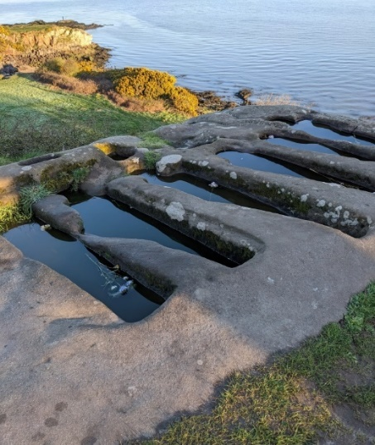
Figure Six: Graves at St Patrick’s Chapel. Photograph C Allen 2023.

Moskvina found that the ‘east-west axis of the chapel… divides the group precisely in half, aligning the group as a whole with the chapel’. My axial measurements confirmed this – see Figure Eight. The significance of this orientation is unclear and more research into rock-cut graves is needed to make sense of this connection. Too small to contain bodies, it is possible the grave were reliquaries for the bones of holy men and women (Nash, 2015). Other large lumps of exposed rock lie around this site and, time and effort being needed to carve these graves, it is perhaps reasonable to assume their positioning was a deliberate act by the people who created them.

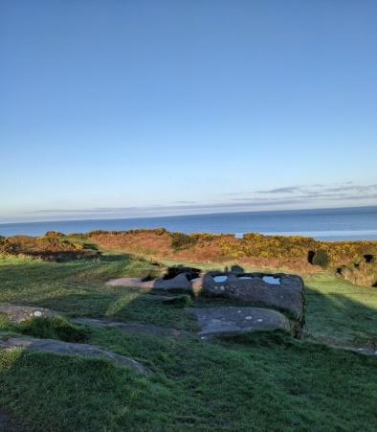
Figure Seven: This is the view from the inside the chapel looking out towards the rock-cut graves. Photograph C Allen April 2023.

Window of visibility
Silva suggested it is useful to try to reproduce the window of visibility of the horizon that would have been experienced from the structure being surveyed, as opposed to simply measuring narrow, straight axial lines. The Chapel sits atop the high rocks over Morecambe Bay and the eye is naturally drawn outwards to the horizon, to the place where heaven and earth meet so it makes sense to explore the window of visibility - see Table Three and Figure Eight for findings.

Axis | Azimuth | Altitude | Latitude | Declination | Possible Dates*
Diagonal from D | 272 | 0 | 54.04 | 1.17 | 19th March or September 16th
Diagonal from A | 252 | 0 | 54.04 | -10.45 | 1  2th April or 21st October
*The dates have made allowance for the Julian calendar, for the year 750 AD, by subtracting four days from the Gregorian readings.
Table Three: Orientation Measurements for Window of Visibility

While the dates suggested by the window of visibility readings extend the possible orientations to include the approximate time of the Spring Equinox (diagonal from D), what was interesting to note was how the diagonal lines, and the direct line from where they meet, intersect with the graves – see Figure Eight.

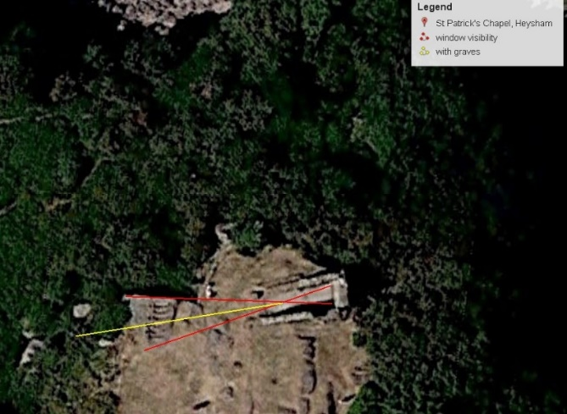
Figure Eight: The image from Google Earth Pro showing the window of visibility lines in red, and the line in yellow is the direct line from where the two diagonal lines intersect.
The red diagonal lines appear to align with the outer edges of the two end graves and the line in yellow, running directly out from where the two lines cross, appears to line up with the middle of the graves. Without being certain that the graves precede the chapel, it is difficult to attribute significance to the relationship between the diagonal lines and the graves, but it might indicate that the axial relationship between the chapel and the graves was intentional, as suggested by Moskvina (2020). With tall crosses sitting in the post holes, these would have been clearly seen by boats sailing in and out Morecambe Bay, especially once the tall-walled chapel with its white plaster exterior was constructed, which suggests that they were a very significant feature of the site – see Figure Nine.

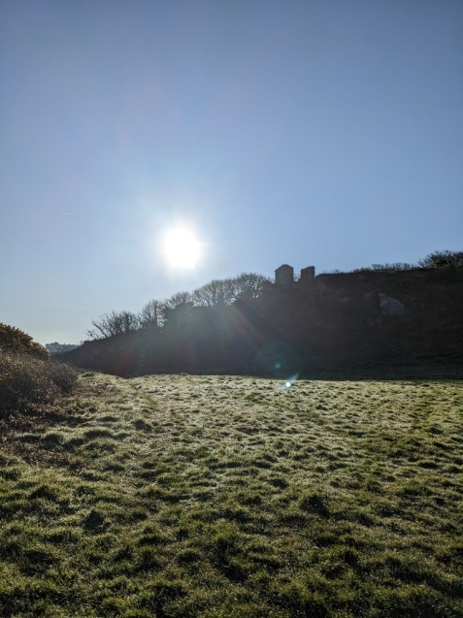
Figure Nine: Looking up at the chapel from the higher part of the beach below the rocks. Photograph by C Allen April 2023.

Conclusion
This project sought to conduct some simple fieldwork in Heysham to investigate the likelihood of celestial alignments of medieval St Patrick’s Chapel. In particular, the project intended to explore whether the altar oriented towards the east (on the equinox) and the entrance towards the west, as decreed by Isidore of Seville and/or whether the westward orientation appears to have been significant (Brady, Gunzburg and Silva, 2021). The project also intended to explore the relationship of the chapel with the rock-cut graves on the cliff top (Moskvina, 2020). The project found that the altar was probably positioned in the east and the entrance in the west (prior to the 10th century rebuilding of the south-facing wall and the addition of the archway door in that wall). The east orientation was found to suggest a possible alignment with Mary’s Feast of the Assumption on the 15^{th of} August, which was an important festival in medieval times. The west orientation was found to suggest an alignment with the feast-day of Michael the Archangel on the 29^{th of} September. Furthermore, connections were found between Mary and Archangel Michael as he, being a protector angel, was tasked with protecting Mary herself. This strengthens the suggestion that the builders of the chapel intentionally oriented the building to align with particular days in the liturgical calendar, as well as perhaps aligning the building with days that would have been significant for the local economy, equinox days (as found when using Silva’s window of visibility technique revealed that the spring equinox would have been embraced by the westward window of visibility). The site is rich with material remains and lends itself to more in-depth research to understand how the ruins of the site relate to each other and to the culture of early medieval Heysham, for example, the significance of the graves found in and around the chapel. It would also be worth exploring the relationship of the chapel with early Irish church building which are similar in style with their tall, narrow interiors, especially as Heysham and St Patrick’s appear to have some connection with Ireland. Additionally, more research is needed into the relationship of St Patrick’s with the development of Christianity across early medieval Northumbria, as it is such an early example of Christian architecture in the region. Tilley suggested that humans attribute meaning to place through being ‘grounded in existential or lived consciousness of it’. My first fieldtrip visit to St Patrick’s was magical. The air was crisp and ice still clung to the grass around the chapel. A couple of yard dogs barked half-heartedly in the village below. A lone fisherman sat on the rocky outcrop, silhouetted against the misty horizon as the dawn sunshine cast long shadows westward. With my back to the village and all the stresses and strains of daily life, looking out from St Patrick’s Chapel at the quiet majesty of the merging of land, sea and sky in this location, it was easy for me to understand why the people of early medieval Heysham chose this spot as a place of quiet reflection, worship and contemplation.

Bibliography

Primary Sources
Ordnance Survey Explorer, map number 296, ‘Lancaster, Morecambe and Fleetwood’
(Ordnance Survey Ltd, 2017).

Converting between Julian and Gregorian Calendar in One Step (stevemorse.org)

http:// www.ngdc.noaa.gov/geomag-web/#declination

Google Earth Pro online app.

www.HeyWhatsThat.com

Fabio Silva’s ‘Change in Solar Declination through the year’ Reference Tables for Skyscape
Archaeology, 22/01/2019 provided by University of Wales, Trinity St David.

Secondary Sources

Bernadette Brady, ‘Star Phases: the naked-eye astronomy of the Old Kingdom Pyramid Texts’
in Skyscapes: the Role and Importance of the Sky in Archaeology, ed. by Fabio (Fabio
P.) Silva and Nicholas Campion (Oxford, [England] ;: Oxbow Books, 2015)

Brady, Bernadette, Darrelyn Gunzburg and Fabio Silva, ‘The Sun’s Light at Michaelmas And
The Cistercians of Britain And Ireland’, Cîteaux – Commentarii cistercienses, t. 72, fasc. 1-4 (2021)

Brady, Bernadette, Darrelyn Gunzburg, and Fabio Silva, ‘The Orientation of Cistercian
Churches In Wales: A Cultural Astronomy Case Study’, Cîteaux – Commentarii cistercienses 67 (2016), p. 275-302

Caval, Sasa, ‘Locating the Festival, Positioning the Feast: Natural and Calendar Festivals in
Medieval Slovenia’, World Archaeology, 50.2 (2018), 300–322.

Farrer, William and J Brownbill, "The parish of Heysham," in A History of the County of
Lancaster: Volume 8, ed. William Farrer and J Brownbill (London: Victoria County History, 1914), 109-118. British History Online, accessed April 27, 2023, http://www.british-history.ac.uk/vch/lancs/vol8/pp109-118

Hinton, Ian, ‘Church Alignment and Patronal Saint’s Days’, Antiquaries Journal, 86 (2006),
206–26

Hoare, Peter G, and Caroline S Sweet, ‘The Orientation of Early Medieval Churches in
England’, Journal of Historical Geography, 26.2 (2000), 162–73

Iwaniszewski, S., ‘Concepts of Space, Time, and the Cosmos’ in in Handbook of
Archaeoastronomy and Ethnoastronomy, ed. by Ruggles, C. (New York, NY: Springer New York, 2015)

Karasawa, Kazutomo, The Old English Metrical Calendar (Menologium), NED - New edition
(Woodbridge: Boydell & Brewer, 2015).

McCluskey, Stephen C. “Gregory of Tours, Monastic Timekeeping, and Early Christian
Attitudes to Astronomy.” Isis, vol. 81, no. 1, 1990, pp. 8–22. JSTOR, http://www.jstor.org/stable/234080. Accessed 23 Apr. 2023.

McCluskey, S.C., ‘Astronomy in the Service of Christianity’ in Handbook of Archaeoastronomy
and Ethnoastronomy, ed. by Clive L.N. Ruggles, 1st ed. 2015. (New York, NY: Springer New York, 2015)

McCluskey, Stephen C, ‘Calendrical Cycles, the Eighth Day of the World, and the Orientation
of English Churches’, in Ruggles, Clive, and Gary Urton, Skywatching in the Ancient World: New Perspectives in Cultural Astronomy (Boulder: University Press of Colorado, 2010)

Moskvina, Anastasia, Alignment and Axiality in Anglo-Saxon Architecture: 6th -11th
Centuries (Unpublished PhD thesis, University of East Anglia, 2020)

Nash, George. Death and Memorial in an Early Medieval Ecclesiastical Landscape in North-
West England: An Appraisal of St Patrick’s Chapel and St Peter’s Church, Heysham, Lancashire. Spiru Haret University, Bucharest, Romania and the Museum of Prehistoric Art, Mação, Portugal (2015)., ResearchGate, accessed April 2024.

Nowell, Alan, ‘Gilgamesh, Kells And Heysham’, Archaeology Ireland , Summer 2014, Vol. 28,
No. 2 (Summer 2014), pp. 35-39 Published by: Wordwell Ltd. Stable

Prendergast, F., ‘Techniques of Field Survey’ in Ruggles, C. (eds) Handbook of
Archaeoastronomy and Ethnoastronomy. (Springer, New York, NY. 2015)

Ruggles, Clive L.N., Handbook of Archaeoastronomy and Ethnoastronomy, ed. by Clive L.N.
Ruggles, 1st ed. 2015. (New York, NY: Springer New York, 2015)

Ruggles, C.L.N., ‘Analyzing Orientations’, in Handbook of Archaeoastronomy and
Ethnoastronomy, ed. by Ruggles, C. (New York, NY: Springer New York, 2015)

Ruggles, Clive, and Gary Urton, Skywatching in the Ancient World: New Perspectives in
Cultural Astronomy (Boulder: University Press of Colorado, 2010)

Silva, Fabio, Nicholas Campion, and Bernadette Brady, Skyscapes: the Role and Importance
of the Sky in Archaeology, ed. by Fabio (Fabio P.) Silva and Nicholas Campion (Oxford, [England], Oxbow Books, 2015)

Silva, Fabio. ‘The Role and Importance of the Sky in Archaeology’ in ” Skyscapes: The Role
and Importance of the Sky in Archaeology, edited by Fabio Silva and Nicholas Campion, Oxbow Books, 2015, pp. 1–7. JSTOR, https://doi.org/10.2307/j.ctvh1dksg.5. Accessed 23 Apr. 2023.

Silva, Fabio, ‘A Tomb with a View: New Methods for Bridging the Gap Between Land and Sky
in Megalithic Archaeology’, Advances in Archaeological Practice : a Journal of the Society of American Archaeology, 2.1 (2014), 24–37

Tilley, Christopher Y., A Phenomenology of Landscape: Places, Paths and Monuments
(Oxford: Berg, 1994)

Weiser, Father Francis, ‘Catholic Activity: The Feast of the Assumption Customs and
Traditions’, https://www.catholicculture.org/culture/liturgicalyear/activities , accessed 28/04/23

Peter G. Hoare and Caroline S Sweet, ‘The Orientation of Early Medieval Churches in England’, Journal of Historical Geography, 26.2 (2000), 162–73.
Sasa Caval, ‘Locating the Festival, Positioning the Feast: Natural and Calendar Festivals in Medieval Slovenia’, World Archaeology, 50.2 (2018), p. 301.
Fabio Silva, “The Role and Importance of the Sky in Archaeology: An Introduction.” Skyscapes: The Role and Importance of the Sky in Archaeology, edited by Fabio Silva and Nicholas Campion, Oxbow Books, 2015, p. 3.
Silva, “The Role and Importance of the Sky in Archaeology” Skyscapes, edited by Fabio Silva and Nicholas Campion, Oxbow Books, 2015, pp.1–7.
Silva, “The Role and Importance of the Sky in Archaeology” Skyscapes, ed.by Silva and Campion, Oxbow Books, 2015, p. 2.
Silva, “The Role and Importance of the Sky in Archaeology” Skyscapes, ed. by Silva and Campion, Oxbow Books, 2015, pp.1–7.
Caval, ‘Locating the Festival, Positioning the Feast’, World Archaeology, 50.2 (2018), p. 301.
Caval, ‘Locating the Festival, Positioning the Feast’, World Archaeology, 50.2 (2018), p. 301.
Caval, ‘Locating the Festival, Positioning the Feast’, World Archaeology, 50.2 (2018), p. 301.
The chronology of the St Patrick’s Chapel site is discussed in the section Background below.
Bernadette Brady, Darrelyn Gunzburg, and Fabio Silva, ‘The Orientation of Cistercian Churches In Wales: A Cultural Astronomy Case Study’, Cîteaux – Commentarii cistercienses 67 (2016), p. 275-302 and Brady, Bernadette, Darrelyn Gunzburg and Fabio Silva, ‘The Sun’s Light at Michaelmas And The Cistercians Of Britain And Ireland’, Cîteaux – Commentarii cistercienses, t. 72, fasc. 1-4 (2021)
Bernadette and Brady, Bernadette, Darrelyn Gunzburg and Fabio Silva, ‘The Sun’s Light at Michaelmas And The Cistercians Of Britain And Ireland’, Cîteaux – Commentarii cistercienses, t. 72, fasc. 1-4 (2021), p. 64.
Caval, ‘Locating the Festival, Positioning the Feast’, World Archaeology, 50.2 (2018), p. 317.
Caval, ‘Locating the Festival, Positioning the Feast’, World Archaeology, 50.2 (2018), p. 318.
Stephen C. McCluskey, ‘Calendrical Cycles, the Eighth Day of the World, and the Orientation of English Churches’, in Skywatching in the Ancient World (University Press of Colorado, 2010), p. 341.
Stephen C. Mccluskey, ‘Calendrical Cycles, the Eighth Day of the World, and the Orientation of English Churches’, in Skywatching in the Ancient World (University Press of Colorado, 2010), p. 345.
Clive Ruggles, Analyzing Orientations’ in Ruggles, C. (eds) Handbook of Archaeoastronomy and Ethnoastronomy, (Springer, New York, NY. 2015) p. 422.
Anastasia Moskvina, Alignment and Axiality in Anglo-Saxon Architecture: 6 th -11th Centuries, (Unpublished PhD Thesis, University of East Anglia, 2020)
George Nash, Death and Memorial in an Early Medieval Ecclesiastical Landscape in North-West England: An Appraisal of St Patrick’s Chapel and St Peter’s Church, Heysham, Lancashire. Spiru Haret University, Bucharest, Romania and the Museum of Prehistoric Art, Mação, Portugal (2015)., ResearchGate, accessed April 2024. P. 306
Nash, Death and Memorial in an Early Medieval Ecclesiastical Landscape in North-West England. Spiru Haret University, Bucharest, Romania and the Museum of Prehistoric Art, Mação, Portugal (2015)., ResearchGate ,accessed April 2024.
I requested a copy of this report from the authors via ResearchGate but at the time of writing this essay, I had not received a reply to my requests.
Alan Nowell, ‘Gilgamesh, Kells and Heysham’, Archaeology Ireland , Summer 2014, Vol. 28, No. 2 (Summer 2014), pp. 35-39 Published by: Wordwell Ltd. Stable URL: https://www.jstor.org/stable/23771308, p. 38
Anastasia Moskvina, Alignment and Axiality in Anglo-Saxon Architecture: 6 th -11th Centuries (Unpublished PhD Thesis, University of East Anglia, 2020), p. 231.
Moskvina, Alignment and Axiality in Anglo-Saxon Architecture (Unpublished PhD Thesis, University of East Anglia, 2020), p. 233.
William Farrer and J Brownbill, “The parish of Heysham," in A History of the County of Lancaster: Volume 8, ed. William Farrer and J Brownbill, (London: Victoria County History, 1914), 109-118. British History Online, accessed April 27, 2023, http://www.british-history.ac.uk/vch/lancs/vol8/pp109-118
Moskvina, Alignment and Axiality in Anglo-Saxon Architecture (Unpublished PhD Thesis, University of East Anglia, 2020), p. 233.
F. Prendergast, ‘Techniques of Field Survey’ in Ruggles, C. (eds) Handbook of Archaeoastronomy and Ethnoastronomy. (Springer, New York, NY. 2015), p. 392.
http:// www.ngdc.noaa.gov/geomag-web/#declination
Ordnance Survey Explorer Map 296, ‘Lancaster, Morecambe and Fleetwood’ (Ordnance Survey Ltd, 2017).
This table, created by Fabio Silva, was provided to students on University of Wales, Trinity St David’s MA in Ecology and Spirituality, Sacred Skies module.
Converting between Julian and Gregorian Calendar in One Step (stevemorse.org)
Fabio Silva’s ‘Change in Solar Declination through the year’ Reference Tables for Skyscape Archaeology, 22/01/2019, provided by University of Wales, Trinity St David.
Bernadette Brady, Darrelyn Gunzburg, and Fabio Silva, ‘The Orientation of Cistercian Churches In Wales: A Cultural Astronomy Case Study’, Cîteaux – Commentarii cistercienses 67 (2016), p. 283.
Such as, Karasawa, Kazutomo, The Old English Metrical Calendar (Menologium), NED - New edition (Woodbridge: Boydell & Brewer, 2015).
Fabio Silva, ‘A Tomb with a View: New Methods for Bridging the Gap Between Land and Sky in Megalithic Archaeology’, Advances in Archaeological Practice : a Journal of the Society of American Archaeology, 2.1 (2014), p. 27.
Hinton, Ian, ‘Church Alignment and Patronal Saint’s Days’, Antiquaries Journal, 86 (2006), p. 207.
Silva, ‘A Tomb with a View’, Advances in Archaeological Practice : a Journal of the Society of American Archeaology, 2.1 (2014), p. 27.
See Figure National Trust noticeboards, Figure One.
The allowance for the Julian calendar was calculated by Converting between Julian and Gregorian Calendar in One Step (stevemorse.org)
Hoare and Sweet, ‘The Orientation of Early Medieval Churches in England’, Journal of Historical Geography, 26.2 (2000), p. 165.
Hoare and Sweet, ‘The Orientation of Early Medieval Churches’, Journal of Historical Geography, 26.2 (2000), p. 167.
Kazutomo Karasawa, The Old English Metrical Calendar (Menologium), NED - New edition (Woodbridge: Boydell & Brewer, 2015), p. 169.
Karasawa, The Old English Metrical Calendar, (Woodbridge: Boydell & Brewer, 2015), p. 174.
McCluskey, Stephen C, ‘Calendrical Cycles, the Eighth Day of the World, and the Orientation of English Churches’, in Ruggles, Clive, and Gary Urton, Skywatching in the Ancient World: New Perspectives in Cultural Astronomy (Boulder: University Press of Colorado, 2010), p. 340-341.
Hoare and Sweet, ‘The Orientation of Early Medieval Churches’, Journal of Historical Geography, 26.2 (2000), p. 168.
Ian Hinton, ‘Church Alignment and Patronal Saint’s Days’, Antiquaries Journal, 86 (2006), p. 208.
Hinton, ‘Church Alignment and Patronal Saint’s Days’, Antiquaries Journal, 86 (2006), p. 211.
Father Francis Weiser, ‘Catholic Activity: The Feast of the Assumption Customs and Traditions’, https://www.catholicculture.org/culture/liturgicalyear/activities , accessed 28/04/23
The allowance for the Julian calendar was calculated by Converting between Julian and Gregorian Calendar in One Step (stevemorse.org)
Karasawa, The Old English Metrical Calendar (Woodbridge: Boydell & Brewer, 2015), p. 176.
Bernadette Brady, , Darrelyn Gunzburg and Fabio Silva, ‘The Sun’s Light at Michaelmas And The Cistercians Of Britain And Ireland’, Cîteaux – Commentarii cistercienses, t. 72, fasc. 1-4 (2021) p. 63. .
Brady, Bernadette, Darrelyn Gunzburg and Fabio Silva, ‘The Sun’s Light at Michaelmas And The Cistercians Of Britain And Ireland’, Cîteaux – Commentarii cistercienses, t. 72, fasc. 1-4 (2021) p. 63.
Bernadette Brady, ‘Star Phases: the naked-eye astronomy of the Old Kingdom Pyramid Texts’ in Skyscapes: the Role and Importance of the Sky in Archaeology, ed. by Fabio (Fabio P.) Silva and Nicholas Campion (Oxford, [England] ;: Oxbow Books, 2015),p. 85.
Bernadette Brady, ‘Star Phases’ in Skyscapes: the Role and Importance of the Sky in Archaeology, ed. by Silva and Campion (Oxford, [England] ;: Oxbow Books, 2015),p. 85.
Moskvina, Alignment and Axiality in Anglo-Saxon Architecture (Unpublished PhD Thesis, University of East Anglia 2020), p. 196.
Moskvina, Alignment and Axiality in Anglo-Saxon Architecture’ (unpublished PhD thesis, University of East Anglia, 2020), p. 234.
Moskvina, Alignment and Axiality in Anglo-Saxon Architecture’ (Unpublished PhD thesis, University of East Anglia 2020), p. 234.
Silva, ‘A Tomb with a View’, Advances in Archaeological Practice : a Journal of the Society of American Archaeology, 2.1 (2014), p. 27.
The allowance for the Julian calendar was calculated by Converting between Julian and Gregorian Calendar in One Step (stevemorse.org)
Tilley, Christopher Y., A Phenomenology of Landscape: Places, Paths and Monuments (Oxford: Berg, 1994), p. .

