LEVEL 4 ASSESSMENT SPECIFICATION
Student name: | Sioned Hughes | Student ID number: | 2503173
Programme: | DA Program - BSC in Supply Chain and Logistics
Module: | Data Analytics Principles
Module code: | ACMA 4016 | Contribution to Overall Module Assessment (%): | 100%
Lecturer: | Dr Moutushi Tanha | Internal Verifier: | Dr Irina Neaga
Assignment Title: | Developing a Data-Based Report | Word count (or equivalent): | 1500 words
Submission deadline: | 01/03/2026 | Return date of provisional marks & written feedback: | 20 working days after submission
Submission method: | All written assessments, where practical and possible, must be submitted via Turnitin unless otherwise instructed by the Lecturer. (Please DO NOT put this assessment specification into Turnitin or it will match many similarities with other students’ submissions.)  Alternative submission method (if applicable):  Late submission of the assessment will result in a late penalty mark:  Work which is submitted up to 1 week late will be capped at 40% for the first attempt and will be awarded a mark of 0% for re-assessment. Late submission penalties may be lifted only if there is an approved extenuating circumstances claim.  Work submitted more than 1 week late will be considered as a non-submission and will not be marked. The work may be considered as a submission for reassessment if offered by an Examining Board or if there is an approved extenuating circumstances claim.
Academic honesty / referencing: | Academic honesty is required. In the main body of your submission you must give credit to authors on whose research and ideas your work is based. Append to your submission a reference list that indicates the books, articles, etc. that you have used, cited or quoted in order to complete this assessment.
 APPENDIX GA36a
Use of Generative AI in Assessment
(Lecturer to indicate Yes or Not against each element)
RESEARCH | For this assessment, you can use Generative AI to support you in research, including searching for bibliography, using tools to summarise, compare and interrogate materials. | Yes ☒  No ☐
STRUCTURE | For this assessment, you can use Generative AI to support you in structuring your submission, including creating a draft argument structure, identifying parts and headings, etc. | Yes ☒  No ☐
PROOFREADING | For this assessment, you can use Generative AI to check your own text/creation for grammatical and syntactical mistakes, including rephrasing of your own work within specific standards. | Yes ☒  No ☐
WRITING | For this assessment, you can use Generative AI to create text for submission. | Yes ☐  No ☒
CREATIVE | For this assessment, you can use Generative AI to create creative materials, such as images. | Yes ☐  No ☒
PROGRAMMING | For this assessment, you can use Generative AI to create and check code. | Yes ☐  No ☒
NONE | For this assessment, you are not allowed to use any type of Generative AI support. This includes research support, structure support, writing/proofreading support and creative support. | Yes ☐  No ☒

AI Acknowledgement
I confirm that I have not present any AI-generated materials as my own work in this portfolio.
However, I acknowledge that I have used or may have used the AI in the research and proofreading of my portfolio.
Name: Sioned Hughes
Student ID: 250317
Table Of Contents:
1.0 Part 1: Supply Chain & Logistics Disruption Case: 3
1.1 Executive Summary 3
1.2 Introduction 4
1.3 Overview of the incident 4
1.4 Supply Chain Implementations 4
1.5 Understanding data for addressing the problem 5
1.6 Literature Review 5
1.7 Data Collection 6
1.8 Data Analysis 8
1.9 Discussion 9
1.10 Conclusion 9
2.0 Part 2 – Business Statistics over 5 years (2021 –2025) 9
2.1 Data collection (2021 –2025) 10
2.2 Descriptive Statistics 10
2.3 Year-wise Comparison & Discussion 12
2.4: Correlation & Regression 12
2.5: Charts 13
2.6: Gorry & Scott Morton 3x3 Decision Matrix 13

Word Count – 1620 words (excluding cover page, table of contents, acknowledgement, executive summary, diagrams, pictures, references, tables, graphs, bibliography, and appendix).

1.0 Part 1: Supply Chain & Logistics Disruption Case:

1.1 Executive Summary
Thomas Plant Hire Ltd suffered a major logistical challenge when one of its wagons and trailers broke down while returning to the Holywell depot in South Wales. This incident disrupted operations, affected transport schedules, increased costs, and required urgent resources. The company successfully resolved the issue by adopting a data-driven approach, analysing the problem and implementing appropriate solutions. This report examines the context, data, and benefits of the actions taken to resolve the logistical challenge.

1.2 Introduction
Thomas Plant Hire Ltd is a UK-based company with numerous depots that hire out heavy plant machinery to a wide range of customers across the United Kingdom. As a result, reliable transport, logistics, and mechanical support are crucial to ensuring customer demand is met, service levels are maintained, and operational costs are reduced. This report investigates a logistical breakdown incident in South Wales and examines how the company combined a data-based approach with hands-on labour to overcome the issue.

1.3 Overview of the incident
Whilst returning to Head Office in Holywell, a Thomas Plant Hire wagon and trailer suffered a mechanical breakdown in South Wales, resulting in the driver pulling into a nearby services area:
- A wheel detached from the trailer during the journey, causing further damage to the trailer chassis.
- Due to the breakdown occurring in South Wales, access to immediate roadside repairs was limited becaue of the distance from the depot.
- As the parts department is based at Head Office in Holywell, this caused delays in sourcing parts and sending a mechanic down to repair the issue.
- The wagon and trailer had to be moved by the following day, as the services the vehicle was parked was closing due to refurbishments and resurfacing works.

1.4 Supply Chain Implementations
This logistical challenge caused several issues including:
- Delays in equipment availability for customers with ongoing and upcoming hires.
- Unplanned additional operational costs as mechanics/fitters had to be removed from their schedules to travel to the breakdown site.
- Increased risk of further damage and safety concerns if the issue is not resolved promptly.
This unplanned incident disrupted normal transport operations and highlighted potential gaps and challenges in preventive maintenance planning.

1.5 Understanding data for addressing the problem
Thomas Plant Hire Ltd responded effectively by collecting and analysing internal operational data.
Data Type | Purpose in decision-making
Vehicle Maintenance History | Identifies previous issues and potential risk patterns.
Real-time transport status | Identifies the exact breakdown location and any contributing factors.
Parts inventory & lead time | Determines how quickly parts can arrive and repairs can begin.
Staff availability | Identifies which fitter/mechanic could be rescheduled and sent to the site.

These data-driven decisions allowed the company to take precautionary actions and repair the wagon safely so it could return to the Holywell depot.

1.6 Literature Review
Several key variables were considered during the analysis of this incident:
Key Variable | Reasoning
Downtime Duration | Length of time the wagon was off the road.
Repair costs | Parts and Labour
Transport & Travel Costs | Recovery of wagon or travel costs for fitter.
Replacement lead time on parts (hours/days) | Tie taken to source required parts.
Impact on operations & deliveries | Number of delayed or cancelled hires.

By assessing these variables, the financial and operational impact of this incident can be clearly identified.

1.7 Data Collection
The data used in this report was collected from Thomas Plant Hire Ltd’s internal system (Syrinx) and through discussions with suppliers, fitters and colleagues. The data included:
- Suppliers' quotes providing information on parts costs and availability.
- Labour and repair costs.
- Transport and driver logs.
- Hire logs identifying machinery assigned to the affected wagon.
- Breakdown records to identify any recurring issues with the same or similar vehicles.
Reviewing these records ensured all relevant areas were covered when forming recommendations and conclusions, which overall ensured that the business continued to its regular operational expectations.
1: Supplier Quotes
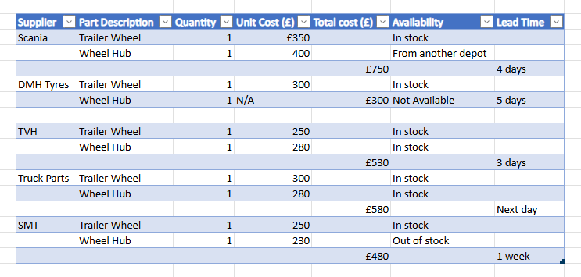
2: Labour & Travel Logs
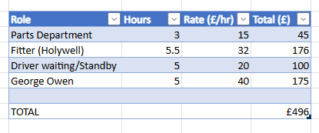

3: Transport Logs
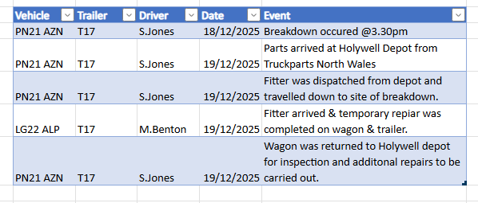
4: Hire Logs
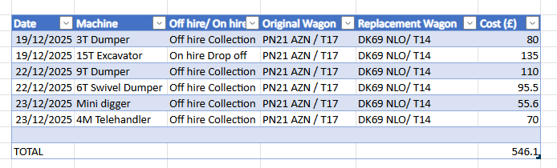
5: Breakdown Records
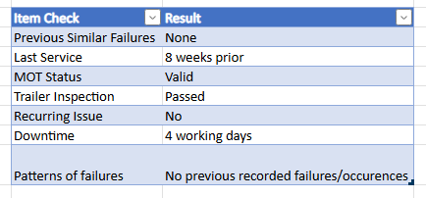
6: Cost Summary
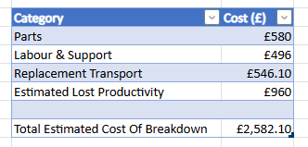

1.8 Data Analysis
These reports have been created based on the realistic daily operations of the business surrounding the time the incident occurred. From these reports collected, we can identify that a minor disruption has incurred additional costs on the company and has caused significant disruptions to transport operations over 4 days when the wagon was out of action.
Data from the Supplier quotes report shows that various suppliers had reasonable availability & purchasing costs, however as the wagon & trailer needed to be moved the following day it meant we had to purchase the parts of Truck parts who were one of the more expensive suppliers to ensure the part arrived in time.
Collecting a labour & travel report was important as we needed to assess and ensure all the potential costs are covered and that a thorough inspection has been carried out.
Collecting the transport logs of the driver were important as we were able to assess if anything may have caused this issue to evolve and how this could be prevented in the future.
Hire logs were a crucial part of this process as we needed to discover what drop offs/collections the driver had booked and how we could come up with replacement transport for the necessary days.
Breakdown records were important as we needed to understand if there was anything recurring that may be causing this issue and to ensure that the wagon 7 trailer were getting all the necessary checks and services to keep it in the best condition.
Finally, the cost summary shows a total of what impact this issue has caused financially and how we will be able to reduce the risk of this incident happening again in the future.

1.9 Discussion
From the data created relating to the incident, the analysis shows that emergency actions had to be actioned to ensure that the wagon was on the road as quick as possible. Therefore, this resulted in additional costs being incurred, including a 20% increase in part cost due to sourcing from a more expensive supplier to meet the urgent delivery requirement. Additional costs were also incurred through labour rates and additional travel costs for both the fitter and mechanic. Immediate action was required to reduce vehicle downtime as this would have resulted in delayed deliveries to customers and a reduction in revenue. In addition to this, increased downtime of the vehicle could have caused an increase in safety and compliance risks and negatively impacted the company's reputation based on reliability and availability.
Finally, by collecting this data it enabled the company to assess and identify opportunities to reduce future costs by implementing precautionary measures including preventative maintenance schedules, maintaining stock of crucial spare parts and setting out competitive emergency pricing of parts with suppliers.

1.10 Conclusion
In conclusion, the data pulled from these reports show that this is not part of a recurring issue. Furthermore, it supports the statement that the incident was unforeseen and not due to a lack of servicing. This breakdown caused significant challenges to the logistics operations of the company. By using the data driven approach, it meant that the company was able to respond effectively, ensure safety and prioritising getting operations back to normal. The event has revealed areas of improvement for the company to reduce the risk of future disruptions.

2.0 Part 2 – Business Statistics over 5 years (2021 –2025)
Below is an overview of sales figures, cost figures of goods sold, promotional expenses and administrative expenses over 5 years from Thomas Plant Hire Ltd. This data below will provide information how the business operates and how the company bring in revenue every year.
Thomas Plant Hire Ltd operates on a 30% uplift on all of their products to account for the promotional and administrative expenses. This is to ensure that all costs incurred are covered.
Below are the files used to create this data:
Purchases and Adjustments 01Jan20 to 02Feb26.xlsx
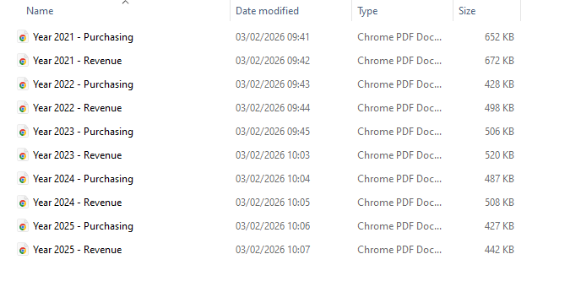

2.1 Data collection (2021 –2025)
Year | Purchasing (£) | Revenue (£)
2021 | 361,183.81 | 467,237.13
2022 | 183,411.24 | 235,617.19
2023 | 184,097.29 | 235,574.19
2024 | 251,416.80 | 325,556.50
2025 | 169,918.27 | 218,984.92

2.2 Descriptive Statistics
Purchasing Costs (2021-2025)
- Mean: £230,005.48
- Median: £184,097.29
- Mode: None
- Variance: High (£6,388,809,551.86)
- Standard Deviation: £79,930.03 (square root of 6,388,809,551.86)
Variance:
Year | Value (£) | Value – mean
2021 | 361,183.81 | + 131,178.33
2022 | 183,411.24 | -46,594.24
2023 | 184,097.29 | -45,908.19
2024 | 251,416.80 | +21,411.32
2025 | 169,918.27 | -60,087.21

Squared Difference:
Year | Difference | Squared Difference (£)
2021 | + 131,178.33 | 17,207,754,261.59
2022 | -46,594.24 | 2,171,004,604.82
2023 | -45,908.19 | 2,107,572,017.12
2024 | +21,411.32 | 458,444,356.38
2025 | -60,087.21 | 3,610,474,922.78
Total |  | 25,555,238,207.43

Calculating Variance:
25,555,238,207.43 ÷ 4 = 6,388,809,551.86

Revenue (2021-2025)
- Mean: £296,593.99
- Median: £235,617.19
- Mode: None
- Variance: High (£10,855,643,147.300
- Standard Deviation: £104,190.39 (square root of 10,855,643,147.30)

Variance:
Year | Value (£) | Value – mean
2021 | 467,237.13 | +170,643.14
2022 | 235,617.19 | -60,976.80
2023 | 235,574.19 | -61,019.80
2024 | 325,556.50 | +28,962.51
2025 | 218,984.92 | -77,609.07

Squared Difference:
Year | Difference | Squared Difference (£)
2021 | +170,643.14 | 29,118,989,332.18
2022 | -60,976.80 | 3,718,172,682.24
2023 | -61,019.80 | 3,723,415,841.44
2024 | +28,962.51 | 838,826,734.00
2025 | -77,609.07 | 6,023,167,999.32
Total |  | 43,422,572,589.18

Calculating Variance:
43,422,572,589.18 ÷ 4 = 10,855,643,147.30

2.3 Year-wise Comparison & Discussion
From the data pulled, we are able to see that the revenue exceeds the purchasing costs over the last 5 years which supports that the 30% uplift strategy is effective for this business.
In addition to this, we also notice that 2021 stands out as the purchasing and revenue year. Once could argue that this is because of the major fleet investment and maintenance as well as an increased demand of machinery after the Covid-19 pandemic.
From 2022 onwards, the purchasing and revenue costs stabilise which could suggest an improvement in forecasting, better control over fleet maintenance and a more structured operational demand for machinery.
In conclusion, this data shows that Thomas plant Hire Ltd demonstrates financial consistency and cost control over the last 5 years.

2.4: Correlation & Regression
The Data (2021-2025)
Year | Purchasing (x) | Revenue (Y)
2021 | 361,183.81 | 467,237.13
2022 | 183,411.24 | 235,617.19
2023 | 184,097.29 | 235,574.19
2024 | 251,416.80 | 325,556.50
2025 | 169,918.27 | 218,984.92
Mean Purchasing (x) = £230,0005.48
Mean Revenue (Y) = £296,593.99

Correlation:
Calculate deviations from the mean:
Year | X – X | Y - Y
2021 | + 131,178.33 | +170,643.14
2022 | -46,594.24 | -60,976.80
2023 | -45,908.19 | -61,019.80
2024 | +21,411.32 | +28,962.51
2025 | -60,087.21 | -77,609.07

Multiply deviations (X – X) (Y-Y)
Year | Product
2021 | 22,384,682,131
2022 | 2,841,167,653.60
2023 | 2,801,308,572.20
2024 | 620,125,569.61
2025 | 4,663,312,487
Total | 33,310,596,413

Step 4:
25,555,238,207.43 x 43,422,572,589.18 = 1.109 x 10(21)
1.109 x 10(21) = 33,304,950,000

Step 5:
r = 33,310,596,413 ÷ 33,304,950,000 = 0.999

Analysis:
There is a strong positive relationship and correlation between purchasing costs and revenue. This means that as the purchasing costs increase, the revenue costs also increase equally. This result is expected in a heavy plant hire company as machinery demand increases income.
Regression:
Formula Y = a+bX
B = Slope
A = Intercept

Step 2: Calculate slope (b)
b = 33,310,596,413 ÷ 25,555,238,207.43 = 1.30
Step 3: Calculate the intercept (a)
a = Y – bX
a= 296,593.99 - (1.30 x 230,005.48)
a= -2,414
Revenue = -2,414 + 1.30 x 230,005.48 = 301,421.124

Analysis:
Revenue values can be assessed accordingly due to the purchasing costs of the company. This is because it reflects the recovery of promotional and administrative expenses through the 30% uplift on products sold to customers.
In conclusion, this shows that the company's strategy of using the 30% uplift pricing model is predictable and sustainable for both purchasing costs and revenue expectations.

2.5: Charts
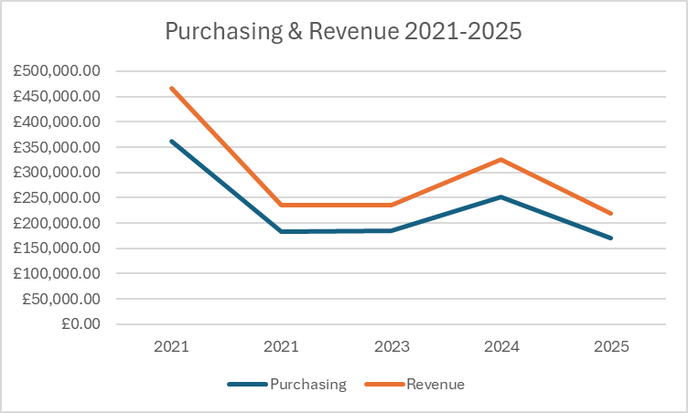
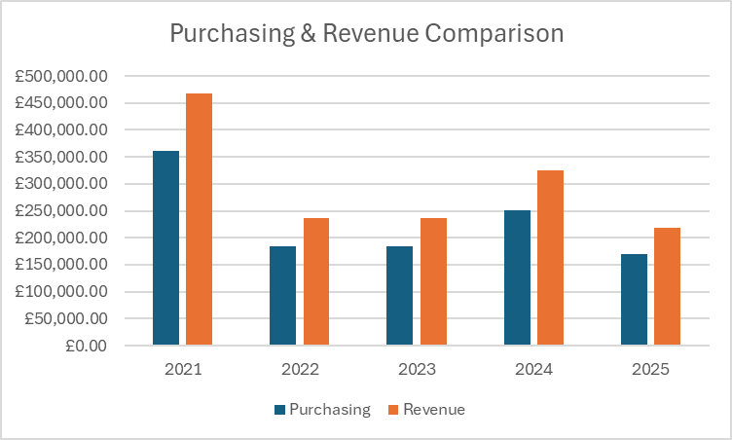

2.6: Gorry & Scott Morton 3x3 Decision Matrix
Management Level | Structured (Routine, rule-based) | Semi-structured (Some judgement) | Unstructured (High judgement)
Operational | Scheduling plant machinery maintenance based on usage levels and demand between 2022 –2023. | Adjusting weekly hire availability in line with demand from customer and increased demand from 2024. | Responding to unexpected breakdowns and repairs of equipment during peak periods.
Managerial | Monthly monitoring of purchasing and revenue figures in correlation with the 30% uplift rule. | Assessing annual purchasing structures based on the 2021 expenditure spike compared to other years. | Assessing supplier contracts and costs based on purchasing costs of parts over the years.
Strategic | Annual financial performance assessed from 2021-2025 data. | Planning fleet expansion based on demand over the years and revenue recovery. | Long term growth of the business such as expanding to new locations and expanding fleet.

Operational Level
- Stable purchasing throughout 2022-2023 supports the routine maintenance scheduling of machinery.
- These decisions are highly structured and repetitive.
Managerial Level:
- Through historical trends the 2021 spike from expenditure prompts needs for a budget review.
- Judgement is created when adjusting purchasing volumes, pricing and suppliers.
Strategic Level:
- From the data pulled, we can assess long term suggestions to support investment and expansion planning.
- These decisions are uncertain and unstructured due to the constant change in the business and relying on customers for revenue.

