

Student name: ADELA Jaimes Flores
Student ID:2443012

Module name:Introducction to Health and Social Care
Module code: LCHS 4003
Lecturer name Muhammad Aliy
Introduction…………………………………………………………………1
Origins of Residential Care Services…………………………………………………………….1
Functions of Residential Care Homes………………………………………………………1
Critical Evaluation…………………………………………………………………………………….2
Conclusion………………………………………………………………………………………………2
References list………………………………………………………………3

Parmacy Services
Student: Adela jaimes
Course Introduccition Health and Social Care.

How work Pharmacy Services
Dispensing Medicines
Pharmacies receive prescriptions from doctors, nurses, and other authorised prescribers. Pharmacists check the prescription for accuracy, safety, and suitability. They ensure the medicine is the correct dose, strength, and form. They also provide clear instructions and answer patient questions. This process helps prevent medication errors and protects patient safety.
- Clinical Services
Pharmacies now offer a wide range of clinical services. These may include Vaccinations (such as flu, COVID-19, and travel vaccines),blood pressure checks blood glucose testing, cholesterol screening, smoking cessation support, weight management advice, minor illness treatment (e.g., sore throat, earache, skin infections).These services help reduce pressure on doctors and hospitals by providing quick, accessible care.
- Medication Reviews
Pharmacists regularly review patients’ medicines, especially for people with long-term conditions such as diabetes, asthma, or heart disease. They check whether medicines are working well, whether side effects are occurring, and whether doses need adjusting. This improves treatment outcomes and helps patients stay healthy.
- Public Health Support
Pharmacies play an important role in public health. They provide advice on healthy living, disease prevention, and safe medicine use, they also support national health campaigns, such as flu vaccination drives or awareness programmes for cancer screening.
- Collaboration with Healthcare Teams
Pharmacists work closely with doctors ,nurses, hospitals, and community health services. They share information, help manage complex medication plans and support safe transitions when patients move from hospital to home. This teamwork improves patient care and reduces the risk of medication errors.
- Use of Technology
Digital tools have become essential in pharmacy practice. Electronic prescriptions reduce paperwork and errors. Automated dispensing machines improve accuracy. Digital health records allow pharmacists to access important patient information. Online pharmacy services also help patients order medicines and receive advice remotely

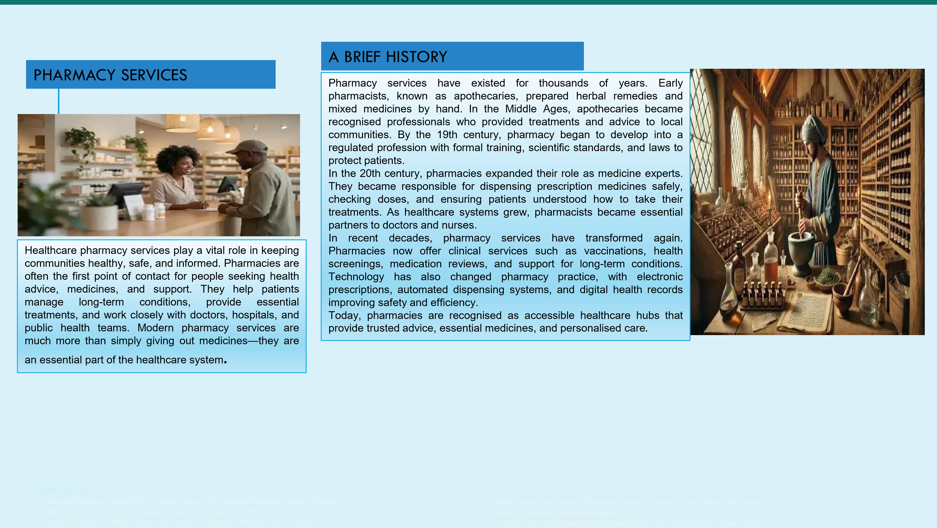
Text
A
Challenges faced by Pharmacy Services
- Increasing workload and staff shortages
Pharmacy services are facing growing pressure due to rising patient demand. More people are living longer with long-term conditions, which increases the need for medicines and clinical support. At the same time, many pharmacies struggle with staff shortages. Pharmacists and pharmacy technicians often manage heavy workloads, which can lead to stress, burnout, and reduced service capacity. This challenge affects the quality and speed of care that pharmacies.
- Financial Pressures and Funding Issues
Many pharmacy services face financial difficulties. The cost of running a pharmacy—staff salaries, medicine supply, equipment, and technology—continues to rise. However, funding from healthcare systems does not always increase at the same rate. Some pharmacies struggle to stay open, especially in rural or low-income areas. Financial pressure can limit the ability of pharmacies to expand services, invest in new technology, or hire additional staff. This challenge threatens the long-term sustainability of community pharmacy services.

Conclusion
healthcare. They provide safe access to medicines, offer clinical support, and help patients manage their health. Their history shows a long tradition of care, professionalism, and innovation. Today, pharmacies continue to evolve, offering more services and playing a larger role in public health. However, they also face significant challenges, including staff shortages and financial pressures. Addressing these issues is important to ensure pharmacies remain strong, accessible, and effective for future generations.

References list:
World Health Organization (WHO)Pharmacists healthcare Systems
NHS England, community Pharmacy Services.
General Pharmaceutical Federation. workforce report
Royal Pharmaceutical Society. History of Pharmacy practice.

Pharmaceutical Jornal, Challenges

RESIDENCIAL CARE HOME

Introduction
Residential care homes are places where people who cannot live safely on their own receive support with daily tasks. Most residents are older adults or people with disabilities who need help with washing, dressing, eating, taking medication, or staying safe. These homes aim to provide comfort, dignity, and a sense of belonging.
Origins of Residential Care Services
The idea of caring for vulnerable people in shared accommodation has existed for centuries. In medieval England, churches and charities created almshouses to give shelter to the poor, elderly, and sick. These early homes were based on charity and offered basic support.
During the 19th century, the Poor Law system introduced workhouses. These places provided food and shelter for people who could not support themselves. However, workhouses were strict, uncomfortable, and focused more on discipline than care. They were not designed to improve quality of life.
A major change came in the 20th century. After World War II, the creation of the Welfare State meant the government began funding care for older people. This led to the development of modern residential care homes that focused on personal care, safety, and emotional support—not punishment or charity. Over time, care homes became more regulated, professional, and centred on the needs of the individual.
The growth of residential care homes is linked to wider social changes:
Urbanisation: Families moved to cities for work, often living far from older relatives. This made home-based care harder.
Longer life expectancy: Medical advances meant people lived longer, increasing the number of people with long-term health conditions.
Changing attitudes: Society began to recognise that older people deserved dignity, comfort, and proper care.
Policy changes: By the late 20th century, both public and private organisations were running care homes, creating a large and diverse care sector.
Functions of Residential Care Homes
Residential care homes provide several important functions like
Personal care helping residents with washing, dressing, eating, and mobility.
Health support giving medication, monitoring health, and working with doctors and nurses.
Social Interaction organising activities and events to reduce loneliness. Safety and security offering a protected environment with staff available day and night.
Emotional Support creating a friendly community where residents feel valued.
These functions work together to support residents’ physical, emotional, and social wellbeing.
Critical Evaluation
Residential care homes can greatly improve the quality of life for service users, but their impact depends on how well they are managed.
Quality depends on staff skills trained staff can provide consistent care, which improves safety and health. However, if staff are undertrained or overworked, care may become rushed or unsafe. This shows that good outcomes rely on proper staffing and investment.
Social activities must be meaningful activities can reduce loneliness, but only if they match residents’ interests and abilities. Poorly planned activities may make residents feel bored or excluded. This highlights the need for person-centred planning.
Safety vs. Independence Care homes offer safety, especially for people with dementia or mobility issues. However, strict routines can reduce independence. Some residents may feel they have lost control over their daily life. This shows a tension between protection and autonomy.
Emotional wellbeing depends on culture a warm, respectful culture helps residents feel valued. But homes with poor leadership or high staff turnover may struggle to provide emotional support. This shows that leadership is just as important as physical care.
Access and Fairness, high costs mean some families cannot access good-quality homes. This creates inequality and raises ethical questions about fairness in social care.
Currently residential care homes vary widely from small family-run homes to large facilities with specialised staff.

Conclusion
Residential care homes have developed from simple charitable shelters into regulated, professional services that aim to provide comfort, safety, and dignity. Their history reflects major social changes, including longer life expectancy and shifting family structures. When well-run, care homes can greatly enhance quality of life by offering safety, social interaction, and emotional support. However, their success depends on staff training, leadership, funding, and person-centred care. Strong regulation and investment are essential to ensure all residents receive high-quality support.

References list

- Andrews, J. (2014). A History of care Homes in the UK. Care Press
- Social Care Institute for Excellence (SCIE). (2020). Models of care Homes.
- Nursing Home Care in the United Kingdom.

- Glasby, J. & Dickinson, H. (2014). Partnership Working in Health and Social Care. Policy press
- Department of Health and Social Care (DHSC). (2022). Adult Social Care Reform. Improving Care for older people.uk Government.
- Age UK (2021). Care Homes. How they Work. Age UK.

