
Skills for the Workplace
Module Assignment Submission
Student Name: | Angel Brazier-Lewis
Student Number: | 1702844
Module No: | BMSK4002
Module Title: | Effective Team Working and Communication  Part 2

Statement of Confirmation of Authenticity
By the act of making this submission, the student declares that this is the work of the student named above. The work has not, in whole or in part, been knowingly presented elsewhere for assessment, or where assessment has been built on a previous assessment, this has been identified. Where materials have been used from other sources it has been properly acknowledged. If this statement is untrue, the student acknowledges that an assessment offence has been committed.
Attention is drawn to the plagiarism and unfair practice policies of both the University and of ILM.

Table of Contents
Part 2 Communication 3
1.0 Effectiveness of Workplace Communication 3
Communication Cycle 3
Noise 5
Communication Models 6
Communication in the Workplace 6
Active Listening 6
2.0 8
Assessing Own Communication Skills as a Manager 8
Gap Analysis 8
PDP 9
Personal Development Plan to Improve own Communication Skills 9
References 10
Appendix A 10
Appendix B 11
Appendix C 12
Appendix D 12

Part 2 Communication

Effectiveness of Workplace Communication
In this report, I will be examining the effectiveness of workplace communication. I will look at different models, theories and ideas to evaluate communication in the workplace.

Communication Cycle

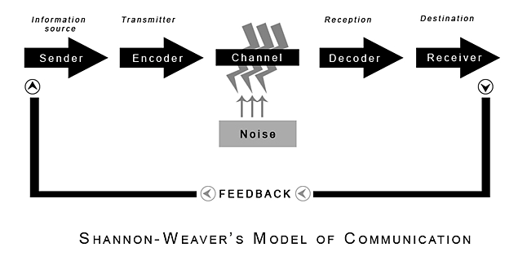
(Shannon and Weaver, 1949)
This is a transmission model which describes communication as a one-way process, where the ‘sender’ transmits a message to a ‘receiver’.
The ‘sender’ starts the cycle as the information source. They choose who the message is intended for, and how it will be sent. The ‘Encoder’ converts the idea into signals sent to the receiver which are interpreted. The ‘channel’ is the medium that takes the information to the sender. ‘Noise’ interrupts a message on the path from the ‘sender’ to the ‘receiver’. ‘Noise’ can interrupt the perception of a message.
The ‘decoder’ decodes into something that is understood by the receiver. So, the ‘decoder’ in relation to telephone communication would be that the message is decoded from sound waves, into something that is understood by the ‘receiver’, which would be words or sounds.
The ‘receiver’ is the destination for the message. This is the endpoint of the technical communication process.
Feedback is where the ‘receiver’ responds to the ‘sender’. They can express that they received the message, or to ask for further clarification if the message is misunderstood.

(Schramm, 1954)
Schramm’s Model of Communication was proposed in 1954. The theory consists of 4 key principles. (Drew, 2022)
- Communication is circular, not linear. Each person is both a sender and receiver. They can communicate with each other.
- Communication is usually equal and reciprocal. Both members of the conversation should have back-and-forth discussion.
- That there is a lot of interpretation involved when receiving a message. Meaning can be lost, and information can be misinterpreted.
- That all communication requires 3 steps. Encoding, Decoding and interpretation.
Once a message has been decoded and interpreted, the cycle begins once more. The receiver will encode their own message to send. The cycle will be ongoing.
In 1960, David Berlo presented the SMCR Model of Communication.

(Berlo, 1960)
The source is where the message originates. You require communication skills to communicate with others. They need to be knowledgeable. ‘Social’ focusses on the persons upbringing, culture, values and religion.
The message comprises of content. Elements include body language, gestures, writing style etc. Treatment relates to the way the message is sent or delivered and passed on. ‘Structure’ refers to how the message is written or arranged. The code relates to the means in which the message is sent and in what form. This could be body language, language or gestures.
The Channel refers to the 5 senses. For example, hearing or listening to the message via verbal communication.

Noise
Noise is any barrier to an effective communication process. There are different types of noise in communication.
Physical noise is an external barrier. Physical noise could be sounds or lights, or anything that interferes with or disturbs the physical environment.
Physiological noise is a barrier created from the communicator’s psychological factors, such as their values, beliefs, attitudes and personal behaviours. This kind of noise interrupts our thought process and interferes with listening. For example, you wouldn’t want to listen to someone criticising your religion or beliefs.
Semantic noise occurs when there is confusion over the meaning of words or sounds. It can occur when there are grammatical errors or sound issues. It is important that messages are constructed with clarity and accuracy, to avoid this kind of noise.
Cultural noise is created by a wrong explanation of another person’s behaviours. It derives from nonverbal communication from people with different cultural backgrounds. The basic kinds of non-verbal communication cues are gestures, eye contact, touch and posture. These can be conflicting, culture to culture. It is important to consider the cultural impact body language has on communication, to ensure this cannot be misconstrued.

Communication Models
I have looked at examples of Shannon and Weaver’s communication cycle, and how this directly links to my own work processes. The example I have focussed on below, is an experience of my own communication via email.
Sender: In this case, this was me, sending an email to a supplier to express that we would need to cancel an order and all future orders of a specifically manufactured product.
Encoder: This is the email software, transmitting the information to the receiver. In this case, this would have been Outlook.
Channel (Medium): This is also Outlook.
Noise: A server error had blocked the email from leaving my outbox, and this had gone unnoticed. The issue was not resolved for several days before realising this had occurred.
Decoder: The email software on the recipient’s computer will show the message contents.
Receiver: The receiver (supplier) had received the message and understood clearly.
Reflecting on this cycle, I can see the errors that occurred that prevented the information from reaching the recipient. If another method of communication had been used, such as by telephone, or face-to-face, this issue would not have occurred.

Communication in the Workplace
Communication in the workplace is pivotal to ensure the goals of the business are met. The main two types of communication used are verbal, written and non-verbal.
Verbal communication we use in the workplace are face-to-face team meetings, Teams meetings, and simply speaking to colleagues. This is the preferred method of communication in our workplace according to policy.
We use written communication methods, such as Teams chats, Email, letters and using ticketing systems. I prefer to use teams chats internally, as I receive quicker responses. However, this would not be an appropriate means of communication for contacting our suppliers or stakeholders.
Written communication is primarily used between us and international suppliers, which does pose translation issues sometimes. It is important to ensure our letters and emails translate well, if they are conveying important information.
Body language is not effective in my place of work, but it does start conversations. It is important to discuss feelings with colleagues and understand why these feelings are occurring. Poor body language decreases morale within the business and has a huge impact.

Active Listening

Active listening is the ability to hear and understand what is being communicated. Not many people know how to be successful at it. Michael Hoppe suggests that there are 6 key skills to consider.

(Hoppe. 2006.)
Hoppe describes the process of active listening as making an exchange with people. The quality and effectiveness of a conversation can be improved when they are engaged with active listening.
Each skill above contributes to an active listening mindset, which encompasses various techniques and behaviours. The skills are not mutually exclusive. The skills are also not of the same level of importance.
You should pay attention to your frame of mind, body language and the other person. Good listeners hold judgement, even if they disagree with the other persons’ views. Practice empathy.
“Tell yourself, “I’m here to understand how the other person sees the world, it is not time to judge or give my view.” (Hoppe. 2006)
You can indicate your open mind, acknowledge differences and show patience.
Reflecting on the other persons’ thoughts, ideas, perspectives and feelings is a good way to show that you understand and shows the other person that you have listened.
Clarifying, open-ended and probing questions are important tools. These questions will open the conversation and ensure everyone has expressed their views fully and thoroughly.
Summarizing helps to see key themes of the conversation as it proceeds. You should briefly summarize what you have understood as you listen.
To be an active person in the conversation, it is important to share. You can share your own feelings, suggestions and concerns. This gives an opportunity to collaborate.
There are 4 types of listening styles. People-oriented listening is where listeners are focussed on the feelings of those involved in the conversation. These listeners pay attention to the key message and the speaker. Content-oriented listeners evaluate facts and evidence given by the speaker. They pay more attention to the technicalities rather than general conversation. Action-oriented listeners look forward to the key point and take on board the critical point of the speech. Time-oriented listeners prefer clear and concise information. They have a limited attention span or are bound to a set time due to other commitments, for example. They utilise and manage their time well.
(Kobiruzzaman, 2022)
I have taken a questionnaire to discover what type of listener I am, and reflected on my result, this can be found in appendix A. I also invited my manager to complete the questionnaire, which can be found in appendix B. I have also summarised their result.

2.0

Assessing Own Communication Skills as a Manager

I have been assessing the effectiveness of my own communication skills. To do this, I have taken a communication style questionnaire, so I can identify my strengths. As seen in appendix C. The results of my communication style questionnaire suggests that I am an ‘Assertive Communicator’. I do agree with the points that I am confident, direct and show empathy. However, I do think there are areas I can improve on.
As per my recent presentation on Effective Communication, I have reflected on the feedback given by my peers and course tutor. Overall, I am happy with the feedback given but I was hoping for more constructive criticism. I can see that my peers have enjoyed my presentation and given positive feedback on my tone, speed, content and presentation slides. There are some fair criticisms about the delivery and content of the presentation. I will use my Personal Development Plan to outline how I will improve my skills based on the feedback. It is clear to me that the areas I need to improve are referencing, use of tone and voice, professional presenting (in an academic style) and personally, my confidence to present.
I have identified where I am lacking in strength and have listed these in my Gap Analysis below. Using the gaps in my strengths, I have also created a personal development plan to describe how I will reach these goals, using SMART targets.

Gap Analysis

Objective | Current Position | Deficiency | Action
What do I want to do? | What can I already do? | What am I lacking? | How do I fix this?
To create presentations that are of an academic and professional standard. | I can use Microsoft PowerPoint well; I am familiar with the features. | Training in creating academic and professional presentations. | I can take courses or use resources to improve my skills in constructing a presentation on Microsoft PowerPoint.
Gain confidence in presenting to multiple team-members. | I can present using technology and recording my presentations online. | I am lacking the confidence and have great anxiety about presenting to an audience. | I can practice and take small steps towards presenting to an audience such as presenting 1:1, then moving on to small groups and so forth.
Reference correctly as per APA v7 system. | I know the basic elements and rules of citation. | I lack the knowledge to reference and cite correctly for each reference I use. I am not familiar enough with the APA system and need to develop this skill. | I can read the referencing handbook as provided by UWTSD to ensure I am referencing correctly.

PDP

Personal Development Plan to Improve own Communication Skills

Objectives | Tasks | Success Criteria | Time Frame | Resources
List your Goals | What do you need to do to achieve these goals? | How will you identify your success? | When do they need to be done by? | Who or what do you need to help you?
Pursue learning about academic and professional presentations so that my presentations are accessible and presented in the correct style. | I can ask my course tutor if they are aware of any courses or resources to improve my presenting skills, specifically constructing a presentation on Microsoft PowerPoint. | I will be able to present an academic presentation or professional presentation to a high standard. | Target Date as 01/09/2022 as this is the date of my next personal development review. | I can seek support from my course tutor and work manager to build my confidence in presenting and constructing presentation slides.
Present to a team of 5 people or more. | I need to practice presenting to small groups of people and increase my confidence. | I will be able to present confidently to a team of 5 people. | Target date as 01/09/2022 as above. | I can seek support from my manager, and practice presenting to smaller groups or on a 1:1 basis to begin with.
Learn to reference as per APA v7 System | I need to research and read about the APA v7 referencing system to be able to communicate my citations and references properly in my work. | I will be able to reference correctly with minimal errors. | Target date as 01/05/2022. | I can use resources developed by UWTSD such as the Referencing Handbook. I can always reach out to my course tutor too.

References

Berlo, D. (1960). The process of communication: an introduction to theory and practice, Holt, Reinhart and Winston, New York.
Blenkinsop, P. (2010) The Communication Cycle. [online] Available at: http://manyana-education.blogspot.com/2010/10/communication-cycle.html Accessed: 25.03.22
Drew, C. (2022). Osgood-Schramm Model Of Communication – Pros & Cons. Retrieved 29 March 2022, from https://helpfulprofessor.com/osgood-schramm/
Hoppe. (2006). Active listening improves your ability to listen and lead (1st edition). Centre for Creative Leadership.
Kobiruzzaman, M. (2022). Listening Styles People, Content, Action & Time Oriented Listening. Retrieved 2 April 2022, from https://newsmoor.com/types-of-listening-styles-are-people-content-action-time-oriented/#:~:text=The%20four%20types%20of%20listening%20styles%20are%3A%201,Action-oriented%20listening%203%20Content-Oriented%20Listening%204%20Time-Oriented%20Listening
Malacoff, J. (2022). QUIZ: What's Your Communication Style? - Glassdoor Blog. Retrieved 2 April 2022, from https://www.glassdoor.com/blog/quiz-whats-your-communication-style/
How Good Are Your Listening Skills?: Understanding Someone's Entire Message. (2022). Retrieved 2 April 2022, from https://www.mindtools.com/pages/article/listening-quiz.htm
Shannon, C. and Weaver, W. (1949) The Mathematical Theory of Communication. Urbana: University of Illinois Press.

Appendix A
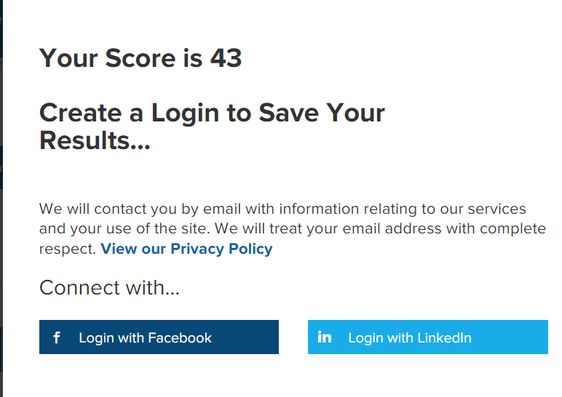
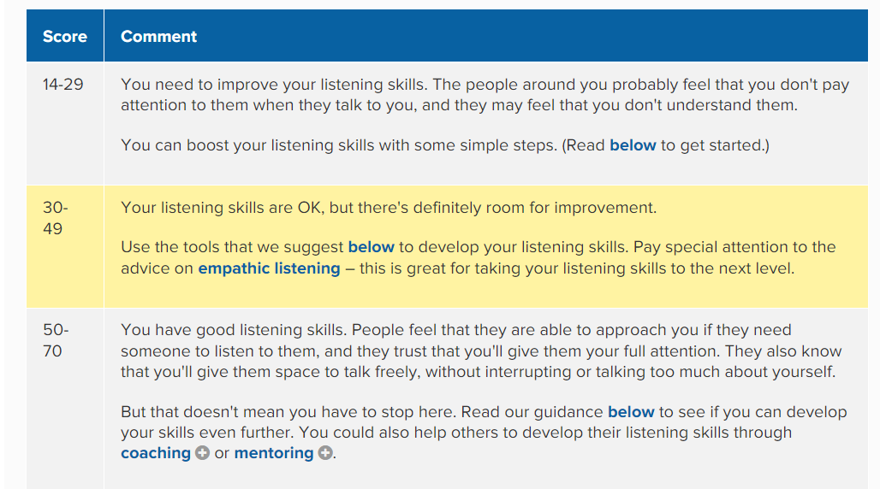
How Good Are Your Listening Skills?: Understanding Someone's Entire Message. (2022).
I was not surprised by my result, but this gives me something to work towards. I need to develop my empathy skills according to this questionnaire.

Appendix B
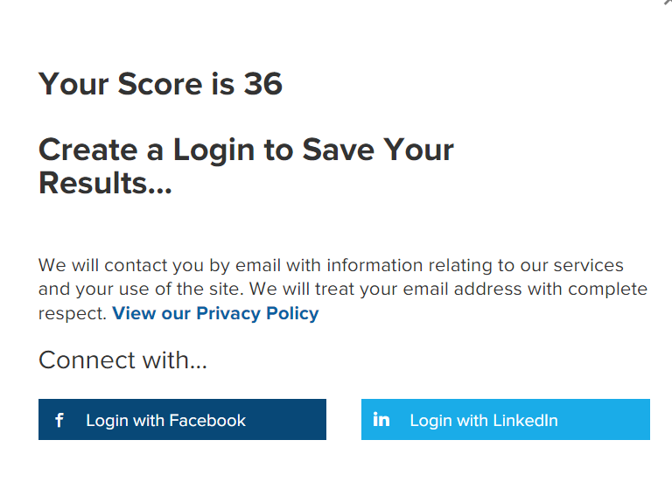
How Good Are Your Listening Skills?: Understanding Someone's Entire Message. (2022).
My colleague was most surprised by their result, as a manager with over 12 years’ experience in Purchasing, they felt that they had all the skills necessary. This has prompted them to learn more about empathic listening. I shared my results with my manager, as they are similar, and we have agreed to discuss empathic listening and broaden our skills together.

Appendix C
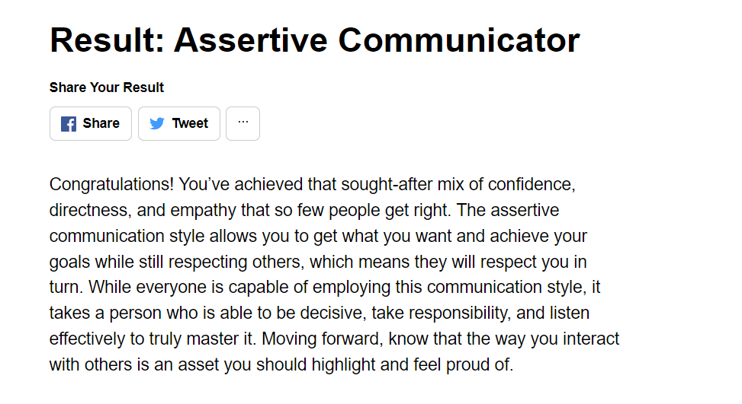
(Malacoff, 2022)

Appendix D
Evaluation from Michael Thomas

Evaluation from Tracey Howells
Evaluation from Natasha Mitchell
Evaluation from Julia Ault

