DSP and Communications Assignment 2021- The Performance of ASK, PSK and QPSK Models in the Presence of Additive White Gaussian Noise
L5 - Digital Signal Processing and Communications (ACDA5008)
Thomas A Harwood (1906968)
University of Wales Trinity Saint David

Abstract
This report evaluates the relationship between the Signal to Noise Ratio and the Bit error rate of ASK, PSK and QPSK modulators and demodulators, it takes a brief look into the background of digital modulation, Amplitude Shift Keying, Phase Shift Keying, Quadrature Phase Shift Keying, Signal to Noise Ratio and Bit Error Rate. The report then illustrates and describes the three simulator models used to evaluate the experiment and then uses the collected data to compare the performance of each model under the specific levels of noise and the bit error rate for each model.

Contents
- Introduction

- Background Information

- Simulator Circuits

  - ASK

  - PSK

  - QPSK

- Results

  - ASK Graph

  - PSK Graph

  - QPSK Graph

  - Combined Graph

- Discussion

- Conclusion

- References

- Annex A- Filter Design Parameters

- Annex B- Sine Wave Parameters

- Annex C- ASK Results Table

- Annex D- PSK Results Table

- Annex E- QPSK Results Table

Introduction
This report uses Simulink software to create simulation models of Amplitude Shift Keying, Phase Shift Keying and Quadrature Phase Shift Keying modulators and demodulators. These simulation models are equipped with Additive White Gaussian Noise channel, this component allows the operator to change the Signal to Noise ratio (SNR) of the model. All the models also include an error rate calculator which enables the simulation to produce the Bit Error Rate (BER) for the model. For each of these simulations the Bit Error Rate is the value which is going to be measured and is thus the dependant variable, the SNR is the parameter which is going to be changed throughout the experiment and is thus the independent variable. For these simulations the control variables are the carrier frequency, data rate and sample rate, to allow for a comparison between the simulations these parameters were a constant throughout the experiment. To allow for a reliable comparison the SNR will be varied between -60 and 0 for each of the simulations, the recorded results will be displayed on a graph with the Bit Error Rate on the Y-axis and the SNR on the Y-axis. To allow for any computing errors and a fair test each SNR level will be simulated three times and a mean of the results will be calculated. The standard deviation will also be calculated to allow for the use of error bars on the graphs, error bars are useful as they indicated the level of uncertainty for that plot of data. The parameters chosen for the bit error rate were from 0 to 0.6, 0.6 was chosen as the operator considered that if 60% of the information is lost then it renders the overall signal unsalvageable. The prediction for this experiment is for the QPSK model to be to withstand the all the levels of noise and still produced an output with at least 60% of the information still intact.

Background Information
The models referenced in this report are digital modulators and demodulators. Modulation is split in to two varieties analogue modulation and digital modulation, Analogue modulation consists of Amplitude Modulation (AM), Frequency Modulation (FM) and Phase Modulation. Amplitude modulation and frequency modulation are widely known for their uses in radios that appear in cars and homes across the world, AM is changing the amplitude of a message signal while keep the frequency of the signal constant whereas FM is achieved by changing the frequency of the signal while keeping the amplitude of the signal the constant. Digital modulation on the other hand consists of Amplitude Shift Keying (ASK), Phase Shift Keying (PSK) and Frequency Shift Keying. ASK and PSK are the two types of digital modulation referenced in this report, Ask is when the amplitude of the carrier wave is interchanged between two values and PSK is when the carrier waves phase is edited at the start of the signal this is also between two values. PSK can be split into two other categories Binary Phase shift Keying (BPSK) and Quadrature Phase Shift Keying (QPSK), QPSK is utilised within one of the models. QPSK is utilised when there are multiple binary signal inputs, these two inputs are combined to form the quadrature signal. BPSK is also used in one of the models mentioned in this report, BPSK has been referred to as PSK for these simulations. Signal to Noise Ratio and Bit Error rate are the two measurables used in this report, SNR is the measurable created by an Additive White Gaussian Noise (AWGN) channel this component appears in all three of the models to allow the operator to change the level of noise within the system. AWGN is a model used to simulate noise on an electric circuit, noise is an unwanted biproduct of analogue and digital modulators which can negatively affect the output signal causing loss of information. To allow for noise within the simulations used AWGN channel is used so the operator can increase the noise applied to the system to see how the output is affected by the noise. Bit Error Rate is the value which quantifies the percentage of information that has been lost as the signal travelled through the system, the BER value is given as a decimal number which represents a percentage for example a bit error rate of 0.4 is the equivalent of 40% of the signals information is lost. [1] [2] [3] [4] [5] [6] [7]

Simulator Circuits

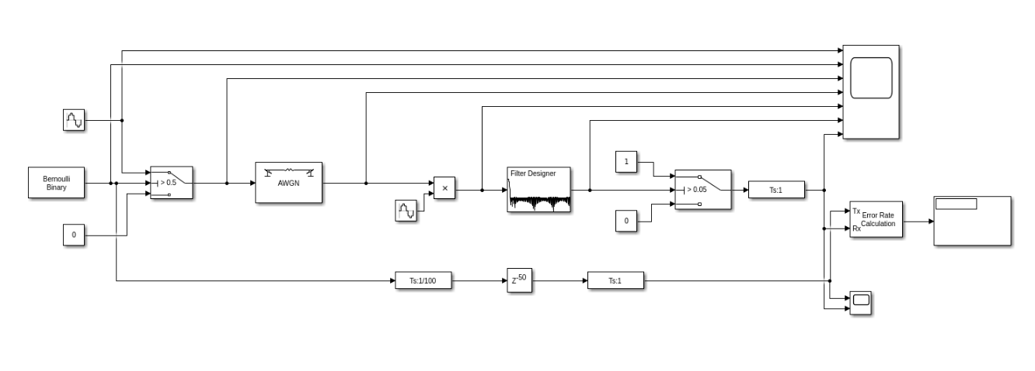
ASK
Figure 1- ASK Model

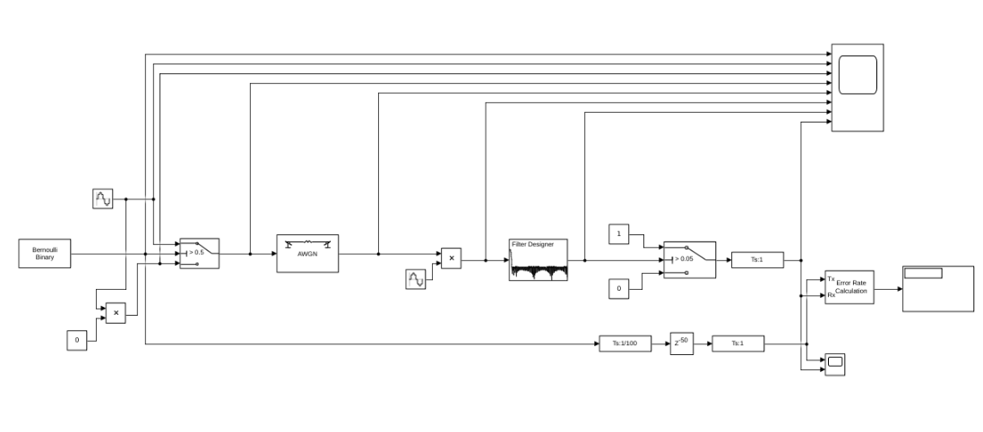
PSK
Figure 2- PSK Model

Figure 1 and figure 2 are screen captures of the models used to simulate the ASK and PSK modulators and demodulators; this model includes a Bernoulli binary generator which is the component that generates the signal for this model. The component above the Bernoulli binary generate is the component which allows the operator to edit the parameters of the sine wave, the next company in the circuit is the switch which has an allowance of 0.5. The next component is the additive white gaussian noise channel which allows the operator to increase or decrease the amount of noise experienced by the system, after the AWGN channel is another sine wave editor which is then followed by a filter designer this component allows the operator to design a filter to ensure the system achieves the desire output. After the filter designer is another switch which has a 0.05 allowance, after the final switch there is an error rate calculator which when combined with a display allows the operator to view to bit error rate which is then plotted onto the graphs referenced in this report. Other components within these models are the scopes to view the sign waves and input signals and then three signal specification channels which allow the operator to edit the signal when required.

QPSK
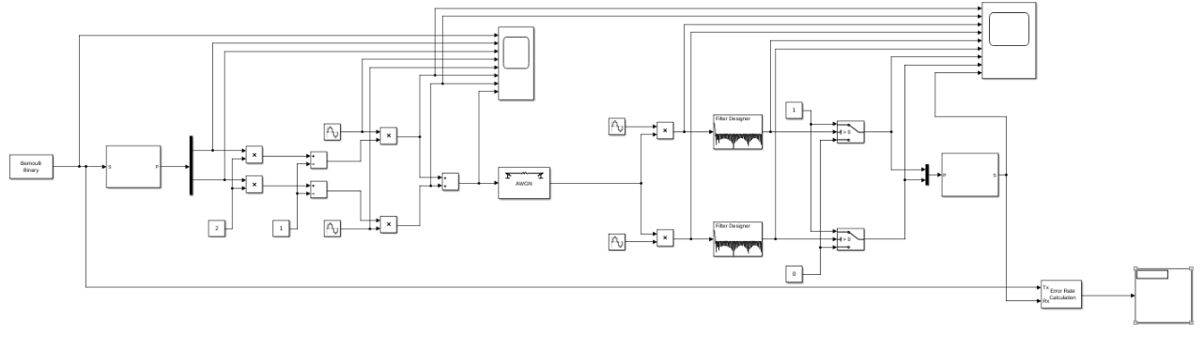
Figure 3- QPSK Model

Figure 3 is a screen capture of the QPSK simulation model, this model has a similar set of components to the ASK and PSK models, only this simulation includes more components in total. Unlike the ASK and PSK Models this model has four sine wave editors and two filter designers, this is because the QPSK utilises two binary signals for the systems input. To allow for a fair comparison between all simulations a set of control variables were set, this included the filters and sine wave parameters and the length of simulation. Annex A is a screen capture of the parameters inserted into the filter designs for all the simulation referenced in this report, Annex B is two screen captures of the parameters listed in the sine wave editor window the left screen capture is the parameters for all the sine waves in the ASK and PSK Simulations it is also the parameters for half of the sine waves in the QPSK simulation. The right screen capture is the parameters for the other half of the QPSK simulation. The reason for the different parameters in the QPSK model is because there are two binary signals, the second binary signal needs to be half a phase out when compared to the first binary signal.

Simulation Results

ASK graph
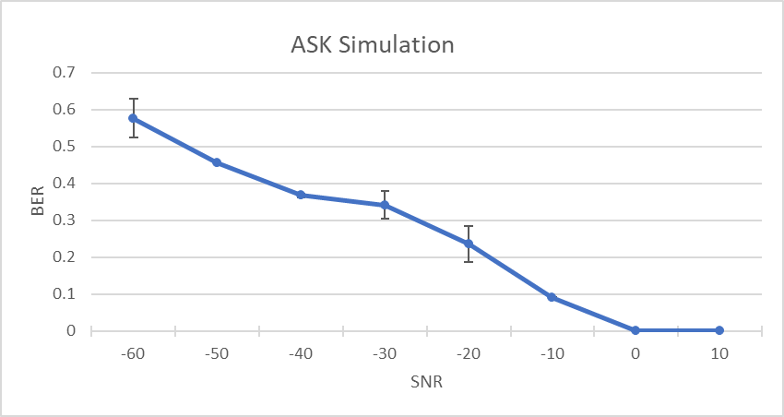
Figure 4- ASK graph

PSK Graph
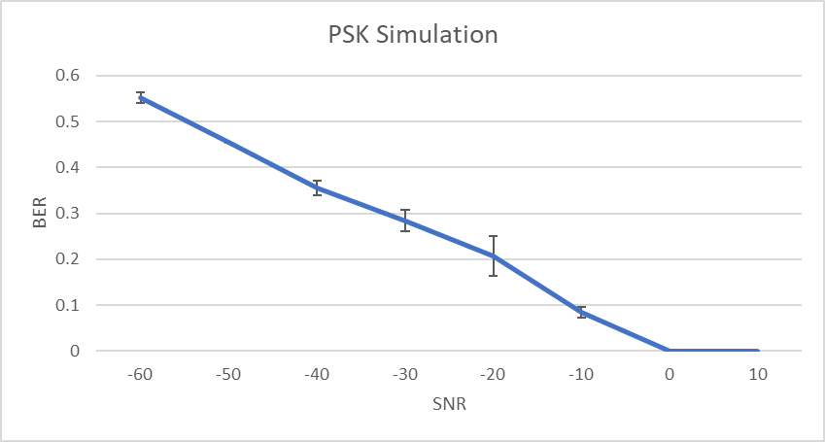
Figure 5- PSK graph

QPSK Graph
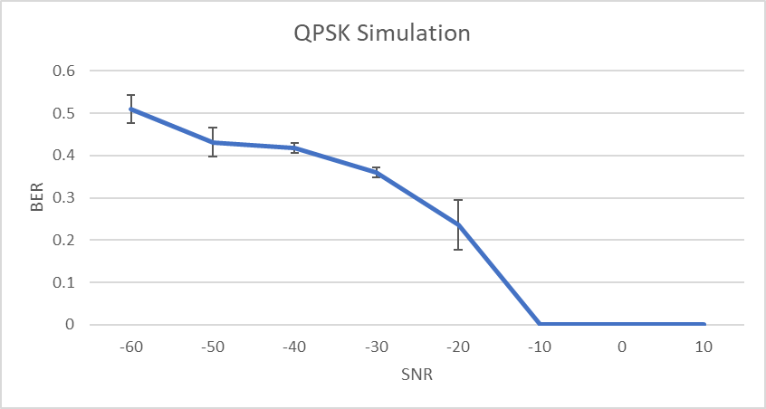
Figure 6- QPSK graph

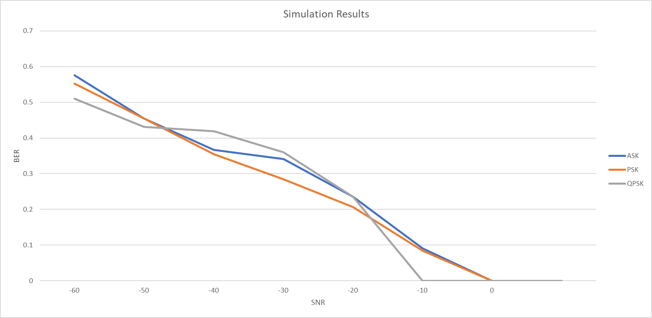
Combined Graph
Figure 7- Combined graph

Discussion
The results shown above in figures 4, 5 and 6 are from each of the separate simulation model, to achieve these results each noise level was ran three times to create an average for each noise level subsequently being plotted on the graph. the standard deviation for each noise level was calculated which is represented on the graph as the error bars. Some of the plots appear to not have error bars this is because either the deviation between the output was too minimal to appear on the graph or the model produced the same number for all three simulations. Figure 7 is the combine graph for all three off the simulations, the legend on the right explains which colour is which simulation, to ensure the graph wasn’t congested the error bars were not shown on the combine graph. All three of the simulations have similar trends, all the graphs indicate that as the signal to noise ratio increases the Bit error rate decreases. This means that as the amount of noise within the system increases the percentage of information lost also increases, when taking a closer look at the trendlines for each simulation there are some differences in how the different models perform when the noise is increased. The ASK graph shows a steady decrease of bits lost with some of the changes being more significant than others, looking at the error bars the data indicates a mix of consistent results and others which deviated between the simulations. The PSK graph shows a more even regression with each noise level reducing at a similar rate giving an almost straight line, the error bars on PSK graph appear on most but not all the plots this is due to the results within the simulation like what appears on the ASK graph. The QPSK graph is slightly different from the two mentioned previously it has the same trend but has a more inconsistent regression as the changes from noise level to noise level are more drastic than the ones on the ASK and PSK graphs, unlike the other two graphs each of the noise levels that had a bit error rate of above zero has an error bar this indicates that the simulation results varied on at least two of the simulations. After reviewing the graphs produced and the original data it was decided that the QPSK model was the more reliable model out of the three tested, this was determined because of the QPSK model’s performance at the low-end of the noise scale producing 0% of information while at -10 decibels of noise, whereas both other simulations produce some level of loss at the negative ten noise level. The model also performed the best the high-end producing the lowest percentage of bits lost at the negative sixty noise level although the QPSK model did present an average of 50% information loss at -60 decibels this was the lowest average out of the three models tested. The QPSK model did produce a higher level of bits lost than what the operator was expecting and yet it still overall performed the best compared to the ASK and PSK models.

Conclusion
To conclude, the aim of this report was to compare how ASK, PSK and QPSK models handle specific levels of noise within a modulator and demodulator system. To complete this objective three Simulink models were created to produce a simulated version for each model, after the simulations were completed the data presented a similar trend shared with all three of the models that indicated that as the amount of noise within a circuit is increases the amount of information lost from the original input also increases. Overall, the data indicated that the QPSK model performed better than the ASK and PSK models but the QPSK model did not perform to the level of the original prediction set at the start of the experiment as it lost slightly over 50% of the information on average over the three simulations.

References

[1] | V. Authors, Encyclopedia of Physical Science and Technology, Tarzana. Ca: Academic Press, 2001.
[2] | M. Krarti, Optimal Design and Retrofit of Energy Efficient Buildings, Communities, and Urban Centers, Boulder, CO: Butterworth-Heinemann, 2018.
[3] | P. P. Regtien, Sensors for Mechatronics, Hengelo, The Netherlands: Elsevier, 2012.
[4] | W. Ciciora, J. Farmer, M. Adams and D. Large, Modern Cable Television Technology, Unkown: Morgan Kaufmann, 2004.
[5] | R. W. Middlestead, Digital Communications with Emphasis on Data Modems: Theory, Analysis, Design, Simulation, Testing, and Applications, Unkown: Wiley Telecom, 2017.
[6] | M. E. V. Valkenburg, Reference Data for Engineers 9th Edition, Unkown: Newnes, 2002.
[7] | A. Grami, Introduction to Digital Communications, Unkown: Academic Press, 2016.

Annex A- Filter Design Parameters
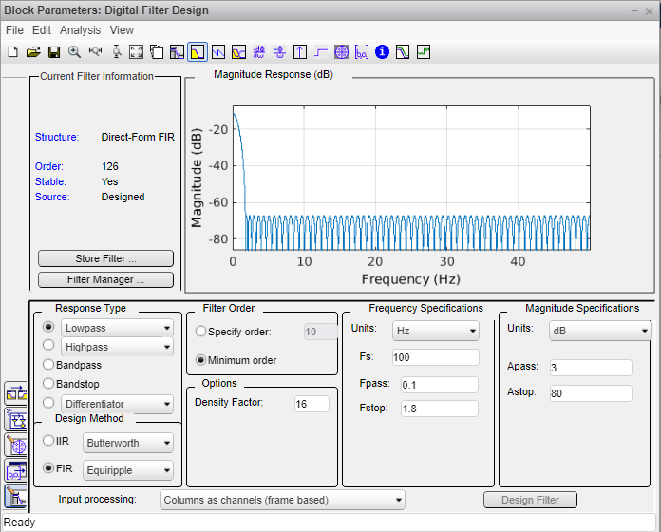

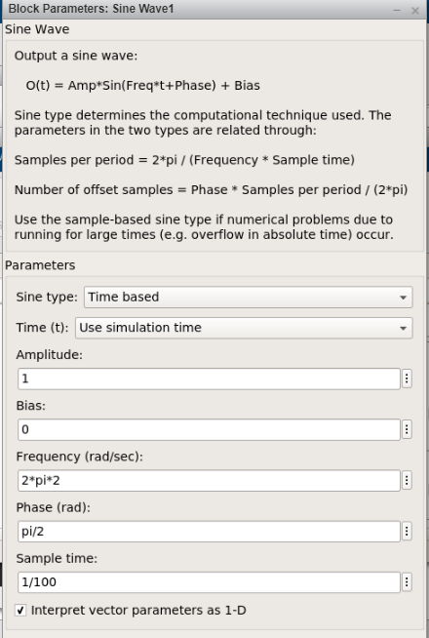
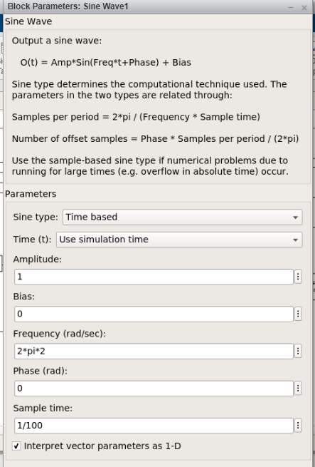
Annex B- Sine Wave Parameters
Sine wave parameters for other half of QPSK simulation
Sine wave parameters for ASK, PSK and half of QPSK simulations

Annex C- ASK Full Results
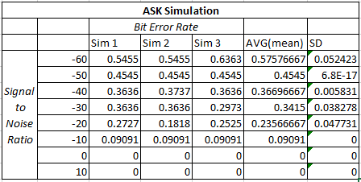

Annex D- BPSK Full Results
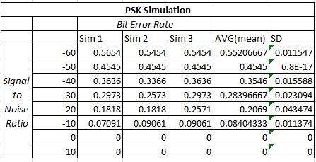

Annex E- QPSK Full Results


