Academic & Employability Skills
  - Module ACCA4016 Assignment
by
  - John Doe
1903715

Contents

- Presentation
  - Brief overview
  - Screengrabs
  - Key points learned
  - Future improvements
- Skills Evaluation
  - Skills required for successful learning in Higher Education
  - Skills employers look for in prospective job candidates
  - Self-evaluation
  - Sort and long-term goals
  - Action plan
- Application
  - Looking after your data
    - Backup strategy
    - Disaster scenarios
    - Ransomware report
  - Time management
  - Self-organisation
- Conclusion and Evaluation
- References
- Appendices
  - Ransomware Report
  - Linkedin Profile
  - Curriculum Vitae

Presentation

1.1 Brief Overview
Born and brought up in Bridgend, John lived and worked in South Wales his whole life. The author of several talks and history walks that tell the story of Bridgend over the last thousand years, that aimed to improve the popular opinion of the town, John is a recognised local historian of Bridgend which has seen him interviewed live on BBC radio and even television.
A man of many hobbies, and not one to sit on a sofa watching Netflix, John has played guitar and sung in a band, done archery for several years. An avid writer with a Creative Writing degree and newspaper column, and also quite in to cooking and fitness.
Videogames also belong on this list, but were left until last because it ties in to John’s main pass-time at present: Cosplay.
For a number of years, John has been making, wearing and performing in costumes of characters from videogames and movies, competing around the country. Qualified for the World Championships back in May 2019, and a finalist in the UK Borderlands Cosplay Competition in October 2019.

1.2 Screengrabs
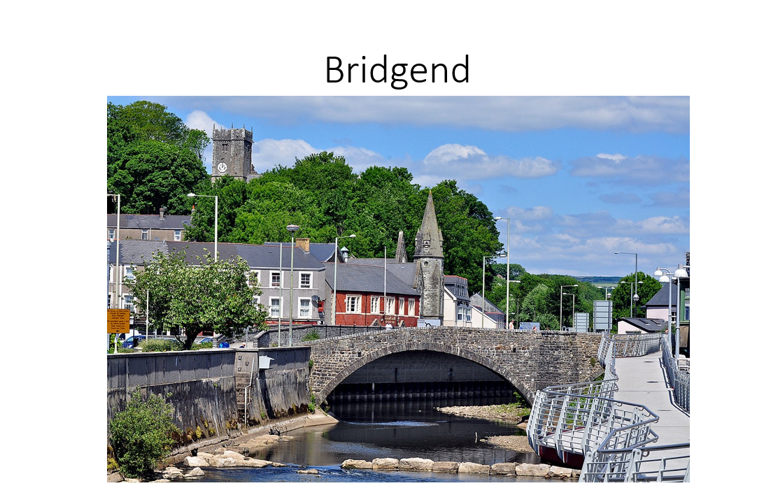
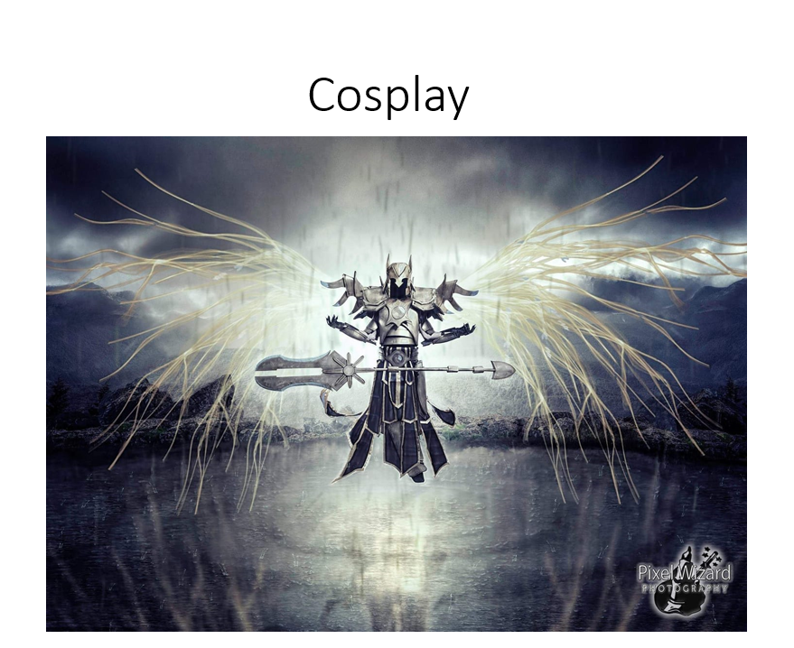

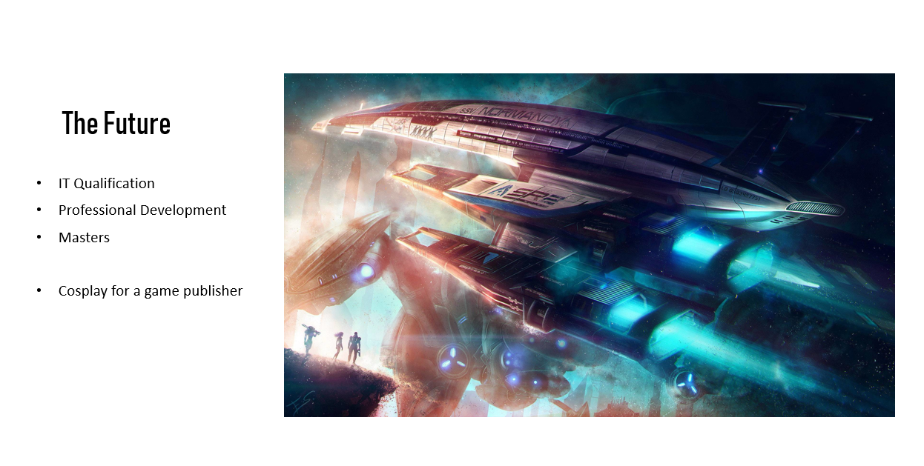

1.3 Key points learned
Having previously accumulated a great deal of experience delivering presentations, habits have had time to develop and as such, certain aspects of a presentation are almost automatically created without enough pause and thought given to the specific audience and environment. Software developments have also made it simple to add subtle visual improvements within Power Point itself by the use of templates, themes or designs, and it is good practice to stay abreast of these features as they release as opposed to sticking to the same template and format which has been in use for several years.

1.4 Future improvements

- Maintain good current knowledge of software developments and tools available within PowerPoint or other relevant application.
- Consider audience, room and screen size when sizing text to ensure clear visibility through the audience.
- Include video or audio files, or external links where possible to change up delivery pace and better maintain audience engagement.

Skills Evaluation

Skills required for successful learning in Higher Education

- Higher education, by its very definition, introduces new ideas, concepts, techniques, and more, based on those that have come before. When entering in to higher education, one should be prepared to experience new things with the intent to develop further towards academic specialisation in a chosen subject area; open-minded even when the ideas presented might conflict with the individual’s already established experiences and beliefs in order to develop one’s knowledge in the specified field. [1]

At the same, individuals will benefit most from having the confidence to question the information before them, express their own ideas and share their own experiences in order to develop discussions and theories. Learn to analyse opposing views and consider the ideas and evidence that broaden subjects as a whole.

This confidence extends further, to being able to present one’s own work and ideas to their peers, and being open to scrutiny thereafter, can push a student to develop ideas to a high academic standard. [2]

- Self-motivation, especially with difficult tasks is very important. Time spent with lecturers in higher education is formulated to spark ideas and present concepts for students to go away and research and report on further of their own initiative. When the time comes for assignment completion, the motivation to persist through the task while referring back to the knowledge accumulated over the duration of the course, as well as the diligence to search out additional source material and evidence to support or challenge ideas is essential to success. [3]

- Similarly, organisation is important. Assignments come with deadlines, and these can often bunch up as semesters reach their end. Students will perform better for having planned their time through the academic year to work at a reasonable pace through one assignment at a time, or else face being left with having to juggle multiple complex subjects and produce what can be very different reports in a very short amount of time. [4]

- Research is an important part of academic life. While course materials will be invaluable throughout academic development, in order to develop ones’ own ideas, research should be carried out to explore specific points of interest and develop reports and assignments accordingly. It would show poor academic development to simply reflect on the content delivered directly through the course material. [5]

- The ability to process research, which can often come in the form of complex literature, is also a useful skill. The ability to extrapolate the key information to support academic ideas and present that as evidence as one develops a report will be a boon to report-writing students. As this skill is practiced, efficiency will develop for processing such information even more quickly, being able to quickly extract the key information required while simultaneously passing over the information of less relevance.

- Being able to compare evidence and ideas from countering viewpoints is another useful ability. Taking an objective viewpoint allows a researcher to compare, perhaps even score evidence quality against each other and decide which ideas and theories are best supported. [6]

- Being able to process researched information and report on it in the author’s “own words” is important. While one might quote or reference the evidence of others in the field, it is important to develop one’s own voice, to avoid plagiarism as much as anything else. Reading already produced literature is an essential part of the academic process but reproducing the work of others is more severe than just “bad practice”, it comes with strict consequences. Being able to write on a subject “in your own words” also demonstrates that the author has a good understanding of the content or subject matter. [7]

- Objectivity is useful even when referring to one’s own work. To question one’s own evidence and method. Being able to objectively review one’s own research and experience, makes allowance for external factors and context that may not have been considered as influencing factors while reaching an end point. [6]

- Motivation can come through organisation. Strategies can be applied for the starting of a new task, such as developing a roadmap, or writing a contents page at the start of an assignment. This allows a student or author to move from point to point, developing the idea at each one and knowing immediately where to progress to next without having to stop, think, and interrupt productivity pace. [8]

- Having a well-developed filing system for notes and research is important. “Light bulb” ideas will happen frequently throughout higher education, but the specifics of these ideas will be lost to students who don’t have these key pieces of information filed and organised for easy reference and re-use. Making use of the ideas that developed throughout the academic year will make for a much deeper and more thorough report.

- Writing style can differ from a report, to an essay, to an assignment. Learning when best to use a bullet point list to display key facts, when to flesh out prose to explore an idea, or when to simply extract a key line and include the rest in the appendix in response to requirements and demands such as word count, format and even target audience, is a worthwhile skill students might take the time to develop through academia and beyond. [6]

- Being able to use technology to one’s advantage makes for efficiency through academia. Premade templates on Microsoft Office applications, reference management software and much more, can be utilised to complete small tasks with greater efficiency, and allow students to then focus on the content, research and evaluation of a report. [9]

Skills employers look for in prospective job candidates

While academic education and qualification can be of vital importance in a specialised field, employers will place equal, if not greater value on the demonstration of knowledge and experience being applied, and on certain key qualities that they will place value in, that they feel are integral to working in their organisation. [10] Much of these skills will differ not only from job to job, but by the person reviewing each specific application. [11] What a prospective job applicant can aim for however, is the demonstration of core qualities that would be appealing to the widest target audience, if the specific qualities sought after aren’t openly shared. In either of these cases, research is key.
- Resilience: When it comes to applying theory, things quite often won’t go according to plan. An important quality to show, is the ability to deal with this. As an applicant, one can score points for showing that while one might be affected by a stressful or unexpected situation, they can still apply themselves, or a response strategy to navigate towards a positive outcome. [12]
- Communication: The ability to communicate effectively makes a very big difference to life in general. Most arguments are merely a result of an inability or unwillingness to communicate after all, and the number of situations that might be resolved by simply being open to a discourse cannot be overstated. As for an employable characteristic, the ability to demonstrate good communication skills, both written and orally is essential in almost every industry. Whether one is required to communicate with a team on a factory floor, customers in an open store, managers or employers, or organisation stakeholders, and whether this communication is in person, by email, or even in published journalistic format, there will usually be a combination of more than one of, if not the above list, then certainly the far more extensive one that I’m not sure any one report would include without making it the focal point. [13]
- Organisation: As something that has featured heavily above as a useful skill to possess for academic life, organisational skills are every bit as important when one progresses in to the world of work, which will be every bit as full of deadlines, but will likely have much less of a predefined structure as one would see in the carefully constructed academic syllabus. Requirement might be set in a similar manner to academic life, but it will often be left to the employee to organise their own work-life to achieve what will often be a list of requirements and deadlines. Being able to demonstrate excellent time management, especially if this is pro-actively done and can be reinforced with real-world examples of where the job applicant has applied it, is a staple requirement in the world of work. [14]
- Adaptable: In addition to being organised and self-motivated, the world is a place of constant change. Change in the workplace is a frequent cause of distress, for the front-line staff who are happy knowing how to do their jobs, for the managers who have to convince those staff to change the way they work, and for those that set new practices to improve efficiency or even just keep up-to-date with the rest of the world. As such, it has become an appealing quality if an applicant can demonstrate adaptability, a willingness to learn and apply new ideas and skills, and a readiness to act on opportunities as they arise, to take initiative and be innovative, and not see change as a threat to one’s daily work-life. [15]
- Analysis: Data analysis is a field of its own, but the ability to review and analyse data is a widely applicable skill. Outside of the specific field, a person in marketing needs to be able to analyse the success of their work. A librarian needs to analyse stock usage in order to keep the best quality of stock. A retail assistant needs to analyse “conversion;” the number of people who entered the store versus the number of purchases to improve direct customer selling points. Data is essential and will almost always be used to inform business decisions. To this end, being able to take an objective position and scrutinize the key data to improve a process the next time it is carried out, is a staple skill in any workplace. [16]

2.3 Self-evaluation
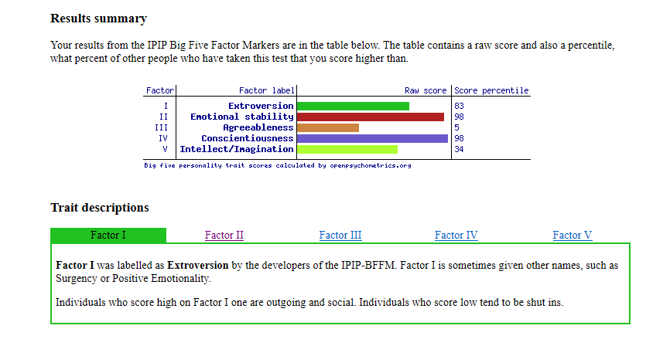
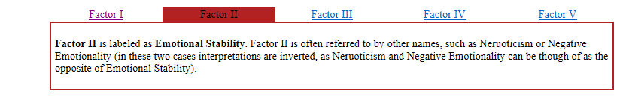
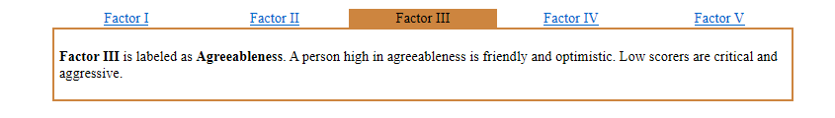
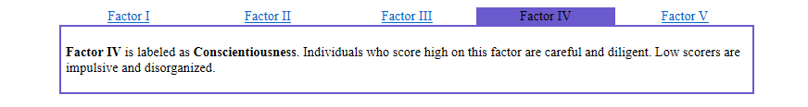
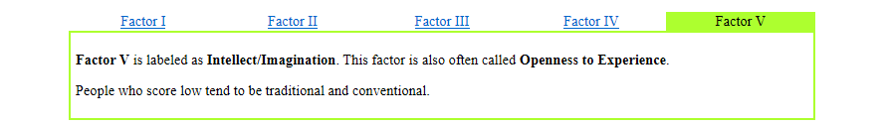
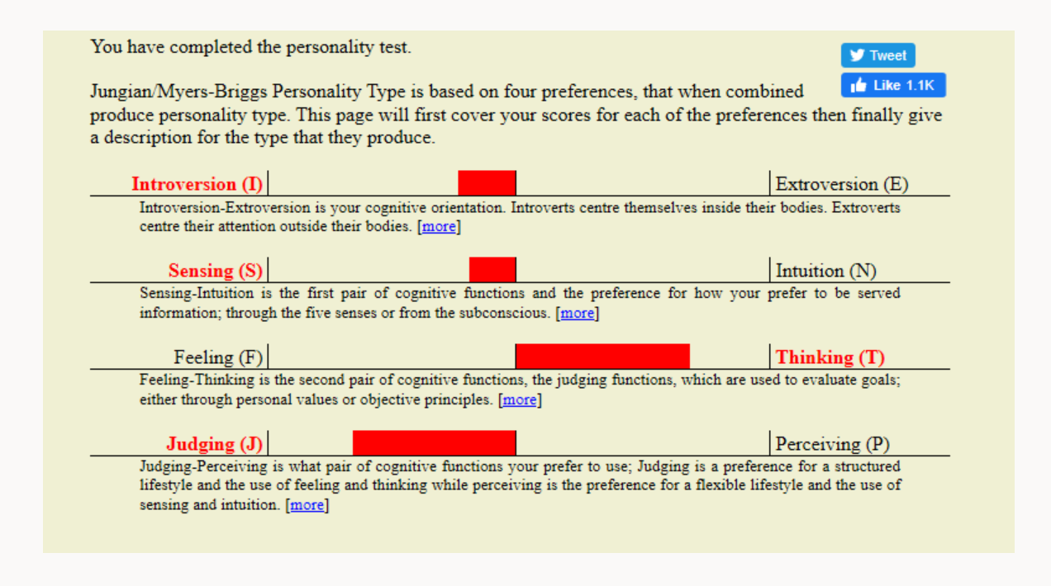
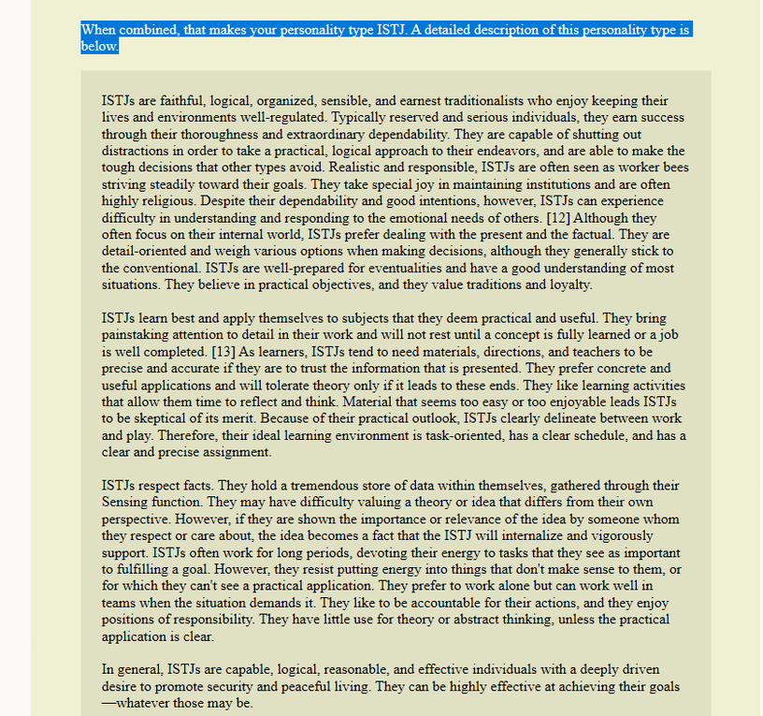
Comparing the results of personality tests to the author’s earlier presentation shows a good match.
- Though an ISTJ requires regulation, the attention to detail and concept completion characteristics show through in creative Cosplay.
- ISTJs “will not rest until a job is well completed” and “can be highly effective at achieving their goals” are in line with the statement of being driven.
- ISTJs are “logical” and “earn success through their thoroughness” – but what the author sees as efficiency has a reverse aspect also; “...only tolerate theory if it leads to these ends.” As an ISTJ the author is in the habit of disregarding information that is not immediately deemed as useful to achieving a give task.
- This carries through to the author’s objectivity, but again, comes with perhaps the negative trait of “difficulty understanding and responding to the emotional needs of others.”
- Organisation again is an integral part of the ISTJ personality type.
The author’s proclaimed weaknesses are also reflected; difficulty engaging with matters of low interest, the perfectionist attention to detail, and taking a break - “Material that seems too easy or too enjoyable leads ISTJs to be sceptical of its merit.”
Aware, and even proud of these character strengths, this exercise has further cemented the authors self-belief. While some weaknesses had also been acknowledged and accepted to a certain point, this exercise has highlighted a more objective viewpoint of traits that were previously believed to be unquestionable strengths, as having more negative opposing effects in some situations also.
Being aware of one’s strengths and weakness can lead to a happy, healthy life. “Playing” to one’s strengths when choosing a career for example, or even choosing the environment one puts themselves in will lead to comfort and success. At the same time, knowing one’s weaknesses can be protective, but should also be used to show when the help of others would be of most benefit, as well as give an individual the opportunity to improve on those weaknesses. Also, it increases understanding if one accepts that there are also personality types of differing natures that can also be beneficial in the right context, and if those strengths to are utilised. Better understanding leads to better communication, which in turn almost always leads to reduced conflict. [17]

2.4 Short and long-term goals

Short term goals
- Complete the implementation of a single sign-on authentication system of NHS Wales e-Library for Health by April 2020
- Finish and launch the new website for NHS Wales e-Library for Health by January 2020
- Complete all first year University assignments and exams, achieving 2:1 or higher by July 2020
- Complete the 90-day Fitness League challenge by March 2020
  - Complete LIIFT4 (first cycle)
  - Complete Shaun Week
  - Complete LIIFT4; Transform 20 hybrid
- Upgrade Nightwing costume by January 2020
- Make Wolverine costume by January 2020
- Reach 1000 Instagram followers by the end of 2019
Long term goals
- Continue to develop professionally, ideally to at least a band 6 by the end of 2020
- Gain a second degree to further aid my professional development
  - Achieve a 2:1 result or better
- Stay fit and healthy
  - Maintain body confidence for cosplay and modelling
  - Be happy with how I look in everyday clothes
  - Refrain from taking it “too far”
  - Have a positive message and example to share
- Make bigger and better cosplays year on year, get further in national and international competitions
  - Win a UK category and compete overseas
- Work with a videogame developer
- Continue to double social media following year on year
- Grow my family
  - Have children
  - Continue to support my wife and ensure her personal happiness

2.5 Action plan

Strengths, skills and qualities
1.Organised
2.Driven
3.Objective
4.Creative

What I need to work on, develop or improve
1.Staying Engaged
2.Slowing Down
3.Perfectionist
4.Dealing with poor organisation

My Priorities: What I am going to do, When and How
What? | When? | How?
1.Improve my ability to stay engaged with a subject. | Over the next year. | Use music to block out distractions. Take more breaks and break down subjects in to smaller chunks to complete.
2.Slow down. | Over the next year | Schedule down time in my calendar to just watch movies or play videogames, to make sure I’m taking “down time.”
3.Reduce “perfectionist” tendencies | Ongoing | Stick to deadlines; after having spent a certain amount of time on something, move on. Get better at accepting good quality without wanting 100% perfection.
4.Get better at dealing with external elements | Over the next year | Worry less about elements beyond my control and focus on my own responsibilities.

How will I measure if I have improved?
1. Break down large tasks in to smaller chunks and log those chunks individually in my calendar to work through, putting breaks in between them.
2. Look back at my calendar for entries at least once per month, where I blocked a day out to relax.
3. Look back at my calendar for booked time slots for having allocated time to complete a task, and not having run over unnecessarily before moving on.
4. Identify (mark) moments where I was externally held up or diverted and make a note of what I did INSTEAD of having let my emotions rise.

Application

3.1 Looking after your data

Backup Strategy
For the purpose of this exercise, data types can be broken in to three categories: Work, University and Personal files.
Work files are saved to three separate locations:
Location | Accessibility | Authentication | Security | Back-up | Recovery
Laptop Hard drive | No internet connection required | OS Login | Organisation installed security software | The two additional locations | As below
NHS Network Drive | On-site or via VPN token | OS login, plus VPN token authentication off-site | NHS network security | NHS organisational back-up strategy | Ticket to IT Service Desk
SharePoint | Cloud storage accessible via internet | Microsoft work account | Microsoft Cloud Security | Last 30 versions recoverable | In the event of complete removal or corruption; ticket to IT Service Desk.

University files are saved to three separate locations:
Location | Accessibility | Authentication | Security | Back-up | Recovery
USB drive | Plug in hardware | None | None | Two additional locations | As below
NHS Network Drive | On-site or via VPN token | OS login, plus VPN token authentication off-site | NHS network security | NHS organisational back-up strategy | Ticket to IT Service Desk
One Drive | Cloud storage accessible via internet | Microsoft student account | Microsoft Cloud Security | None | None

Personal files vary. Photographs are most frequently created and so the back-up strategy for these files are as follows; (other file types “mopped up” when strategy is fulfilled)
Location | Accessibility | Authentication | Security | Back-up | Recovery
Internal phone memory | With phone authentication | Password, thumb print | Built-in Samsung software | Automatic; to Google | From Google Drive
SD Card | Plug in hardware | None | None | None | None
Home Desktop Computer | Static location | OS login | AVG Anti-virus | Manual, to external hard drive | From external hard drive
External Hard Drive | Plug in hardware | None | None | None | None

Disaster Scenarios

Disaster | Work | University | Personal
Fire | Multiple physical and virtual locations; highly unlikely all physical locations would be affected at once. | Multiple physical and virtual locations; highly unlikely all physical locations would be affected at once. | Multiple physical and virtual locations; highly unlikely all physical locations would be affected at once.
Flood | Multiple physical and virtual locations; highly unlikely all physical locations would be affected at once. | Multiple physical and virtual locations; highly unlikely all physical locations would be affected at once. | Multiple physical and virtual locations; highly unlikely all physical locations would be affected at once.
Power Surge | Multiple physical and virtual locations; highly unlikely all physical locations would be affected at once. | Multiple physical and virtual locations; highly unlikely all physical locations would be affected at once. | Multiple physical and virtual locations; highly unlikely all physical locations would be affected at once.
Virus | Security would contain virus to a single location. Files would persist elsewhere. | Security would contain virus to a single location. Files would persist elsewhere. | Manual connections from mobile phone, to desktop, to external hard drive, render it unlikely that the virus would spread throughout systems unnoticed. Also, system contains one cloud based virtual store.
Hardware Failure | Multiple physical and virtual locations; highly unlikely all physical locations would be affected at once. | Multiple physical and virtual locations; highly unlikely all physical locations would be affected at once. | Multiple physical and virtual locations; highly unlikely all physical locations would be affected at once.
Cloud Data Loss | Multiple physical locations. | Multiple physical locations | Multiple physical locations
Theft | Multiple physical and virtual locations; highly unlikely all physical locations would be affected at once. | Multiple physical and virtual locations; highly unlikely all physical locations would be affected at once. | Multiple physical and virtual locations; highly unlikely all physical locations would be affected at once.
Loss of Service Provision | Multiple physical and virtual locations; highly unlikely all physical locations would be affected at once. | Multiple physical and virtual locations; highly unlikely all physical locations would be affected at once. | Multiple physical and virtual locations; highly unlikely all physical locations would be affected at once.
Hacking | Multiple physical and virtual locations; highly unlikely all physical locations would be affected at once. | Multiple physical and virtual locations; highly unlikely all physical locations would be affected at once. | Multiple physical and virtual locations; highly unlikely all physical locations would be affected at once.

By utilising the data back-up rule of 3-2-1, [18] including both physical and virtual data stores with varied security between locations, physical threats are almost completely mitigated, with virtual threats needing to navigate multiple and widely varied security barriers to access all of the data in any one backed up system, and for personal files, the manual connection of multiple external pieces of hardware.
File recovery time varies depending on impact. In most cases files can be quickly recovered from an alternate data store. In absolute failure, it may take a few days in the worst-case scenario of catastrophic failure on a Friday evening, and having to wait for the IT Service Desk until a Monday.

Ransomware Report

Computer viruses are malicious pieces of software that pose a risk to files and even hardware on any given computer system. They operate by inserting or attaching themselves to legitimate programs or documents that supports the use of macros to execute its code. [19]
Ransomware is a specific type of virus intended to extort money from a victim. This can range from a simple pop-up telling a user that they are vulnerable to virus attack, and should purchase software to prevent harm, to far more advanced Trojan threats, capable of infecting a computer and encrypting any file a user creates, before demanding payment for an encryption key to regain access to the lost files.
Ransomware is difficult to detect, and increasingly so as newer versions are developed. Fundamentally, if a file is created and the virus encrypts it, you wouldn’t know until you attempted to revisit that file. It is this behaviour that makes Ransomware such a threat to even experience computer users with back-up strategies in place. Common practice with backup strategies is an established routine, for example, backing up files automatically every four hours. If Ransomware infects a computer and the user doesn’t notice before the automatic backup occurs, the infection has spread to the backed-up data as well.
See full Ransomware Report

3.2 Time management

The majority of time management and self-organisation in this author’s case is managed with digital calendars.
A work calendar is built week-by-week, by extracting requirements and objectives from the Clinical Directorate’s version of a Gantt Chart, and populating around any prior booked time.
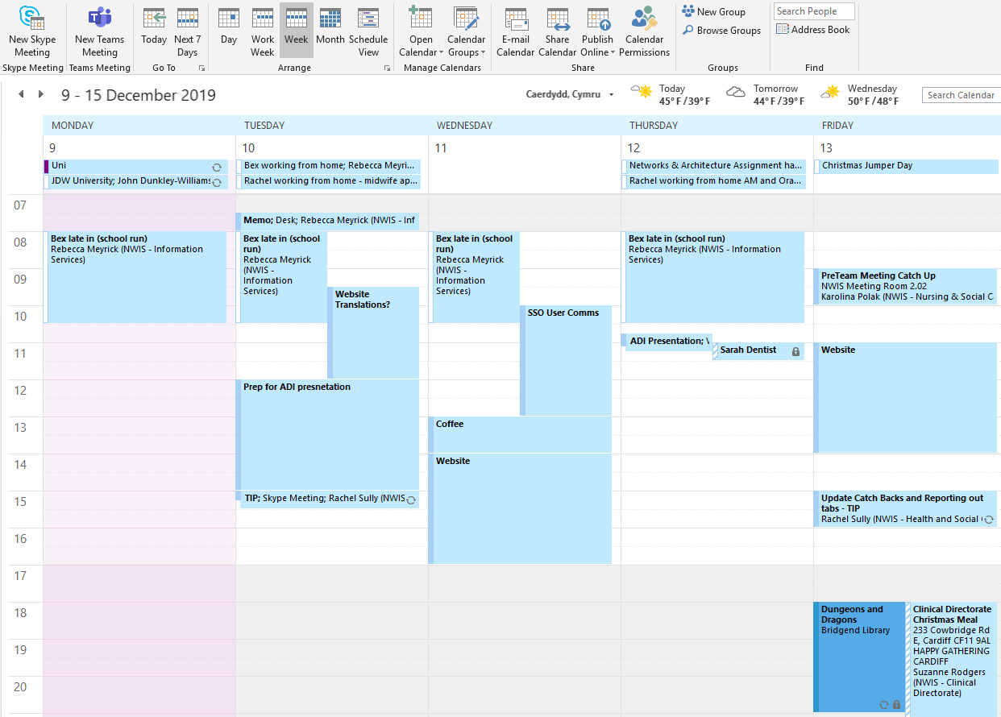

This calendar is used in conjunction with a personal calendar. Where personal events might clash, or require travel time, they are included in the work calendar with a colour distinction as can be seen above. The personal calendar is primarily accessed by mobile phone and is consolidated from 3 separate calendars to reflect family appointments.
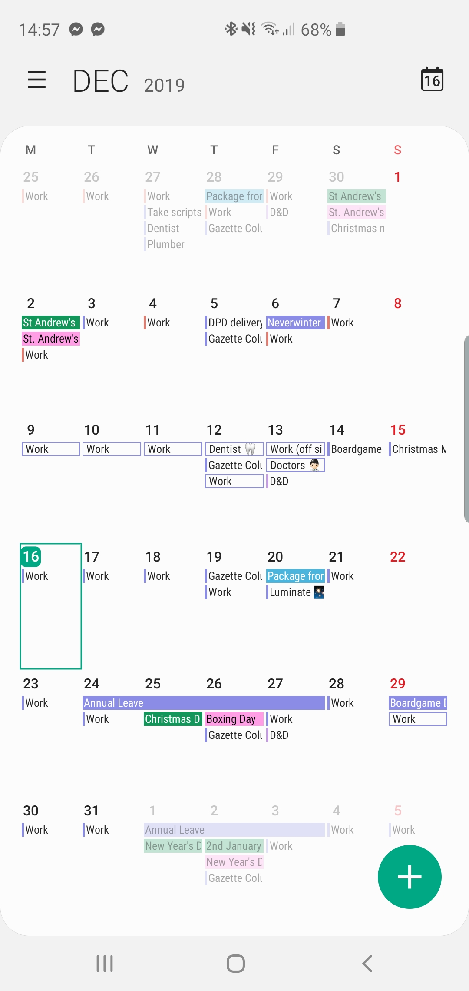
Events in the personal calendar will often be arranged much further in advance to manage availability. Particularly through the summer months, weekends are often populated with cosplay conventions and photoshoots, warranting as much organisation as the work calendar.
The author chooses to maintain a distinct work calendar in order to “switch off” work outside of work hours.
Most calendar events will have programmed reminders, set to produce an alert as much as a week before if preparation time is a requirement. Both calendars utilise recurring events, such as University days, or the weekly submission deadline for the author’s column in the local newspaper.
The personal calendar is also programmed with videogame release dates. To counter the busy lifestyle that can often neglect recovery time, when a videogame release date approaches, this might prompt blocking time in the calendar to not do anything, thereby scheduling down time.
Calendars can be populated more than 6 months in advance, not just for recurring events, but for significant deadlines at the end of long projects, cosplay convention dates when they are released, the usual regular events and now key university dates to reduce the risk of missing important dates.

3.3 Self-organisation

Self-organisation extends to how one orders accumulating information for easy access and reference. Using a specific file structure taken from a USB stick as an example:
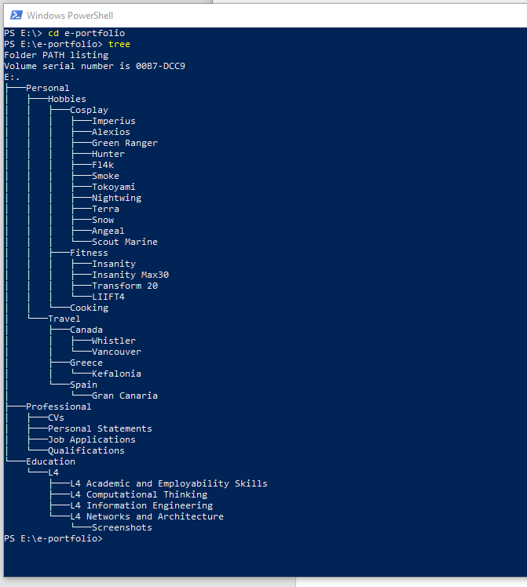

This example USB drive contains a selection of photographic content; cosplay work organised by character, fitness photography, often including “results” pictures, food photography, often showcasing healthy recipes, and some travel photography.
The USB drive in question then also holds some professional reference material, and some organised University files.
Content is categorised at a high level then broken down logically. A logical file structure will differ between authors, but the example of this USB drive should prove simple and effective.
As a second, perhaps more complex example, below is a section of a network drive from work:
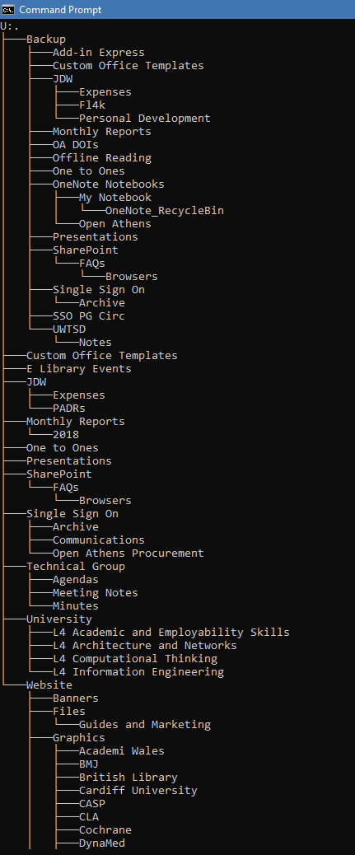

Conclusion and Evaluation

The Academic and Employability Skills module has covered a breadth of topics. To begin with, a study of oneself. The presentation made for a good introduction, or in this case reintroduction to academia and higher education in the University setting, while also serving as an icebreaker for the students.
This also provided a platform to consider individual strengths and weaknesses, and with these highlighted, formulate strategies that utilised strengths and approached weaknesses for optimal success, not just in academia but applicable beyond.
As a student already having achieved a Bachelor’s degree and having worked at a career for 10 years, the perspective is considerably different to that of an individual straight out of high school. Self-awareness is more developed, and strategies have been used knowingly or not to have travelled to this point. Habits have also had opportunities to develop however, and certain aspects of the everyday are taken for granted. This initial pause to consider these things, whether cementing previously acquired knowledge or illuminating that which has not been considered before, or even perhaps forgotten, made for solid foundations to approach academia from.
The instigation of research in to these somewhat personal subject areas can only serve to improve self-awareness, and there is room to continue to do so to put responsive, or even pre-emptive strategies in place to improve one’s chances of success, and happiness in general. Resources such as Ackerman’s self-motivation strategies [8] or even articles on utilising the knowledge of one’s own strengths and weaknesses [17] can be explored further, as one can continue to look for a strategy that best suits the individual.
Taking the next step of formulating short and long-term goals and setting an action plan is the first step to making these changes achievable. Vague concepts are impossible to implement, but by planning targets and dates to accomplish them by, one can begin to make the changes one step at a time, while taking the positive feelings of success as they do so. [20]
Moving next on to the more technical aspects of University education, taking the time to review the referencing standards employed by the university, since there are numerous standards in circulation, and many students are coming in to contact with academic referencing for the first time, proved useful practice.
Being assigned the task of exploring back-up strategies for data; something that is such common knowledge, much like regularly changing one’s passwords, but also commonly disregarded. One of the more common bad habits in or outside of academia. This allocated task and time almost forced students to stop and set up these security strategies which will almost certainly bear fruit before the University degree is achieved. The class discussion also presented the opportunity to learn, and perhaps apply new strategies that fit more easily in to the routines of individuals.
The ransomware report also proved good practice. Even on a second degree, the practice applying the specific report writing style, the research paths and resources available, and even the subject matter in general was all relatively new, and this report provided a good example and good practice at producing a report of the particular variety required for the Computer Science degree.
Overall there was also plenty of opportunity to begin the practice of time management and self-organisation, along with the other skills required for success at university, both previously known and newly discovered or rediscovered as a result of the assigned research task.
The author is happy with the standard of work produced thus far, along with the developments and learning gained from the process. The goals outlined in the action plan clearly illustrate further direction for development, and research and reading have brought out new ideas to read on further, along with some reliable sources for researching computational theory.

References

[1] | W. Hare, “Open-minded inquiry,” [Online]. Available: https://www.criticalthinking.org/pages/open-minded-inquiry/579. [Accessed 23 December 2019].
[2] | “Student Confidence & Self-Esteem,” 2012. [Online]. Available: http://www.edu-nova.com/articles/student-confidence/. [Accessed 23 December 2019].
[3] | Y. Breyer, M. Marrone, L. N. Wood, M. Taylor and H. Shaheen, Success in Higher Education, Singapore: Springer, 2016, pp. 22-35.
[4] | “7 Time Management Tips for Students,” 20 April 2017. [Online]. Available: https://www.topuniversities.com/blog/7-time-management-tips-students. [Accessed 23 December 2019].
[5] | “Academic Integrity,” 25 October 2012. [Online]. Available: https://www.kent.ac.uk/ai/students/whyreference.html. [Accessed 31 December 2019].
[6] | “Rhetorical functions in academics writing: Taking a stance,” [Online]. Available: http://www.uefap.com/writing/function/stance.htm. [Accessed 23 December 2019].
[7] | “Writing in your own words: How do I use my own words,” [Online]. Available: https://help.open.ac.uk/how-do-i-use-my-own-words. [Accessed 23 December 2019].
[8] | C. E. Ackerman, “Self-Motivation Explained + 100 Ways To Motivate Yourself,” 11 November 2019. [Online]. Available: https://positivepsychology.com/self-motivation/. [Accessed 23 December 2019].
[9] | J. Daly, “How Technology is Powering Academic Success,” EdTech Magazine, 1 October 2012.
[10] | J. Cole, “Qualifications or experience: what's more important?,” 17 February 2014. [Online]. Available: https://www.totaljobs.com/insidejob/whats-more-important-qualifications-or-experience/. [Accessed 31 December 2019].
[11] | L. Ryan, “What Do Employers Value More - Experience or Education?,” 9 January 2017. [Online]. Available: https://www.forbes.com/sites/lizryan/2017/01/09/whats-more-important-to-employers-experience-or-education/. [Accessed 31 December 2019].
[12] | R. Swain, “What skills do employers want?,” May 2019. [Online]. Available: https://www.prospects.ac.uk/careers-advice/applying-for-jobs/what-skills-do-employers-want. [Accessed 16 December 2019].
[13] | A. Doyle, “Top Skills and Attributes Employers Look For,” 24 August 2019. [Online]. Available: https://www.thebalancecareers.com/top-skills-employers-want-2062481. [Accessed 16 December 2019].
[14] | A. Rolfe, “Five CV Skills Employers Look for in every Jobseeker,” [Online]. Available: https://www.reed.co.uk/career-advice/five-cv-skills-employers-look-for-in-every-jobseeker/. [Accessed 16 December 2019].
[15] | SkillsYouNeed, “Employability Skills,” [Online]. Available: https://www.skillsyouneed.com/general/employability-skills.html. [Accessed 16 December 2019].
[16] | K. Boogaard, “8 Skills That Employers are Looking for in 2019,” January 2019. [Online]. Available: https://www.goskills.com/Soft-Skills/Articles/Best-skills-to-learn-for-jobs. [Accessed 16 December 2019].
[17] | “Why It's Important To Know Your Strengths and Weaknesses,” 24 March 2014. [Online]. Available: https://leaderonomics.com/personal/why-its-important-to-know-your-strengths-and-weaknesses. [Accessed 23 December 2019].
[18] | “Best Practices: Backing Up Data,” 7 September 2017. [Online]. Available: https://www.trendmicro.com/vinfo/us/security/news/virtualization-and-cloud/best-practices-backing-up-data. [Accessed 31 December 2019].
[19] | Symantec, “What is a computer virus?,” 2019. [Online]. Available: https://us.norton.com/internetsecurity-malware-what-is-a-computer-virus.html. [Accessed 22 11 2019].
[20] | “The importance of action planning,” 2017. [Online]. Available: https://www.open.edu/openlearncreate/mod/oucontent/view.php?id=53774&section=1.3.2. [Accessed 23 December 2019].
[21] | “What is a Trojan Virus?,” [Online]. Available: https://www.webroot.com/us/en/resources/tips-articles/what-is-trojan-virus. [Accessed 22 11 2019].
[22] | S. Mohrule and M. Patil, “A brief study of Wannacry Threat: Ransomware attack 2017,” International Journal of Advanced Research in Computer Science, vol. 8, no. 5, June 2017.
[23] | “CryptoWall and HELP_DECRYPT Ransomware Information Guide and FAQ,” [Online]. Available: https://www.bleepingcomputer.com/virus-removal/cryptowall-ransomware-information. [Accessed 18 November 2019].
[24] | J. Petters, “The State of CryptoWall in 2018,” 1 June 2018. [Online]. Available: https://www.varonis.com/blog/cryptowall/. [Accessed 18 November 2019].
[25] | J. Vigo, “TechRepublic,” 21 10 2014. [Online]. Available: https://www.techrepublic.com/article/cryptowall-what-it-is-and-how-to-protect-your-systems/. [Accessed 22 11 2019].
[26] | S. Lee, H. K. Kim and K. Kim, “Ransomware protection using the moving target defense perspective,” Science Direct, vol. 78, pp. 288-299, September 2019.

Appendices

Additional Personality Test Results
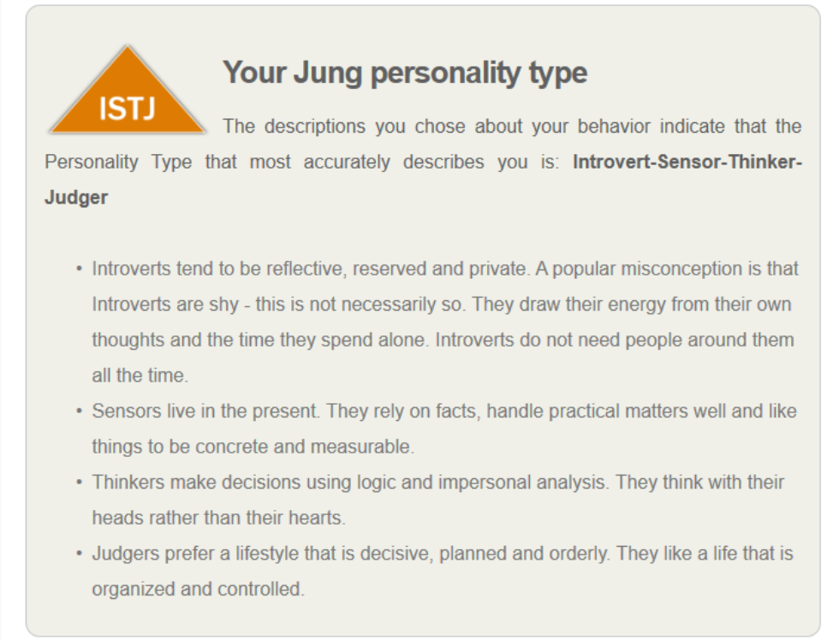
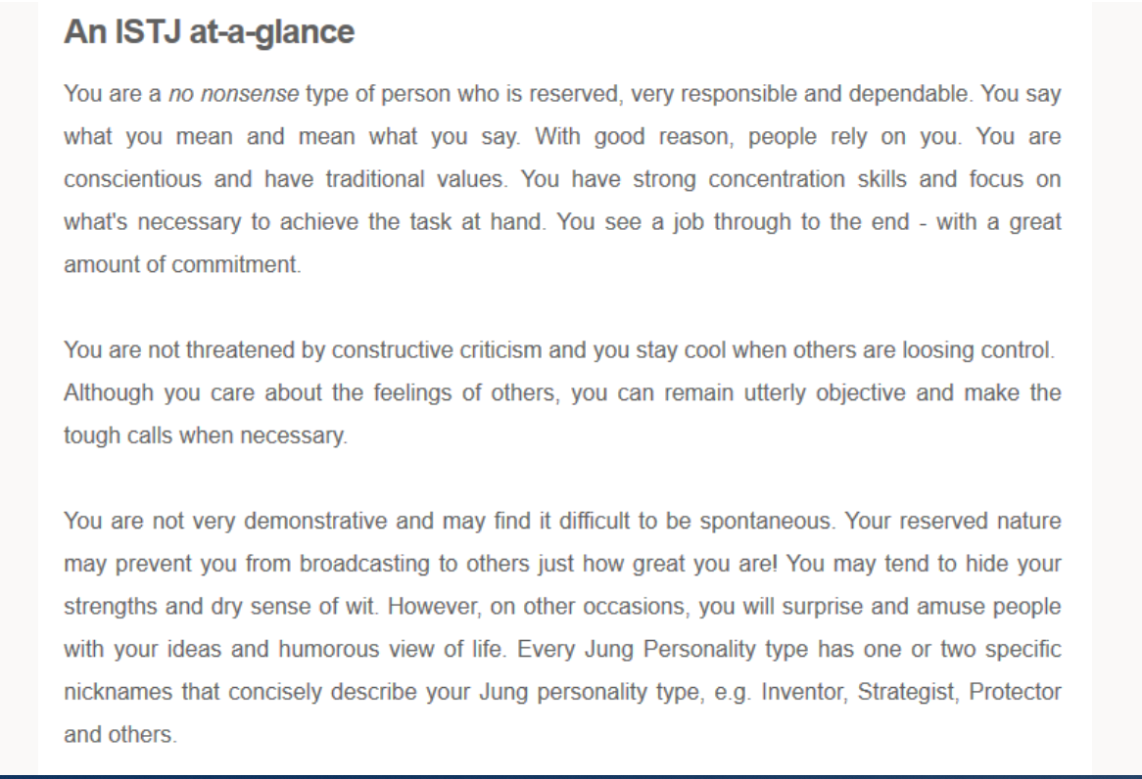
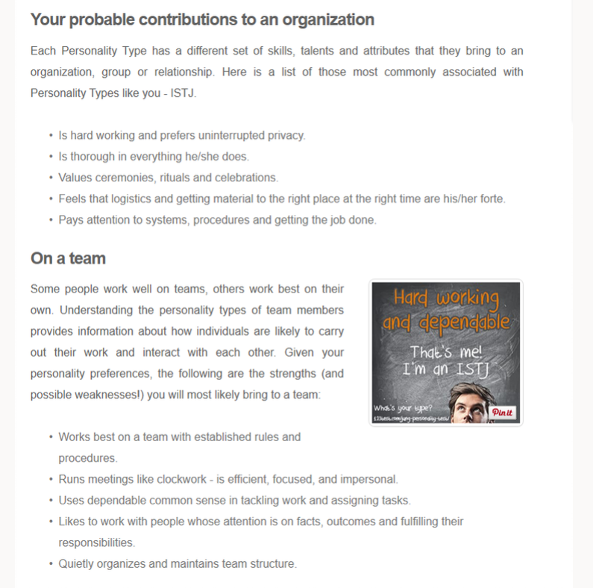

Ransomware Report

Contents
- Introduction
- Trojan Viruses
- Ransomware
- The CryptoWall Trojan
- Best Practice
- References
- Further Reading
Introduction

This report will look at the potential threat of ransomware viruses, and specifically, the Cryptowall Trojan Virus.

Trojan Viruses

Computer viruses are malicious pieces of software that pose a risk to files and even hardware on any given computer system. They operate by inserting or attaching themselves to legitimate programs or documents that supports the use of macros to execute its code. [19]
Computer viruses come in myriad shapes and form, but one of the best-known malware threats are Trojan Viruses.
A Trojan, or Trojan Horse, is a type of malware that conceals its true content to fool a user into thinking it’s a harmless file. Like the wooden horse used to sack Troy, the “payload” carried by a Trojan is unknown to the user, but it can act as a delivery vehicle for a variety of threats. [21]
Some common types of Trojan virus include:
- Backdoor Trojans, which allow hackers to remotely access and control your computer.
- Exploit Trojans, which are coded to search out and take advantage of a weakness often specific to a piece of software.
- Banker Trojans, which are designed to target personal information, particularly bank or payment details.
- Distributed Denial of Service or DDoS Trojans, which flood a computer with requests in an attempt to disable it.
- Downloader Trojans, which are written to download additional malware. [21]

Ransomware

Ransomware is a specific type of virus intended to extort money from a victim. This can range from a simple pop-up telling a user that they are vulnerable to virus attack, and should purchase software to prevent harm, to far more advanced Trojan threats, capable of infecting a computer and encrypting any file a user creates, before demanding payment for an encryption key to regain access to the lost files.
Ransomware is difficult to detect, and increasingly so as newer versions are developed. Fundamentally, if you create a file and the virus encrypts it, you wouldn’t know until you attempted to revisit that file. It is this behaviour that makes Ransomware such a threat to even experience computer users with back-up strategies in place. Common practice with backup strategies is an established routine, for example, backing up files automatically every four hours. If Ransomware infects a computer and the user doesn’t notice before the automatic backup occurs, the infection has spread to the backed-up data as well.
In 2017, a Ransomware attack labelled “WannaCry” was the worst to date. It blocked user access to files or systems, holding files or entire devices hostage and demanding ransom. WannaCry attacked hospitals, companies, universities and government organisations, affecting more than 2,000 victims. [22]

CryptoWall

The CryptoWall Trojan has been around since April 2014 [23] and over the years has continued to be refined and developed in to increasingly problematic malware. Ransomware incidents make up 40% of malware incident reports [24].

Background
CryptoWall is a specific type of ransomware that, once it has managed to install itself on a computer, sets about encrypting files so that they can no longer be accessed, before then demanding payment for a decryption key to restore a user’s access.

Infection
As with any virus, they can come from a number of sources. The infection process doesn’t differ greatly from either virus infection, however, once it has infected a computer, it begins by establishing a network connection to random servers, where it uploads connection information like the public IP address, locations and system information. [25]
A random encryption key is generated, and whenever a file is created by the user encryption is applied.

Best Practice

Since the threat of CryptoWall Ransomware emerged, naturally the world has set about preventative methods by which to protect, or at the very least mitigate the threat of the virus. As the world of computing develops, so too does the combat of “light vs dark”. For every malware development, there will be people developing counter software and procedures.
Research has found a means to protect files by exploiting the fact that most ransomware finds the file extensions and infects files, therefore the main counter-concept is to randomly change the file extensions of valuable files in the system. [26]

Linkedin Profile

As part of the personal development process, a Linkedin Profile was created:
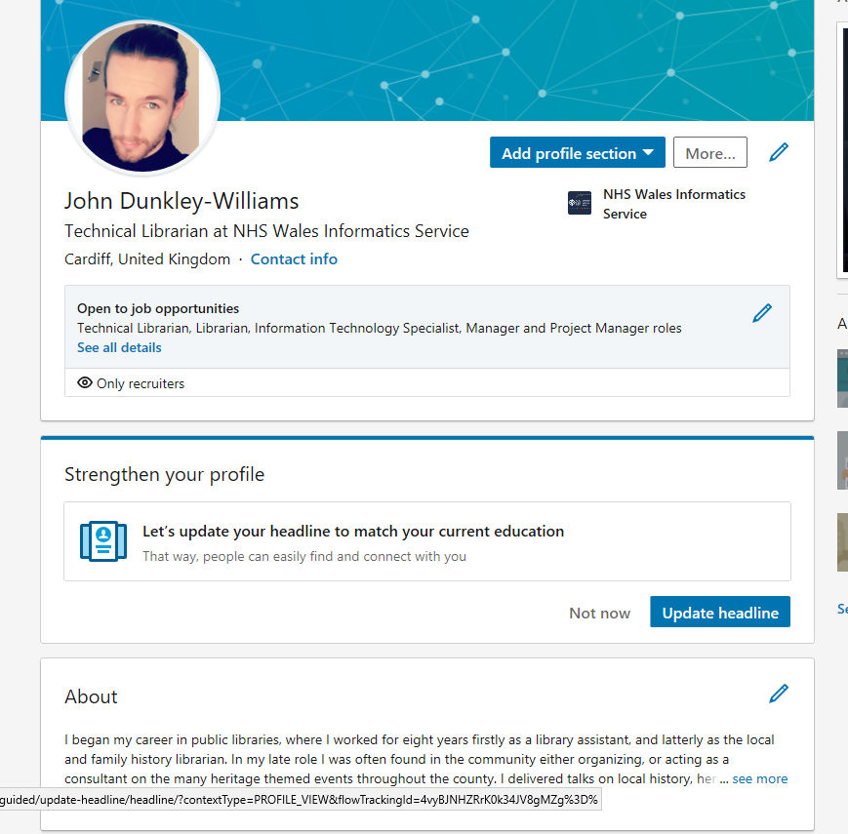

Curriculum Vitae

John Dunkley-Williams Curriculum Vitae

16 Nant Yr Adar
Llangewydd Court
Bridgend
CF31 4TY
Mobile: 07798757658
Email: john.dunkley-williams@outlook.com

Personal Profile
I graduated from the University of Wales, Newport with a 2:1 in English and Creative Writing. Since then, while continuing to develop professionally, I have maintained multiple blogs and websites, edited and written as a freelance journalist and am now a columnist for Wales Online.I have written information leaflets, presentations, talks and heritage walks, and am credited on 3 heritage panels in Bridgend town. I am described by colleagues as a confident and self-motivated individual who always strives to achieve a high standard in all things undertaken. I enjoy a challenge, and both in and out of work I always push myself to succeed. In my spare time I make costumes of popular characters from movies and videogames and compete in national competitions, always driven to develop in any pursuit.

Skills and Qualities

Communication | Numerical | Management
Highly Computer Literate | Resourceful | Trustworthy
Writing | Diligent | Confident
Organisation | Methodical | Hard working
Staff Training | Adaptable | Driven

Education and Qualifications

Currently studying
Computer Science (BA)

Qualifications obtained in 2013
ECDL

Qualifications obtained in June 2011
University of Wales, Newport | BA (hons) English and Creative Writing | Upper Second Class Honours (2:1)

Qualifications obtained in August 2006
Ynysawdre Comprehensive School | BTEC - Music performance | Distinction
 | A level - English literature | C
 | A level - Electronics | D

GCSE's obtained in August 2004
Ynysawdre Comprehensive School
Maths | A | English Language | B
English Literature | B | Electronics | B
Religious education | B | Music | B
Double Award Science | C, C | Geography | D

Work History

NHS Wales Informatics Service | 26/11/18 – Present | e-Library Technical Librarian

As the Technical Librarian in NHS Wales, I am responsible for the maintenance and service support of the NHS Wales e-Library systems for the 92,000 entitled users contracted by the NHS. In addition to my day to day work, resolving calls and raised issues, I am also responsible for the integration of the e-Library and its tools in to other NHS Wales systems, the development of a new website and most significantly, the implementation of a single sign on authentication system.

Bridgend Library and Information Service | 01/02/14 – 14/11/18 | Local and Family History Librarian

After being promoted to the senior position at the Local and Family History Centre, I undertook further responsibilities. These include: making decisions with regards to the day to day running of the library, overseeing members of staff, finance, organising the events calendar, cataloguing stock, ordering stock, organising cover, organising building maintenance, staff training, maintaining the library website, organising marketing, producing and managing social media content for the library service. In the last year I have trained the entire library service on a new library management system. Over the years working in this role I have developed a reputation as a local historian and as such have been interviewed by the BBC as the authority’s expert on the H.M.S. URGE, and am regularly approached by various external organisations, such as the GWR and Bridgend Town Council to advise them on projects.

Bridgend Library and Information Service | 01/01/11 – 01/02/14 | Library Assistant

I worked both as a Branch Library Assistant, dealing with the day to day running of a conventional library and council information point, and I have been a library assistant at Bridgend’s Local and Family History Centre. This more specialised area of work has involved teaching genealogy on both a one to one and group basis, performing in depth research on particular subjects of local interest both for visitors and for our own archives, organising, writing and presenting talks and exhibitions to promote the centre, and managing multiple projects which included other members of staff, such as the on-going compilation of the Glamorgan Gazette index now viewable on the centre’s website, which receives worldwide attention. In addition to this I was also made a Learn Direct Champion, with responsibility for demonstrating and enrolling people on to Learn Direct courses.

Hobbies and Interests

Reading | Fitness
Writing | Learning
Building/Repairing Computers | Crafting
Guitar Playing | Cooking
Archery | Challenges

References available upon request.

