ACCB4017 SOFTWARE DEVELOPMENT
ASSESSMENT 1 / PART A / TERM 2 / GROUP 1

Prepared for
Renuga Jayakumar
University of Wales Trinity St David – SOD

Prepared by
Metodi Dalov

Student ID 2009796
BCs Cloud Computing


Table of Contents
Part A: 2
A1 2
A2: 2
A3: 4
Part B 6
Exercise 1: 6
Exercise 2: 7
Exercise 3: 8
Exercise 4: 9
References: 11

Figure 1: exercise 1 code 6
Figure 2: exercise 1 output 6
Figure 3: exercise 2 code 7
Figure 4: exercise 2 output 7
Figure 5: exercise 3 code 8
Figure 6: exercise 3 output 9
Figure 7: exercise 4 code 10
Figure 8: exercise 4 output 11

Part A:

A1
The variables are information that labeled with some data or descriptive names. It is a kind of information that are manipulated and referenced in a computer program. It is used to store some data so that program can understandable more. It is kind of container that contain some information as locally and globally. They are more important because using variable, the information can be store for some time and used by other programmer many time. It is used to create a program more efficient(Python.org, 2012).
For example –
make ="" #string type
model = "" #STRING type
mileage = 0 #float type
door =0 # int type
These are variables in python. Above is a way for creating variables. The variables are storing some information’s like model variable is storing empty string and mileage variable is storing zero data. So these are a way how variables handled.

A2:
If else are conditional statements. Using if-else statement true and False both part is handled. If the condition is true then ‘if’ statement/block will run and if the condition is false then ‘else’ block will run(Tutorialspoint.com, 2021).
How we used?
Below is a syntax of if-else statement for how use if-else statement--
Syntax:
If (some condition)
{
// if block
}
Else
{
//else block
}
Why we used: we used if-else statement because we want to check some condition using True/False. We want if True condition will run then some particular block will run on behalf of True as well as False that why we use if-else.
For example-
We want to check if Sam age is more than 20 then ‘Sam is big’ will print else ‘Sam is small’ print. Below is a code of this problem—
If (sam_age>20)
{
Print(“sam is big”)
}
Else
{
Print(“sam is small”)
}
Another example with multiple conditions-
If Sam age is more than 20 then check again Sam DOB year is 1996 or not. If he has then print “Sam is good” else print “Sam is bad”.
Below is a code of this problem—
If (sam_age>20)
{
If( sam_dob_year == 1996)
{
Print(“sam is big”)
}
else
{
Print(“Sam is bad”)
}
}

A3:
If user wants to print a particular data in many times then loops comes into the picture. It is help to execute one or more statements some amount of numbers time(Softwaretestinghelp.com, 2021).
For Loop:
The syntax of for loop showing below—
for( variable name; condition; increment)
{
//loop body
}
While loop:
The syntax of while loop is –
While ( condition)
{
// while loop body
}
The for loop is used when some statement want to run many time or fixed time. Whereas while loop will run which is being used to execute a set of programming statements enclosed within {....}. It will check condition first and run while block and again check condition and so on while it becomes false.

Example of For loop:
Print hello world 5 time—
For(int i=0;i<5;i++)
{
print(“Hello world”)
}
Example of While loop:
print hello world 5 time—
while(i<5)
{
I =i+1;
Print(“Hello world”)
}

Part B

Exercise 1:
i) Logical Stages:
- Initially create make, model, mileage and door then store empty string, empty string, and zero and zero in these variables respectively.
- Create try block.
- Prompt user to enter make
- Prompt user to enter model
- Prompt user to enter mileage
- Prompt user to enter door
- Print make, model, year and door to screen

ii) Code
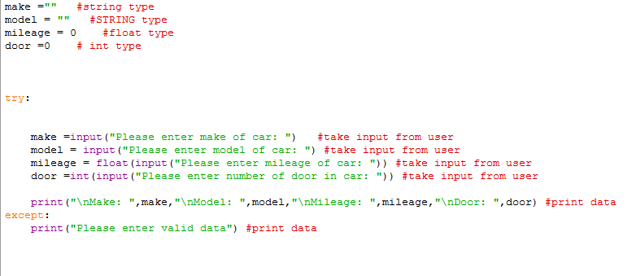
Figure 1: exercise 1 code

Testing:
i) Normal value passed
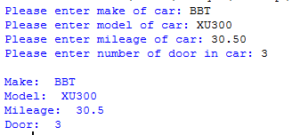
Figure 2: exercise 1 output

Result: program perform as expected.
ii) Enter string in mileage
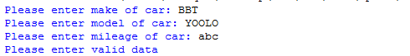
Result: integer or float value should be used in mileage variable

Exercise 2:
Below is a code of given problem-
i) Logical stages:
- Import math library and create two variables, first is xdimention and second is ydimention.
- Create while loop and make try-except block.
- Write some code in try-exception block.
- Prompt xdimention from user and check it is greater than 0 or not. If it is greater than zero then proceed next input else again ask for input.
- Again prompt ydimention input from user.
- Calculate output with multiple x and y dimension and divide it by 64.
- Print output on screen
ii) Implementation
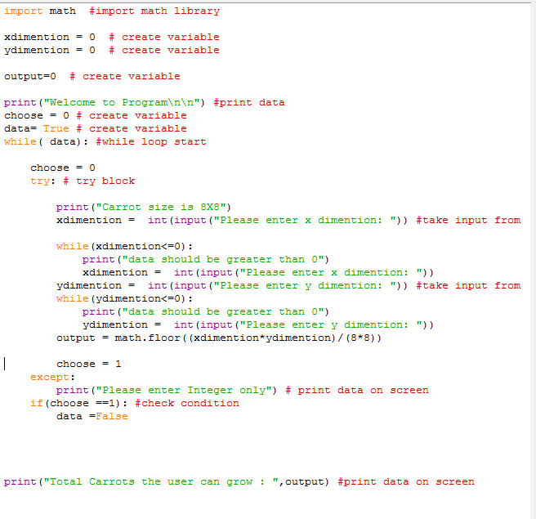
Figure 3: exercise 2 code

Testing :
i) normal flow:
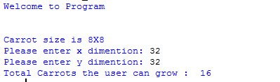
Figure 4: exercise 2 output
ii) enter 0 in x direction:
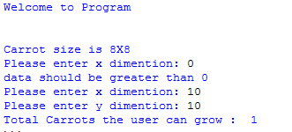
iii) enter 0 in y direction:
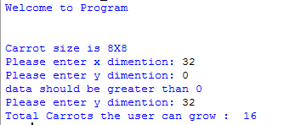

Exercise 3:
Below is a code of given problem-
i) Logical Stage
- Create two list, first is product_name and second is product_price
- Create for loop that finished after 5 iteration
- Prompt user to enter product name
- Push product name in product_name list
- Prompt user to enter price
- Push product price into product_price list
- Initially store zero in final variable
- Create for loop and run till 5 iteration.
- Print product name and product price and calculate final variable with adding product
ii) Implementation:
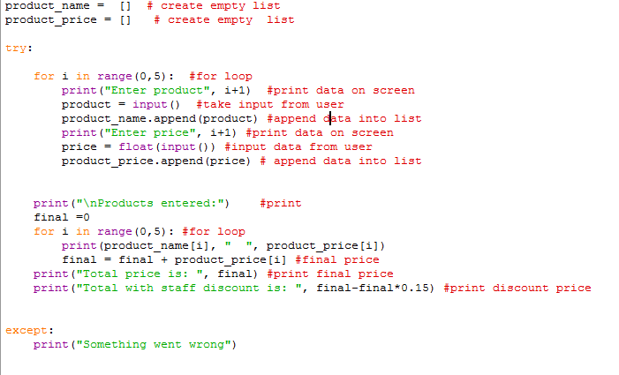
Figure 5: exercise 3 code

Testing:
i) normal flow:
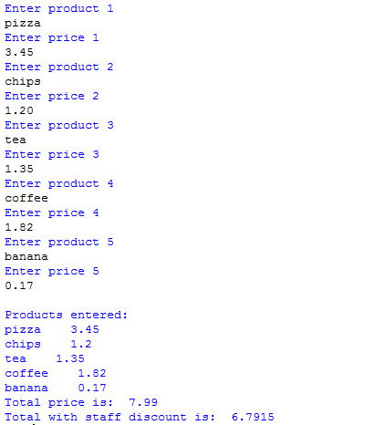
Figure 6: exercise 3output
ii) Write string data instead of float

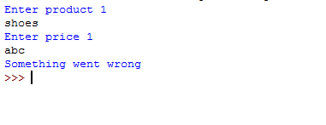
Exercise 4:
Below is a code of given problem-
i) Logical Stage
- Import random library.
- Create ‘board’ list with zero value.
- Create a function that print a data present in board list.
- Create while loop with try block and prompt position between 0 to 15 from user
- Check if board position is used or not. If used then print message “this position is used” else increase chance variable and check position is equal to random number or not.
- If so then print winning message else print “Miss ! unlucky” and fill board list to ‘x’ data after that call function.
ii) Implementation
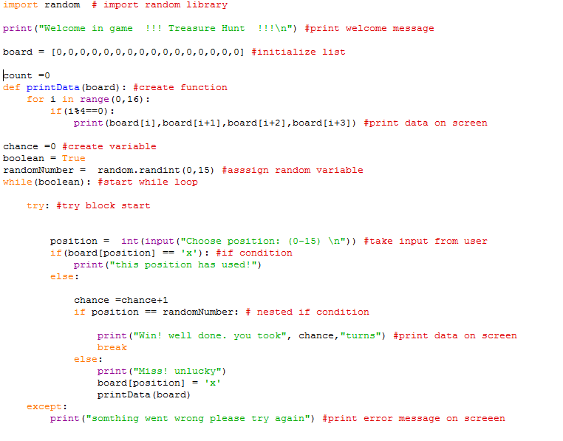
Figure 7: exercise 4 code
Testing:
i) Normal flow:
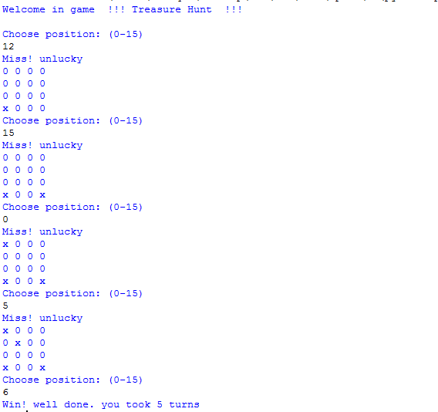
Figure 8: exercise 4 output

ii) Position is already filled:
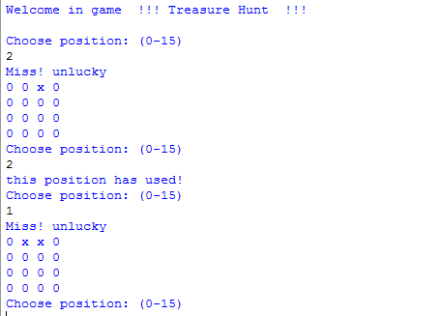
Result: everything is in normal flow.

References:
Softwaretestinghelp.com. (2021). Python Loops - For, While, Nested Loops With Examples. [online] Available at: https://www.softwaretestinghelp.com/python/looping-in-python-for-while-nested-loops/#:~:text=In%20Python%2C%20loops%20can%20be%20used%20to%20solve,loop%20works%20best%20here%29.%20For%20Loop%20In%20Python [Accessed 13 Apr. 2021].
Python.org. (2012). Why is Python a dynamic language and also a strongly typed language - Python Wiki. [online] Available at: https://wiki.python.org/moin/Why%20is%20Python%20a%20dynamic%20language%20and%20also%20a%20strongly%20typed%20language [Accessed 13 Apr. 2021].
‌Tutorialspoint.com. (2021). Python 3 - IF...ELIF...ELSE Statements - Tutorialspoint. [online] Available at: https://www.tutorialspoint.com/python3/python_if_else.htm [Accessed 13 Apr. 2021].
‌

‌

