Supporting pupil progress: a detailed analysis of one child’s holistic development, with justification for the next steps in learning.

Introduction
The school in which this research has been conducted in is in South Wales. As of the last Estyn inspection in 2018 there were nearly 300 pupils on roll aged 3-11 years, including 16 part-time and 32 full-time pupils in the nursery (Estyn, 2018). This English-medium school has 10 classes, including four single-age classes, five mixed-age classes, and a nursery class. The school also has a learning resource class with, at the time of writing, nine pupils from Key Stage 2. Most of these pupils come from a wide geographical area within the local authority. The number of pupils currently eligible for free school meals is 30%, well above the national average of 19%. The school identifies around 24% of pupils as having additional learning needs. This is marginally above the national average of 21%, however it includes pupils in the learning resource class. Very few pupils have a statement of special educational needs, come from an ethnic minority background, are in the care of the local authority, or have English as an additional language.
The class in which I have been teaching is a mixed year five and six class, with 29 pupils aged 9-11. Three pupils in the class have mild learning difficulties while one has more severe learning difficulties. There is usually an additional adult present who is assigned to the pupil with more severe learning difficulties, but this adult will work with the group when present. On occasions where their assigned pupil is out of class, the three other pupils in this group will work with the rest of the class.
Data collection
As this research requires the detailed analysis of one child’s holistic development, I selected a focus pupil from the class in which I am undertaking PTE. All data collection methods used in this research are outlined in the Mosaic approach (Clark & Moss, 2001; Clark, 2004). Data was collected via observation, a collection of photographs taken by the pupil themselves, a semi-structured interview with the child, an informal discussion with the class teacher, pupil-led feedback on various learning experiences during their time at the school, samples of work, and the pupil’s tracking record completed throughout the academic year. This provided a large amount of both qualitative and quantitative data to be analysed.
Data has been collected in line with the UWTSD and BERA (2018) code of ethical guidelines. As such, no information will be included that could be used to identify the focus pupil or their school. All data collected during the study was handled as per these guidelines and stored on an encrypted secure device. To minimise any issues regarding sensitive data, the interview conducted with the pupil was transcribed and anonymised, and the original audio recording has been deleted.
Assent was gained from the pupil by outlining the task, providing clear instructions regarding what they would be required to do, and allowing them to read the questions that would be asked during the interview before proceeding. The pupil was also reminded of their right to withdraw from the research at any time and also asked if they gave permission for the data to be used in research upon completion of the interview. The class teacher was also informed of the research, its purpose, and its methods, and provided formal consent, as included in appendix 2.
Large amounts of the early data, including the process of selecting the focus pupil, consist of my regular observation notes and tracking throughout the normal school day. However, a significant amount of this observation followed the selection of the focus pupil and asking them if they would be interested in participating in this research. A result of this, and therefore a potential limitation of using observation as a data collection method, is that I cannot be completely sure that I did not influence my focus pupil to behave or answer questions in a certain way. Literature supports the idea, first mentioned by Roethlisberger Dickson (1939), that the mere presence of an observer, which I might appear as given my role in the class when the class teacher is present, can have a significant impact on anyone who believes they are the subject of an observation.
The congruity theory (Osgood & Tannenbaum, 1955) and my specific innate biases will also impact on an observation. Cognitive biases such as confirmation bias are so robust and pervasive that even being highly aware of them does not lessen their impact (Watson, 1960). However, observation is a commonly used method for research such as this because it is usually suitable, in that it is ethically sound and allows for the collection data in real-time (Sharman, Cross & Vennis, 2004).
One strength of the Mosaic approach is how closely it is linked to the development of the United Nations Convention on the Rights of the Child (United Nations, 1990). The school in which I conducted my research has recently been awarded the title of a Rights Respecting School (appendix 1); as a result, pupils are fairly comfortable with knowing their rights and discussing topics outside of their usual work within the classroom. Many pupils know what it means to attend as an active participant rather than a passive one (Clark, McQuail & Moss, 2003; Clark, Kjorholt & Moss, 2005). This contributed to my decision to use this type of data collection as, somewhat fortunately, the pupils were already comfortable with some of the tasks I would be asking of them, particularly the focus pupil. This will be evident by some of her roles and responsibilities around the school that will be discussed later.
However, there are certain limitations, including that this approach was largely unfamiliar to me in practice. Despite research into the area, I still found that I lacked practical experience in carrying out tasks with the pupil. The pupil, however, was very competent in discussing her own experiences, contributing to the interview being completed to a high standard (Langsted, 1994).
Analysis of learner
To analyse the learner and their current ability across the curriculum, I will be utilising the ASK (Attitudes, Skills, and Knowledge) model. This has been defined as “the ability of an individual to select and use the knowledge, skills, and attitudes that are necessary for effective behaviour in a specific professional, social or learning situation” (Vinke, 2002). Upon familiarising myself with the the ASK model, I was reminded of the new Curriculum for Wales and the four purposes it sets out, specifically “ambitious, capable learners, ready to learn throughout their lives” (Donaldson, 2015). Accordingly, the ASK model could be a very effective tool to assess pupils’ learning, especially under the new curriculum once in place.
The focus pupil was selected as they are one of the pupils I have had the most contact with, due to being in the More Able and Talented (MAT) groups for maths and English, as well as my main PTE class. They are not the only pupil in both the maths and English MAT groups, but discussion with the class teacher noted that they would be the most appropriate focus child for this research given their personality and involvement in other aspects of school life.
The pupil is currently working at a level 6 in maths, and according to the class teacher, has been for some time. They are expected to finish this academic year as a solid level 6, as opposed to a number of other pupils in the class who are on the cusp of a level 6. The pupil is consistently engaged during maths lessons, finishes work regularly, and steadily achieves a green rating in my red, amber, green (RAG) system of pupil tracking. In the MAT group, the pupil regularly completes work aimed at introducing certain skills that will be built upon during comprehensive school, such as applying problem-solving skills.
Despite this consistent high achievement, the pupil mentioned during the interview not enjoying maths and even feeling anxious during mathematics lessons. This is something that I noticed during my observations and could be a case of maths anxiety, which is defined as “a strong negative emotional reaction towards mathematics that can occur when being involved in maths in any way” (Ashcraft, 2002).
Maths anxiety has been investigated thoroughly since being defined by Ashcraft (2002). Previous research on maths anxiety focused heavily on adults and teenagers, but more recent research has investigated its existence among children. It has been found that maths anxiety not only exists among children, but is more common in children than in other groups (Hill et al., 2016), supporting my theory that this is something experienced by my focus pupil. Maths anxiety is thought to be specific to mathematics and not reflect anxiety in other subjects; this matches the focus pupil’s comments of maths being the only subject they felt anxious about. Females have been found to report higher levels of maths anxiety than boys (Devine et al., 2012), so it is not surprising that my focus pupil is female. At primary school level, maths anxiety was found to have a non-significant effect on performance, but it should cause concern that it is thought to have a significant effect on mathematical achievement at secondary level. Possible solutions will be discussed in the next steps section.
The focus pupil only took one picture that linked to mathematics – this was the scoring display for the Numeracy Ninjas scheme that is run throughout all of Key Stage 2 at the school (appendix 3). This has shown to be a transformative intervention that improves students’ mental fluency when it comes to numeracy skills, increasing the average pupil’s result by at least 70% in both the mental strategies and key skills (Emeny, 2016). The focus pupil is consistently one of the higher scorers in the class and expressed a belief that it was helping her gain confidence in maths lessons (appendix 4).
The focus pupil has been working at a level 6 in mathematics (Curriculum for Wales, 2016), producing extremely high quality work that involves applying mathematical knowledge to real life and authentic contexts (appendix 5), which was the one area of mathematics that they said was enjoyable. This supports research that suggests one of the key ways to encourage engagement with mathematics is to teach it creatively and show how it can be applied to an authentic context, allowing pupils to apply it themselves (Papanastasiou & Bottiger, 2004). The focus pupil runs a fruit club at breaktime which is an excellent opportunity to apply mathematical knowledge to a real-world situation (appendix 6) (Karp & Niemi, 2000).
The pupil is currently achieving a level 6 in English for reading and writing, but a level 5 for oracy. (Curriculum for Wales, 2016). Their writing is engaging, adaptable, informative, and accurately spelled, and her presentation is consistently excellent across all subject areas. She is able to use relevant, appropriate language to discuss the meaning of texts and provide personal, individual responses that can be justified by selecting various features of texts. With regards to oracy, the pupil is beginning to adapt their use of English to the appropriate situation, and is able to talk confidently in a wide range of contexts as evidenced by their place on the School Council and role on the panel that interview potential staff members (appendix 7).
During the interview the pupil was enthusiastic towards English schoolwork, particularly the creative writing, such as a short story and letter home recently completed (appendix 8). They also stated that they enjoy other creative writing and poster-making, and reading a wide range of literature. When asked about any form of English outside of school, the pupil enthused about reading at home. There is significant research extolling the benefits of reading for pleasure in primary school children: a literature review by Clark and Rumbold (2006) found that main benefits include increases in reading attainment and writing ability, text comprehension and grammar, breadth of vocabulary, positive reading attitudes, greater self-confidence as a reader, as well as a better understanding of other cultures and a greater insight into human nature and decision-making. Each of these benefits appeared to be evident in the pupil during my observations. To further emphasise this pupil’s passion for reading, they are part of the school librarian team (appendix 9).
Reading for pleasure should be encouraged among all pupils; research strongly supports that it consistently leads to increased attainment in language tasks (Clark & DeZoya, 2011). It has also been proposed as a cost-effective method to steadily raise education standards and combat social exclusion. This is supported by evidence that suggests that reading for pleasure is more important for children’s educational success than the socio-economic status of their family, which is thought to be a significant indicator of attainment (OECD, 2002).
One aspect of the pupil’s language skills that could require improvement was oracy among peers. Despite being a confident individual, the focus pupil mentioned in the interview a preference for avoiding conflict that can sometimes lead to a lack of engagement in group or class discussions. The main worry with this lack of competence in a group situation is that it will largely negate the benefits of any collaborative learning opportunities arising in the classroom.
I have previously observed this occurring within the classroom. I have used observation notes to inform my planning and tried to ensure, if a lesson utilises collaborative learning, that I am able to use the focus pupil’s group as my focus group during the lesson. This allows me to more easily instigate discussions and ensure that all pupils are contributing sufficiently to the discussion and putting forward ideas with confidence. In previous practice, I have been aware of lower-achieving pupils’ reluctance to articulate ideas in front of peers but have not previously encountered this with one of the more able pupils in the class.
This lack of confidence, if left unchecked, could have a significant impact on the focus pupil’s education, as collaborative learning is a widely used teaching method that, according to the Sutton Trust Toolkit (2015), has been found to have a consistently positive impact of five additional months of learning. If the focus pupil is able to develop confidence in this classroom situation, it could contribute greatly to addressing some of the weaknesses within their language skills.
A key issue affecting the wellbeing of the pupil is the upcoming transition to secondary education and Key Stage 3. During the interview, they discussed an end of year school trip as being something they have “looked forward to all year” and expressed sorrow that it would mark “the end of primary school”. A variety of research suggests that the transition to secondary school can have a dramatic effect on pupil wellbeing, in extreme cases triggering underlying mental health issues (Mowat, 2019).
Despite their academic achievements, the focus pupil describes themselves as lacking in confidence inside the classroom. This was surprising as, I had not identified this lack of confidence during my time teaching the pupil, with the exception of occasional reluctance to work in a group. However, this lack of confidence seems to be limited to inside the classroom; when asked about favourite places in school are, the pupil replied “the yard and the field” (appendix 10) – the pupil is involved in numerous sports clubs both in and out of school. While discussing sports, the pupil mentioned their decision to eat a healthier diet in order to aid sports performances, seeming acutely aware of their own physical wellbeing.
Outside of the classroom, the pupil is a significant contributor to general school life and holds many roles including librarian, digital leader, fruit club leader, active buddy, and member of both the school council member and eco-club member (appendix 11). Some of these roles, digital leader and school council especially, often require the pupil to be absent for part of a lesson, necessitating catching-up on work during free time. Other roles require the pupil to give up many breaktimes and parts of some lunchtimes in order to fulfil duties. The pupil takes great pride in all of her roles around the school and endeavours to complete them all to the highest standard. Providing pupils with responsibilities such as these around the school are vital to developing skills and knowledge, but also give the pupil a stake, and pride, in the school (Alexander, 2010).
The focus pupil is a capable, enthusiastic contributor during science lessons, noting during the interview enjoyment of “real life activities” and “finding out the science behind” every day, relatable tasks, such as the investigation into lung capacity that we conducted during class (appendix 12). Linking classroom science activities to experiences that the pupils will often have has often been reported as one of the most effective ways of teaching science in a primary context (Nilsson & Loughran, 2012).
Although the pupil stated that they “look forward” to science investigations, there was no mention of science as a subject during the interview or among the pictures taken by the pupil. Rather than a slight on the subject, I believe this shows how well-embedded science has become, in this school, as a cross-curricular opportunity. Many science activities occur within a maths, topic, history, or art lesson; this may therefore imply that the lesson is not specifically a science one (Hayes, 2010).
The pupil is a regular participant in the school’s Helpwr Heddiw scheme and has recently started to read stories, in Welsh, to Foundation Phase classes. The pupil enjoys doing this and it provides valuable experience of reading in front of an audience, as well as practicing and improving Welsh oracy skills. The pupil is able to use complex language patterns, sentence structures, and relevant vocabulary to plan a piece of writing about a given topic (appendix 13). The pupil was also an active participant in the Eisteddfod celebrations and spoke enthusiastically about the activities involved as well as the wider meaning of celebrating Welsh culture (appendix 14).
Next steps
When analysing the focus pupil, I introduced the idea of maths anxiety. Maths anxiety has many definitions, but generally all of them describe fear, panic, increased heart rate, and the inability to answer mathematical questions when required. The end result is decreased self-esteem and confidence which can eventually develop into a cycle that further debilitates the pupil. Maths anxiety is thought to be a widely experienced phenomenon among a wide variety of age groups (Stuart, 2003; Shields, 2005).
It is thought that a key factor behind maths anxiety is the attitude and biases students with which arrive at school; these play a key role in influencing their ability to succeed at a given topic. Negative preconceptions surrounding mathematics are often inherited from parents who struggle with maths, tell their children about their struggles and impart the belief that the child will also struggle with the subject. This sets low expectations for the child and the parents (Cordes, 2003). Pupils from families of low socio-economic status are most at risk from this idea of an innate inability at maths (Furner & Berman, 2003). This could apply to my focus pupil, who stated during the interview that she has struggled with homework on occasions because the adults at home do not understand the topic either, so cannot provide any meaningful help. The Dimensions of Learning Models theory (Marzano, 1992) supports this perception of maths anxiety and its origins by stating that a positive attitude and self-belief is required from pupils in order for them to successfully learn.
In the classroom, it is important for teachers to adopt the perspective of the pupil and recall their own anxieties when trying to grasp a new concept. This was a key point during my interview with the focus pupil who stated “I struggle when I get asked a question and I don’t know the answer…you feel the pressure and just sit there”. When asked about their preferred form of questioning they expressed dislike of using a random method, such as lollipop sticks or picking a name from the register, and prefers asking for volunteers or having a class discussion. Research supports this idea, suggesting that the uncertainty surrounding questioning and increase in attentiveness created by using lollipop sticks is outweighed by the inability to correctly aim a question at someone with an appropriate understanding (Dallimore, Hertenstein & Platt, 2012). A key next step to ensure progress in mathematics for this learner would be to incorporate different questioning strategies, such as think, pair, share (Lyman, 1981).
A key next step for the focus pupil is improving oracy, particularly within a group setting. Despite the importance placed on developing oracy, researchers have found numerous barriers to teachers successfully doing so, the most prevalent of which is a lack of time (Millard and Menzies, 2016). Furthermore, there is somewhat of a cycle when it comes to issues regarding oracy. Research suggests that over a quarter of teachers actively avoid oracy-heavy activities in an attempt to prevent less confident pupils becoming uncomfortable (Dockrell et al., 2012). However, the lack of oracy activities will prevent these pupils from improving in that area.
Strategies that could be implemented to improve the pupil’s oracy include: more modelling from staff of the talk they expect from students, specifically regarding formality and content; having the class set rules for types of talk during lessons (this could also be extended to the school); providing sentence starters to scaffold students’ questions and responses during activities. The website Talking Point, run by a charity dedicated to improving communication among children, is something that I will look to implement in future practice (Talking Point, 2018).
A more specific intervention could be required, such as: reading aloud; extending the pupil’s spoken vocabulary; using structured questioning to develop reading comprehension; the use of curriculum-centred dialogue and interaction. Interventions such as these consistently show a positive impact, average amounting to five months of additional progress per year (Sutton Trust Toolkit, 2015). The focus pupil could benefit significantly from such an intervention, however given her current academic success perhaps more generalised class activities would have the required impact.
An increase in structured dialogue during lessons would be the most predictable next step to improve oracy. A wide range of benefits could be expected from such a change, as students participating orally and discussing complex ideas is thought to lead to cognitive gains (Jay et al., 2017), enhanced self-esteem, and a reduction in anxiety (Hanley P et al., 2015; Gorard et al., 2015). This also increases the level of civic engagement and understanding about social issues (Nagda and Gurin, 2007). All of these expected outcomes would help progress the pupil in their education and towards the four purposes of Successful Futures (Donaldson, 2015).
Prevalent throughout my interview with the focus pupil was their lack of confidence in their ability within the classroom. Having confidence in an ability to learn and feeling comfortable to make mistakes within the classroom is vital to a healthy education and essential for a pupil to engage in and pursue their educational goals (Elliott, Hufton & Illushin, 2005; Fredricks, Blumenfeld, & Paris, 2004; Reeve, 2006). It is widely accepted that very little effective learning can occur unless pupils have the confidence to engage with the lesson (Palmer, 2007).
Self-efficacy is the strength of an individual’s belief in their own ability to complete tasks and reach goals, and has been a topic of considerable research given its wide-ranging implications for education. Bandura (1982), a key contributor to this literature, has suggested that the interplay within a pupil’s social environment provides vital feedback to them about their attempts to utilise their knowledge and skills, namely whether they were successful or unsuccessful. This has been defined as reciprocal determinism (Bandura, 1999) and is evident in the majority of learning environments. Research into this area has supported the original theory and posited that students who possess the skills and ability necessary to positively engage with reciprocal determinism have a much greater likelihood of attaining higher than average grades (Lancellotti & Thomas, 2009).
A next step supported by extensive evidence and a reported impact of six months additional learning progress over a year of teaching is Philosophy for Children (P4C) (Sutton Trust Toolkit, 2015). P4C has been designed to aid pupils to think logically, voice opinions, use appropriate language in debates, and listen to the views and opinions of others. The class will set, and abide by, a series of appropriate rules ensuring fair discussions and foster a deep respect of each individual and their opinion. It centres around a topic or material that the teacher introduces but then takes the form of a class discussion for most of the lesson, though there may be individual thinking time. From personal experience delivering P4C in a different school, it greatly enhanced my relationship with pupils as topics not usually not covered in the classroom would be discussed. Many teachers report that it improves confidence among pupils as they are required, in a safe and nurturing environment, to discuss their views with their peers.
P4C is a relatively affordable intervention to implement, although a common criticism is that there simply is insufficient time in the timetable to complete the recommended two 30-minute lessons a week. Given extensive supporting evidence for the lasting, important benefits of P4C in the classroom I would endeavour to find the time.
During the interview it became apparent that despite carrying out numerous scientific investigations, the focus pupil was not fully aware of what constituted a science investigation or lesson. This is possibly an unintended result of embedding science so completely throughout the school curriculum. When I highlighted examples of recent science tasks, the pupil responded with a different subject that they thought that lesson was meant to be.
A logical next step after this experience would be to discuss the idea of cross-curricular learning with the class as a whole. I would design a lesson that involved creating their own activities and investigating how many areas of the curriculum they could touch upon within those activities. As well as being an enjoyable lesson and giving pupils a sense of role-reversal, this should deepen their understanding of learning within the curriculum. It could also represent a valuable assessment for learning opportunity when examining what exactly we have learnt from various lessons.
The class that I have been teaching are heavily involved in planning the scheme of work for the half-term (appendix 15). A deeper understanding of cross-curricular teaching could use our plan for this half-term to clearly illustrate that we use skills from many subjects in each activity.
The focus pupil is confident in her use of Welsh and consistently produces high-quality work, both written and spoken, in Welsh lessons. However, as with the questioning techniques discussed in maths lessons, during the interview the pupil cited Welsh as “the worst lesson for being put under pressure” due to random questioning. This is logical, as one of the reasons people can feel so anxious in maths is due to it consisting of alien and abstract concepts. Therefore, it makes sense that speaking a non-native language could result in similar anxious feelings (Cavangh, 2007). An ideal next step for this would be a whole-school approach that provided pupils with more chances to use their knowledge and skills in Welsh, ideally in as many authentic situations as possible throughout the school day.
Conclusions
In conclusion, this research has been an enjoyable, informative experience that will strongly influence my future practice. The opportunity to sit and discuss school life, including likes and dislikes, with a pupil was extremely valuable, and I would look to replicate this in my own classroom.
There are limitations associated with the research. It was my first practical experience of the Mosaic approach; if I attempted it again with this experience behind me, I would have a more complete idea of how to conduct the research. I also feel that I would be able to ask more relevant questions to the pupil during the interview. Another limitation that would be less of an issue in my own class is the relatively short length of time that I have had to get to know the focus pupil. As I was not an independent researcher, due to my role within the class, there is also a possibility that this had an impact on the data collection and the experience of the focus pupil.
However, the approach allowed me to collect a wide array of data in different formats, which provided me with an alternative, deeper, insight into the pupil and how they view their own experiences at school and more generally. It is this part of the experience that I feel will prove valuable for me in my future practice.

References
Alexander, R. (2010). Children, Their World, Their Education: Final Report and Recommendations of the Cambridge Primary Review. London: Routledge
Ashcraft (2002). Math Anxiety: Personal, educational, and cognitive consequences. Current Directions in Psychological Science 181-185.
Bandura, A. (1982). Self-efficacy mechanism in human agency. American Psychologist, 37, 122-147.
Bandura, A. (1999). Social cognitive theory: An agentic perspective. Asian Journal of Social Psychology, 2, 21-41.
British Educational Research Association (BERA), (2018). Ethical guidelines for educational research.
Cavangh, S. (2007). Math anxiety confuses the equation for students. Education Week. February 26, 24. Academic Search Premier Database.
Clark, A. 2004. The Mosaic approach and research with young children. In The reality of research with children and young people. eds, V. Lewis, M. Kellett. C. Robinson, S. Fraser. & S. Ding. London; Sage.
Clark, A., & P. Moss. 2001. Listening to young children: The Mosaic approach. London: National Children's Bureau
Clark, A., A. Kjorholt. & P. Moss, eds. 2005. Beyond listening: Children's perspectives on early childhood services. Bristol: Policy Press
Clark, C and De Zoysa, S. (2011). Mapping the interrelationships of reading enjoyment, attitudes, behaviour and attainment: An exploratory investigation. London: National Literacy Trust.
Clark, C. (2011). Setting the Baseline: The National Literacy Trust’s first annual survey into reading - 2010. London: National Literacy Trust.
Clark, C., and Rumbold, K. (2006). Reading for Pleasure a research overview. The National Literacy Trust.
Clark, A., S. McQuail & P. Moss. (2003). Exploring the field of listening to and consulting with young children. Research Report 445. London: Department for Education and Skills
Cordes, H. (2003). Helping her avoid math anxiety. Daughters, 8. 2. Academic Search Premier Database.
Curriculum for Wales: Programme of Study for English, Key Stages 2–4 (2016). Welsh Government
Curriculum for Wales: Programme of Study for Mathematics, Key Stages 2–4 (2016). Welsh Government
Curriculum for Wales: Programme of Study for Welsh, Key Stages 2–4 (2016). Welsh Government
Vinke, D. (2002). Industrial design at TU/e: the student as a junior employee, Interim report.
Dallimore, E. J., Hertenstein, J. H., & Platt, M. B. (2012). Impact of Cold-Calling on Student Voluntary Participation. Retrieved May 19, 2019, from http://journals.sagepub.com/doi/abs/10.1177/1052562912446067
Hayes, D. (2010). The seductive charms of a cross-curricular approach, Education, 3-13, 38:4, 381-387, DOI: 10.1080/03004270903519238
Devine, A., Fawcett, K., Szűcs, D. and Dowker, A. (2012). Gender differences in mathematics anxiety and the relation to mathematics performance while controlling for test anxiety. Behavorial and Brain Functions, 8(1), p.33.
Dockrell, J., Bakopoulou, I., Law J, et al. (2012). Developing a communication supporting classrooms observation tool: Research Report DFE – RR247-BCRP8. Department for Education.
Donaldson, G. (2015). Successful Futures: Independent review of curriculum and assessment arrangements in Wales.
Elliott, J.G., Hufton, N.R., Willis, W., & Illushin, L. (2005). Motivational, engagement and educational performance: International perspectives on the context of learning. New York: Palgrave Macmillan.
Emeny, W. (2016). The impact of using Numeracy Ninjas on the numeracy fluency of Key Stage 3 students in a large comprehensive secondary school.
Fredricks, J.A., Blumenfeld, P.C., & Paris, A.H. (2004). School engagement: Potential of the concept, state of the evidence. Review of Educational Research, 74, 59-109
Furner, J.M., & Berman, B.T. (2003). Math anxiety: Overcoming a major obstacle to the improvement of student math performance. Childhood Education, Spring 79, 3. 5. Academic Search Premier Database.
Gorard, S., Siddiqui, N. and Huat, B. (2015) Philosophy for Children: Evaluation report and Executive summary. Education Endowment Foundation.
Higgins, S., Katsipataki, M., Kokotsaki, D., Coleman, R., Major, L.E., & Coe, R. (2014). The Sutton Trust-Education Endowment Foundation Teaching and Learning Toolkit. London: Education Endowment Foundation.
Hill, F., Mammarella, I., Devine, A., Caviola, S., Passolunghi, M. and Szűcs, D. (2016). Maths anxiety in primary and secondary school students: Gender differences, developmental changes and anxiety specificity. Learning and Individual Differences, 48, pp.45-53.
James. A,. & A. Prout. 1997. Constructing and reconstructing childhood: Contemporary issues in the sociological study of childhood. 2nd ed. London: Falmer
Jay, T., Willis, B., Thomas P, et al. (2017). Dialogic Teaching: Evaluation report and executive summary. Education Endowment Foundation.
Karp, K.S. & Niemi, R.C. (2000). The math club for girls and other problem solvers. Mathematics Teaching in the Middle School, 5 (7), 426– 432.
Lancellotti, M., & Thomas, S. (2009). To take or not to take: Effects of motivation, self-efficacy, and class-related factors on course attitudes. Marketing Education Review, 19, 35-47
Langsted, O. 1994. Looking at quality from the child's perspective. In Valuing quality in early childhood service: New approaches to defining quality, eds. P. Moss & A. Pence, 28-42. London: Paul Chapman.
Lyman, F. (1981). The Responsive Classroom Discussion: The Inclusion of All Students. Mainstream Digest. University of Maryland, College Park, MD.
Marzano, R.J. (1992). A different kind of classroom: Teaching with dimensions of learning. Alexandria, VA: Association for supervision and Curriculum Development.
Millard, W. and Menzies, L. (2016). l The State of Speaking in Our Schools. London: Voice 21/LKMco.

Mowat, J.G. (2019). Supporting the socio-emotional aspects of the primary–secondary transition for pupils with social, emotional and behavioural needs: Affordances and constraints, Improving Schools, 10.1177/1542305018817850, 22, 1, (4-28).
Nagda, B. and Gurin, P. (2007). Intergroup Dialogue: A critical-dialogic approach to learning about difference, inequality and social justice. New Directions for Teaching and Learning, 111: 35–45.
Nilsson, P., & Loughran, J. (2012). Exploring the development of pre-service science elementary teachers pedagogical content knowledge. Journal of Science Teacher Education, 23(7), 699-721.
OECD. (2002). Reading For Change Performance And Engagement Across Countries - Results From PISA 2000.
Osgood, C. E., & Tannenbaum, P. H. (1955). The principle of congruity in the prediction of attitude change. Psychological Review, 62, 42-55.
Palmer, D. (2007). What Is the Best Way to Motivate Students in Science? Teaching Science-The Journal of the Australian Science Teachers Association, 53(1), 38-42.
Papanastasiou, E.C. & Bottiger, L. (2004). Math clubs and their potentials: Making mathematics fun and exciting. A case study of a math club. International Journal of Mathematical Education in Science and Technology, 35 (2), 159–171.
Reeve, J. (2006). Teachers as facilitators: What autonomy-supportive teachers do and why their students benefit. The Elementary School Journal, 106, 225-236.
Roethlisberger, F. J., & Dickson, W. J. (1939). Management and the worker. Cambridge, MA: Harvard University Press.
Sharman, C., Cross, W. & Vennis, D., (2004). Observing children: a practical guide 3rd ed., London: Continuum.
Shields, D. J. (2005). Teachers have the power to alleviate math anxiety. Academic Exchange Quarterly, 9, 3. Academic Search Premier database.
Stuart, V. B. (2003). Math curse or math anxiety? Teaching Children Mathematics, 6, 5. Academic Search Premier Database.
Sutton Trust Toolkit. (2015). Available at https://educationendowmentfoundation.org.uk/projects-and-evaluation/projects/metacogition. [Accessed May 21st 2019]
Talking Point. (2018). Progress checker. Available at: http://www.talkingpoint.org.uk/progress-checker (accessed 26 May 2019).
United Nations. (1990). United Nations Convention on the Rights of the Child. Online: www. unhchr.ch/html/menu3/b/k2crc.htm.
Wason, P. C. (1960). On the failure to eliminate hypotheses in a conceptual task. Quarterly Journal of Experimental Psychology, 12, 129-140.

Appendix
1 – Rights Respecting School display
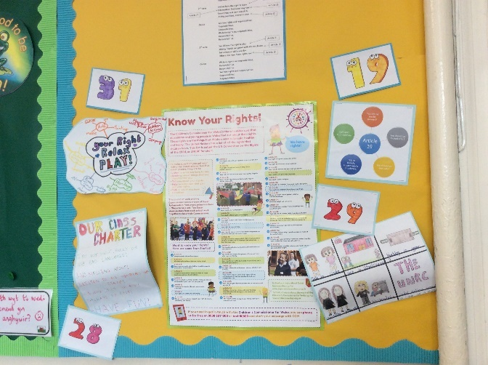
2 - Class teacher permission letter
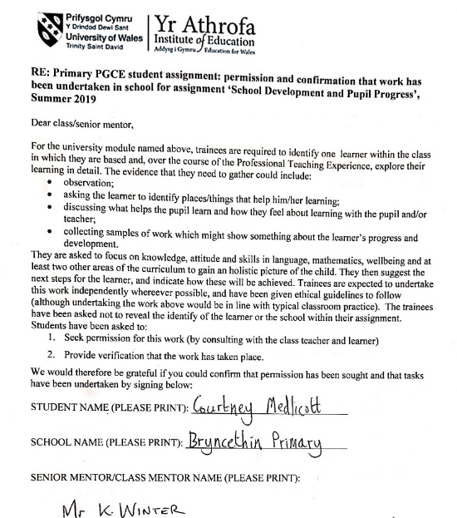
3 – Numeracy ninja display
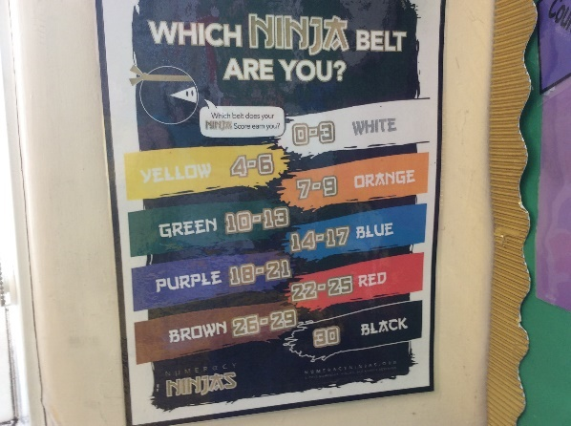

4 – Numeracy ninja work
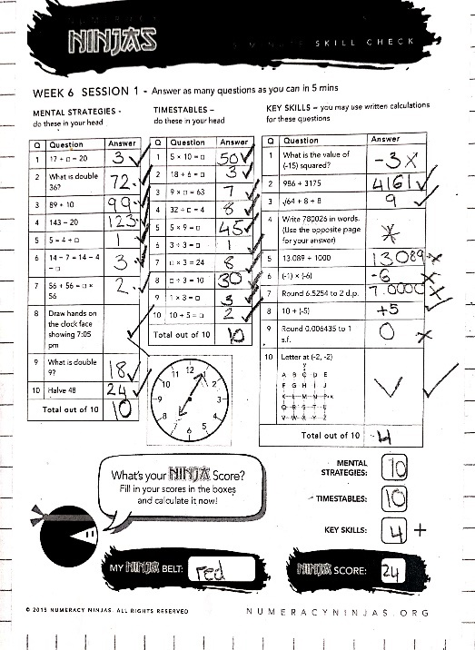
5 – Maths work showing applying maths to an authentic context
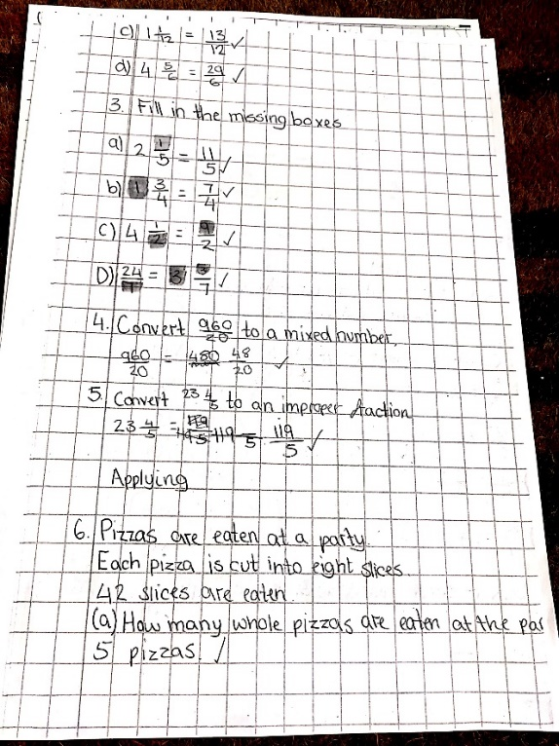

6 – Fruit club
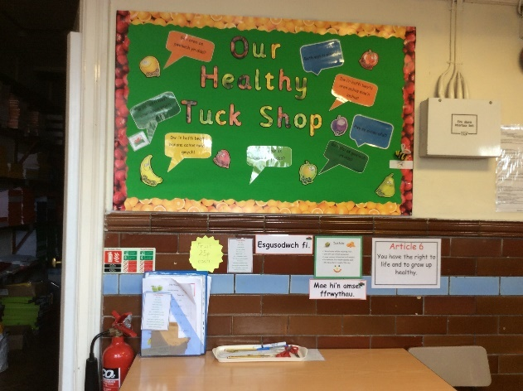
7 – School Council display
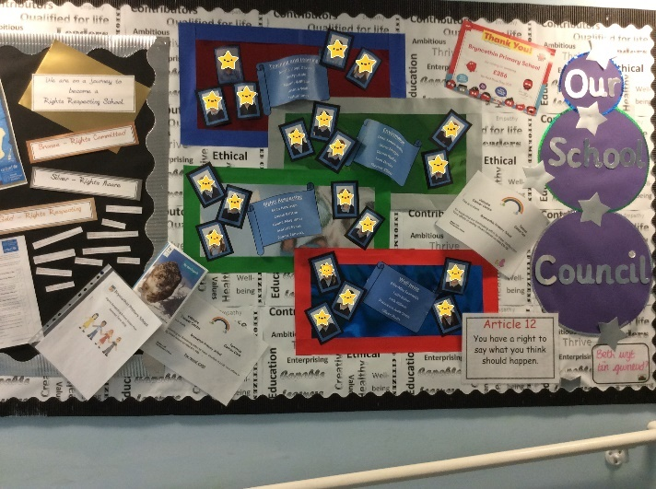
8 – Short story and evacuee letter
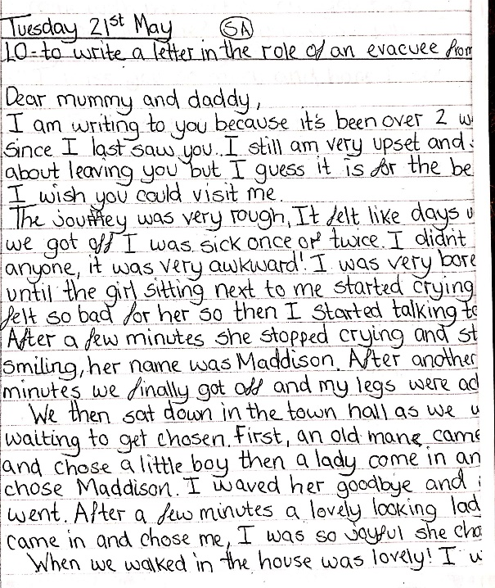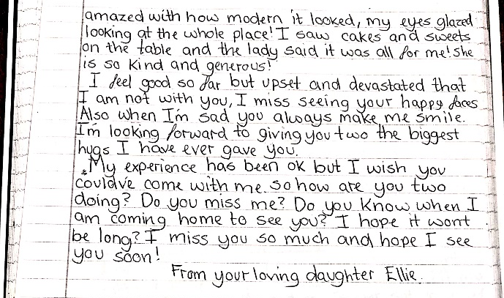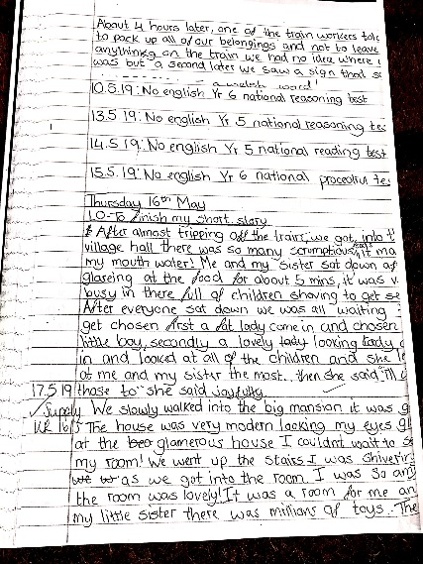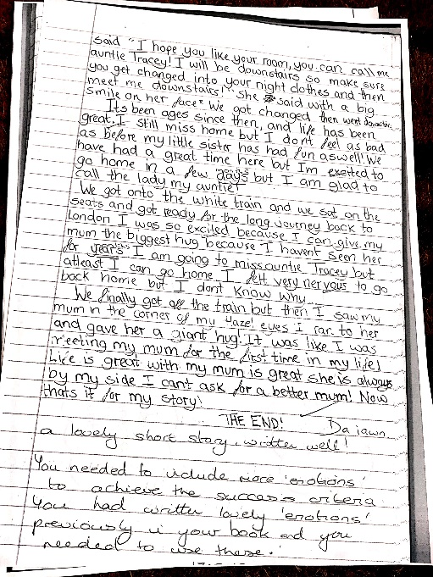

9 – Library
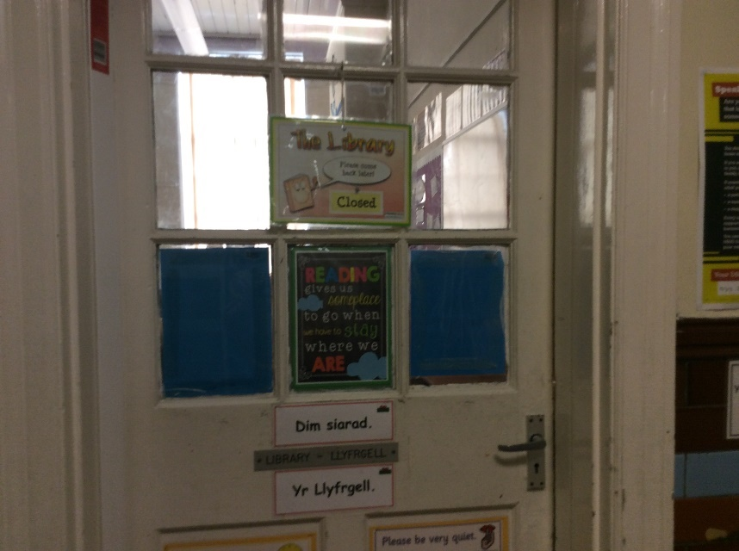
10 – Field

11 – Digital Leaders
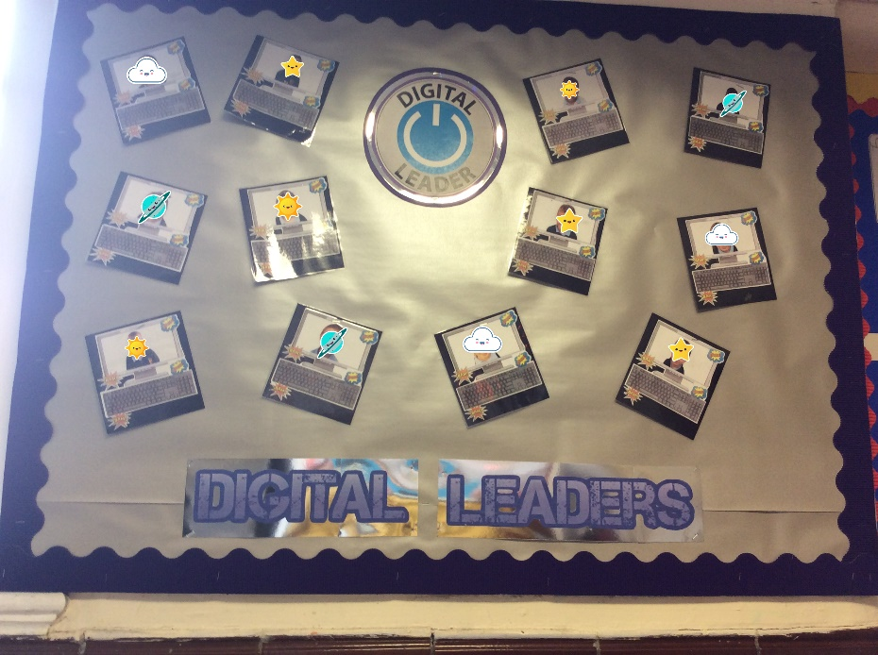
12 – Science Investigation
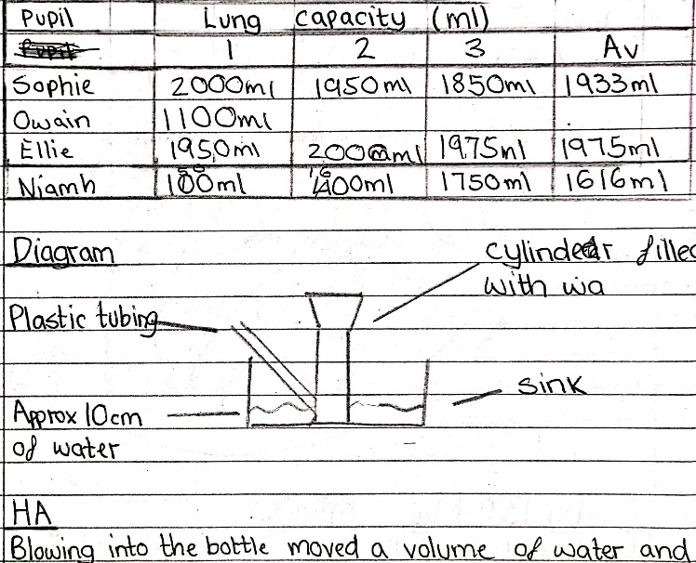
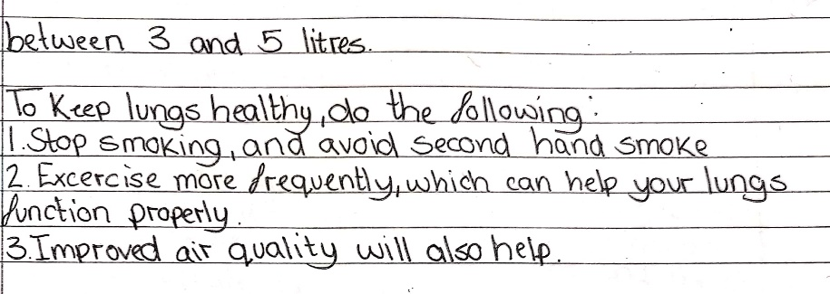

13 – Welsh
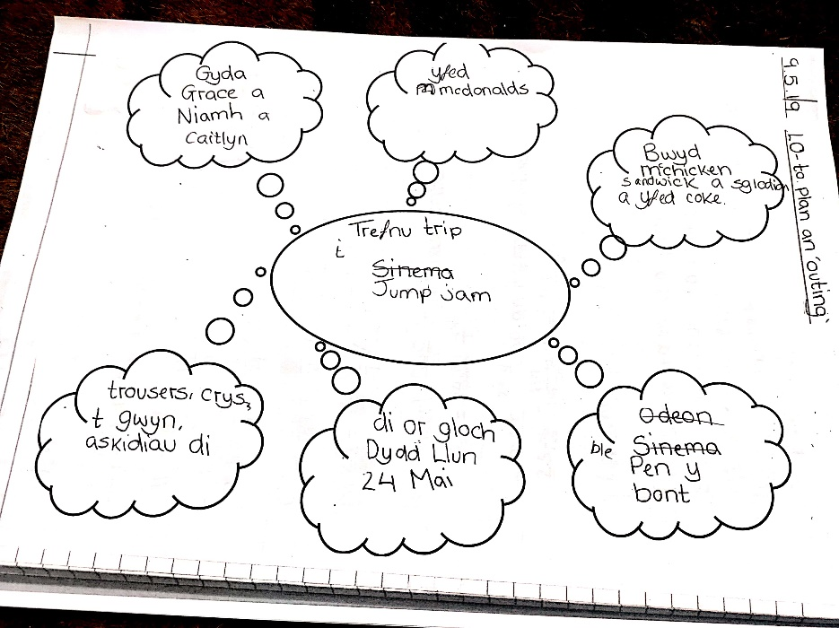

14 – Eisteddfod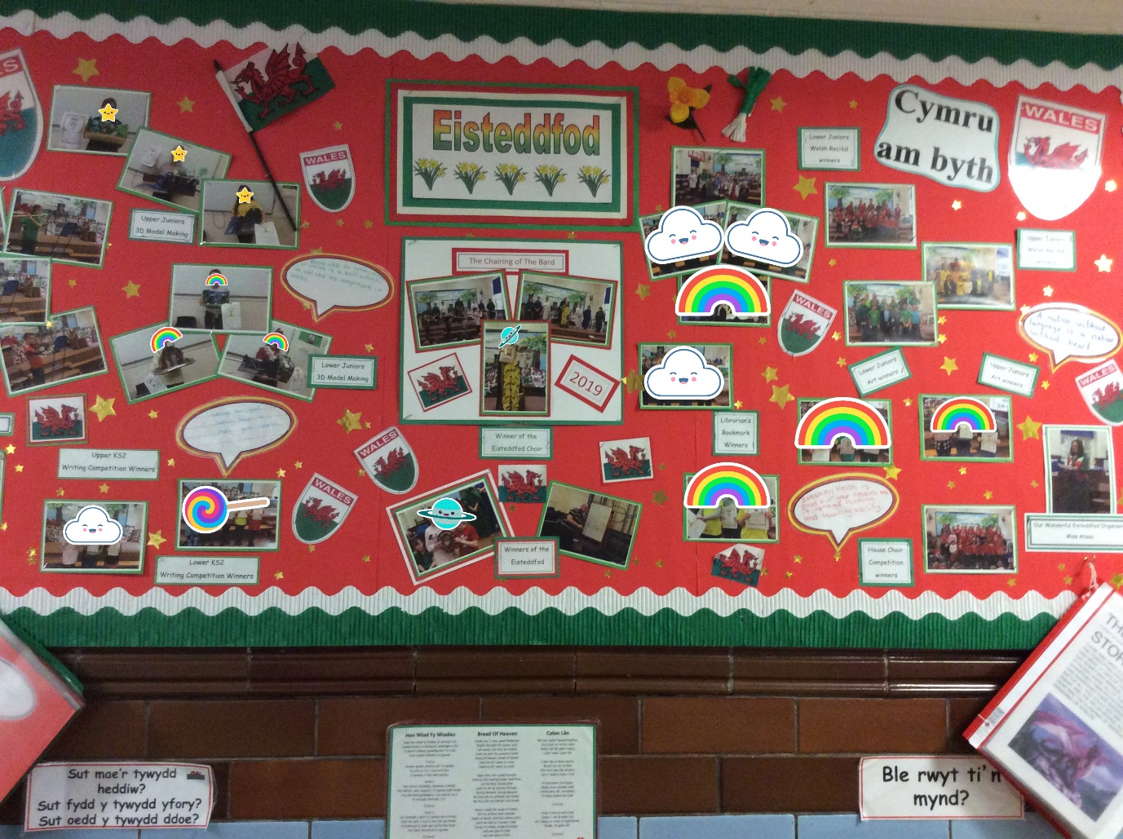
15 – Half term planning

