Student: Iftey Jewel
ID Number: 1708789
BMSW6104
Strategic Management for SME’s
Lecturer: Olu Adegbite

Executive summary
The report discusses the strategic management processes and procedures of IBCO Ltd which is a specialist food importer to United Kingdom (UK) market. The report highlights that fish and other fresh products importation, and distribution market is highly competitive due to the existence of larger number of supplier base with respect to the low entry barriers to the market.
Further it emphasizes that product development strategy should be implemented and executed to retain the competitive position in the market and ensure the differentiation of the products compare to the other products in the market to achieve the business sustainability. In addition to that stakeholder analysis of the report highlights that IBCO Ltd should evaluate both internal and external environmental factors in the UK market to develop the optimum strategic management strategies for IBCO Ltd.

Table of Contents

01. Introduction 4
02. Critical appraisal of current strategic direction of IBCO Ltd 5
2.1. Strategic intent 5
2.2. Five forces model 7
2.3. Value chain analysis 8
2.3.1. Primary activities 8
2.3.2. Support activities 8
03. External and internal environment analysis for IBCO Ltd 9
3.1. PESTEL model 9
3.2. SWOT analysis 11
3.3. Ansoff Matrix 13
3.4. VRIO framework 15
04. Stakeholder analysis for IBCO Ltd 16
4.1. Minimum effort 17
4.2. Keep informed 18
4.3. Keep satisfied 18
4.4. Manage closely 19
05. Discussion on strategic growth choices for SMEs in the market and propose a new strategy for IBCO Ltd 19
06. Key strategic recommendations for IBCO Ltd for future developments and implementations 21
07. Conclusion 23
08. References 25

01. Introduction
Strategic management is an important functional approach of the business organizations to achieve the business and corporate objectives and ensure the competitive position of the business in the competitive business environment (Khazanchi & Owens, 2018). The report discusses the strategic directions, internal and external business environmental implications, implications of the stakeholders to the businesses, strategic growth opportunities and methodologies and implementation of sustainable strategies in the context of IBCO Ltd which is a specialist food importer to United Kingdom (UK) market (IBCO, 2020). The primary business activity of IBCO Ltd is importing the white fish and king prawns from the natural sources of Bangladesh, Vietnam, India and China and distributing to the UK market.
During the last 40-year period, IBCO Ltd has positioned the product portfolio for seafood including Anchovies, Smelt, Climbing Perch, Catfish etc. and recently IBCO Ltd expanded the product portfolio to fresh vegetables, confectioneries and finger food under the product development strategies (IBCO, 2020). Over the period of time IBCO Ltd has built the loyalty customer base by assuring the quality of the products to ensure the trustworthiness of target market customers. The report aims to develop the sustainable strategic approaches for IBCO Ltd to enhance the current competitive advantage position and expand the market share in the UK market.

02. Critical appraisal of current strategic direction of IBCO Ltd

2.1. Strategic intent
Strategic intent analysis for IBCO Ltd focuses on vision statement, mission statement and objectives (Khazanchi & Owens, 2018). Further, it evaluates the how vision statement and mission statement have been linked with the objectives of IBCO Ltd.
Vision statement emphasizes the future aspirations of the business organizations through successful achievement of business level strategies and corporate level strategies (Khazanchi & Owens, 2018). The vision statement of IBCO Ltd aims to ensure the excellent quality products and services with the competitive prices to provide the customers’ convenience (IBCO, 2020). The main vision statement gap of IBCO Ltd is lack of expressing the outcome and ultimate aspiration of delivering excellent quality products and services. Considering that it is suggested to update the vision statement of becoming the market leader in seafood importation and distribution sector in the UK market.
Mission statement discusses the purposes and influences of the business processes and operations to achieve the business and corporate goals and objectives of the business organization (Khazanchi & Owens, 2018). Currently there is no clear guidance over the mission statement for IBCO Ltd. Considering the business processes and vision statement of IBCO Ltd, it is recommended mission statement for IBCO Ltd as introduce incredible varieties of food product across fish, seafood, poultry, vegetables and finger foods with natural freshness and excellent quality to compatible with the purchasing power of the target market customers in UK market.
The objectives of the business organizations should have the characteristics of Specific, Measurable, Accessible, Reliable and Timeliness (Khazanchi & Owens, 2018). Strategic intent review of IBCO Ltd highlights that objectives have not been determined properly. Considering the implications of the vision statement and the nature of the business operations of IBOC Ltd, it is suggested the example of objectives for IBCO Ltd as follows;
- Increase the market share in Seafood market in the UK by 10% within the next 5-year period.
- Develop the repeated customer base by 5% within next 2-year period.
- Maintain the per day customer complaints below 10 number customer complaints per day during next 12-month period.
- Increase the sales income, gross profit margin and net profit margin by 20% within the next 3-year period.

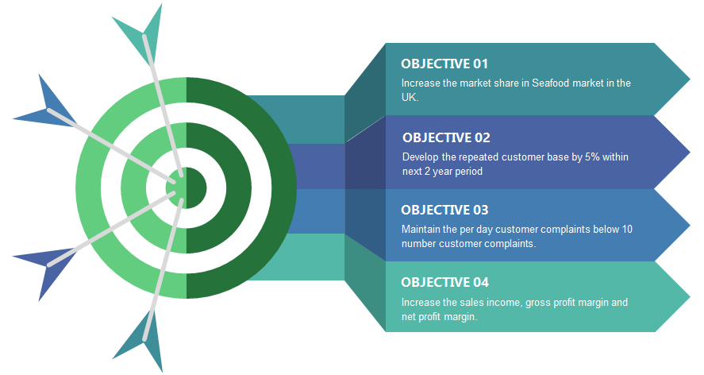
Figure 2.1.1: Objectives of IBCO Ltd

2.2. Five forces model
Five forces model provides the guidance to evaluate the strategic position of the business organizations considering five aspects such as rivalry, customer bargaining power, supplier bargaining power, threat of new entrants and threat of substitute products (Greiner & Julian, 2017). Based on the above aspects, five forces analysis for IBCO Ltd is as follows;
- There is a higher rivalry in seafood distribution market in UK due to the existence of larger number of seafood suppliers in the UK market such as Marrfish Ltd, Superfish UK ltd etc. IBCO Ltd should use both price and product quality strategies to face the industrial rivalry.
- Customer bargaining power in seafood and other fresh food products supplying market is at higher position due to low switching cost for customer to change the supplier to purchase products for their consumption.
- Sustainability of the business operations of IBCO Ltd depends on the continuous supplying of seafood and other fresh food products by the international suppliers in Bangladesh, Vietnam, India and China. It has increased the supplier bargaining power and IBCO Ltd has entered the long-term business agreements with their suppliers to mitigate the risk of supplier bargaining power.
- Higher compliance regulations and rules in the UK to start the natural food importation and distribution have been caused to reduce the threat of new entrants to the market in terms distributing the seafood and other fresh food products.
- Due to lack of close substitute products for seafood and other fresh food products in the market, threat of substitute products is at a lower position for IBCO Ltd.

2.3. Value chain analysis
Value chain analysis aims to identify the value addition factors from the processes and operations of the business organizations (Zamora, 2016). Porter’s value chain analysis mainly contains two aspects such as primary activities and support activities (Zamora, 2016). Value chain analysis for IBCO Ltd is as follows;

2.3.1. Primary activities
The inbound logistic process of IBCO Ltd initiates with the ordering process and use the sea and air freights based on the circumstances. IBCO Ltd track to product transportation process from supplier’s warehouse to IBCO Ltd warehouse. In addition to that IBCO Ltd uses Just In time (JIT) inventory management model to handle the stocks in the warehouses. Operations of IBCO Ltd mainly focus on sell the seafood and other fresh products to the customers in UK within a limited period of time to deliver the products to the customers ensuring the freshness and natural quality. For that purpose, digital marketing process of IBCO Ltd plays a vital role to make the customer aware and interact with the customers frequently to accelerate the sales process and complete sales orders quickly.

2.3.2. Support activities
IBCO Ltd accepts the online orders via the official website and provides facilities to inquire the prices and get the best quotations for the products to expand the customer base. Financial management activities of IBCO Ltd are managed through centralized system which provides the most clear information to take the financial management decisions within the shorter period of time. Human resource management department of IBCO Ltd ensures the effectiveness and efficiency of the HRM process such as recruitment, selection, trainings, performance appraisals etc. Procurement management activities of IBCO Ltd are handled through cloud system which has been integrated with the warehouses of IBCO Ltd and supplier warehouses management unit.

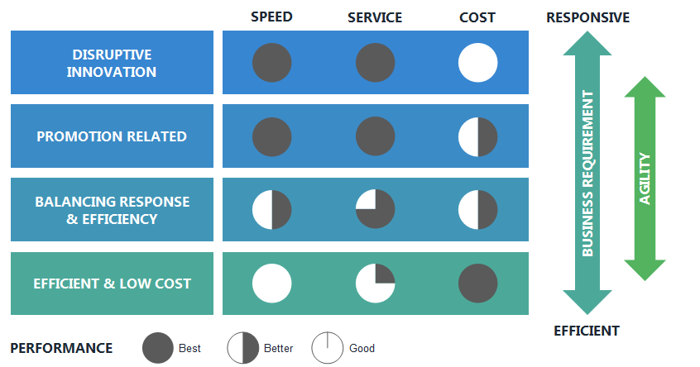
Figure 2.3.2.1: Value Chain Performance Analysis for IBCO Ltd

03. External and internal environment analysis for IBCO Ltd
Business organizations take the business decisions and implement the business strategies considering the implications and interpretations of internal and external environment analysis. PESTEL model, SWOT analysis, Ansoff Matrix and VRIO framework are used to perform the external and internal environment analysis for IBCO Ltd.

3.1. PESTEL model
PESTEL model analyzes the external environments of the business organizations based on six environmental factors such as political, economic, social, technology, environment and legal (Layth et al, 2019).
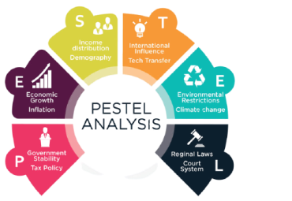
Figure 3.1.1: PESTEL model
PESTEL analysis for IBCO Ltd is as follows;
- Current political stability in the UK creates advantages to IBCO Ltd to develop the strategic plan to achieve the growth objectives based on long term monetary policy and fiscal policy of UK government.
- There is a higher inflation rate in the UK economy, and it reduces the purchasing power of the people. Due to that reason IBCO Ltd is facing the problem of introducing the high-quality organic vegetables to the UK market at premium prices. Further Sterling Pound depreciation against the Euro and US Dollar was the main reason to generate foreign currency exchange losses for IBCO Ltd during the international trading.
- People consumption patterns and perceptions towards consuming seafood and vegetables are changing rapidly. For example, most of the people are demanding organic vegetables. Considering that IBCO Ltd has to change and update the product portfolio with respect to the changes of the people buying behaviors.
- Technological tools and applications can be used to enhance the operational efficiency and effectiveness of IBCO Ltd. Currently IBCO Ltd is using online ordering platform to get the customers’ orders. Further, it is recommended to use the digital marketing platforms such as social media, YouTube, etc. to make the customer aware over the products of IBCO Ltd.
- IBCO Ltd should mainly consider on the waste management process to avoid the damages to the natural environment from its business activities. Further, it is recommended to integrate the triple bottom line framework with the business and corporate strategies of IBCO Ltd.
- IBCO Ltd should comply with the health and safety assurance rules and regulations of UK government to ensure the freshness and standard quality for the consumption. Considering that it is recommended to perform the random sample checks from the field and warehouses to ensure that products of IBCO Ltd meet the standard level for the consumption.

3.2. SWOT analysis
SWOT analysis contains four main elements such as strengths, weaknesses, opportunities and threats (Pickton & Wright, 1998). The main objective of SWOT analysis is to deploy the strengths and opportunities to manage the adverse impacts of weaknesses and threats of the business organization (Pickton & Wright, 1998). SWOT analysis for IBCO Ltd is as follows;
- Brand reputation and loyal customer base of IBCO Ltd in, UK market is considered as the key strength to compete with the competitive businesses. In addition to IBCO Ltd has a worldwide supplier network that is providing high quality seafood continuous basis to differentiate the products of IBCO Ltd.
- Lack of a structured mechanism to apply the digital marketing techniques to position the product values is the major weakness of IBCO Ltd. In addition to that IBCO Ltd does not have proper customer relationship management system to determine the product portfolio with respect to the behavioral changes of the target market customers in the UK.
- Currently, most of the people in UK market tend to consume fresh and natural products. Further, there is a higher market demand for the organic food products. It is a good indication in increase the future market demand for seafood and vegetable products of IBCO Ltd.

- There is a huge market competition in UK among the seafood delivering businesses due to higher attraction towards seafood delivering sector with respect to the increase of market demand for seafood during last five years period in UK. Further COVID-19 pandemic has limited the importations and reduced the seafood and vegetable harvesting of the suppliers of IBCO Ltd.

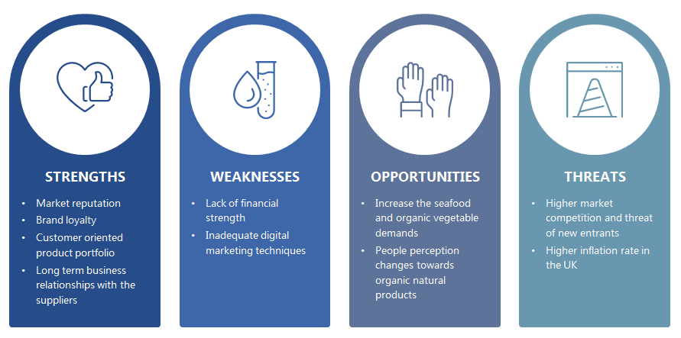
Figure 3.2.1: SWOT Analysis for IBCO Ltd

3.3. Ansoff Matrix
The Ansoff matrix provides the guidance and directions to the business organizations to implement and execute the business development strategies considering their financial and non-financial strengths and objectives (Hussain et al, 2013). It focuses on four aspects such as penetration, product development, market development and diversification (Hussain et al, 2013). Penetration approach involves with introducing existing products to the existing market and market development approach encourages targeting the new markets with the existing product portfolio (Hussain et al, 2013). Further product development approach highlights that business organization can introduce new products to the existing targets. Diversification approach emphasizes that businesses should introduce new products to the new market and diversification approach is considered as a risky business development method (Hussain et al, 2013).
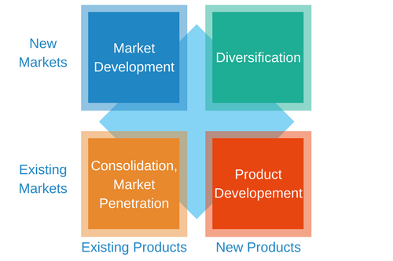
Figure 3.3.1: Ansoff Matrix Framework

When review the business development approach of IBCO Ltd, it is more towards the product development approach. IBCO Ltd starts the business operations in UK by specializing for the seafood and now seafood products of IBCO Ltd are considered as the signature product due to effective and efficient product positioning techniques. Eventually IBCO Ltd expanded the product portfolio to vegetable, pastry, confectionery, chicken, meat, halal game and prawns to respond to the changes of market demand and deviations of the consumption pattern of the target market customers in the UK.
Further, it is recommended to follow the market development strategies for IBCO Ltd to expand the market share by increasing the customer base. IBCO Ltd can enter the export business sector targeting on the Europe region with the franchise or joint venture agreements with the business partners in target international market to ensure the effectiveness and efficiency of the distribution process of products under IBCO Ltd brand name.

3.4. VRIO framework
VRIO framework is applied to evaluate the resource capabilities of the business organization to assess the capacity to ensure the competitive advantages in the industry. It discusses the four characteristics of resources such as Value, Rarity, Inimitable and Organized (Cardeal & António, 2012).
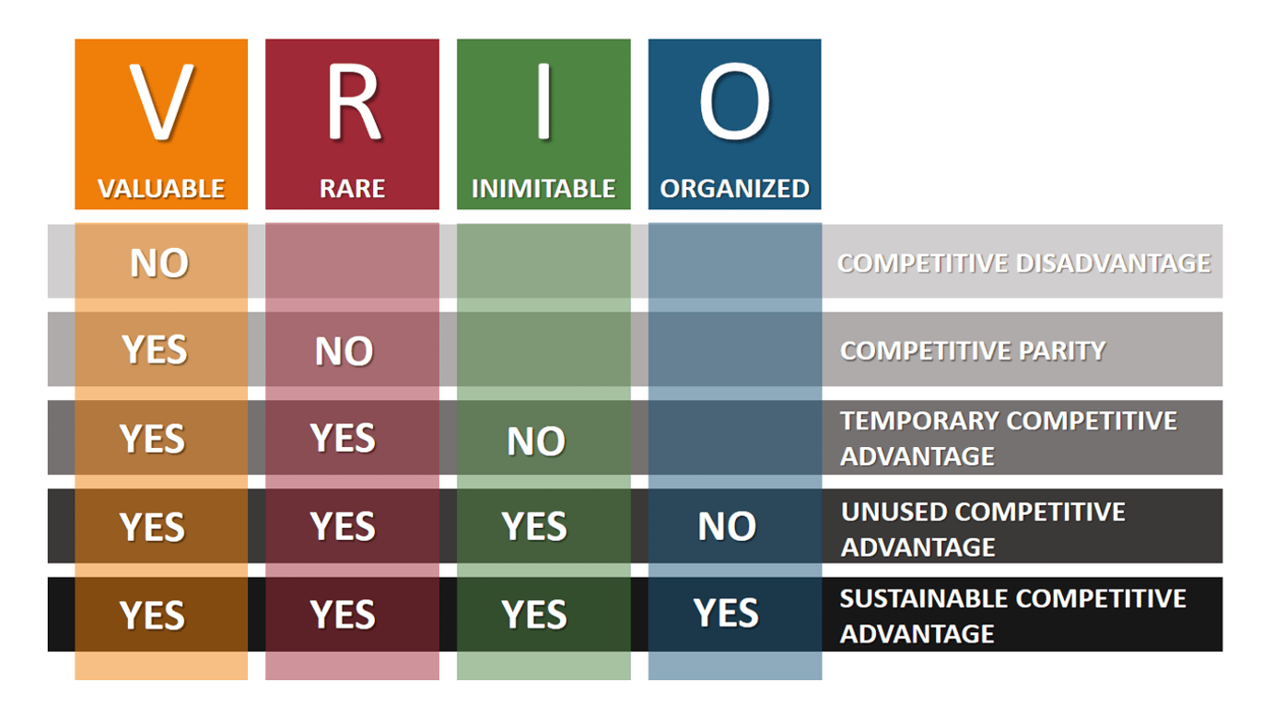
Figure 3.4.1: VRIO framework

The most valuable resource capability of IBCO Ltd is brand reputation which has been developed and shaped during last 40 years. It can be used to attract the new customers towards IBCO Ltd ensuring the trustworthiness on consuming the products of IBCO Ltd.
When evaluate the rarity of the current resources of IBCO Ltd, it identifies the long-term business relationship with the excellent quality seafood suppliers. These suppliers are working with IBCO Ltd under the exclusive supplying agreement by preventing the exporting the products to any other business organization in UK. Further current distribution network of IBCO Ltd is inimitable due to well-established distribution chain with proper coordination between central distribution unit and regional distribution centers of IBCO Ltd.
IBCO Ltd has a flat organization structure which ensures the internal communication efficiency and provides the right information to the management to take the right business decisions at the right time. However, IBCO Ltd should improve the quality and update the content of current training and development programs for the sales and marketing team to boost the sales volume and position the brand value in the target market customers by improving the knowledge of sales and marketing team on digital marketing methodologies and techniques.

04. Stakeholder analysis for IBCO Ltd
Stakeholders are parties who are interested in the business decisions and influence to the decisions making process and strategy implementation process of the business organizations (Yawson & Greiman, 2018). Stakeholder analysis categorized the stakeholders into the four categories such as minimum effort, keep satisfied, keep informed and manage closely based on their interest and power to influence to the business (Yawson & Greiman, 2018). Minimum effort stakeholders have low power and low interest while keep satisfied stakeholders have high power and low interest towards the business decisions and operations (Yawson & Greiman, 2018). Further keep informed stakeholders have low power and higher interest and manage closely stakeholders have high power and high interest (Yawson & Greiman, 2018).
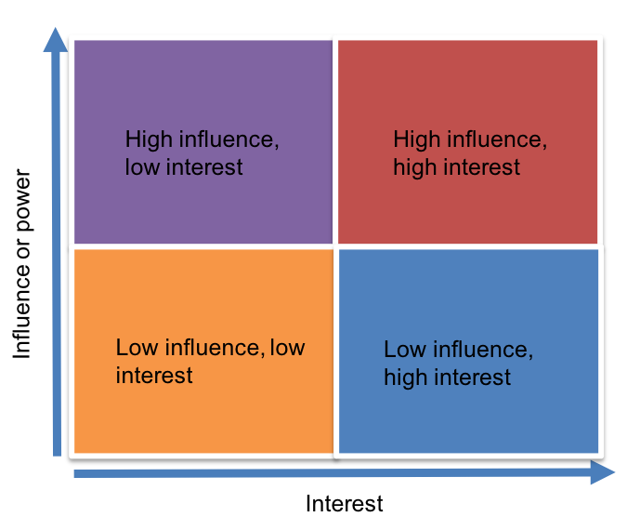
Figure 4.1: Stakeholder Mapping Model

Stakeholder categorization under four categories of minimum effort, keep satisfied, keep informed and manage closely for IBCO Ltd is as follows;

4.1. Minimum effort
- Customers of IBCO Ltd have a minimum interest towards the business decisions and actions of IBCO Ltd since they have alternatives to purchase the similar nature products from the competition suppliers in the UK market. However, IBCO Ltd should evaluate the behaviors of the customers to plan and execute the business strategies. (E.g., sales and marketing techniques, product developments etc.)
- Pressure groups focus on the business operations of IBCO Ltd to ensure that IBCO Ltd is doing the business activities to compatible with the ethical requirements and values. For example, health and safety NGOs in UK are expecting that IBCO Ltd is delivering high quality seafood and other consumable products which do not cause to the long-term diseases of the people.
- Market researchers evaluate and measure the business performances of IBCO Ltd to gather statistics for their researches and other market analysis.

4.2. Keep informed
- IBCO Ltd has competitors in the UK market that creates pressures and challenges to retain the market share and customers. Competitors are highly considering on strategic and operational decisions of IBCO Ltd to evaluate the impacts of those decisions of IBCO Ltd to their business sustainability.
- Banks and financial institutions in UK focus on business performance of IBCO Ltd to evaluate the debt recovery capacity and assess the liquidity position of IBCO Ltd. Banks and financial institutions evaluate the financial performance of IBCO Ltd to measure the financial risk position to recover their short term and long-term debt commitments.

4.3. Keep satisfied
- The quality of the products of IBCO Ltd depends on the suppliers' products. Suppliers of IBCO Ltd have high power to influence to the sustainability of the business by stopping or temporary holding the supplies. In order to mitigate that risk IBCO Ltd should enter the long-term business agreements with the key suppliers.
- Human resource of IBCO Ltd interested in the performances and the sustainability position of the organization to evaluate their job security and ability of the organization to pay their compensations for the employments.

4.4. Manage closely
- Government of the UK directly influences to the business decisions of IBCO Ltd by changing the fiscal policy (e.g., change the corporate tax rates) and changing the monetary policy (e.g., change the lending interest rates). In addition to that government monitors the business activities of IBCO Ltd to ensure that all the business activities are complying with the civil and criminal law of the UK.
- Investors of IBCO Ltd have the controlling power and strategic decision-making power over the business operations. Investors' concern on the business performance to ensure whether business has generated their required rate of return for the investment to take the decision on the continuation or termination the investment at IBCO Ltd.
IBCO Ltd should measure the current influences and power and predict the future influences and power of the stakeholders when implementing the business level strategies and corporate level strategies to mitigate the risk associates with the behavioral and perceptual changes of the key stakeholders

05. Discussion on strategic growth choices for SMEs in the market and propose a new strategy for IBCO Ltd
Due to the competitiveness of the business environment most of the business organizations implement and execute the growth strategies and choices to expand their businesses to ensure the long-term business sustainability and retention in the market (Ilhan, & Durmaz, 2015). The strategic growth choices for IBCO Ltd should aim to.
- Increase the current market share position.
- Increase the sales volume per annum.
- Increase the customer retention period and loyalty customer base.
- Become the market leader in seafood and other consumable food market in UK.

Strategic growth choices for IBCO Ltd can be categorized as internal growth choices and external growth choices. Internal growth choices for IBCO Ltd are as follows;
- Product development strategy discusses introducing new products to the target market customers in the UK. Product development strategies aim to respond to the changes of consumption pattern and tastes of the customers to ensure the highest-level customer satisfaction (Ilhan, & Durmaz, 2015).
- Market development strategy emphasizes that business organizations should distribute and sell their products to the new markets in order to expand the market share. In the modern business world, SMEs are focusing on exporting strategy to reach new markets in other countries (Ilhan, & Durmaz, 2015).
- Diversification strategy involves with entering into the completely new market with a new product portfolio. However, diversification strategy is a risky choice for SMEs that do not have adequate financial strength and operational capacity to bear the unexpected losses from the diversification (Ilhan, & Durmaz, 2015).
Further IBCO Ltd can considering on following external growth choices as well.
- Merger arrangement is applied by most of SMEs to join with the well-established business organization in the same industry. It helps to create the synergy benefits to SMEs in terms of financial capacity and operational capabilities.
- Business acquisition is another strategic growth choice which involves with acquiring the controlling power and ownership of a business organization by another business organization (Ilhan, & Durmaz, 2015). However, business acquisition is a difficult strategic choice for SMEs due to the financial constraints and operational constraints.
- Joint venture arrangement has two aspects such as operational joint venture and the entity joint venture. Operational joint venture means two or more organizations jointly manage the functions of a business and entity joint venture emphasizes that two or more organizations jointly manage a business entity (Ilhan, & Durmaz, 2015).
In order to determine the optimum strategic choice for IBCO Ltd, it is considered the following problems and challenges of IBCO Ltd to ensure the business sustainability in UK market.
- Numbers of seafood importers and distributors have been increased in the UK market. Due to that reason all the competitors including IBCO Ltd are competing to attract the limited customer base in UK market.
- Higher inflation rate in the UK economy limits the price increases for the products by using premium pricing strategy since higher inflation rate reduces the purchasing power of the customers.
- Due to the busy work life schedule of UK people, most of the people are demanding the processed foods which are ready to eat. It has been caused to reduce the market demand for the fresh and natural products of IBCO Ltd.
Considering above problems and challenges for IBCO Ltd, IBCO Ltd should implement and execute the market development growth strategy to reach the new customer segments. For that purpose, IBCO Ltd should initiate the product exporting to other few countries in Europe region. It is recommended to select two to five countries in Europe region to export the products of IBCO Ltd considering the existing suppliers, number of people and consumption pattern. In addition to that IBCO Ltd should integrate the external growth strategy of joint venture arrangement to perform the marketing and distribution activities with the coordination of established business organizations in target countries to reach the target market customers within limited period of time.

06. Key strategic recommendations for IBCO Ltd for future developments and implementations
The strategic recommendations for IBCO Ltd aim to ensure the future developments and overcome the challenges being a SME organization to implement the strategic directions. As mentioned above rivalry in UK seafood and other fresh food market is increasing gradually due to the demand and profit motivation (Leminen & Mika, 2012). Now multinational organizations are targeting on UK seafood and fresh food market segments and it creates barriers to protect the market share to SMEs like IBCO Ltd. Considering above challenges it is recommended to target on new, untouched market segments in other European countries using the exporting business development approach to maintain or expand the market share and sales volume of IBCO Ltd consistently.
Economic environment review under the external environment analysis highlights that the purchasing power of UK people is at lower levels due to the high economic inflation rate. It has created barriers for IBCO Ltd to implement the premium pricing strategy for their products. In order to implement the premium pricing strategies for the products of IBCO Ltd, it is recommended to introduce value added product portfolio to the market (Kemppi et al, 2015). For that purpose, IBCO Ltd should introduce a new seafood product range for star level hotels in UK by maintaining less than 3-day freshness from the harvest date. Further, it is recommended to provide facilities to see the how products are packaged at the harvesting point prior to receive to their hotel kitchen within the three days.
As a SME business organization IBCO Ltd does not have financial strength due to the limitation to expand the business operations. Further IBCO Ltd has to manage the working capital issues due to the higher customer credit period to retain the existing whole selling customer base. In order to enhance the financial strength position of IBCO Ltd, it is recommended to open few seafood restaurants in the capital cities of the UK as a business diversification strategy. It will help to diversify the business operations of IBCO Ltd and add new revenue stream to IBCO Ltd, Further restaurant businesses do not have credit sales and it will help to enhance the working capital strength of IBCO Ltd. Further it is recommended to develop a strategic plan to build a restaurant chain under the brand name of IBCO Ltd which has specialized seafood dishes.
Further IBCO Ltd should perform the comprehensive risk assessment of the key strategic actions suggested above by screening the internal and external environmental factors (Kemppi et al, 2015). Based on that it is recommended to rate the risks, measuring the likelihood and impact and develop the risk mitigation strategies to ensure the successful implementation and execution of the above strategies. In addition to that financial attractiveness of above strategic actions should be evaluated using the investment appraisal techniques to choose the most profitable strategic approach for IBCO Ltd and decide the lower cost of financing methods to acquire the financial resources to execute above strategic actions (Kemppi et al, 2015).

07. Conclusion
Business organizations, especially SMEs including IBCO Ltd implement and execute the business growth strategies to expand the current market position and develop competitive advantages to ensure the business sustainability and face the market competition (Leminen & Mika, 2012). Strategic intent analysis of IBCO Ltd highlights that mission statement and objectives should be developed by the management of IBCO Ltd to describe the path to achieve the vision and outcomes of achieving the vision and mission statements. As per the external environmental analysis, seafood and fresh food market in the UK is highly competitive and customers have lots of alternative suppliers to purchase the same products. Due to that reason IBCO Ltd has to accept the market determined prices adhering to the competitive pricing strategy. The main strength of IBCO Ltd is the reputation and brand loyalty which has been developed and shaped during the last 40 years by delivering excellent quality products to the customers in the UK.
Competitive advantages have been developed by IBCO Ltd using the interpretations of product development strategy. IBCO Ltd expanded the product portfolio to vegetable, pastry, confectionery, chicken, meat, halal game and prawns to respond to the changes of market demand and customers’ preferences. However, IBCO Ltd does not have adequate financial capacity and strength to expand the business operations and conduct the research and developments to introduce the value-added features and specifications for the existing product portfolio to position the product uniqueness and differentiation in the market compared to the competitors’ products. Further IBCO Ltd does not have structured mechanism to apply the digital marketing techniques to position the product values to the target market customers.
Further growth strategies for IBCO Ltd should focus on expanding the market locations for IBCO Ltd to increase the market share and reach to the new market segments. Considering that it is recommended to introduce the products of IBCO Ltd especially seafood to another less competitive Europe countries to create the new market for IBCO Ltd. For that purpose, IBCO Ltd should enter the operation joint venture agreement with established business organizations in particular new country or countries to ensure the effectiveness and efficiency of the product distribution and selling process. Further key strategic recommendation for IBCO Ltd suggests to introduce the value added seafood product range to the star level hotels in UK by positioning the freshness of particular seafood product as the differentiation. It will help implement the premium pricing strategy within IBCO Ltd.
Considering the overall operation processes and strategic development plan of IBCO Ltd, it is recommended to change management strategies within the organization to capture the business environment changes and respond to those changes by updating the business level strategies and corporate level strategies (Leminen & Mika, 2012). For example, with respect to the changes of customers’ buying perceptions, IBCO Ltd should update the product portfolio. Further IBCO Ltd should perform the internal environmental analysis and external environment analysis, periodic basis to identify the challenges and risks of the business environment and develop the risk mitigation actions to respond to those challenges and risks (Leminen & Mika, 2012).

08. References
Cardeal, Nuno & António, Nelson. (2012). Valuable, rare, inimitable resources and organization (VRIO) resources or valuable, rare, inimitable resources (VRI) capabilities: What leads to competitive advantage? South African Journal of Business Management. 6. 10159-10170. 10.5897/AJBM12.295.
Greiner, Michael & Julian, Scott. (2017). An Empirical Test of the Five Forces Model. Academy of Management Proceedings. 2017. 11870. 10.5465/AMBPP.2017.11870abstract.
Hussain, Sajjad & Khan, Jamshed & Rizwan, Arshad & Latif, Adnan. (2013). ANSOFF matrix, environment, and growth-an interactive triangle. Management and Administrative Sciences Review. 2. 196-206.
IBCO (2020), The official website of IBCO Ltd, [online] Available at: https://www.ibco.co.uk/index.html [Accessed 10th November 2020].
Ilhan, Ahmet & Durmaz, Yakup. (2015). Growth Strategies in Busınesses and A Theoretical Approach. International Journal of Business and Management. 10. 210-214.
Kemppi, Katja & Pätäri, Satu & Jantunen, Ari & Kyläheiko, Kalevi. (2005). Growth Strategies and Their Effects on Firm Performance – Empirical Analysis in the Global Pulp and Paper Industry.
Khazanchi, Deepak & Owens, Dawn. (2018). From Strategic Intent to Implementation: How Information Technology initiatives take shape in organizations. 10.24251/HICSS.2018.602.
Layth, Salman & Khalid, Layth & Rahman, Ismail. (2019). Conceptual Model for the External Factors Affecting Project Performance Using PESTLE Factors.
Leminen, Seppo & Mika, Westerlund. (2012). Categorizing the Growth Strategies of Small Firms. Technology Innovation Management Review. 2. 5-9. 10.22215/timreview/553.
Pickton, David & Wright, Sheila. (1998). What's SWOT in strategic analysis?. Strategic Change. 7. 101-109. 10.1002/(SICI)1099-1697(199803/04)7:23.0.CO;2-6.
Yawson, Robert & Greiman, Bradley. (2018). Stakeholder Analysis as a Tool for Systems Approach Research in HRD. 10.31124/advance.7433933.v1.
Zamora, Elvira. (2016). Value Chain Analysis: A Brief Review. Asian Journal of Innovation and Policy. 5. 116-128. 10.7545/ajip.2016.5.2.116.

