Motorcycle Geometry Analysis and Dynamic Handling Investigation
Unit (ACHA4003)
Brody Crockford
2300783

University of Wales Trinity Saint David
School of Engineering
Motorcycle Engineering BEng
17/12/2023


Contents

Introduction 1
Measured Motorcycle Geometry 1
Gear Ratios 2
Handling Characteristics 2
Application Dependant Motorcycle Geometry 3
Potential Motorcycle Alterations 4
Conclusion 5
References 5

Introduction
Every motorcycle is different, with the geometry and engine characteristics designed to suit the application that it has been designed for (Racing, Touring, Off-Road, etc). This report looks at the difference between production motorcycles that were available and measured specifically, as well as looking at the top performing bikes in different categories and understanding what geometry decisions were made and why it affects their discipline. This report will also include a look at the gearbox and driving forces of a motorcycle and a top speed calculation based on the ratios and resistive forces.

Measured Motorcycle Geometry
The data used to calculate the centre of gravity position was collected by weighing the motorcycle at the front and rear while level, as well as weighing the front when the rear is elevated, as shown in figure 1.
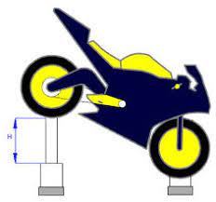
Figure 1 - A diagram showing the rear elevation for the centre of gravity calculations. (NT Project, 2023)

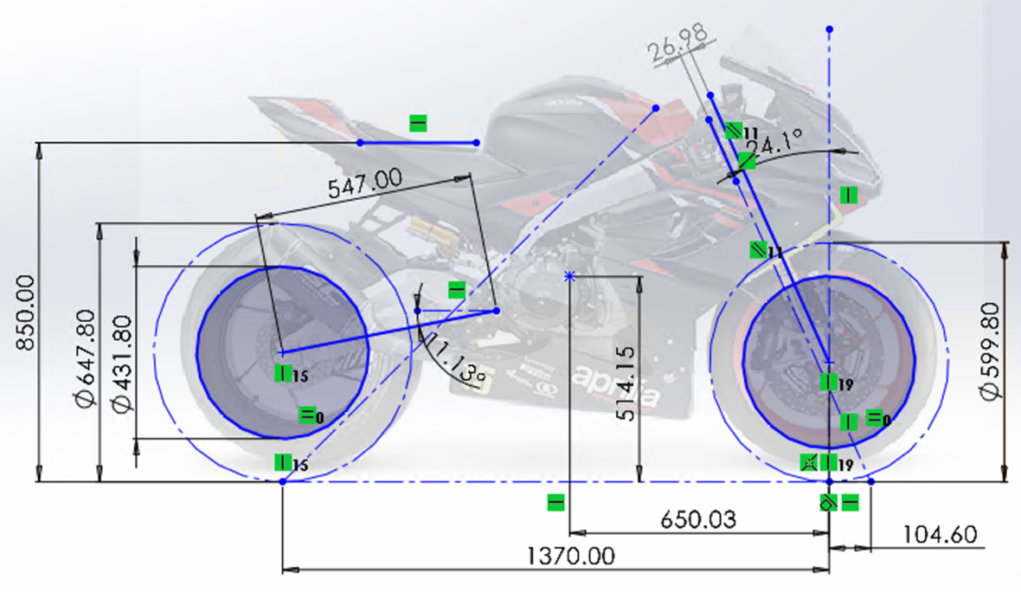
Figure 2 - Geometry schematic for the Aprilia RS660 Trofeo. Created by the author.
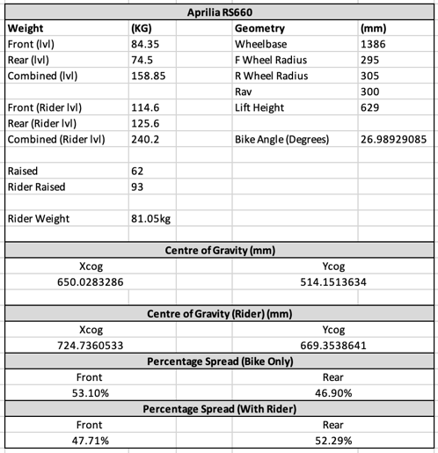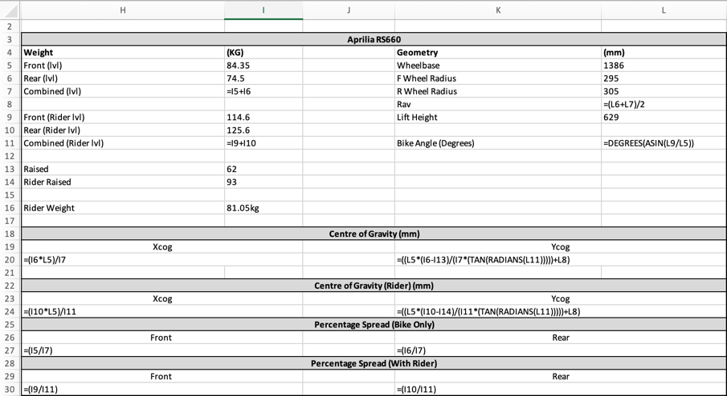
Figure 3 - Centre of gravity (CoG) position results and calculations for the Aprilia RS660 Trofeo.

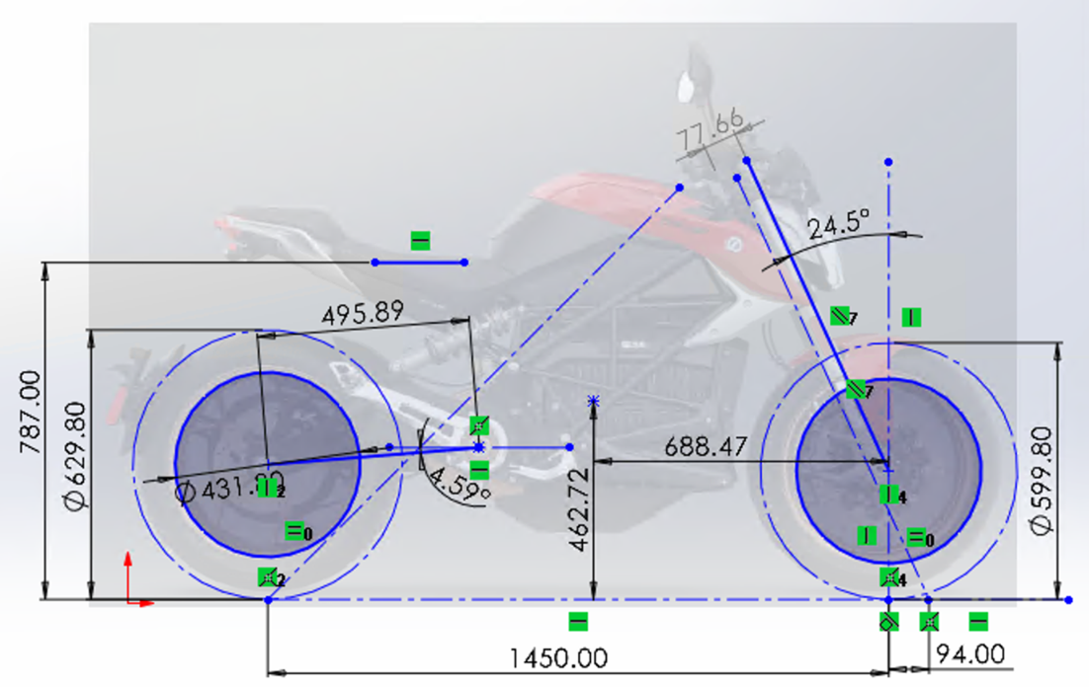
Figure 4 - Geometry schematic for the Zero Model SR-F. Created by the author.
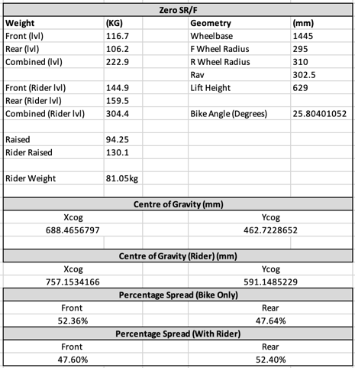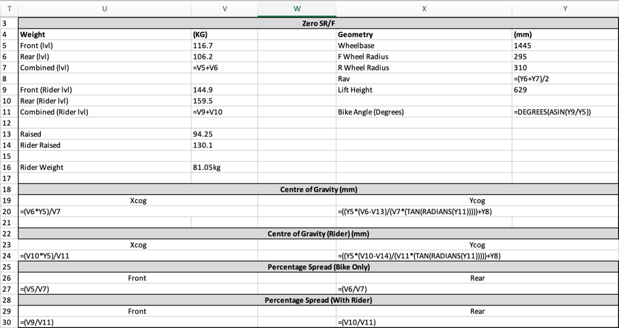
Figure 5 - Centre of gravity (CoG) position results and calculations for the Zero Model SR-F.

Gear Ratios
All the work in this section was stored and calculated in an Excel spreadsheet, created by the author.

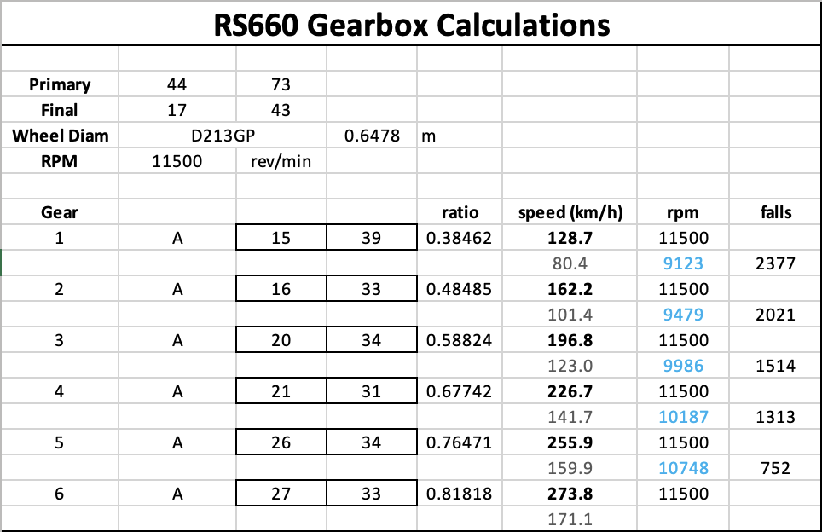
Figure 6 - Calculating the maximum speed and RPM in each gear on the RS660 with the standard final ratio.

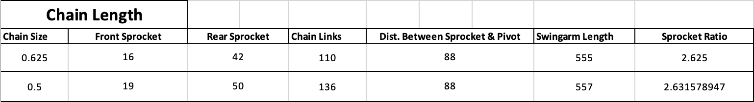
Figure 7 - Swingarm length calculations looking at different chain pitches, sprocket sizes and chain links.

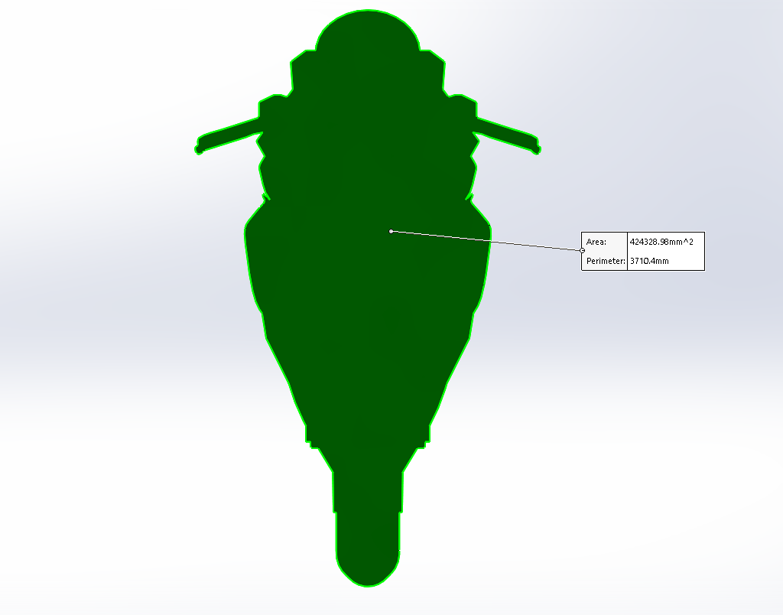
Figure 8 - Measuring the frontal area in SolidWorks by outlining a sized photograph of the motorcycle.
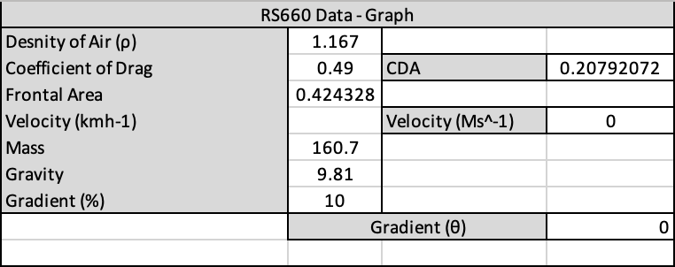
Figure 9 - The table of data used to create the resistive force results. The coefficient of drag is an average of the 'racing motorcycle' range in literature. (Bradley, 1996)
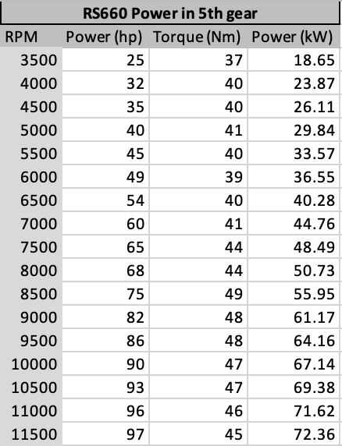
Figure 10 - Dyno data for the RS660

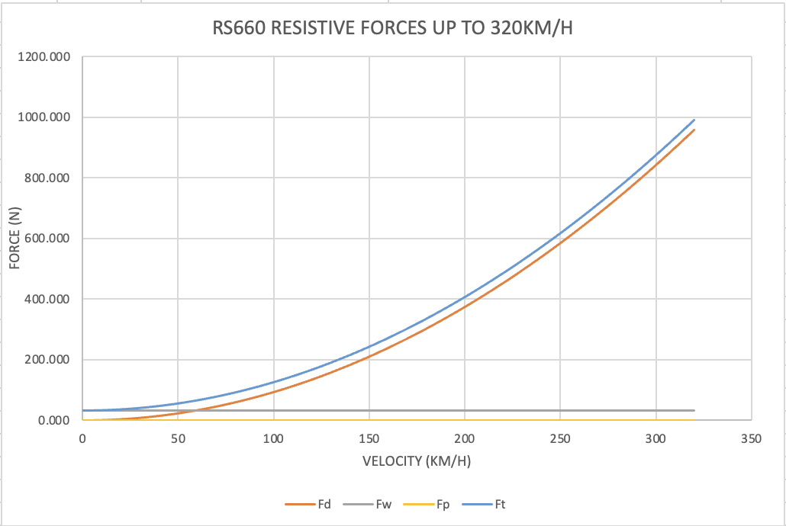
Figure 11 - A graph of resistive forces calculated using the data in Figure 8.
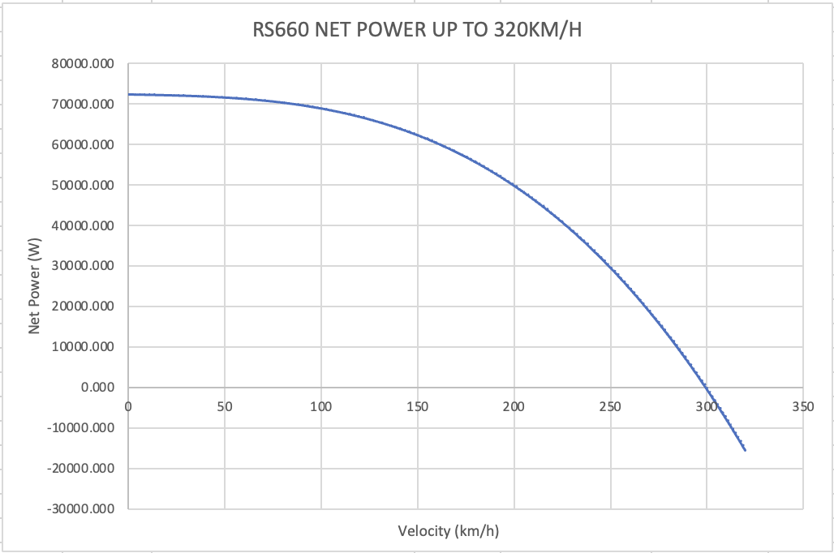
Figure 12 - By multiplying the resistive force (N) by the velocity (m/s) a power can be calculated. Terminal velocity is when this power is equal to the driving power.

Figure 13 - Using 'goal seek' to find the speed required to make the net power equal zero.
Excel shows that the physical limit of the RS660 is 299.3km/h, when the drag prevents it from going any faster. On the gearing chart (Figure 5), it is shown that the maximum speed achievable in 6th gear with the standard ratios is 273.8km/h, which means the bike is limited by its own RPM limiter before it reaches terminal velocity. To be able to reach the speed where drag overcomes the bikes power, a final ratio of 2.3 must be used, with a theoretical top speed of 301km/h.

Handling Characteristics
The Aprilia RS660 Trofeo is a factory converted production machine, with only very minor geometric changes in comparison to the road-going model. The road bike is promoted as a ‘sports-tourer’, meaning that it should have comfort as well as high performance when it is needed, and this shows in the decisions that were taken in relation to the geometry.
The RS660 has a short wheelbase, helping it be agile through the corners and hold a line well. The common downside to this is a lack of stability, but for a bike with less than 100hp this is less of a problem due to the lack of driving force. The short wheelbase is created by a small fork offset and tight steering head angle, which contributes to a fast turn in and quick reaction from minimal inputs at the handlebars, making the movements of the bike more precise. The swingarm length is long for such a short wheelbase, which allows for more flex on the side of the tyre due to the additional leverage from the wheel to the swingarm pivot, which is important on this bike as the engine is used as a stressed member. This means the engine forms the central part of the chassis and contributes very little flex, so the extended swingarm helps to increase traction at lean angle when the suspension is less effective. It has a large swingarm angle, which could contribute to an increased level of anti-squat dependant on the chain’s position. By increasing anti-squat, the driving force of the engine is being used to drive forward as opposed to squashing the suspension, which can decrease feel but resists ‘squatting’ on the exit of corners while accelerating, helping to hold a tighter line.
The centre of gravity (CoG) of the RS660 is very central, allowing an even load over the tyres in a neutral position while still giving good pitching due to the height of the higher CoG. An important point to note about the CoG position is its proximity to the 1G acceleration line, a 45-degree line coming from the rear contact patch. By being this close the bike can wheelie easily during acceleration, which is not ideal for racing purposes, showing the compromises made when designing this motorcycle.

The Zero SR-F is an electric road-going naked bike which is designed for road riding, with no sports nature. In comparison to the RS660, this is evident due to the major geometry differences between them.
The Zero has a much longer wheelbase, which gives the bike more stability, ideal for its class since roads often have large radius corners, therefore not needing the agility of a sports bike. The forks help make this wheelbase difference as they have a larger offset, softening the rider’s inputs and giving the feeling of stability, reducing the headshakes that can often come from small offsets. The Zero also has a short swingarm in comparison, reducing the leverage it has over the shock and swingarm pivot, stiffening both the suspension and flex properties of the rear end. This is due to the riding style of this bike, which has been determined by the low profile of the rear tyre, promoting low lean angles and negating the need for edge grip and therefore swingarm flex. The swingarm is also at a very low angle, which can produce less anti-squat and use the suspension more when accelerating. This is important for road riding as the rear load gives good feedback to the rider but sacrifices performance.
The CoG on the Zero is further back and down, partly due to the wheelbase but also due to the battery weight of this electric motorcycle. A low CoG means less pitching on the throttle and brakes, which helps with rider control but will also be useful due to the overall weight of the motorcycle. The heavier bike will produce more pitching naturally, and so this lower CoG will counteract this and bring it back to normal levels. Having the weight further back also helps with rear connection, however, reduces the handling abilities of the motorcycle. This is not important for the Zero as its low lean angle riding style means that it isn’t designed for performance, therefore not needing the geometry or CoG for this. Finally, the CoG position is further from the 1G line, mostly due to the wheelbase difference, however this will help with rider control.

Application Dependant Motorcycle Geometry
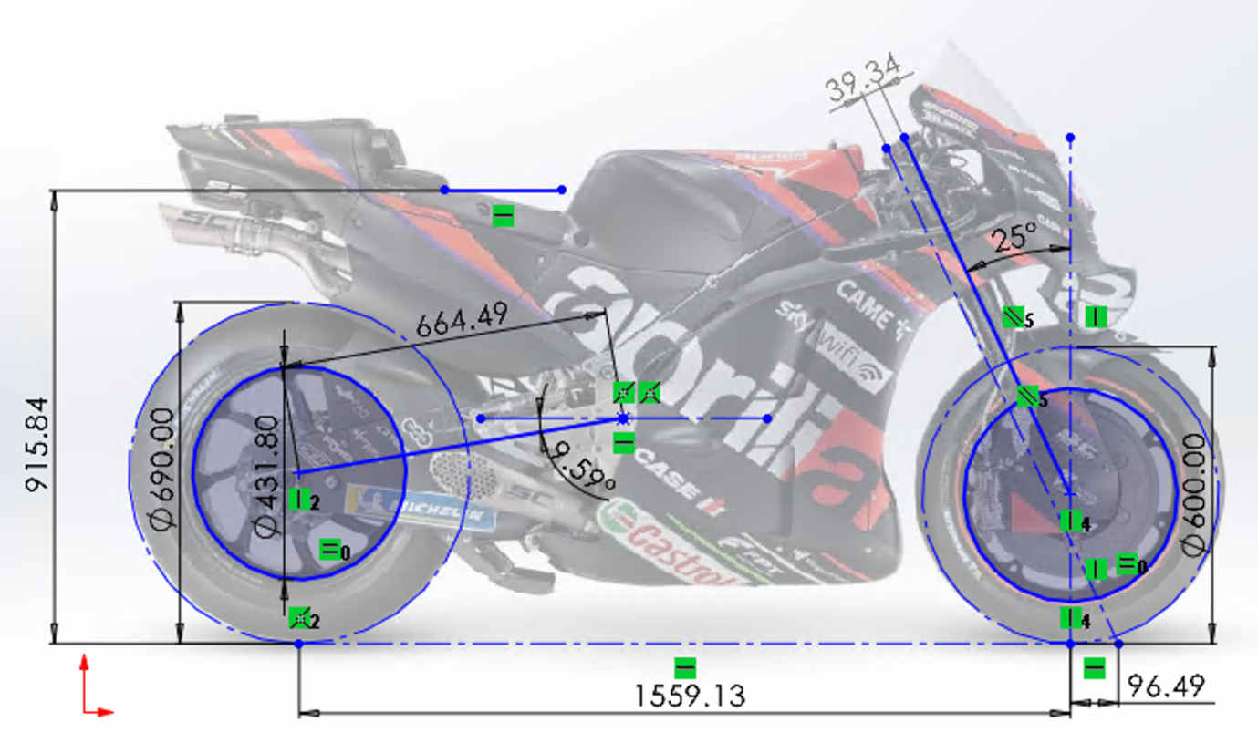
Figure 14 - Geometry schematic for the Aprilia RS-GP MotoGP bike (2022). Created by the author.
The Aprilia RS-GP is one of the competitive motorcycles in MotoGP, and being entirely prototype means that its only purpose is to go around a track as fast as possible. The geometry trend of the RS-GP shows that its assisting to control its 300hp and carbon brakes by having a long wheelbase and swingarm, keeping stability and allowing a lot of wheel travel to keep grip during acceleration and braking. The long swingarm also allows for a more even spread of flex throughout the whole unit, contributing to more lateral movement and better traction at high lean angles. The wheelbase is also made longer due to the slack head angle (assuming the forks and head tube are parallel), which helps with stability but also moves the engine further back in relation to the wheels, reducing load on the front. A slack head angle also means that when the front forks compress, the wheelbase change is more dramatic and the turning character and weight distribution changes, allowing the motorcycle to be more agile while the front is loaded.
The swingarm angle of the RS-GP is shallower than the RS660 previously analysed, which could cause less anti-squat. This would be done to use more suspension travel in the acceleration phase to gain grip. The RS-GP still maintains a significant swingarm angle, however, to retain the ability to hold a line on corner exit.
A key factor in the RS-GP’s design is the aerodynamic and shapeshifting devices which are in use when in a dynamic situation, such as the ride-height device. This allows the motorcycle to drop the rear down to its maximum travel during an acceleration phase to lower the CoG and reduce pitching/wheelie. By having this device, it allows the designers to raise the CoG in its natural position to counteract the long wheelbase, including a higher seat height which places the rider higher on the machine.

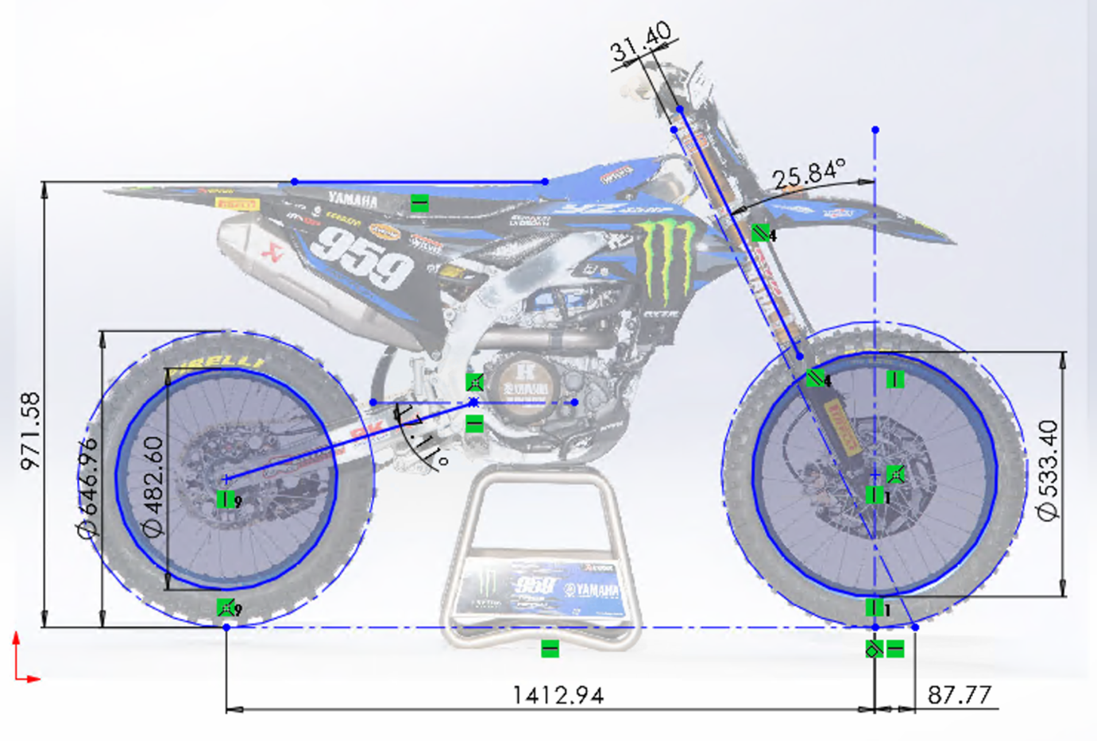
Figure 15 - Geometry schematic for the Yamaha YZ450FM MXGP bike (2023). Please note that the bike is on a stand and therefore the suspension is fully extended, making this data different to a dynamic situation. Created by the author.
The needs of a motocross bike are very different to those of a tarmac-based motorcycle, with loose surfaces, jumps, ruts and a constantly changing environment making it more important for the motorcycle to be adaptable.
The wheelbase of the bike is a middle ground compared to the road-going bikes looked at so far, giving a compromise between agility and stability, however, the headstock is where this bike becomes individual. The head angle is very slack, which is usually for good stability but will also allow the suspension to work better over rough terrain as its closer to being perpendicular to the surface. This also reduces stress by absorbing more load through the damping rather than in the fork flex. To counteract the slack head angle, the trail has been made small to give good connection through the handlebars and allow tight cornering, which is required for motocross. The swingarm angle has been made big to allow the driving force to work for performance, allowing the soft rear suspension to work with the tyre to dig in and find grip on loose surfaces.
The suspension travel for motocross must be long to allow complete absorption of the jumps, but another side-effect of this is a tall seat height. As previously explained on the RS-GP, by placing the rider high up on the bike the CoG is raised, and more pitching is introduced. In off-road environments, this is ideal as it loads the tyres more and helps them generate grip.

Potential Motorcycle Alterations
To help make the Aprilia RS660 a more capable racing machine, the data collected on the RS-GP can be used. The RS660 has much less power than the RS-GP, and therefore does not need the long wheelbase for stability, instead prioritising the agility. However, the main factor which allows the RS-GP to accelerate as quick as it can is the ride-height device. As previously explained, this causes the CoG to lower and reduce pitch, this also moves it further away from the 1G acceleration line, an area in which the RS660 could be improved. A ride-height device is impossible to achieve in the same way on the RS660 as it doesn’t have a rear shock linkage, however by moving the CoG the same effect can be achieved, moving it forward and/or down from the rear wheel to remove it from the 1G line. This could be done by removing weight in the upper rear section with titanium hardware and adding lead weight to the lower front of the engine. To stop this from affecting the handling too much, the chassis and suspension can be adjusted to regain the attitude desired.

Conclusion
This report has shown how varied motorcycle geometries can be for different disciplines and uses. Motorcycles have been optimised over the years for their specialities, however modification can allow them to adapt into other areas, and continued development in prototype racing helps to improve these machines further.

References
Bradley, J., 1996. The Racing Motorcycle: A Technical Guide for Constructors Volume 1. 1st Edition ed. York: Broadland Leisure Publications.
NT Project, 2023. Utility for calculating the centre of gravity. [Online]
Available at: http://www.ntproject.com/calculation_gravity_bike.php?&width=1440&height=814&dpr=2
[Accessed 12 December 2023].

