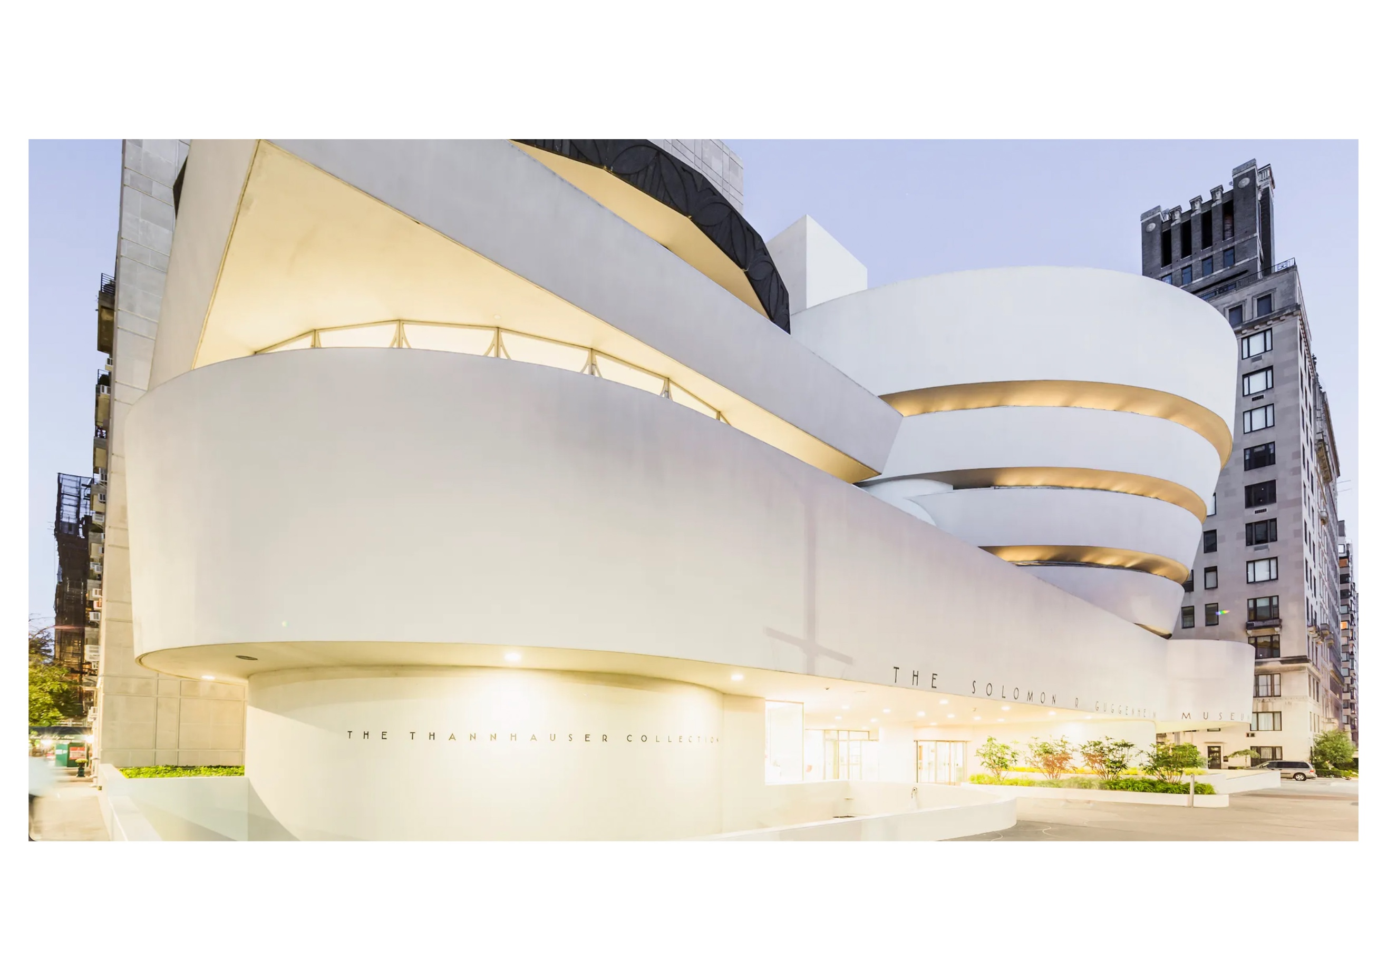  Solomon r. guggenheim museum  History & Theory 2 | Abstract  A critical analysis of the Solomon R. Guggenheim Museum, New York. Looking at the design philosophy, controversies and asking, ‘Is it an art museum or masterpiece in its own right’?  Nicholas Smith (2006099)  BSc Architecture

Solomon R. Guggenheim Museum
Frank Lloyd Wright 1943-1959
‘Artwork or Art Museum, polarising opinions’

The Solomon R. Guggenheim Museum, open to the public as of this afternoon, is a war between architecture and painting in which both come out badly maimed – John Canaday, New York Times 1959 (New York Times, 1959).

Introduction
In January 1927, Hilla Rebay, a French born artist moved to America to begin a new life.
She settled in Manhattan and quickly immersed herself in the art scene, completing portrait commissions, designing posters, and giving art lessons. It was whilst exhibiting some of her work, she met Irene Guggenheim, who commissioned her to paint her husband, Solomon (Artstory, 2022).

During these sittings, Rebay, who had a passion for non-objective art, convinced Guggenheim that he should start his own collection. Over the next decade Guggenheim and Rebay, his now art advisor, would amass a substantial collection. Rebay again convinced Guggenheim of the need for a ‘public space’ in which to exhibit the works. By 1939, she had her wish and ‘Art of Tomorrow, the Museum of Non-objective Painting’ was opened on East Fifty-Fourth Street (Artstory, 2022).

This, however, was only a temporary solution and by late 1942, Rebay began to work on plans for a permanent home for the Guggenheim collection.

In June 1943, Rebay wrote to Frank Lloyd Wright. In her letter Rebay asked Wright to design a museum which would house the Guggenheim collection of ‘non objective art’ by innovative painters such as Kandinsky, Klee & Mondrian (Guggenheim, 2003).

Guggenheims only requirement was that the building be unlike any other museum in the world (Guggenheim, 2003), Rebay on the other hand was far more invested in the idea and in her letter to Wright arguably appealed directly to the architect’s ego. In it she wrote, ‘I need a fighter, a lover of space, an originator, a tester, and a wise man – Your three books, which I am reading now, gave me the feeling that no one else would do.’ (Frank Lloyd Wright Foundation, 2022).

Rebay had reached out to the master and the seed of the Solomon R. Guggenheim Museum was sewn.

Location
The location for the museum provided much conjecture. Wright made no secret of his dislike of New York in general. In 1949 he wrote ‘I can think of several more desirable places in the world to build this great museum, but we will have to try New York’ (Architectural Digest, 2019).
Wright considered multiple locations in New York before finally settling on the current site on Fifth Avenue, between 88th and 89th street. It’s suggested that Wright preferred this site due to the proximity to Central Park, which was the closest thing to nature the city offered (Guggenheim, 2003).

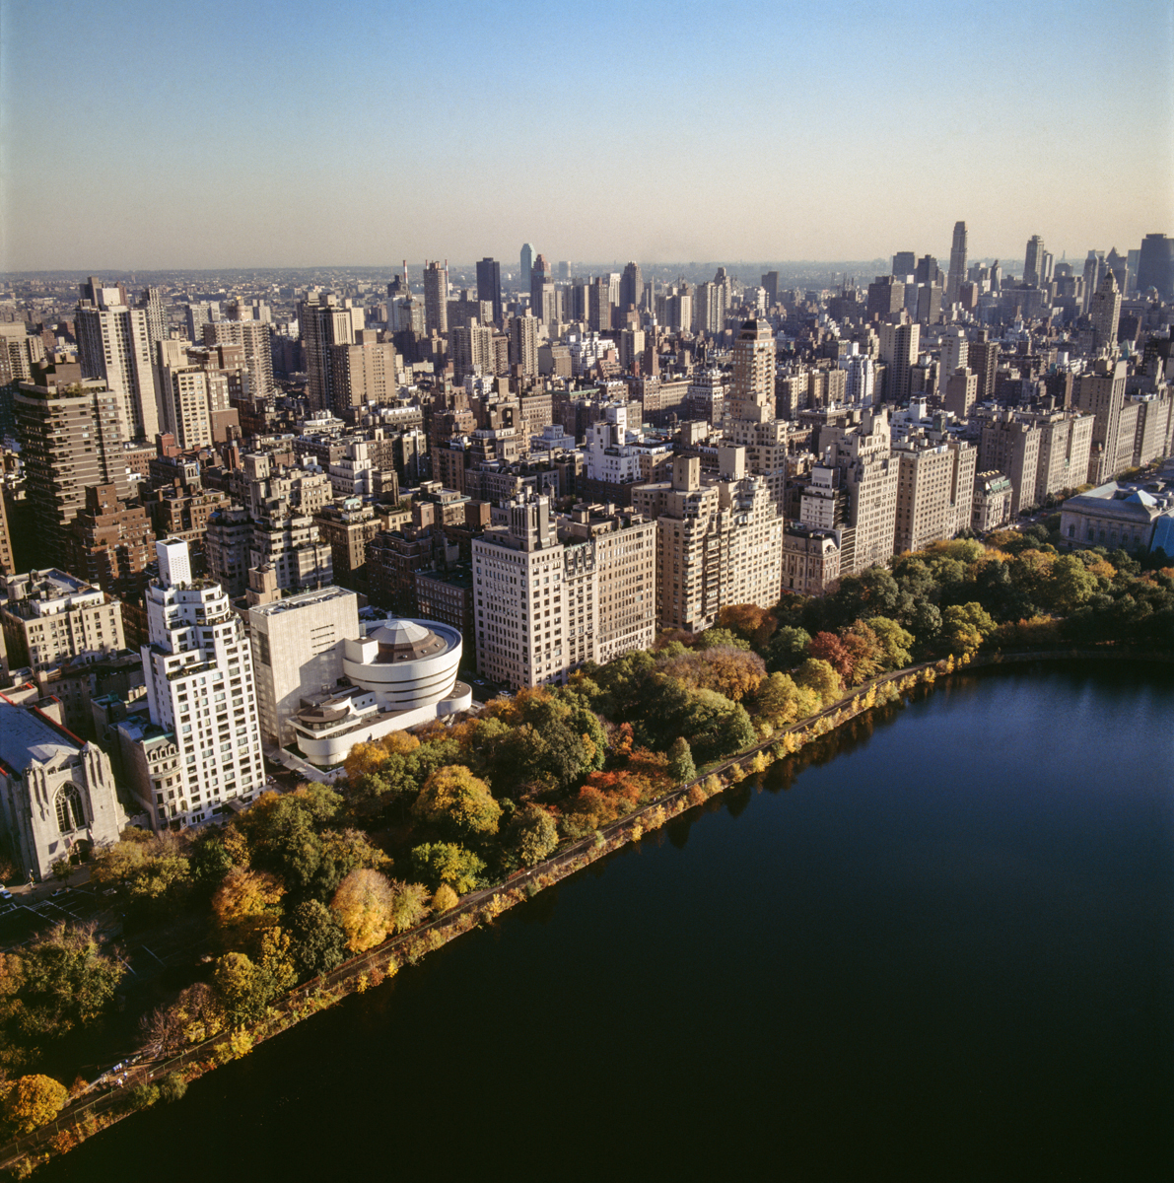

Solomon R. Guggenheim Museum, view looking eastward to Fifth Avenue with Central Park reservoir in foreground (Heald, D, 2022), © Solomon R. Guggenheim Museum, courtesy of the Frank Lloyd Wright Building Conservancy

Design Philosophy
Wright produced over 700 sketches and had 6 sets of working drawings for the museum over the 16 years to completion. He wanted to create a masterpiece. As much as he outwardly criticised New York, ‘it’s all a race for rent, and it is a great monument I think to the power of money and greed’, he said in an interview with Mike Wallace in 1957 (New York Times, 2017), it could be argued that he knew his legacy would be lesser had he not completed a significant commission in the city.
He described the form of the Guggenheim as an ‘inverted ziggurat’ a type of Mesopotamian pyramid. It is suggested that this form was adapted from a previous, unrealised design of Wrights.

In 1924, Gordon Strong commissioned Wright to design a resort which was to be placed on the side of Sugarloaf Mountain. The scheme Wright developed was that of a circular ziggurat with spiralling ramps from top to bottom. Wright took these principles for the Guggenheim and by inverting the ziggurat and placing the spiralling ramp on the inside, his scheme began to take shape (Smithsonian, 2009).

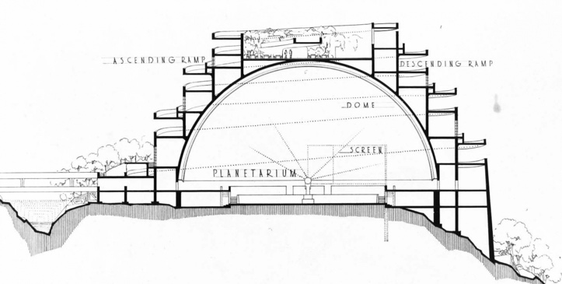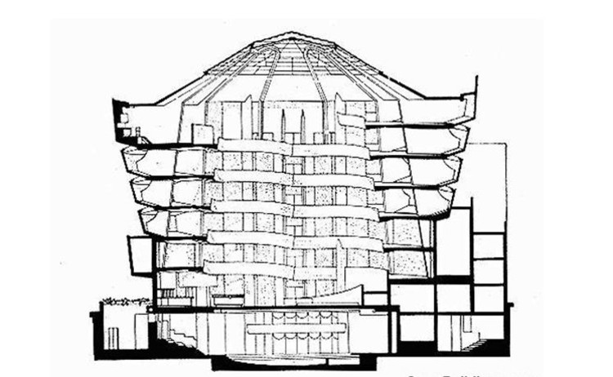
Section of the proposed Gordon Strong Automobile Objective building (Frank Lloyd Wright Foundation, 2022) and Guggenheim, right (Archdaily, 2022)

The use of the spiral and the curves of the walls was Wright staying true to his organic architecture even if the site didn’t allow a direct link with nature itself.

Wright wanted to create a large open space in which he could lead visitors. Unlike in traditional museums, the visitor is not left with a sense that they may have missed something important. Wright ensures clarity within the space and cleverly ushers you to where you need to go. He gives you two options, take an elevator to the top and work down or vice versa, nothing is missed, just the opportunity to enjoy the art and the inward facing vistas the building affords you (Guggenheim, 2003).

The ramps diameter is smaller at the top than at the bottom, tapering inwards from floor to floor within the rotunda. This allows Wright to create the open vistas across the space. The diameter of the external banding of the building, however, increases as the floors rise, creating the ‘inverted ziggurat’ Wright mentioned. The geometry of this enables the structure to counterbalance itself and allows the ramp to be cantilevered, creating a sense of the ramp floating as it ascends the space. This also creates the sloping walls at 3 degrees, which Wright felt would replicate the art being positioned on the artists easel.

Directly above the spiral at around 90 feet above the ground sits the buildings oculus. Spanning 58 feet, it is constructed of 6 u-shaped concrete beams or hairpins, which is adorned with 169 sections of glass. Wright envisaged this feature as being key to having the museum naturally lit. He wanted the paintings to be seen under natural light, James Johnson Sweeney though, disagreed with his vision (Guggenheim, 2014).

After revealing his design and explaining its form was ‘a true logarithmic spiral’, made up of a single element, the ramp, which flows from top to bottom and is connected to external cladding and the internal parapet, Wright shocked the assembled crowd by declaring it would survive an atomic bomb, simply bouncing (Dal Co, 2017). His joke may have been in bad taste, but he clearly intended to express that this building was here to stay.

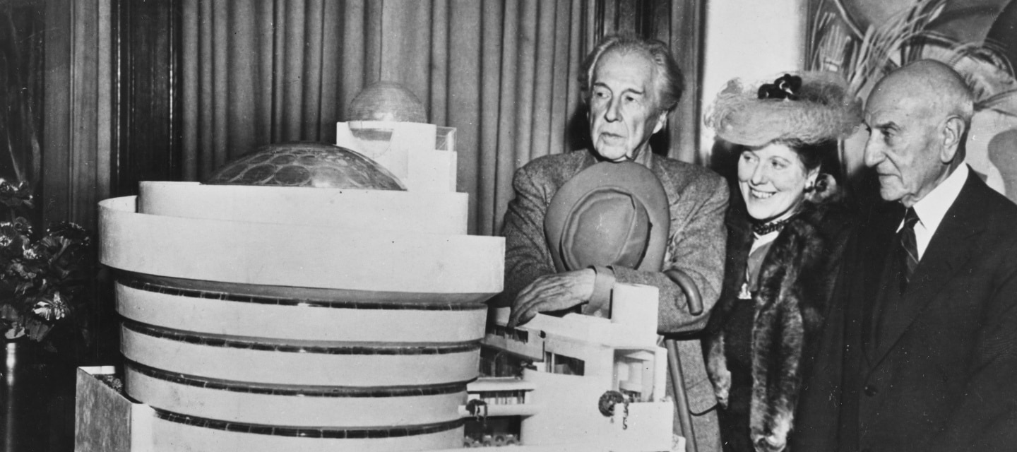
Frank Lloyd Wright, Hilla Rebay and Solomon R. Guggenheim at the unveiling of the Guggenheim Museum model (Frank Lloyd Wright Foundation, 2022)

1943-1959
Traditional art museums were rectilinear. Whether this was due to building technologies of the time or the perceived need for flat surfaces to exhibit the art, it was generally accepted that this was the type of building you needed.

The Museum of Modern Art (MoMA, 2022), which opened in 1939, is a prime example. Designed by Phillip Goodwin & Edward Durrell Stone, in the modernist style, it was a 6 storey ‘box’ essentially of white marble and glass.

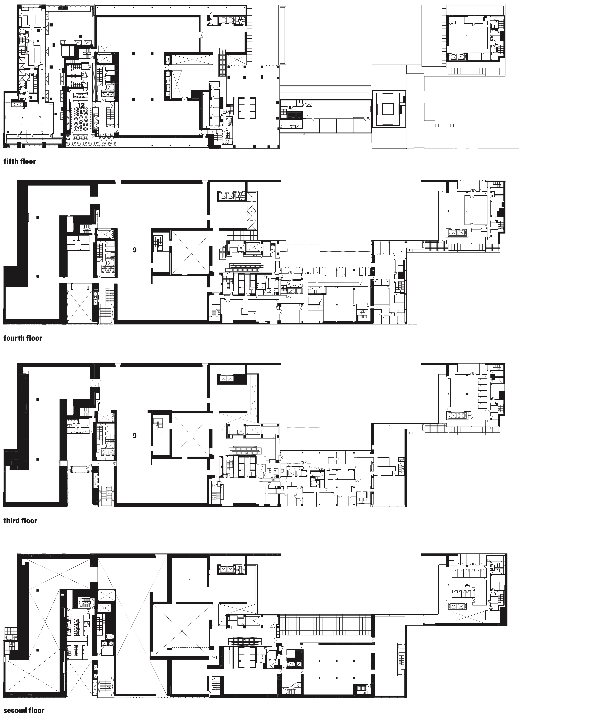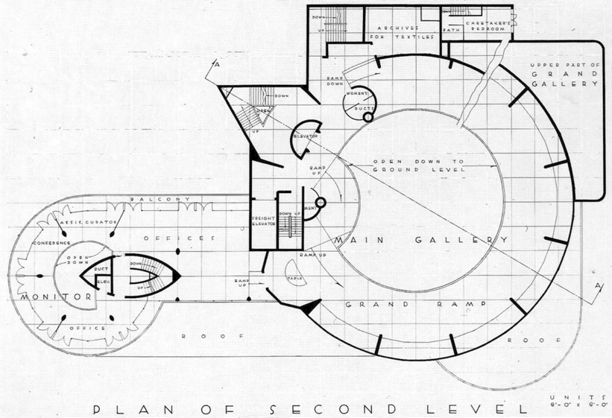
Floor plan of the 1939 MoMA (The Architectural Review, 2021) and Guggenheim (Frank Lloyd Wright Foundation, 2022)

This layout followed generic museum design that had remained unchanged for centuries. Little wonder then, that when Wright proposed a spiral form for the Guggenheim, critics were bound to challenge him.
Among his biggest critics were the artists themselves. They argued that the building would overpower the art inside. Wright did not agree, he wrote ‘On the contrary, it was to make the building and the painting an uninterrupted, beautiful symphony such as never existed in the World of Art before’ (Guggenheim, 2003).
Although conventional art museums were rectilinear and despite criticism of the curved forms, Wright argued that the walls would allow the artworks to be hung as if they were on the artists easel. Not for the first time, Wright’s vision was not implemented. The paintings were ultimately mounted away from the sloping walls using steel rods.

In Wrights early vision the Guggenheim was to be red. He argued that red was the colour of creation. Hilla Rebay however, did not share the same enthusiasm. She wrote to Wright in 1945 explaining that the colour displeases Mr Guggenheim ‘as much as it does me’ (Architectural Digest, 2019). Wright had found in Rebay a very strong women in a time when society didn’t encourage them to be. Ultimately, this would prove to be her undoing, nevertheless, Wright referred to Rebay as a ‘Superwoman’ and claimed he ‘built the museum only for her’ (Spiegel, 2005).

Wright did what he very rarely did, he compromised on ‘buff’ and the building would not be painted red as he had originally planned. It is thought that he chose buff as it would fit in with the limestone clad buildings that surrounded it. Wrights compromised position, however, was never to be realised, as after his death in 1959, the colour was changed on-site to a creamy yellow.

This was just one of a series of changes that were implemented at the behest of the museum’s new director James Johnson Sweeney. Sweeney, who took up the position after Hilla Rebay resigned in 1952, did not like Wright’s design. He was an ‘art’ man, who agreed with the artists claims that the architecture would overpower the art.

Sweeney would also overrule Wright on the interior. Firstly, instead of the Ivory colour chosen by Wright for the walls, Sweeney insisted on white. ‘Sweeney white, the colour of death’, Wright commented at the time (TIME, 1960).

Wright’s relationship with Sweeney was strained. In a letter to Rebay in 1952, Wright says of Sweeney, ‘He seems to be a regular museum-man with regular connections’ (Dal Co, 2017). Sweeney had worked at MoMA prior to his appointment, an establishment for which Wright held little regard.

By 1956, after significant fine-tuning of the plans, the Department of Buildings finally granted the permit for the building which had previously been refused (Dal Co, 2017).

7000 cubic feet of concrete and 700 tonnes of structural steel was used to construct the Guggenheim. For the swooping curves, plywood forms were created for the ‘gun-placed-concrete’ to be sprayed in to. Ever the perfectionist, Wright challenged the contractor in charge of the concrete by letter. In it he remarks, ‘I am sure your good conscience and pride in your work would tolerate nothing so derogatory to the work as a whole’ when discussing the quality of the finish (Guggenheim, 2015). Wright, as always, was insisting on perfection as a minimum.
By this time, however, Wright had grown tired of Sweeneys constant resistance to the project. Wright addressed his concerns with Sweeney in a letter dated 9 March 1956. He asks, ‘either you do not appreciate the building or, as gossip has had it, you tend to prevent its erection’ (Dal Co, 2017).

Wright had become embroiled in a personal battle with Sweeney, and it was one he feared would see his masterpiece altered from what he envisioned. In December 1958, Louis Carré wrote to his friend Alvar Alto discussing the progress of the museum. Perhaps more importantly he remarked, ‘Thus, it seems things are not going very well, and some say that Sweeney wished Wright would die before construction began in order to be released from the contract’ (Dal Co, 2017).

Wright, in a letter to Harry Guggenheim, Chair of the Guggenheim Foundation Board, in December 1958 states of Sweeney, we are not safe, as in fact he knows less about architecture in general and our building in particular than anyone I’ve ever met’ (Dal Co, 2017).

In January 1959, he again reaches out to Harry Guggenheim and after telling him that he had been advised by his wife and physicians to ‘sequester himself’ he writes, I plead with you now not to fail me in completing this work as it was originally conceived’ (Dal Co, 2017). Wright knew the end was near. It is interesting that facing a deadline in life, arguably, he knew he could not be as stubborn as his younger self, he recognised the need to concede and adopt a position of diplomacy in order for the building to be completed as near to his vision as possible.

Wright died in April 1959, six months before the museum opened to the public.

Sweeney resigned as director of the Guggenheim in 1960. It was felt that he could no longer be involved it a museum that was fast becoming a monument to Wright. In the first 9 months 750,000 people visited the museum. Sweeney was never a supporter of Wright’s design but as much as he fought it, Wright’s architecture fought back stronger.

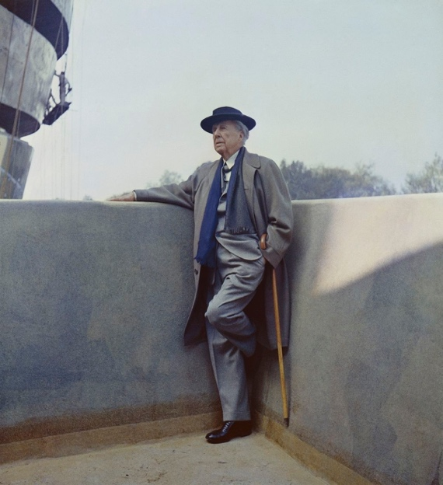
Frank Lloyd Wright at the Guggenheim shortly before his death (Short, W, 1959)

Conclusion
It is easy to appreciate why this building was so controversial at the time. It could be easily argued that it was ahead of its time and that the people of 1940’s and 50’s New York just weren’t ready for this type of architecture. However, as in the case of other now recognised icons of architecture, for example I.M Pei’s pyramid at the Louvre, public opinion quickly changed and New Yorkers appreciated the jewel that Wright had gifted them. In August 1990, the building was designated an official New York Landmark, the youngest building to achieve this.

The building however has its flaws. Hanging paintings on curved walls is difficult. The museums Director Richard Armstrong said, ‘I like the building more, because I don’t really try and fight it any longer’ (Frank Lloyd Wright: The Man Who Built America, 2017, 0:57:30-0:57:37). Perhaps history would tell a different story of his predecessor James Johnson Sweeney had he adopted the same philosophy.

As much as Wright insisted he was creating a building which would enhance the paintings it housed, it leaves you questioning whether he truly believed that. Ultimately, this was to be his last project, one which he never saw completed. Wright knew he was creating a masterpiece and as much as he did make a few compromises along the way, you are left to feel that the building came first, the artwork was arguably just a biproduct that facilitated it.

The influence of Hilla Rebay also needs to be recognised. Rebay was a strong, confident, and passionate woman who was arguably the driving force behind the project. She was also someone who it was well documented that Wright had great respect for. Maybe the greatest tragedy then, is that it is suggested Rebay never visited the completed museum having effectively been removed from her position following the death of Solomon.

Is the museum the artwork? Unquestionably. Does that impact the space and ability to display the collections, no.

Ultimately, Wright undoubtedly created an icon. As much as he was obstructed by the borough of New York, Sweeney et al, he used all his skill and newfound ability to compromise in order to deliver a masterpiece to New York. When Hilla Rebay said to Wright in her initial correspondence, ‘I need a fighter, a lover of space, an originator, a tester, and a wise man’ little would anyone know how right she would be.

Archdaily (2022) Image of the section of the Guggenheim Museum
Available at: https://www.archdaily.com/60392/ad-classics-solomon-r-guggenheim-museum-frank-lloyd-wright
(Accessed 12 February 2022)

Architectural Digest (2019) ‘7 things you didn’t know about New York City’s Guggenheim Museum’
Available at: https://www.architecturaldigest.com/story/you-didnt-know-new-york-city-guggenheim-museum
(Accessed 18 February 2022)

Dal Co, F (2017) The Guggenheim: Frank Lloyd Wright’s Iconoclastic Masterpiece
Yale University Press

Frank Lloyd Wright Foundation (2022) ‘Solomon R. Guggenheim’
Available at: https://franklloydwright.org/site/solomon-r-guggenheim-museum/
(Accessed 7 February 2022)

Frank Lloyd Wright Foundation (2022) Image of the section of the Gordon Strong Building
Available at: https://franklloydwright.org/architecture-in-motion-the-gordon-strong-automobile-objective/
(Accessed 16 February 2022)

Frank Lloyd Wright: The Man Who Built America (2017)
Available at: https://www.youtube.com/watch?v=76F3DJvESKA
(Accessed 5 February 2022)

Guggenheim (2015) How one simple material shaped Frank Lloyd Wright’s Guggenheim
Available at: https://www.guggenheim.org/blogs/checklist/how-one-simple-material-shaped-frank-lloyd-wrights-guggenheim
(Accessed 13 March 2022)

Guggenheim (2014) Shine On: The history and vision behind the Guggenheim’s Iconic Skylight
Available at: https://www.guggenheim.org/blogs/checklist/shine-on-the-history-and-vision-behind-the-guggenheims-iconic-skylight
(Accessed 7 February 2022)

Guggenheim (2003) ‘The Architecture of The Solomon R. Guggenheim Museum’
Available at: https://www.guggenheim.org/wp-content/uploads/2016/10/guggenheim-education-architecture-teacher-resource-final.pdf
(Accessed 13 February 2022)
Heald, D (2022) Image of the Solomon R. Guggenheim Museum
Available at: https://www.chicagoarchitecture.org/2015/02/02/listpix-wright-buildings-could-become-official-world-treasures/flw-22/
(Accessed 13 February 2022)

Frank Lloyd Wright Foundation (2022) Image of the model of the Guggenheim Museum
Available at: https://franklloydwright.org/concerning-the-solomon-r-guggenheim-museum/
(Accessed 13 March 2022)

MoMA (2022) The Museum of Modern Art History
Available at: https://www.moma.org/about/who-we-are/moma-history
(Accessed 24 February 2022)

New York Times (2017) Frank Lloyd Wright at 150: Unpacking the archive
Available at: https://www.nytimes.com/interactive/2017/06/08/arts/frank-lloyd-wright-at-150-moma.html
(Accessed 22 February 2022)

New York Times (1959) ‘Wright vs Painting’
Available at: https://www.nytimes.com/1959/10/21/archives/wright-vs-painting-a-critique-of-guggenheim-museum-finds-design.html
(Accessed 16 February 2022)

Short, W (1959) Frank Lloyd Wright on the balcony of the Guggenheim
Available at: https://www.artsy.net/article/artsy-editorial-7-things-frank-lloyd-wright
(Accessed 8 February 2022)
Smithsonian Magazine (2009) The Triumph of Frank Lloyd Wright
Available at: https://www.smithsonianmag.com/history/the-triumph-of-frank-lloyd-wright-132535844/
(Accessed 21 February 2022)

Spiegel International (2005) The German artist who inspired the museum gets her due in new show
Available at: https://www.spiegel.de/international/spiegel/guggenheim-s-muse-the-german-artist-who-inspired-the-museum-gets-her-due-in-new-show-a-348980.html
(Accessed 11 March 2022)

The Architectural Review (2021) Image of Floor Plan of MoMA
Available at: https://www.architectural-review.com/places/united-states/museum-of-modern-art-extension-new-york-by-diller-scofidio-renfro
(Accessed 18 February 2022)

The Art Story (2022) ‘Biography of Hilla Rebay’
Available at: https://www.theartstory.org/artist/rebay-hilla/life-and-legacy/
(Accessed 8 March 2022)

TIME (1960) Art: Man v Building
Available at: http://content.time.com/time/subscriber/article/0,33009,869683,00.html
(Accessed 15 March 2022)

