Entrepreneurship, Assignment 2
– A report on Entrepreneurship



January 2019

MODULE NAME: entrepreneurship m5x00846
Project Name: business case for ai
Name: grazia martone
Student Number: 1703121

2. Introduction
This report will conduct the background of the world’s largest online retailer ASOS, by mentioning an overview of the background of the entrepreneur and what motivated the individual to start this idea. By looking how far they have come and looking at theories that helped influence to get things started and that there are different aspects with some major factors needing to be considered.
2.1 Definition of Entrepreneurship
“An entrepreneur sees an opportunity which others do not fully recognize, to meet an unsatisfied demand or to radically improve the performance of an existing business. They have unquenchable self-belief that this opportunity can be made real through hard work, commitment and the adaptability to learn the lessons of the market along the way”. (Boutillier and Uzunidis, 2017).
2.2 Biography of Entrepreneur
ASOS first started in June 2000, the name was ‘As Seen on Screen’. Nick Robertson was the founder of ASOS (asos.com,2010) the name then got changed to ASOS in 2003 so that it was shorter. The company idea came from a company called Entertainment Marketing, which was set up by Nick Robertson in 1996 which was funded by large brands to help them with celebrities Nick had the idea from fashion, television and films. Nick looked into episode of ‘Friends’ which is a television programme owned by NBC who received 4000 calls requesting where a lamp which appeared on the tv show could be bought. From that he realised how big of a necessity for an online website ‘As Seen on Screen’. could be good idea. Nick realised this could not be accomplished on his own as he’s an entrepreneur classified as a fashion buyer. He knew he needed the best people working with the business to get things started as he pictured it. ASOS when it first started in 2000 was paid with the help of Nicks older brother Nigel. Nigel gave Nick £1.4 million investment, a small number of Nicks £29 million fortune he had profited from freepages and scoot. (Startups.co.uk: Starting a business advice and business ideas, 2019). Nick had some money to start up ASOS as this wasn’t the first business venture. By starting in an advertising job for Young and Rubicam, this enabled him a good experience to learn ‘negotiating’ as this of primarily his main field of skills of the job at hand. He moved into a planning role with a company called carat in ASDA. When leaving ASDA to start up Entertainment Marketing as stated before, he started this up with a friend and it was funded by his father who has experience in the advertising sector. And then from this he went to start up ASOS, Nick realised there was a niche gap in the market for ASOS’S website to be produced and put out there. The unique selling point was very clear them days ‘selling clothes like those celebrities on television. There was not another company out there doing this through an online retail company. Nick says that he was very lucky because his brother had moved to Monaco with some wealthy friends and had a small fortune. By this point he could give Nick the £1.4 million start-up fee. Nick says that there was not a formal contract made between the brothers, but he was confident that he would make more profit from the £1.4 million that he had lent to him (Asosplc.com, 2019) .Simon and Hitt (2003) make it clear through the social capital theory the importance of entrepreneur’s ability to lure on properties from their social network for persistence and evolution which both Davidson and Honig push forward in stating that Nick had the inspiration and backing from his grandfather, Austin Reed, his brother and his father which was one of the biggest aspect to starting his the business (ASOS,2019). 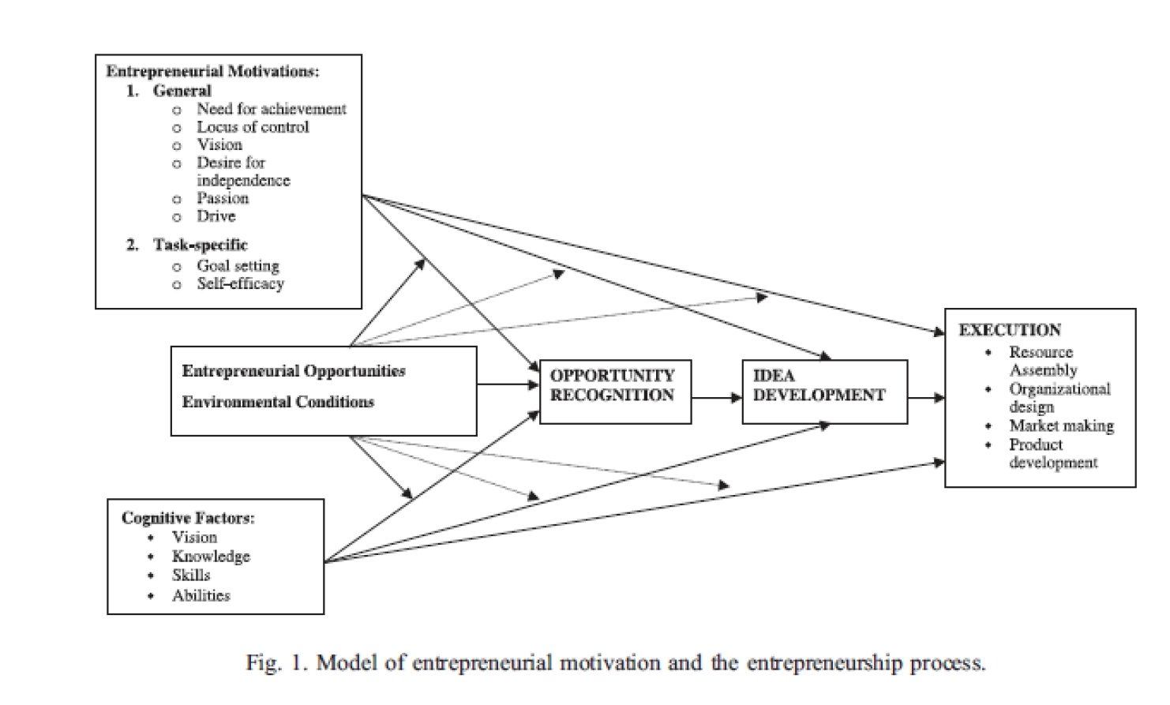 (Shane,et al,2003).
getting the primary motivation to start up a business can come in two different influences pull- an opportunity and push- a necessity, a few of pull influences could be redundancy, unemployment and job insecurity, misfit or early retirement. And push influences are desire for independence, a desire to exploit an opportunity, financial incentive and lifestyle.
3. Motivational theories
Physiological- Harvard phycologist David McClelland was a specialist in human motivation he became a member of the human faculty in 1956 he went on to teach and tail out exploration for 30 years. His research covered more than five years, he pacifically investigated producing an influential body of testing tools, data and academic models of human motivation and achievement. McClelland undertook research into consciousness and looking into personalities, McClelland performed research into personality and consciousness, one of the most important and known theory is the Thematic Apperception Test (TAT), which is a scoring system it was brought out in the 1930’s by psychologists Henry Murray and Christiana Morgan. This test is still in use today by many people for things like mate and occupation selection an individual will look at various scenes which are ambiguous this gives the respondent time to analyse scenes and understand different aspects of the picture.
3.2 Social- Max Webber was a well-known political and sociologist economist of Germany, he started writing in the 20th century have this has prejudiced sociological religious and political thinking until this day, the book ‘the theory of social and economic organisations’ which he wrote and was edited by Parsons (1964) Webber declares that ‘entrepreneurship is a function of religious beliefs and the impact of religion shaped the entrepreneurial culture’ (p.36). he states that ‘entrepreneurship energies are exogenous basically they come from external factors and are encouraged by religious aspects.’ (p.37) Webber says that the increase of capitalism in Europe was because of the protestant theology which is called ‘the spirit of capitalism’ (social structure and personality, 1964) there is a factor urging the making of businesses in his theory is the making of profit which people can be motivated by the scenarios of making a profit from their enterprise (social structure and personality, 1964) His theory planned that capitalism rising from the protestant ethic so it joins with the motive of resulting profit in the making of a number of businesses.
another sociological theory was made by Everett E Hagen his theory looked into social changes. The model he made showed that an entrepreneur’s originality was the most important aspect and looking at economic growth and social transformation.
Cultural-
Hozellitz theory says that the source of entrepreneurship is regulated by cultural factors and ethnically small groups are the influencers of economic and entrepreneurial growth. This can suggest why certain social cultural groups have supported development in small business develop in different countriessome examples are the Jews, Chinese in south Africa and the Indians that are in east Africa. These sectional groups have been at the head of economic growth and development through and enterprise entrepreneurship, (Chetty, 2019). Hosellitz was one of some theorists to face that leadership capabilities as well as managerial abilities in adding to the determination to collect wealth were important to entrepreneurship. His theory is similar with Max Webbers perceptions of the how it drives capitalism. Hozelitz grasps the role of change as an incentive for innovation in his hypotheses of marginal men he says that marginal men are better to make productive modifications in times of economic change this has a general view of entrepreneurship by considering the effect of factors such as culture, social, innovation and any changes. (Chetty, 2019)
3.3 Economic- Richard Cantillon was from France he was a economist. He would pay to the economy and other parts of society in the late 17th century. He wrote books and journals during his lifetime and one in which is necessary was ‘Essai sur la Natur du Commerce en General’’ this looked into the characteristics and position of an entrepreneur. the well-known economist Murray Rothbard states that Cantillon was the first theorist use the word entrepreneur. Cantillon’s resourceful invention says that the entrepreneurs are the experts in solving on their own duties. they hire employees by paying their effort, earlier to finish manufacturing the product and then testing it out in the market first to see whether the supplies would sell or not. It is difficult to ascertain the reaction of the customer to the product and its price of it. On the other hand, a lot of our money can be invested into land and paying money to produce a product that does not even sell or make a profit. The outcome will be losing all investments that was made. Richard Canitillon would class as a risk is impulsiveness of customers behaviours and their responses to any product or service. Cantillon states that individuals who act as a market arbitrager and makes promises for employees to have a set income while dealing with the risks of volatile market price is a risk taker which is an entrepreneur as it is always about making the right move at the time. Cantillon explored that the entrepreneurs should be responsible for all consequences and the improvements for example the entrepreneur should be a risk taker on their business whether it goes successful or not and their needs to be assessed by the customers in a viable market. For employees to be paid and to cover the cost of the land you are renting an entrepreneur needs to earn profits they need to be higher than their expenses. They need to maximise the selling amount and Cantillon says that the entrepreneur balances between demand and supplies in the economy (Mises Institute, 2019).
another theorist Schumpeter investigates innovation he says that it is in the centre aspect of economic development. An entrepreneur is always the motorist of change. Schumpeter says that innovation is creative destruction this is a procedure of trade transformation that continuously transforms economic structure whilst pushing the old one out and constantly making a new one. The idea of imaginative damages is used in methods to look into a situation where a new and improved and more advanced product replaces and pushes out the ancestors for example oil replacing coal. Innovation today has been preserved to be essential to entrepreneurship. Innovation today has grown massively some of the 7 aspects would be the improvement of quality of existing goods, introducing new goods a faster, new, cheaper and more effective method of production and discovering new ways to get raw materials or an invention of a new market idea. Schumpeter stated and believed that larger organisations were the main cause of entrepreneurship as they had more access to resources and money to conduct in development and research. He later went on to say that even small businesses were involved in entrepreneurship as the size can allow flexibility and agility. the statement was controversial as he said that larger and smaller businesses are in a good position to innovate. This made out that the size does not moderate innovation capability. Schumpeter declare that innovation was the main influencer to entrepreneurship. This can be seen as criticising as it states innovation is a crucial quality of an entrepreneur whilst weakening the role of technical skills or risk taking and companies capabilities as they issue for entrepreneurship. (Śledzik, 2019).
4. conclusion
in conclusion to this report all theories have a slight input into the industry I intended to look at, the most relevant theory which I think applies would be Schumpeter’s theory as it covered all topics as ASOS is an online fashion retailer by looking at the points innovation is most effective for this entrepreneur.

References
ASOS. (2019). About Us | ASOS. [online] Available at: https://www.asos.com/about/who-we-are/ [Accessed 7 Jan. 2019].
Asosplc.com. (2019). [online] Available at: https://www.asosplc.com/~/media/Files/A/Asos-V2/reports-and-presentations/26-10-2018-ar-v2.PDF [Accessed 12 Jan. 2019].
Boutillier, S. and Uzunidis, D. (2017). Entrepreneur. London, UK: ISTE, Ltd.
Chetty, P. (2019). Cultural theories of entrepreneurship. [online] Knowledge Tank. Available at: https://www.projectguru.in/publications/cultural-theories-of-entrepreneurship/ [Accessed 13 Jan. 2019].
Econlib. (2019). Joseph Alois Schumpeter - Econlib. [online] Available at: https://www.econlib.org/library/Enc/bios/Schumpeter.html [Accessed 11 Jan. 2019].
Ireland, R., Hitt, M. and Sirmon, D. (2019). A Model of Strategic Entrepreneurship: The Construct and its Dimensions. [online] Papers.ssrn.com. Available at: https://papers.ssrn.com/sol3/papers.cfm?abstract_id=1342534 [Accessed 13 Jan. 2019].
Mises Institute. (2019). Richard Cantillon: The Founding Father of Modern Economics | Murray N. Rothbard. [online] Available at: https://mises.org/library/richard-cantillon-founding-father-modern-economics [Accessed 11 Jan. 2019].
Psychology.fas.harvard.edu. (2019). David McClelland. [online] Available at: https://psychology.fas.harvard.edu/people/david-mcclelland [Accessed 11 Jan. 2019].
Śledzik, K. (2019). Schumpeter’s View on Innovation and Entrepreneurship. [online] Academia.edu. Available at: http://www.academia.edu/5396861/SCHUMPETER_S_VIEW_ON_INNOVATION_AND_ENTREPRENEURSHIP [Accessed 10 Jan. 2019].
social structure and personality. (1964). Free press of glencoe (1964).
Startups.co.uk: Starting a business advice and business ideas. (2019). Nick Robertson: ASOS - Startups.co.uk: Starting a business advice and business ideas. [online] Available at: https://startups.co.uk/nick-robertson-asos/ [Accessed 11 Jan. 2019].
WiseStep. (2019). Projective Tests: Theory, Types, Advantages & Disadvantages - WiseStep. [online] Available at: https://content.wisestep.com/projective-tests-theory-types-advantages-disadvantages/ [Accessed 11 Jan. 2019].

