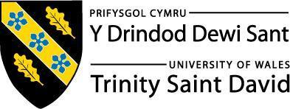
Applied Leadership and Management Outreach
Module Assignment Submission

Student Name: | Samantha Paton
Student Number: | 2318459
Module No: | BMSK5014
Module Title: | Project Management

Statement of Confirmation of Authenticity
By the act of making this submission, the student declares that this is the work of the student named above. The work has not, in whole or in part, been knowingly presented elsewhere for assessment, or where assessment has been built on a previous assessment, this has been identified. Where materials have been used from other sources it has been properly acknowledged. If this statement is untrue, the student acknowledges that an assessment offence has been committed.
Attention is drawn to the plagiarism and unfair practice policies of UWTSD.

Table of Contents
Introduction 3
Project Management Methodologies - Waterfall - Iterative - V-Model 3
Key Performance Indicators (KPIs) 5
Costs and Benefits of the Project 11
Workbreakdown structure and project management tools 12
Assess appropriate communication and monitoring and review techniques to ensure successful implementation of the project 15
Risk assessment 16
Project closure 18
Personal development and Reflection 18
References 20

Introduction

This assignment will focus on the elements of project management in the workplace.A project is typically defined as a temporary, goal oriented set of tasks designed to deliver a specific outcome. Wysocki (2029) describes a project as a sequence of unique, complex, and connected activities with a clear objective, constrained by time, cost, and quality requirements. Similarly, Axelos (2020) defines a project as a temporary organisation created to deliver one or more business products according to an agreed business case. While both definitions agree that projects are time limited and focused on achieving defined outcomes, Wysocki places greater emphasis on the complexity and structure of the task sequence, whereas Axelos highlights the organisational and strategic purpose behind a project. Together, these viewpoints provide a comprehensive understanding of what a project entails, both in terms of execution and its contribution to wider business goals.

Project Management Methodologies - Waterfall - Iterative - V-Model
When it comes to managing projects, especially in areas like software development or structured service delivery three common models often come up. The Waterfall model, the V-Model, and the Iterative model. Each of these has its strengths and weaknesses, and their suitability depends on the nature of the project, how well the requirements are known, and how flexible the process needs to be.
The Waterfall model is probably the most well known and traditional approach. It works in a straight line, moving from one phase to the next, starting with gathering requirements, then moving through design, development, testing, and finally, deployment. It’s clear, organised, and easy to follow, which makes it great for projects that have very clear and fixed goals from the beginning like construction projects. The downside is it is quite rigid. Once a phase is complete, going back to make changes is difficult and costly. If anything changes in the middle of the project it can throw the whole timeline off. Sommerville (2016) highlights that while the Waterfall model is efficient when everything is well understood from the start, it doesn’t adapt very well to change.
The V-Model is quite similar to Waterfall in structure but brings a strong focus on testing at every stage. For every development phase, there’s a corresponding testing phase, so design decisions are directly linked to how the system will be validated later. This makes the V-Model particularly valuable in safety critical industries like healthcare,or automotive where rigorous validation is a must. One of its main benefits is how it encourages early detection of problems through well planned testing. However, like Waterfall, it’s not very flexible if requirements change in the middle of a project. Pressman (2014) points out that the V-Model is highly suited to environments where documentation, traceability, and compliance are important. However it can feel heavy and formal in more creative or fast moving settings.
The Iterative model takes a very different approach. Rather than trying to get everything perfect in one go, the project is broken down into smaller parts, or iterations, and each one goes through its own mini cycle of planning, design, development, and testing. Feedback is gathered early and improvements are made as the project progresses. This makes it ideal for projects where not everything is known at the beginning, or where the needs are expected to evolve, like developing a new app, starting a wellness platform, or launching a course that might change based on student input. It’s flexible and collaborative, which reduces risk and keeps the project user focused. However, without good planning, it can lead to scope creep or a lack of clarity over the final deliverable. The Iterative model supports adaptive planning and early value delivery, which is why it’s often used in agile and creative project environments. Boehm (1988).
Each model has a place depending on the kind of project you’re working on. The Waterfall model suits projects that are predictable and tightly controlled. The V-Model adds a testing focused structure that works well for high risk or regulated work. Meanwhile, the Iterative model brings flexibility and responsiveness, which is essential when user input and evolving requirements are key. Choosing the right one means thinking about how much is known up front, how likely things are to change, and how important early testing or rapid feedback might be.
Will use the iterative approach as this project could evolve and change along the way.
Agile management is a flexible, iterative approach to project management that focuses on adaptability, communication, collaboration, and continuous improvement rather than rigid long term planning Agile Manifesto (2001). Its origins are in software, but is now widely applied in education and healthcare.
Agile Tools/Techniques
. Kanban boards - visualise workflow, track tasks, and manage workload.
. Scrum - uses sprints and regular meetings to keep progress transparent.
. Retrospectives - reviews after each phase to improve next steps.
Agile in a Wellness Massage Teaching Project
In the teaching project, using Agile means:
. Breaking the project into small deliverables for example - curriculum design - trial workshop - feedback - refinement - final delivery.
. Using a Kanban board to manage tasks - venue, materials, health & safety checks, marketing.
. Building in feedback loops from learners after each module to improve the teaching style and course content.
. Allowing the schedule to adapt if, for example, more time is needed on health and safety or practical demonstrations.
. Agile will help the massage teaching project remain flexible, learner-focused, and continuously improving.

Business case
To utilise an existing Level 3 Education & Training qualification to deliver holistic massage training within an established wellness studio, generating additional income and expanding the business offering.
The project lead has already achieved a teaching qualification but delayed launching due to confidence barriers and competing demands. With strong client interest and underused studio space, now is the ideal time to launch a manageable, part time course that builds personal confidence while generating income. This project will serve as a pilot to develop a long term training program under the studio’s brand.
In managing the teaching of wellness massage, the iron triangle framework highlights how health and safety requirements interact with the project’s time, cost, and quality constraints Atkinson (1999). For example, allocating sufficient time for safety inductions and risk assessments may extend the training schedule, while investing in high quality equipment and safe facilities impacts the project budget. However, these factors directly enhance the overall quality and credibility of the program, ensuring compliance with professional standards and safeguarding both learners and clients.
Beckmann (2005) emphasises that health and safety underpins all complementary therapy practice, with issues such as risk assessment, infection control, and safe working environments forming the foundation of professional standards. In the context of project management, this aligns with the iron triangle model, which highlights the interrelationship between time, cost, and quality in delivering successful outcomes. Together, these perspectives show that embedding health and safety is both a regulatory requirement and a strategic decision that strengthens project delivery.

Key Performance Indicators (KPIs)

KPI | Target
Launch date met | Within 1 month
Course enrolments | 16 students
Revenue generated | £5,760
Student satisfaction | 4.7/5 average
Personal confidence rating | 50% improvement post-launch (self-rated)
Curriculum successfully delivered | 100%
Course completion rate | 90%+

Dendron Diagram – Overview
The use of a Dendron diagram visually maps the structure and key phases of the teaching project:
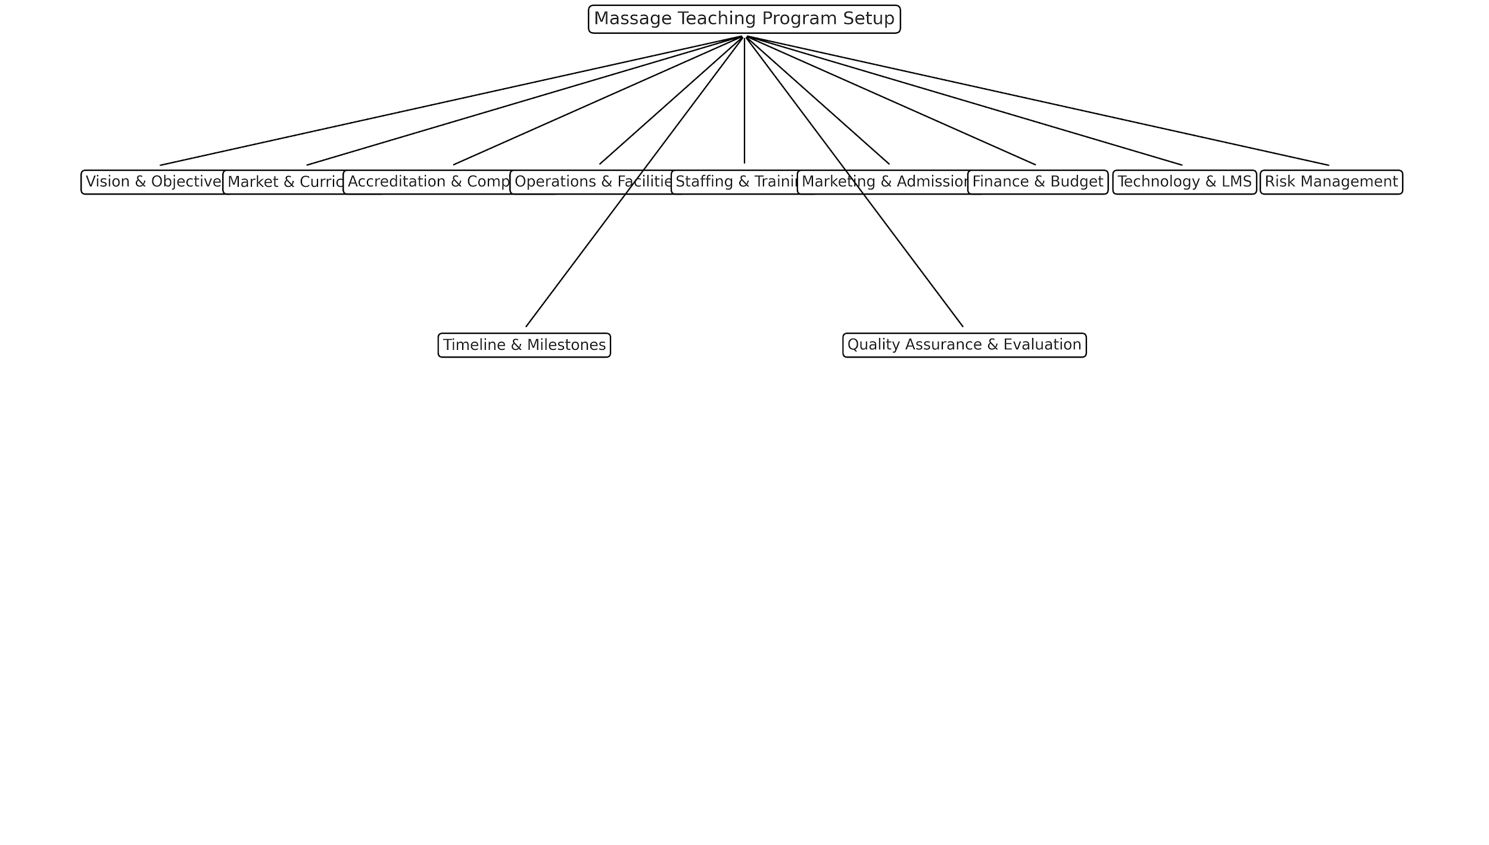
This structure ensures a phased, manageable project that supports confidence building and professional delivery.

Before launching a new service, it is essential to understand the external environment that could influence the project’s success. One method for doing this is the PESTLE analysis, which examines six key external factors: Political, Economic, Social, Technological, Legal, and Environmental. By analysing these areas, it is possible to better anticipate risks and opportunities that may affect the project of the wellness teaching. This is especially important in the wellness and adult education sectors, where regulations, economic conditions, and changing social attitudes can directly impact course delivery, enrollment, and long term sustainability. Conducting a PESTLE analysis ensures that the planning of the project is informed, proactive, and responsive to the wider environment in which the business operates Rastogi & Trivedi (2016).
PESTLE Analysis - Launching a Wellness Teaching Project

Factor | How it Applies to the Project
Political | Local regulations around teaching qualifications, adult education, and health and safety may affect how the course is delivered. Public funding or incentives may shift.
Economic | Rising printing and material costs could increase setup expenses. Economic uncertainty may affect potential students’ willingness to invest in training.
Social | There is increased public interest in holistic health and flexible careers, creating a strong market for training. However, delays risk damaging professional trust.
Technological | Tools like online learning platforms and digital booking systems can expand access and improve course delivery. Lack of digital readiness could limit reach.
Legal | Compliance with health and safety, GDPR, insurance, and teaching liability regulations is essential. Non compliance could delay or block course delivery.
Environmental | There is a growing preference for sustainable materials and eco friendly business practices. Offering digital manuals or eco-printed materials supports this trend.

Swot analysis
To support strategic planning for the launch of the wellness teaching project, SWOT analysis was used to evaluate the internal strengths and weaknesses of my business, as well as the external opportunities and threats in the current market. This tool helped identify key factors such as qualifications, reputation, and existing client base as strengths, while also acknowledging weaknesses like limited time and inexperience in teaching delivery. Externally, opportunities such as growing demand for wellness education and potential for online learning were balanced against threats like rising costs and competitor activity. Conducting a SWOT analysis allowed me to make informed decisions about how to position and structure the teaching offer effectively Weihrich (1982).
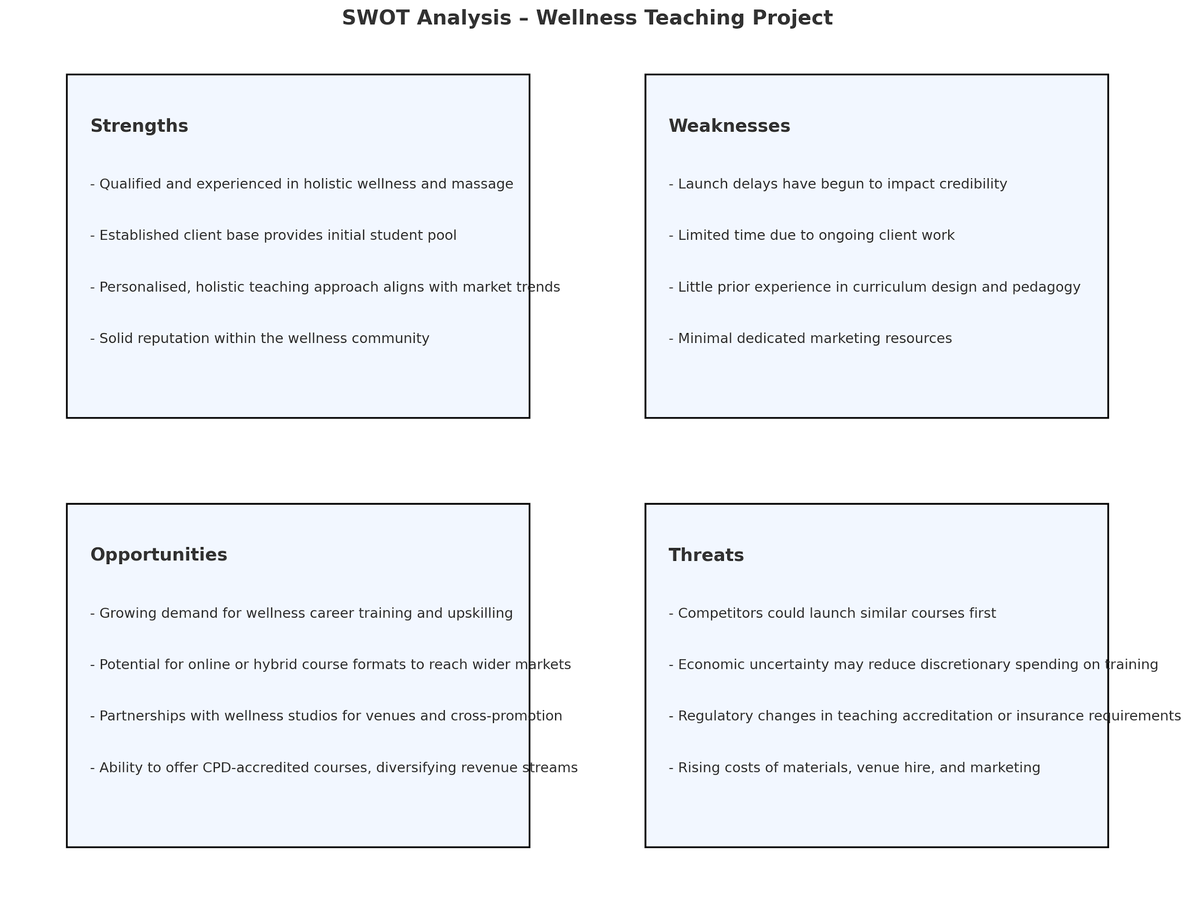

Despite completing my teaching qualification six months ago, I have not yet progressed to delivering courses. The 5 Whys analysis tool has helped to identify the root cause of this delay. Initially, I recognised that I had not launched the teaching element of my business because the teaching materials and manuals had not been completed. Upon further reflection, this was due to a lack of dedicated time for content development, as client treatments continued to take priority. This situation arose because I had not created a clear project plan or timeline, nor had I fully appreciated the time and focus required to develop structured course content. The underlying issue became evident, I had underestimated the complexity of transitioning into teaching and lacked a project management framework to support the shift. As a result the continued postponement is beginning to affect my professional image. This highlights the urgent need to put in place formal planning tools, such as a Gantt chart and Kanban board, to manage and deliver the teaching project effectively and restore both business momentum and credibility.
To better understand the delay in launching the teaching aspect of my wellness business, I applied the 5 Whys technique, to get to the root cause. This method involves asking “why” five times, to explore the root cause of a problem rather than just addressing its symptoms. In this case, the initial issue was not progressing with course delivery despite gaining my teaching qualification six months ago. Through the 5 Whys process, it became clear that the root cause was a lack of structured planning and prioritisation, which led to delays in creating course materials. This, in turn, has resulted in lost income and a growing risk to professional credibility, as potential students remain waiting. The exercise demonstrated the importance of formal project planning tools and revealed how neglecting internal project deadlines can affect long-term business growth Liker (2004).
To ensure effective delivery of teaching, it is essential to consider the range of learning styles students may have. Different learners absorb and retain information in varied ways, and adapting to these preferences supports better engagement and outcomes. Visual learners benefit from diagrams and colour coded resources. Auditory learners respond to verbal instruction and discussion. Reading/writing learners prefer written content like manuals and slides. Kinesthetic learners gain most from hands-on practice. Understanding these differences allows me to tailor teaching materials and delivery style, ensuring inclusive and effective training for all learners.
Myself and a work colleague used the brainstorming model Proctor (2005) to find a range of creative ideas and solutions to different learning styles. Collaboration with mentors and wellness therapists when exploring the project can only enhance the project and create better solutions.
Below is the mind map diagram we produced from myself and my colleagues brainstorming sessions to explore different teaching styles.
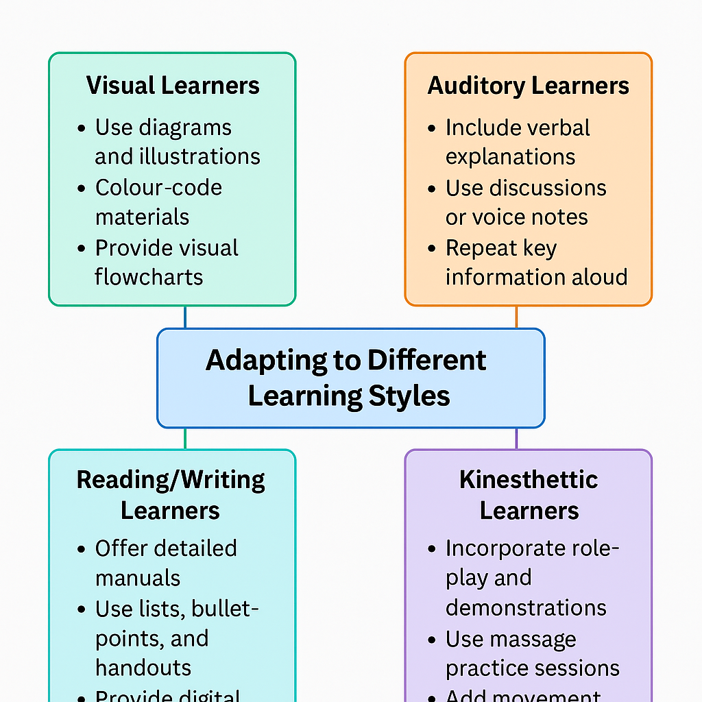

Costs and Benefits of the Project
Setting up a massage teaching program in a wellness studio does come with upfront costs, both financial and time related. There would be expenses for developing the course materials, getting the program accredited, marketing the course, and setting up a suitable teaching space. It might also mean pulling staff or resources away from existing services during the setup phase. However, the long term benefits really outweigh those initial investments. For one, it opens up a whole new income stream for the business and helps attract a wider audience, not just clients, but potential students who may later become loyal clients or even team members. It also builds the studio’s reputation as a professional training hub, which can boost credibility and visibility in the wellness industry. On top of that, offering educational programs supports growth for both the business and the wider community. So while it may take time and money to get off the ground, the project has strong potential to pay off in the long run Kotler et al (2016).

Workbreakdown structure and project management tools

A Work Breakdown Structure is a tool used in project management that breaks down a project into smaller, manageable parts based around the dependencies of the project. WBS is organised into different levels:
Level 1 This is the main project goal or title.
Level 2 This includes major components or phases of the project that help achieve the main goal.
Level 3 These levels break down the major components into detailed work groups.
Each level provides more detail, helping project teams see how all parts of the project fit together. Using levels in a WBS makes it easier to plan, schedule, and allocate resources for the project Raeburn (2025).
The Critical Path Method is a project management technique used to determine the longest sequence of tasks in a project that must be completed on time for the entire project to be finished. Understanding the critical path helps project managers identify which tasks are essential and cannot be delayed without affecting the overall project completion date.
Key points about the Critical Path include:
Sequence of Activities - the critical path consists of tasks that are dependent on each other, meaning the completion of one task must happen before the next can begin.
Duration - the overall duration of the project is determined by the longest path through these critical tasks.
Slack Time - tasks not on the critical path have slack time, allowing for some flexibility without delaying the project's completion.
Using the critical path helps project managers prioritise tasks, allocate resources more effectively, and maintain project timelines.

As part of the expansion of my wellness business, I am now moving into the teaching space, having already completed the necessary training to become a qualified instructor. The next step is to develop comprehensive teaching manuals and supporting materials to deliver professional, structured courses to students. To ensure this transition is effective, I have created a project that will span one month and will focus on producing, finalising, and preparing these materials for teaching. This includes planning content, designing and printing manuals, organising a preteach practice session, and preparing all logistical and educational resources needed to begin the project.
The project will be managed using a Gantt chart to map out each phase, track progress, and ensure completion within the set timeframe.
Below is a gantt chart with the relevant steps from start to finish including monitoring afterwards how the project is going. The Gantt chart spans the one month project to launch the wellness teaching materials. Each task is laid out with its planned start and end date to help manage time effectively.

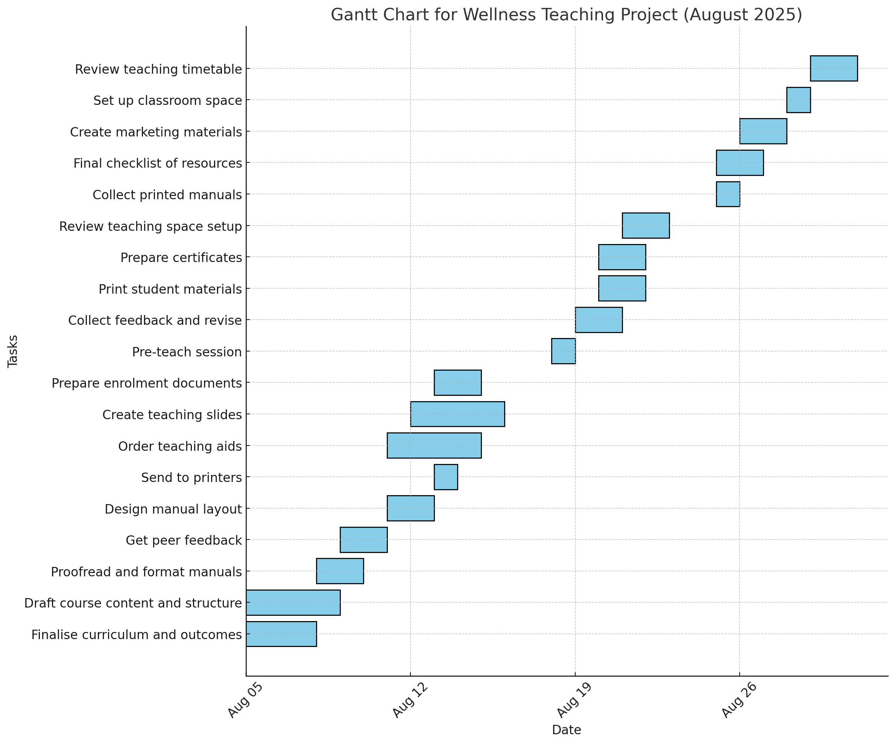

From the gantt chart I can visually see that I should have put a greater emphasis on health and safety issues and planning. By doing this we could have ironed out any issues that may have arisen. Planning correctly is crucial when putting a project into plan. ScienceDirect (2018).

Kanban
A Kanban diagram or board is a visual tool used to enhance projects by improving workflow management to help stay organized throughout the month-long process of creating the wellness teaching manuals. Kanban is a visual workflow tool that categorises tasks into columns like To Do, In Progress, and Done, making it easy to monitor task status and workflow efficiency Axelos (2020). This approach supports better task prioritisation, reduces overwhelm by limiting the number of concurrent tasks, and promotes individual accountability. Kanban also complements a Gantt chart, which visually maps the project timeline, start and end dates, and dependencies between tasks Wysocki (2029). While the Gantt chart provides a structured overview of deadlines and scheduling, the Kanban board supports real time task management and encourages continuous improvement by revealing problems and process inefficiencies Burton (2021). Together, these tools provide both strategic and practical insight into project planning and execution, enhancing the overall success of the teaching project.

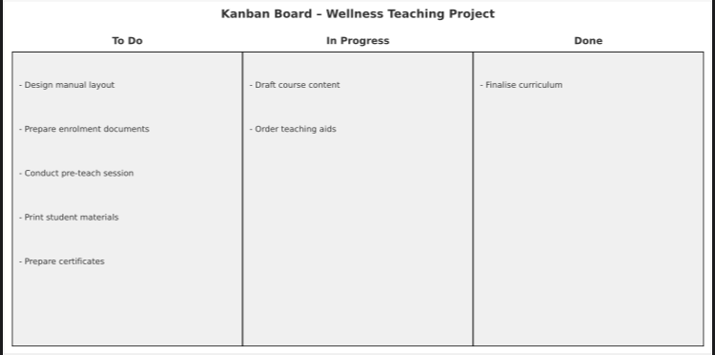

Assess appropriate communication and monitoring and review techniques to ensure successful implementation of the project
By using the Influence Interest Matrix, Mitchell et al. (1997), we can prioritise the stakeholders engagement needs and how often we will keep them updated on the progress of the project. Some stakeholders will be regularly updated, others will be informed from time to time depending on their level of interests. Effective communication will be key to ensuring the success of this project. Stakeholders include internal staff such as admin or studio assistants, potential students, and trusted external suppliers such as the printer. A combination of verbal briefings, shared digital tools, and visual project timelines to keep everyone informed. Daily and Weekly checkins will ensure progress stays on track. Updates will be shared through emails and in-person studio meetings. Regular updates on milestones, such as when manuals are drafted, sent to the printer, or ready for student use, will help maintain transparency and team accountability.
Since I will be the sole course tutor, delegation is essential to stay focused on teaching content and delivery. A trusted studio colleague will be assigned to coordinate with the printing supplier, ensuring that draft materials are delivered, picked up, and returned on time. They will also manage scheduling with the printer and handle basic errands. I will maintain control over content creation and quality by proofreading and approving all teaching manuals before printing. A shared project folder will track progress, and tasks will be assigned via a Kanban board, which all involved parties can access and update as needed.

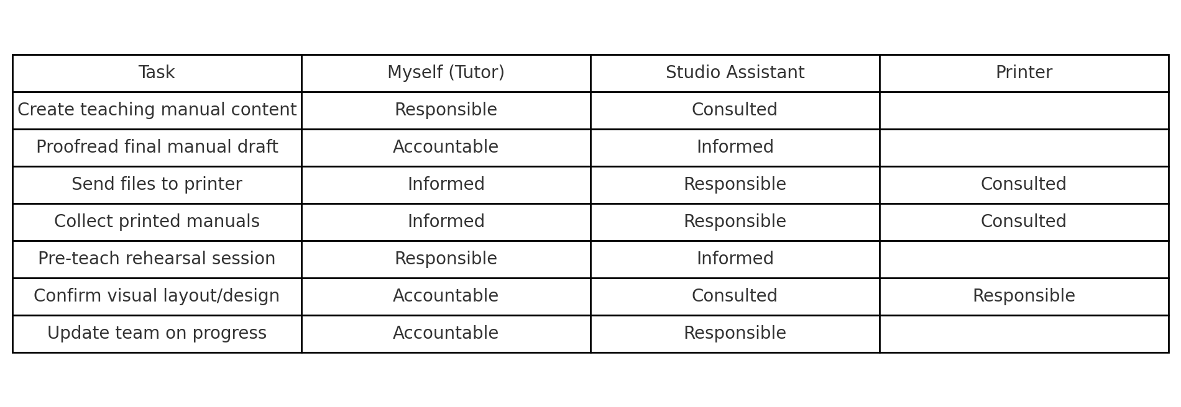
By monitoring the project effectively using a RACI table ,we can ensure the project stays on track.

Risk assessment
Risk assessment is an essential part of managing a massage teaching program to ensure the safety of students, staff, and clients, as well as the smooth running of the business. Risks should be assessed at the beginning of the project and then revisited regularly, especially whenever changes are introduced, such as new teaching spaces, equipment, or class structures. Each time a significant change occurs, the risks should be reviewed and updated to ensure that all health, safety, and business factors remain under control. Any updates to the risk assessment should be clearly communicated to all relevant parties. This includes instructors, students, support staff, and venue management, so that everyone is kept safe and informed. A log of changes should also be maintained, and any new safety measures should be explained during class introductions or staff briefings.
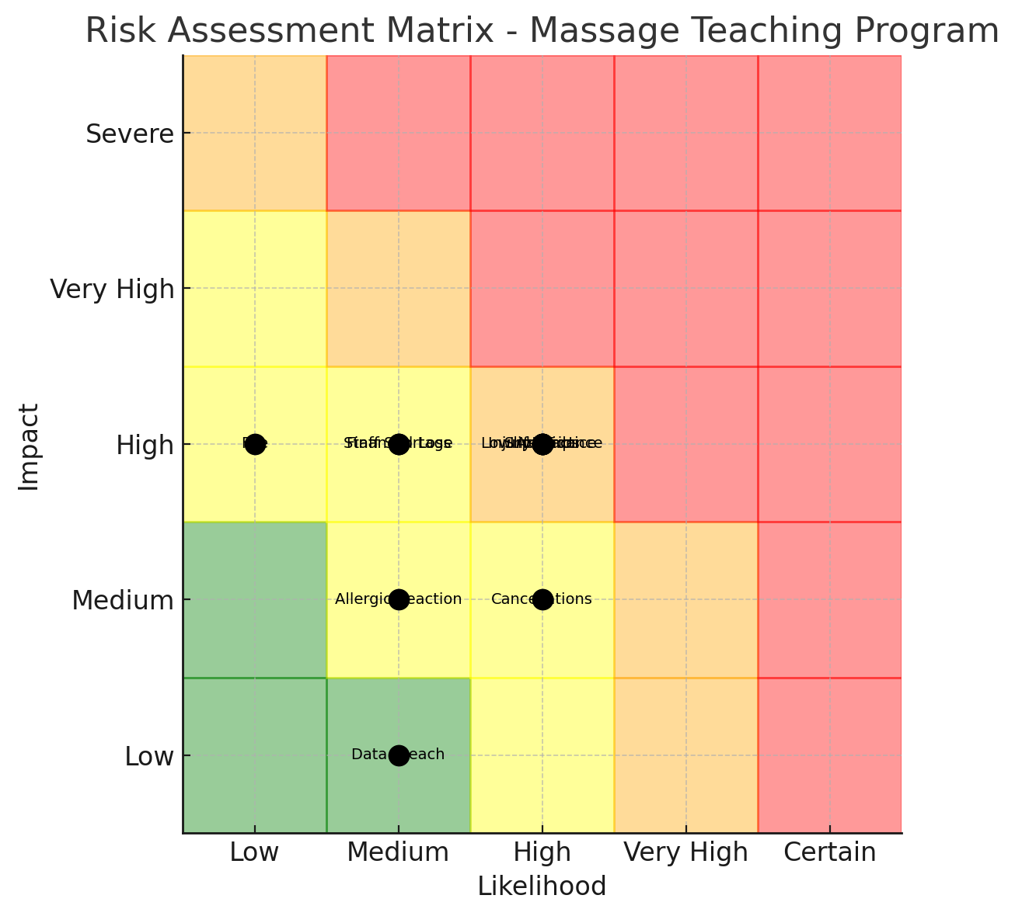

Effective project planning must consider risks that could delay or affect delivery. For this project, risks include delays in content creation, printing errors, low student engagement, and quality control of visuals. A common project management strategy is to assess each risk’s impact, then design a new plan to reduce disruption PMI, (2017). For example, by scheduling extra time for printing and personally proofreading all manuals before final submission, it is possible to mitigate risks related to timing and quality. Sharing non teaching tasks also helps reduce overload while maintaining control of essential decisions.
A small but focused budget has been allocated to ensure the production of high-quality teaching materials. This includes costs for manual printing, one month of design tools such as Canva Pro, and visuals or stock imagery. A rehearsal session, and marketing materials for both print and digital learning styles will also need to be cost. Cost planning supports transparency and ensures the project is financially viable from the start Meredith et al (2017).

Project closure
To effectively close the launch of this part of the teaching project, we need to evaluate whether the initial objectives of the project were met. This can be done through feedback from students and stakeholders. It is then possible to analyse the outcomes and document key learnings to identify successes and areas for improvement. Celebrating achievements, through certificates or a presentation showcasing the project's results can be shared in social platforms for advertisement purposes and personal achievements.
We can then prepare a final report summarising findings and recommendations, and share it with all involved. In the wellness space we encourage reflective practices among team members, this will encourage a culture of continuous improvement and growth. Finally, all administrative tasks should be completed, including finalising budgets and resources. By doing this it will ensure success for the teaching project going forward.

Personal development and Reflection
In planning the wellness teaching project, Covey’s (1989) principle of prioritising important but non urgent tasks was applied. According to The 7 Habits of Highly Effective People, effective individuals focus their time on activities that are important for future success but not immediately urgent. These include planning, preparation, and relationship building. Covey argues that without deliberately scheduling time for such tasks, people often become reactive, overwhelmed by urgent but less meaningful activities. By proactively blocking time to develop manuals, organise preteaching sessions, and structure the course, I ensured the project progressed without being overshadowed by day to day client demands as this along with self doubt is what caused delay in the previous project.
The setup of the massage teaching program required clear planning, coordination, and structured project management tools. By incorporating a Dendron diagram, Gantt chart, and risk assessment, the project finally gained clarity, control, and flexibility throughout its launch. These tools allow the project team to break down bigger tasks, manage time efficiently, and to address potential risks. Ultimately applying this structure ensures quality education delivery for future massage therapy students.
Reflecting on this project, I recognise that although I have experience in business and many years in the wellness and massage sector, this is my first step into the world of teaching. While this transition presents new challenges, I have leaned on my existing strengths to complete this project such as being a trusted wellness therapist, task delegation, and industry knowledge. I have built a solid support system, including reliable printers and access to a mentor if guidance is required. I also recognise that trial runs and feedback is essential to refining the teaching skills. This project represents both a personal and professional milestone, and I am now confident that with careful management, it will lay the foundation for a successful teaching career. As Kolb (1984) highlights in his experiential learning theory, reflecting on new experiences is essential to personal development, helping turn practice into knowledge.
From completing and launching this teaching program using relevant project methods the brand had a successful first teaching lesson and we look forward to many more.

References
. Agile Alliance. (2001) Manifesto for agile softw\re development. https://.agilemanifesto.org/.
. Atkinson, R. (1999). Project management: Cost, time and quality, two best guesses and a phenomenon, it’s time to accept other success criteria. International Journal of Project Management, 17(6), 337–342. https://doi.org/10.1016/S0263-7863(98)00069-6
. Axelos. (2020). Managing successful projects with PRINCE2 (6th ed.). The Stationery Office.
. Beckmann, E. (2005). The essential guide to holistic and complementary therapy. Cheltenham: Nelson Thornes.
. Boehm, B. (1988). A Spiral Model of Software Development and Enhancement. ACM SIGSOFT.
. Burton, D. (2021). Kanban for project management: A practical guide. Project Flow Press.
. Covey, Steven, R. (1989). The & Habits Of Highly Effective People. Simon & Schuster UK Ltd.
. Kolb, D. A. (1984). Experiential learning: Experience as the source of learning and development. Prentice Hall.
. Kotler, P., & Keller, K. L. (2016). Marketing Management (15th ed.). Pearson Education.
. Lipker, J. K. (2004). The Toyota Way: 14 management principles from the world’s greatest manufacturer. McGraw-Hill.
. Meredith, J. R., & Mantel, S. J. (2017). Project management: A managerial approach (9th ed.). Wiley.
. Pressman, R. S. (2014). Software Engineering: A Practitioner’s Approach (8th ed.). McGraw-Hill.
. Project Management Institute. (2017). A guide to the project management body of knowledge (PMBOK® guide) (6th ed.).
. Rastogi, N., & Trivedi, M. (2016). PESTLE technique–a tool to identify external risks in construction projects. International Research Journal of Engineering and Technology (IRJET).
. Weihrich, H. (1982). The TOWS matrix: A tool for situational analysis. Long Range Planning, 15(2), 54-66. https://doi.org/10.1016/0024-6301(82)90173-4
. Wysocki, R. K. (2029). Effective project management: Traditional, agile, extreme (9th ed.). Wiley.
. MindTools, (2024). Decision Matrix Analysis. Mindtools.com. Accessed from Google August 17th 2024.
. Mitchel, R.K., Agle, B. R., and Wood, D.J., (1997). ‘Toward a Theory of Stakeholder Identification and Salience: Defining the Principle of Who and What Really Counts.’ Academy of ManagementReview 22(4)
. Proctor, T. (2005). essentials of Marketing Research., 4th edition, financial Times/Prentice Hall
. ScienceDirect (2018). Gantt Chart. sciencedirect.com. Accessed from Google August 27 2024.
. Sommerville, I. (2016). Software Engineering (10th ed.). Pearson.

