Module code and name: BMIH6008
Placement Project
Student name: Delia Sandra Isaic
Student id number: 2119909
Lecture’s name: Christopher Wilkin

Investigate the impact of poor hiring practice on service quality and customer satisfaction: a case study of Hilton Cambridge city centre

Introduction
This research will see what the main problem is identified in the Hilton Hotel Cambridge, also boasting about the reviews of the clients. How important it is to have employees with good experience and a barriers language. Being a four-star hotel, it is not only important to have facilities such as room service, spa, pool in the hotel, but also professionalism to achieve customer satisfaction. Also go on to analyse how professional employees feel with employees with little experience. And whether this is good or not for the company and how they behave and what consequent are there on the employees but also on the company. But it will also explain what Hilton is and where it is located. The analyse of price quality and SWOT analysis by basing on what the customers say in base to their reviews by choosing 5 negative reviews and 5 positive reviews. And to see where the real problem is at Hilton and why so many turnovers and why employees don't stay in hotels for long. And how important is the professionalism of the employees for a hotel, but also how important it is that the hotel is renovated as soon as possible, especially because prices have gone up, but the quality of services and products have not. And also see how important the education of each employee is to achieve a high quality of a hotel. Used of only secondary data and case study based on searches of various sites such as library but also like google, not used artificial intelligence in any way. In the case study, the entire research process, from data collection to data analysis, is often driven by hypotheses and in some cases by a more general theory that links them. Alongside the hypotheses that guide the study, alternative hypotheses are defined. The framework of hypotheses will adapt to the empirical evidence collected. The hypotheses will be confirmed and based on this they can be changed or eliminated, and others can be added, taking them in the set of alternative hypotheses or devising new ones based on what emerged from the books read. A multiple case study will be used to compare multiple employees and clients and their opinions, and not to predict a priori statistical generalizations for the results that will be produced.
Literature Review
When choosing a perfect candidate for the job, choices are made through the candidate's CV where is chosen on the basis of the work experience, the professionalism, the experience that they have in the world of industry, the flexibility and skill they have but also a basic level of elegance. After all this, a day is set for the introduction and then if everything goes well it is lowered to the bureaucratic part (Ritu,2023) states that hiring an employee is a possibility that every company evaluates over time, and especially in periods when the trend is positive. In these conditions, in fact, the employer is more inclined to invest in new resources. However, there are precise legal rules to consider, first and foremost those on the contracts that can be stipulated. Following every single step correctly is essential in order not to risk legal consequences, to ensure compliance with all contractual clauses and to be sure not to see the possibility of enjoying hiring incentives evaporate. As you well know, the important thing that a candidate must have been to offer to be able to be professional enough to be able to give the customers an unforgettable experience (Lochner et al. 2021). How important is the guest experience in the hospitality industry? In a word, a lot. Those who manage a hotel or accommodation facility know that satisfying guests is essential to build a relationship of trust and increase the likelihood of future stays, but also to receive positive reviews and increasingly improve their reputation on and offline (Deters, 2022).Guest experience refers to the set of experiences that the guest lives from the moment meets the accommodation facility until the moment of check-out. Expectations play an essential role in the formation of the guest experience, as guests are inevitably led to compare the reality of the hotel with what they imagined before departure ( Benjamin,2020).The guest experience therefore must do both with the structure itself, its rooms, its services and its staff, but also with the phase that precedes arrival, which includes the moment of booking, any communications with the reception, the guest experience on the hotel website or on the booking channel, etc (Ritu,2023). For this reason, you must have employees with a beautiful professional and communicative structure. And it is at this point that the employee tries to have Perfect candidates for their job (Undurraga,2019). Based on the professionalism and experience of a candidate, a unique experience is obtained from the clients from which the quality and price of the service is derived. The professional figures in the tourism sector are of different kinds, which is why it is also essential to know them (Shubeck et al, 2020). Before evaluating any area to apply for an internship, it is necessary to know what the possible roles are to be filled. These professionals are fundamental in the tourism sector. They are because the tourist needs to be guided by the employees if need. It is a professional sector that is constantly changing and evolving. This depends on the needs of each individual traveller that change over the years (El,2023). There is no shortage of opportunities to be hired. Experience is fundamental, but this can also be done on the field (Reynolds,2022). The existing activities in UK – as well as abroad – know the difficulties of those who are beginners (Lo,2023). For this reason, ad hoc training courses are also created for future employees. Nothing is left to chance (Tolbert,2020). Tourism and hospitality operators are indispensable and there are never enough. In any case, to be complete, training will also have to be based on new communication tools (Li,2021). Looking at some hotels in the industry, it can be observed that each of them tries to have better candidates for their profession but unfortunately there are not enough people who could work in the industry for the simple facts of money or because they want to work in another field rather than in the hospital industry (Wagner,2019). Also, because the hospitality industry It is a demanding experience, which involves you for the whole day. But it helps to understand what customers want. An enriching experience, given that you often have to deal with tourists from abroad. And it is for this reason that having a vast knowledge of several languages can be an extra to be able to better learn the job (Østerud,2024). As a main example, we will use the Cambridge Hilton where they try to pass each step listed above in order to have the best candidate. But unfortunately, the level of candidates in the world of hospitality is not a large one so it makes it difficult for the Hilton Hotel to have workers with experience in a professional way but also with a broad language, many of the time they tend to hire people who have problems with language barriers but who often know how to do their job less well. From what can be observed from the reviews of some customers, this type of problem makes the trend of the professionalism of the Hotel suffer. In the appendix in figures 1 to 7 it is possible to observe the opinions that the various customers have on the employees of the Hotel (For the stay,2024). In the above, each of them tries to have satisfactory candidates for their industries with a lot of experience, with certain firms, with a lot of professionalism and with certain skills (Undurraga .2019).
Methodology
As stated in the article by (Lindgreen et al. 2021), the case study, is a entire research process, from data collection to data analysis, is often driven by hypotheses and in some cases by a more general theory that links them, expressed in the form of a system of assertions. Alongside the hypotheses that guide the study, alternative hypotheses are already defined in advance, which are taken into consideration if the empirical evidence refutes the former. (Zhang et al. 2016) states that case studies are divided into holistic case studies, and multiple case studies (embedded case study). A characteristic of the case study is that it does not foresee a priori statistical generalizations for the results that will be produced. We speak of transferability of the results, if the conclusions obtained can be applied to other cases whose starting assumptions are like those of the case studied (Hancock et al. 2021). Reading the article by (Gioia,2021) it was found that the case study aims to take into account as much as possible the complexity of the concrete situation in which the events under examination occur, assuming that there are many more factors operating in the situation than can be considered in research and that this should be conducted according to a holistic approach, that is, considering chance as a system whose behaviour is determined by the behaviour of individual subsystems. The data collection techniques used in the case studies are many and are qualitative in nature, with a prevalence of the former, given the idiographic purposes of the research. Case studies tend to collect data with particular attention to the historical reconstruction of events. (Baron,2019). In these case studies, data collection was used as the first resource of the Cambridge Hilton but also other hotels that are part of the Hilton brand but from different locations in the city centre, (DoubleTree,2024) in a generic way but in some very specific such as (Hilton,2024). The case study is more appropriate to the research done by (Hoorani et al. 2019) but also on (Cakar et al. 2021), the case study is composed of single case types such as comparing empirical date. But above all in line with what is happening today in the world of hospitality and tourism (Mulet-Forteza et al., 2019). The following body is also based on the interrogation of (Tasci et al., 2019), which has gone to simplify reflective analyses, on a vast research of reflective studies on the problems in today's world, in hospitality and tourism, that of language barriers and cultural differences. But above all it will analyse past literature to analyse past problems but also future ones of the hospitality and tourism sector.
Case Study
Histon Hotel situated in heart of the city Cambridge and by size is one of the largest central hotels which is situated at show in Figure 8 in the appendix the address is 20 Downing Street Cambridge CB2 3DT. Nest to the largest chain shop Grand Arcade. The Hotel offer a range of choices including a fitness centre, an on-site restaurant, piano bar, meeting rooms which some of those rooms are pet-friendly rooms (Hilton,2024). It is situated in such a good area accessibility to numerous shops, restaurants and other tourist attractions, in fact it is a short walk from the world and famous King’s College Chapel: 0.50 miles, Cambridge Corn Exchange: 0.20 miles, Cambridge University Botanic Garden:0.80 miles, Huntingdon Racecourse:24 miles, Newmarket Racecourse:13.70 miles Fitzwilliam Museum and the River Cam where the last one can be seen by using one of the boats available on the side of the river, the staff is really friendly and all of them have a story for every college you are going to see (booking,2024).At the Histon hotel you can enjoy the Piano bar and at the same time a good and breakfast buffet, all day dining and afternoon tea. The Hotel it is locate in a zone that if you need to travel using an airport it is just 35 minutes’ drive from London Stansted Airport. Histon Hotel offers 198 stylish suites, and all rooms come with free WIFI, air conditioning, housekeeping, refrigerator, Tv and a sofa bed at the same time guests can enjoy an all-day dining or Piano bar which offer an outstanding wine selection and cocktails and at the same time the hotels provide a Living Well Fitness gym to stay active during your journey at the hotel. For people which are travelling for work the company offers meeting rooms, executive lounge or business services for guest and for a charge of £30.00 can use the self-parking or a valet parking. You can see in figure 9 of the appendix how it is structured, Histon Hotels have a select area where pets are welcome too up to two pets per room allowed with no more than 30kg each (Guest reservation,2024). The Hilton Cambridge City Centre has an interesting story, is built where Cambridge Corn Exchange was demolished in the early 2000s and he Hotel itself opened in 2009. One of the characteristics of Hilton Hotel it was designed to engage both business and leisure travellers providing a range of services to ensure a comfortable stay. Its location has an ideal base for Cambridges many attractions including the river cam. Also, the design of the hotel’s design harmonizes with Cambridges classic architecture. In the community of Cambridge, the Hilton Hotel offer spaces for events and meetings or hosting academic conferences for business meetings and event weddings (Tripadvisor,2024). The hotel’s central location helps tourists who wants to experience the historic culture of Cambridge, and its role extend beyond just being a place to stay. Additionally, is committed to using locally ingredients, which is part of its effort to support local farm and business and itself offers a cozy atmosphere perfect for intimate dinners or casual meetings. Histon Hotel also take part in local event like the annual Cambridge Science festival or Cambridge Film Festival which this whole involvement boosts the hotels profile and reputation of it. Often the hotel collaborates with university for events or guest accommodation and many visiting scholar’s lecturers stay there. Also, the Hotels has sustainability points where this includes energy-efficient lighting or water-saving fixtures and a recycling program. Special offers are one of the options provided by hotel where are included dining credits, spa treatments or guided tours of the city. Regularly the hotel participates in charity events and support local charities where sometimes they are hosting fundraising events (Hotels,2024). It’s nice to see how they manage to blend tradition with modernity making customers stay uniquely while are in Cambridge. They have also a courtyard area where is suits for a morning cup of coffee and at the same time the host a yoga courtyard so you can enjoy fresh air while customers are working out. Each guest receives an artisanal welcome gift which can include handmade chocolate and can make guest feel a part of the Cambridge community. The Histon Cambridge City Centre have a dedicated team who can help guest during the stay whether you need a tour along the river cam or a table at a hidden restaurant or tickets for a local show. As mentioned early for travelling businesspeople the hotel has and equipped meeting rooms and a ballroom that can accommodate large events or conferences plus the business centre offer services as printing, copying and a secretarial service. Also, their special events as they are close to Christmas they host special events dinners and at the same time arrange visits from Santa for the little ones. With all this, the Hilton Cambridge City Centre make sure that guest have memorable stay whether the guest is there for pleasure or business. Each room at Histon Hotel situated in city centre of Cambridge has little touches like a pillow menu so you can choose the perfect type for the guest good sleep at night, and they are also providing shoeshine to keep customers looking sharp at all the time. In terms of accessibility the hotel offers rooms specifically designed for guest with disabilities, hearing-impaired or visual alarms. In addition to what mention above the hotel the public areas are wheelchair accessible ensuring that every guest can feel comfortable and enjoy their stay at Histon Hotel. At the same time for fitness guest beside the internal gym the company have a partnership with local cycling clubs and guest can enjoy group activities to get recommendations for routes around the city of Cambridge. In case the guest come to the Hotel with young children the site has special family packages including kids’ menu and babysitting services also offer fun activities packs to keep the little ones entertained while they are staying at the Hotel. Hilton Cambridge City Centre aims to make each guest’s stay special and pleasant to their stay needs and is fascinating how they continue to stand out with community engagement and blend of tradition.

Descriptive information such as turnover
"A change of scenery" for a company is not always positive. It happens to have employees who leave their jobs (because they are fired or voluntarily resigned) and are replaced more or less quickly by new hires. This phenomenon is physiological, indeed, it is often a good thing, but, if it is constant and takes on certain proportions, it can be a sign of suboptimal management of personnel and activities, as well as becoming a significant cost for the company (Minzlaff,2024). This phenomenon of "entry and exit" of employees is called turnover. The term "turnover" refers to the rate of staff turnover, i.e. the flow of people entering (hired) and leaving (resigned or fired) from a company (Carlos,2021). It is a natural process, in fact, it is usually positive and does not threaten the stability of the company, nor the continuity of production. The benefits are also seen on employees who remain: thanks to contact with new colleagues, they can feel more encouraged to continue with work and find innovative solutions to existing problems. The opposite situation is negative: too much static and too little creativity can result from a zero-turnover rate (Basnyat, 2020). The hotel suffers from these turnovers at roughly 32% this year (Mark,2024). but it is not the only one the whole industry suffers from it for various reasons The department that suffers the most from turnover in the Hilton in Cambridge city centre is that of F&B. is not only a reason for that geese that happens but many because it varies from one person to another but some more main reasons for what happens are because the hospitality industry is not well paid in general and therefore most of the of employees are trying to change the hospitality industry into a much better-paid industry like IT.
Considering the direct and indirect costs of the "pathological" turnover of personnel and which is usually a symptom of the company's suffering, it is important to try to understand what the current situation is and intervene to reduce critical issues. (Rubenstein et al, 2018). Gather the motivations that drive employees to leave. You can do this by simply talking to employees who are leaving, or by giving them "exit interviews." It will help you understand what the internal climate is in the company and what competing companies offer, which aspire to the same talents as some else (Afzal,2019). Have company and development staff training plans in place. As we have already mentioned, one of the reasons that can push an employee to leave his job is the lack of growth prospects within the company (Islam ,2023). Involve staff in tasks and decisions. You don't necessarily have to be the most strategic choices, just start with the daily ones. To learn more, read our tips on how to engage employees (De et al, 2019). Maintain transparency in communications. Lack of transparency is a factor that negatively affects the climate in the company and the mood of employees (Biswakarma et al ,2024). Provide the right expectations, both at the time of hiring and afterward. It is important that the expectations that are given correspond as closely as possible with what is then offered (Huang et al,2022). Considering, analysing, evaluating and intervening on employee turnover is important to ensure the stability of the company and not slow down activities. It also serves to retain the most talented and qualified employees, who are often the first to leave their jobs when they feel dissatisfied (Bufquin et al,2017).

Key analyses: SWOT
SWOT analysis is one of the strategic planning tools through which companies can consider in advance the strengths, weaknesses, opportunities and threats of a given project. Its best-known representation is the graphic one, in the form of a matrix (Phadermrod,2019). The swot analyses have been done Let's focus on 6 choices – maximum 10 – to try to have a more targeted view and avoid too generic analyses that would give us too much data influenced by "fake" competitor hotels. Looking at the appendix in figures 1 and 7 we can see very well a well-defined SWOT analysis.
– strengths (e.g.: particularly nice waiter, excellent position,)
– weaknesses (e.g.: high parking cost, noisy rooms, uncomfortable beds)
– opportunities (e.g.: meeting rooms, events area, dog support, family friendly)
– threats (e.g.: opening of similar hotels in the area, price war between competing hotels)

Competitor Analysis (Price vs Quality)

The quality-price ratio is one of the most used sales arguments by companies, behind which there is the assumption that in order to push the possible customer to buy it is necessary to present him with the prospect of concluding a good deal. On the consumer side, it is one of the main reasons for purchase, which rests on the belief that you will get the best at the cheapest price (Kim et al, 2021). This concept, although commonly used in buying and selling, is valid only in appearance because it lacks objectivity. The fact is that quality and price are subjective variables since they depend on the perception of the individual (Cottrel,2024). Quality is difficult to define objectively, whether it is understood in the sense of value or as the set of intrinsic and extrinsic characteristics of a good. The quality of a product or service varies from person to person as a result, some individuals consider a certain good to be of quality, while others do not appreciate it in the same way. The price, although expressed through a precise numerical datum, is also affected by subjective perception which, in addition, can vary according to the context (An et al,2022). A certain amount associated with a good may be judged too high by some people, fair or even low by others, depending on the economic availability and the value that each person assigns to money. In addition, the judgment on the price is affected by the framework in which the purchase of the service is inserted. From what has been said, it is evident that relating quality and price between them is not very reasonable (Wen,2021). The thing, then, becomes further complicated if you have to evaluate the quality-price ratio of a service, because in this case factors come into play that affect even more the individual perception: such as precision, speed of execution, courtesy and professionalism of the hotel to realize how difficult it is to make a comparison and express an objective opinion (Kim,2023). On how the public perceives the quality of the good connected to its ability to satisfy certain needs, especially those that occupy the upper part of Maslow's pyramid, related to identity, self-fulfilment and affirmation within one's social group. At this level, the quality-price ratio loses its importance and the concept of utility becomes important, so that people can make value choices independent of economic convenience, choices that make them happy and fulfilled( Jeong,2019). In what has been said so far, make a quality-price analysis by relying only on the reviews of each customer who has stayed in the Cambridge Hilton in the last four months (Curios,2024). Using about ten reviews from various sites such as TripAdvisor, Booking and Sykes cottage we came to the following conclusion. Parking too expensive, Rooms too expensive but without improvements, New hotels and B&Bs are entering the market all the time .They have 4 stars but, the menus are not up to par, parking is too expensive, the professionalism of the staff is not up to par, not all rooms have a gym, high prices, low quality, only one type of pillow, the location is worth the money but not the rooms and comfort , access to room, comfort of room, meal in restaurant.

Theme

On the other hand, very dissatisfied (or frustrated) customers are likely to spread negative word of mouth that not only tarnishes the image and reputation of the targeted hotel but also decreases hotel revenue by deterring potential customers. Indeed, it has been documented that one negative review from an unhappy customer can translate into the subsequent loss of 30 customers (Olsen, 2010). The key elements that can best describe the impact of poor hiring practice on service quality are therefore two:1. the absence of workers from the workplace;2. The absence of experience on the job. The quality of work can be affected on these two points, since the employees present must manage a greater workload, and it may be difficult to maintain the same quality standards. Errors and omissions can become more frequent, compromising the quality of the products or services offered by the company (Gilmartin,2021). Quality is the set of characteristics and properties of a product, process or service, which give it the ability to satisfy the implicit or expressed needs of the customer (Hangartner et al,2021). Since quality is different for every company and for every customer or user, it follows that different organizations adhere to quality standards according to their needs. However, it is necessary to have methods to manage quality in a standardized way, in order to satisfy the target market Lindquist et al ,2012). That's where TQM - Total Quality Management comes in: a process by which specialized entities (internal or external to the company) examine the quality of all the factors involved in the production of products or services (Luthra et al, 2021). Compromised quality of work and delays in service can negatively affect customer satisfaction. If customers perceive a decline in the quality of products or services, they may turn to competitors, which can reduce the company's retention and revenue (Ragavan,2921). Positive morale can lead to increased employee engagement and better teamwork, increased engagement and a sense of belonging to the organization, faster conflict resolution, and a healthier and safer environment for everyone. High morale also makes it easier to motivate employees and improve their performance (Gadzala,2010). But it can also lower team morale, as employees who are present or have a higher experience must endure a greater workload and may feel frustrated or demotivated. Low morale can reduce employee motivation and engagement, negatively affecting team productivity and effectiveness(Gewurtz,2016). Meanwhile, low morale is characterized by a lack of interest in the job. This usually happens when employees feel unappreciated for their efforts and can lead to absenteeism and high employee turnover. Lack of employee recognition in the workplace can be very detrimental to overall morale(Passey,2024). The type of customer service you offer your customers can make or break your business. Providing excellent customer service can make all the difference in building strong relationships, building customer loyalty, and attracting new customers (Reese,2021).But what exactly is good customer service? Good customer service means providing customer service and support before, during, and after a purchase or interaction with a business. It goes beyond meeting customer needs. You must strive to create a positive and memorable experience that leaves the customer with the feeling of being appreciated, heard, and satisfied(Strauser,2024). Providing high-quality service is one of the biggest concerns for almost every business. The quality of service can be an important factor when the customer decides which hotel to turn to for their needs. Customers have certain expectations about the level of satisfaction they get from the hotels they choose. Companies that have a habit of meeting these expectations can do good business and have a good customer base(Peskoe et al,2024).
There are several studies that show the negative aspects that a company can have due to "bad hiring", some of them are: Recruitment expenses: job websites, contact times on networks... Costs of the service of a recruitment consultant if hired. Time for filtering resumes, phone and in-person interviews(Gigli,2024). Low morale in the workplace can cause low employee engagement and lead to more complaints, more conflict, dissatisfaction, toxic work environment, reduced productivity, and lack of motivation. Keeping employees, especially young people, motivated has now become more difficult than hiring them: 3 out of 4 millennials and gen Z are willing to leave their jobs by the end of the year due to the lack of growth opportunities within their company. Organizational are studying new professional development paths through the global trends of internal reshuffle and quiet hiring, i.e. a change of role within the same company through upskilling and training programs (Michelli,2008) For this reason, there is an increasing attempt to hire people with little qualification and poor linguistics, which is why the quality of the hotel's service is also low, almost non-existent (Natalia et al ,2023). The work of employees can be hindered if they must follow endless worthless rules, but some kind of direction is needed for sensitive areas such as customer service. Associates should know exactly what is expected of them when interacting with customers and providing the company's services. For most businesses, this includes friendly and helpful, a willingness to please the customer, and prompt and professional service. Additional requirements may vary, it is up to the company management to clearly communicate goals to employees. And therefore, all this can affect company on service quality and customer satisfaction(Papay,2016). Another very important point is that of the linguistic barrier. Language barriers are obstacles to communication that emerge when people who speak different languages try to interact. These barriers not only limit mutual understanding but can also profoundly affect how they perceive and interact with the world around them. When one is unable to understand or express oneself in the other's language, a distance is often created that can fuel misunderstandings, prejudices and even conflicts(Barber,1999). It's essential to break down language barriers as they can affect cultural perception, create social isolation, and limit opportunities for collaboration. For example, in the workplace, the lack of a common language can prevent effective teamwork and the sharing of ideas and in general for a hotel it can lower the quality of service (Liu,2020). Language barriers (which are encountered when a customer and the hotel staff do not speak the same native language) have a major impact on the cost and quality of hotel services, putting at risk the provision of quality services in compliance with human rights and the principle of fairness for all employees. Disparities in treatment resulting from language barriers can create inequalities and differences in client outcomes (Lo,2023). Those who encounter language barriers tend to develop a greater number of unpleasant events and flock especially to review sites. Reducing the degree of satisfaction on both sides and worsening the quality of the service (Sancak,2022). The use of interpreting services, made available by some hotels to improve communication between those who do not speak the same language, indirectly contributes to increasing the costs and duration of visits and many of the times can be unprofessional by the hotels. A hotel like Hilton is well known for its multilingual staff.(Herman,2024) This only lowers the expectations of each customer. On the contrary, the use of free translation tools available online, such as Google Translate, can increase customer satisfaction by improving the quality of performance without any increase in costs. But there is always one point that can lower the quality of the Hilton brand(Hyerd,2018). Computer-aided an application where it translates from language to another. China, memory database, when WPS text is stolen, once there is an error, the system will automatically remind and underline the wrong place. By improving their professional level, the staff can become a qualified translator (Beiza,2024). It proves that video hosting on YouTube, online presentations, mind maps, and educational blogs effectively influences the formation of students’ foreign language communicative competence (Svittana ,2021). Tourism and international business to make them fully equipped for professional activities by developing their critical thinking skills while forming the foreign language competency.

Conclusions and Recommendations
A good policy for attracting good employees (and improving the loyalty of existing ones) is to offer your staff members a "career," rather than a job. This means a reasonable and consistent salary level with competitive benefits and (most importantly) the possibility of promotions if you work hard. Associates who see benefits in long-term work are more willing to invest extra time and effort to provide customers with exceptional service. Hold regular quality of service meetings with employees. Ask contributors for reviews to improve the service. Review the training plan for new employees from time to time. If necessary, consider dedicating resources to monitoring the company's online "profile" (or hiring new staff or interns to do so). Provide the customer with a service in the customer's native language where possible to increase understanding and have more accurate results. However, with the right strategies and tools, non-native English speakers can overcome these language barriers and improve their communication skills in the workplace. Speaking slowly and clearly can help non-native English speakers understand what is being said. Take breaks from time to time to allow others to ask questions or provide feedback. Active listening is an important skill for effective communication in the workplace. Active listening is all about focusing fully on what is being said, understanding the message, and providing feedback. It's important to actively listen to your colleagues and supervisors to ensure that you understand what is being communicated. You can also ask questions or provide feedback to show that you are engaged and interested in the conversation. In conclusion, overcoming language barriers in the workplace can be a challenge, but it's not impossible. Non-native English speakers can use a variety of strategies to improve their communication skills, build relationships with colleagues, and succeed in the workplace. By improving language skills, using visual aids, considering cultural differences, building relationships with native speakers, and staying positive and persistent, non-native speakers can overcome language barriers and achieve their professional goals. As we have seen, TQM - Total Quality Management is a management model. It is based on six pillars, also called 6Cs, because in English they are all words that begin with the letter "C": Commitment, Culture, Continuous improvement, Co-operation, Customer focus, Constant Control. These six pillars (6C) allow the quality management system to be included in the company, making it part of the company's normal procedures Amasakaa ,2021).
Mai trebuie 300 cuvinte pentru concluzie.
Findings: From the findings, it is revealed that there is a significant impact of organizational culture on employee satisfaction. When, the management of an organization focuses highly on providing supportive organizational culture, then, it helps in enhancing the satisfaction level of employees. The satisfied employees in an organization serve as a competitive advantage.

Reflective piece
In my first week at the Hotel Hiton I was assigned a team leader from the housekeeping team. Towards the end of the first week, I had the opportunity to discuss extensively with my team leader the various problems of the hotel, such as a linguistic barriers among the employees and among the employees with the customers. Housekeeping being a very vast team from a cultural and obviously linguistic point of view, I had the full opportunity to face the problem of linguistic barriers. For me personally it was not a big problem ,being a person who speaks 4 languages Italian, Romanian, Franch and English, but a small problem of language barrier I encountered with people from the Poland, unfortunately the English of some employees was not even at the basic level , understanding myself with them was almost impossible, we used a language more of indication and facial more than linguistic. But their luck was that my team leader was from the same native city and communicating with each other was much easier than communicating with me. And from what has been observed, the supervisors of the team were 4, each of them of a different culture and the teams were divided so that the linguistic barriers did not exist between them. From my point of view this can be an advantage but at the same time a disadvantage for others. Although it is good for them that they speak the same language, so communicating with each other what they have to do throughout the day does not reveal any problem. But it can happen that the work shifts between them change and that they are done with the same problem of the linguistic barrage with other colleges. And of course, all this makes the team's land a slow runner. When we do not understand what exactly is asked of us, it can happen that it is not done as it should, and this can have repercussions on the quality and professionalism of the team. And above all, it can decay on the entire building through the reviews of the customers who may encounter this type of problem. For example, if the team leader asks to make room 346 double but for the sake of the linguistic barrier it is prepared as a single, at the time of check-in the customer will be disappointed with his expectations but also certain, because the customer pays for a double rather than for a single. Also because it happened to me to observe an episode between a customer and an employee who was not a speaker of the English language where the customer asked him if it was possible for him to have two mineral waters to the room that it was in front of, up to here everything was fine also because understanding the room number was easy because she was told which room and could read the room number from the door . The problem dates to the moment when the employee gave him natural water instead of mineral water. It is also true that it was not a very serious problem also because it could happen even to someone who knew English very well. But this episode could create a less general to the hotel as far as the professionalism of it was concerned. In my following weeks I had the opportunity to observe directly another episode that very well addresses the problem of language barriers in the F&B department. The moment my first team leader from the housekeeping department introduced me to my second team leader from the F&B department, he introduced me to it and explained what I was doing in the Hilton Hotel for and what I had to do. In the beginning I was there to observe first how the department is made up, who it is composed of and how they worked. When the housekeeping team leader left, the F&B tutor directly started cleaning the tables without giving me any explanation of where the various dishes, glass and so on should be placed. At that point I was a little puzzled because I didn't know how to start because I didn't get any explanation from any of the Hilton teams how the F&B team worked. So, I decided to go to her and try to make her understand that I didn't know about any F&B practices. At that point the woman answers me with little interest and told me to go to the bar because she was busy with the work and had no time for me. From my point of view, I don't think she understood either what the housekeeping team leader or what I told to her had understood. I understood that also since the F&B department was full of customers and obviously, I didn't want to put it in a situation that would have compromised the management of the team. But I just wanted her to explain to me only where I had to put the various dirty things that were on the tables but also where the clean pots were needed to put on the tables, I had not asked her to give me general information about the hotel. That's why I concluded that there was a language barrier between the F&B team leader and me, which didn't allow me to learn but i couldn't help her either. And this was not the only moment in which I tried to go to her and have my drain in her department better explained to me but every time without succeeding, she without giving me even a minimum of explanation preferred to send me to the Bar with other colleagues from the team. From these types of examples that I or listed above but also experienced in person I concluded that the Hilton hotel also tends to hire staff with a language barrier. And to be surer of my impression, I have asked the various employees why they hire people who do not know the basic language English, even if I believe working in a hotel requires a broad knowledge of foreign languages especially for those who work in direct contact with hotel customers. All this is not just a matter of one person but in the general of the hotel on the quality and satisfaction of the customer.

References (

Afzal, S., Arshad, M., Saleem, S., & Farooq, O. (2019). The impact of perceived supervisor support on employees’ turnover intention and task performance: Mediation of self-efficacy. The Journal of Management Development, 38(5), 369–382. Available at : https://doi.org/10.1108/JMD-03-2019-0076

Amasakaa, K. (2012). Science TQM, New Quality Management Principle : The Quality Management Strategy of Toyota. Bentham Science Publishers.

An, Q., & Ozturk, A. B. (2022). Assessing the effects of user-generated photos on hotel guests’ price, service quality, overall image perceptions and booking intention. Journal of Hospitality and Tourism Technology, 13(4), 608–625. Available at : https://doi.org/10.1108/JHTT-05-2021-0146

Baron, A. (2019). Case study methodology in higher education (A. Baron & K. McNeal, Eds.). IGI Globe. Available at: https://doi.org/10.4018/978-1-5225-9429-1 (Accessed: 07 November 2024).

BARBER, A. E., WESSON, M. J., ROBERSON, Q. M., & TAYLOR, M. S. (1999). A TALE OF TWO JOB MARKETS: ORGANIZATIONAL SIZE AND ITS EFFECTS ON HIRING PRACTICES AND JOB SEARCH BEHAVIOR. Personnel Psychology, 52(4), 841–868. Available at : https://doi.org/10.1111/j.1744-6570.1999.tb00182.x

Basnyat, S., & Clarence Lao, C. S. (2020). Employees’ perceptions on the relationship between human resource management practices and employee turnover: A qualitative study. Employee Relations, 42(2), 453–470.Avaliable at : https://doi.org/10.1108/ER-04-2019-0182 (Accessedd: 06 November 2024).

Beiza, A., Maneethai, D., & Madera, J. M. (2024). How gendered language emerges in applicant materials and leadership descriptions in the hospitality industry: A text analysis study. International Journal of Hospitality Management, 120, 103756-. Available at : https://doi.org/10.1016/j.ijhm.2024.103756

Benjamin Lochner. (2020). Recruiting Intensity and Hiring Practices: Cross-Sectional and Time-Series Evidence. IZA - Institute of Labor Economics.

Biswakarma, G., Aithal, P. S., Singh, S. K., Gnawali, A., & Ghimire, J. (2024). Workplace bullying and employees’ turnover intention in hospitality industry: evidence of Nepal. Available at : https://doi.org/10.1080/23311975.2024.2317197

Booking (2024), Hilton, Available at:
https://www.booking.com/searchresults.en-gb.html?aid=357029&label=yho748jc-1DCAsoUEIWaGlsdG9uLWNhbWJyaWRnZS1ob3RlbEgJWANoUIgBAZgBCbgBF8gBDNgBA-gBAfgBAogCAagCA7gC583euQbAAgHSAiQ5NTY2YzhjNC1mY2JjLTQ5OGQtYmM0YS1lOTU5NDQ5YTFkMzTYAgTgAgE&highlighted_hotels=36157&redirected=1&city=-2591658&hlrd=user_sh&source=hotel&expand_sb=1&keep_landing=1&sid=54718b9e8c2bc75b57973bc3a6480b17 (Accessed: 25 October 2024).

Bufquin, D., DiPietro, R., Orlowski, M., & Partlow, C. (2017). The influence of restaurant co-workers’ perceived warmth and competence on employees’ turnover intentions: The mediating role of job attitudes. International Journal of Hospitality Management, 60, 13–22. Available at : https://doi.org/10.1016/j.ijhm.2016.09.008

Çakar, K., & Aykol, Ş. (2021). Case Study as a Research Method in Hospitality and Tourism Research: A Systematic Literature Review (1974–2020). Cornell Hospitality Quarterly, 62(1), 21–31. Available at: https://doi.org/10.1177/1938965520971281 ( Available at: 27 October 2024).

Carlos Carrillo-Tudela. (2021). Equilibrium Job Turnover and the Business Cycle. IZA - Institute of Labor Economics.

Cottrell, S. (2024). The study skills handbook (6th ed.). Bloomsbury Publishing Plc.

Curio (2024) The Fellows House Cambridge, Curio Collection by Hilton. Available at:
https://www.hilton.com/en/hotels/stncaqq-the-fellows-house-cambridge/

De Winne, S., Marescaux, E., Sels, L., Van Beveren, I., & Vanormelingen, S. (2019). The impact of employee turnover and turnover volatility on labor productivity: a flexible non-linear approach. Available at : https://doi.org/10.1080/09585192.2018.1449129

Deters, J. (2022). Analytics and Intuition in the Process of Selecting Talent : A Holistic Approach (1st ed.). De Gruyter. Available at : https://doi.org/10.1515/9783110980967

DoubleTree (2024) By Hilton Manchester- Piccadilly. Available at: https://www.hilton.com/en/locations/united-kingdom/doubletree-by-hilton/

El Maohub, Y., Rangelov, N., & Suggs, L. S. (2023). The best person for the job is the most qualified, right? An experimental study about Islamophobia in hiring practices. Available at : https://doi.org/10.1108/JSOCM-07-2021-0164

For the stay,(2024) Hilton. Available at: https://www.hilton.com/en/?WT.mc_id=zINDA0EMEA1MB2PSH3GGL4INTCRB5dkt6MULTIBR7_121127646_1003528_p76766253536&&ads_rl=7695469998&&&&gclsrc=3p.ds&&msclkid=0da37698636d14c3bd9e11af75d771e6&gclid=0da37698636d14c3bd9e11af75d771e6&gclsrc=3p.ds ,(Accessed : 11 October 2024).

Gadzala, A. W. (2010). From formal- to informal-sector employment: examining the Chinese presence in Zambia. Review of African Political Economy, 37(123), 41–59. Available at : https://doi.org/10.1080/03056241003637904

Gewurtz, R. E., Langan, S., & Shand, D. (2016). Hiring people with disabilities: A scoping review. Available at : https://doi.org/10.3233/WOR-162265
Gigli, K. H., Calhoun, J., Dierkes, A. M., & Martsolf, G. R. (2024). The Perspectives of Advanced Practice Provider Directors on Acute Care Nurse Practitioner Alignment and Hiring. Policy, Politics & Nursing Practice, 25(1), 20–28. Available at : https://doi.org/10.1177/15271544231204879

Gilmartin, H., Reese, S. M., & Smathers, S. (2021). Recruitment and hiring practices in United States infection prevention and control departments: Results of a national survey. American Journal of Infection Control, 49(1), 70–74 . Available at :
https://doi.org/10.1016/j.ajic.2020.07.024

Gioia, D. (2021). A Systematic Methodology for Doing Qualitative Research. The Journal of Applied Behavioral Science, 57(1), 20–29. Available at : https://doi.org/10.1177/0021886320982715

Guest reservation (2024). Hilton. Available at: https://www.guestreservations.com/hilton-cambridge-city-centre/booking?msclkid=9ea78cb323681df913f9eb8485acca16 (Accessed : 08 O
Hancock, D. R., Algozzine, B., & Lim, J. H. (2021). Doing Case Study Research: A Practical Guide for Beginning Researchers. (4th ed.). Teachers College Press.

Hangartner, D., Kopp, D., & Siegenthaler, M. (2021). Monitoring hiring discrimination through online recruitment platforms. Nature (London), 589(7843), 572–576. Available at : https://doi.org/10.1038/s41586-020-03136-0

Herman, B. D. (2024). Inclusive Faculty Hiring: Promising Practices for Increasing Higher Education Faculty Diversity. Journal of Higher Education Theory and Practice, 24(9). Available at : https://doi.org/10.33423/jhetp.v24i9.7284

HYERS, D., & Kováčová, M. (2018). THE ECONOMICS OF THE ONLINE GIG ECONOMY: ALGORITHMIC HIRING PRACTICES, DIGITAL LABOR-MARKET INTERMEDIATION, AND RIGHTS FOR PLATFORM WORKERS. Psychosociological Issues in Human Resource Management, 6(1), 160–165. Available at : https://doi.org/10.22381/PIHRM6120187

Hilton (2024) For the stay. Available at:
https://www.hilton.com/en/locations/united-kingdom/cambridge/ (Accessed: 09 November 2024).
Hilton (2024), Liverpool City Centre. Available at: https://www.hilton.com/en/locations/united-kingdom/. (Accessed: 09 November 2024).

Hoorani, B. H., Nair, L. B., & Gibbert, M. (2019). Designing for impact: the effect of rigor and case study design on citations of qualitative case studies in management. Scientometrics : An International Journal for All Quantitative Aspects of the Science of Science, Communication in Science and Science Policy., 121(1), 285–306. Available at : https://doi.org/10.1007/s11192-019-03178-w

Hotel.com (2024). Hilton Cambridge city centre. available at : https://uk.hotels.com/ho149282/hilton-cambridge-city-centre-cambridge-united-kingdom/?pwaDialog=uitk-date-selector-dialog-dialog-2 (Accessed : 09 November,2024).

Huang, W., Wang, D., Pi, X., & Hewlin, P. F. (2022). Does coworkers’ upward mobility affect employees’ turnover intention? The roles of perceived employability and prior job similarity. International Journal of Human Resource Management, 33(12), 2442–2472. Available at : https://doi.org/10.1080/09585192.2020.1861058

Islam, M. A., Jantan, A. H., Yusoff, Y. M., Chong, C. W., & Hossain, M. S. (2023). Green Human Resource Management (GHRM) Practices and Millennial Employees’ Turnover Intentions in Tourism Industry in Malaysia: Moderating Role of Work Environment. Global Business Review, 24(4), 642–662. Available at : https://doi.org/10.1177/0972150920907000

Jeong, E., & Jang, S. (Shawn). (2019). Price premiums for organic menus at restaurants: What is an acceptable level? International Journal of Hospitality Management, 77, 117–127. Available at : https://doi.org/10.1016/j.ijhm.2018.06.020

Kim, J., Jhang, J., Kim, S. (Sam), & Chen, S.-C. (2021). Effects of concealing vs. displaying prices on consumer perceptions of hospitality products. International Journal of Hospitality Management, 92, 102708-. Available at : https://doi.org/10.1016/j.ijhm.2020.102708

Kim, J., Jhang, J., Kim, S. (Sam), & Stylidis, D. (2023). The Impact of Price Preciseness, Price Reduction, and Lay Rationalism on Travelers’ Perceptions of Deal Attractiveness, Purchase Intention, and Choice. Journal of Travel Research, 62(7), 1550–1568. Available at : https://doi.org/10.1177/00472875221129255

Li, L., Lassiter, T., Oh, J., & Lee, M. K. (2021). Algorithmic Hiring in Practice: Recruiter and HR Professional’s Perspectives on AI Use in Hiring. Proceedings of the 2021 AAAI/ACM Conference on AI, Ethics, and Society, 166–176. Available at : https://doi.org/10.1145/3461702.3462531

Liu, Y., & Zhang, J. (2020). Research on the Role of Computer-aided Translation from the Perspective of Language Service Industry. Journal of Physics. Conference Series, 1648(3), 32144-. Available at : https://doi.org/10.1088/1742-6596/1648/3/032144 (Accessed: 28 October 2024)

Lindgreen, A., Di Benedetto, C. A., & Beverland, M. B. (2021). How to write up case-study methodology sections. Industrial Marketing Management, 96, A7–A10. Available at : https://doi.org/10.1016/j.indmarman.2020.04.012

Lindquist, L. A., Cameron, K. A., Messerges-Bernstein, J., Friesema, E., Zickuhr, L., Baker, D. W., & Wolf, M. (2012). Hiring and Screening Practices of Agencies Supplying Paid Caregivers to Older Adults. Journal of the American Geriatrics Society, 60(7), 1253–1259. Available at : https://doi.org/10.1111/j.1532-5415.2012.04047.x

Lochner, B., Merkl, C., Stüber, H., & Gürtzgen, N. (2021). Recruiting intensity and hiring practices: Cross-sectional and time-series evidence. Labour Economics, 68, 101939-. Available at : https://doi.org/10.1016/j.labeco.2020.101939

Lo, S., Arevalo, E., Fuentes-Lopez, E., & Wilton, M. (2023). Abstract 1176: Diversifying academia: Understanding and implementing equitable and inclusive hiring practices through faculty learning communities. The Journal of Biological Chemistry, 299(3), 103483-. Available at : https://doi.org/10.1016/j.jbc.2023.103483

Luthra, S., Garg, D., Agarwal, A., & Mangla, S. K. (2021). Total quality management (TQM) : principles, methods, and applications (1st ed.). Routledge.

Natalia Plakhotniuk, Oksana Chernysh, & Oleh Makarevych. (2024). The Use of ICT for the Development of Foreign Language Communicative Competence in Hospitality Industry

Sancak, M. (2022). Global production, national institutions, and skill formation : the political economy of training and employment in auto parts suppliers from Mexico and Turkey (First edition.). Oxford University Press.

Strauser, D. G., Price, R. A., Brehmer, C. E., & Strauser, D. R. (2024). Exploring Employer’s Successful Hiring and Retention Practices of Individuals with Disabilities. Rehabilitation Counseling Bulletin. Available at : https://doi.org/10.1177/00343552241265319

Students. Proceedings of the International Conference on Applied Innovations in IT, 12(1), 41–50. Available at : https://doi.org/10.25673/115640

Mark (2024) Direct dialog ,

Michelli, J. A. (2008). The new gold standard : 5 leadership principles for creating a legendary customer experience courtesy of the Ritz-Carlton Hotel Company (1st edition). McGraw-Hill.

Minzlaff, K. A., Palmer, S., & Fillery-Travis, A. (2024). The significance and challenges of turnover and retention of millennial professionals.

Müller, F., Denk, A., Lubaway, E., Sälzer, C., Kozina, A., Perše, T. V., Rasmusson, M., Jugović, I., Nielsen, B. L., Rozman, M., Ojsteršek, A., & Jurko, S. (2020). Assessing social, emotional, and intercultural competences of students and school staff: A systematic literature review. Educational Research Review., 29. Available at : https://doi.org/10.1016/j.edurev.2019.100304

Østerud, K. L., & Vedeler, J. S. (2024). Disability and Regulatory Approaches to Employer Engagement: Cross-National Challenges in Bridging the Gap between Motivation and Hiring Practice. Social Policy and Society : A Journal of the Social Policy Association, 23(1), 124–140. Available at : https://doi.org/10.1017/S1474746422000021

Papay, J. P., & Kraft, M. A. (2016). The Productivity Costs of Inefficient Hiring Practices: Evidence From Late Teacher Hiring. Journal of Policy Analysis and Management, 35(4), 791–817. Available at : https://doi.org/10.1002/pam.21930

Passey, L. (2024). An Examination of Hiring Practices and Employee Retention Today Compared with Pre-Pandemic Characteristics in Orthodontics. VCU Scholars Compass.

Peskoe, S., Slade, E., Rende, L., Boulos, M., Desai, M., Gandhi, M., Gelfond, J. A. L., Khalatbari, S., Schulte, P. J., Snyder, D. C., Taylor, S. L., Troy, J. D., Vaughan, R., & Pomann, G. (2024). Methods for building a staff workforce of quantitative scientists in academic health care. Stat (International Statistical Institute), 13(2). Available at : https://doi.org/10.1002/sta4.683

Phadermrod, B., Crowder, R. M., & Wills, G. B. (2019). Importance-Performance Analysis based SWOT analysis. International Journal of Information Management, 44, 194–203. Available at: https://doi.org/10.1016/j.ijinfomgt.2016.03.009 (Accessed : 20 October 2024).

Ragavan, M. I., Zenni, E. A., Turner, T. L., & Klein, M. (2021). Academic General Pediatrics Hiring Practices and Completion of Academic General Pediatrics Fellowships. Academic Pediatrics, 21(5), 912–916. Available at : https://doi.org/10.1016/j.acap.2021.04.014

Ritu Chawla Mathur. (2023). Build inclusive hiring practices in hospitality for the right business reasons. In Business world (India). Athena Information Solutions Pvt. Ltd.

Rubenstein, A. L., Eberly, M. B., Lee, T. W., & Mitchell, T. R. (2018). Surveying the forest: A meta‐analysis, moderator investigation, and future‐oriented discussion of the antecedents of voluntary employee turnover. Personnel Psychology, 71(1), 23–65. Available at : https://doi.org/10.1111/peps.12226 Access : 22 October 2024).

Shubeck, S. P., Newman, E. A., Vitous, C. A., Antunez, A. G., & Dossett, L. A. (2020). Hiring Practices of US Academic Surgery Departments—Challenges and Opportunities for More Inclusive Hiring. The Journal of Surgical Research, 254, 23–30. Available at : https://doi.org/10.1016/j.jss.2020.03.054

Svitlana I. Medynska. (2021). DEVELOPMENT OF CRITICAL THINKING AND FOREIGN LANGUAGE COMPETENCY IN THE TRAINING OF EXPERTS FOR THE HOSPITALITY INDUSTRY, TOURISM AND INTERNATIONAL BUSINESS. Visnyk Universytetu Imeni Alʹfreda Nobeli͡a︡. Serii͡a︡: Pedahohika i Psikholohii͡a, 1(21), 198–204. Available at : https://doi.org/10.32342/2522-4115-2021-1-21-23

Tasci, A. D., Wei, W., & Milman, A. (2020). Uses and misuses of the case study method. Annals of Tourism Research., 82. Available at : https://doi.org/10.1016/j.annals.2019.102815

Tolbert, E. (2020). Best Midlevel Provider Hiring Practices. The Journal of Medical Practice Management, 35(5), 250–254.

Tripadvisor (2024) Hilton City Centre. Available at : https://www.tripadvisor.co.uk/Hotel_Review-g186225-d189358-Reviews-Hilton_Cambridge_City_Centre-Cambridge_Cambridgeshire_England.html (Accessed : 11 November 2024).

Undurraga, R. (2019). Who Will Get the Job? Hiring Practices and Inequalities in the Chilean Labour Market. Bulletin of Latin American Research, 38(5), 575–590. Available at : https://doi.org/10.1111/blar.12888

Wagner, R., & Scott, M. K. (2019). Socially Just Hiring Practices. New Directions for Student Services, 2019(168), 29–39. Available at : https://doi.org/10.1002/ss.20329

Wen, J., Lin, Z., Liu, X., Xiao, S. H., & Li, Y. (2021). The Interaction Effects of Online Reviews, Brand, and Price on Consumer Hotel Booking Decision Making. Journal of Travel Research, 60(4), 846–859. Available at : https://doi.org/10.1177/0047287520912330

APPENDIX AICI PUI POZELE
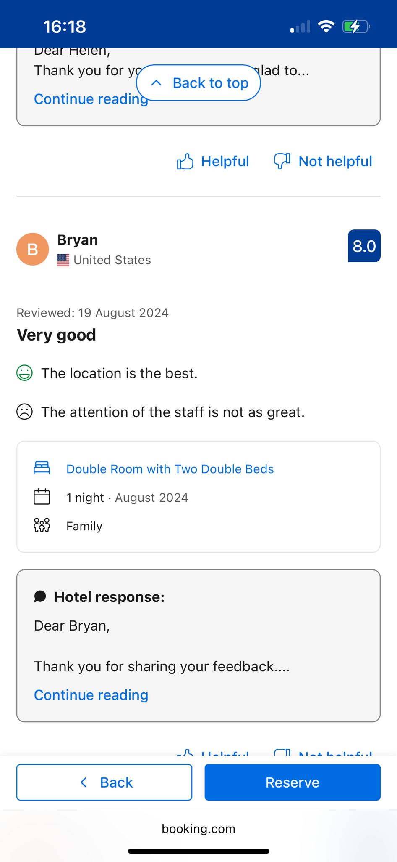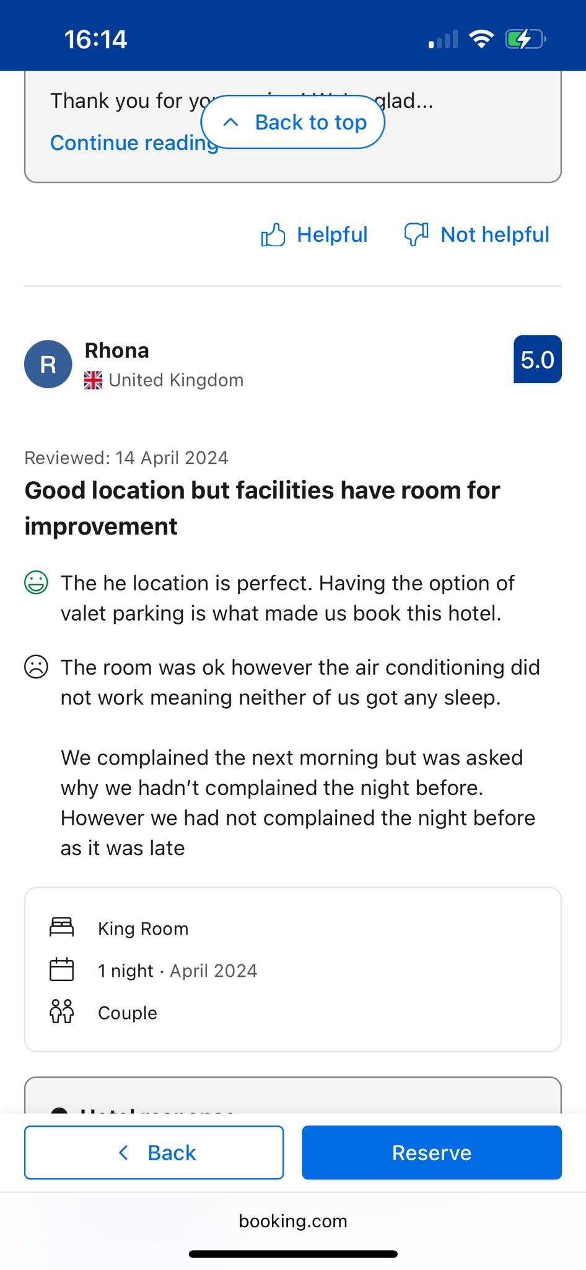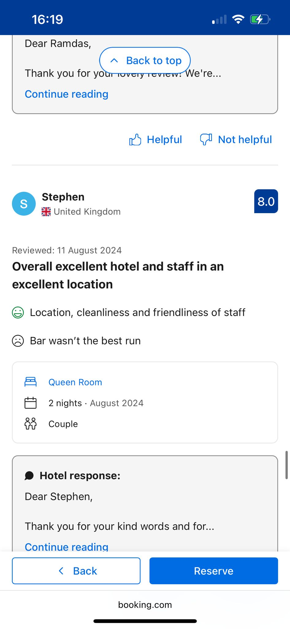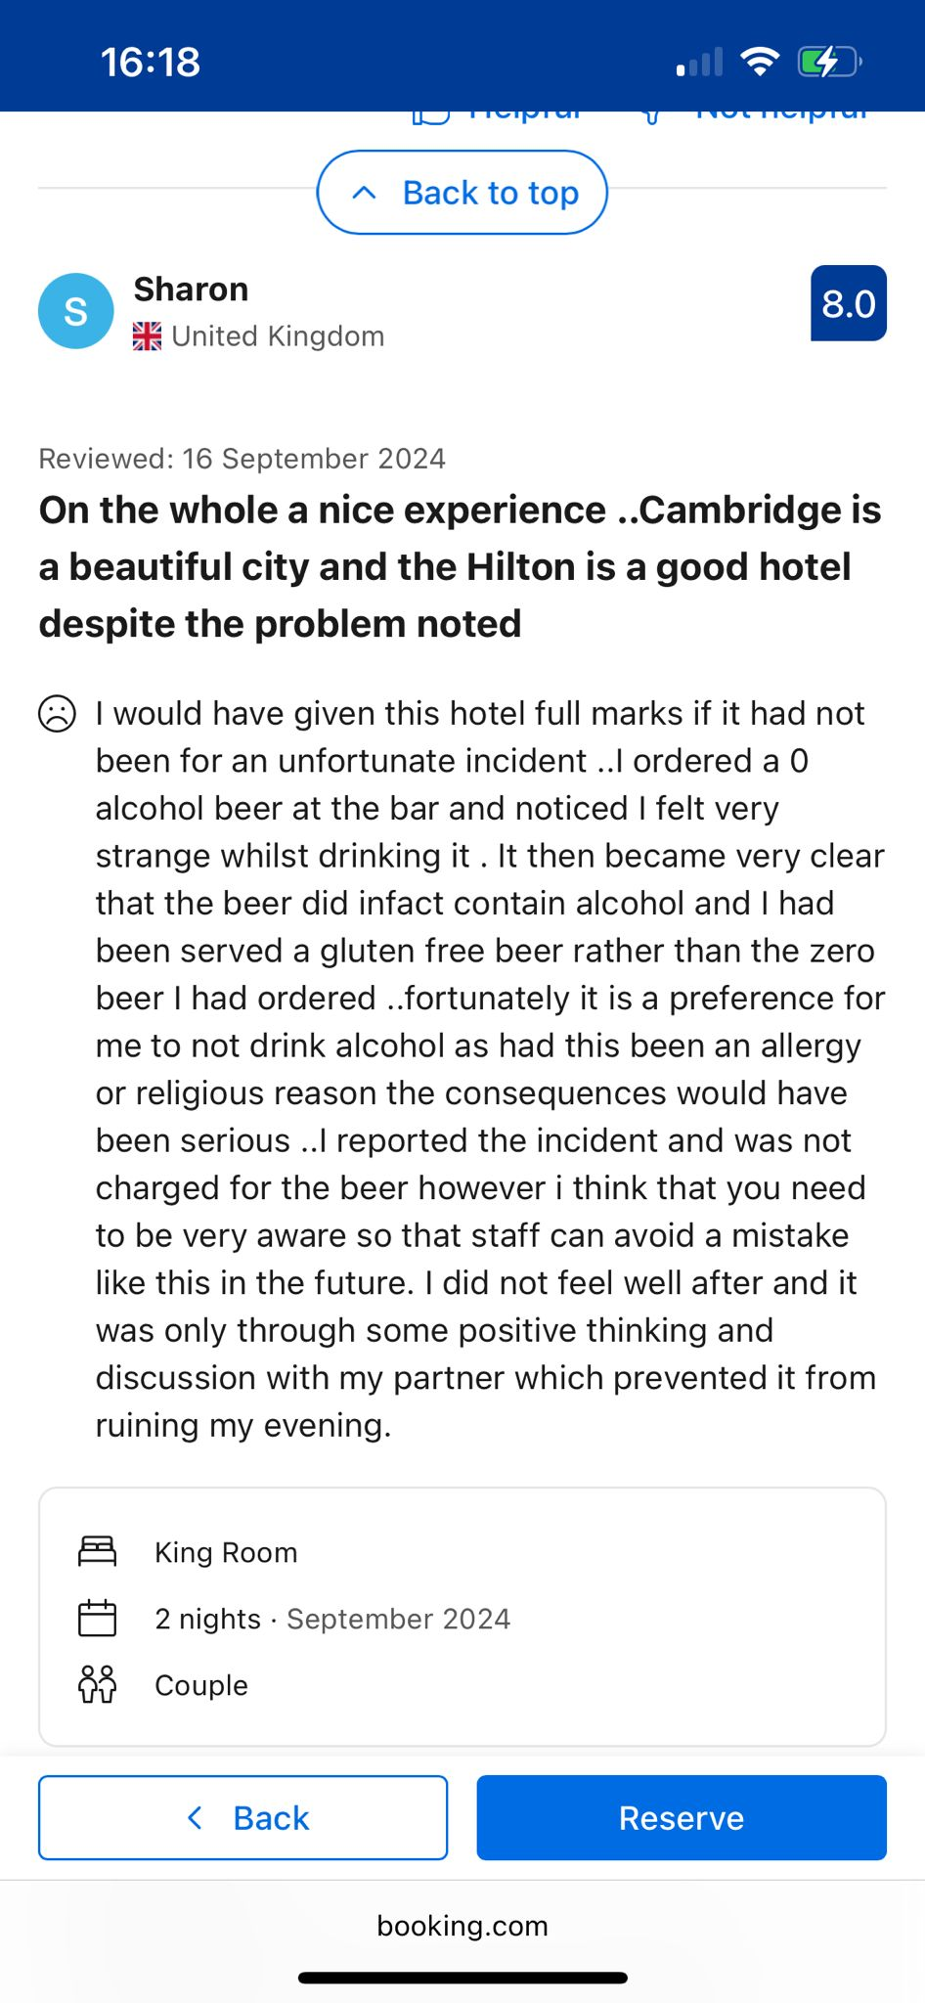

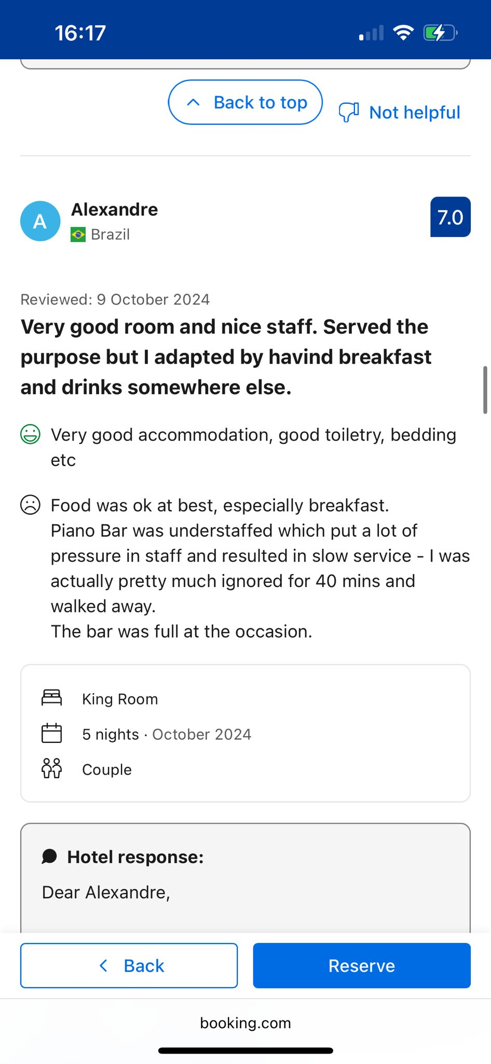

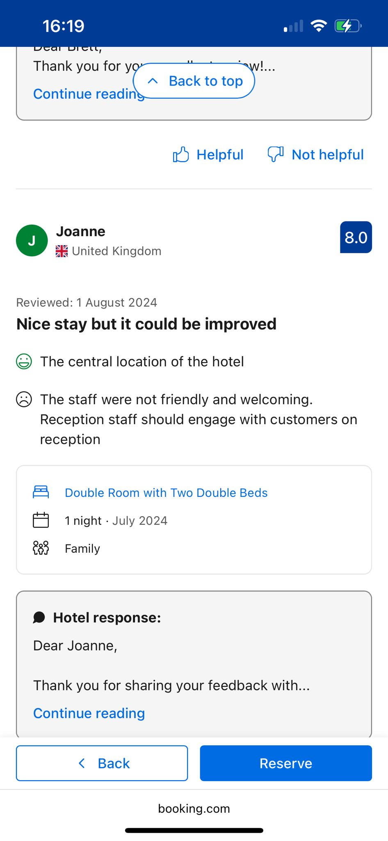
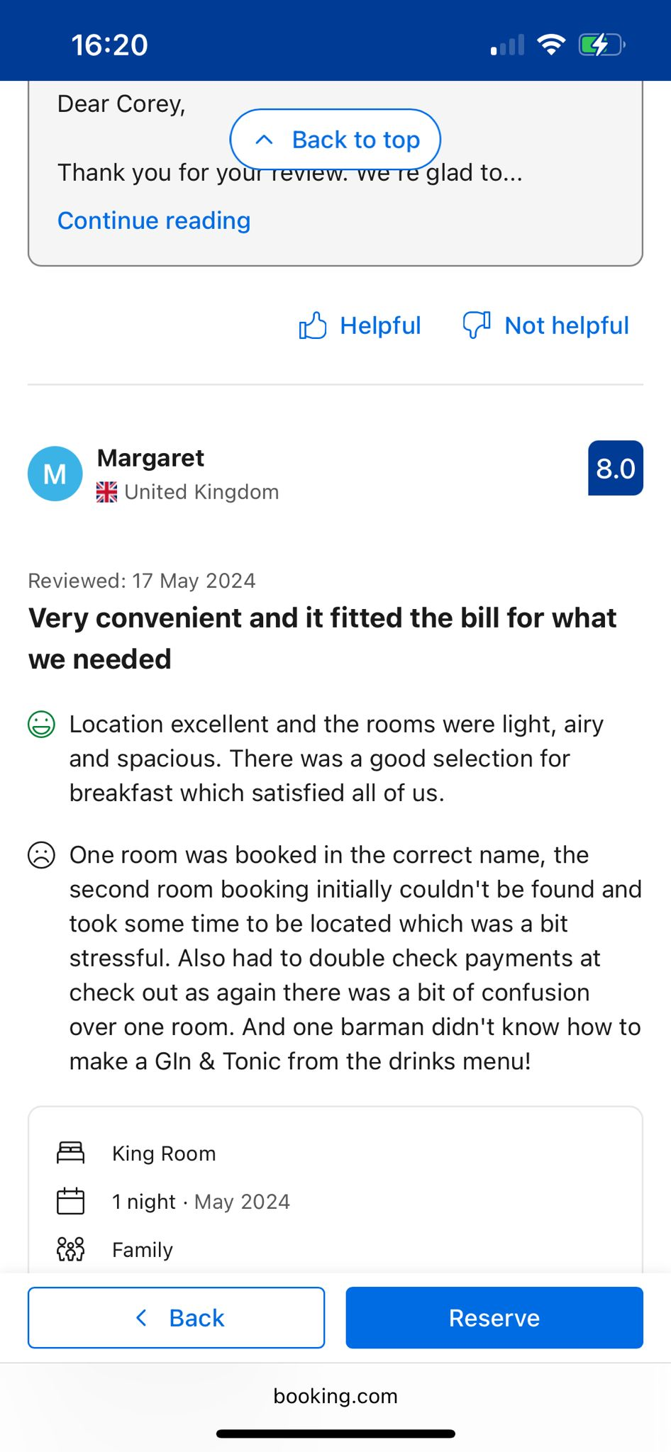
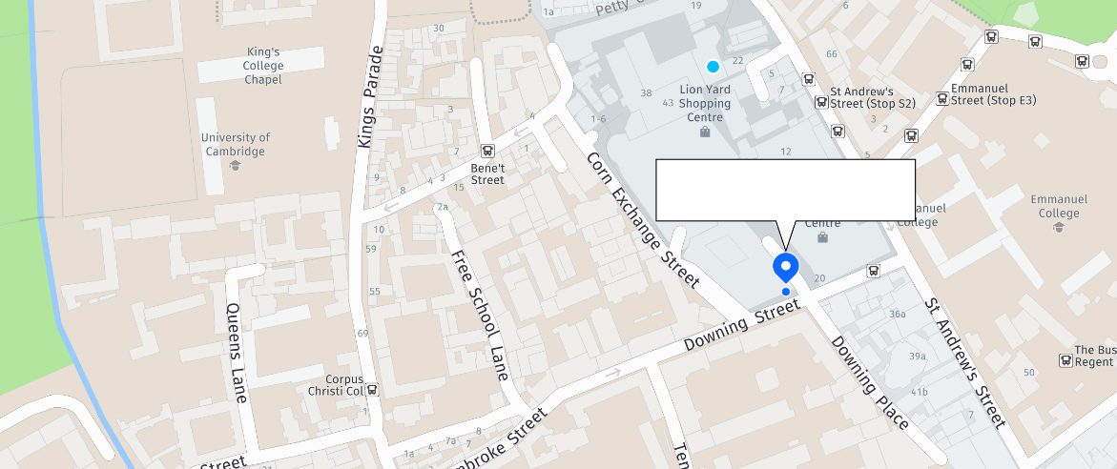
REFFER TU APPENDIX 1 2 3 ASTA TREBUIE SA SCRII IN TEXTUL DE SUS PLUS SA LE REFERI DE UNDE LEAI LUAT ETC



AICI TREBUIE SA PUI SI CELE CU REVIW

