Automation of Jobs and the Impact on Future Job Opportunities

How might the Rise of AI Generated Art effect the Art Industry?
Thomas Nurse (2004043)
This report will be discussing the rise of AI Generated Art, the impact that it is currently having on the Art Industry and discussing the potential future of the technology as the industry adapts to it. This challenge is a subset of Job Automation as it deals with issues such as people’s jobs being replaced by a machine which could lead to significant employment issues in the industry as the number of available jobs dwindles. When discussing AI art in this report, I will be focusing on freely available text-to-image art generators that are accessible to the public as these are what has had a large impact on the Art Industry.
In 2022, the most significant AI art generators were released to the public within a very short period of time. Midjourney was the first to release to the public in open beta on the 13th of July 2022 ^{[1]}. Closely followed by DALL-E created by OpenAI releasing into on July 20th, 2022 ^{[2]}. And with Stable Diffusion by Stability AI getting a public open source release on August 22nd, 2022 ^{[3]}. This sudden access to AI Art Generators has resulted a great influx of AI art throughout the web as people are rushing to explore and experiment with this new technology. This has sparked large debates over the ethics of using AI art, reignited the conversation around the nature of art and what it means for a piece to be considered artistic.
In August 2022, Jason M. Allen submitted a piece titled "Théâtre D'opéra Spatial" to the Colorado State Fair Fine Arts Competition. This work had been created by using the Midjourney Art Generator, winning first prize in the “emerging artist division's "digital arts/digitally-manipulated photography" category” ^{[4]}. This event spurred on the ethics debate surrounding AI Art with responses such as “AI artwork is the ‘banana taped to the wall’ of the digital world now.” ^{[4]}. However, one of the judges responded after the event and defended their initial decision.
“He didn’t realize that it was generated by AI when judging it. Still, he sticks by his decision to award it first place in its category, he said, calling it a “beautiful piece””^{[4]}.
While this event is likely not going to be the last time AI art is used in a way that causes controversy, it shows that there are people that stand on both sides of the argument whether supporting the potential use of the technology or denouncing it.
In one of the largest Anti-AI Art demonstrations seen as of yet, in early December 2022, a protest began on the popular online artist community on ArtStation, the protest centred around the fact that AI Generated art was being promoted directly alongside art created by users on the main homepage of the website. The method the users used to protest was by uploading an image to their portfolio that stated “NO TO AI GENERATED IMAGES” under the letters AI with a red line going through it ^{[5]}. Users would join the protest by either posting the same image or their own variant of it and upvoting each other’s posts. This protest led to the trending page of ArtStation to become flooded with Anti-AI imagery.
“Epic does not make any agreements with companies allowing them to scrape content on our website. Any use of ArtStation content that is not consistent with our terms of service may be an infringement on the rights of ArtStation users.”
In the FAQ released by Epic in response to the protest, Epic hints that the use of user images by these companies could be a potential infringement of the rights of the artist. The conversation around the legality of using copyrighted works as training data for AI Art models is still ongoing with no clear resolutions being made as of this time. However, there are still major arguments both for and against the use of publicly accessible art in the training of AI Models.

One of the main arguments for the use of this data is that the models are typically trained on millions of images, this would mean that while the model is still deriving its outputs from these images, considering the size of the data pool, anything created by that model would be considered transformative as each individual work used has a very minor and relatively negligible influence on the final work. However, this argument could only be applied to models with expansive datasets. If a model is trained on a small set of images, in particular if they are from the same artist then this would not apply as that model is trained to copy the style of that artist ^{[7]}.
Another argument for the use of the art is that all the images that are used in the training of the models are all publicly available and accessible with basic web scraping which is what other companies such as Google already do for their search engine ^{[8]}.
In early 2023, Getty Images announced that they were filing a lawsuit against Stability AI. The lawsuit is on the grounds of copyright infringement as Getty Images claims that “Stability AI copied more than 12 million images from its database “without permission ... or compensation ... as part of its efforts to build a competing business,”” ^{[9]}. These events have largely occurred because images created by the Stable Diffusion model can on occasion create a Getty Images watermark on the right side of the image generated. For the model to be creating this watermark, the training data used must have large influence of images that share this element which is easily explained by Stability AI scraping Getty Images’ website for their watermarked images.
While this lawsuit has not concluded, it is likely that the outcome of it will directly influence the future development of AI Art Generators because if the developers are able to be held accountable for copyright infringement over the training datasets, it could result in a significant restriction in the variety and the quantity of training data images used. In turn, potentially harming the quality of the works that the AI is able to produce due to the limited training dataset.
In conclusion, while the potential future impact of AI Art Generators on the industry is not yet known, they are currently causing a large level of controversy and conflict in the industry that has yet to take its toll on the industry. While AI can be used as a tool by artists, it is capable of being used for abuse that could lead to harm to the livelihoods of people within the industry in years to come.

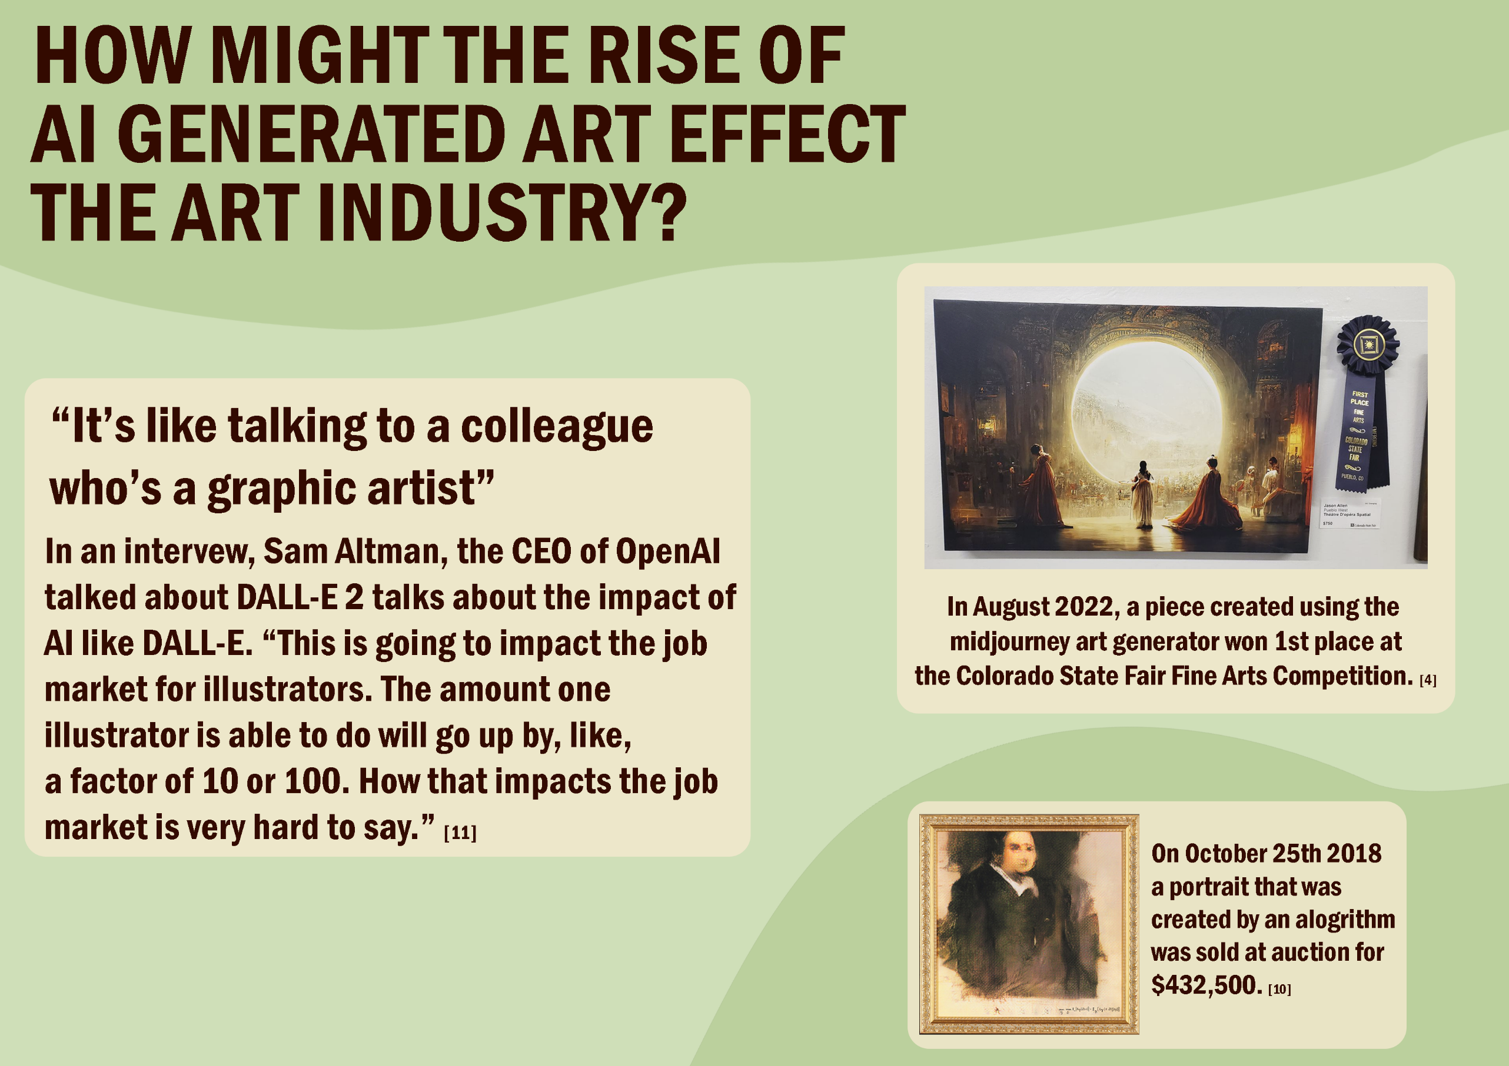
References
[1] Midjourney, “We're officially moving to open-beta!,” Twitter, Jul. 13, 2022. [Online]. Available: https://twitter.com/midjourney/status/1547108864788553729 [Accessed Feb. 15, 2023].
[2] OpenAI, “DALL·E now available in beta,” openai, Jul. 20, 2022. [Online]. Available: https://openai.com/blog/dall-e-now-available-in-beta [Accessed Feb. 15, 2023].
[3] EMostaque, “Delighted to announce the public open source release of #StableDiffusion!,” twitter, Aug. 22, 2022. [Online]. Available: https://twitter.com/EMostaque/status/1561777122082824192 [Accessed Feb. 15, 2023].
[4] R. Metz, “AI won an art contest, and artists are furious,” cnn, Sep. 3, 2022. [Online]. Available: https://edition.cnn.com/2022/09/03/tech/ai-art-fair-winner-controversy/index.html [Accessed Feb. 22, 2023].
[5] I. Chayes, “AI ”art” is trash,” artstation, Dec. 12, 2022. [Online]. Available: https://www.artstation.com/artwork/mzB16Y [Accessed Feb. 26, 2023].
[6] C. Xiang, “Artists Are Revolting Against AI Art on ArtStation,” vice, Dec. 14, 2022. [Online]. Available: https://www.vice.com/en/article/ake9me/artists-are-revolt-against-ai-art-on-artstation [Accessed Feb. 26, 2023].
[7] J. Vincent, “The scary truth about AI copyright is nobody knows what will happen next,” the verge, Nov. 15, 2022. [Online]. Available: https://www.theverge.com/23444685/generative-ai-copyright-infringement-legal-fair-use-training-data [Accessed Feb. 26, 2023].
[8] D. Smith, “The ArtStation Protests,” medium, Dec. 22, 2022. [Online]. Available: https://medium.com/mlearning-ai/the-artstation-protests-96c3b626d48c [Accessed Feb. 26, 2023].
[9] J. Vincent, “Getty Images sues AI art generator Stable Diffusion in the US for copyright infringement,” the verge, Feb. 6, 2023. [Online]. Available: https://www.theverge.com/2023/2/6/23587393/ai-art-copyright-lawsuit-getty-images-stable-diffusion [Accessed Feb. 27, 2023].
[10] Christie’s, “Is artificial intelligence set to become art’s next medium?,” christie’s, Dec. 12, 2018. [Online]. Available: https://www.christies.com/features/A-collaboration-between-two-artists-one-human-one-a-machine-9332-1.aspx [Accessed Mar. 5, 2023]
[11] MIT Technology Review, “Sam Altman: This is what I learned from DALL-E 2,” mit technology review, Dec. 16, 2022. [Online] Available: https://www.technologyreview.com/2022/12/16/1065255/sam-altman-openai-lessons-from-dall-e-2/ [Accessed Mar. 5, 2023]

Bibliography
I. Spektor, “From DALL·E to Stable Diffusion: how do text-to-image generation models work?,” tryolabs, Aug. 31, 2022. [Online]. Available: https://tryolabs.com/blog/2022/08/31/from-dalle-to-stable-diffusion [Accessed Feb. 13, 2023]
M. Broadhurst, “The Best AI Text-to-Image Generators of 2022 [October update],” broadhurst digital, Jun. 23, 2022. [Online]. Available: https://www.broadhurst.digital/blog/the-best-ai-text-to-image-generators-of-2022 [Accessed Feb. 13, 2023].
Midjourney, “We're officially moving to open-beta!,” Twitter, Jul. 13, 2022. [Online]. Available: https://twitter.com/midjourney/status/1547108864788553729 [Accessed Feb. 15, 2023].
OpenAI, “DALL·E now available in beta,” openai, Jul. 20, 2022. [Online]. Available: https://openai.com/blog/dall-e-now-available-in-beta [Accessed Feb. 15, 2023].
OpenAI, “DALL·E now available without waitlist,” openai, Sep. 28, 2022. [Online]. Available: https://openai.com/blog/dall-e-now-available-without-waitlist#OpenAI [Accessed Feb. 15, 2023].
J. Monge, “Stable Diffusion Finally Released To The Public,” medium, Aug. 25, 2022. [Online]. Available: https://medium.com/codex/stable-diffusion-finally-released-to-the-public-db1aa417d85b [Accessed Feb. 15, 2023].
EMostaque, “Delighted to announce the public open source release of #StableDiffusion!,” twitter, Aug. 22, 2022. [Online]. Available: https://twitter.com/EMostaque/status/1561777122082824192 [Accessed Feb. 15, 2023].
Stability AI, “Stable Diffusion Public Release,” stability.ai, No Date. [Online]. Available: https://stability.ai/blog/stable-diffusion-public-release [Accessed Feb. 15, 2023].
Stabilityai, “Stable Diffusion 2.1 Demo,” hugging face, No Date. [Online]. Available: https://huggingface.co/spaces/stabilityai/stable-diffusion [Accessed Feb. 15, 2023].
B. Edwards “AI wins state fair art contest, annoys humans,” arstechnica Dec. 8, 2022. [Online]. Available: https://arstechnica.com/information-technology/2022/08/ai-wins-state-fair-art-contest-annoys-humans/ [Accessed Feb. 22, 2023].
C. Vallance, “"Art is dead Dude" - the rise of the AI artists stirs debate,” bbc, Sep. 13, 2022. [Online]. Available: https://www.bbc.co.uk/news/technology-62788725 [Accessed Feb. 22, 2023].
R. Metz, “AI won an art contest, and artists are furious,” cnn, Sep. 3, 2022. [Online]. Available: https://edition.cnn.com/2022/09/03/tech/ai-art-fair-winner-controversy/index.html [Accessed Feb. 22, 2023].
D. Smith, “The ArtStation Protests,” medium, Dec. 22, 2022. [Online]. Available: https://medium.com/mlearning-ai/the-artstation-protests-96c3b626d48c [Accessed Feb. 26, 2023].
R. Stanton, “World's biggest art portfolio site embroiled in user protest against AI art,” pcgamer, Dec. 15, 2022. [Online]. Available: https://www.pcgamer.com/worlds-biggest-art-portfolio-site-embroiled-in-user-protest-against-ai-art/ [Accessed Feb. 26, 2023].
C. Xiang, “Artists Are Revolting Against AI Art on ArtStation,” vice, Dec. 14, 2022. [Online]. Available: https://www.vice.com/en/article/ake9me/artists-are-revolt-against-ai-art-on-artstation [Accessed Feb. 26, 2023].
I. Chayes, “AI ”art” is trash,” artstation, Dec. 12, 2022. [Online]. Available: https://www.artstation.com/artwork/mzB16Y [Accessed Feb. 26, 2023].
J. Vincent, “The scary truth about AI copyright is nobody knows what will happen next,” the verge, Nov. 15, 2022. [Online]. Available: https://www.theverge.com/23444685/generative-ai-copyright-infringement-legal-fair-use-training-data [Accessed Feb. 26, 2023].
J. Vincent, “Getty Images sues AI art generator Stable Diffusion in the US for copyright infringement,” the verge, Feb. 6, 2023. [Online]. Available: https://www.theverge.com/2023/2/6/23587393/ai-art-copyright-lawsuit-getty-images-stable-diffusion [Accessed Feb. 27, 2023].
Canva, “How to make an infographic,” canva, No Date. [Online]. Available: https://www.canva.com/learn/how-to-make-an-infographic/ [Accessed Mar. 5, 2023]
T. Graham, “After a piece of art ‘created’ by an AI sold for $430,000, Thomas Graham looks at what the age of the machine means for art,” bbc, Dec. 12, 2018. [Online]. Available: https://www.bbc.com/culture/article/20181210-art-made-by-ai-is-selling-for-thousands-is-it-any-good [Accessed Mar. 5, 2023]
Christie’s, “Is artificial intelligence set to become art’s next medium?,” christie’s, Dec. 12, 2018. [Online]. Available: https://www.christies.com/features/A-collaboration-between-two-artists-one-human-one-a-machine-9332-1.aspx [Accessed Mar. 5, 2023]
MIT Technology Review, “Sam Altman: This is what I learned from DALL-E 2,” mit technology review, Dec. 16, 2022. [Online] Available: https://www.technologyreview.com/2022/12/16/1065255/sam-altman-openai-lessons-from-dall-e-2/ [Accessed Mar. 5, 2023]

