
\

Student name: Lourdes Cristina Fabre
Student ID: 2412080

Module name: Changemakers: Building your Personal Brand for Sustainable Employment
Module code: BMHP5015
Lecturer name: Caroline Salami

Assessment Component 1 BMHP5015

Introduction
This portfolio reflects on what I have learned through the Moodle, Changemakers: Building your Personal Brand for Sustainable Employment, activities, forum discussions, and reflective exercises completed during this module. It explores how the four units Brand You, It's a Small World, Opportunity Knocks, and The Pursuit of Happiness have helped me develop my professional identity, broaden my global awareness, explore career opportunities, and understand the importance of maintaining my wellbeing.
Throughout this portfolio, I reflect on how the knowledge and skills gained from each unit have influenced my personal and professional growth. I also explain how this learning has strengthened my personal brand and prepared me for my future career in Public Health, with the long-term goal of becoming a Public Health Analyst.

Reflection on Unit 1: Brand You
Unit 1 helped me develop a clearer understanding of my professional identity and career goals. As an aspiring Public Health professional, I am passionate about reducing health inequalities and improving community wellbeing. My experience in nutrition, healthcare administration, education, and communication has helped me build strong interpersonal skills and an evidence-based approach to promoting healthier lifestyles. Khedher (2018) explains that personal branding consists of six interconnected elements: cultural capital, social capital, verbal self-presentation, mediated self-presentation, authenticity, and appearance. Together, these dimensions help graduates communicate their strengths and improve employability. This encouraged me to recognise that my empathy, integrity, collaboration, and communication skills form the foundation of my personal brand. These skills will help me to achieve my long-term goal of become a Public Health Analyst, using data and research to improve population health. Coetzee (2018) also highlights that authenticity, communication, professional networks, and self-presentation are essential to building a successful personal brand.
One of the most valuable lessons was the importance of ambition supported by clear goals. Locke and Latham (2002) argue that specific and challenging goals improve motivation and performance. As a result, I have set short-term goals: complete my degree, gain relevant volunteering or entry-level experience in Public Health, and develop technical skills in Excel, Power BI, SQL, and population health data analysis to prepare for an analytical role.
The concept of the boundaryless career also changed my perspective. Arthur and Rousseau (1996) explain that careers develop through varied experiences and transferable skills rather than within a single organisation. Reflecting on my own journey, I realised that my background in nutrition, education, customer service, and communication has equipped me with valuable skills, including communication, organisation, and problem-solving. These are essential when working with diverse communities and multidisciplinary teams. This reflection also reinforced the importance of adaptability and self-awareness in improving employability (Peeters et al., 2020).
The unit also increased my understanding of emotional intelligence and self-awareness. Goleman (1995) asserts that emotional intelligence involves understanding and managing our own emotions while recognising those of others. Through self-reflection, I identified empathy, resilience, and communication as strengths, while recognising leadership and decision-making as areas for development. I sometimes find it difficult to delegate tasks because I want to ensure they are completed to a high standard, and I tend to predict outcomes instead of considering different options before making decisions. To improve, I plan to use decision-making frameworks, seek constructive feedback, and continue reflecting on my experiences to become a more confident leader.
Overall, Unit 1 changed my understanding of personal branding. I now see it as communicating my values, skills, and professional identity rather than simply promoting my achievements. This is particularly important in Public Health, where trust, integrity, collaboration, and lifelong learning are essential. Scheidt, Gelhard and Henseler (2020 research also highlights that personal branding plays an important role in career development by helping individuals communicate their professional identity and improve employability.
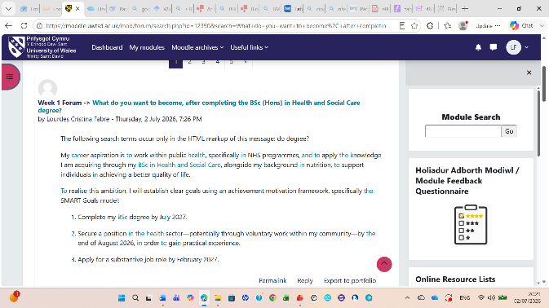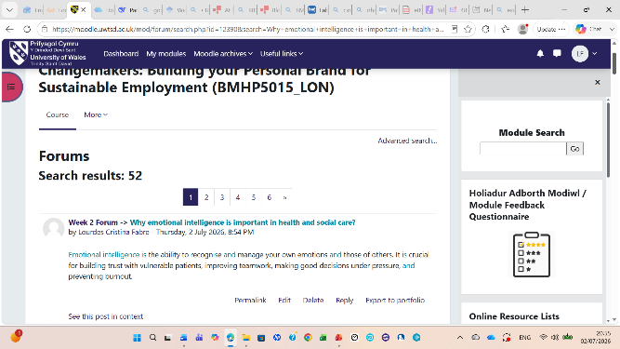

Reflection on Unit 2: It’s a Small World
Unit 2 showed me how important global connections and networking are in health and social care. The topics included professional networking, cultural competence, diversity, communication, organisational structures, and the role of digital platforms in building relationships. As I plan to work in Public Health, I realised that networking is not only about career opportunities but about sharing knowledge, improving collaboration, and finding better ways to address health inequalities.
According to Cross Country (2024) search networking is essential for professional growth in healthcare. It helps professionals develop new knowledge, improve patient care, and build supportive relationships. It also states that creating genuine professional connections through networking events, organisations, and online platforms can enhance career opportunities while contributing to continuous learning and development. I reflected on this and realised as I am new in this field and I haven’t many contact in healthcare sector. So, this unit gave me a kind of wakeup, and I have already started to improve my professional networking. Firstly, I updated my LinkedIn profile and started to follow some healthcare professionals from different roles, such care works, and institutions like NHS, charities, universities and councils' communities. I am also planning to participate in some public health forums and online communities. So, I believe these actions will help me to develop my professional networking.
Granovetter (1973) argues that valuable career opportunities often arise through wider professional networks rather than close personal contacts. This has encouraged me to take a more proactive approach to building and maintaining my professional network. For example, I volunteered and later worked at The Bridge, a women's wellbeing charity, for three years, where I developed strong relationships with colleagues. Many of them have since moved into roles in other charities and wellbeing organisations. Reconnecting with these contacts to share my professional development and let them know I am seeking opportunities in Public Health could help me gain valuable advice, expand my network, and identify potential career opportunities.
The unit also strengthened my understanding of cultural competence and diversity. I learned that Healthcare professionals must respect different cultures, beliefs, and experiences to provide person-centred care. Campinha-Bacote's (2002) model states that developing cultural competence is an ongoing process rather than something that is achieved once. Additionally, recent research emphasises that cultural safety and cultural humility are essential for reducing health inequalities and improving patients' experiences of care (Curtis et al., 2019; Allwright et al., 2019). This has encouraged me to reflect on my own attitudes and recognise that every person's experiences, beliefs, and behaviours are shaped by their unique background. Developing this understanding will help me continue to build my cultural awareness and provide more respectful, inclusive, and person-centred care.
Another important lesson was the influence of digital communication. I learned that professional platforms such as LinkedIn make it easier to connect with healthcare professionals, access current research, and build a professional reputation. Besides that, social network research helps explain how relationships and interactions between people influence the way healthcare works. It can identify issues such as communication breakdowns, bottlenecks, professional isolation, and gaps in collaboration that can negatively affect patient safety and the quality of care (Pomare et al., 2022).
Overall, Unit 2 has changed the way I think about networking. I now see it as an essential skill for collaboration, continuous learning, and improving health and social care. Moreover, the knowledge I gained has increased my confidence in building professional relationships and reinforced the importance of working with diverse communities to achieve better health outcomes.
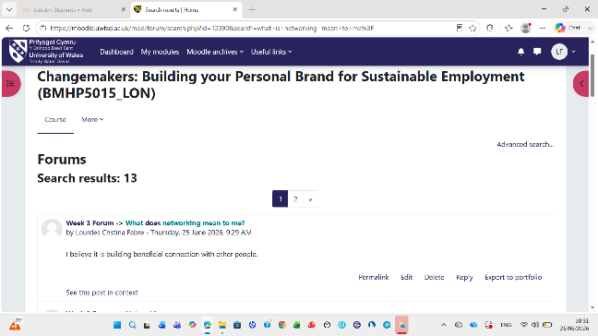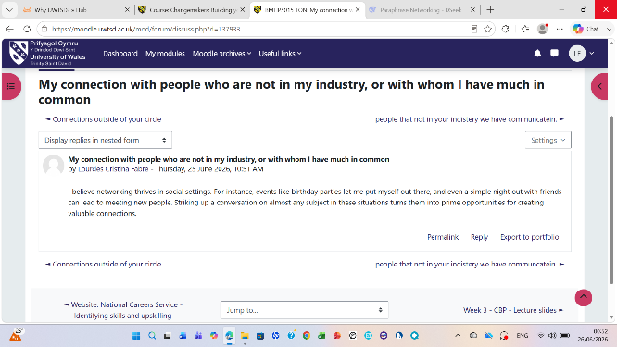

Reflection on Unit 3: Opportunity Knocks
Unit 3, Opportunity Knocks, helped me understand that career opportunities are often created through preparation, planning, and being open to new experiences. The unit covered topics such as recognising opportunities, goal setting, personal development planning, the serendipity mindset, professional online presence, and influencing others. These topics showed me that career success involves much more than gaining qualifications.
I also learned how setting clear goals can help me stay focused. Using the principles of Goal-Setting Theory, Locke and Lathan (2002), I have started creating realistic short-term goals, such as gaining more volunteering experience, completing additional training, and expanding my professional network, while working towards my long-term goal of becoming a Public Health Analyst.
Another valuable lesson was the importance of maintaining a professional online presence. I am now more active on LinkedIn and have started building connections with professionals working in Public Health. This helps me expand my network, learn more about the skills needed for the field, and explore future career opportunities.
In contrast, professional online presence can bring many benefits, but it also carries risks if not managed carefully. Sharing information or images that identify patients or colleagues may breach confidentiality and professional standards. Inappropriate posts can damage a professional's reputation and affect career opportunities or accepting friend requests from patients may blur professional boundaries and raise ethical concerns. In addition, online content can remain permanently accessible, influencing public trust. Sharing inaccurate health information or using weak privacy settings can also lead to misinformation, identity theft, phishing, and other cybersecurity risks (HCPC, 2023).
Altogether, this unit has increased my confidence and encouraged me to take greater responsibility for my career development. I now understand that success comes from setting goals, building professional relationships, and continuing to develop my knowledge and skills throughout my career (Department of Health and Social Care, 2022).
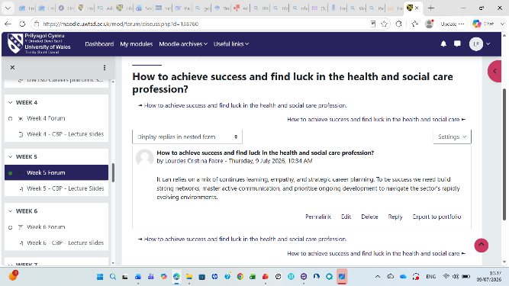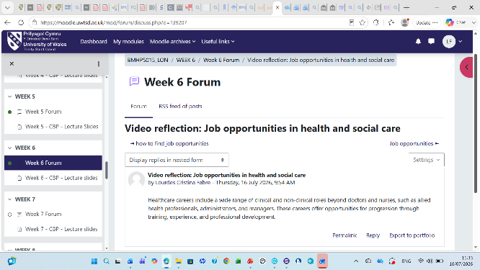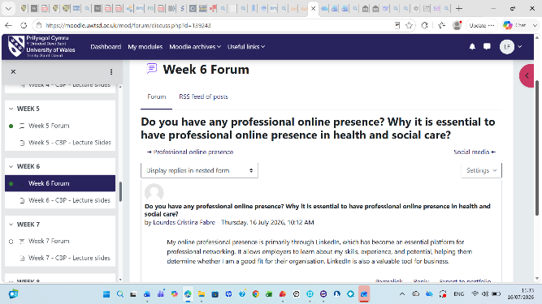

Reflection on Unit 4: The Pursuit of Happiness and Conclusion
Unit 4 supported me understand the importance of personal wellbeing, resilience, and adaptability in my future career in Public Health. The unit explored topics such as overcoming limiting beliefs, dealing with failure, maintaining work-life balance, career changes, the impact of technology on employment, antifragile thinking, social learning theory, and the importance of mentors.
One limiting belief I identified is that I often feel I need to have all the answers before taking on a new challenge. This has sometimes stopped me from applying for opportunities or volunteering for leadership roles because I worried I was not experienced enough. However, completing my nutrition qualification, returning to university, and successfully delivering nutrition workshops have shown me that I can learn and grow through experience. In the future, I will challenge this belief by focusing on progress rather than perfection and reminding myself that confidence develops through practice.
To maintain my wellbeing, I plan to organise my studies using a weekly timetable, set realistic deadlines, take regular breaks, exercise three times a week, and spend quality time with my friends. If I begin to feel overwhelmed, I will seek support from my tutors, classmates, or employer rather than trying to manage everything alone.
According to Saligman’s PERMA model (2018), highlights that wellbeing is supported by positive emotions, engagement, relationships, meaning, and achievement. This model assisted me reflect on the importance of building supportive relationships, finding purpose in my work, and celebrating progress. I maintain positives emotion by walking or reading a good book, it helps me with my engagement with university assignments and researching public health. I also have weekly night out with my close friends, and I believe that it is the best way to spend my time.
I believe that challenges help us grow, and one of my proudest achievements was delivering an 'Understanding Food Labels' workshop at The Bridge women's charity. Speaking in English, my second language, to around 30 people for over an hour challenged me but successfully completing it boosted my confidence and self-esteem. It also reminded me that stepping outside my comfort zone helps me grow both personally and professionally.
Furthermore, As I hope to become a Public Health Analyst, I recognise that technology will play a central role in my career. I therefore plan to improve my skills in Microsoft Excel, Power BI, data visualisation, and health information systems. Developing these digital skills will help me analyse population health data, identify trends, and support evidence-based decision-making.
The Social Learning Theory, Bandura (1977) explains that people learn through observing and interacting with others. It has inspired me to find a mentor who works as a Public Health Analyst within the NHS or a local authority. I hope to connect with professionals through LinkedIn, NHS networking events, and university careers services. A mentor could provide advice on developing analytical skills, preparing job applications, understanding career pathways, and building confidence as I transition into Public Health. Cunningham et al. (2012) define that professional social network structures in health care are linked to quality, safety, and staff outcomes
In general, Unit 4 has helped me become more resilient and prepared for the challenges of working in Public Health. I now understand that to become a successful professional depends on knowledge and qualifications achieved, but also on adaptability, emotional wellbeing, continuous personal development, and the ability to learn from others.
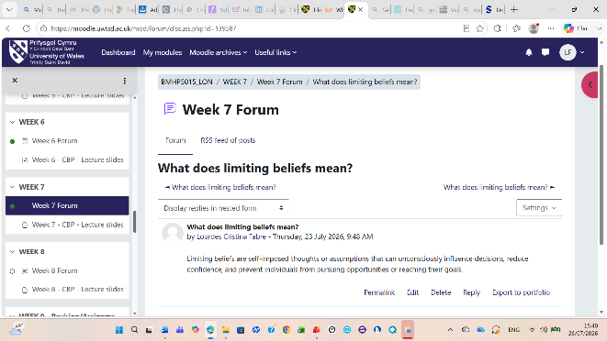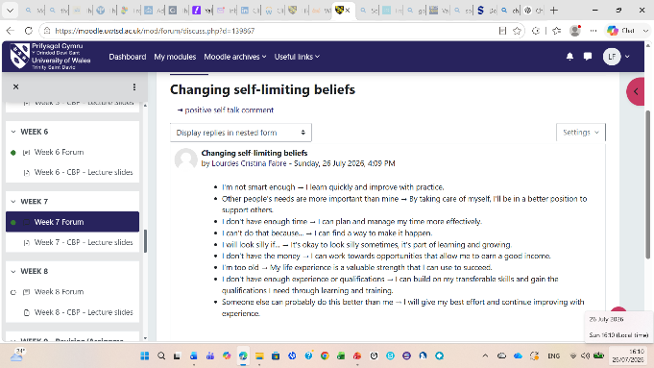

Conclusion
Overall, these four units have helped me develop a clearer understanding of my professional identity and career goals in Public Health. They have also helped me recognise both my strengths and the areas I need to continue developing. My next steps are to complete my degree, improve my data analysis skills, and gain more experience through volunteering or work opportunities in Public Health. These actions will strengthen my personal brand, demonstrate my commitment to continuous learning, and prepare me for a successful and sustainable career as a Public Health Analyst.

Reference
Allwright, K., Goldie, C., Almost, J. and Wilson, R. (2019). Fostering positive spaces in public health using a cultural humility approach. Public Health Nursing, 36(4). doi:10.1111/phn.12613.
Arthur, M.B. and Rousseau, D.M. (2001). The boundaryless career. Oxford University Press.
Bandura, A. (1977). Social learning theory. Englewood Cliffs; London: Prentice-Hall.
Campinha-Bacote, J. (2002). The process of cultural competence in the delivery of healthcare services: A model of care. Journal of Transcultural Nursing, 13(3). doi:10.1177/10459602013003003.
Coetzee, M. (2018). Career Development and organizational support. Oxford Research Encyclopedia of Business and Management. doi:10.1093/acrefore/9780190224851.013.168.
Cross Country Search (2024) ‘Why Networking in Healthcare.’ Available at: https://www.crosscountrysearch.com/blogs/the-importance-of-networking-in-healthcare.(Accessed 3 August 2026).
Cunningham, F.C., Ranmuthugala, G., Plumb, J., Georgiou, A., Westbrook, J.I. and Braithwaite, J. (2012). Health professional networks as a vector for improving healthcare quality and safety: A systematic review. BMJ Quality & Safety, [online] 21(3), pp.239–249. doi:10.1136/bmjqs-2011-000187.
Curtis, E., Jones, R., Tipene-Leach, D., Walker, C., Loring, B., Paine, S.-J. and Reid, P. (2019). Why cultural safety rather than cultural competency is required to achieve health equity: A literature review and recommended definition. International Journal for Equity in Health, 18(1). doi:10.1186/s12939-019-1082-3.
Department of Health and Social Care (2022) ‘A Plan for Digital Health and Social Care.’ Available at: https://www.gov.uk/government/publications/a-plan-for-digital-health-and-social-care (Accessed: 18 July 2026).
Goleman, D. (1995). Emotional intelligence: Why it can matter more than IQ. New York: Bantam Books.
Granovetter, M.S. (1973). The strength of weak ties. American Journal of Sociology, 78(6). doi:https://doi.org/10.1086/225469.
Khedher, M. (2018). Conceptualizing and researching personal branding effects on the employability. Journal of Brand Management, 26(2). doi:10.1057/s41262-018-0117-1.
Locke, E.A. and Latham, G.P. (2002). Building a practically useful theory of goal setting and task motivation: A 35-year odyssey. American Psychologist, 57(9). doi:https://doi.org/10.1037/0003-066X.57.9.705.
Health and Care Professions Council (HCPC) (2023) ‘Guidance on social media.’ Available at: https://www.hcpc-uk.org//standards/meeting-our-standards/communication-and-using-social-media/guidance-on-use-of-social-media/?utm_source=chatgpt.com. (Accessed: 1 August 2026).
Peeters, E.R., Akkermans, J. and De Cuyper, N. (2020). The only constant is change? Movement capital and perceived employability. Journal of Career Assessment, 28(4). doi:10.1177/1069072720918195.
Pomare, C., Long, J.C., Churruca, K., Ellis, L.A. and Braithwaite, J. (2022) 'Social network research in health care settings: Design and data collection', Social Networks, 69. https://doi.org/10.1016/j.socnet.2019.11.004

Scheidt, S., Gelhard, C. and Henseler, J. (2020). Old practice, but Young Research Field: A systematic bibliographic review of personal branding. Frontiers in Psychology, 11. doi:10.3389/fpsyg.2020.01809.
Seligman, M. (2018). PERMA and the building blocks of well-being. The Journal of Positive Psychology, 13(4). doi:10.1080/17439760.2018.1437466.

