My Reflection Report

Professional Career Development
Grace Jones

Contents
Introduction/Summary
SWAT analysis
The 7 Habits
Go Mad
Vark
PDP Plan
Conclusion

Introduction
This essay will show you how I am developing in my professional development to help me achieve my goals and ambitions. Obtaining a new set of skills to improve knowledge and build on my confidents but also to find out what my strengths and weaknesses are and what my plan is in order to be able to reach my goals.

Reflection review
My Name is Grace Jones I am 21 years old and looking for new opportunities to better myself and help me achieve my long-time goals as well as working a part time job. On this course, Skills for the workplace, I’m hoping to get the qualification/Certificate but also to gain as much knowledge and confidence as I possibly can. Getting to know myself through personal development and new kills for future employment and hopefully to be my own manager of a business one day. I will be doing a SWAT analysis on myself, pointing out my strengths, weaknesses and threats and what I can do to choose the right approach. We have also been learning about Steven Covey The 7 Habits which I would like to highlight. I will also be using the Go Mad learning cycle in my assignment to show you that I understand how to put learning styles into my own plans. PDP is also a really good way for you to organise and out a plan into place and to keep on the right tracks.

This is a Swot analysis about me.

My Swot Analysis

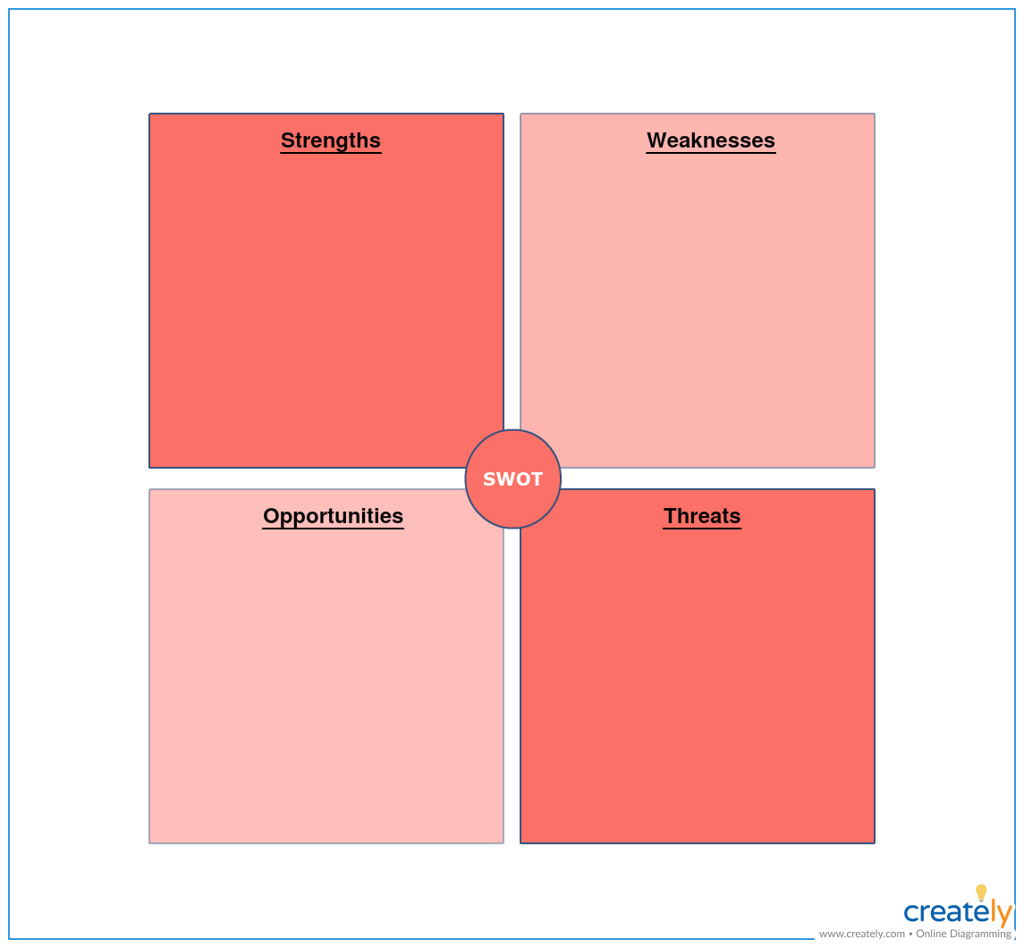

Strengths
I think my strengths include communication skills as I had worked in calls centres since I left school in order to help build my confidence but it also helped me to be able to be good at working in a team but also on my own and using my own initiative. Good at following instructions given and learning from mistakes in order to ensure that they don’t happen again.

Weaknesses
What weaker points I think I have is lacking confidence and feeling anxious when it comes to speaking in front of an audience. Having a negative attitude towards things on times and needing a little bit of reassurance to make sure I’m on the right tracks. Another one of my weaknesses is time keeping and that’s something I will be working on.

Opportunity
One of the best opportunities I’ve had is getting accepted on this course in order to better myself and develop new skills for further employment and new career change and also new social communication skills. Gaining knowledge and understanding about employability skills and to learn about myself.

Threats

What I think my biggest threats are is having a full-time job as well as being able to find time after work to be able to complete my university work. Standing up and doing a presentation in front of an audience is always something I lack in confidence with.

Turning strengths into opportunities
- Use my computer skills from school to help with my ability to use word/PowerPoint etc.
- Makin sure that I attend every lesson and keep on top of the homework in order to get the results I want.
- To gain as much knowledge and skills abut employability to help me achieve my goals in future employment.

We have also been learning about “The 7 Habits” and putting a plan into place in order to reach my future goals.
Steven R. Covey’s book, the 7 Habits of highly effective people, continues to be a best seller for the simple reasons that it ignores trends and pop psychology and focuses on timeless principles of fairness, integrity, honesty, and human dignity.
One of the most compelling books ever written the 7 habits of highly effective people have empowered and insured readers for over 25 years and played a part in the transformation of millions of lives, across all age groups and professions. Making people concentrate on their future goal but also how to put a plan in place in order to succeed.
The purpose of the 7 Habits of Highly Effective People is to help you lead your life in a truly effective way. They represent a proven process of personal and interpersonal growth that can have an immediate and lasting impact.

- Be proactive
- Begin with the end inside
- Put first things first
- Think win win
- Seek first to understand, then to be understood
- Synergize
- Sharpen the saw

Be Proactive – Being organized and managing a full-time job as well as trying to do a 12-month course in university. To achieve new skills and gaining more knowledge to help me progress in my future and get a job I enjoy doing and can have a career out of.
Begin with the end inside - Making a plan of where I want to be in the next 5 years and focusing on my goals and ambitions in order to achieve them. Doing this university course skills in the workplace Level 4 will help me gain the skills and knowledge I need to reach my future goals.
Putting things first – Keeping things organised and prioritizing the important things in my life making sure in get everything done. Balancing out a full-time job as well as attending my university course every Monday and Tuesday but also ensuring I’m making enough time to put into my university work and complete all my assignments and meeting deadlines.

Think win win – Keep my head on the end goal and what I want to achieve. Keeping positive.

Seek to understand then to be understood – Takin advice of people to see how other people look at things. Taking new ideas and building on them. More knowledge. Putting a plan in place and reaching it.

Synergise – Building my confidence up to be able to achieve to my full potential. Building on my strengths and my weaknesses in order to Improve. Focusing to meet my deadlines and to attend all my lectures. Keep researching if I don’t understand something.

Grow – I will be taking everything on board what I learn from university and also from my experiences and will continue to put a plan in place to ensure I get the results I want in order to reach my end goal and get the career I want and a job I will enjoy. Taking on new challenges I get set and always putting 100% effort into everything that I do to get the best results. Always listen to other people’s advice because it could help a lot through my journey.

GO MAD
The Go M.A.D results framework and solution focused thinking method enables people and teams to more easily solve problems and improve productivity. When organisations adopt and embed this method as a shared language/ toolkit the results are dramatic.
The Go M.A.D. and ThinkOn range of development materials and business improvement programmes were developed to help organisations improve their productivity and effectiveness by transforming the way people think and engage in the workplace.

Our approach is to role model the use of the Go M.A.D.® Results Framework when designing client programmes and solutions.

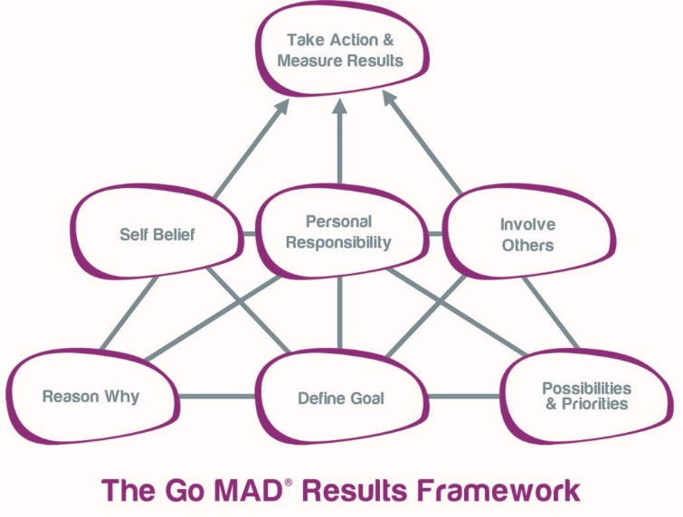

Taking Actions and responsibility- Attend all classes and complete all work assigned to me meeting deadlines. Putting my priorities in place. Making time to do thing like job work etc.
Self-belief – Concentrate on my weaknesses and turning them into strengths in order to succeed. Make sure I meet all deadlines in order to pass this course with a qualification to better myself for future employment.
Personal responsibility – Ensuring that I’m balancing my job in order to carry on paying bills whilst I attend this full -time course and then hopefully I can get this certificate and further my education into something much better.
Involve others – Involving myself in this course is giving me better social skills, help share ideas so I can always look at things in more than one way. But most importantly build my confidence.
Reasons why – Will help me get more opportunities and give me a whole new range of skills for future employment. A career I will enjoy. To gain more knowledge.

Define goals- Complete my university course skills for the workplace level 4 and get the certificate. Get a job I truly love. And to be able to in the next 10 years be my own boss and have my own business.
Plan – Balance out my job and university and prioritize time to do my assignments and get them in on time in order to complete Level 4.

Vark

The acronym VARK stands for Visual, Aural, Read/write, and kinesthetics’ sensory modalities that are used for learning information. Fleming and Mills (1992) suggested four modalities that seemed to reflect the experiences of the students and teachers. Although there is some overlap between them, they are defined

Vark is a questionnaire to find out how we learn best. The questionnaire will show your preferred style for maximum benefits.

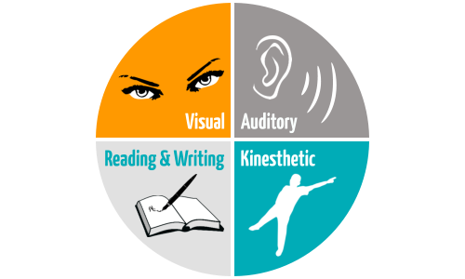

These are the learning preferred styles. I did a questionnaire on myself to find out which one is my learning style. I had to answer each question with a 4-choice answer but only had to pick one, these are the results I had.
- Visual – 2
- Auditory – 3
- Reading & Writing – 2
- Kinaesthetic – 5

This makes my preferred learning style Kinaesthetic. Kinaesthetic learn best when they can move around and engage their small and large muscle groups. Oftentimes, Kinaesthetic feel their way of learning isn't as good because they can't “sit and do the work,” but there are lots of ways to maximize their learning style.

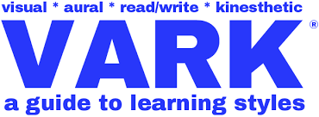

Personal Development plan
My personal development plan will include taking this future education course and learning a lot about myself, ways of learning that I can adopt and take on board to progress in my future. Prioritizing the most important things in my life to get the better results. Making sure I don’t miss any work so I can pass this course and get the qualification that I want to get the dream job I want to be able to open up a riding school and teach people how to ride horses and to have my own stables. Keeping on using the learning styles that I have in class and making sure that I am always organised. Identifying and developing the skills I need. Focusing on what I want to achieve it and how I’m going to do it.

Conclusion
After doing my report on my reflective journey and researching about different learning styles I have realised how important it is too me to want to complete this course and get the qualification I want to better myself and to achieve my future goals. Using the strategies, I have in this report for example the VARK which has shown me my preferred learning style in order for me to understand which way I work best and easier for me. I also learned a lot from the SMART learning style by giving me a structure to go by and help me to plan things more efficiently. The GO MAD framework strategy helps you put in to place how I can get to the next level to achieve your goal and who I will need to help. My personal Development Plan is set in place to allow to reach my future dreams and make them real. This course has given me the opportunity to get a new range of skills to help me along my journey.

1)
Article title: | The 7 Habits of Highly Effective People
Website title: | Franklincovey.com
URL: | https://www.franklincovey.com/Solutions/Leadership/7-habits-signature.html

2)
 | 015 Strategicning Gap In Marketing Analysis Header2x Incredible Strategic Planning Plan What Is A ~ Dialmforminky
Website title: | Dialmforminky.com
URL: | https://www.dialmforminky.com/marketing-plan/015-strategicning-gap-in-marketing-analysis-header2x/

3)
Article title: | The 7 Habits of Highly Effective People
Website title: | Franklincovey.com
URL: | https://www.franklincovey.com/the-7-habits.html

4)
Go MAD Thinking
Website title: | Gomadthinking.com
URL: | https://www.gomadthinking.com/

5)
Article title: | ThinkOn
Website title: | Thinkoninternational.com
URL: | https://www.thinkoninternational.com/

6)
Article title: | Go MAD Thinking
Website title: | Gomadthinking.com
URL: | https://www.gomadthinking.com/about/our-approach/

7)
Website title: | Bing.com
URL: | https://www.bing.com/images/search?

8)
Website title: | VARK - A Guide to Learning Preferences
URL: | http://vark-learn.com/introduction-to-vark/the-vark-modalities/

9) Helping kinesthetics Learners Succeed / Education.com
Website title: | Education.com
URL: | https://www.education.com/magazine/article/kinesthetic_learner/

10)
Website title: | VARK - A Guide to Learning Preferences
URL: | http://vark-learn.com/introduction-to-vark/the-vark-modalities/

