Knowledge and Information Management Skills for the

Workplace (BMSK5006)

Student Name: Titu Miah 1708802
Lecturer Name: DR. Buddhi Pathak

Table of Contents
Introduction 4
Data Information(question1) 4
Data, Information and Knowledge (question2): 6
Explicit and Tacit Knowledge (question3): 8
Five Decisions Made Today (question4): 8
Collecting Demographic data (question5): 9
Appendices: 10
Figure 1 Diagram 11
Figure 2: 11
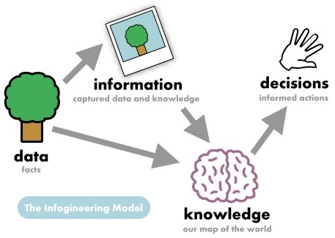 12
Figure 4. 12
Figure 5.0 Demographic Data of Population: 13
Bibliography: 15
Part 1 Case Study Assignment: 17
Question 1: 17
Question 2: 18
Question 3: 19
Part 2 - Information Systems 20
Question 3: 21
Appendices: 22
BIBLAGROPHY: 24

Introduction
Knowledge is what we know, and it is stored in our brain. If you can imagine a map stored inside our brain and it helps us to navigate to where things are, but it also contains our expectations and beliefs that we have. The human brain connects every information, ideas, memories, predictions, beliefs etc all together into a big network. From the signals that are coming through the eyes, mouth, ears, skin which the brain is constantly updating this to our map. Everything is interconnected in the brain. The brain uses two sources to build its knowledge that is information and data. Within a business organization two types of knowledge are defined; one is codified knowledge which is found in documents that is explicit and non-codified knowledge which is personal/experience-based knowledge. Knowledge management can help employees and managements to work smarter by optimising strategy that selects in knowing what to do and filters the information to help improve.

Data Information(question1)
Data needs go through a process before it can be turned into something useful which is identified as” data processing”. Data comes in many forms such as symbols, words and numbers. Data can be transaction, events and facts. See Appendices figure 2. Data isn’t useful on its own. Dark and redundant, obsolete and trivial (ROT) business data, which has an unknown value is a huge burden to organization (Structured, 2020) and that is because it hasn’t been analysed. Not having the knowledge of what is being stored is a risk because you have to comply with either EU regulation (General Data Protection Regulation (GDPR), 2020) or UK data regulations (GOV.UK, 2020).The regulatory body will implement mandatory breach notification and will force businesses to comply with having information and knowledge of data they have. Information is a data that has been processed into a form that is meaningful to recipient according to (Davis and Olson, 1984). Examples of data are below:
If you shop at Asda, after you have paid for the items purchased, you get a receipt of your transaction. This receipt contains data which is processed at the point of sale. It will contain information such as the number of items bought, the price of each individual item and also change given if paid in cash. If you need to exchange an item later the receipt is your proof of purchase. For the store manager this data is useful because its processed to information relaying as to total sales, which product is bestselling and how many customers have been served today. So, the data of all shop transaction has to be captured in order to process it into the managers daily report.
Banks also have data processing of customer information such as Name, address, D.O.B., also all transaction made from your account up to date. This information is important and useful for the bank because they need your personal information in order for identity check, keep a credit check on you to be able to either approve or disapprove borrowing in the future. They also have information on how you maintain your account, overdraft, salary, incoming and outgoing transactions. This knowledge is used by the bank and they keep it stored in their data base. The negative side of this knowledge for the customer is when they apply either for credit cards, loans or overdraft the bank uses the data processed information that they already hold in their system to determine whether to approve or not.
University of Wales Trinity Saint David (UWTSD) they capture information such as student names, date of birth, previous qualifications, the course being studied at present, attendances and which group they are in. This information is organized into the university online system which is then processed and inputted into their data base. The data then is maintained by keeping it in the main campus in Swansea or at an Amazon Warehouse System for data storage. The university will access this data for information in various situations i.e. to issue pass certificates, keep records of study progress, any discipline, exam results and also if the Student Finance of England request for information of that student. The negative part is human error can happen, if you were not ticked in the register when you were in class but was given absent, if you exam results was marked incorrectly, all these incorrect information can be rectified by accessing your data and then correcting it. See appendices fig 1 diagram.

Data, Information and Knowledge (question2):
Data, information and knowledge all have an interchangeable relationship between them, and they are similar concepts, but with some key differences. Thus, it can be said that at present employees, customers, suppliers in organizations all have vital resources which is the collective knowledge that is residing in their minds. Consider for example Amazon, one of the top companies in the world has a net worth of millions in buildings, market capitalization and other physical assets. Amazons valuation also represents its intellectual assets (Learning Solutions Magazine, 2020). This includes copyrights, customer data bases, cloud computing (AWS), utility patent, trademark and Alexa voice assistant According to majority of scholars in the field approach knowledge as compromising of which are tacit and explicit are the primary classes (Crane, 2016). To understand the difference between information and knowledge, there is a need to also know what explicit and tacit knowledge are. The definition of this all is below to understand better:
- Data is without any structure, raw facts and figures, it is valueless, is unprocessed, on its own has limited use, it can be expressed in the form of numbers, letters or symbols and it is just basic information.
- Information is data that is structured, framework of data, it is dependent on data, it is valuable, can be used in decision making, is an answer to a question and meaningful.
- Knowledge is emerged from the transformation of information; it is information that has been synthesized, has values, has contextual information, contains expert insight, these can assist in decision making and taking actions. Knowledge has become the key resource, the quality of knowledge and the productivity of knowledge (Drucker, 1999). You also have human capital who have the knowledge that resides in their minds which are people like researchers, business managers and software developers.
- Explicit is knowledge that is codified and formalized. It is found in memos, notes, documents and data bases.
- Tacit is found in the minds of people and it includes their experience, values, attitudes, skills, capabilities, expertise and cultural beliefs.
When data is collected it is filtered which turns it into information. The filtered information is then determined by how useful the relevant information is according to the subject and this is called knowledge. Data isn’t dependant on information, but information is dependent on data. Data doesn’t carry or have a meaning, but information must have or carry a logical meaning. Below are examples:
A student mark at university is a number which is data but to get the average marks for all students in the class is information that can be achieved after analysing the data.
The temperature readings are data. When this data is analysed and organised to find that the temperature is declining or rising, that finding is called information.
Before a drug can be used by hospitals/doctors, it needs to be approved by an organisation but the manufacturer will have to conduct trial tests and present a lot of data to demonstrate that the drug is safe and useful to prescribe to patients. This data is essential as proof of evidence in helping to back up a claim made by a company. The data has to be analysed into useful information and then it can be put into context to make organizations to see and understand the relevant information.
Websites that have traffic or users from around the world is also data which can be turned to information. There could be information that shows traffic numbers from India is increasing and japans traffic number is decreasing is analytic information which can be useful. The numbers in the traffic can be converted into information that gives a meaning to what these data is displaying on the websites.
Data can be termed as the input for a computer system and the information is the output of data. I.T.is playing a key role in helping to retain, acquiring data, to keeping it stored and also distributing of the information. Therefore IT is needed to manage information and generate knowledge, retain data in the hard drives but that is then stored into big hard drives in data warehouses with large racks of terabytes storage and after that the data is duplicated to several places such as I cloud as backups to make sure the information is saved and it is retained.
Marks (numbers) achieved in an exam results are raw data but from the processed data it then transforms to different sorts of information such as total marks, percentages and overall achievement of that student.
Internet contains inputs of data stored that has been transformed to information in various databases. The internet is now being accessed by organisations, individuals and groups to various information that was inaccessible previously to use as knowledge about, individuals, authors of books, news, government policies etc but the government has erected barriers to certain types of information by introducing the freedom of information act (Data protection, 2020) to protect the public and organizations as to how, what sort of information is accessible.

Explicit and Tacit Knowledge (question3):
In a card game a player would use his tacit knowledge based on his experience, practice, wisdom to analyse the game and plan a strategy. A book about how to play tennis is an example of capture and the sharing of explicit knowledge. However, I could read the whole book or even watch a video online to learn how to play tennis and this would be explicit knowledge. Another example, I took a written examination test for motorcycle license about 20 years ago, to answer the questions I acquired some degree of tacit knowledge from actually riding a motorcycle in Bangladesh. You can show or tell a customer how to write a business plan, how to do market research or how to perform basic accounting skills which are all explicit knowledge. It would be difficult trying to explain how to identify new opportunities for business or explain which local resources is best for them and these are tacit knowledge.
If an old worker in a factory is retiring soon then if the company doesn’t capture their experience, then the person retiring will leave with their knowledge and that is why it is important for companies to be able to relay relevant tacit information to new generation in the organization.

Five Decisions Made Today (question4):
- I was researching a book called BA in Leadership and Management (Maund, 2018).The book is knowledge from the authors point of view, the information is for the person reading it (myself) and the data as well which is contained in the book.
- I went to William hill to place a bet on Liverpool to win against Atletico Madrid. The cashier gave me the slip containing my bet. The knowledge was that I said Liverpool will win, it’s a probability theory of mine but the expected return of wining sum of money is information and the figures (numbers) is the data.
- I went to my GP to give blood samples and also to have my blood pressure checked. The blood pressure is the data, I was told by the GP it is slightly higher than normal that is information. The reason given as to why by my GP was because of my family history, so the conclusion is based on my GPs experience and knowledge.
- I went to local grocery to obtain extra stock in case food prices or if there are shortages. My wife gave a list of items e.g. 1 basmati rice, 2vegetable oil, 10 chicken and 20 kg onions. The items on the lists are data containing numbers(quantity). Using the information on the list I was able to understand using my knowledge as to what are the individual items and the quantity that was required.
- I had a food order to be delivered for a customer at work. As I am not familiar with the area, I had to use my mobile map app. The order slip contained the customers address, phone number and the items of food. I had to input data of the address into the mobile map, then use the information that I needed to take change because the customer hasn’t paid, had to drive using my knowledge of the highway code to get to the customers address and after I reached there I had to read and explain what the items of food was on the order, that was using my knowledge and information.

Collecting Demographic data (question5):
I have developed a new Indian curry dish called Abafado-Decamaro. This is a fusion dish of Goa and Portuguese origin. I will be using data, information and knowledge to launch this product. Census statistic data can help businesses to understand customers, where i.e. the best place to advertise? Which areas and people should be surveyed?
Demographic data population of Warwick is in appendix figure 5, 5.1 and 5.2. As in the census of Warwick north the population was 50% male and 50% female, average age 38, 95.8% speak English, 23.8% are professional, managers & senior officials 12.8%, admin & secretary10.2%, skilled trades 8.3%, business & public service professionals 9.4% and caring, leisure and other services 7.8%. The data
I would use the data of the population in Warwick north by doing the following to promote my new Indian curry dish:
- Do an Email Marketing about free sampling of the dish to local businesses. This could be a monthly newsletter. The newsletter can be used to promote or discuss new dishes in the menu, special offers and new upcoming events.
- Give free samples for customers to introduce the dish and to also get their feedback.
- Discounted price for the dish for a limited period and this will get customers to try the dish at lower price.
- Putting the dish with photos on the restaurants Facebook and website for interaction with online customers. Visual content online is in high demand at present times, having delicious looking photos of the dish across various social media outlets drawing curiosity and hungry eyes.
- Set up comment cards to be placed on every tables in the restaurant to get comment and feedback from customers. From the feedback, whether positive or negative it’s important to take into consideration the reviews of the customer
- Place promotional advert of the dish in local papers, pubs and businesses e.g. one stop shop, hotels, bed & breakfast.
- Restaurant telephone is another way to inform customer about the new dish when the staff who is taking orders for take away service.
- Monitoring social media presence is another marketing strategy. Businesses with strong social media presence as a marketing plan is essential for social success and to engage with your customers. Tools like e.g. Hootsuite, buffer and uber eats will help.

Appendices:
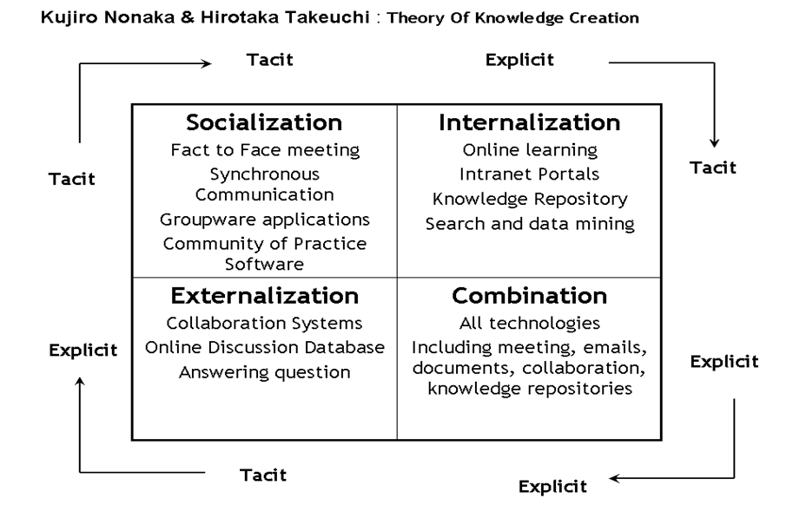
Figure 1 Diagram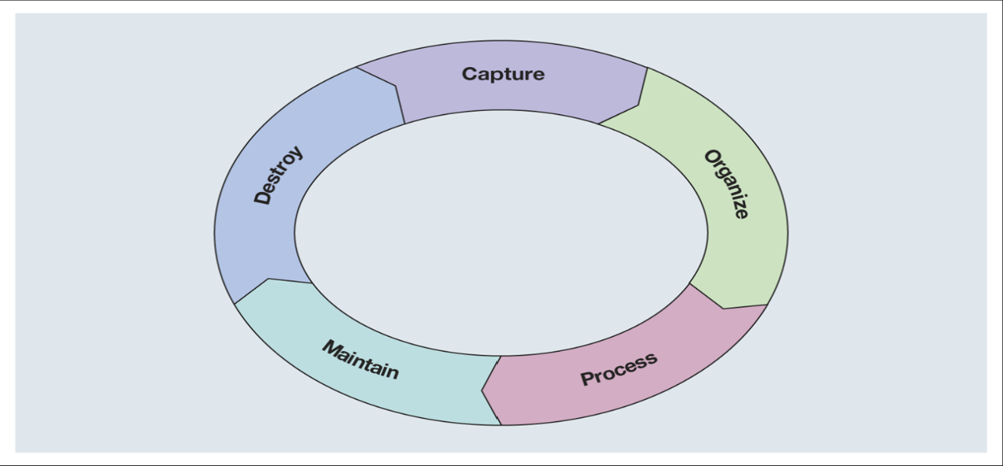

Figure 2:
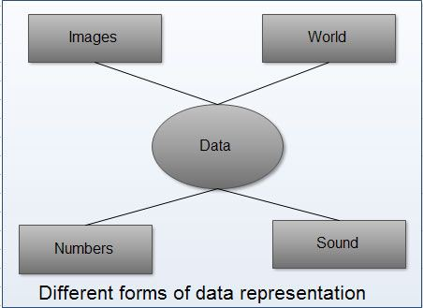
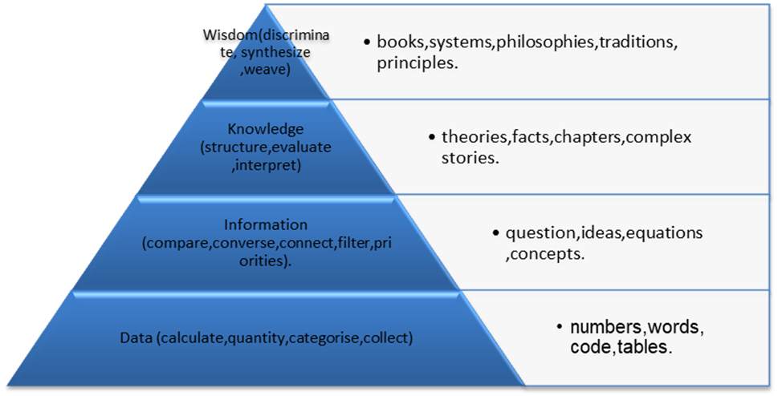Figure 3

Figure 4.

Figure 5.0 Demographic Data of Population:

Figure 5.1

Figure 5.2
Source: Office for National Statistics, (www.statistics.gov.uk) © Crown Copyright 2013.
Figures may not sum due to rounding and all figures are rounded to the nearest 100.

Figure 5.3
Warwickshire Average Salary Comparisons Graph Below:
An average salary is ranging between 30.1k in Nuneaton and Bedworth and 41.7k in Warwick. UK average salary is 37.4k in 2019. Gross average salary is calculated for full-time employees. Employee has to be in the same job for over 12 months. The data collected is Tax Year Ending. The income includes incentive payments and are available for local government districts/counties.

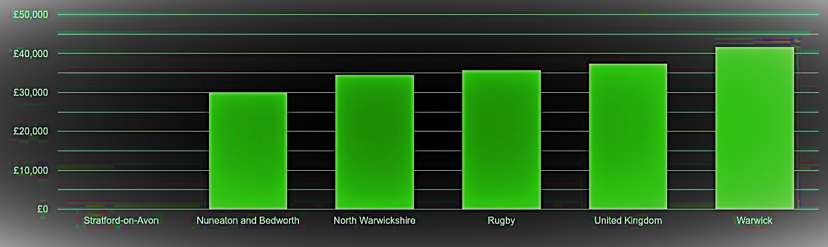

Bibliography:
Baumard, P. (1999). Tacit Knowledge in Organizations. London: Sage Publications.
Bocij, P., Greasley, A. and Hickie, S., n.d. Business Information Systems, 5Th Edn.
Breedt, M. and Van Rensburg, A. (2012). KNOWLEDGE MANAGEMENT PRINCIPLES. The South African Journal of Industrial Engineering, 10(1).
Collins, H. (2013). Tacit and explicit knowledge. Chicago: The University of Chicago Press.
Chapman, R. and Hunt, M., 2010. Freedom of Information. Farnham, Surrey, England: Ashgate Pub
Crane, L., 2016. Knowledge and Discourse Matters. Hoboken, New Jersey: John Wiley & Sons, Inc.
Davis, G. and Olson, M., 1984. Management Information Systems. New York: McGraw-Hill.
Desouza, K. and Hensgen, T. (2005). Managing information in complex organizations. Armonk, N.Y.: M.E. Sharpe.
Drucker, P. (1999). Knowledge-Worker Productivity: The Biggest Challenge. California Management Review, 41(2), pp.79-94.
General Data Protection Regulation (GDPR). (2020). General Data Protection Regulation (GDPR) – Official Legal Text. [online] Available at: https://gdpr-info.eu/ [Accessed 9 Mar. 2020].
Goldman, S. and Scardamalia, M. (2013). Managing, Understanding, Applying, and Creating Knowledge in the Information Age: Next-Generation Challenges and Opportunities. Cognition and Instruction, 31(2), pp.255-269.
GOV.UK. (2020). Data protection. [online] Available at: https://www.gov.uk/data-protection [Accessed 9 Mar. 2020].
Harris, P. (2005). Managing the knowledge culture. Amherst, Mass.: HRD Press.
From <http://warwick-north.localstats.co.uk/census-demographics/england/west-midlands/warwick/warwick-north
Learning Solutions Magazine. (2020). The Knowledge Management Genius of Amazon.com. [online] Available at: https://learningsolutionsmag.com/articles/1480/the-knowledge-management-genius-of-amazoncom [Accessed 8 Mar. 2020].
Lynda.com - from LinkedIn. (2020). Knowledge management skills. [online] Available at: https://www.lynda.com/IT-Infrastructure-tutorials/Knowledge-management-skills/599614/671197-4.html [Accessed 22 Jan. 2020].
Legislation.gov.uk. 2020. [online] Available at: <http://www.legislation.gov.uk/ukpga/2000/36/pdfs/ukpga_20000036_en.pdf> [Accessed 10 March 2020].
Machado, C. and Davim, J. (2014). Transfer and management of knowledge. London: ISTE LTD and John Wiley and Sons, Inc.
Maund, A., 2018. BA In Leadership and Management. [Los Angeles]: SAGE.
Mertins, K., Heisig, P. and Vorbeck, J. (2003). Knowledge management. Berlin: Springer.
Miller, A. (1997). Tacit knowledge. [S.l.]: [s.n.].
Next-Generation Challenges and Opportunities. Cognition and Instruction, 31(2), pp.255-269.
Newell, S. (2015). Managing Knowledge and Managing Knowledge Work: What we know and what the Future holds. Journal of Information Technology, 30(1), pp.1-17.
Pauleen, D. and Gorman, G. (2011). Personal Knowledge Management. Farnham: Ashgate Pub.
Remmen, A., Jensen, A. and Frydendal, J. (2007). Life cycle management. Nairobi, Kenya: United Nations Environment Programme.
Rumizen, M. (2002). The complete idiot's guide to knowledge management. Indianapolis, IN: Alpha.
Sabherwal, R. and Fernandez, I. (2015). Knowledge management - systems and processes. 2nd ed. New York: Routledge.
Starbuck, W., Holloway, S., Whalen, P. and Tilleman, S. (2008). Organizational learning and knowledge management. Cheltenham, Glos, UK: Edward Elgar Pub.

Warwickshire population stats in maps and graphs. - Plumplotwww.plumplot.co.uk › Warwickshire-population
Stoyanov, S. (2018). Ikujiro Nonaka's a dynamic theory of organisational knowledge creation. S.l.: Macat Library Intl.
Structured. (2020). Veritas Global Databerg Report Finds 85% of Stored Data Is Either Dark or Redundant, Obsolete, or Trivial (ROT) - Structured. [online] Available at: https://www.structured.com/veritas-global-databerg-report-finds-85-stored-data-either-dark-redundant-obsolete-trivial-rot/ [Accessed 9 Mar. 2020].
Source: Office for National Statistics, (www.statistics.gov.uk) © Crown Copyright 2013.
Figures may not sum due to rounding and all figures are rounded to the nearest 100.

Part 1 Case Study Assignment:

Question 1:
Cost Leadership strategy is to ensure future long-term competitive advantages, achieving scale economies, utilizing them to produce high volumes at a lower cost compared to other competitors (other airline companies) (Cool and Woo, 1984). Because of the low costs the margins may be narrower, and the quantity is larger, thus enabling higher revenues. These are critically important because the position in the cost curve can have an impact on profitability. The cost leadership was incorporated by American Airlines by changing the manual handwritten system to a web-based reservation system. Moving from manual system to digital SABRE system has saved the company 30% on its investment but it also allowed American Airlines to expand its operation online, gave leverage because of the reservation making assets of the airline, expanding of the system benefitted their travel agents and also made it easier for customers to reserve their seats by using online terminals. The transferring over to ticketing online would also have impact on the reduction of American Airlines operational costs. The SABRE system would also reduce staff costs and also reduce errors. The SABRE was manufactured to reduce the cost of making seats reservation for travelling in American Airline because the other alternative system that was previously in place that was the old handwritten system which was used previously for customer seat reservations. By using the SABRE system resulted in reducing costs, helped to reach more customers, reduced the threat of competitors and enhanced the use of the system efficiently with things such as yield management, crew scheduling and various other executive decisions support tools. Airlines have a level of rivalry because there is a lot of airlines competing for customers globally and these competitive dynamics will have an impact on the profitability within the industry for everyone (Telser, 1998).
Product Differentiation
According to porter’s competitive strategies the risk of customers switching can be reduced by doing the following, first by creating a unique product that is difficult to copy (replicate) and this was done by creating the SABRE system. The second was being able to tailor products to the needs of the customers’ requirements (Zhao, 2012), this was done by having the online booking system, which was also used by the travel agents to finding lower fares for customers and also it was used to make online reservation for hotels and car rentals for the customers. Product differentiation and quality of products are important to consumers and this can attract a large number of customers by focusing on these. This can be achieved by focusing on the understanding of consumers needs through market research and also be able to provide what the customer wants.

Question 2:
The SABRE system provided American Airline with a competitive advantage over other airlines was by using porters five forces model, which is bargaining power of buyers, bargaining power of suppliers, threat of new entrants, threat of substitutes and rivalry among existing players (Magretta, 2012).
Bargaining power of buyers is that the airline industry has two groups of buyers. The first one is individuals that buy tickets for business or personal related. The second group are the middleman between the airlines and passengers. They are travel agents and online portals which is the SABRE system, it has added them the advantage of using this technology to find lower priced fares/tickets. The passengers are now able to look online portals to find the best prices for flying.
Bargaining power of suppliers are the manufacturers. Airlines are very high capital products to make and it is the only source of income for the suppliers. There are three inputs that airline have is aircraft, labour, fuel is all effected by external environmental factors. For this reason, the power of the supplier is high because of the need of the three inputs. For example, American Airlines can have multiple or different suppliers for its supply chain rather than relying on one which would shift the bargaining power away from the suppliers.
Threat of new entrant is high because there is a need for large amount of capital investment is required for establishing a new airline and without a strong customer base there won’t be much profit in the first couple of years. Existing airlines have advantages such as, the SABRE system, existing strong customer loyalty, may use motives which can be to lower their prices and taking a loss in order to retaliate against newer airlines. For a new entrant to enter this market they will need to become licensed, then after that they will be constantly regulated by federal aviation administration, department of transport and all of this will cost a lot of money. Alliance such as American Airline and IBM are able to increase the barriers to entry by strengthening their position and can also strengthen the position of a competitor to a market leader in a market so increasing competition.
Threat of substitute has to be considered after looking at threat. There are substitutes in the airline organization. The customers/passengers can choose alternative forms of transport other than airline such as an automobiles, trains, or ships to get them to their desired destination. There is however a cost to switch to think about for the customer because some transport would be more expensive than a plane whereas its less time consuming and be quicker to use the airline. There is also threat of technology, popularity and branding.
Rivalry among existing players in industry would be intense because the competition now is about the different brand of airlines. There are small and large players competing in domestic and international markets. For example, easyJet is known for its low-cost short destination and emirates is known for the first-class service and long-distance travelling destination. The rivalry is high of existing players and they would push out any competitors who don’t have enough money financially. Changes such as SABRE system has created positive changes to new groups of buyers and has made purchasing flight tickets faster and easier. Conducting a market research to understand the supply- demand situation in the industry can be advantageous because this would prevent overproduction. After researching the porters five forces model in the airline industry, I believe it is vital airlines should make dealing with competition their main priority. There is a diagram of porters 5 forces in appendices figure1.

Question 3:
The factors that contributed to the decline of American Airline was mainly I.T. This joint development by IBM and American Airlines created an advantage against their competitors (Schulz, 1992). Other airlines had no choice but to stay in competition with American Airlines they had to find a way to build their own system to compete against SABRE. Most airlines turned to IBM. IBM then started to expand its knowledge of SABRE system to other airlines and developed other systems for them called PARS (Programmed Airline Reservations System). American Airlines introduced a value pricing system to allow customers to have flexibility, simplicity and fairness but intense price competition forced the closure of this program shortly (Dodds and Hunt, 2012). SABRE separated from American Airlines and then formed its own company called Sabre Holdings Corporation in 2000 (Sabre.com). This new PARS system innovation had major impact on other airlines, it made them realize the importance of having a digital electronic reservation system in order to transform their efficiency in the distribution of airline products. Eventually a customer reservation system (CRS) was created within the travel industry. The department of transportation (DOT) in America had The Airline Deregulation Act of 1978(Dempsey, 2015) which lifted restrictions where airlines can travel to, price of fares and access to routes of any destination. This effected big airlines such as American airlines who had a CRS system that they owned that was used to control the dominance of regional airline markets and was used as a weapon against new entrants or existing carriers. Then you had the growth of the internet as a shopping tool for airline passengers. The internet is like a second generation of CRS system (Doganis, 2001). The internet encouraged airlines to communicate directly with their target market (passengers). This made the whole competition evenly open for all so American Airline lost its advantage and now had to compete with everyone in the industry.

Part 2 - Information Systems
- Information system is a combination of hardware, software, data, people and processes such as telecommunications that is built and used for the purpose to collect, create and to distribute data (Kurbel, 2008). It can also be described as interrelated components which work together to collect, process, store, and these information help to support decision making, coordination, control, analysing and is also used in visualization. Hardware is a computer equipment that is used for inputting, processing and outputting of activities. Software is the computer programmes that govern the operation of the computer system. Database is the collection of facts, numbers and information in an organization. People are inputting in the system as network managers, data entry operators, programmers and system analysts. Telecommunications are networks, computer equipment’s and used to connect computers. Procedures are strategies, policies, methods and rules for using computer-based information system. So, it is different components that work together to provide value to organizations.
- A computer-based information system is the processing of data into quality information that is then used as a tool in decision making. These are a few examples below:
- Transaction Processing System. This processing is used to record the day to day transactions. For example, a PDQ machines are used in restaurants and cafes. The PDQ will handle all card transactions, tips or gratuity, cancel transaction for refunds, end of day totals of transaction and also all totals of different cards such as American express, debit cards and other credit cards.
- Data Processing system. Data is raw facts, figures, numbers which is then turned into information. At university a student would fill an admission form. In this form it would have raw facts such as name, address, other qualifications, hobbies, e mail and contact number etc. This data is collected and put into the university computer system which turns this into information of that student.
- Management information system (MIS). This system provides management with summary of operations in the organizations. The MIS consolidates information such as data of sales, production, marketing and finance to help managers and decision makers. Having MIS installed increases operational efficiency in the organization.
- Workflow system. This is a management system that directs, coordinates and monitors all interrelated tasks which have been arranged to form a business process. There are three types of workflow software. The first one is Administrative. This focuses on tracking expense reports, travel requests and messages. The second one is Ad-hoc system which deals with the design or shaping of products, proposal of sales and strategic plans. The third one is Production system which is concerned about insurance claims and mortgage loans. A workflow system can be online based, can also be combined with e mail, it may be based on server architecture that uses database or a file server.

Question 3:
Managers are able to receive information from various sources to help in decision making. The most formal information channel would be the organizations computer-based information system (CBIS). The CBIS uses electronic computing technology to create the information system. The use of computers for the solution of many businesses problems has grown rapidly. The advancement of technology has made it possible for a wide variety of systems that managers are now using to make and implement decisions. There are different kind of information systems and levels in every organizations. The organization will have management, strategic, operational levels and then you have the functional areas, such as manufacturing and production, sales and marketing, accounting and finance and human resources. Information systems are built to manage and serve these different departments in the organizations. Below is a breakdown of how CBIS supports managers at each level:
Management level system is supported by monitoring, controlling, decision making, non-routine decision making (system answer” what if” questions) and middle managers or supervisors’ administrative activities.
Strategic level system is supported by helping management in tackling and addressing strategic issues that occur internally and externally. Also, long-term cost trends for planning ahead in the future.
Operational level system aids operational managers by keeping and updating information about activities and transactions of the organization, these may be sales, cash, workers payrolls, flow of materials and receipts. The system may include information such as number of hours worked by employees, have records of bank deposits, expenses claimed by managers and the information must be current, accurate and be available when needed.
Sales and Marketing system is supported by data of information about daily sales figures, orders processed, track monthly sales figures, reports of sales increasing or decreasing below level and also be able to forecast sales trends over a certain period.
Transaction Processing System is a system that uses both hardware and software components to manage high data volume. The system has input, output, storage and processing functions. This system supports organization by having information such as invoices, customer orders, employee records, check clearances, order processing, delivery of product payments and all this is stored in the memory, it may be in the form of ledgers or other format. This is system used for examples, by trains for tickets, retail stores for selling goods and services and the library use it for keeping track of borrowed books etc.
Decision Support System provides rational, measurable and scientific data to help make informed decisions. The system has manual, hybrid and all types of analytic decision software. This system is able analyse large amount of data, determine patterns, evaluate different alternatives and then be able to provide with a data driven recommendations that helps in making decisions.

Appendices:
Figure 1.
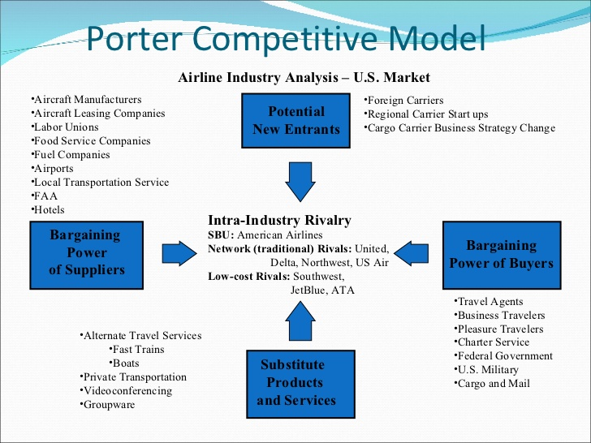

BIBLAGROPHY:
Behavioral, Economic, and Management Sciences, Krannert Graduate School of Management, Purdue University.
Boberg, K. and Collison, F., 1985. Computer reservation systems and airline competition. Tourism Management, 6(3), pp.174-183.
Belobaba, P., Odoni, A., Barnhart, C. and Bamber, G., n.d. The Global Airline Industry.
Bog, A., 2015. Benchmarking Transaction and Analytical Processing Systems. [Place of publication not identified]: Springer.
Boldt, R., 1994. Management Information Systems. Washington, D.C.: National Academy Press.
Burstein, F. and Holsapple, C., 2008. Handbook on Decision Support Systems. Berlin: Springer.
Bhushan, N. and Rai, K., 2004. Strategic Decision Making. London: Springer.
Long Range Planning, 1992. Competitive strategies for product standards: The strategic use of compatability standards for competitive advantage. 25(2), p.130.
CAPA - Centre for Aviation. 2020. Airline Product Differentiation to Customers Still in Its Infancy: CAPA Americas Summit (VIDEO). [online] Available at: <https://centreforaviation.com/analysis/reports/airline-product-differentiation-to-customers-still-in-its-infancy-capa-americas-summit-video-277774> [Accessed 24 March 2020].
Cool, K. and Woo, C., 1984. Porter's (1980) Generic Competitive Strategies. West Lafayette, Ind.: Institute for Research in the Behavioral, Economic, and Management Sciences, Krannert Graduate School of Management, Purdue University.
Dempsey, P., 2015. Federal Preemption of State Regulation of Airline Pricing, Routes, and Services: The Airline Deregulation Act. SSRN Electronic Journal.
Dodds, W. and Hunt, K., 2012. Legend Airlines: American Airlines Worst Nightmare? Journal of Business Case Studies (JBCS), 8(2), pp.135-140.
Doganis, R., 2001. The Airline Business in The Twenty-First Century. London: Routledge.
Hamill, J., 1993. Competitive strategies in the world airline industry. European Management Journal, 11(3), pp.332-341
Hooley, G., Nicoulaud, B. and Piercy, N., 2011. Marketing Strategy and Competitive Positioning. Harlow: Pearson Education UK.
Kim, M., 2008. An Exploration of How Generic Strategies of Cost Leadership and Differentiation Create A Competitive Advantage. Oxford: Oxford Brookes University.
Kurbel, K., 2008. The Making of Information Systems. Berlin: Springer.
Magretta, J., 2012. Understanding Michael Porter. Boston, Mass: Harvard Business Review Press.
Market Realist. 2020. Competition in Airline Industry. [online] Available at: <https://marketrealist.com/2014/12/low-entry-barriers-intensify-competition-airline-industry/> [Accessed 24 March 2020].
Moreno-Izquierdo, L., Ramón-Rodríguez, A. and Perles-Ribes, J., 2016. Pricing Strategies of the European Low-Cost Carriers Explained Using Porter's Five Forces Model. Tourism Economics, 22(2), pp.293-310.
notesmatic. 2020. Five Forces Analysis of American Airlines. [online] Available at: <https://notesmatic.com/2017/11/five-forces-analysis-american-airlines/> [Accessed 18 March 2020].
Oum, T. and Park, J., 1997. Airline alliances: current status, policy issues, and future directions. Journal of Air Transport Management, 3(3), pp.133-144.
Porter Analysis. 2020. Porter’S Five Forces Analysis of Aviation Industry|Porter Analysis. [online] Available at: <https://www.porteranalysis.com/porters-five-forces-analysis-of-aviation-industry/> [Accessed 18 March 2020].
Sabre.com. 2020. [online] Available at: <https://www.sabre.com/files/Sabre-History.pdf> [Accessed 23 March 2020].

Schulz, W., 1992. The emergence of the real-time computer reservation system as a competitive weapon in the U.S. airline industry 1958–1989. A paper on strategic innovation. Technovation, 12(2), pp.65-74...
Shaw, S., 2011. Airline Marketing and Management. Surrey (England): Ashgate.Telser, L., 1998. Theories of Competition. New York: North-Holland.
Shaw, S., 2011. Airline Marketing and Management. Farnham, Surrey: Ashgate.
Valacich, J., Schneider, C. and Jessup, L., n.d. Information Systems Today.
Weil, K., 1985. PORTER, Competitive advantage, creating and sustaining superior performance. Revista de Administração de Empresas, 25(2), pp.82-84.

Zhao, H., 2012. Three Essays in Applied Microeconomics: Product Differentiation, Consumer Preference and Reputation. Pullman, Wash.: Washington State University.

