Jayson Finch student n.o (2533433)

course name: CertHE Computing Skills for Workplace.

module name: Computer Architecture and Operating Systems.
Letucture: Redhwan Al Amiri

Key functions of general Operating Systems

Introduction:
An operating system (OS) regulates system software and administers the computer's hardware and software resources, including Linux, macOS, and Android. Additionally, it permits people to communicate with the computer and ascertain that software operates as intended. Operating systems undertake numerous tasks such as managing processes, overseeing memory, processing files, controlling devices, and ensuring security[1].
2. Oversight of procedural operations
The operating system manages all executing programs. • Commences application submissions • Concludes applications
• Allocates processing power • Distributes CPU resources • Shares computational capacity
• Halts programs that lead to system lock-ups
When you access objects like: • Chrome Browser
• The music streaming service Spotify
• Term
The operating system administers all processes concurrently.

Figure 1 Processes management…

These shows activity monitor in macOS showing processes and CPU usage. Process management these important and key function of a operating system. The operating system controls running applications to run all at the same time and allocates processor resources and it enables multitasking the operating system ensures that multiple programs can run at the same time while still being able to maintain system stability and performanceFormatting...

Memory management
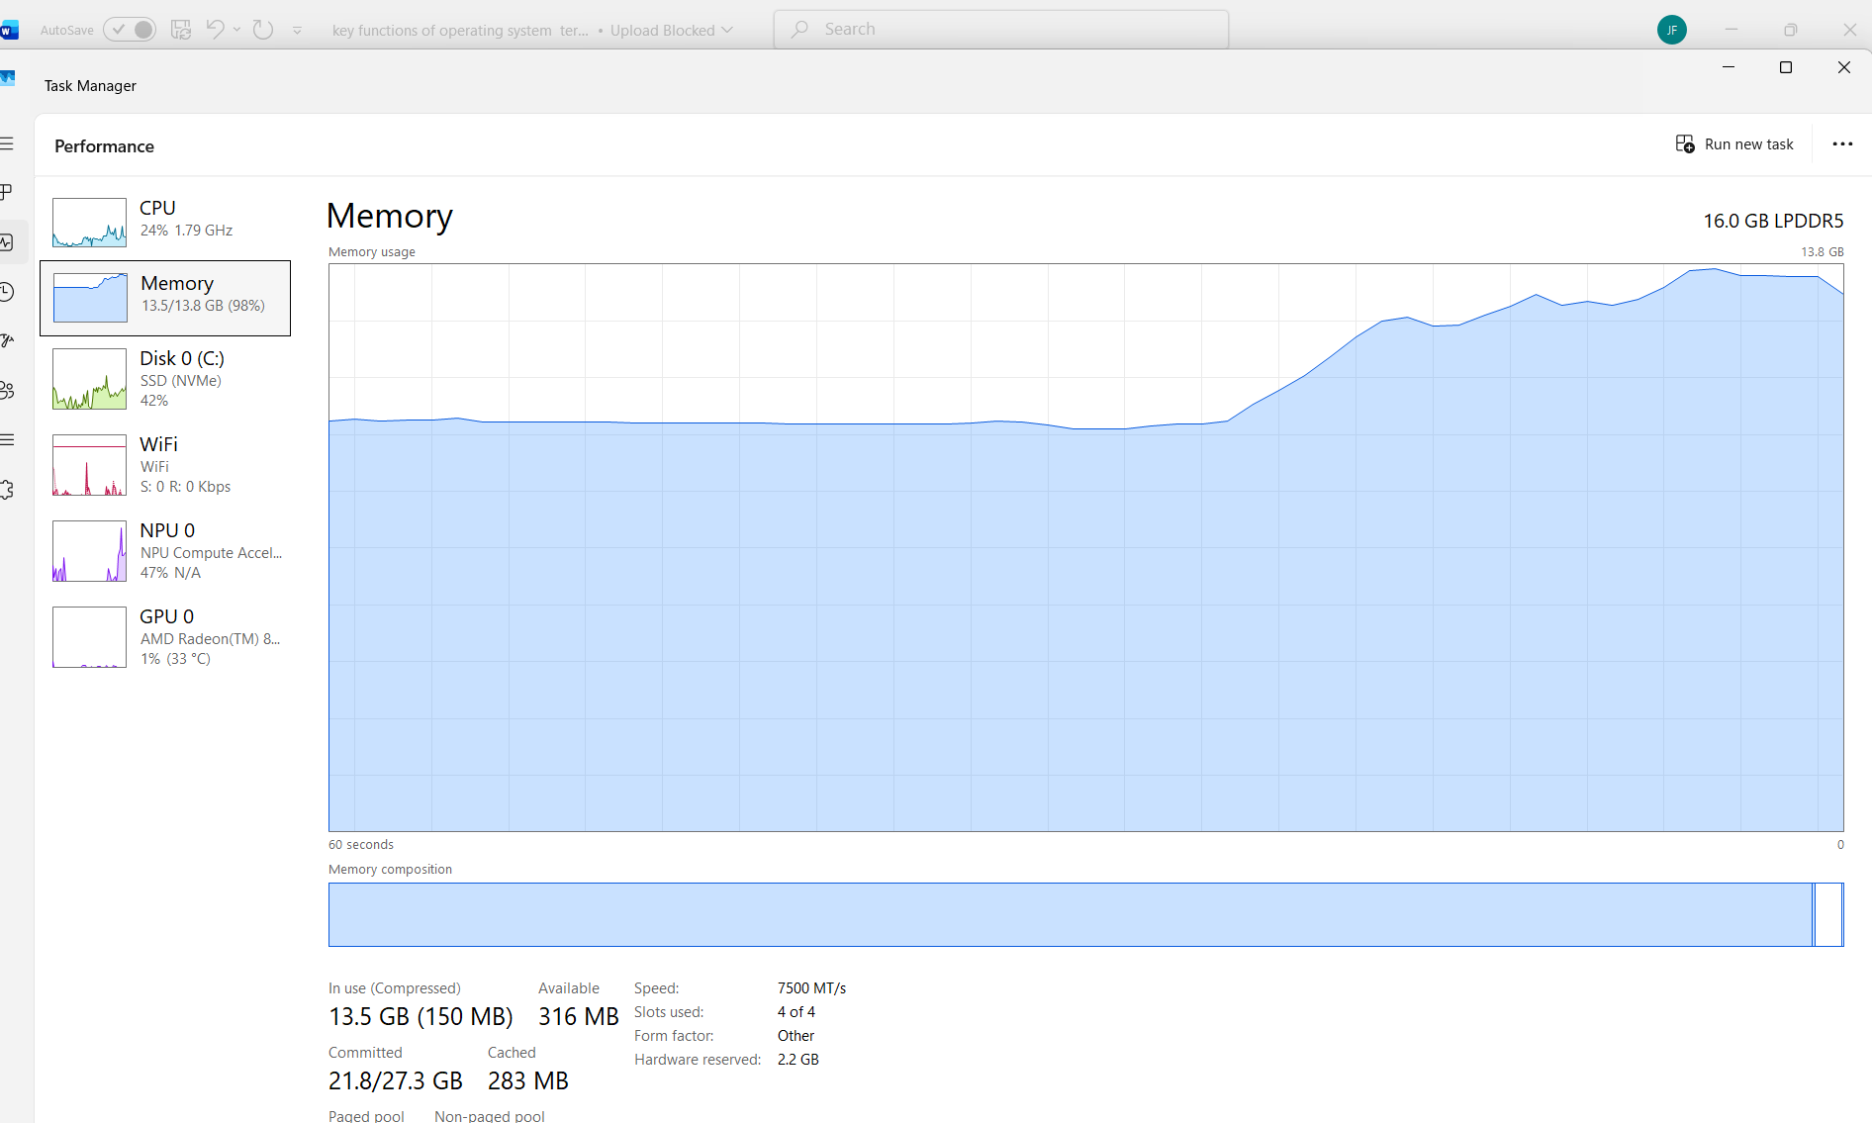
Figure 2 Memory……

These shows memory usage in the macOS and memory management is responsible for locating the ram to applications and system processes. Efficient memory management helps to maintain performance and prevents applications from interfering with one another[1], [2].

Operating system controls how ram is sheard between applications and system processes. Ram is temporary memory that allows programs to run quickly while the computer is switched on.

When applications such as safari, Microsoft , word or finder are opened macOS allocates memory to them so they can work properly .

The operating system also monitors how much memory is being used helps them to prevent one application from using to many resources. These improves system performance and allows the systems from freezing.

File management

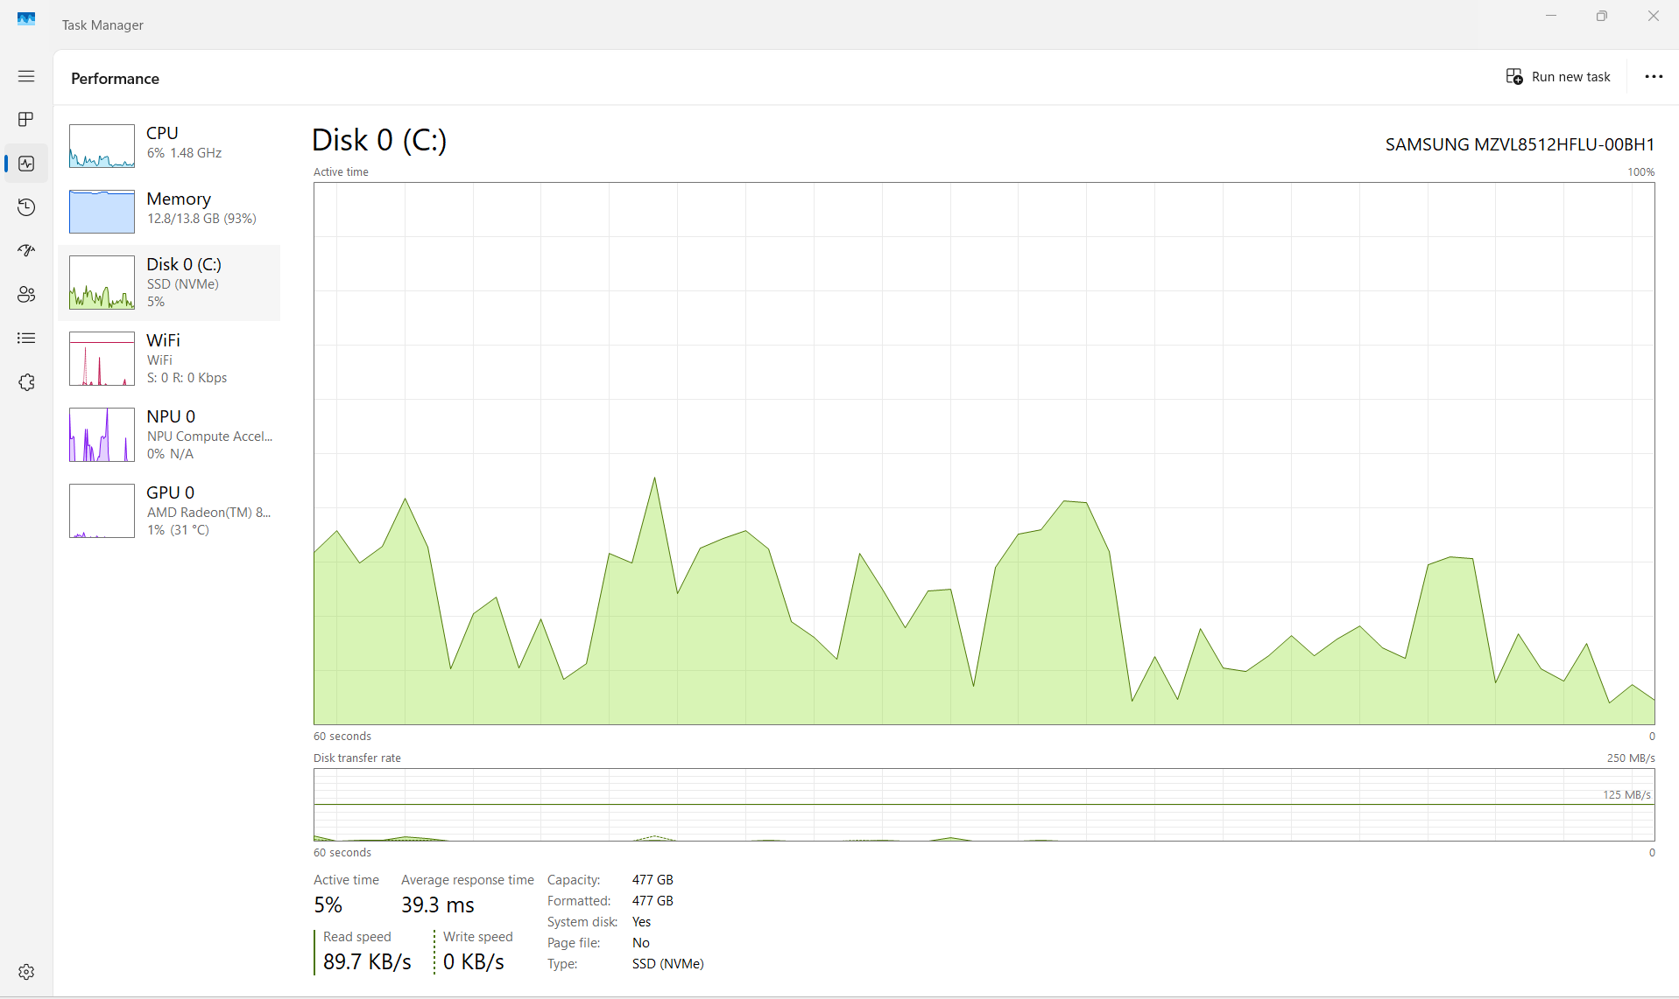

Figure 3

Shows Finder in macOS displaying files and folders also downloads these allows store and organise, move, and delete files. Finder provides an easy way to access and manage stored data on the computer, so this is a key function of operating systems. This allows users to organise, store, move and delete files. They can provide an easier way to access and manage data that is stored on the computer[1]-[3].

Device management

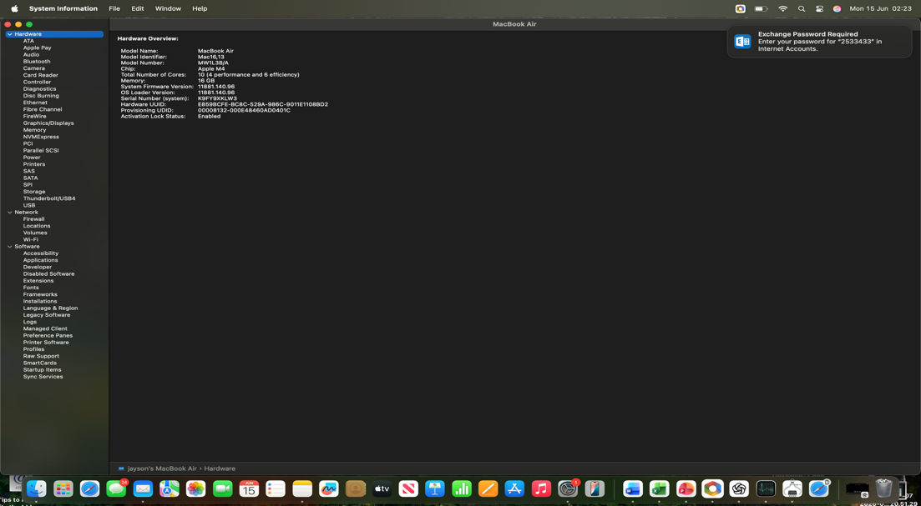
Figure 4 device management…
Shows device management settings in macOS allows the operating system to manage work or accounts a configuration profiles . but no profiles are currently installed on this device. But I recommend getting the system report screenshot instead as it better matches my assignment requirement for device management.
Also, device management for e.g. profiles can manage wi-fi settings, security rules email accounts, app restrictions and device permission. Device management is a very important function because it allows administrators to control how device are configured and secured and connected to services[1]-[4].

Security and user management

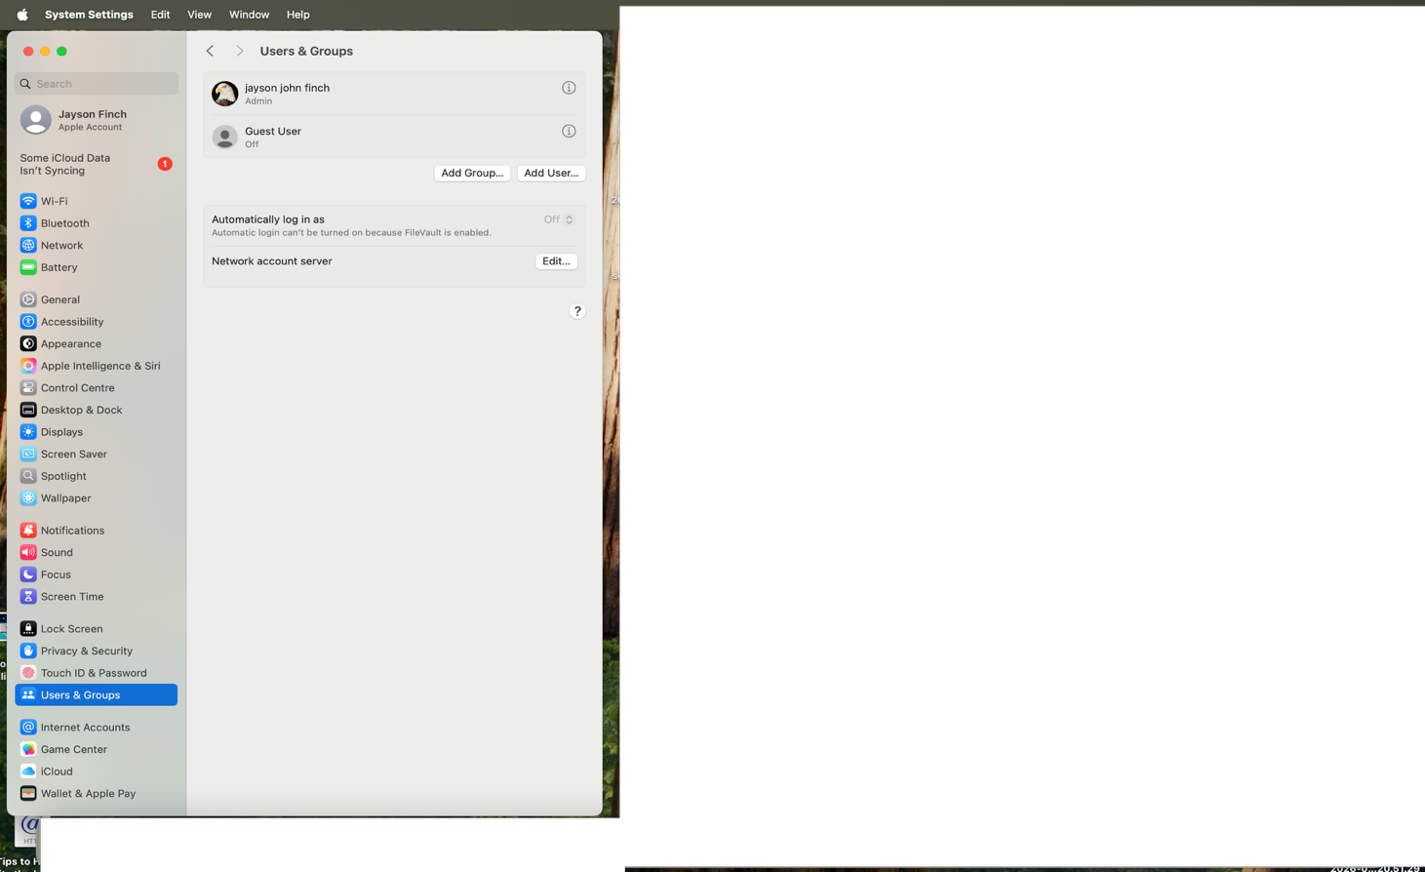

Figure 5 security and user management…
These is showing the users and groups settings in the macOS. Security and user management is very important function because it controls the users accounts passwords and permissions. And the operating system helps to protect data and ensures only authorised users access the system also the page shown allows administrator privilege and guest users settingsFormatting....

Network management

figure 6 network management…
network management is an important function operating system as it shows internet and network connectivity. The operating system job is managing wi-fi connections , Ip addresses and DNS settings and network security. These setting allow devices to communicate with other computers and to accesses online resources.

Windows cli commands
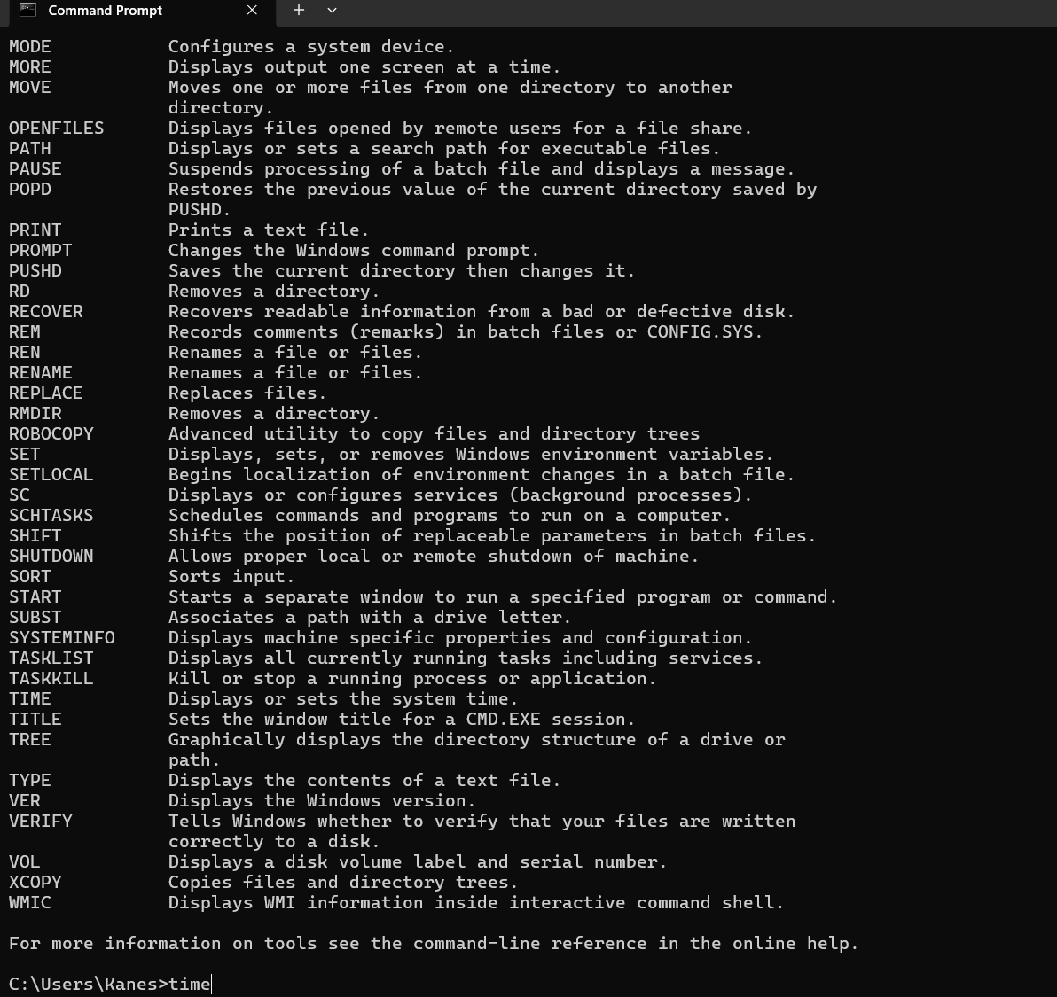
- Time: This command should show the local time of the machine
- I input the time command into the command prompt. This command reveals the present local system time and permits the user to input a new time. I utilised it to verify the time presently configured on the pc[1]-[5].

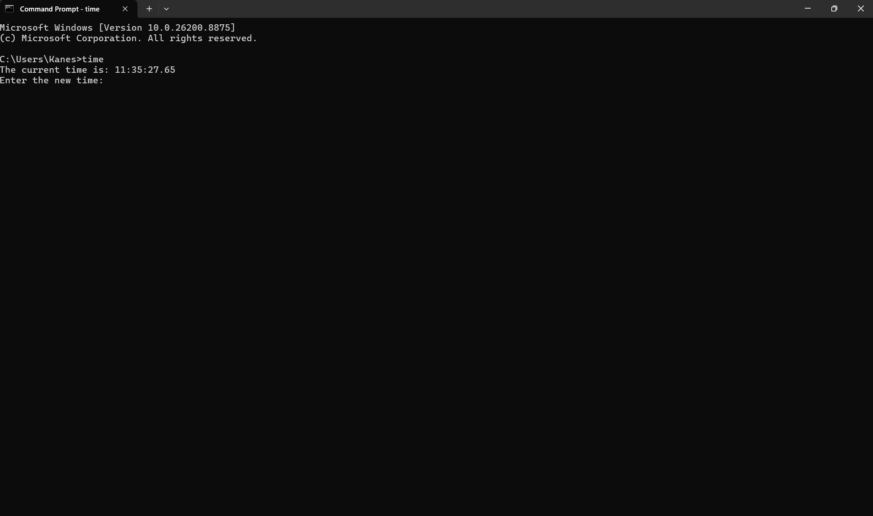

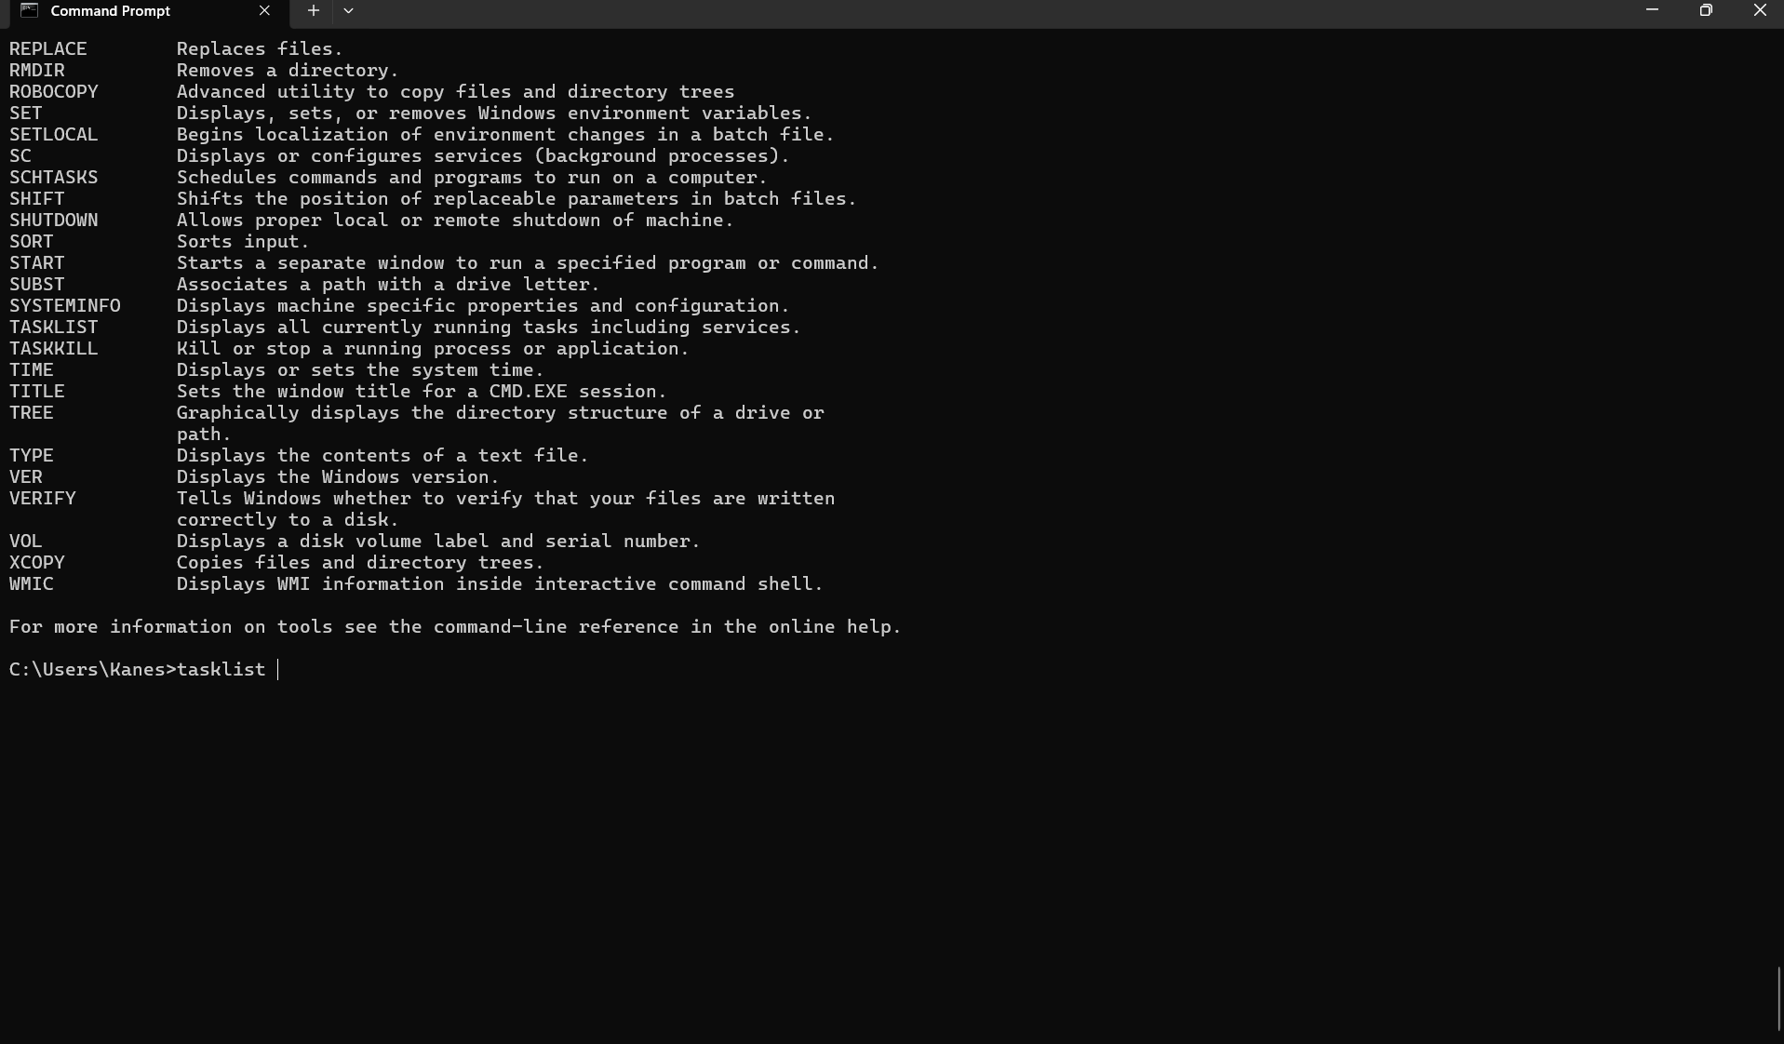
Tasklist
I executed the TASKLIST command within the Command Prompt. This command reveals a roster of the processes and apps that are actively executing on the machine. It can serve as a tool for assessing which programs are currently running and pinpointing processes that could be utilising system resources.

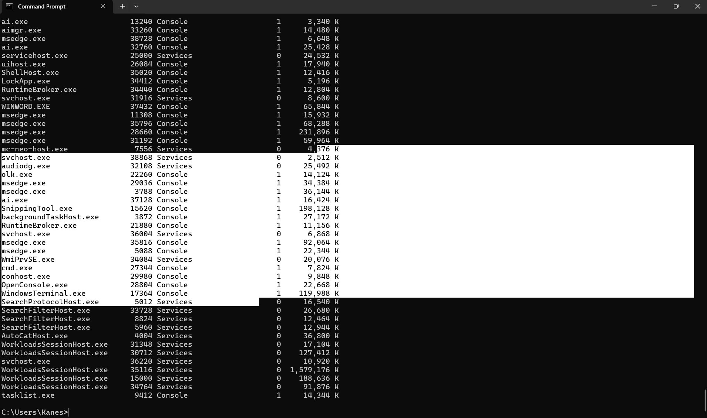
The is the output of the command tasklist showing you all the different task.

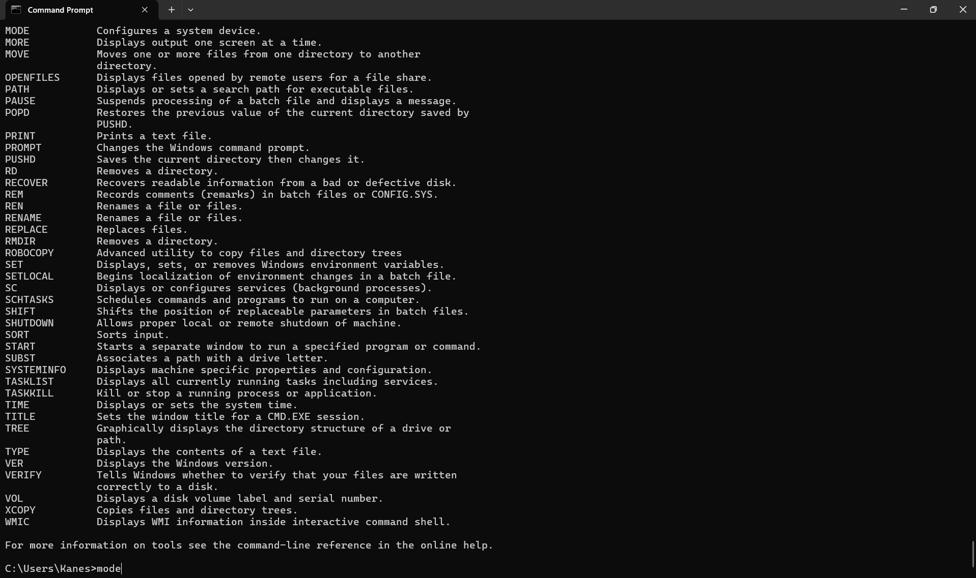
Command Mode:
I inputted the MODE command into the Command Prompt. The MODE command serves to exhibit or adjust system devices and configurations, including communication ports and displays.

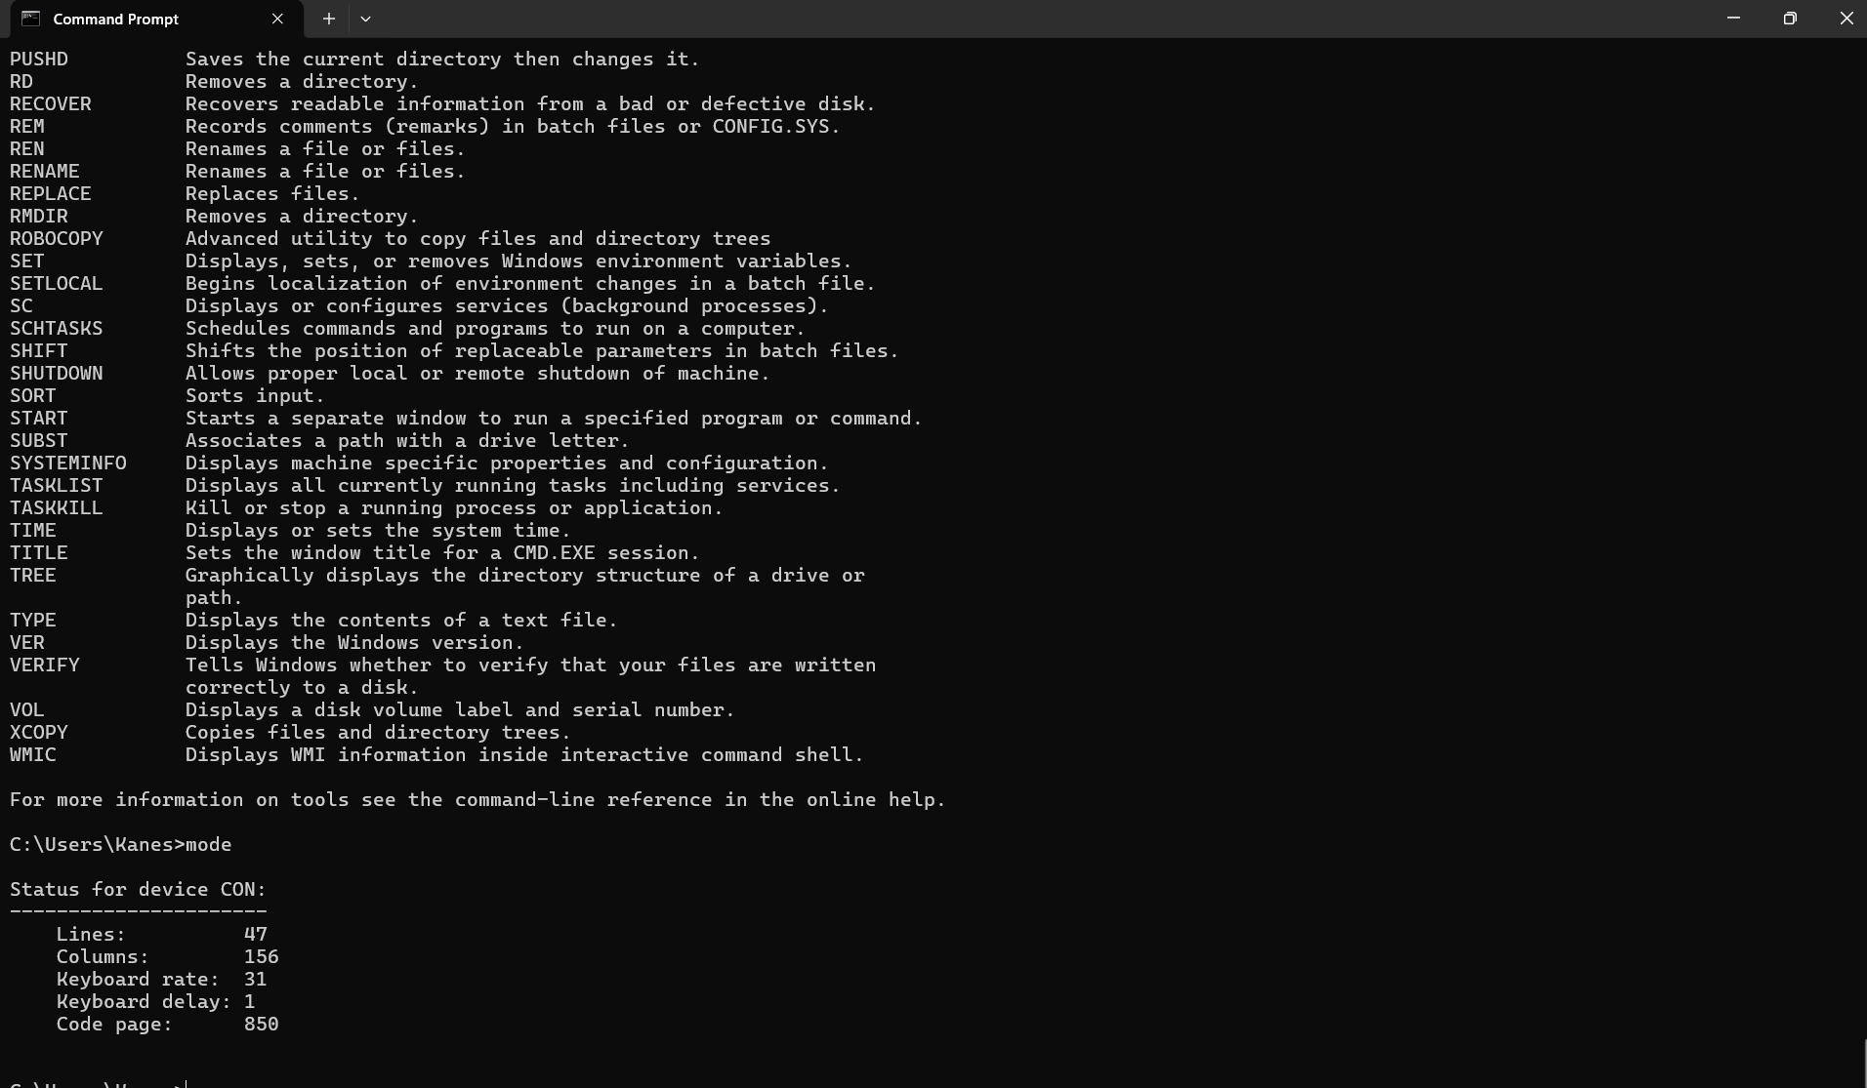
These is the output for command mode .

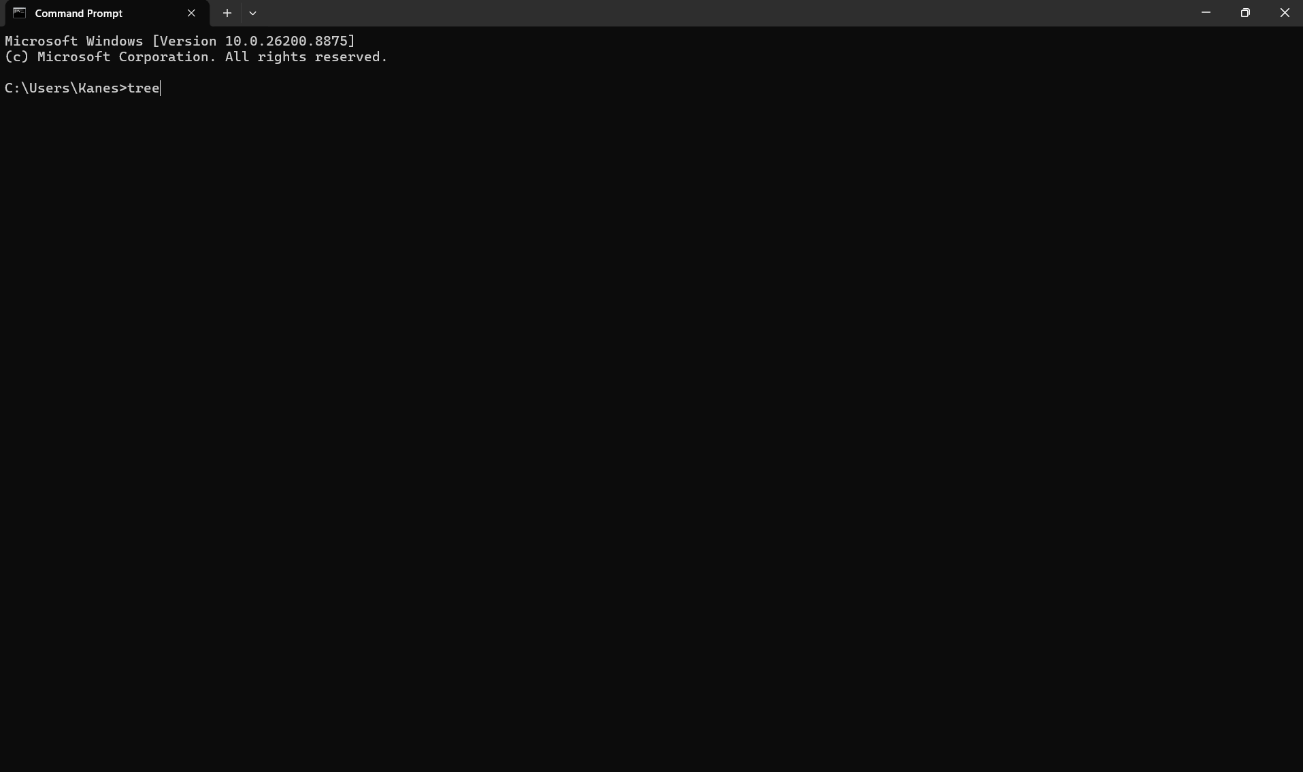
I executed the TREE command at the Command Prompt. This serves as the input, as I am instructing the computer to display the folder and directory configuration.
Subsequently, inscribe beneath the screenshot that displays the outcomes:
I'm sorry, but I need the text you would like me to paraphrase. Please provide the content you'd like me to work on.
The computer executed the TREE command and presented the directories and subdirectories in a hierarchical format. This is the result generated by the command.

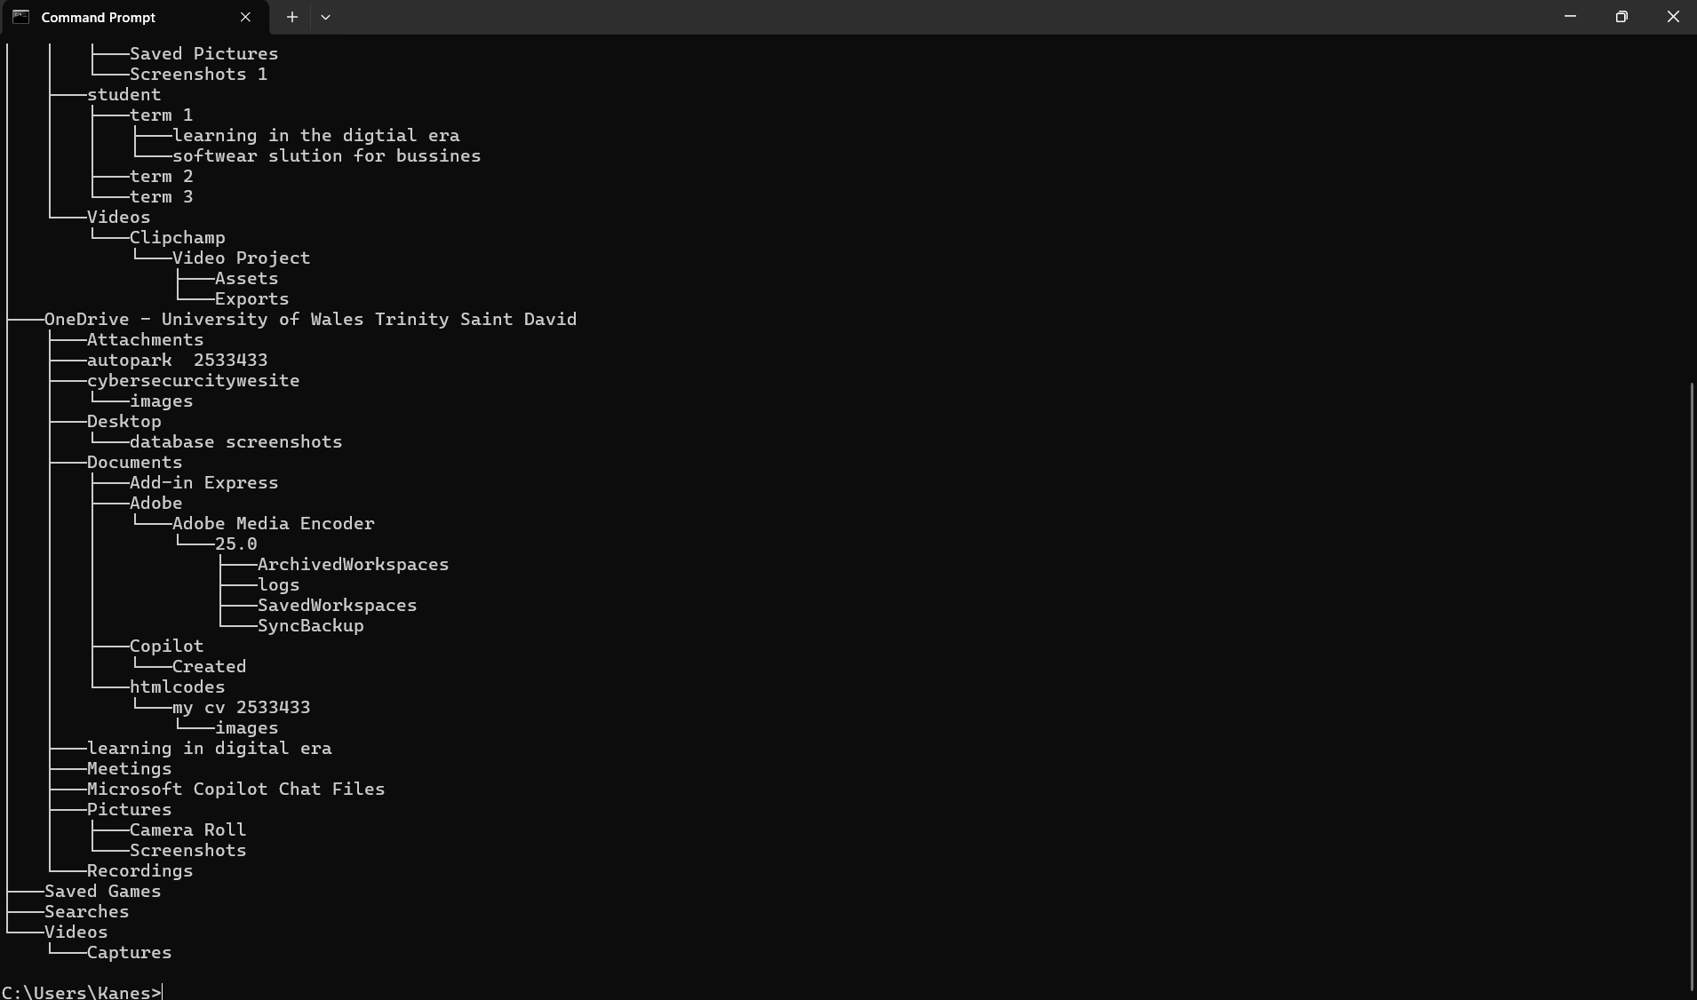
These is the output of the command tree.

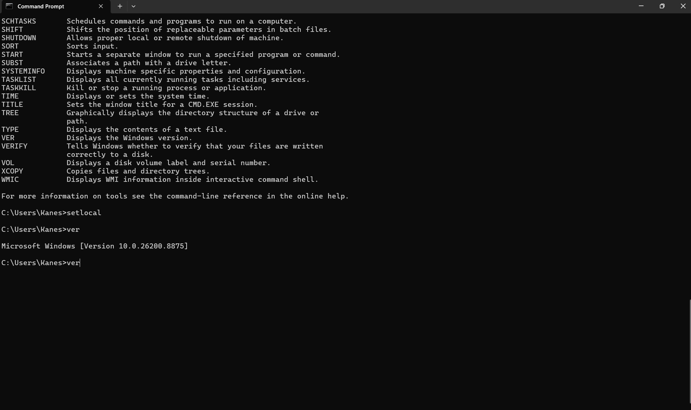 VER Directive:
I entered the VER command in the Command Prompt. This command reveals the version of Microsoft Windows presently installed on the system. The result indicates that the PC is operating on Microsoft Windows Version 10.0.26200.8875.

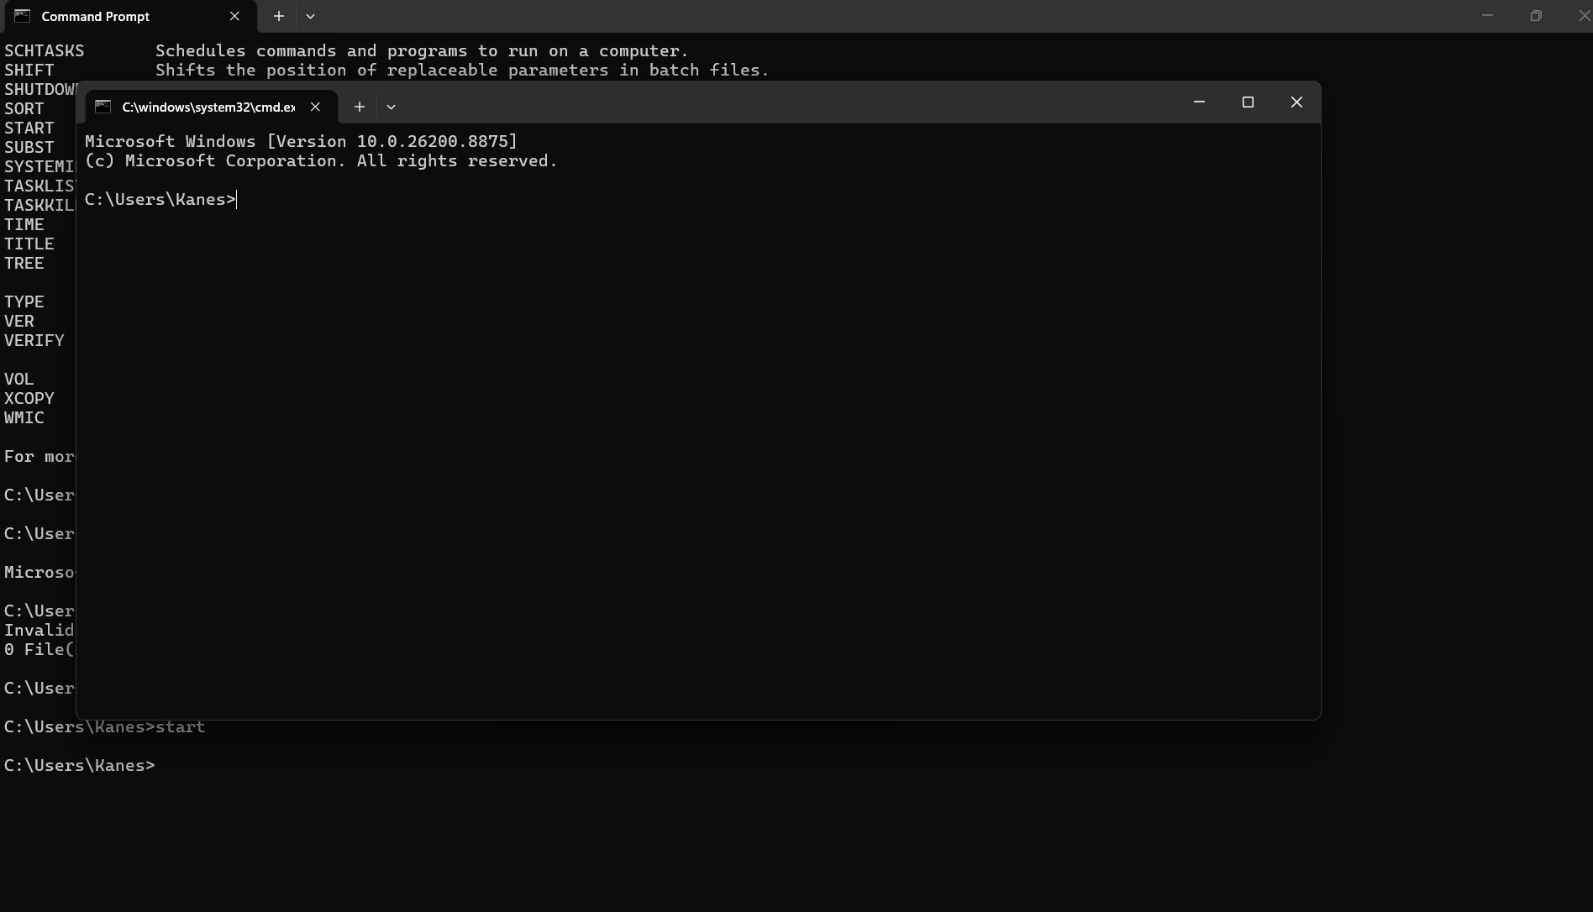

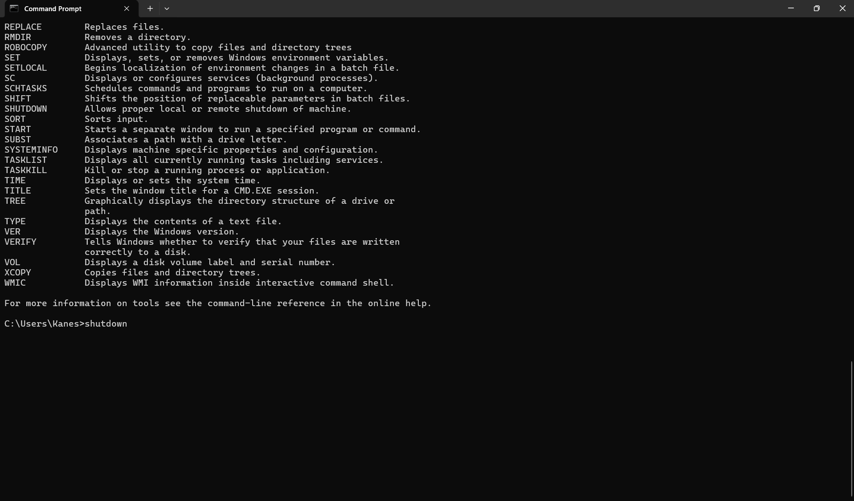 I entered the SHUTDOWN command into the Command Prompt. This command serves to power down, reboot, or log out of a Windows machine. Various alternatives may be incorporated into the command based on the necessary action.

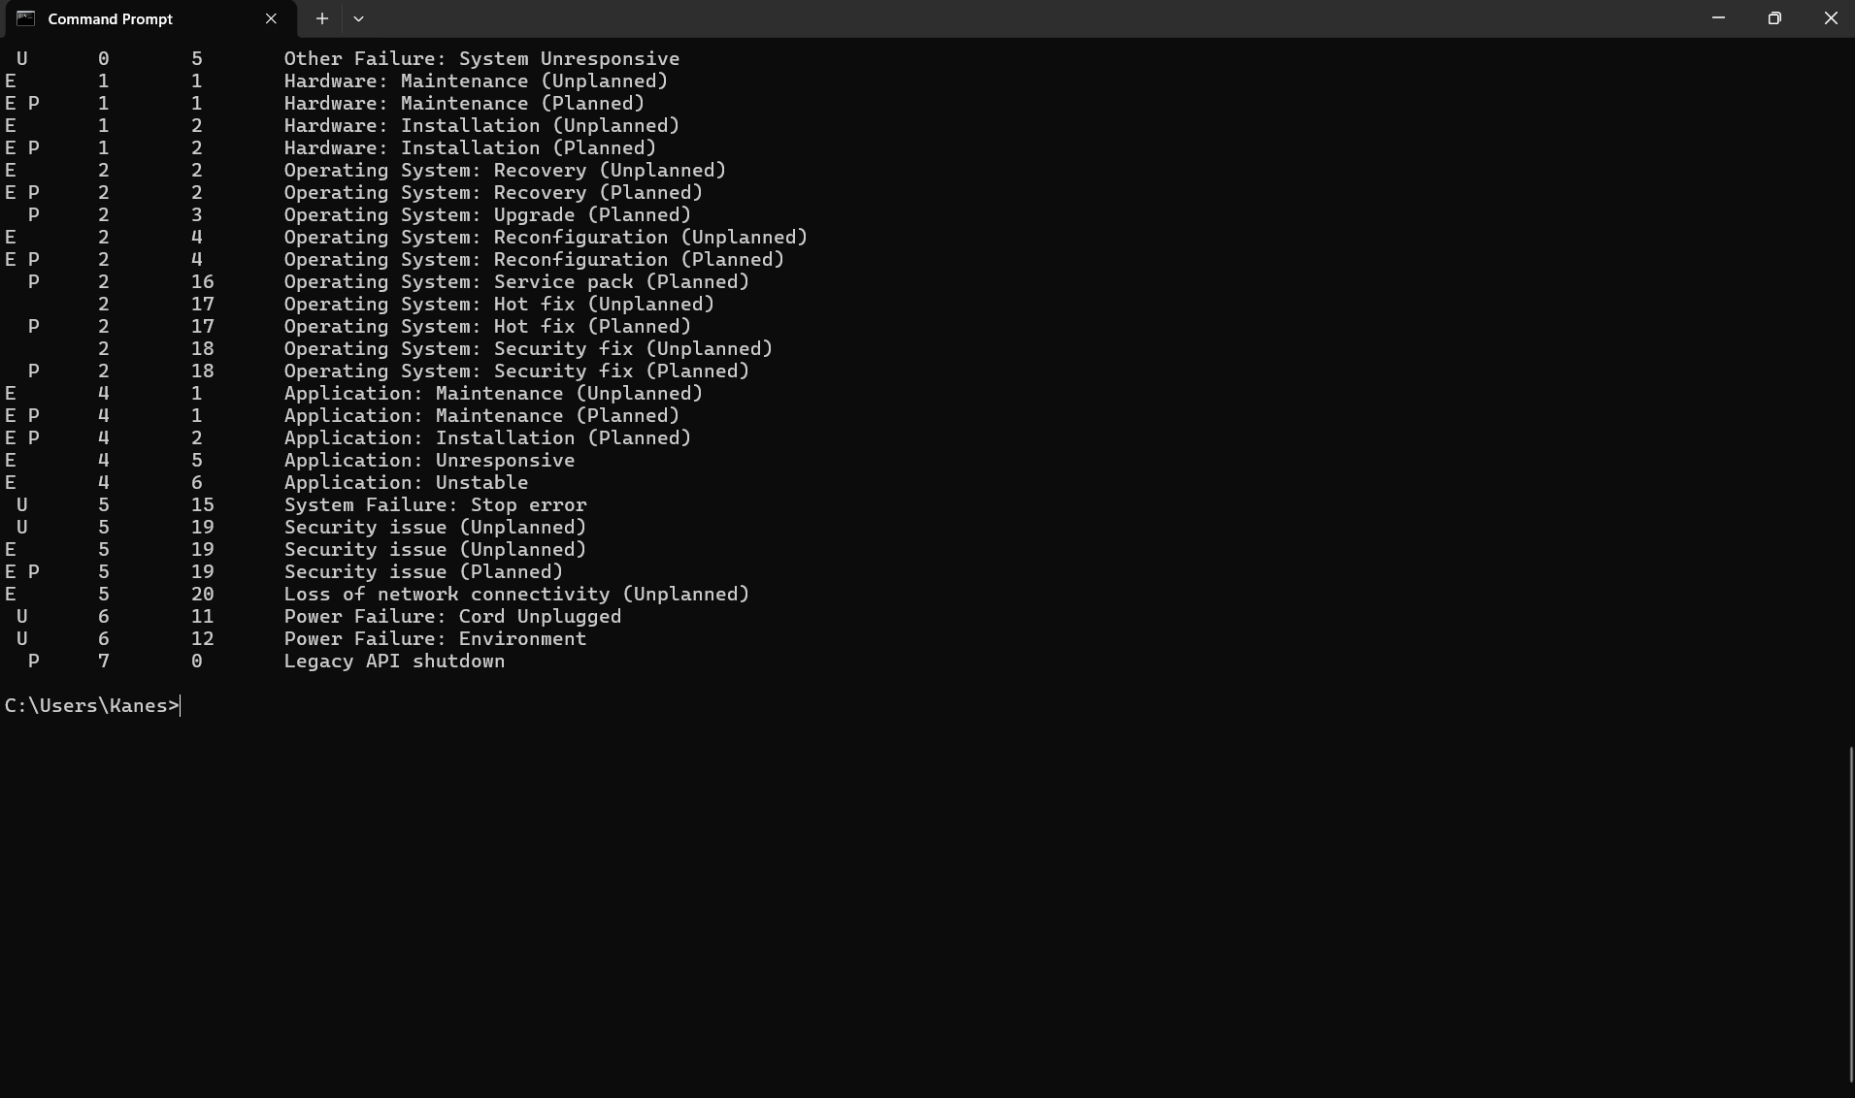

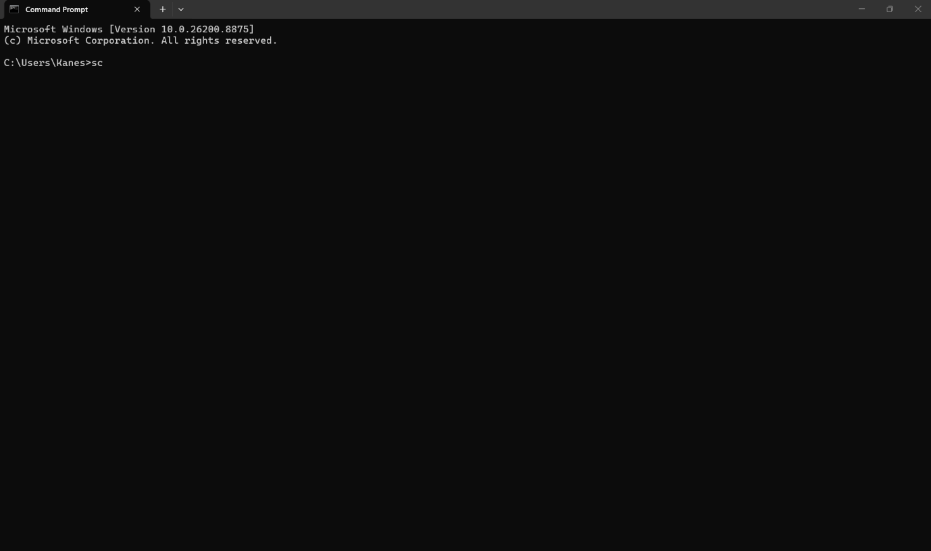
I entered the SC command into Command Prompt. The SC command is used to communicate with the Windows Service Control Manager. It can be used to view, start, stop and configured

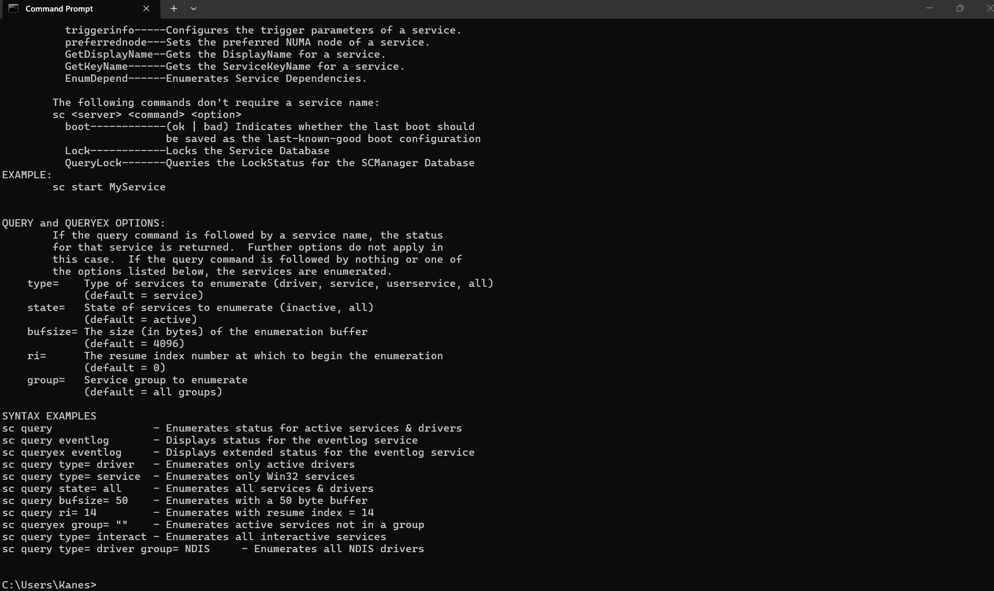
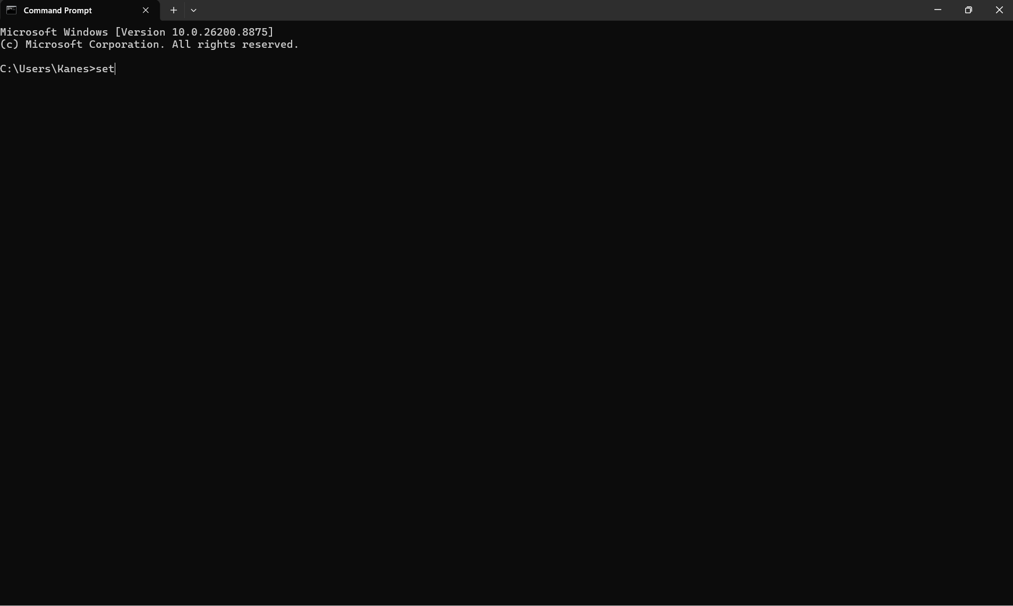 I input the SET command into the Command Prompt. This instruction is utilised to display, configure, or remove environment variables in Windows. Upon hitting Enter, the computer exhibited the environment variables presently configured on the system.

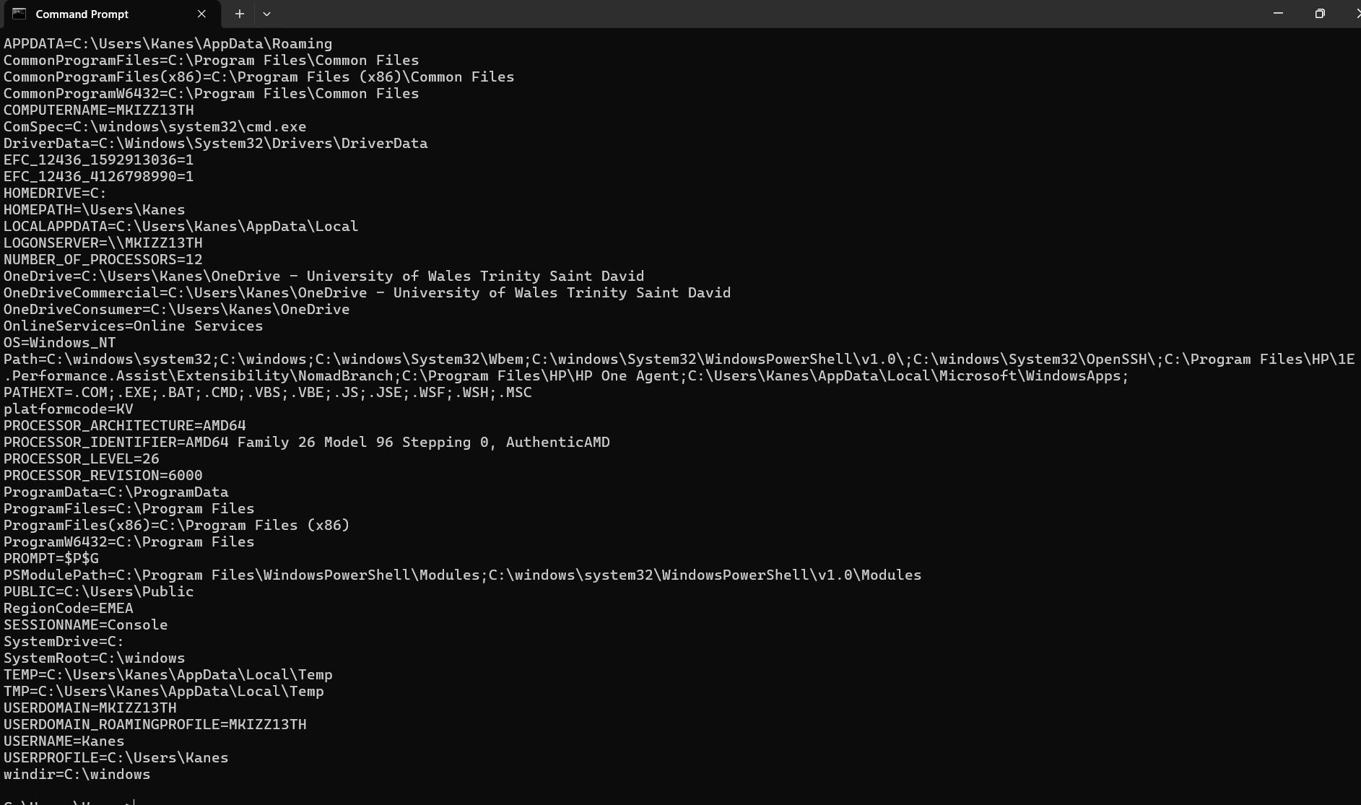
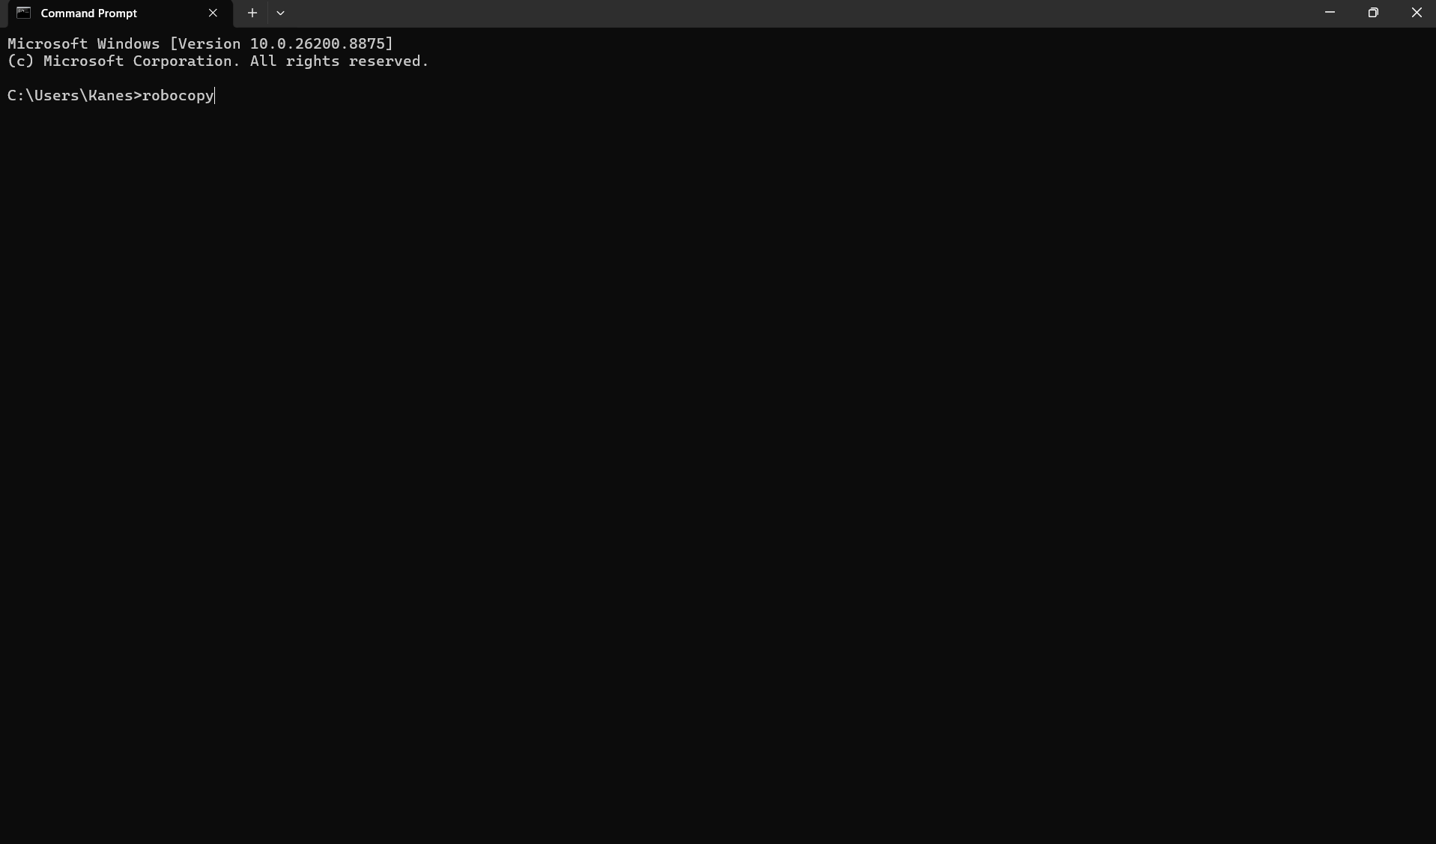 ROBOCOPY command
I entered the ROBOCOPY command into the Command Prompt. This directive facilitates the duplication of files and directories from one site to another. It is advantageous for duplicating substantial quantities of data and can also maintain file metadata and directory configurations.

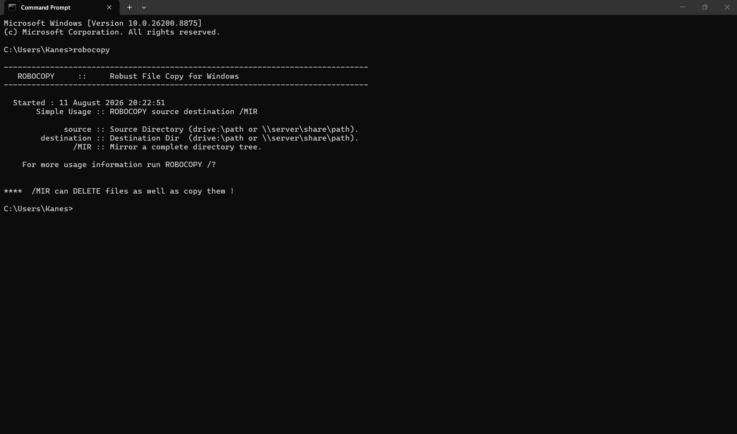

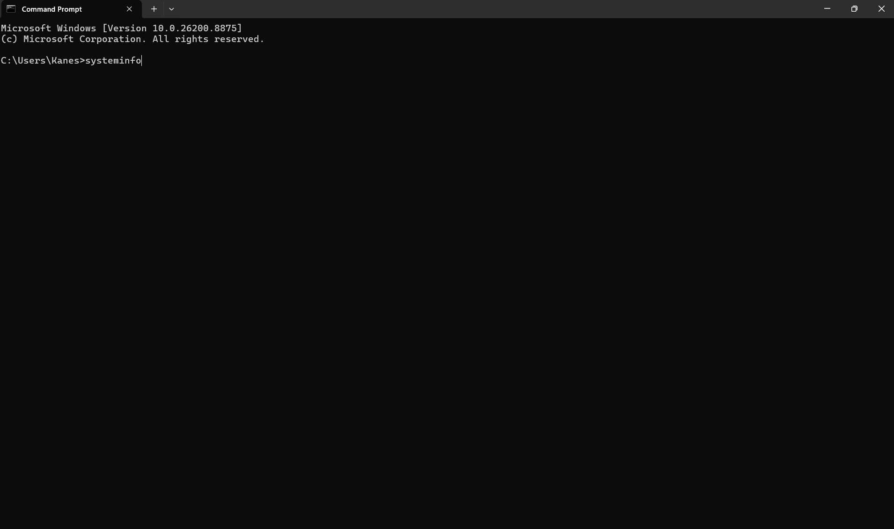 I executed the SYSTEMINFO command at the Command Prompt. This command presents comprehensive details regarding the computer and its operating system, encompassing the Windows version, system manufacturer, memory, network data, and installed updates.

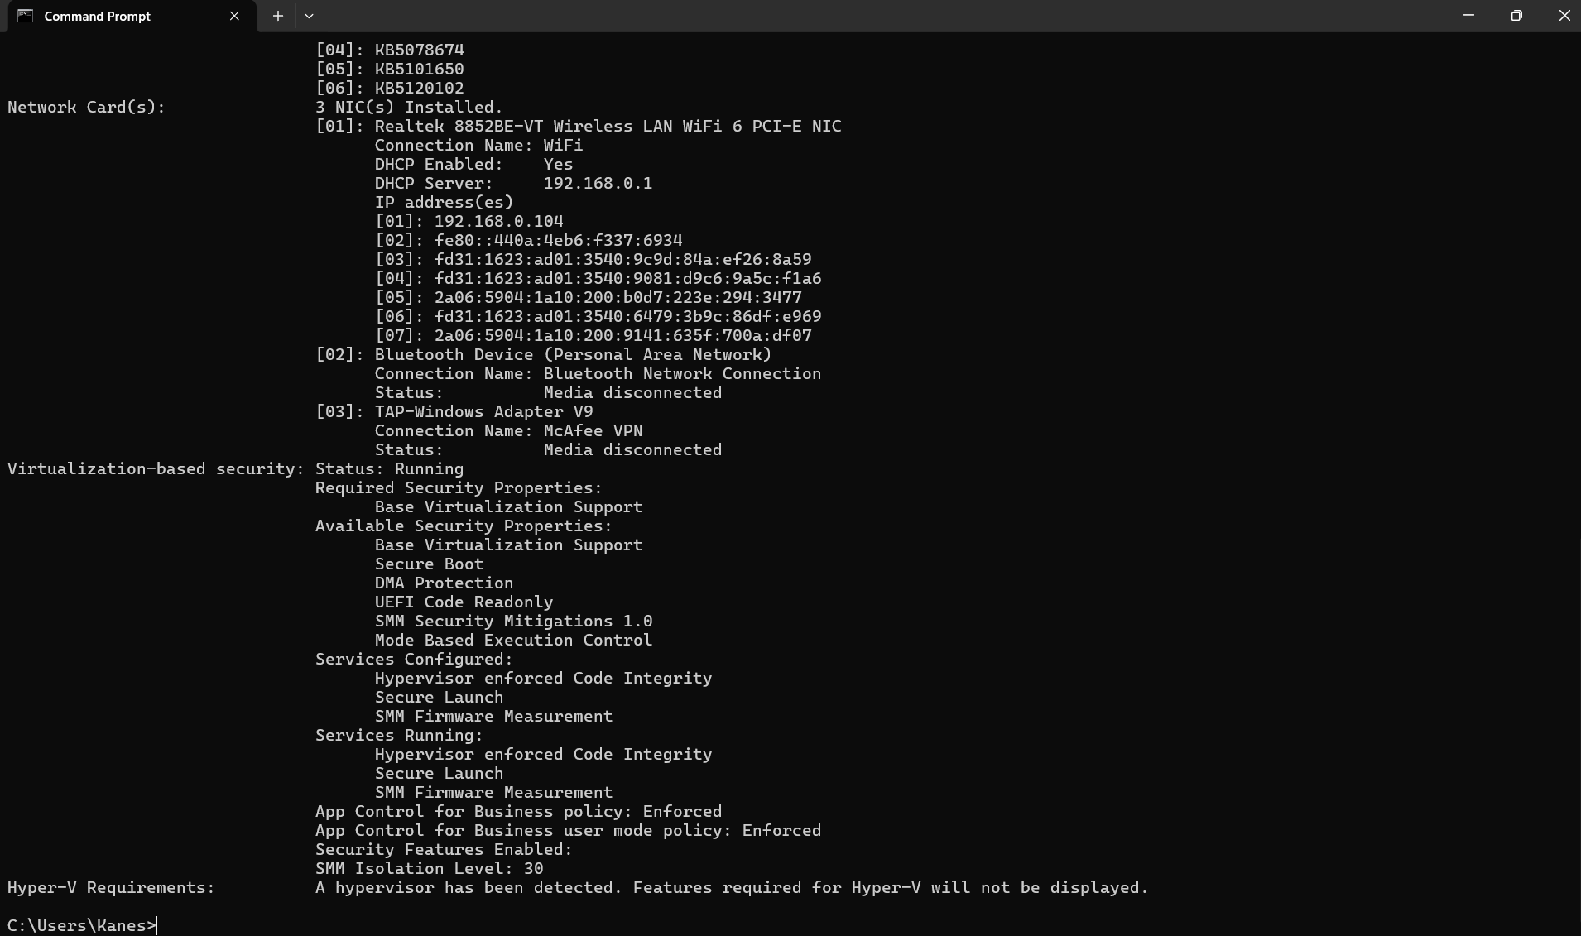

Use of Linux OS CLI commands LS Instruction:
I executed the ls -la command on the Linux terminal. The ls command reveals files and folders. The -l option reveals comprehensive details like permissions, ownership, and file size, whereas the -a option encompasses hidden files. The output displays files and folders present in my current directory[1]-[6].
It is important to note that Linux commands are sensitive to case. Consequently, the system returned "command not found" for PWD, although the lowercase pwd functioned correctly.
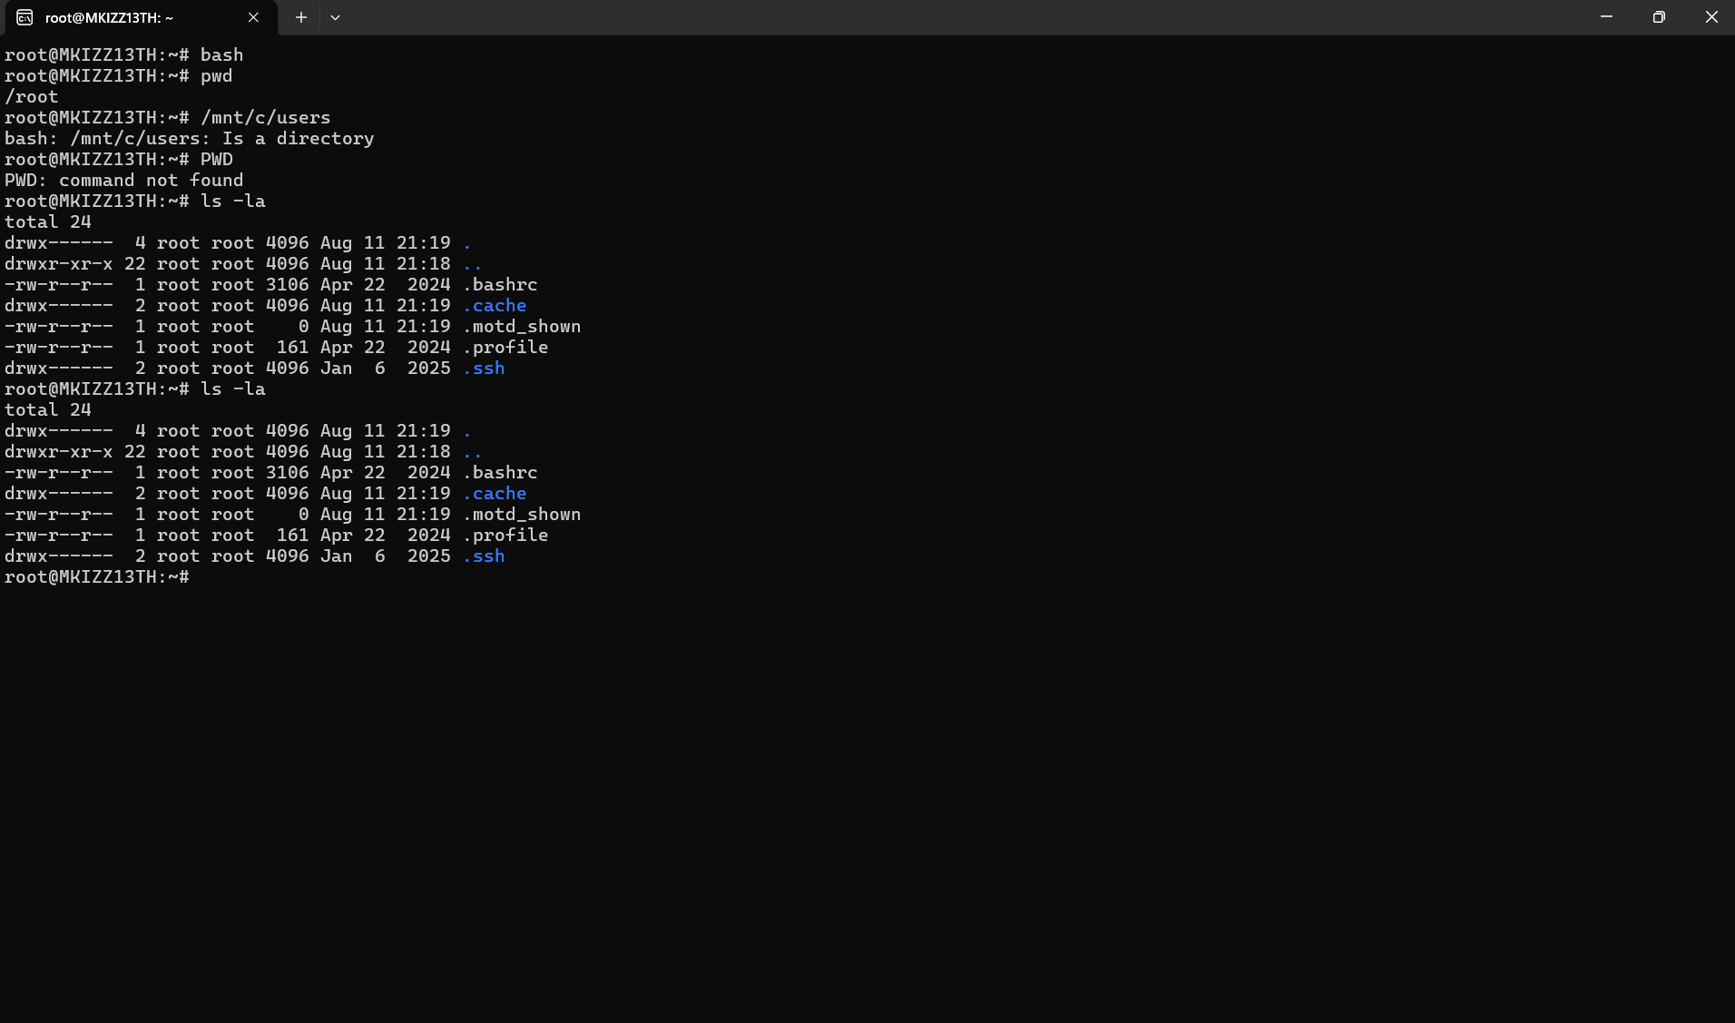

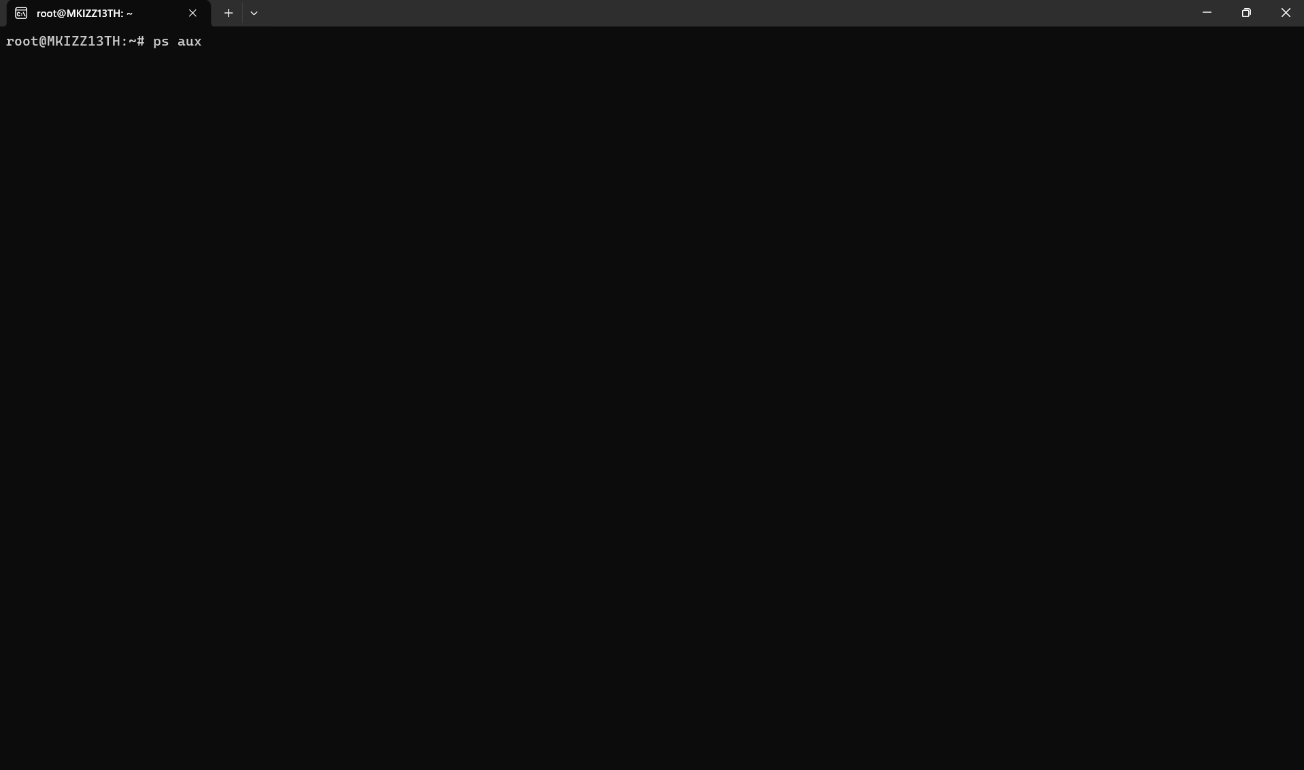
I executed the ps aux command in the Linux terminal to exhibit details on the processes presently active on the machine. The an option reveals processes for every user, u presents comprehensive user details, and x encompasses processes that lack terminal attachment. The output encompasses details including the process ID (PID), CPU utilisation, memory consumption, and the command currently executing.

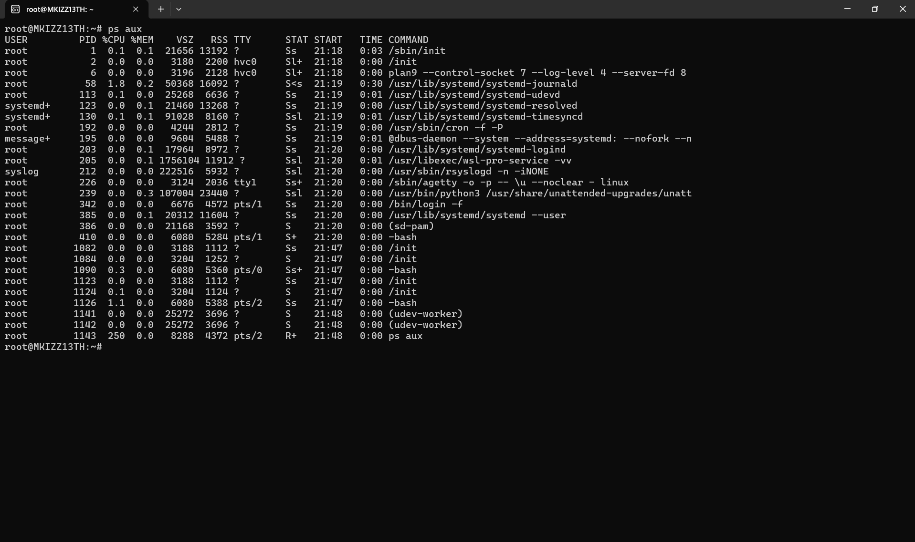

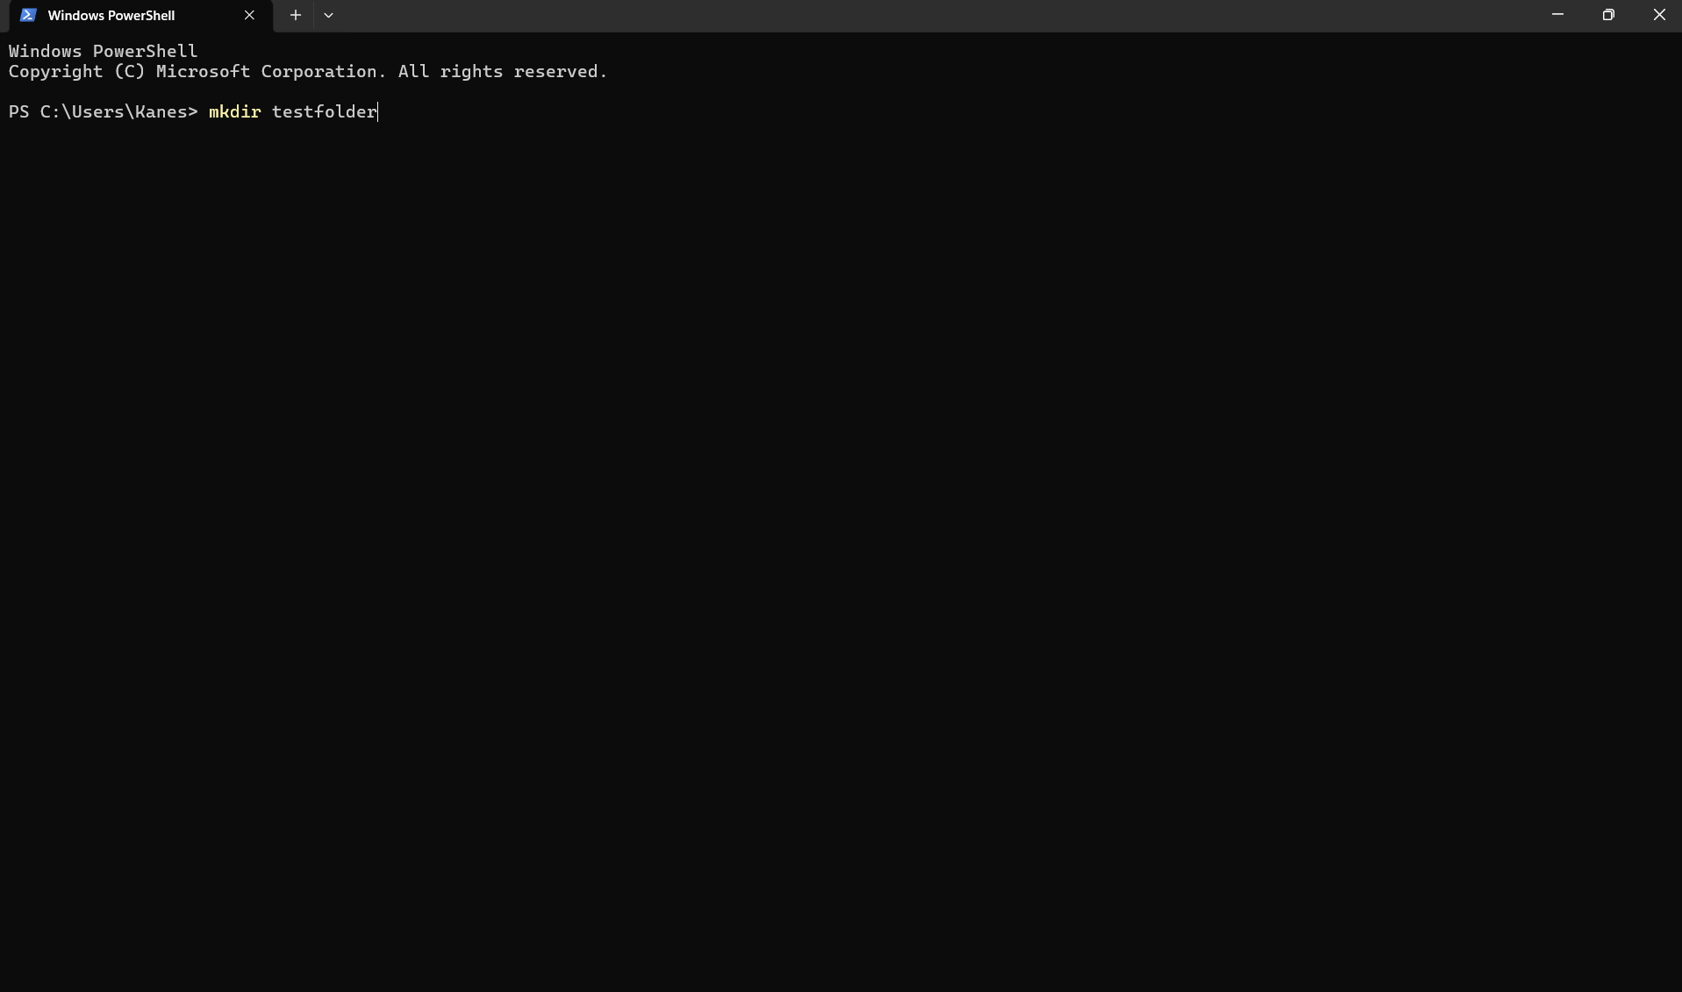 MKDIR and LS Instructions
I employed the mkdir test folder command to establish a new directory named test folder. The mkdir command facilitates the creation of new directories, assisting users in structuring files and folders. I subsequently employed the ls command to display the contents of the present directory. The results indicated the test folder, verifying that the new directory was successfully established.

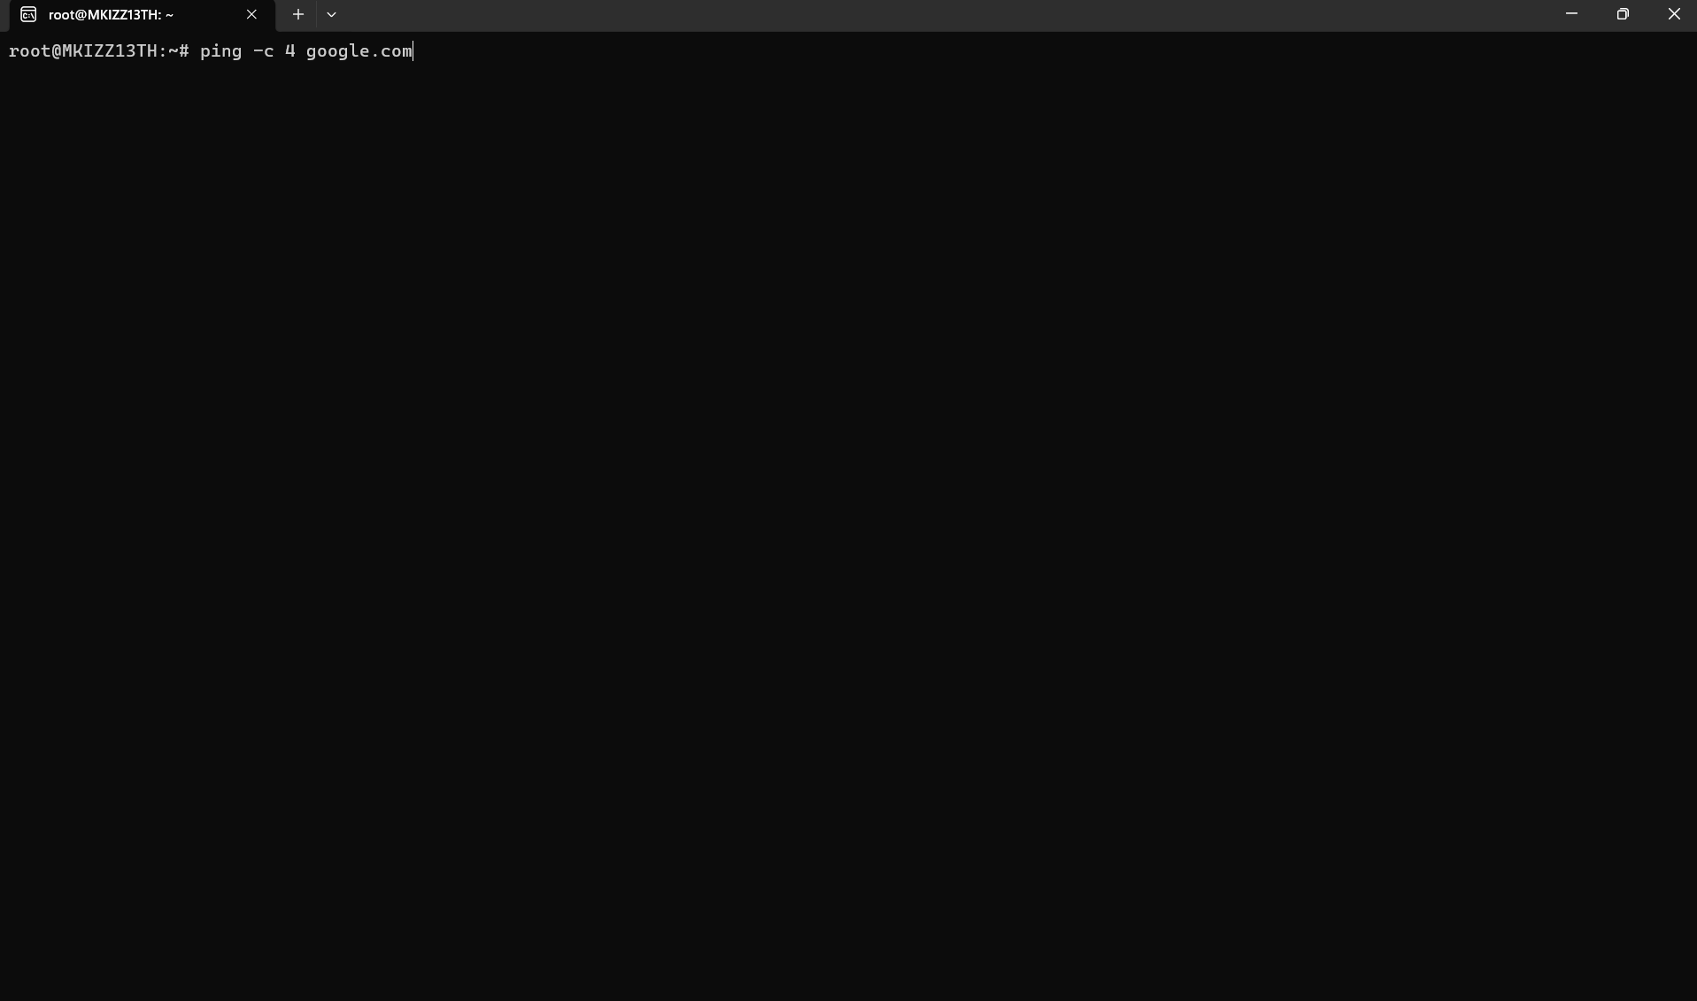
PING Instruction:
I executed the ping -c 4 google.com command to assess the network connectivity between my machine and Google's server. The -c 4 parameter restricts the test to four packets. The findings indicate the successful reception of packets, including response durations and instances of packet loss.

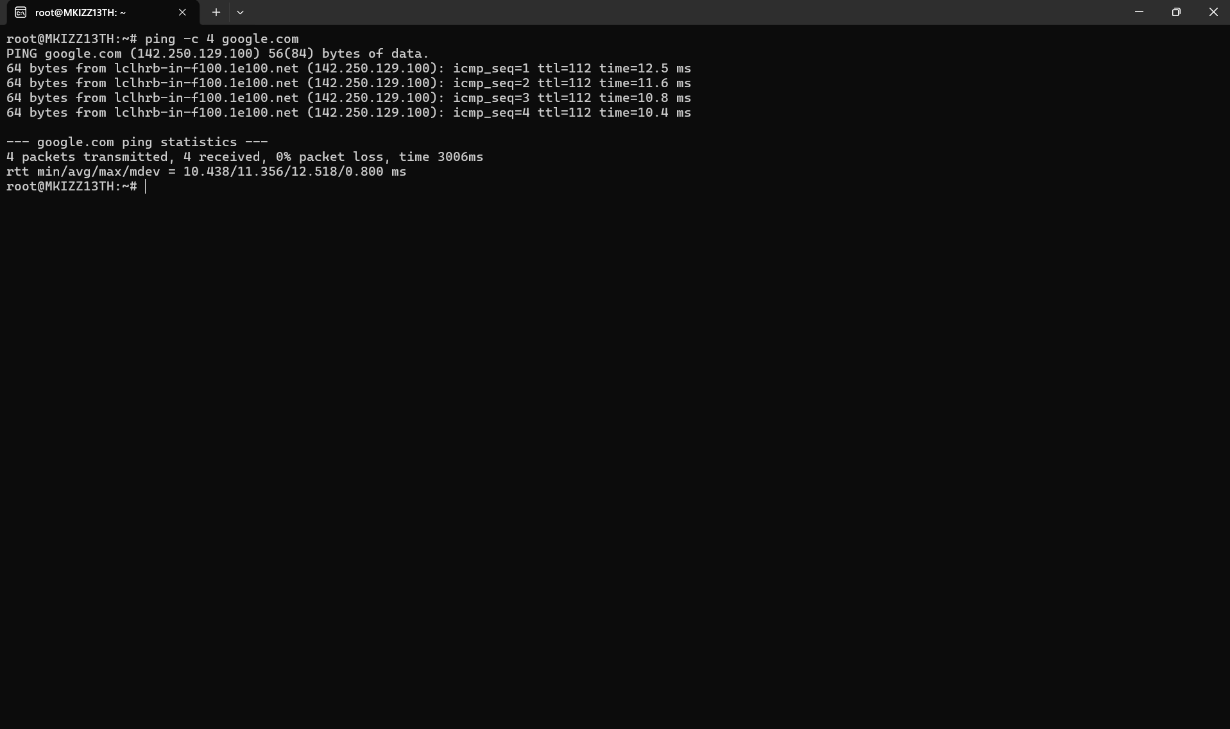
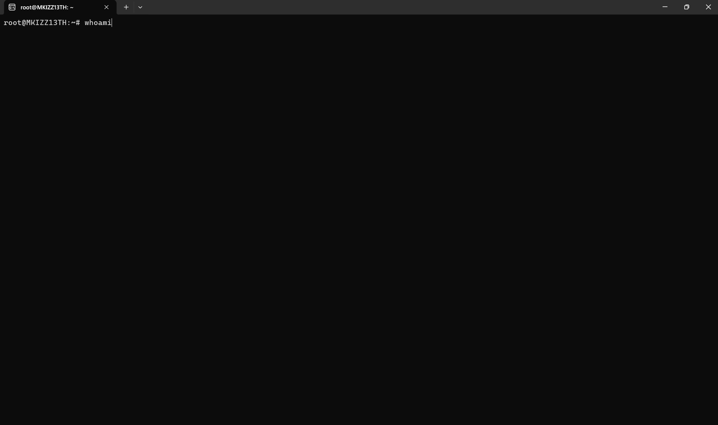
I utilised the whoami command to reveal the username of the account presently logged onto the Linux machine. The output indicated root, verifying that the commands were executed under the root user account.

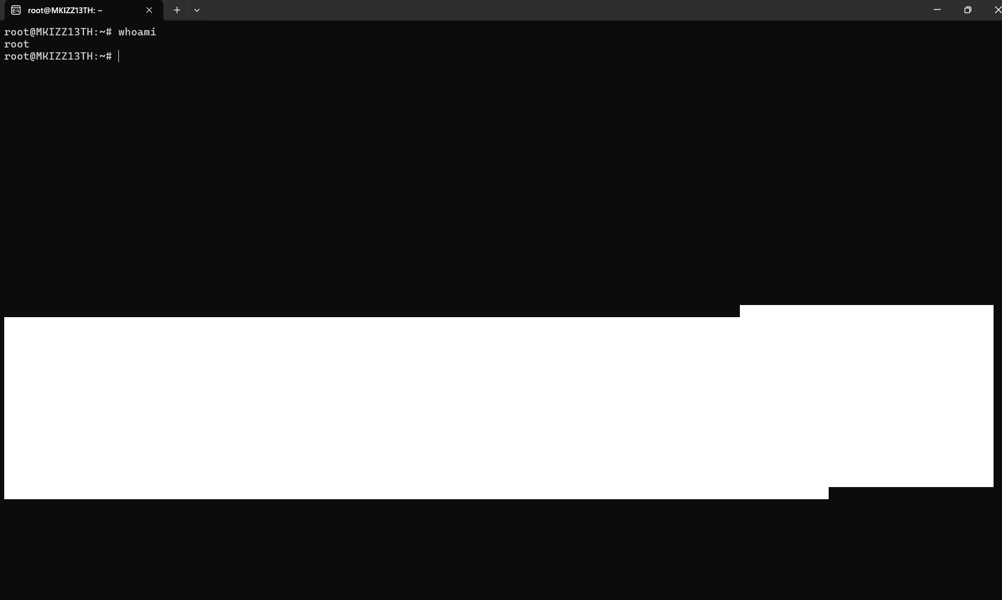

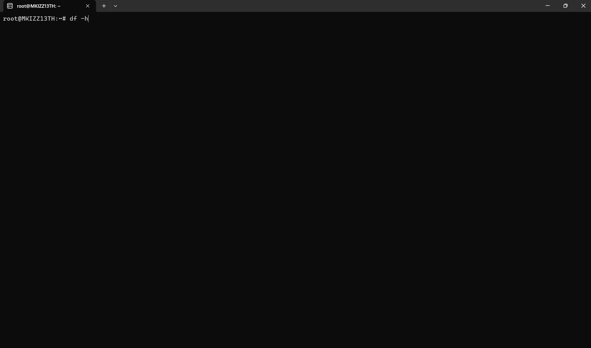
I employed the df -h tool to exhibit details regarding the disc space accessible on the Linux system. The -h flag displays storage capacities in a format that is easily comprehensible, like MB and GB. The result displays the overall size, utilised space, and available space for every file system.

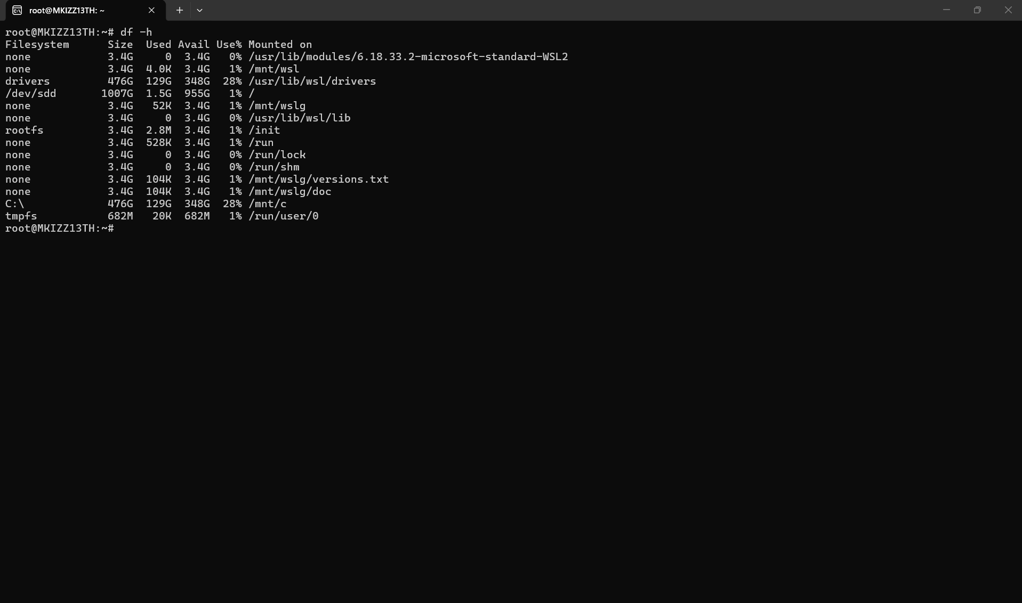

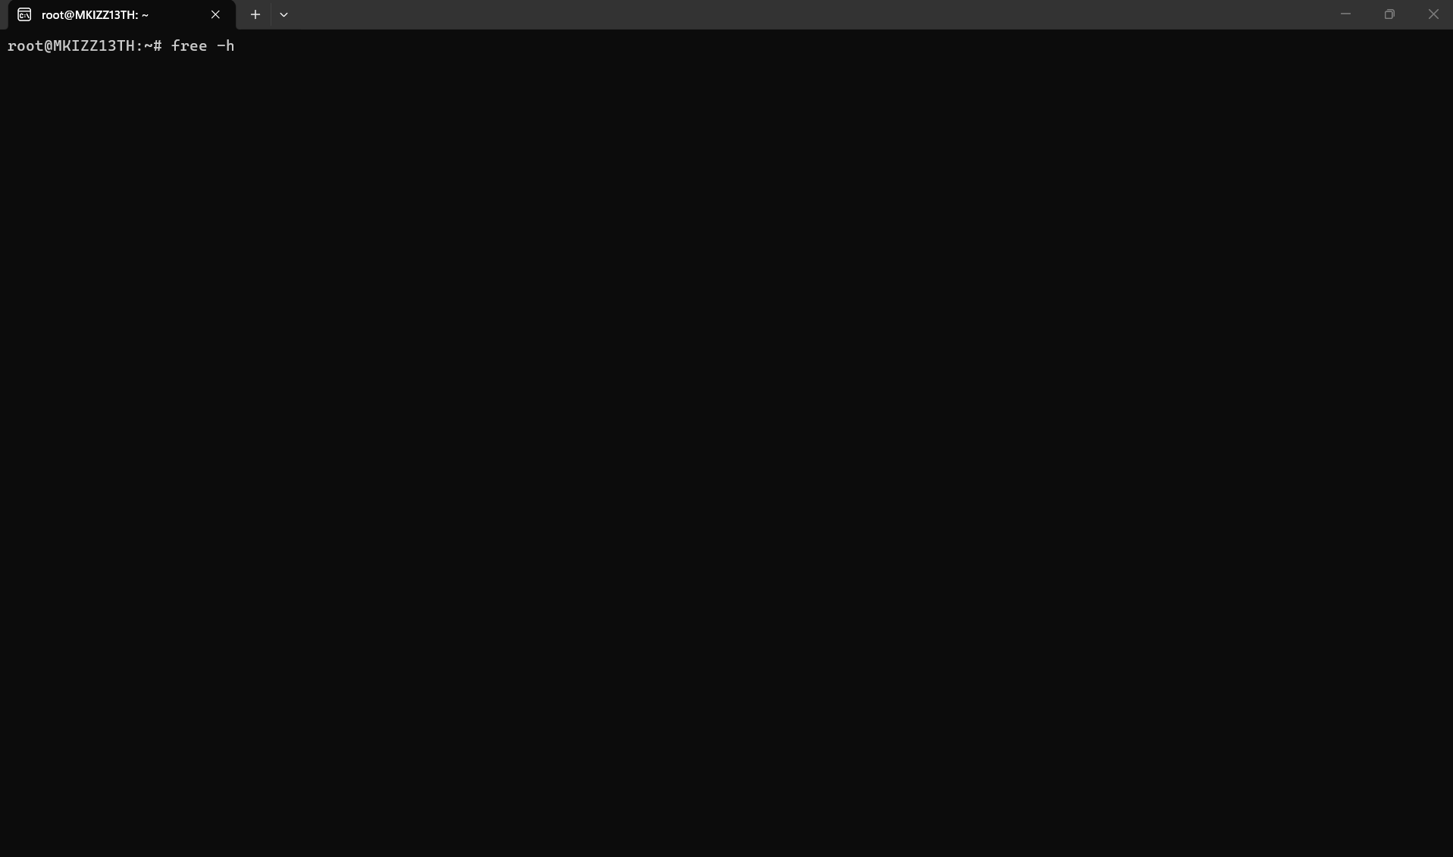
Complimentary Directive:
I employed the free -h command to exhibit details regarding the computer's memory utilisation. The -h option enhances readability by presenting memory in units like MB and GB. The result displays the aggregate, utilised, and accessible RAM and swap memory.

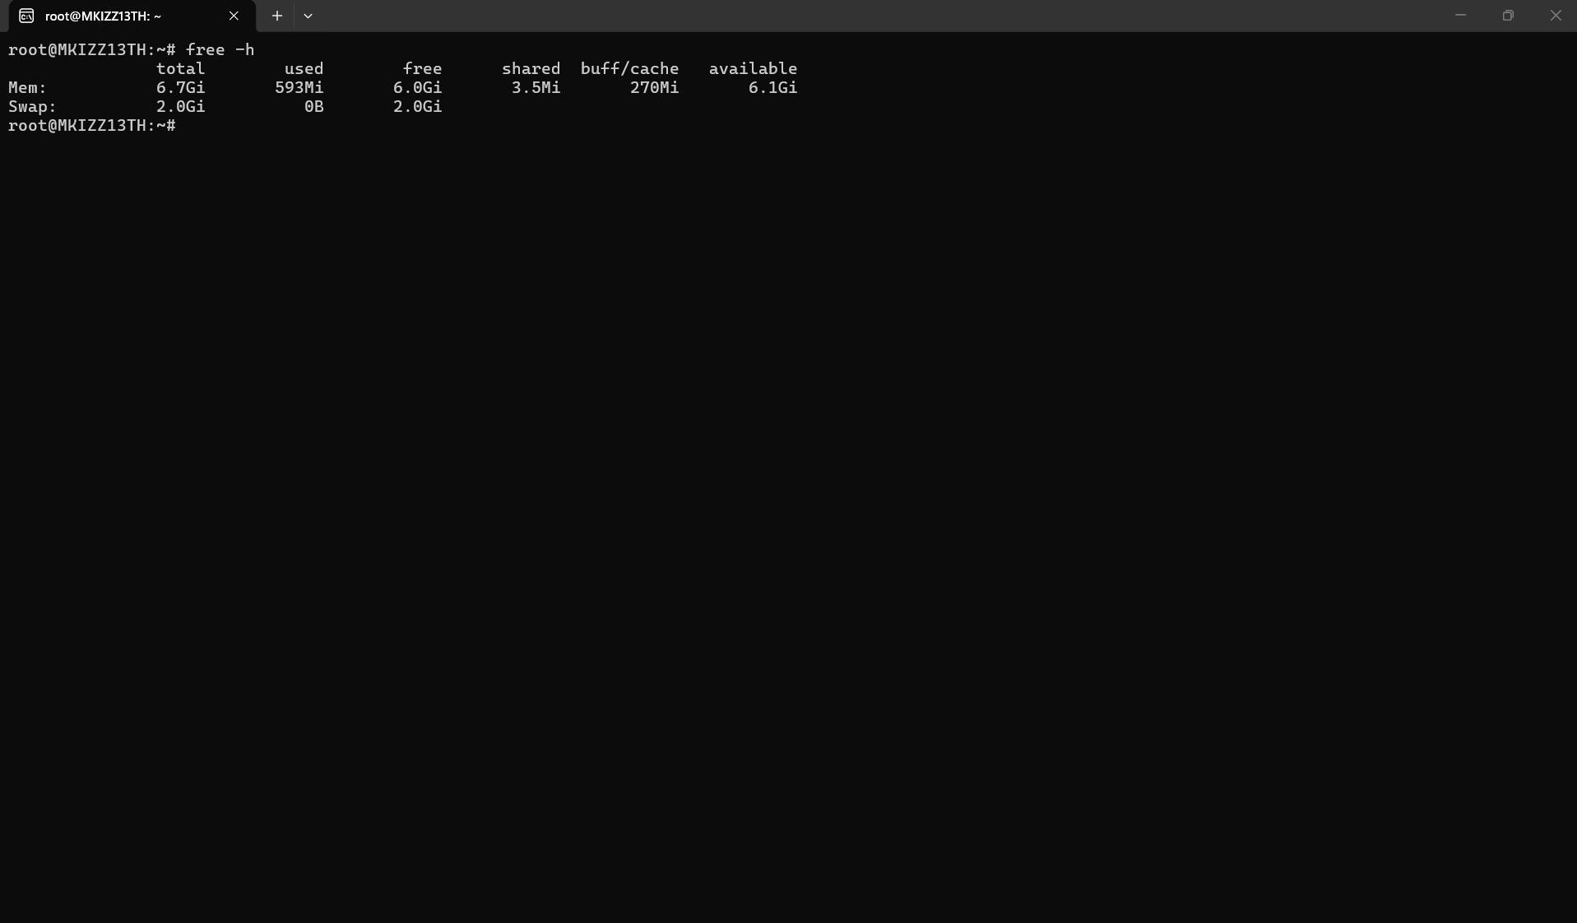
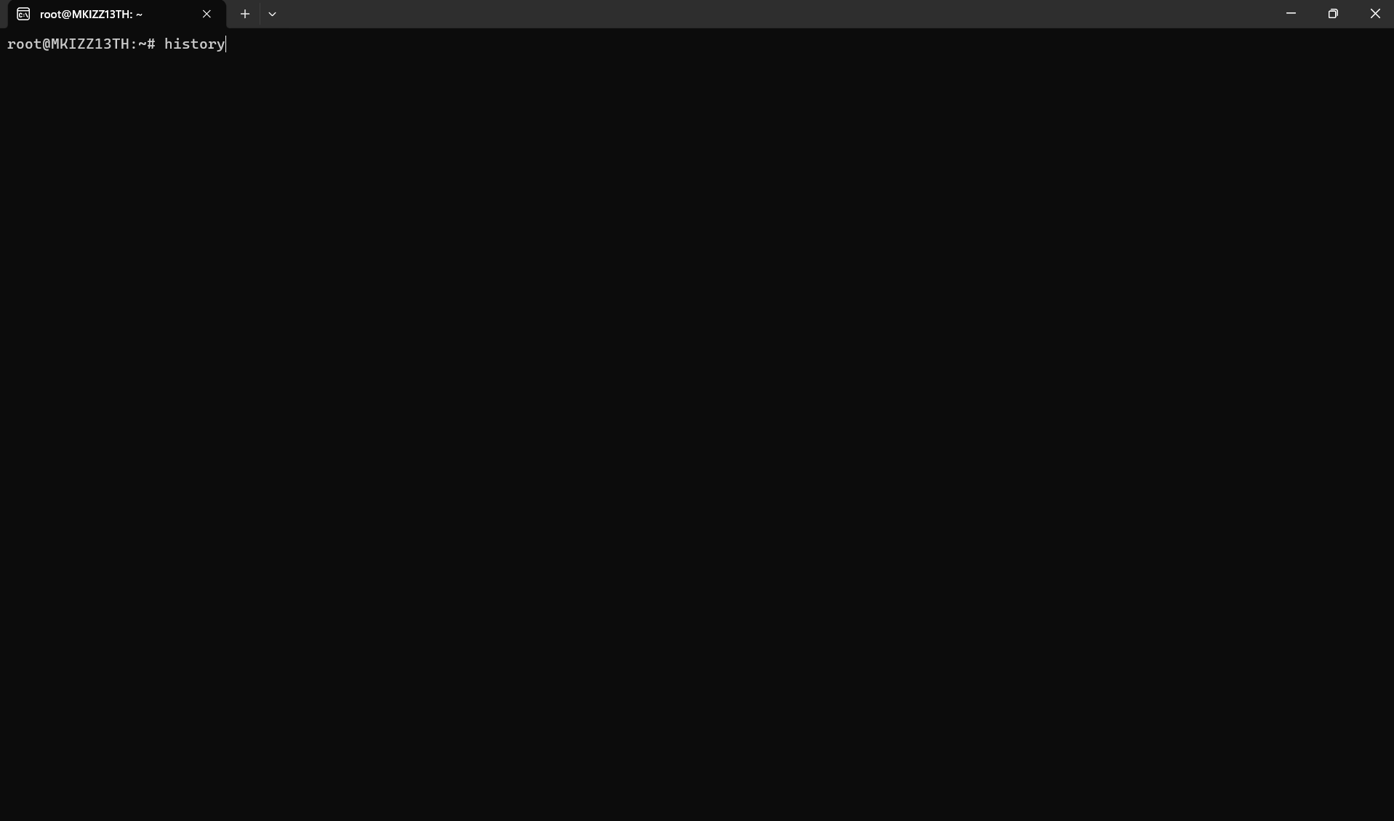
COMMAND of HISTORY:
I employed the history command to exhibit a compilation of commands that had been previously inputted into the Linux terminal. Every instruction is presented with a numerical designation, facilitating the examination and repetition of prior commands. This may prove advantageous when
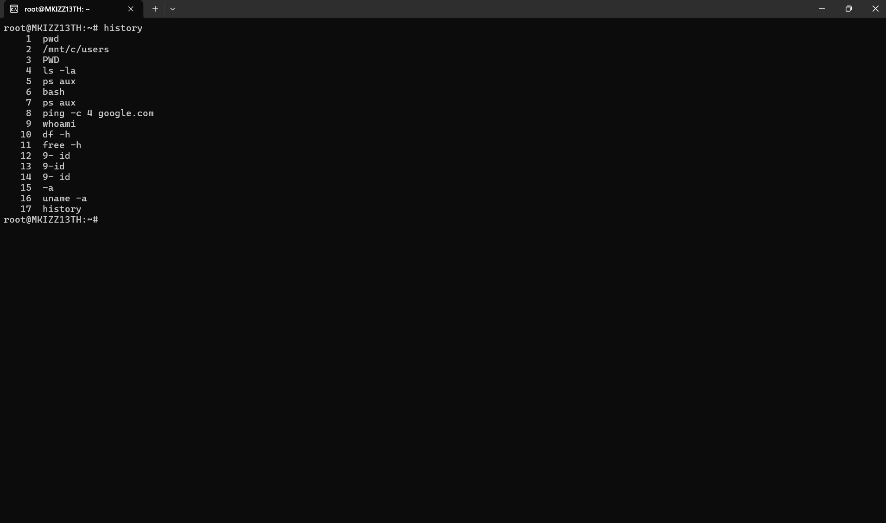

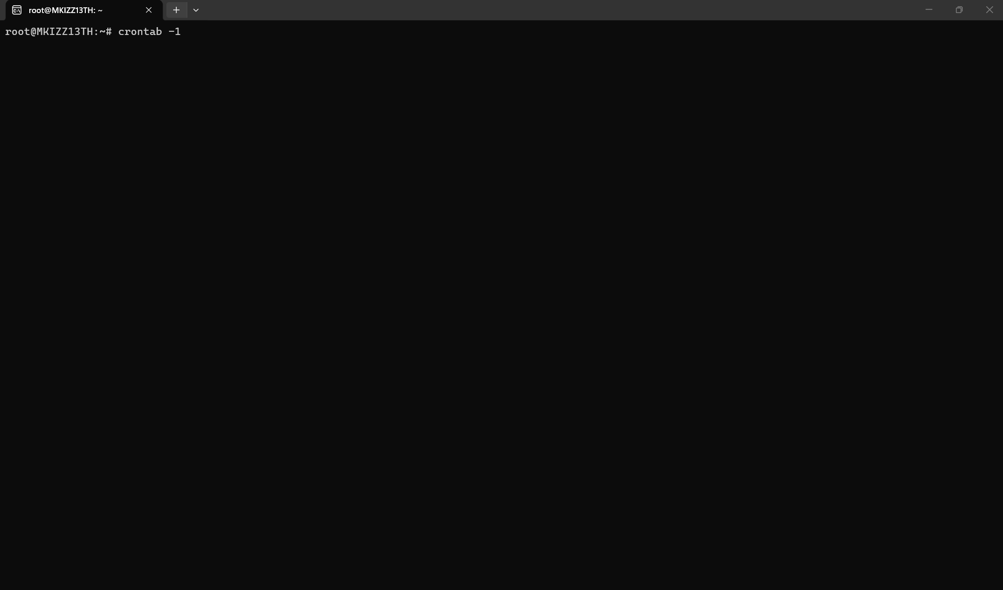 CRONTAB Instruction:
I employed the crontab -l program to verify the scheduled tasks for the active Linux user. The -l option enumerates the user's current cron jobs. Cron can be utilised to execute commands or scripts automatically at designated dates and times. If no jobs are arranged, the terminal indicates that there is no crontab for the user.

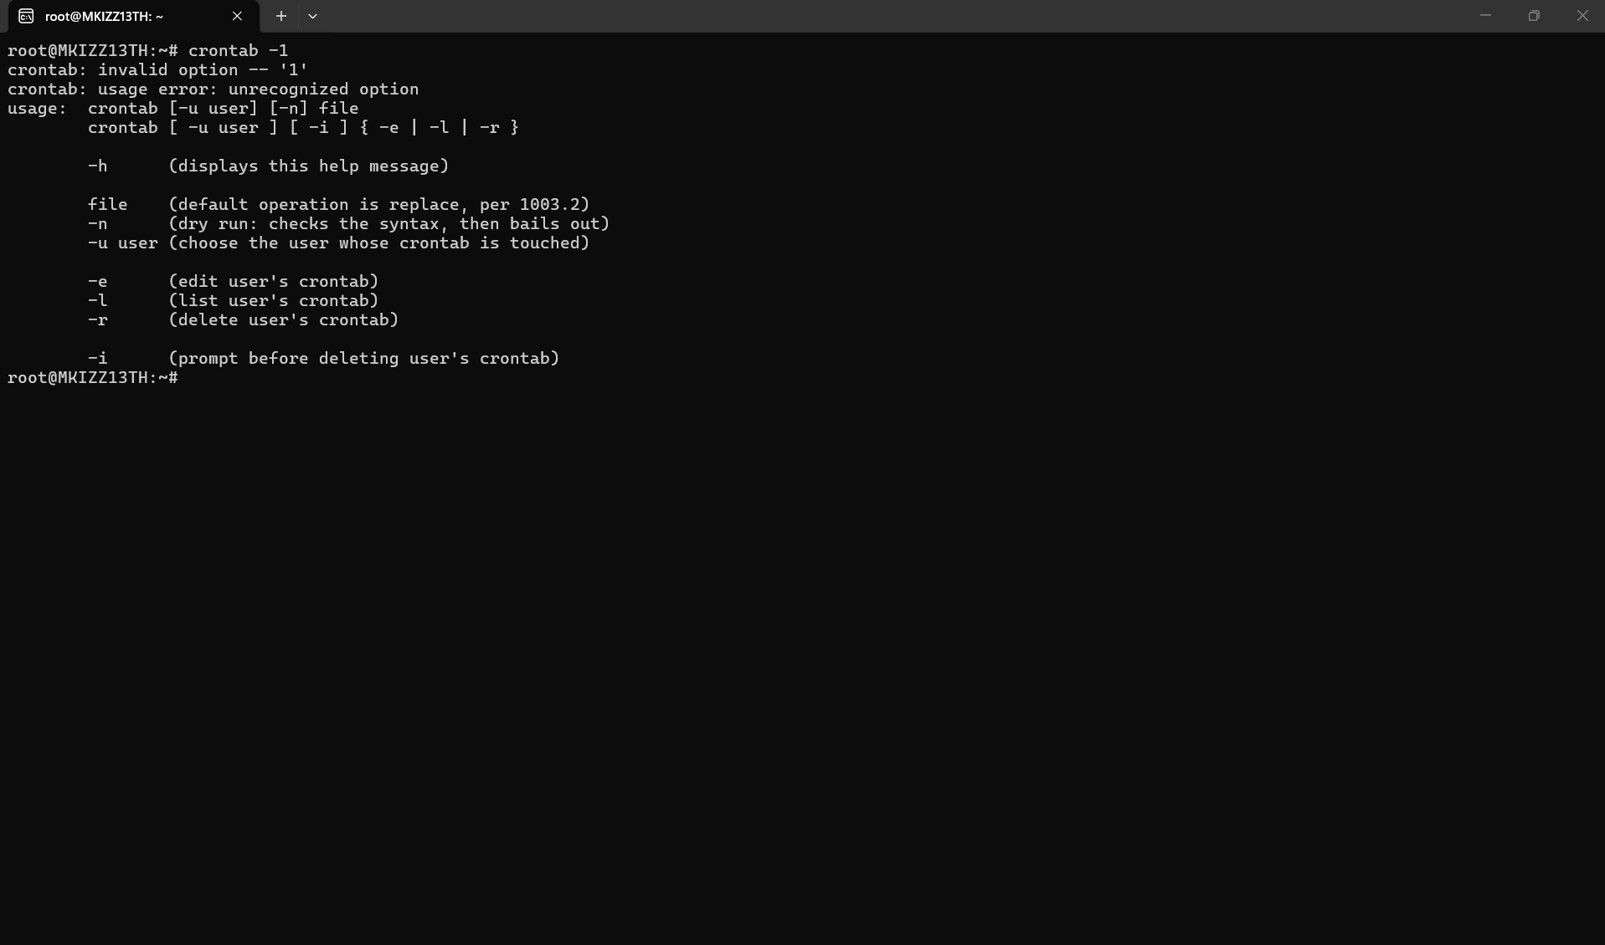

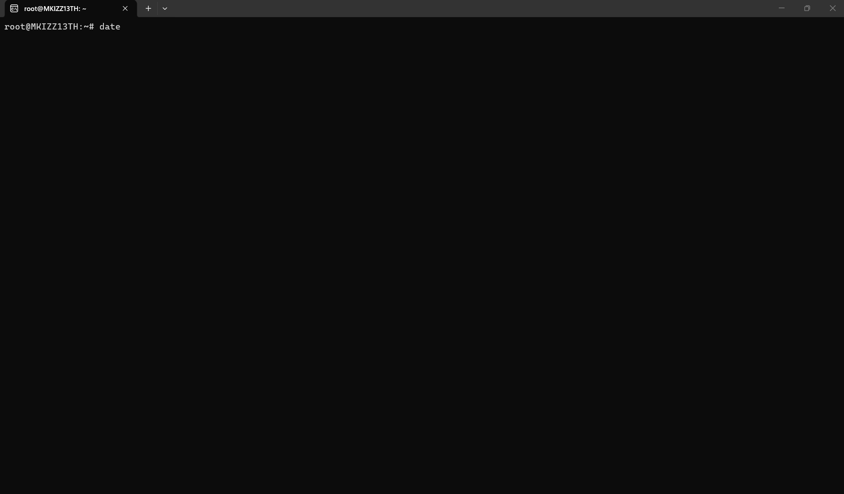
DATE Instruction:
I employed the date command to exhibit the present date and time set on the Linux system. The output has details including the day, date, present time, time zone, and year. This command is beneficial for swiftly verifying the system's date and time configurations.

Use of Windows OS scripts
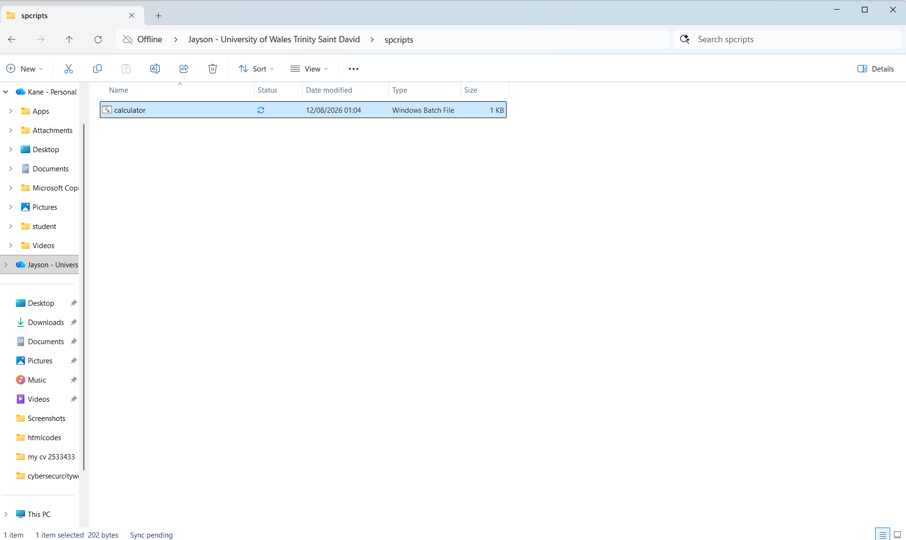

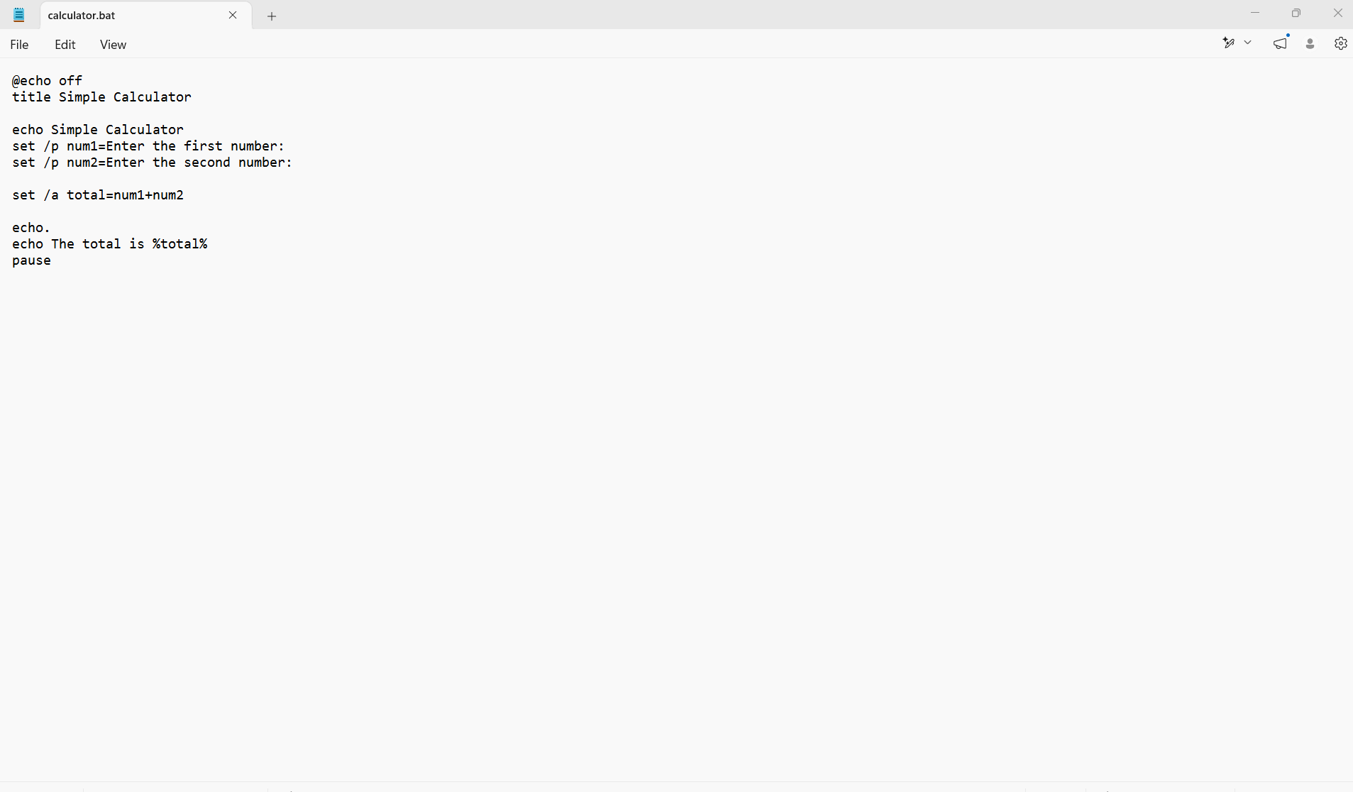

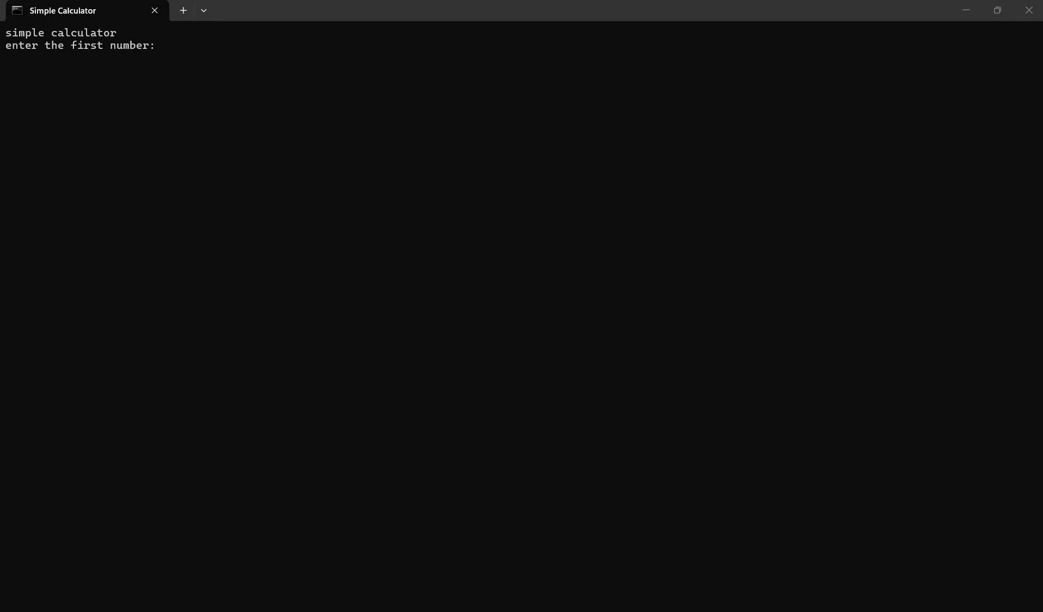

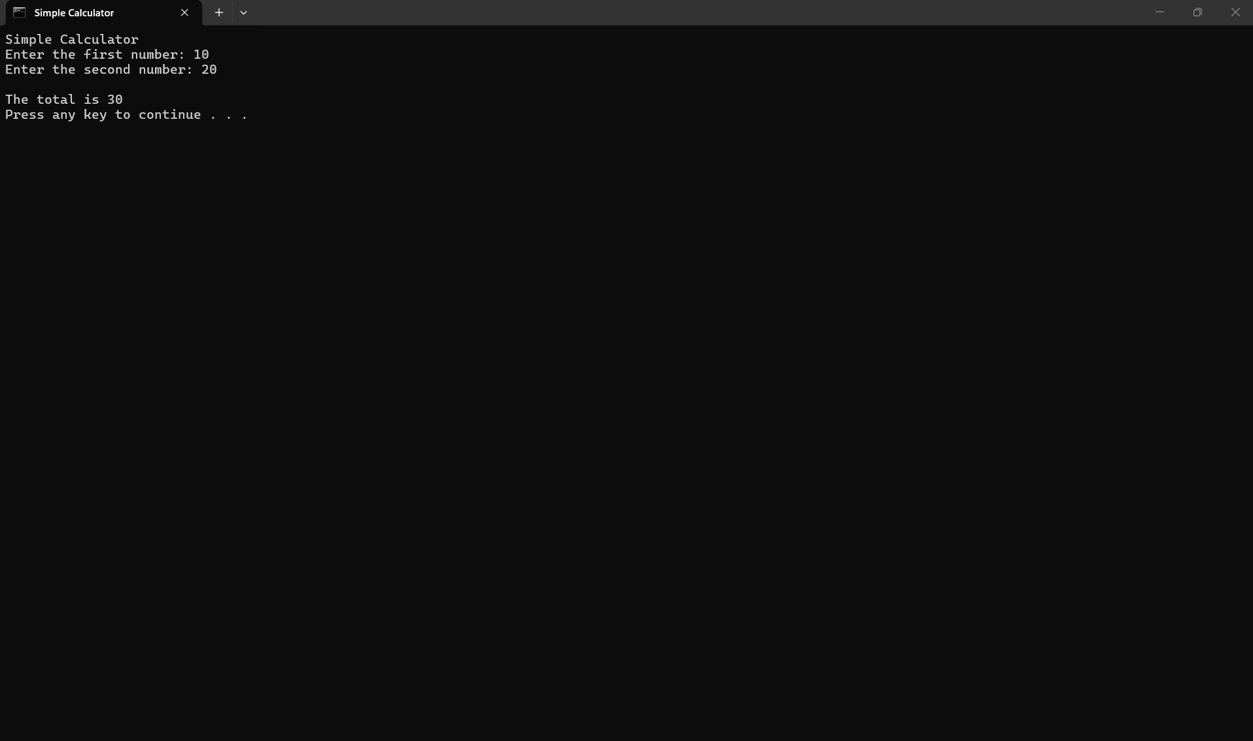
Windows Batch Script 1 - Basic Arithmetic Tool
I developed a basic calculator utilising a Windows Batch script. Initially, I launched Notepad and input the Batch commands prior to saving the document as calculator.bat[1]-[7]. The script employed set /p to prompt the user for two numbers and assign them to variables named num1 and num2. I subsequently employed set /a to perform the arithmetic operation of summing the two figures. The solution was retained in the total variable and presented via the echo command. Ultimately, I employed the pause command to maintain the visibility of the Command Prompt window for result observation. I evaluated the script by inputting 10 and 20, which accurately yielded a sum of 30. This illustrates the use of variables, user input, and mathematical operations in Windows Batch scripting.

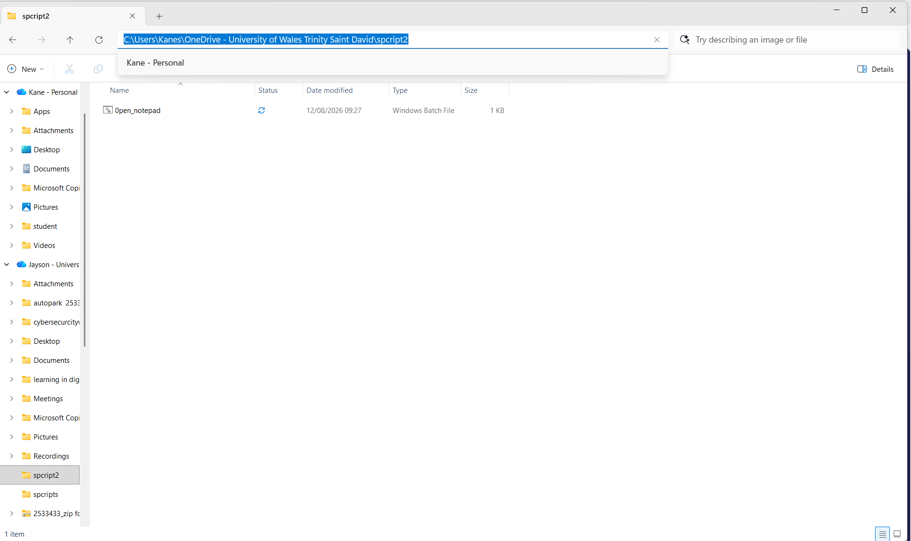

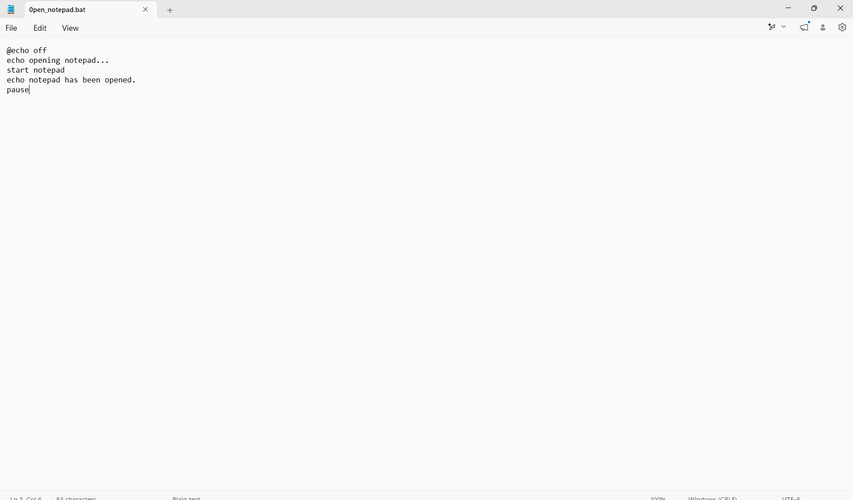
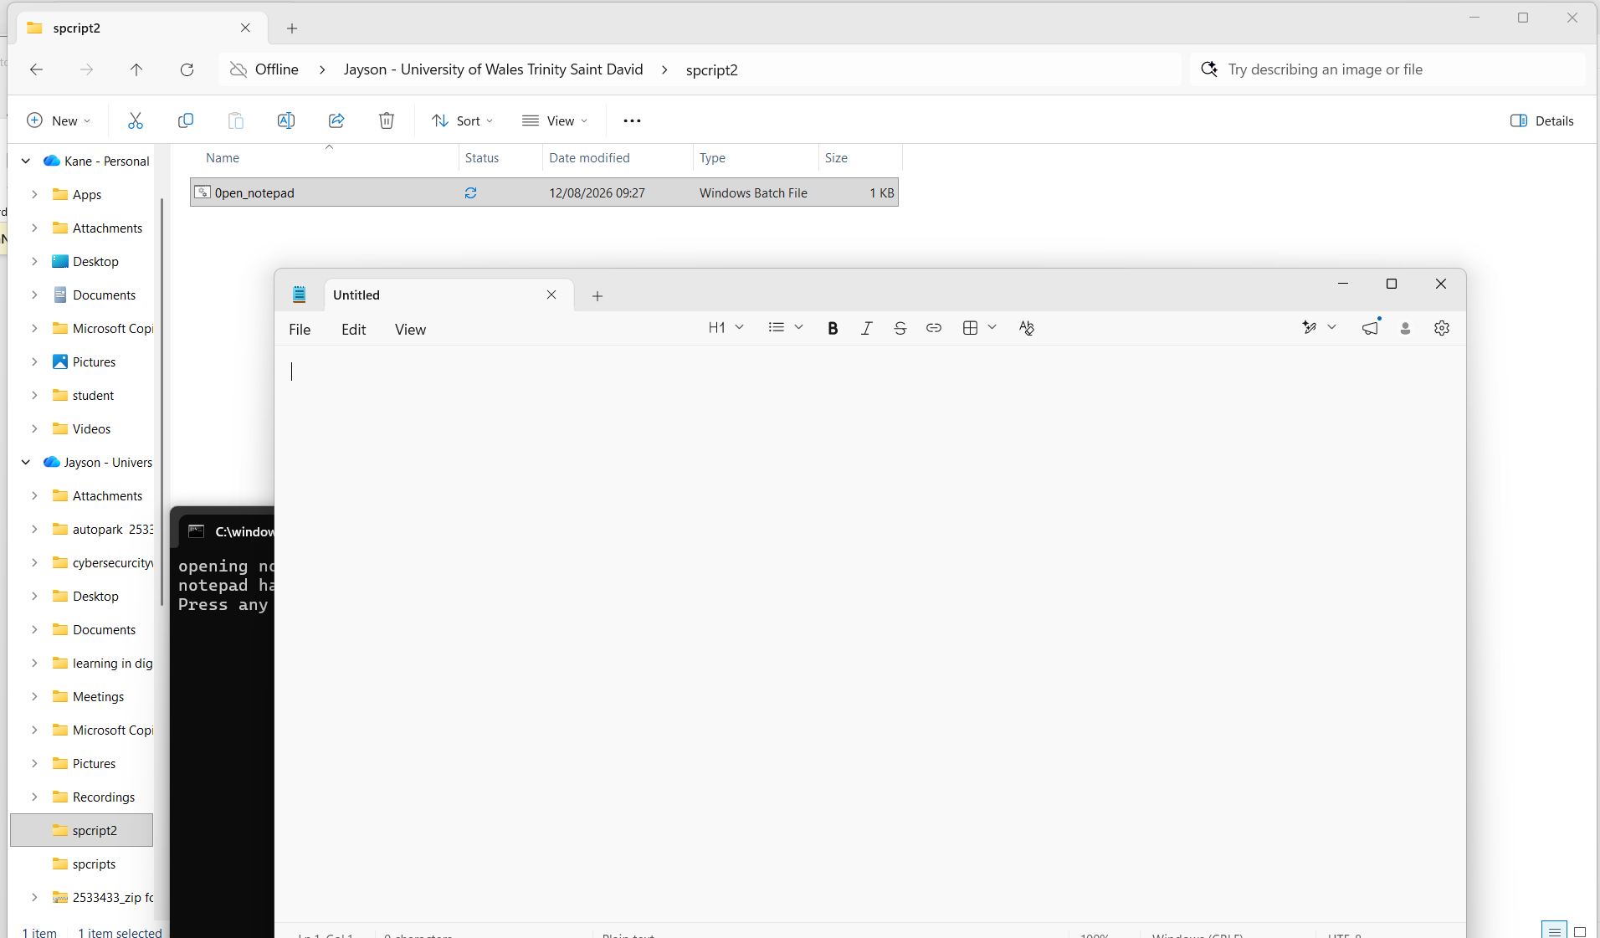
Batch2 spcript
I developed a basic Windows Batch script to launch Notepad automatically. I initially launched Notepad and input the Batch commands prior to saving the document as open_notepad.bat. The @echo off command was employed to enhance the readability of the output. I employed the echo command to present a notification indicating that Notepad was being launched. The initiation of the notepad command subsequently triggered the activation of the Notepad application. Ultimately, I employed the pause command to maintain the visibility of the Command Prompt window for result observation. This illustrates the utilisation of a Batch script to automate a basic routine job in Windows.

Linux script

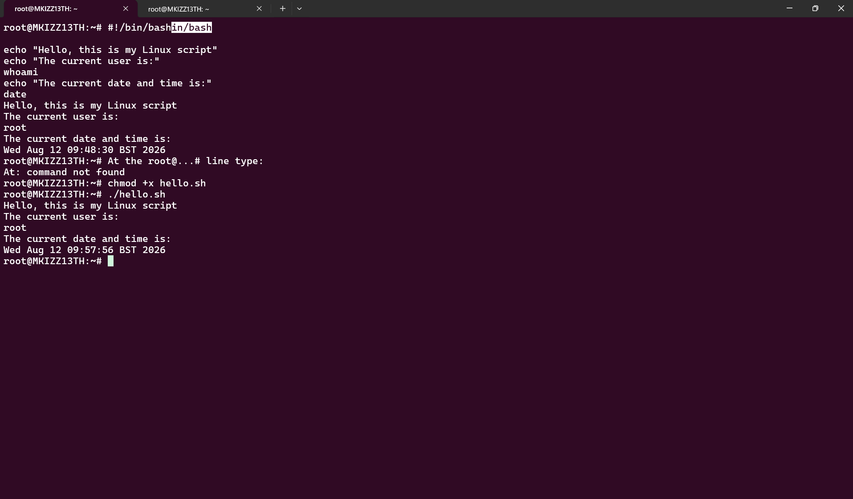

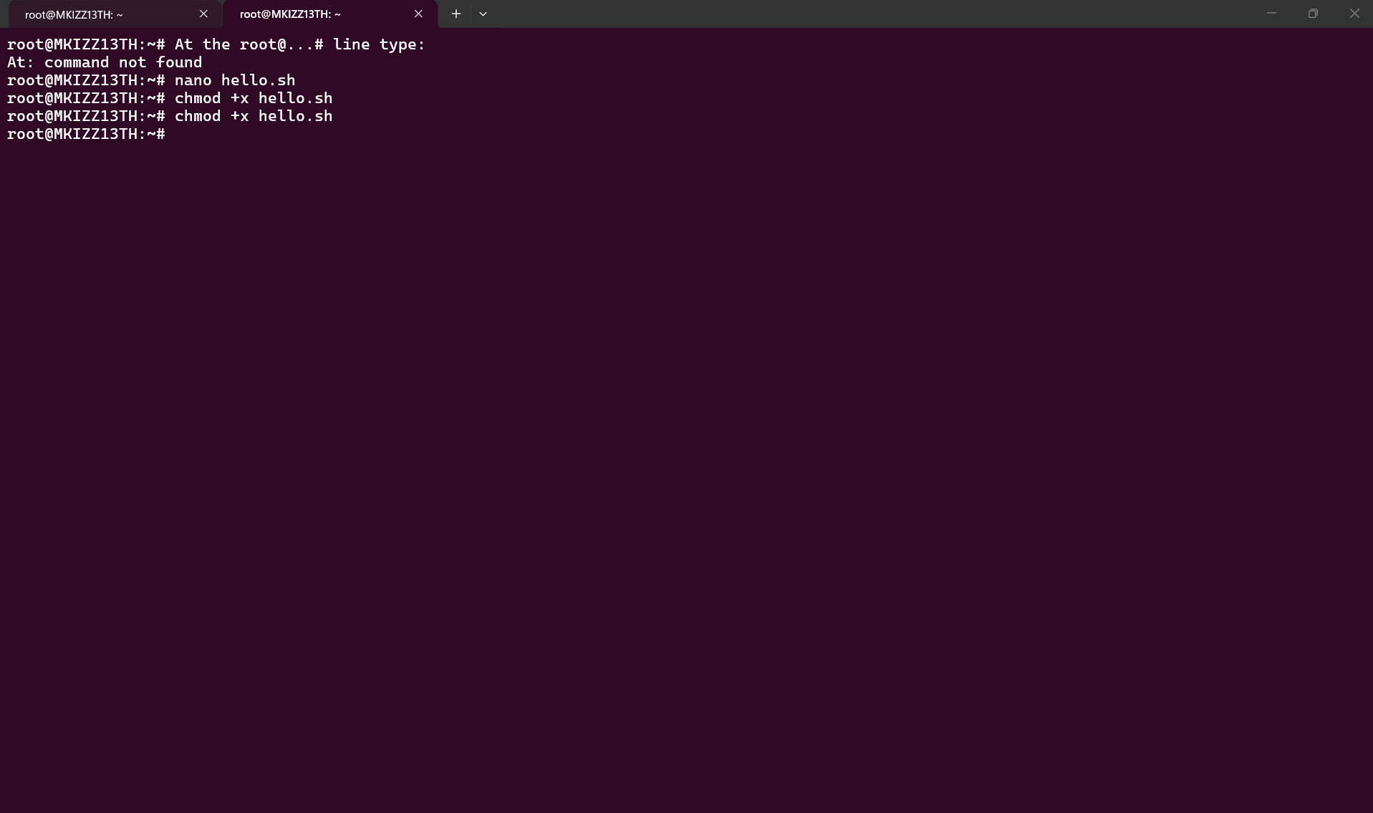

I developed a basic Bash script utilising the Ubuntu Linux command line. Initially, I employed the nano hello.sh to generate a new Bash script named hello.sh. Within the script, I included #!/bin/bash to indicate that the Bash shell is to be utilised for executing the script.
I employed the echo command to display messages on the monitor. The whoami command was utilised to reveal the identity of the presently logged-in user, whereas the date command exhibited the current date and time[8].
Upon completing the script, I utilised Ctrl + X to save it, opted for Y to preserve the modifications, and hit Enter to affirm the filename. I subsequently employed chmod +x hello.sh to grant the file execution privileges. Ultimately, I executed ./hello.sh on the Ubuntu terminal to initiate the script.
The output displayed the messages included in the script together with the current username and date and time. This illustrates how a Bash script can amalgamate many Linux commands and execute them sequentially.
Linux spcript 2

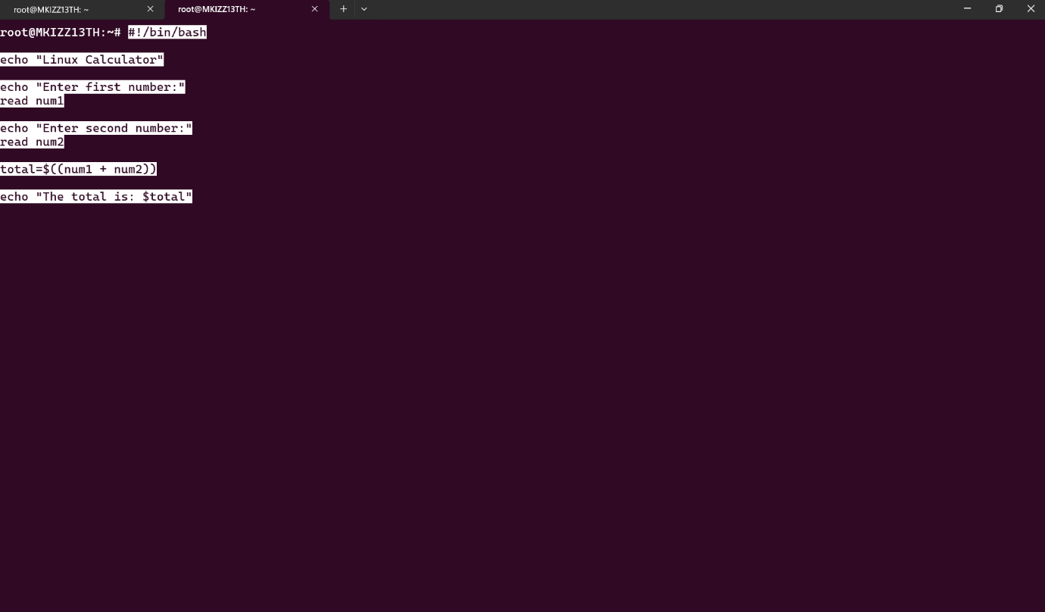
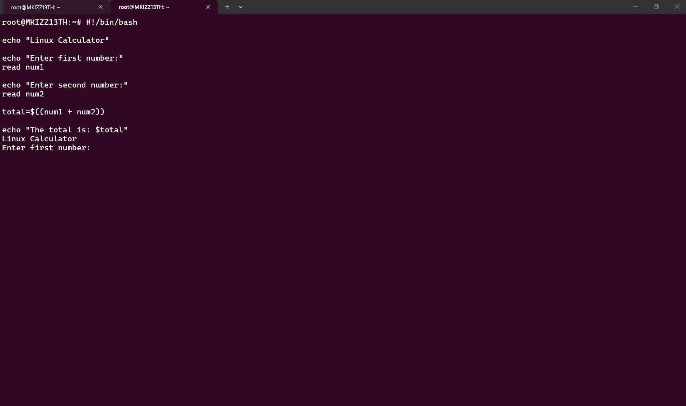
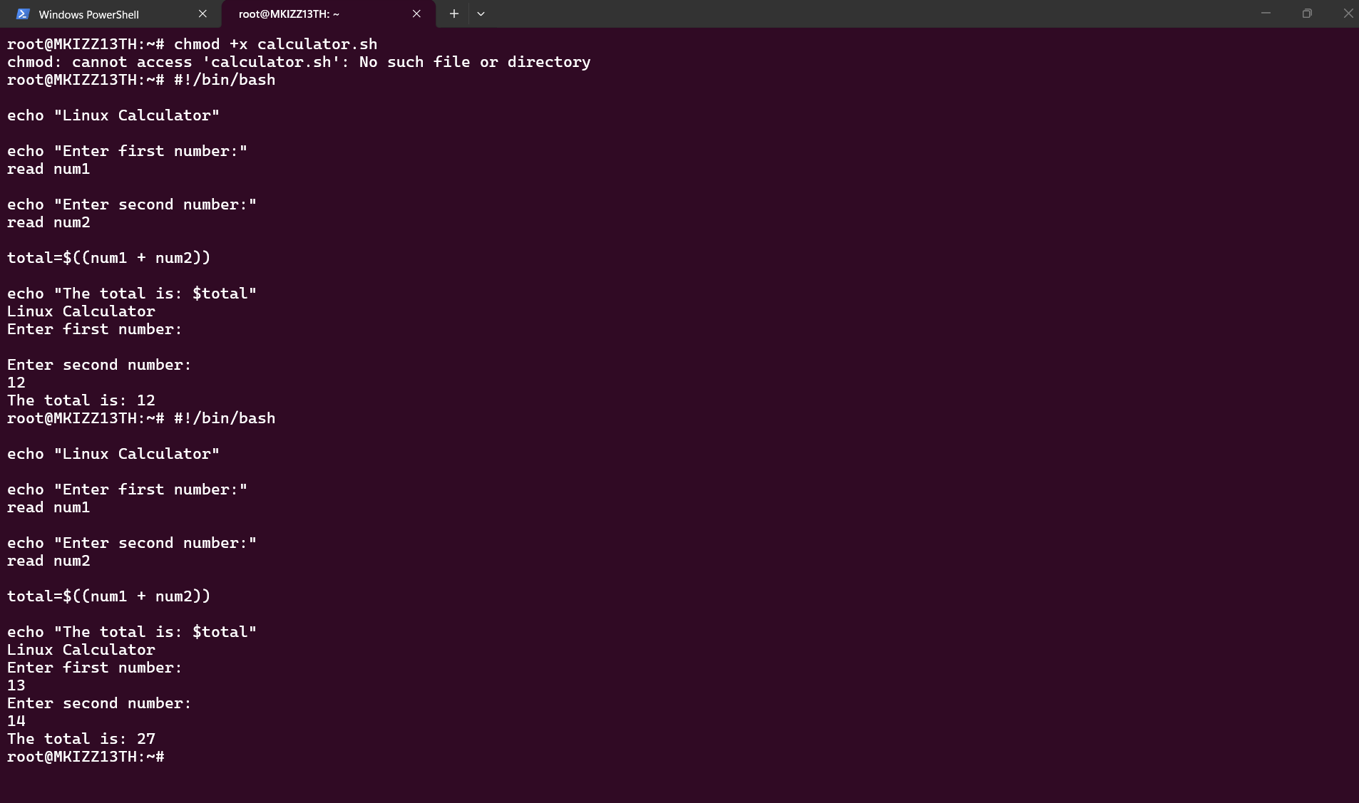
I developed a basic calculator utilising a Linux Bash script within the Ubuntu terminal. Initially, I typed nano calculator.sh to generate a new script and launch it in the Nano text editor.
Within the script, I employed echo commands to present directives requesting the user to input two numerical values. The read command was employed to gather the numbers input by the user and assign them to the variables num1 and num2.
I subsequently employed total=$((num1 + num2)) to execute the arithmetic operation and sum the two values. The echo command presented the ultimate outcome on the display.
Upon completing the script, I utilised Ctrl + X to save it, followed by pressing Y and then Enter. I employed chmod +x calculator.sh to grant execution rights to the script. Ultimately, I executed the script with ./calculator.sh. I evaluated it by inputting 10 and 20, which accurately yielded a sum of 30.
This script illustrates the application of variables, user input, and arithmetic operations in Bash, highlighting how Linux scripts can facilitate the automation of basic activities.

Conclusion: Ultimately, this task has enhanced my comprehension of command-line interfaces and scripting in both Windows and Linux environments. I employed many Windows CMD and Linux Ubuntu commands to execute multiple activities, such as examining system details, organising files and directories, monitoring active processes, assessing network connectivity, and retrieving user information.
I additionally discovered how commands can be integrated within scripts to facilitate work automation. In Windows, I developed Batch scripts, which comprised a basic calculator and a script that launched Notepad automatically. In Linux, I developed Bash scripts that presented system data and executed a basic computation based on user-inputted integers. These tasks enhanced my comprehension of variable use, user input, mathematical procedures, and executable scripts.
The command-line environments of Windows and Linux exhibit disparities in their commands, syntax, and script creation methodologies. Windows often employs Batch files characterised by the .bat extension, while Linux utilises Bash scripts denoted by the .sh extension.
In general, engaging in the practical exercises has enhanced my self-assurance in utilising Windows and Linux command-line utilities. I have acquired hands-on expertise in inputting commands, analysing their results, developing scripts, and resolving issues. These competencies are advantageous in fields of computing including system administration, networking, and cybersecurity.

References
[1] A. Silberschatz, P. B. Galvin and G. Gagne, Operating System Concepts, 10e Abridged Print Companion. 2018.
[2] G. G. Richard III and A. Case, "In lieu of swap: Analyzing compressed RAM in Mac OS X and Linux," Digital Investigation, vol. 11, pp. S3–S12, 2014. .
[3] N. Vandome, macOS High Sierra in Easy Steps: Covers Version 10.13. 2017.
[4] D. Smith, "Mobile device management," in Apple macOS and iOS System Administration: Integrating and Supporting iPhones, iPads, and MacBooksAnonymous 2020, .
[5] J. P. Mueller, Windows Command Line Administration Instant Reference. 2010.
[6] W. Shotts, The Linux Command Line: A Complete Introduction. 2026.
[7] C. Dent, Mastering Windows PowerShell Scripting: Automate and Manage Your Environment using PowerShell Core 6.0. 2019.
[8] M. Ebrahim and A. Mallett, Mastering Linux Shell Scripting: A Practical Guide to Linux Command-Line, Bash Scripting, and Shell Programming. 2018.

References: References

[1] M. Ebrahim and A. Mallett, Mastering Linux Shell Scripting: A Practical Guide to Linux Command-Line, Bash Scripting, and Shell Programming. 2018.

[2] C. Dent, Mastering Windows PowerShell Scripting: Automate and Manage Your Environment using PowerShell Core 6.0. 2019.

[3] W. Shotts, The Linux Command Line: A Complete Introduction. 2026.

[4] J. P. Mueller, Windows Command Line Administration Instant Reference. 2010.

[5] D. Smith, "Mobile device management," in Apple macOS and iOS System Administration: Integrating and Supporting iPhones, iPads, and MacBooksAnonymous 2020, .

[6] N. Vandome, macOS High Sierra in Easy Steps: Covers Version 10.13. 2017.

[7] G. G. Richard III and A. Case, "In lieu of swap: Analyzing compressed RAM in Mac OS X and Linux," Digital Investigation, vol. 11, pp. S3–S12, 2014. .

[8] A. Silberschatz, P. B. Galvin and G. Gagne, Operating System Concepts, 10e Abridged Print Companion. 2018.

Appendices
Appendix a
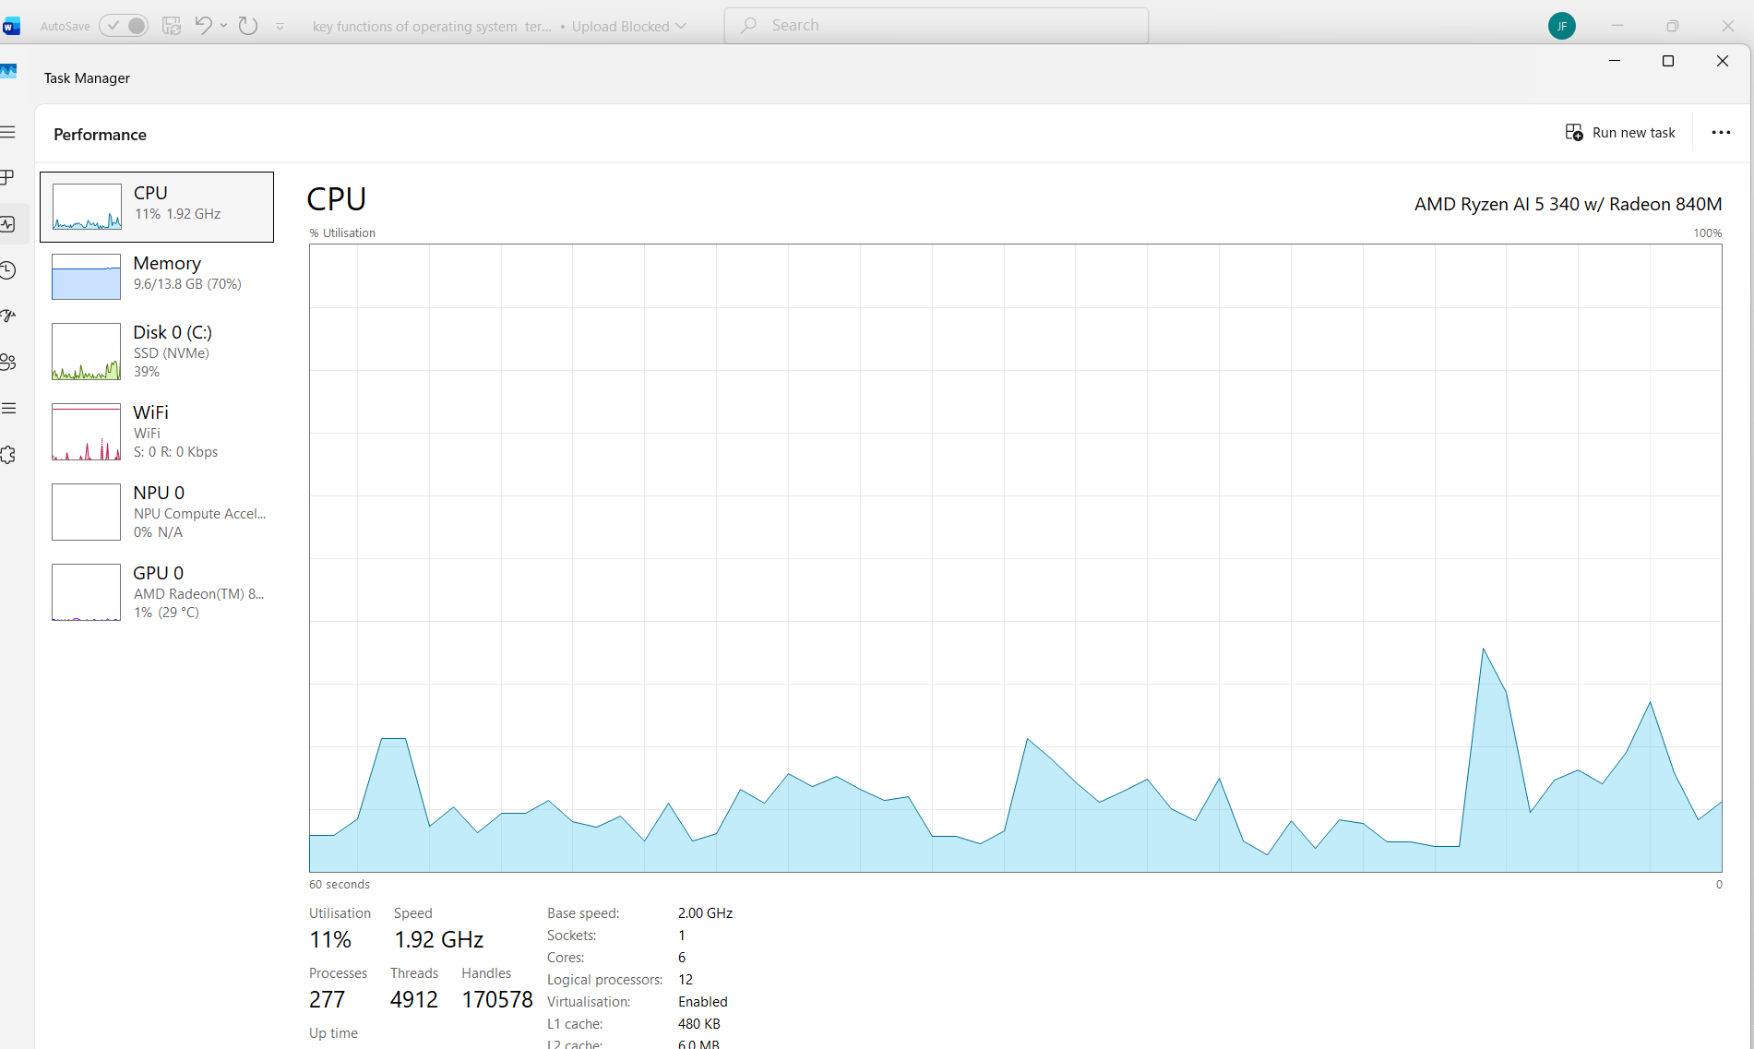

Figure B1 - Activity of Windows Task Manager
In the course of the lesson, I utilised Windows Task Manager to examine the computer's performance. I accessed the Performance area and examined CPU utilisation, velocity, processes, and further system details. This exercise illustrated the utilisation of Windows for overseeing hardware resources and assessing CPU performance throughout the operation of the operating system.

Appendix B
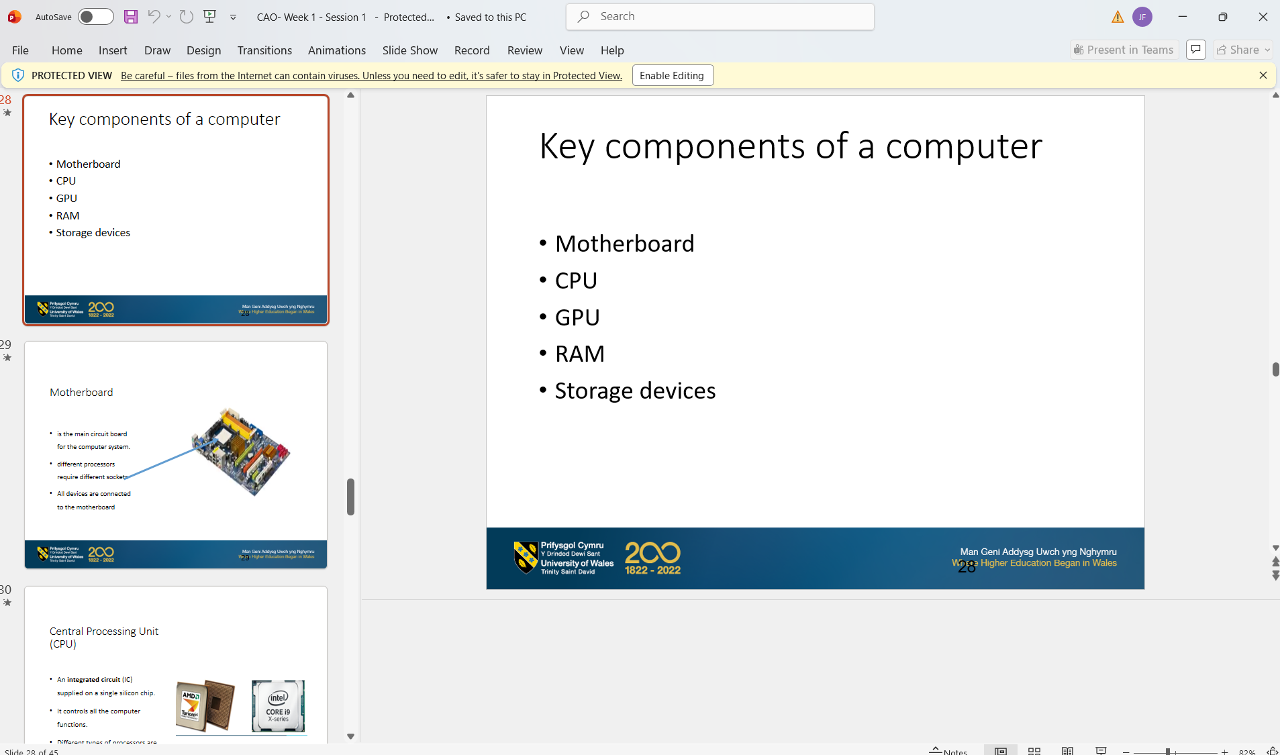

Appendix c
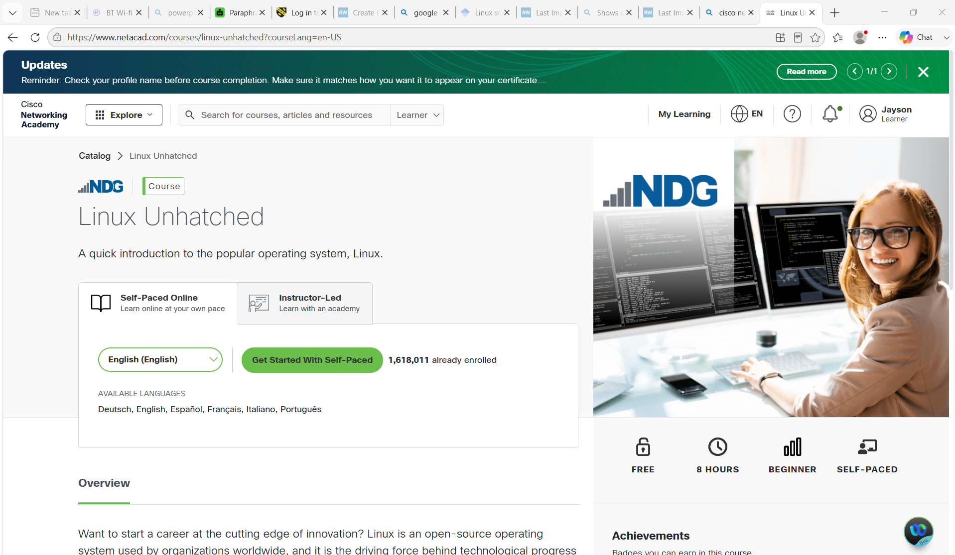

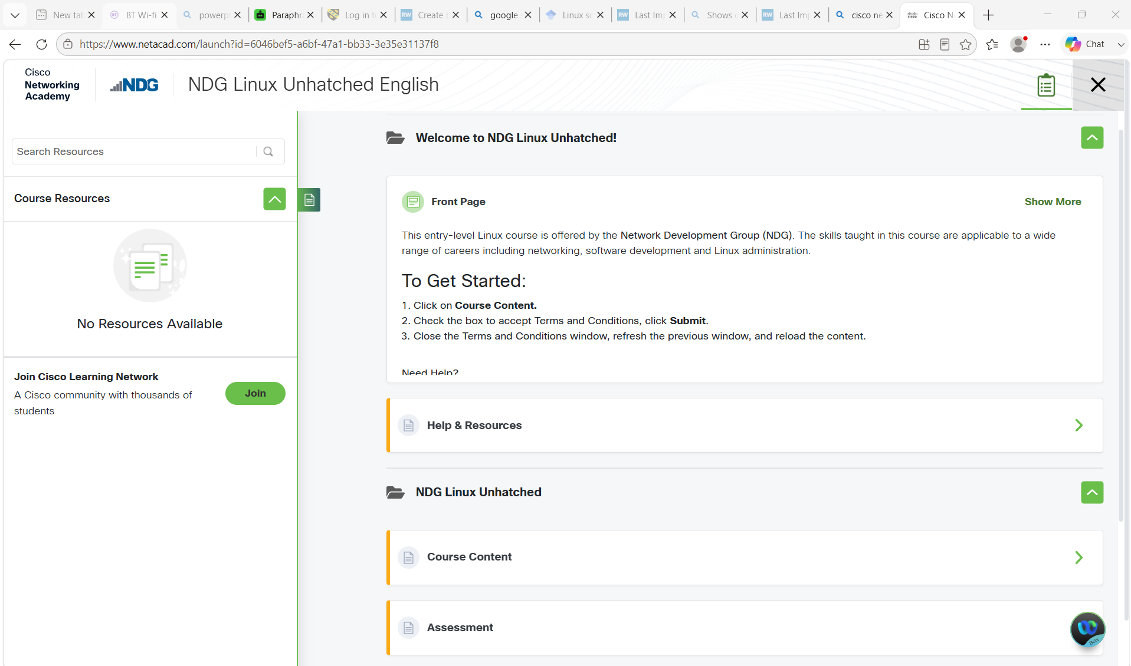
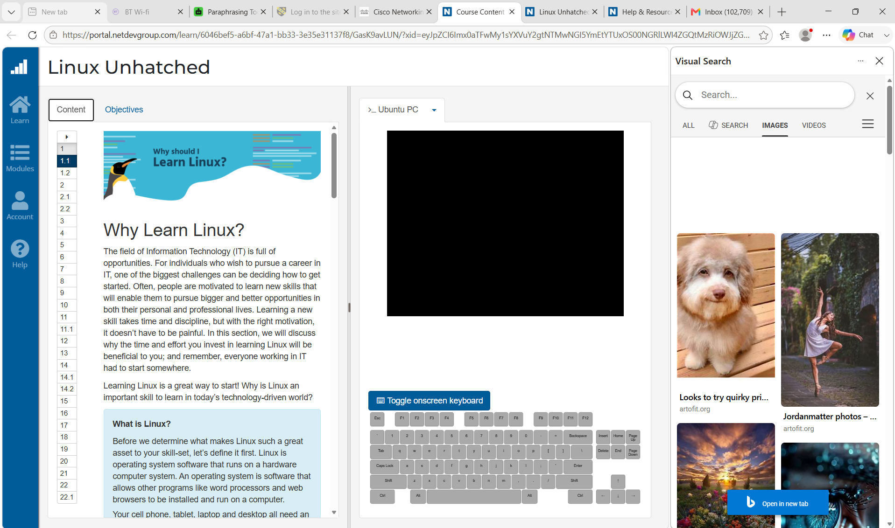

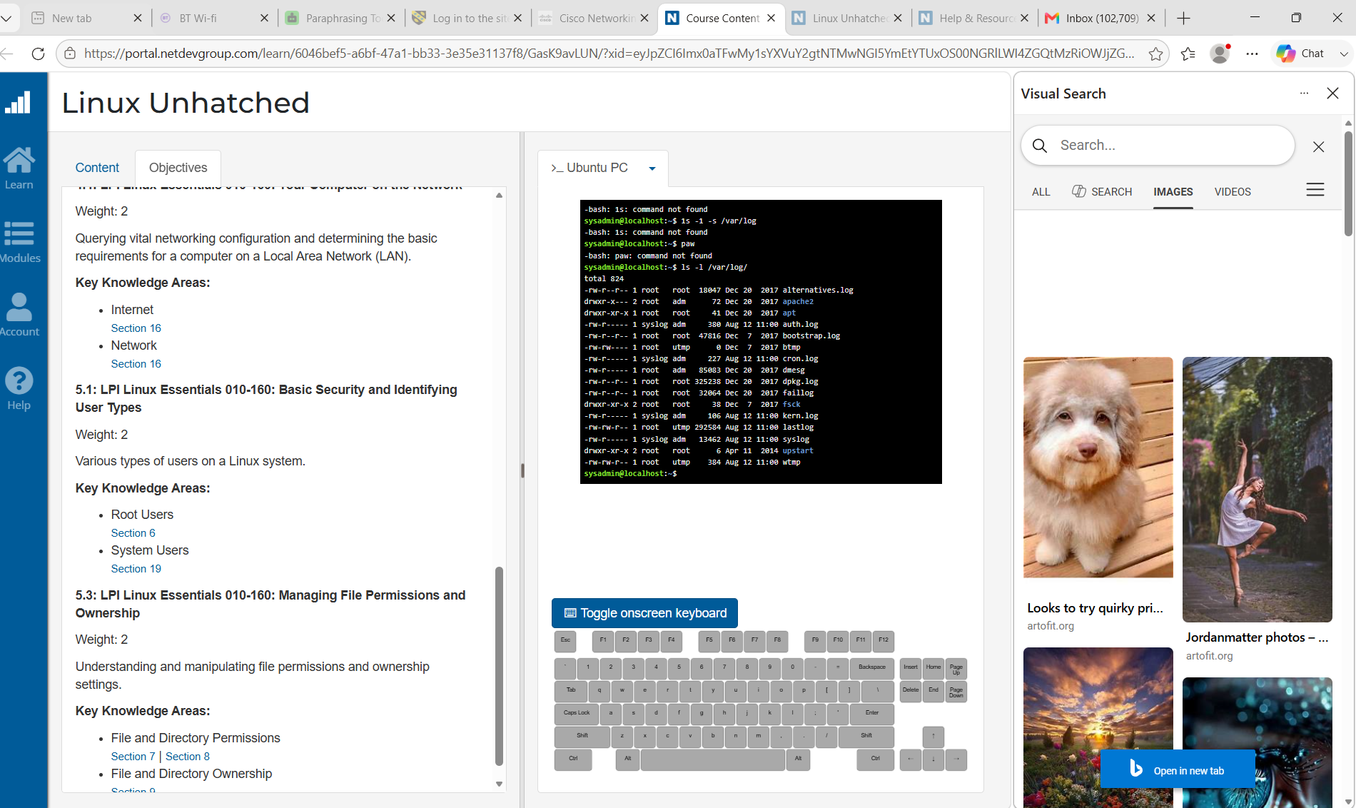

Digital Course: NDG Linux Unhatched
In conjunction with this task, I participated in the NDG Linux Unhatched online course. The course offered hands-on education on the Linux operating system and the utilisation of the command-line interface. The subsequent screenshots serve as proof of my involvement in the course activities.

