

Accounting for Leases

Ryan Price

Executive Summary
This report starts by discussing how leases currently differentiate into finance leases and operating leases. It then goes onto discuss how both are accounted for whilst using substance over form and then summarizes the current criticisms of IAS 17 which are;

- The significant difference in accounting between finance and operating lease.
- Too complex and not transparent
- Does not comply with conceptual framework definitions.

The report then moves onto the replacement of IAS 17 which is IFRS 16, the report discusses how IFRS 16 will be accounted for and clearly identifies the impact the change of standard will have on the balance sheet and profit and loss account. Lastly, it discusses the effects these changes will have on specific industries.

How leases differentiate
The current standard that covers leasing is IAS 17. IAS 17 divides leasing up into two types of leasing, finance leasing and operating lease.
A finance lease is a lease that transfers all the risks and rewards incidental to ownership of an asset to the lessee’ whereas ‘An operating lease is defined as being any lease other than a finance lease.’ (Retallack, 09).
To classify the lease accountants must look at who takes on the risk and rewards of the asset. If the risks and rewards lay with the lessee then it is a finance lease, alternatively if the lessee does not take on the risk and rewards then it is an operating lease. Just for context, a traditional finance lease example would be a vehicle lease. An operating lease example would be a landlord leasing a property to a tenant.
Substance over form must be applied when accounting for leases. This is because by applying substance, the leases will be represented faithfully on the financial statements thus being more reliable to investors/bankers/analysts.

Accounting for Financial and Operating Leases

The initial recognition for a finance lease should look like;
- Dr Non-Current Assets
- Cr Finance lease liability
You must account for the depreciation of a finance lease the depreciation and it should be calculated over the useful economic life. The accounting for this will be;
- Dr Depreciation expense
- Cr Accumulated depreciation
When starting a leasing agreement, it is easy to see that there is a cost hidden in the transaction. For example, if Company XYZ lease an asset worth £20,000 with the economic life of 10 years. Over the 10 years they would pay a rental of £1500 per annum. This would total £15,000 so in this example there is a finance charge of £5000. This extra finance charge is the interest added onto the capital repayment and this must be shown on the profit and loss sheet as a finance cost and on the balance sheet as a reduction of the outstanding liability.
Operating lease aren’t recognized on the balance sheet, but the depreciation is recognized on the profit and loss account. This is because the risks and rewards of the asset are not transferred during the lease arrangements.
Substance over form is an accounting concept that translates to ‘the economic substance of the transaction will be preferred over the legal form of the transaction’ (IASB, 2015). Economic substance means the economic rewards and risks related to the lease. Whereas, the legal form refers to the legal status of the lease and when applying substance over form it is important to only consider the economic substance.
‘For example, an asset may be leased to a lessee without the transfer of legal title at the end of the lease term. Such a lease may, in substance, be considered as a finance lease if for instance the lease term is substantially for entire useful life of the asset or the lease agreement entitles the lessee to purchase the asset at the end of the lease term at a very nominal price and it is very likely that such option will be exercised by the lessee in the given circumstances.’ (Mellwig, 2017).

Criticism of Leasing – IAS 17
The biggest criticism of IAS 17 is how two very similar economic transactions (operating lease and finance lease) can be accounted for so differently. Small contractual adjustments will allow a company to recognize what should be a finance lease as an operating lease. Thus, resulting in untrue comparability between companies. Companies are likely to misclassify their assets because it manipulates key ratios showing their company more favorable than it truly is to investors/bankers.
A well-known example includes fleets of aircraft or rolling stocks that apparently do not meet the criteria for recognition as assets and liabilities. Sir David Tweedie, the previous Chairman of the IASB, acknowledged during a speech in 2008 to the Empire Club of Canada that almost no one in the room has ever flown in a plane that was on the balance sheet of the airline. (Rulmont, 2017)
Another criticism of IAS 17 is that it conflicts with the Conceptual framework set by IASB. The reporting as either an operating or finance lease under IAS 17 conflicts with the conceptual framework: “Permitting alternative accounting methods for the same economic phenomenon diminishes comparability.” And 2.29: “Verifiability helps assure users that information faithfully represents the economic phenomena it purports to represent.” (IASB, 2015).
According to the (IASB, 2015) a liability is ‘a present obligation of the entity arising from past events, the settlement of which is expected to result in an outflow from the entity of resources embodying economic benefits.’ IAS 17 conflicts with the definition taken from IASB’s conceptual framework. Under IAS 17, when a company enters an operating lease the accounting treatment is to expense the profit and loss account with rent payable. The biggest conflict is that there is no asset or liability recognized due to classification of the lease. If you were to consider the conceptual framework when accounting for an operating lease a different treatment would be used. A lease would have to be recognized due to the signing of a lease being ‘a present obligation of the entity arising from past events’ this means that an asset would also have be accounted for which currently under IAS 17 is not the case with operating leases.
The last criticism of IAS 17 is that it is too complex and not transparent enough for investors, bankers and analysts to assess the company’s financial situation correctly.

IFRS 16
The aim of IFRS 16 is to report information that;

- Faithfully represents lease transactions and;
- Provide a basis for users of financial statements to assess the amount, timing and uncertainty of cash flows arising from leases
(IFRS, 2018).

The new standard will introduce a new accounting model that is labelled a ‘single lessee accounting model. This will require companies to recognize assets and liabilities for all leases that run a course more than 12 months, however this excludes assets and liabilities that are of low value. With the introduction of IFRS 16 the lessee will be required to identify the right-of-use asset this represents its right to use the asset and a lease liability representing its obligation to recompence the lease payments
Right-of-use assets will be measured like other assets such as property, plant and equipment this will also be the same for lease liabilities. This means that the lessee will identify depreciation of the right-of-use asset and interest on the lease liability.
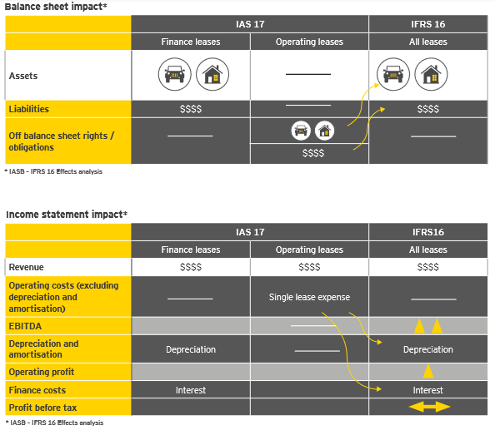
(EY, 2016)

As you can see in the graph above IFRS 16 will impact the balance sheet and profit and loss account.
Firstly, for the balance sheet, the impact IFRS 16 will make is that all leases will be recognized in the assets and liabilities whereas before under IAS 17 the operating leases weren’t on the balance sheet. Secondly, as for the profit and loss account (shown as income statement), the impact will be that operating leases under IAS 17 were accounted for under a single lease expense they will now be accounted for as separate lease expenses under depreciation and interest. To summarize, the major impact will be that all leases will be accounted for the same.

The impact IFRS 16 will have on companies

IFRS 16 will affect specific industries more than other and this is because of the capital structures adopted by these industries. The graph below shows the scope of impact per industry scaled to the effort to comply and the level of impact expected on specific industries.

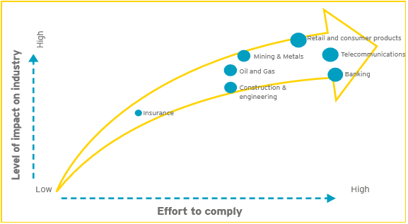
(EY, 2016)
It is forecasted that the retails and consumer product industry will be the heaviest hit by IFRS and this is because this industry in notorious for leasing retail space.
The graph then shows that telecommunications companies are expected to be impacted heavily. This is due to the equipment they provide to customers on lease contracts.
Like retail and consumer product industries the banking and financial services also lease office space for the large administration and call centers.
Other sectors that will be heavily affected will be the Metal and mining industry Oil and Gas and the Insurance industry. These three industries will have to consider similar leases such as equipment, vehicles and land and buildings.

Conclusion

I believe that this new standard is a move in the right direction. Bringing leasing standard up to date will create a truer and more reliable picture of a company’s financial position. However, I think that companies will always find a way to manipulate the standards that govern them to portray their company more profitable than it truly is. This will merely be a speed bump.

Bibliography
EY, 2016. Summary of IFRS 16 and its effects. EY Building a better working world, p. 5.
FASB, 2013. Proposed Accounting Standards Update. Leases (Topic 842), pp. 11-206.
FCCA, T. C., 2011. The IASB's Conceptual Framework for Financial Reporting. Student Accountant Technical, p. 5.
Haywood, A., 16. IFRS 16 Leases is Here – IASB Release New Global Lease Accounting Standard. [Online]
Available at: http://blog.innervision.co.uk/blog/ifrs-16-leases-is-here-iasb-release-new-global-lease-accounting-standard
[Accessed 28 11 2018].
IASB, 2015. Conceptual Framework for Financial Reporting. IASB.
IFRS, 2018. IFRS 16 Leases. [Online]
Available at: https://www.ifrs.org/issued-standards/list-of-standards/ifrs-16-leases/
Mellwig, W., 2017. Conceptual Problems with a New lease Accounting Approach. Journal of Equipment Lease Financing, pp. 1-19.
Retallack, B.-A., 09. Accounting for Leases. [Online]
Available at: https://www.accaglobal.com/uk/en/student/exam-support-resources/fundamentals-exams-study-resources/f7/technical-articles/accounting-for-leases.html#
[Accessed 05 12 2018].
Rulmont, S., 2017. IFRS 16 - Leases: Implications for analysts and investors. pp. 6-8.
Smith, L., 2018. Off-Balance-Sheet Entities: An Introduction. [Online]
Available at: https://www.investopedia.com/articles/analyst/022002.asp

