DS 1- My Digital Life – How Technology Supports My Everyday Activities

My Screenshots/Photos
- Please add 4–6 screenshots or photos of your digital life.
- You can use your phone or laptop.
- For each screenshot, write one or two sentences explaining what it shows.

Screenshot/Photo 1
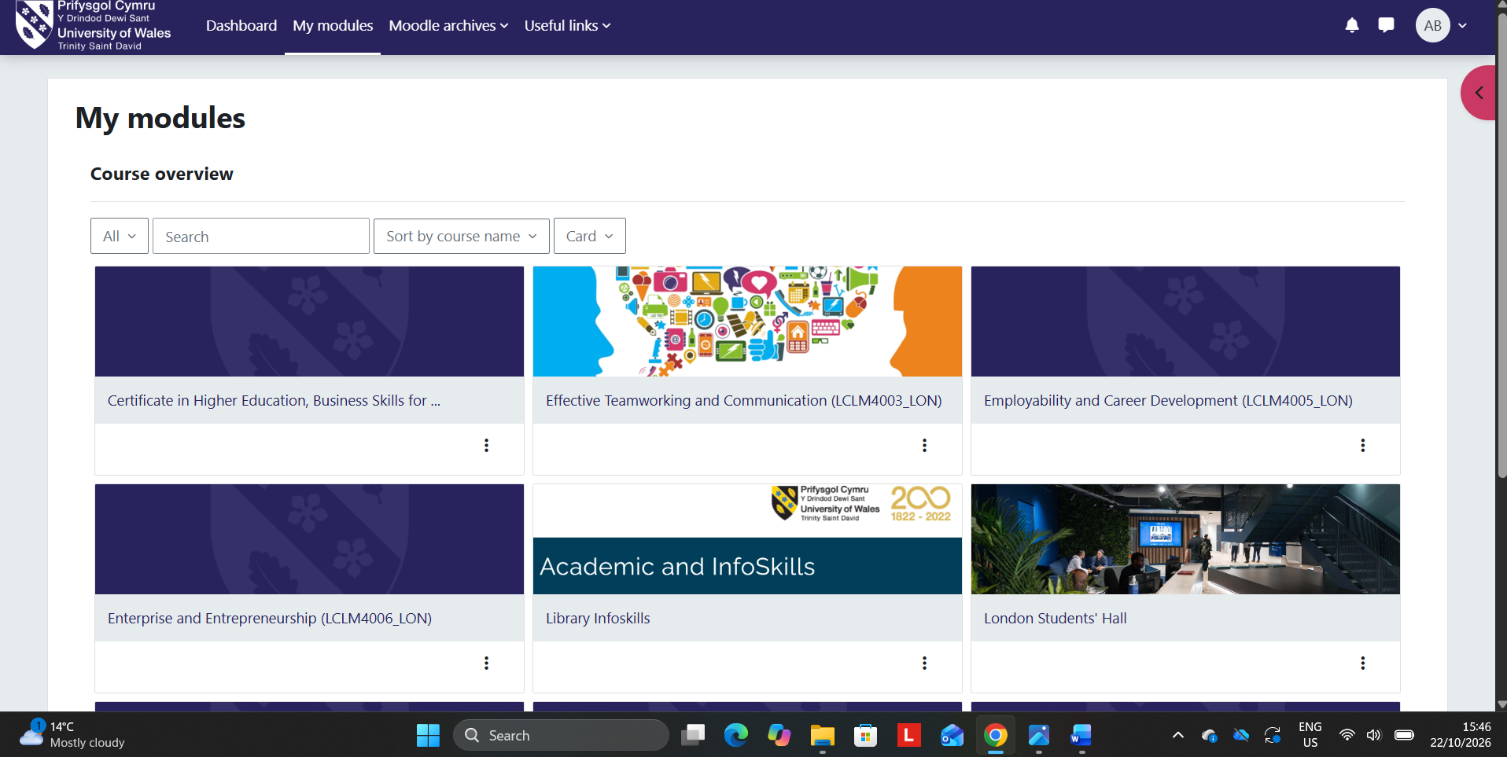
I regularly access Moodle to review learning materials and keep track of my university tasks. Having everything available online makes studying more flexible and helps me prepare for lessons.

Screenshot/Photo 2
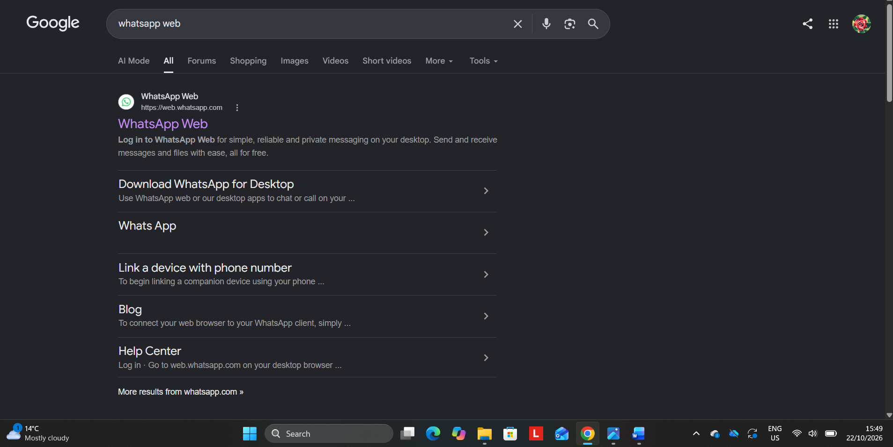
WhatsApp is part of my daily routine because it allows me to stay connected with family and friends. It makes communication easier through messages and video calls, especially when people are far away.

Screenshot/Photo 3
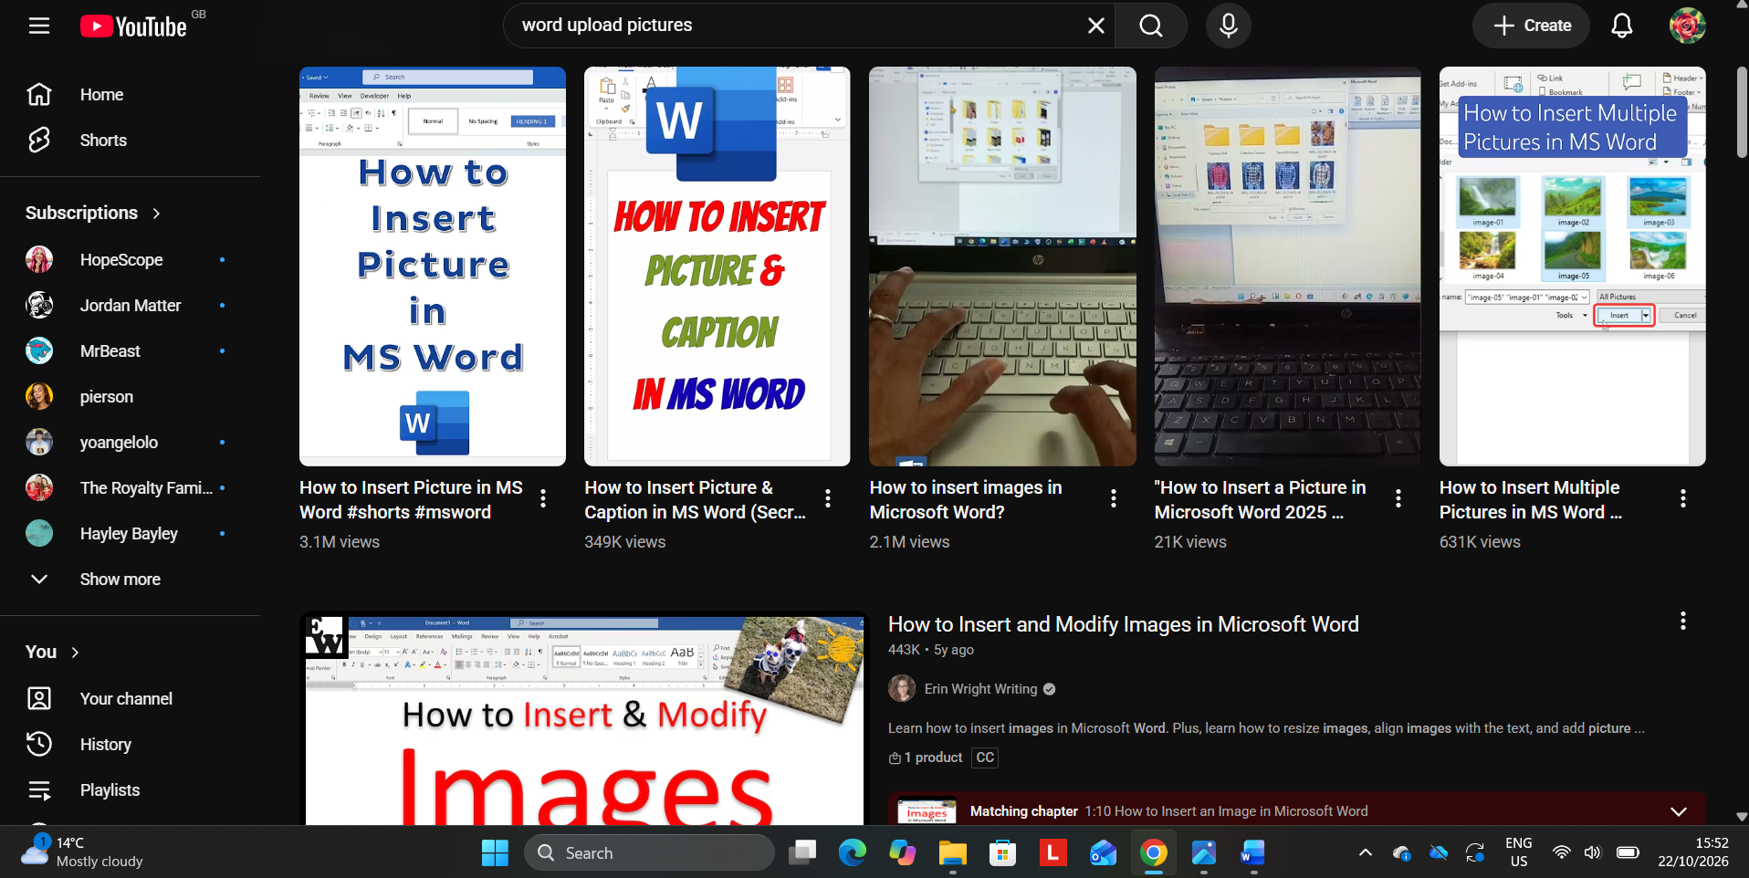
YouTube helps me develop new skills by watching educational videos and practical tutorials. I find it especially useful when learning how to use digital tools, as I can watch the instructions again whenever I need to.

Screenshot/Photo 4
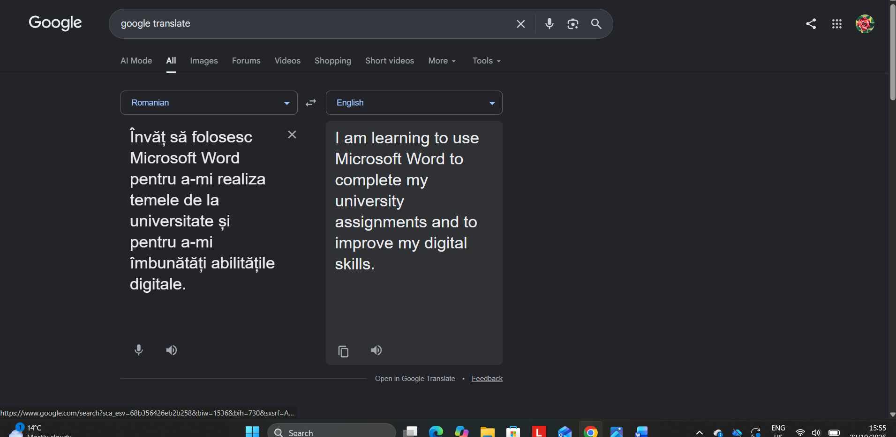
Sometimes I struggle to understand certain English expressions, especially when reading academic materials. Google Translate helps me understand their meaning in Romanian and continue learning with more confidence.

Screenshot/Photo 5
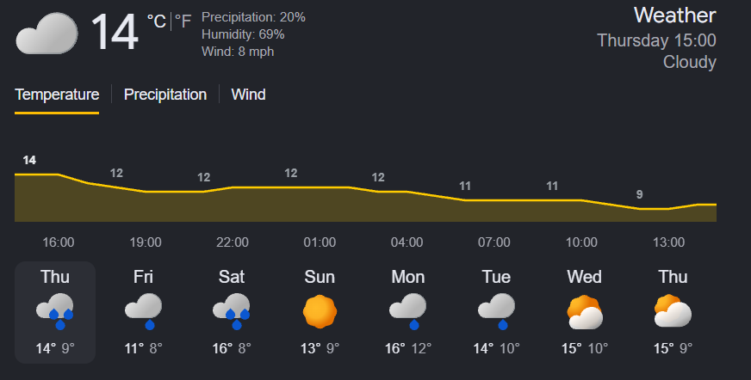
I use weather applications to check the forecast before leaving home and planning my daily activities. This helps me choose suitable clothes and prepare for changes in the weather.

Screenshot/Photo 6

Online shopping makes my daily life easier because I can compare products and prices without visiting different shops. It also helps me save time and make better decisions before buying something.

My Short Reflection
- Write 5–8 simple sentences about your digital life.
- You can use the sentence starters below if helpful.
- I use digital tools to study, communicate with others and organise my daily activities.
- I feel confident when I complete my university assignments using Moodle and Microsoft Word.
- I want to improve my computer skills and learn how to use different applications more independently.
- I often use these tools: Google Translate, WhatsApp, YouTube and online shopping websites.
- I sometimes feel nervous about making mistakes when using unfamiliar technology or understanding difficult English words.
- I hope this module will help me become more confident and develop useful digital skills.
- Digital skills are important for me because they make everyday tasks easier and prepare me for future opportunities.

Sentence starters
- I use digital tools to …
- I feel confident when I …
- I want to improve …
- I often use these tools: …
- I sometimes feel nervous about …
- I hope this module will help me …
- Digital skills are important for me because …
You can write more if you want.

Submission Checklist
Before you submit, please check:
​​​ ☒ I added 4–6 screenshots
☒ I wrote short sentences for each screenshot
☒ I wrote my short reflection
☒ My work is my own
☒ My file opens correctly
​​☒ My file opens correctly

