Fundamentals in Construction Technology

Domestic New-build – ACBA4001

Contents

Foundation and sub-structure………………………………..……3

Detailed drawings…………………………………..………………5

Ground floor detail………………………………………..…..5

First floor detail………………………………………….……6

Eaves and roof covering detail…………………………..….7

Roof structure detail…………………………………..……...8

Advantages and disadvantages of roof structure…………..…...9

Condensation and ventilation………………………………...….10

Causes and sources of condensation…………………….10

Sketches of appropriate ventilation……………...………..11

Measures to reduce condensation……………………......12

References…………………………………………………...……13

Bibliography……………………………………………..…………14

Foundation and sub-structure

Foundation

A suitable foundation based of the given information is a concrete strip foundation. The topography is level which is suitable for strip foundation along with the sub-soil being firm creating a good base for the concrete strip foundation. The trench will be 900mm below ground to allow for the top soil removal and to form a good base. The concrete strip will be 150mm thick as the ground is firm and does not need it thicker. This is all drawn in detail and labelled in figure 1.

Sub-structure

The sub-structure suitable is a block and block cavity with a concrete infill. The concrete infill is up to the same level as the hardcore. The concrete blocks, to British standard 6073, are built up 1050mm from the top of the concrete strip. This allows there to be 150mm from ground level to the air bricks which allow ventilation into the suspended timber floor void. This is all drawn in detail and labelled in figure 1.

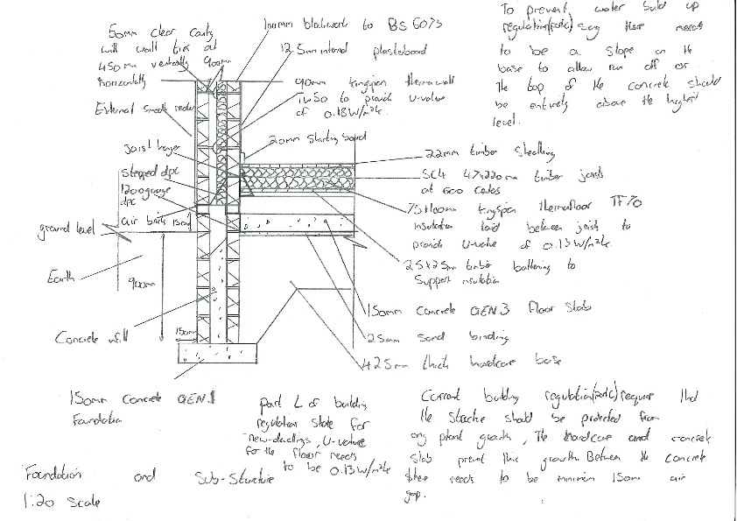

Figure 1

Ground floor detail
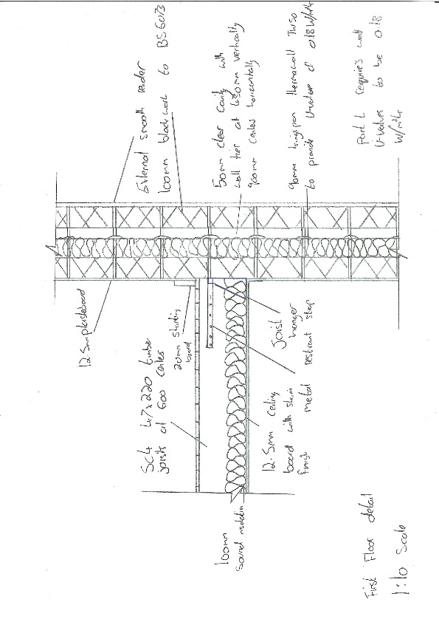

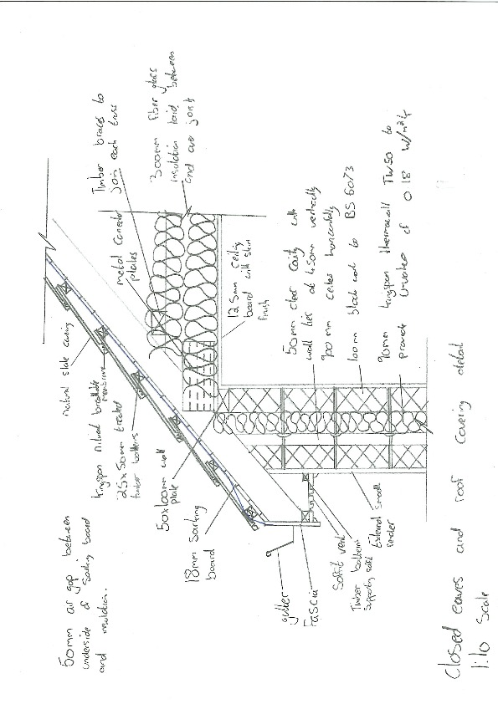

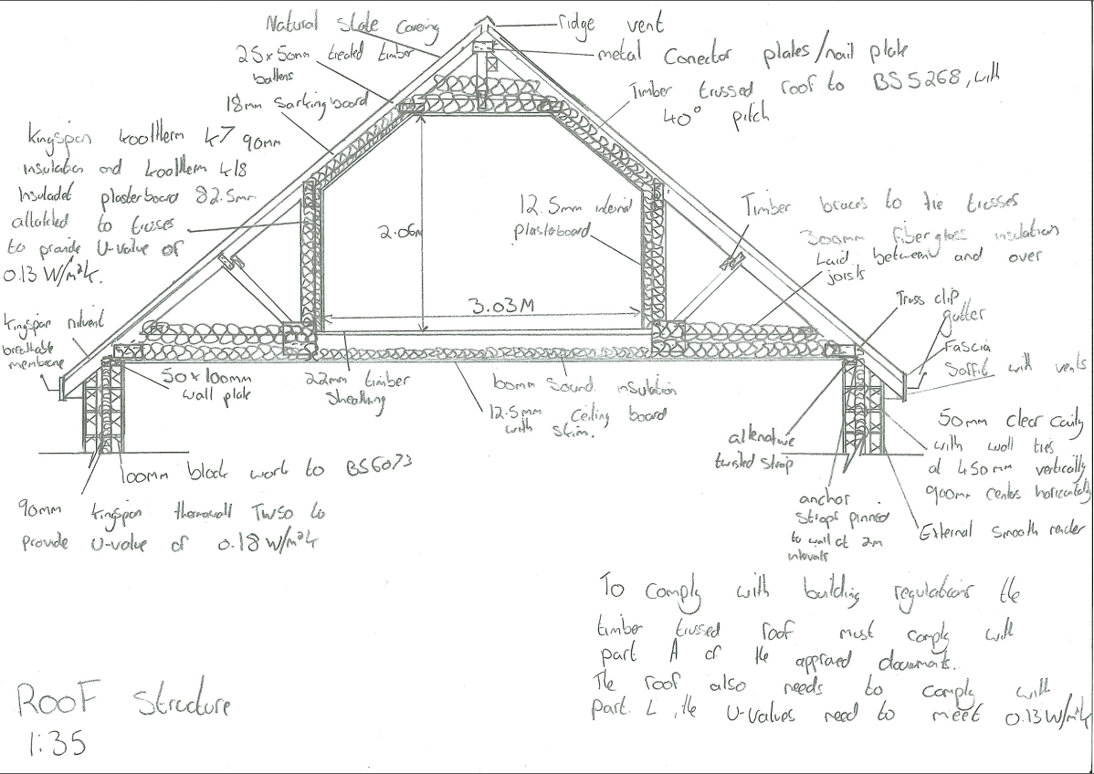
Advantages and disadvantages of roof structure

Advantages
The advantages of using trussed roofs are that they are very quick to erect. This is because they come pre-fabricated which allows them to be erected with ease. Trussed roofs also mean the insulation cost is less. From the roof structure detail on page 8 it shows that sections have insulated plasterboard and PIR insulation on the sloped sections of the roof and the walls which costs a lot more compared to the fibre glass insulation laid horizontally in the detailed drawing.

Disadvantages
The disadvantages to using trussed roofs is that space is restricted as shown on page 8. A trussed roof also isn’t very versatile if changes to the roof were to happen in the future e.g. dormer windows.

Alternative method
An alternative method of construction to a trussed roof is a cut roof. A cut roof is constructed using rafters with the roof covering attached to it which is in turn is supported by purlins. Purlins can be supported if the span is too long by using main trusses, load bearing walls or support braces. The advantages of using a cut roof is that it provides full space in the attic and it can be easily adapted to fit dormer windows or new sections of roof over new extensions. The disadvantages of using a cut roof are that to insulate it you need PIR insulated boards and plasterboard to provide head height in the space which is a very expensive way of insulating.

Condensation and ventilation

Causes and sources of condensation
Sources on condensation in a domestic home can be from cooking, showering/bathing, breathing, laundry, pets and leaks in the structure. This city of York council say that cooking and using the kettle can produce 3 litres of moisture, Bathing or showering can produce 1 litre, drying cloths indoors can produce 4.5 litres and two people being inside for 6 hours can produce 1.5 litres of moisture by just breathing.

Sources of condensation in a domestic home can be from lack of ventilation, thermal bridging or lack of breathable membranes. A lack of ventilation doesn’t allow the moisture to leave the house which caused condensation. Thermal bridging is when a material has a higher thermal conductivity than its surrounding elements which crates a path of least resistance for heat transfer. This causes that element to have a different temperature than the dew point casing the moisture to condense. A lack of breathable membranes can cause poor ventilation and cause the moisture to retain and condense. This commonly happens in roof spaces where the roof membrane is none breathable and causes condensation in the roof space.

Detrimental effects of condensation are it causes staining, decoration damage, mould growth and potential for wood rot or corrosion. Staining is caused through the damp running down the wall and leaving marks on the structure and can cause decorations to peel and crack, this is a commons sign of a condensation problem. Mould growth is a major effect of condensation as it can harm the person living in the home. The mould grows due to the damp conditions and warmth. Wood rot or corrosion can be caused by putting an impermeable membrane in the wrong place. If there was an impermeable membrane on the end of a timber joist and damp occurred it would cause it to sit there and rot the wood, this is the same for metal fixings. In a roof space if there is no breathable membrane or air ventilation gap the moisture can corrode the fixings and cause structural problems.

Appropriate methods of ventilation
Appropriate methods of ventilation to reduce condensation in this building would be fitting correctly sized extract fans in places of high moisture (bathroom, utility, kitchen…..) and openable windows with trickle vents. Having correctly sized extract fans that feed externally will help reduce condensation as it extracts moisture in the air. To size the extracts correctly you need to consider the size of the room, what component will be producing the moisture and how much it will be producing. Extract fans will prevent moisture build up in these rooms with higher moisture levels but for the rest of the house having windows that can open and have trickle vents will be ample ventilation. Being able to open a window will help in the day time if there are multiple people around or you are doing something that produces higher moisture but a trickle vent can always be left open to provide a small but steady source of ventilation which is enough as these rooms don’t have high moisture levels. On page 8 it shows a detailed drawing with appropriate ventilation. For a pitched roof with a loft space there has to be 25mm minimum air gap at the eaves to allow air flow with then a 50mm clear pass between the insulation and underside of the roof. At the ridge there is a vented ridge tile which has a minimum 5mm air gap each side to allow the air to escape. This ventilation along with a breathable membrane prevents moisture build up in the roof space which as I mentioned before can cause wood rot or corrosion. These minimum air gaps meet the building regulations approved document C.

In approved document F it states that a minimum of 4 air changes per hour in each habitable room with purge ventilation. Purge ventilation is for example opening a window to ‘purge’ the internal air from smoke or moisture that has built up.

Measures to reduce condensation
Measures that can be taken to reduce condensation in the proposed building are simply having a high level of construction. This involves a large number of things which will stop any thermal bridging or any cold areas where the moisture can condense. These high-level construction methods include putting thermabate cavity closers around all openings in the structure, having perimeter insulation around the structure, having insulated lintels, correct thicknesses of insulation, correct sized heating services and sealed finishes. If all this has been achieved condensation will only form on the windows as that is the only cold area.

References

Chudly, R. and Greeno, R. (2016) Building Construction Handbook. 11th Ed. Oxon: Routledge
Riley, M. and Cotgrave, A. (2018) Construction Technology: House construction. 3rd Ed. London: Palgrave
Kore system (2016) Thermal bridging: what is it & why you should avoid it. Available at: https://www.kore-system.com/blog_list/thermal-bridging-what-it-is-why-you-should-avoid-it/ (Accessed: 25th April 2019)

Bre Autumn condensation. Available at: https://www.bre.co.uk/page.jsp?id=3507 (Accessed: 25th April)

Welsh government (2018) Part A (structural safety). Available at: https://gweddill.gov.wales/topics/planning/buildingregs/approved-documents/part-a-structural/?lang=en (Accessed: 19th April)

Welsh government (2018) Part C (Resistance to contaminants and moisture). Available at: https://gweddill.gov.wales/topics/planning/buildingregs/approved-documents/part-c-moisture/?lang=en (Accessed: 19th April)

Welsh government (2018) Part F (Ventilation). Available at: https://gweddill.gov.wales/topics/planning/buildingregs/approved-documents/part-f-ventilation/?lang=en (Accessed: 20th April)

City of York council (2019) Dealing with damp and condensation. Available at: https://www.york.gov.uk/downloads/file/5867/dealing_with_damp_and_condensation (Accessed: 24th April)

Bibliography

Rytons (2015) Moisture prevention starts with effective sub-floor ventilation. Available at: http://rts.vents.co.uk/blog/moisture-prevention-starts-with-effective-sub-floor-ventilation/ (Accessed: 18th April)

NHCB (2016) Air bricks to underfloor voids – relationship to ground levels. Available at: http://www.nhbc.co.uk/Builders/ProductsandServices/TechZone/NHBCStandards/TechnicalGuidanceDocuments/61/filedownload,65368,en.pdf (Accessed: 18th April)

Property care Condensation. Available at: https://www.property-care.org/homeowners/condensation/ (Accessed: 19th April)

