
Programme: Master of Business Administration
MBA Dissertation Proposal
Title: Analysing the role of Artificial Intelligence in Shaping Digital Marketing Strategies of TATA Consultancy Services (TCS) In India: Focus on AI-Driven Analytics, Personalization, and Client Engagement.
Supervisor Name: Dian Mayasari
Student Name and ID: Purvi Patel (2419111)
Submission Date: 10-10-2025

ANALYSING THE ROLE OF ARTIFICIAL INTELLIGENCE IN SHAPING DIGITAL MARKETING STRATEGIES OF TATA CONSULTANCY SERVICES (TCS) IN INDIA: FOCUS ON AI-DRIVEN ANALYTICS, PERSONALISATION, AND CLIENT ENGAGEMENT

Table of Contents
1. Introduction/Background/Research problem 3
2. Research aim, objectives, questions 3
3. Preliminary literature search 4
4. Research Methodology 6
5. Risks 6
6. Timeline 7
7. Conclusion 8
References 9

1. Introduction/Background/Research problem
The intended study will focus on the impact of artificial intelligence (AI) on the digital marketing strategy implemented by the Tata Consultancy Services in India. As part of the movement to enhance its B2B marketing, TCS, as a global leader in IT, will increasingly rely on AI tools, such as chatbots, recommendation engines, and predictive analytics. With the aid of artificial intelligence, management practices could potentially change in the future by strengthening a competitive position, personalizing clients, and making decisions based on data that is readily available (Nweke, 2025). The paucity of information regarding the ability of these technologies to accomplish parity between computerization and human-mediated bodies in relationships with consumer management, however, will be a research drawback. In the literature review, the secondary data will be collected.

2. Research aim, objectives, questions
Aim:
This report seeks to explore the use of AI technologies by Tata Consultancy Services (TCS) to support its digital marketing practices in India, particularly analytics, automation, and personalised relationships with clients.
Objectives:
1. To determine how AI technologies were utilised in the digital marketing campaigns of TCS, such as catboat, machine learning, recommendation systems, and predictive analytics.
2. To determine the effectiveness of the current AI-based marketing campaigns that TCS uses in its marketing strategies, regarding the generation of leads, building its brands, and engaging its customers.
3. To evaluate the advantages and challenges of implementing AI in the business-to-business digital marketing strategies of TCS, to achieve the automation-CRM balance.
Research Question:
- How does TCS plan to integrate artificial intelligence (AI) into its digital marketing efforts with chatbots, machine learning, recommendation engines, predictive analytics, and so on?
- To what extent will the AI-driven marketing endeavours of TCS enhance customer engagement, brand positioning, and lead generation?
- What worries us is how TCS could balance automation and people-directed CRM, and what the pros and cons of applying AI in its B2B digital marketing approaches are.

3. Preliminary literature search
Karthikeyan (2025) discussed how artificial intelligence (AI) could impact strategic decision-making, focusing on the Folger model of using AI to drive data-oriented strategies and change organisational behaviour. The research statistics indicated how managers could reduce uncertainty and maximise choices through the use of AI tools. Kamal and Ahmad (2025) also researched the availability of strategic approaches to e-business transformation within the Indian business environment. Their results revealed the impact of digital disruption on marketing strategies and business models in which AI contributes to enabling marketing to be responsive, agile, and competitive.
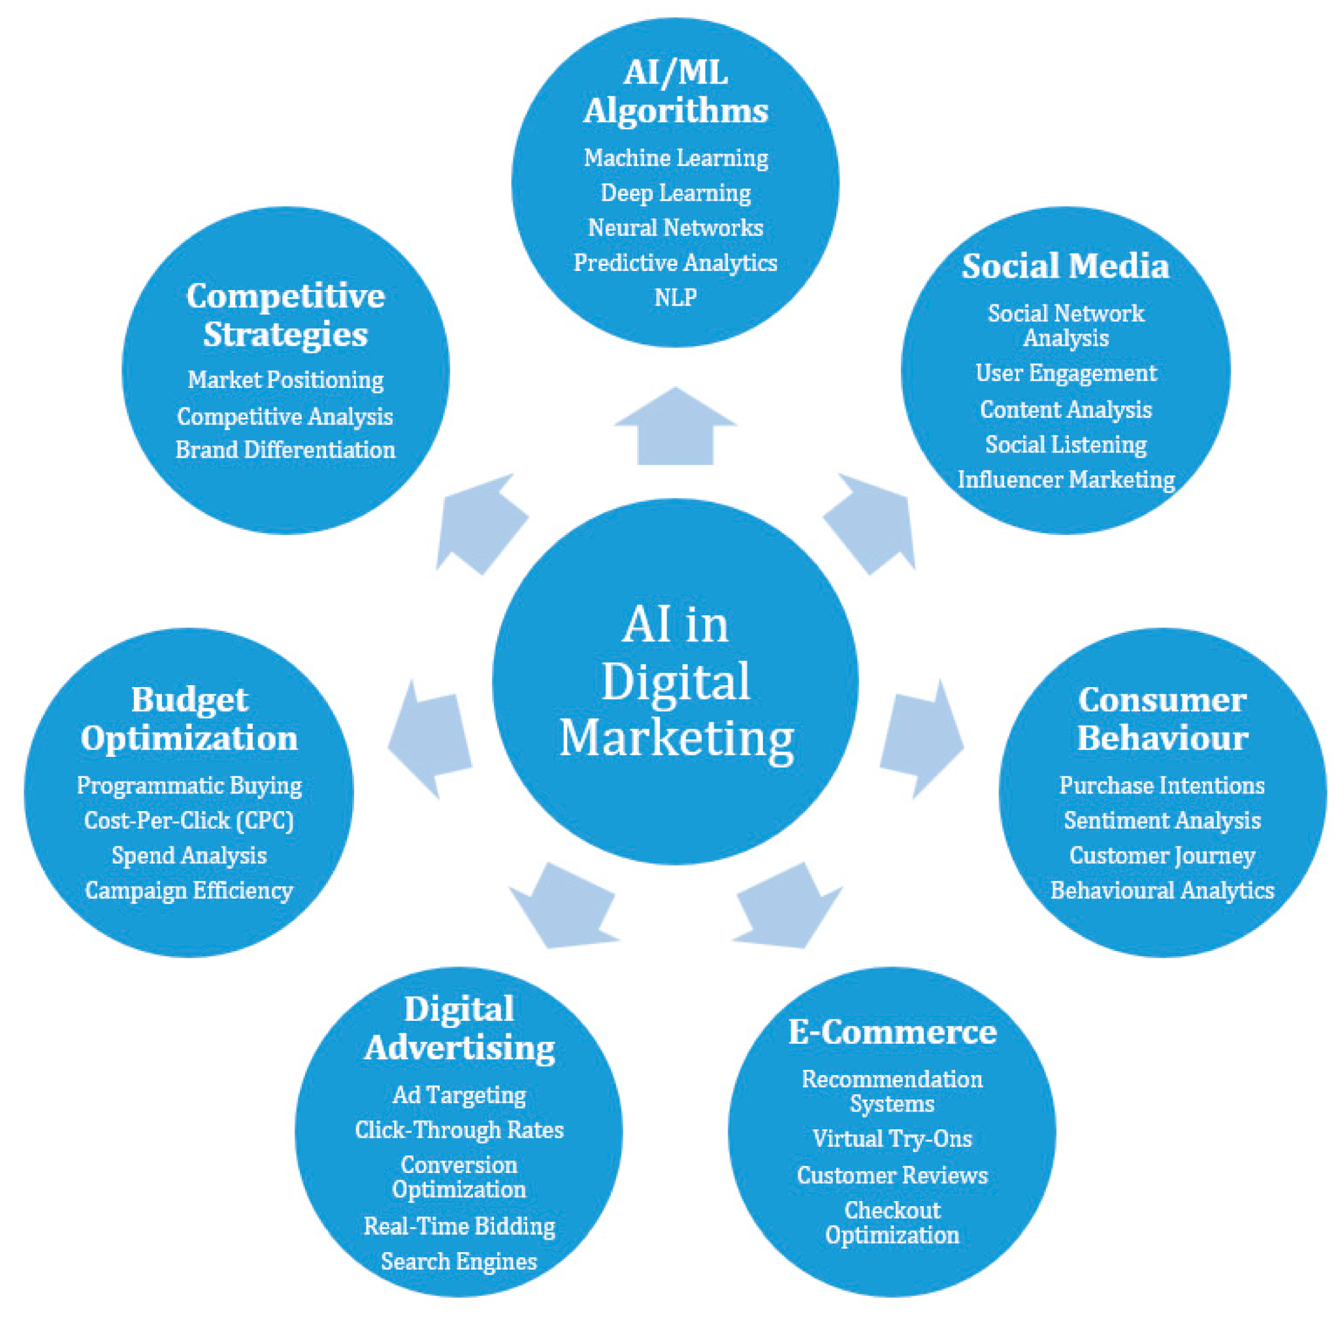
Figure 3.1: Artificial Intelligence in Digital Marketing
(Source: Christos and Macro., 2023)
The above image displays the role of AI in the field of digital marketing. In a case study on Tata Consultancy Services (TCS), Gupta et al. (2024) concentrated on how AI affects HR operations. The results showed how AI strengthened TCS's leadership in digital adoption while streamlining hiring, performance monitoring, and employee engagement. Though this study focused on internal operations, it did not examine how AI influenced TCS's digital marketing tactics. Collectively, the reviewed literature demonstrated AI's transformative power in both the strategic and operational domains. However, it was still unclear how AI specifically affected TCS's marketing initiatives, customer service, and brand positioning in the Indian business-to-business market. This gap warranted additional investigation in the suggested study.

4. Research Methodology
In order to give a thorough grasp of how TCS will incorporate artificial intelligence into digital marketing strategies, the research will use a qualitative case study methodology with elements of mixed methods. Secondary sources, such as TCS's annual reports, press releases, trade journals, and peer-reviewed articles available on Google Scholar, will be the main source of data. The researcher will be able to critically analyse how AI-driven tools will be positioned within B2B marketing practices thanks to this approach. To support the findings, qualitative insights from case studies in the industry will also be examined (Lim., 2025). Throughout the study, ethical issues will be closely examined. In order to maintain academic integrity, any secondary sources will be properly cited. The study will adhere to data protection and ethical principles of responsible management research, and sensitive company information won't be shared without express consent.

5. Risks
Risk | Description | Likelihood | Impact | Mitigation Strategy
access limitations | Internal TCS data may not be fully available for analysis. | Medium | High | Rely on secondary data from Google Scholar, reports, and publications.
Bias in secondary data | Corporate reports may emphasise only positive aspects of AI applications. | High | Medium | Cross-check findings with independent academic and industry sources.
Time constraints | Interviews and campaign analysis may be difficult to schedule within deadlines. | Medium | Low | Use structured timelines and prioritise secondary data collection.
Ethical risks | Risk of breaching confidentiality. | Low | High | Use structured timelines and prioritise secondary data collection.

6. Timeline
The Gantt chart will demonstrate the plan of work, and within it, the introduction will be carried out in Week 1, literature review in Week 2, methodology in Week 3, result analysis in Week 4, and conclusion in Week 5.
Task | Week 1 | Week 2 | Week 3 | Week 4 | Week 5
Introduction
Literature Review
Methodology
Result Analysis
Conclusion

7. Conclusion
The purpose of the proposed paper is to critically evaluate Tata Consultancy Services' (TCS) use of artificial intelligence in order to transform its digital marketing strategies in India. It will look at how AI-based technologies can improve customer service, brand positioning, and lead generation. It will also look at the balance between automation and human relationship management at the same time. These findings will contribute to the body of knowledge on artificial intelligence in marketing as well as practical implications for the necessity for businesses to boost their competitive edge through digital innovation in order to ensure technological productivity and tailored client-centric strategies.

References
Karthikeyan, C., 2025. Artificial Intelligence (AI) Influences on Strategic Decision-Making: Transformational Dynamics for Strategic Decisions. In Navigating Organizational Behavior in the Digital Age With AI (pp. 153-180). IGI Global Scientific Publishing. https://www.igi-global.com/chapter/artificial-intelligence-ai-influences-on-strategic-decision-making/364229
Kamal, Y. and Ahmad, S., 2025. Strategic Approaches to E-Business Transformation: Navigating Digital Disruption in the Indian Business Landscape. In Business Transformation in the Era of Digital Disruption (pp. 89-126). IGI Global. https://www.igi-global.com/chapter/strategic-approaches-to-e-business-transformation/357682
Gupta, T., Vaish, A., Gowda BN, V.K. and Purohit, P., 2024. The impact of artificial intelligence on human resource functions: a case study of Tata Consultancy Services (TCS) In India. Frontiers in Health Informatics, 13(8). https://search.ebscohost.com/login.aspx?direct=true&profile=ehost&scope=site&authtype=crawler&jrnl=26767104&AN=184771484&h=hiasYq2UyWHzujHBFFDUUEhLL%2FHFLgMo0SahTxm6cYX89iCV0tPdE98LOj9zCkYQ1oYsMEY7NyHJx9AZT0sJMA%3D%3D&crl=c
Lim, W.M., 2025. What is qualitative research? An overview and guidelines. Australasian Marketing Journal, 33(2), pp.199-229. https://journals.sagepub.com/doi/abs/10.1177/14413582241264619
Nweke, O., 2025. Utilizing AI driven forecasting, optimization, and data insights to strengthen corporate strategic planning. International Journal of Research Publication and Reviews, 6(3), pp.4260-4272. https://www.researchgate.net/profile/Oluwatosin-Adelusi/publication/391704360_Utilizing_AI_Driven_Forecasting_Optimization_and_Data_Insights_to_Strengthen_Corporate_Strategic_Planning/links/6823a896be1b507dce8b0c4f/Utilizing-AI-Driven-Forecasting-Optimization-and-Data-Insights-to-Strengthen-Corporate-Strategic-Planning.pdf

https://www.mdpi.com/2078-2489/14/12/664

