Using three organisations (e.g. charity/support/government), Produce a portfolio documenting the sources of advice and support available to older people living in supported housing

This overall aim in this assignment is to show the distinct difference between organisations and how they support older people living in supported housing and what they can provide to them by catering to their needs in their diverse way. There will be a presentation of 3 organisations that provide supported housing, whilst acknowledging the advantages and disadvantages it brings.
What is supported housing?

The National Housing Federation states how supported housing allows individuals to live autonomously in their own home whilst still receiving the support they require. They cater for various types of people in different situations providing the distinct care and service they require e.g. older people, victims of domestic violence, individuals with learning disabilities and ex-servicemen and women. Staff support individuals with normal day to day activities and also provide assistance in emergencies instantly (National Housing Federation, 2019).” Supported housing is a something that is a lacking a lot of research at the moment. It is said that around 5% of older people live in specialist housing including support, additionally the UK has around 550,000 units of supported housing for older people which can be socially rented, or provided by organisations that are private or not-for-profit. (J. Pennall., & I. Blood, 2012)
Abbeyfield



Abbeyfield is an organisation that offers supported housing for older people all across the UK, the services they provide are relevant and very essential for older people such as security, autonomy and reassurance. They describe supported housing as living autonomously while still having one’s mind at ease due to the fact that there is always someone available when they are needed, when support is required, it is given. They define it as “living life on your terms.” (Abbeyfield, 2019)
In addition, they are quite client focused and based due to the high level of autonomy they provide, this is relevant to older individuals as sometimes they tend to be overlooked at or seen as a burden but by allowing them to live freely is crucial for their mental health and well-being. Individuals are able to decorate their room as they wish while also maintaining an en suite bathroom and kitchenette in order for it to feel like their own suitable little home. Abbeyfield also emphasise the importance of social interaction. They have designated areas for individuals to socialise together including shared lounges, dining rooms and gardens. This is exceptional as loneliness within older people in increasing rapidly therefore allowing individuals to socialise where they feel is best is impressive. In addition, the locations that older people live in are distinct, therefore enabling individuals to be socially active and interacting with one another as it is the surrounding community that they will be living in. face to face contact is vital for older people in order for them to retain the social skills they may already have or to rebuild them back up. (Abbeyfield, 2019)
Volunteering at Abbeyfield

Abbeyfield allows their residents to volunteer also, they allow their residents to volunteer in activities they would enjoy, for example:
- Gardening,
- Washing up,
- Making tea and coffee,
- Board games
- Book club
- Teaching other residents to knit etc.
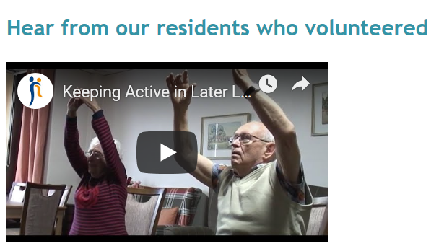
In the video below provided by Abbeyfield it shows their resident, Dorothy who started her own fitness sessions both for herself and the rest of the residents.
Below is the link for the video. (Abbeyfield, 2019) https://www.youtube.com/watch?v=_ZbtgkSqIds#action=share

From the resident’s feedback, they mentioned that volunteering was in their favour as it helped both their physical and mental well-being in order to remain active. It also allows them to have that feeling of contempt, that they matter as they are able to make a change for themselves and those around them. (Abbeyfield, 2019)
Abbeyfield also support their residents with home-cooked meals as well as cleaning, laundry and everyday housekeeping. It is informed that if residents were in need or extra care and support is available for them to access when they require it.
Contact details for Abbeyfield?
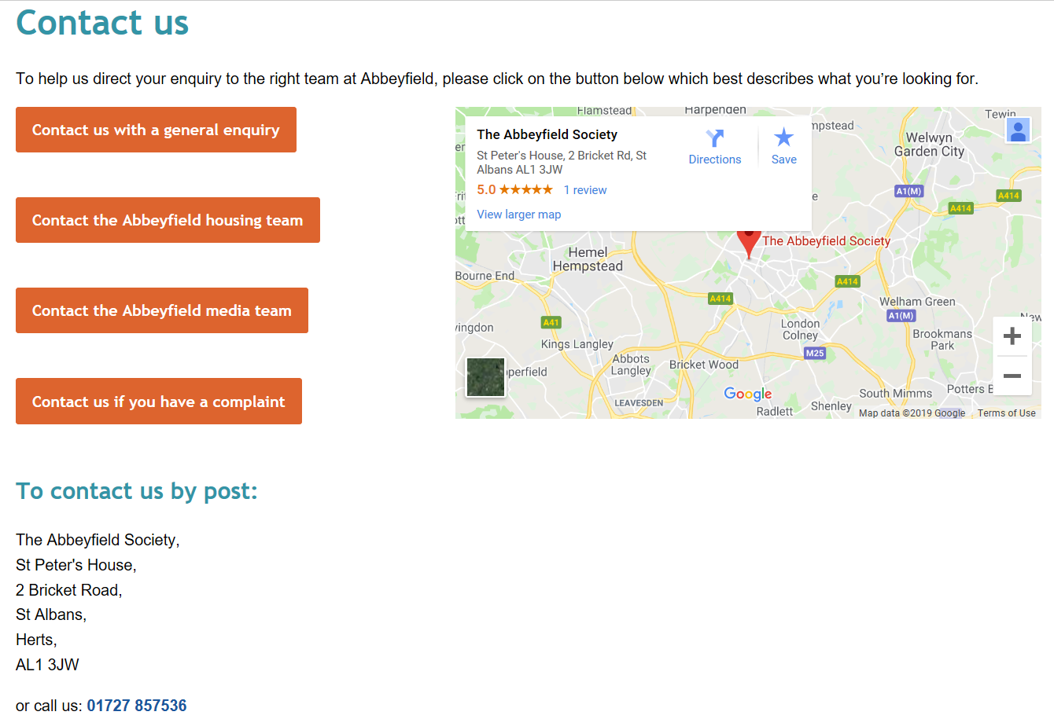

In the photo above it shows different elements that individuals can contact Abbey field about. By clicking on one of these options it will direct it to an online form where people can inform them about any queries, they have regarding their services etc.
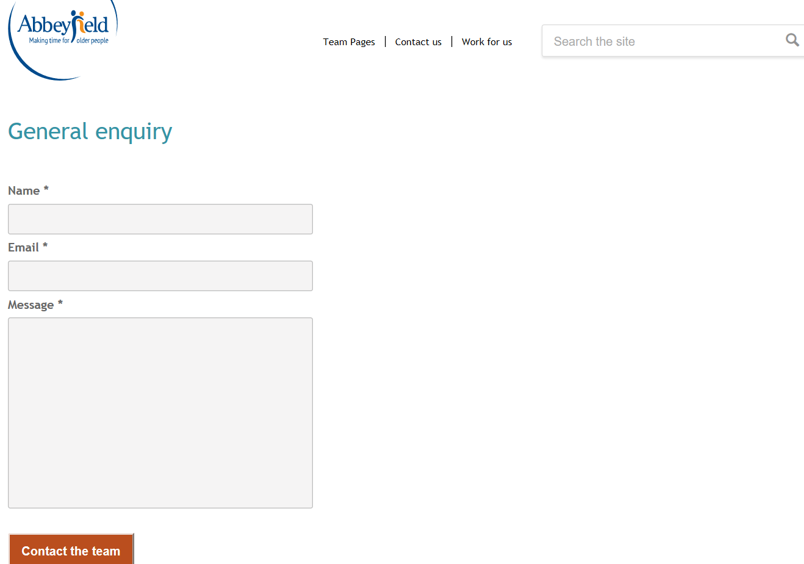
Additionally, if individuals are not able to have access to the internet or are not computer literate, they are able to write into the organisation below as they have provided them with an address for them to do so.
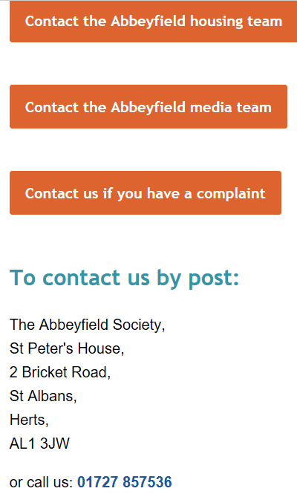
Individuals are able to contact Abbeyfield by phone also at 0172785736

McCarthy & Stone

The second organisation that caters supported housing for elderly is McCarthy & Stone. McCarthy and stone are an organisation that supports elderly by providing them with their own “self-contained property” (McCarthy & Stone, 2019). The properties that they provide are very well suited for older individuals as it consists of a secure door entry system, 24-hour emergency call systems and more. They also provide certain areas where residents can interact with each other such as the lounge area or a landscaped garden where individuals are free to bond and spend their mornings/afternoons/evenings. Every resident will also obtain a house manager dedicated to them whenever support is needed and to organise events, showing how there is hands on support for residents whenever they need it. There are two different plans, this one is the “retirement living plus apartment” which include:
- Estate management team- all year round 24/7 support available for residents at all times as it’s on-site.
- One hour of help each week- which allows residents to help out but then also spend the rest of their time as they wish.
- Flexible level of personal care- an individuals needs will dictate what support is given to them to ensure it is suitable for them.
- Table service restaurant- this is open every day for residents, they are also able to bring their friends and family there.
They are also very resourceful as they also help with the actual move itself, this is “smooth move.” It includes:
Unpacking, hanging pictures and mirrors
Transport everything to the new home
Pack everything up
De-clutter and help organise

McCarthy & Stone also provide a process called “part exchange” this is where they ultimately buy the individuals property off them. Overall, it is sadi that it is a fatser and simplier process instead of dealing with estate agents and viewings. In addition to McCarthy & Stone buying the property if the offer is accepted they will then also contribue towards the solicitor fees, to get more infromation on it, individuals can contact the number below.

Additionally, on their website they advertise properties which are avaiable to purchase, individuals are able to filter the search to their preference. They are also able to see the cost of the property as well as what it incldues such as guest suites, balconies and if pets are aloowed etc. However, there maybe a waiting list for a property. 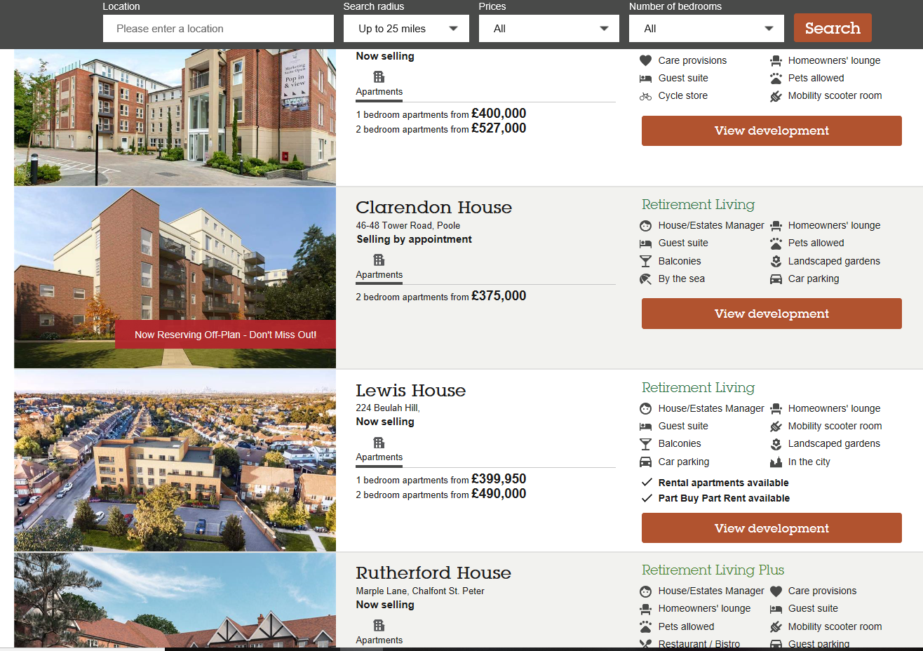

Contact details?
If individuals have enquires about properties, they are able to contact them on 01202292480.
If tehir enquires revole around free entitlements they ca contact them on 01208557261. Alternitavely they are able to write to them if they wish.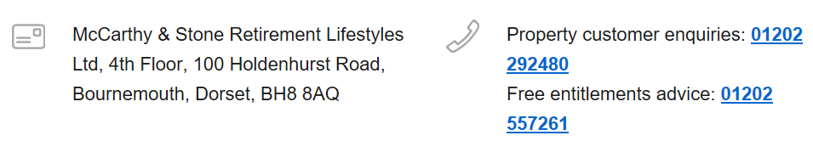
To contact Mcarthy & Stone, individuals can phone their regional office numbers presented below
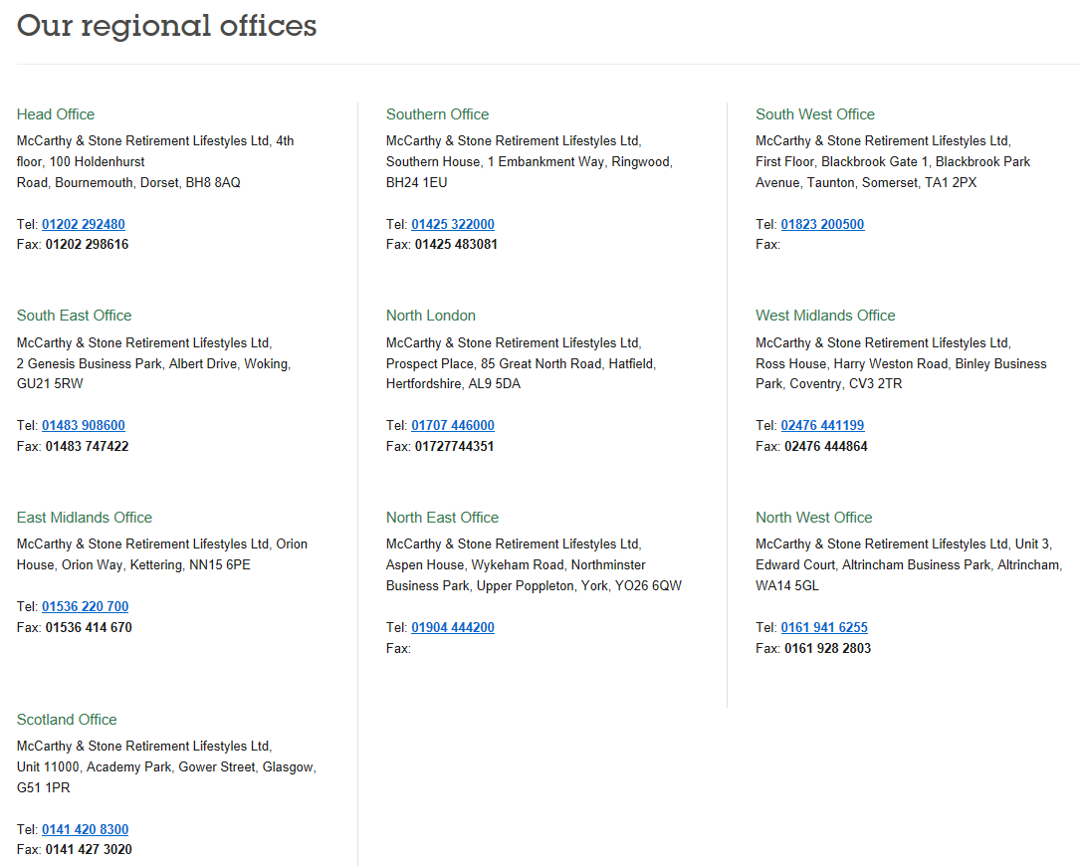

Anchor Hanover Group

The last organisation that accommodates sheltered housing for older people is Anchor Hanover Group, it is England’s largest not-for-profit provider of housing and care. They provide additional care and support when individuals require it in order for them to live as independently as they wish. This is sometimes known as extra care accommodation, it is said that their services are either received first hand or through a third party. Depending on distinct needs and requirements they will distribute care packages (Anchor Hanover Group, 2019). There isn’t any fixed amount to be paid, it all depends on the locations and the level of support that is needed. Their residents obtain a manager in order to upkeep the building maintenance and gardening and an emergency call system which is available 24/7.
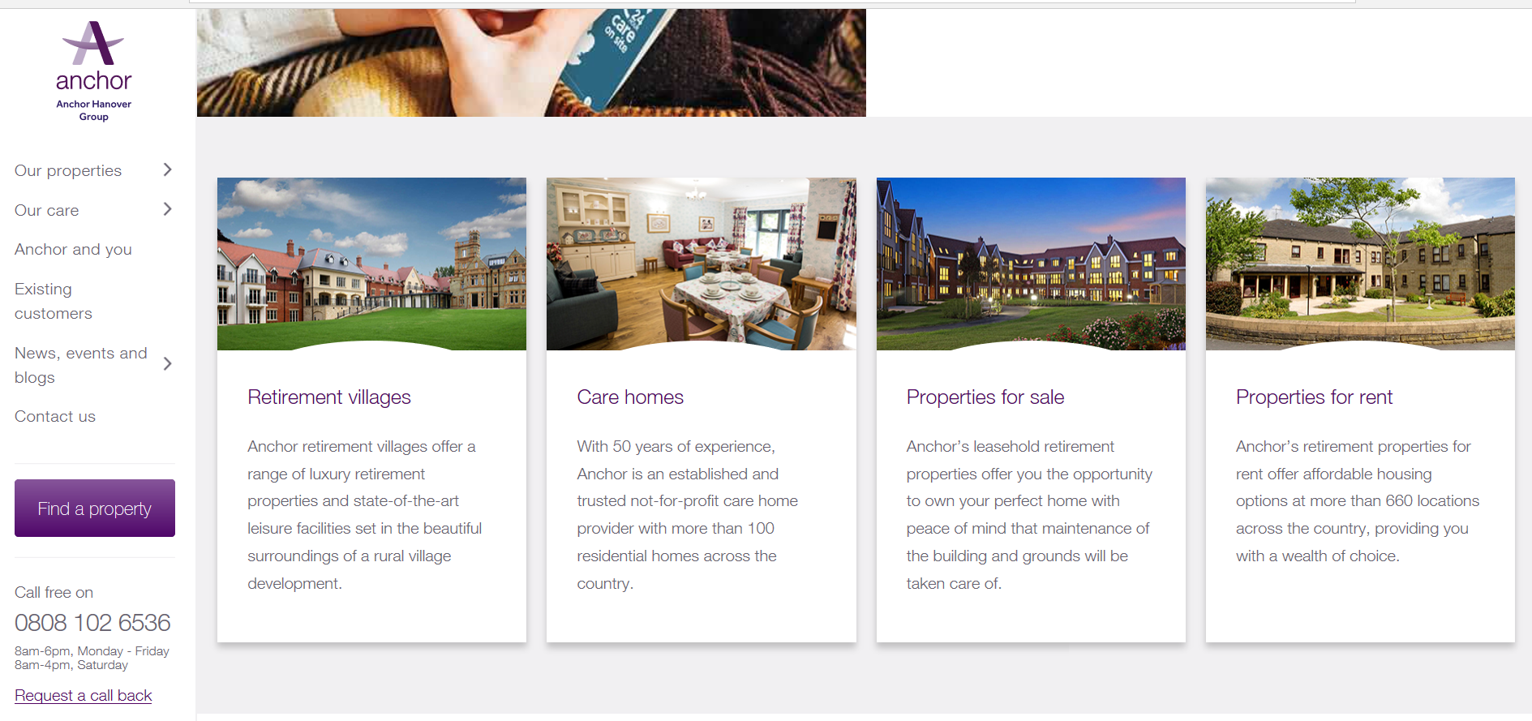
On the website it shows the type of properties that are available in order to meet specific residents needs and preferences. The approach that they present acknowledges these factors of one life: (Anchor Hanover Group, 2019).

- Memory
- Physical
- Lifestyle
- Short-stay
- Recovery
- End of life
They provide residents with professional care and support from the local GP, district nurses, dentist, holistic therapists, chiropodist and physiotherapist that either arrange visits to visit or will regularly visit anyways. (Anchor Hanover Group, 2019.)
Additionally, Anchor Hanover Group, organise specific events throughout the months for both residents and staff to attend which would help with combating loneliness within older people as there are different events that would appeal to different people. E.g. residents that enjoy alcohol may attend the gin tasting afternoon. (Anchor Hanover Group, 2019)



Enquires can be made by email by filling out this form and sending it to the organisation.

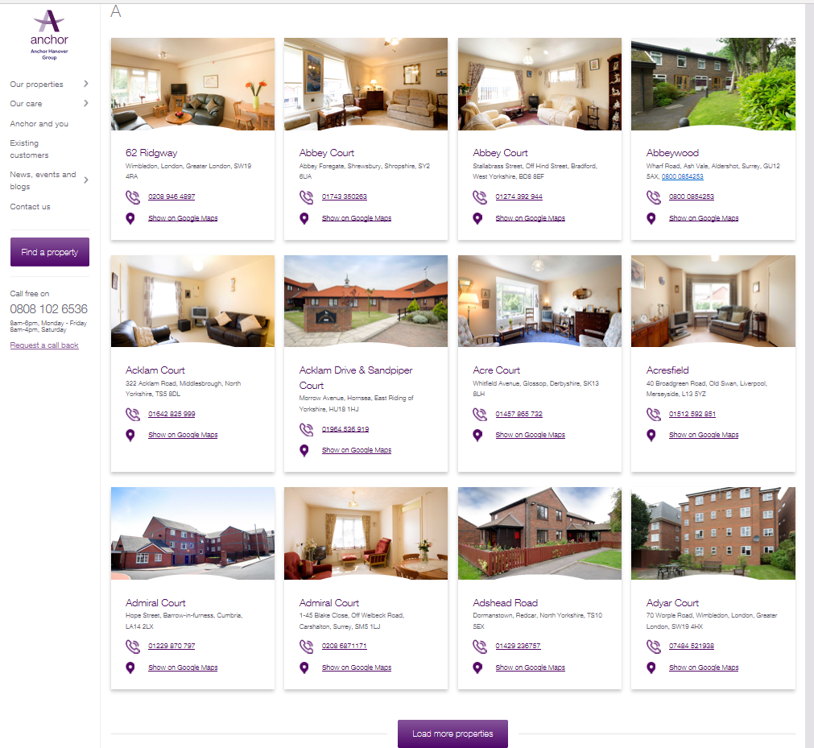
Contact is available Monday-Friday 8am-6pm and Saturday 8am-4pm on 08081026536
Here are the different contact numbers for the different areas alongside the addresses.
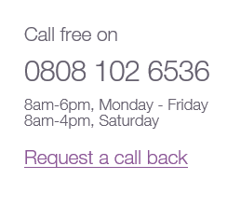

To conclude, this portfolio provides quite in-depth information about what different sheltered housing organisations can provide to their residents and how they may benefit from it, it informs individuals on what different organisations and provide and how it may be suitable for them and their specific needs, it provides how individuals are able to contact the organisations with any enquiries etc.

References
Abbeyfeild. (2019). Residents as volunteers Final evaluation summary repor. Retrieved from https://www.abbeyfield.com/media/27006/abbeyfield-residents-as-volunteers-project-summary-report-2018.pdf
Anchor Hanover Group. (2019). Rented sheltered housing. Retrieved from https://www.anchor.org.uk/our-care/housing-with-care/rented-sheltered-housing
Anchor Hanover Group. (2019.). Community events. Retrieved from https://www.anchor.org.uk/news-events-blogs/events
J. Pennall., & I. Blood. (2012, December 12). Supported housing for older people in the UK: An evidence review. Retrieved from https://www.jrf.org.uk/report/supported-housing-older-people-uk-evidence-review
McCarthy & Stone. (2019.). What is Sheltered Housing?. Retrieved from https://www.mccarthyandstone.co.uk/what-is/sheltered-housing/
National housing federation. (2019). What is supported housing?. Retrieved from https://www.housing.org.uk/topics/supported-housing/what-is-supported-housing

