Outline and critically assess the supposed justifications for either the practice of factory farming or the use of animals in research.
What would life be like without the use of animals in research? “In 2020, 2.88 million procedures were carried out in Great Britain involving living animals”, where “around half of all procedures were experimental procedures” (UK Government, 2021). Animal research, also known as animal experimentation or animal testing is “the use of non-human animals in experiments that seek to control the variables that affect the behaviour or biological system under study” (UK Parliament, 2002). In other words, it can be defined as “simply the study of animals for scientific and medical discovery” (Foundation for Biomedical Research, 2021), as can be seen in Figure 1. The aim of this essay is to explore and discuss the supposed justifications for the use of animals in research, while considering the possible criticisms and objections of using this particular practice. In doing so, it is important to outline significant areas of knowledge, subject to the validation of the use of animals in research. While there are medical and scientific reasons given for the use of animals in research, these reasons in and of themselves do not necessarily justify animal research from a moral perspective.
Medical and scientific reasons appealed to as an attempted justification for the practice include, but are not limited to, “improving our understanding of biology” (The Global Resource for Animal Use in Research, 2021), (See Figure 2). First and foremost, it is crucial to acknowledge that “a living body is an extraordinary complex system” (University of Oxford, 2022), and while it is imperative to note that there is much knowledge on the functioning of a living body, there is also a significant amount that is unknown (University of Oxford, 2022). For this reason, it is important to emphasise that “humans share at least 90% of their genes with every other mammal” (Understanding Animal Research, 2022), meaning humans and non-human animals have many more similarities than they do differences. This includes having “the same vital organs, such as the heart, lungs, liver, kidneys and brain” (Understanding Animal Research, 2022). One example of an animal that shares over 90% of their genes with humans is mice (University of Oxford, 2022). Therefore, “most of their basic chemistry, cell structure and bodily organisation” are the same as humans (University of Oxford, 2022), as can be seen in Figure 3. As a result, this supports using animals for research purposes because animals are “biologically similar to humans and susceptible to many of the same health problems” (American Physiological Society, 2022).
On the other hand, the idea of using animals for research, to improve our understanding of biology, has been rejected by many advocates of animal rights, because “not only have the benefits of animal experiments been exaggerated, but also that their use has actually hindered medical advances” (Cochrane, 2007, p. 300). Cochrane reiterates that if the primary concern was focussed upon medical research only, “then programmes of experiments on human beings” would be their first source of practice. (Cochrane, 2007, pp. 300-301). This is because “human subjects provide the best experimental models for researching human diseases, or testing the effects of drugs on humans”, and therefore, leading to more accurate and “reliable evidence” (Cochrane, 2007, pp. 300-301). Furthermore, information gathered from Independent Scientific Reviews indicates “that research using animals correlates very poorly to real human beings” (Human Society International, 2022).
From the data produced, “animal studies have failed to predict real human outcomes in 50 to 99.7 percent of cases” (Human Society International, 2022). Therefore, even though they may share similar symptoms on a superficial level, “fundamental differences in genetics, physiology and biochemistry” highlights very “different reactions to both the illness and potential treatments” (Human Society International, 2022). For these reasons, using animals as a benefit to “advance human and animal health”, (Stanford Medicine, 2022) medically and scientifically, is considered unethical according to “world-famous primate expert Dr. Jane Goodall” (Goodall, 2013). Goodall argues, “we need to recognise at the outset that what we do to animals from their perspective certainly, and probably from ours, is morally wrong and unacceptable” (Goodall, 2013).
Nevertheless, further medical and scientific reasons appealed to as an attempted justification for the practice, include but are not limited to, developing and testing “potential forms of treatment for diseases” (The Global Resource for Animal Use in Research, 2021), as can be seen in Figure 4. Many advocates of animal experimentation argue, that because some human diseases are found in non-human animals, it is equally beneficial to them as it is to humans to research and test for potential forms of treatment (Kabene and Baabel, 2019). Taking into account previous criticisms, it is nonetheless necessary to recognise that animals contribute enormously to support scientists, to test “potential new drugs and medical treatments for effectiveness and safety”, while “identifying any undesired or dangerous side effects” (Stanford Medicine, 2022).
One example that highlights the importance of using animals in research is the thalidomide tragedy. “Thalidomide is a drug that was marketed as a sedative and treatment for morning sickness in pregnant women in the late 50s and early 60s” (The Thalidomide Trust, 2022). Unfortunately, the resulting impact of this drug, having only been tested on non-pregnant animals, “caused babies to be born with a range of disabilities”, as seen in Figure 5. These include the “shortening and absence of limbs, sensory impairment, facial disfigurement and damage to the brain, internal organs and skeletal structure” (The Thalidomide Trust, 2022). Consequently, “100,000 babies were affected”, an estimation of “over 10,000 babies were born” with disabilities, and less than 3,000 of them survive today (The Thalidomide Trust, 2022). For this particular reason, when executed correctly using the appropriate method, the use of animals in research is extremely crucial to ensure that the safety and welfare of humans and animals is protected.
Likewise, the Institute of Cancer Research emphasises the importance of animal research to better “understand the mechanisms that underpin cancer, such as the growth and spread of tumours, and to develop new ways of diagnosing, treating and preventing the disease” (The Institute of Cancer Research, 2022), (See Figure 6). One treatment for cancer that was created and developed with animal research is Herceptin. The purpose of this medicine is “to treat some types of breast cancer, oesophageal cancer and stomach cancer” (The National Health Service, 2019). “Forty years ago, the five-year survival rate following diagnosis of breast cancer was 50%” (Understanding Animal Research, 2022). However, due to advancements in treatment and screening, that figure is up 30%, meaning the five-year survival rate following diagnosis of breast cancer is now 80%. (Understanding Animal Research, 2022).
As a result, these figures and statistics support using animals in forms of biomedical research because discovering the “causes, diagnosis and treatment of disease and suffering in humans and in animals”, is vital for protecting their health and well-being.
In contrast, the principle of using animals in research as a way of developing and testing “potential forms of treatment for diseases” (The Global Resource for Animal Use in Research, 2021), has been disdained by many proponents of animal rights, because this practice is unethical and inhumane” (Meredith, 2022). According to Peter Singer, humans and non-human animals should be offered the same respect and equal consideration of interests. He presents this idea by emphasising that “the like interests are to be considered equally, not that animals and humans are to be treated the same” (Singer, 1990, p. 704). Therefore, in relation to the use of animals in research, and in terms of equal consideration of interests, both human and non-human animals have the same interest in avoiding pain and suffering. As stated by Jeremy Bentham, “The question is not, Can they reason? nor Can they talk? but, Can they suffer?” (Singer, 1990, p. 704). Some common animal procedures include “food and water deprivation”, “genetic manipulation”, “infliction of wounds and burns” as well as “exposure to drugs, chemicals or infectious diseases, at levels that cause illness, pain and distress, or death” (Human Society International, 2022), as can be seen in Figure 7. Evidently, it would be impossible to argue that these procedures do not inflict pain and suffering on animals and “if a being suffers, there can be no moral justification for refusing to take that suffering into account” (Singer, 1990, p. 705). As a result, “animal experimentations that lead to pain or death are morally illegitimate” (Cochrane, 2007, p. 295), and therefore, one cannot justify this pain “solely by appealing to its contribution to medical progress” (Cochrane, 2007, p. 301).
Finally, medical and scientific reasons appealed to as an attempted justification for the practice, include but are not limited to, “protecting the safety of people, animals and the environment” (The Global Resource for Animal Use in Research, 2021), (See Figure 8). It is important to note that regarding the safety of animals, any animal research conducted is policed and highly regulated, “with laws in place to protect them from mistreatment” (Britannica Encyclopaedia, 2022). The United Kingdom have gone above and beyond for animal rights through writing an “ethical framework into law by implementing the Animals Scientific Procedures Act 1986” (Stanford Medicine, 2022). This framework has introduced much tighter measures and regulations where both the researcher and the project must be separately licensed (UK Government, 2022). The application for a license must include a detailed assessment of the “expected benefits that outweigh the harm that would be caused to the animals involved” and that there is no other alternative method available (Understanding Animal Research, 2022). Additionally, it must be demonstrated that a method “uses the minimum number of animals necessary” and justifies how one “would minimise any possible pain or suffering to the animals” (Understanding Animal Research, 2022) involved. Likewise, The Medical Research Council follow particular guidelines that one must fulfil to allow animal research. One example of this is to “consider all the replacement, refinement, or reduction of the animals in the experiment” (UK Research and Innovation, 2022), meaning any and all experiments must be carefully designed and analysed to the interest of the animals involved.

In relation to protecting the people and the environment, any new medicines produced require testing to “measure both the beneficial and the harmful effects of a compound on a whole organism” (Understanding Animal Research, 2021). It is necessary for medicines to be tested in animals because they are able to detect “potential safety concerns” and provide a calculation on the dose measure that will be offered “to volunteers for the first human trial” (Understanding Animal Research, 2021). Furthermore, testing chemicals on animals “protects consumers, workers and the environment from the harmful effects” that could “accumulate in the water, ground or air around us” (Understanding Animal Research, 2021). As a result, the damage caused from not testing could be catastrophic if not investigated thoroughly using animals.
However, with the many benefits of the laws and regulations that are in place to protect animals, one cannot deny the immense suffering that is encountered upon them. It is significant to voice that treating animals “solely as instruments or objects for our own use” (Humphreys, 2016, p. 12) is appalling because they equally have an “interest in being free to live life natural to their own kind” (Humphreys, 2016, p. 19). According to Anthony Williams, “Earth was created for all of us, not some of us” (Goodreads, 2022) and therefore, equality, being a moral idea (Singer, 1990, p. 703) should be introduced to all kinds, not just humankinds (Goodreads, 2022), (See Figure 9).
To conclude, undeniably, there is no element more valuable to a being than to have equal rights and equal consideration of interests. This essay has evaluated medical and scientific reasons for the use of animals in research, while contemplating criticisms from a moral outlook. It is important to draw attention to the inference that there is no justification for the pain and suffering animals experience, through endless testing and experimentation. It is an unethical and inhumane practice that undoubtedly seeks to only serve the interests of humans and one’s own species. However, undoubtedly, the use of animals in research has provided major breakthroughs in discovering life-changing treatments for the very vulnerable people of society. There is clear, profound evidence to suggest that without such research using animals, humans would suffer. Therefore, as there is no practical solution to this debate, animal rights activists must recognise the incredible advancements made to healthcare and understand that any pain or suffering that animals encounter, is always planned to be minimal.

References
Cochrane, Alasdair. (2007). Animal Rights and Animal Experiments: An interest-based approach. Res Publica, 13(3), pp. 293-318.
American Physiological Society, (2022). Why Do Scientists Use Animals in Research?.
Available at: https://www.physiology.org/career/policy-advocacy/animal-research/Why-do-scientists-use-animals-in-research?SSO=Y
[Accessed 05 November 2022].
Britannica Encyclopaedia, (2022). Should Animals be Used for Scientific or Commercial Testing?.
Available at: https://animal-testing.procon.org/
[Accessed 07 November 2022].
Humphreys, Rebekah. (2016). Dignity and Its Violation Examined within the Context of Animal Ethics. In: Ethics and the Environment, 21(2), pp. 143-162.
Goodall, Jane. (2013). Dr. Jane Goodall: Animal Experiments Are 'Morally Wrong and Unacceptable'.
Available at: https://www.peta.org/blog/dr-jane-goodall-animal-experiments-morally-wrong-unacceptable/
[Accessed 06 November 2022].
Goodreads, (2022). Anthony Douglas Williams Quotes (Author of Inside the Divine Pattern).
Available at: https://www.goodreads.com/author/quotes/6994517.Anthony_Douglas_Williams
[Accessed 08 November 2022].
Foundation for Biomedical Research, (2021). What is Animal Research?.
Available at: https://fbresearch.org/animal-research/
[Accessed 02 November 2022].
Human Society International, (2022). About Animal Testing.
Available at: https://www.hsi.org/news-media/about/
[Accessed 05 November 2022].
Meredith, John. (2022). Is Animal Research Ethical?.
Available at: https://www.understandinganimalresearch.org.uk/news/ethics-of-animal-research
[Accessed 07 November 2022].
Singer, Peter. [1975], (1990). All Animals Are Equal. In: Animal Liberation. 2nd Edition ed. New York: New York Review Books.
Stanford Medicine, (2022). WHY ANIMAL RESEARCH?.
Available at: https://med.stanford.edu/animalresearch/why-animal-research.html
[Accessed 05 November 2022].
Kabene, Stefane and Said Baabel, (2019). Bioethics: A Look At Animal Testing In Medicine And Cosmetics In The UK.
Available at: https://www.ncbi.nlm.nih.gov/pmc/articles/PMC7166243/#B5
[Accessed 06 November 2022].
The Global Resource for Animal Use in Research, (2021). Read The Four Main Reasons Why Animals Are Used In Medical Research.
Available at: https://www.animalresearch.info/en/designing-research/why-animals-are-used/
[Accessed 05 November 2022].
The Institute of Cancer Research, (2022). How We Use Animals - The Institute of Cancer Research, London.
Available at: https://www.icr.ac.uk/our-research/about-our-research/animal-research/animal-research-at-the-icr#:~:text=Animals%20are%20used%20in%20our,those%20of%20human%20cancer%20patients.
[Accessed 07 November 2022].
The National Health Service, (2019). Herceptin (trastuzumab).
Available at: https://www.nhs.uk/conditions/herceptin/
[Accessed 07 November 2022].
The Thalidomide Trust, (2022). About Thalidomide.
Available at: https://www.thalidomidetrust.org/about-us/about-thalidomide/
[Accessed 07 November 2022].
UK Government, (2021). Annual Statistics of Scientific Procedures on Living Animals, Great Britain, 2020.
Available at: https://www.gov.uk/government/statistics/statistics-of-scientific-procedures-on-living-animals-great-britain-2020/annual-statistics-of-scientific-procedures-on-living-animals-great-britain-2020
[Accessed 04 November 2022].
UK Government, (2022). Animal Scientific Procedures.
Available at: https://www.health-ni.gov.uk/articles/animal-scientific-procedures
[Accessed 07 November 2022].
UK Parliament, (2002). House of Lords - Animals In Scientific Procedures - Report.
Available at: https://publications.parliament.uk/pa/ld200102/ldselect/ldanimal/150/15004.htm#a7
[Accessed 02 November 2022].
UK Research and Innovation, (2022). Why We Use Animals.
Available at: https://www.ukri.org/about-us/mrc/our-policies-and-standards/research/research-involving-animals/why-we-use-animals/#:~:text=Animals%20are%20used%20to%20gain,develop%20new%20treatments%20for%20diseases
[Accessed 07 November 2022].
Understanding Animal Research, (2021). Animal Research.
Available at: https://www.animalresearch.info/en/designing-research/why-animals-are-used/
[Accessed 07 November 2022].
Understanding Animal Research, (2022). Why are Animals Used in Scientific Research?.
Available at: https://www.understandinganimalresearch.org.uk/application/files/5916/5226/6815/Why_are_animals_used_in_scientific_research.pdf
[Accessed 05 November 2022].
University of Oxford, (2022). Research Using Animals: An Overview.
Available at: https://www.ox.ac.uk/news-and-events/animal-research/research-using-animals-an-overview
[Accessed 05 November 2022].

Appendix
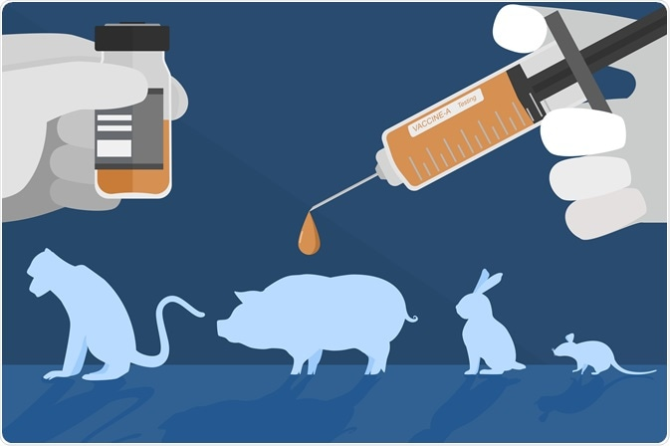
Figure 1: Non-human animals used in experiments for scientific and medical discovery.

https://www.news-medical.net/life-sciences/The-Ethics-of-Animal-Models-in-Preclinical-Testing.aspx Image Credit: Hugethank/Shutterstock.com [Accessed on 08/11/22].
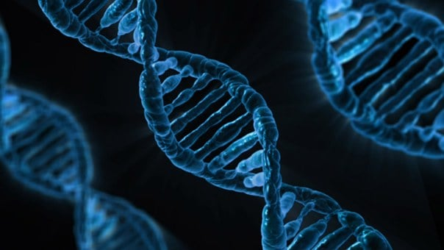
Figure 2: The use of animal in research is supported to improve our understanding of biology.

https://www.photosforclass.com/search/biology [Accessed on 08/11/22].
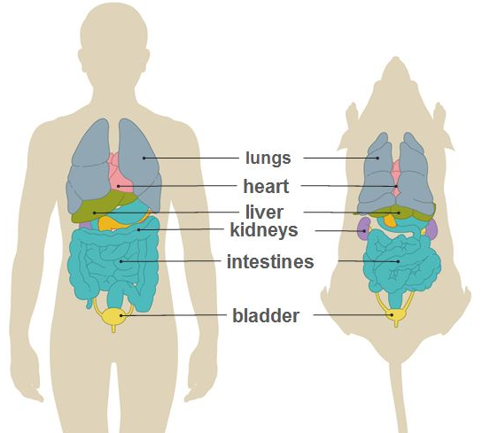
Figure 3: Mice share over 90% of their genes with humans, therefore, their basic chemistry, cell structure and bodily organisation are the same as humans.

https://speakingofresearch.com/facts/the-animal-model/ [Accessed on 08/11/22].

Figure 4: The use of animal in research is supported to develop and test potential forms of treatment for diseases.

https://www.express.co.uk/life-style/health/848551/heart-disease-beta-blockers-lung-medication [Accessed on 08/11/22].

Figure 5: Thalidomide, having only been tested on non-pregnant animals, caused babies to be born with a range of disabilities.

https://www.smh.com.au/national/the-50-year-global-cover-up-20120725-22r5c.html [Accessed on 08/11/22].
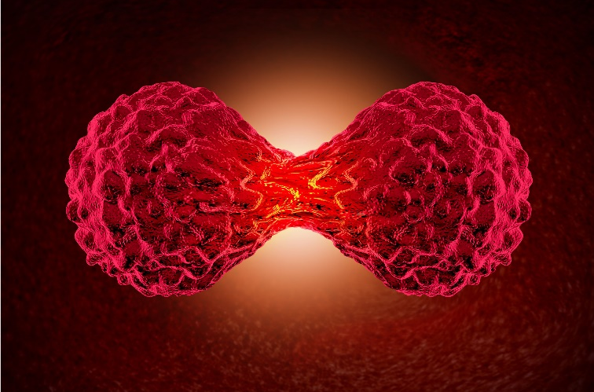
Figure 6: Animal research supports understanding the mechanisms that underpin cancer, such as the growth and spread of tumours, and to develop new ways of diagnosing, treating and preventing the disease.

https://www.livingwellmag.com/what-is-cancer-2/ [Accessed on 08/11/22].

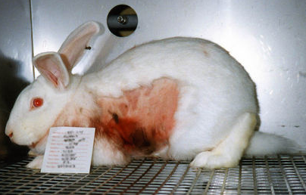
Figure 7: Animal research is unethical and inhuman because of the pain and suffering animals experience during experimentations.

https://www.change.org/p/justin-trudeau-ban-animal-testing-in-canada-0688f2c6-f45e-44bf-abd9-421cd4830108
[Accessed on 08/11/22].

Figure 8: The use of animals in research is supported to protect the people, animals and the environment.

https://www.istockphoto.com/photo/keep-calm-and-get-your-green-on-gm869262288-144758287 [Accessed on 08/11/22].

Figure 9: Earth was created for all of us, not some of us.

https://www.hopeferdowsian.com/how-supporting-human-rights-and-animal-rights-helps-us-all/
[Accessed on 08/11/22].

