Designing a Blended-Learning Model
for ESP Writing Class Based on Action Research

1. The aims of the investigation

This research is mainly aimed at building up a blended-learning model for ESP writing class to solve three problems that I have met in the teaching practice that will be further discussed on the rationale part. Therefore, basically speaking, it is an action research focusing on solving the pedagogical problems through investigating the teaching process of employing the theoretically based model by varied ways of collecting either quantitative or qualitative data and reflect on the effectiveness of the model so as to modify it into a more effective one in solving the problems. Based on the research, four main objectives will be achieved, which are listed below.
- To gain a comprehensive understanding of blended learning.
- To learn the theoretical reference to the research questions including constructivism (philosophical basis of the blended-learning class design), Randy Garrison’s Community of Inquiry Model (theoretical guideline for online learning part) and Merrill’s First Principles of Instruction (theoretical guideline for in-class learning part) that will be applied in building up the blended-model.
- To build up a blended–learning model for ESP writing class based on the theoretical exploration.
- To modify the model based on the teaching practice during which various methods of data collection will be used like questionnaire, focus group and online and face-to-face classroom observation.
2. The rationale and main conceptual themes for the investigation

This project is conducted for the purpose of improving my ESP writing class and, in this part, a detailed explanation on the reasons why this topic is finally chosen and why it is significant to explore before theoretical basis of the project is elaborated.

2.1 The rationale of the research
In the past ten years I have been teaching ESP Writing in which both EAP and EOP related text types are taught for their future study and career such as the abstract of articles, a job application letter and a letter for study admittance to overseas universities, CV and diagram description. In my teaching experience I have met some difficulties which can be mainly listed as follows: 1) Reading and writing practice are not enough due to the limited time in class. 2) With at least 4 classes and 40-60 students for each, many activities cannot be carried out such as the challenging and time-consuming tasks, extended learning activities, more feedback and collaboration in learning. 3) The traditional lecture-focused class with extracurricular writing tasks cannot arouse students’ interest because there is little chance for them to discuss with the teacher about the difficulties they meet in dealing with the assignment after class, neither do they have access to effective peer feedback. So how to redesign the class to effectively solve the problems above mentioned motivate me to do a research. And blended learning, as stated by Garrison & Vaughan (2008, p.12) “…a coherent design approach that openly assesses and integrates the strengths of face-to-face and online learning to address worthwhile educational goals" is finally chosen to be a field to tackle because the positive influence of blended learning has been proved by previous studies to solve the problems mentioned above. For example, according to Yulia (2017) face-to-face learning environment provides more opportunities for social interaction that students need to guide them through learning and online learning environment provides the flexibility of time and place which is not possible in face-to-face learning. Also, Wasoh (2014) holds that online learning creates a student-centered learning environment, enables participants to have more flexible time and place of learning, and improve access to learning materials while Garisson and Kanuka (2004) believe face-to-face learning builds a sense of togetherness, cooperation and collaboration among the students in the real environment to have open dialogue, experience critical debate and participate in various open communication. From what have been discussed above, it is clear to see that with part of contents possibly being dealt with on line for the students, which gives them freedom to study and reflect whenever and wherever they like under instruction, there will be more time and energy for the teacher to design the face-to-face discussion and collaboration.
However, designing a course is not a simple addition of online learning. Instead, it needs to be studied based on the exploration of theoretical framework as well as a well-structured assessment to the design. This research will be an attempt to fulfill this. And the whole research plan can be briefly described like this: first, to build up a blended-learning to-be-tested model for ESP writing class based on theoretical exploration that are in accordance with the above-mentioned three problems in teaching ; second, to practice the model in the teaching to test the effectiveness of it by means of quantitative and qualitative study; third, to modify the to-be-tested model based on the analysis of the data collected and put forward the revised model for the next cycle of research. The model finally set up should be tested in terms of the following three aspects to see whether the following three questions have been solved:

1) Does the blended learning model improve the students' interest in ESP writing?
2) Does the blended learning model promote cooperative learning in and after class?
3) Compared with the traditional teaching, does the blended learning model improve the students' writing proficiency.
The research will basically be an action research. Many researchers have defined from varied perspective, from which Kemmis and McTaggart’s is the most cited one because they put forward a influential framework for the process of action research, is clearly shown in the following figure:

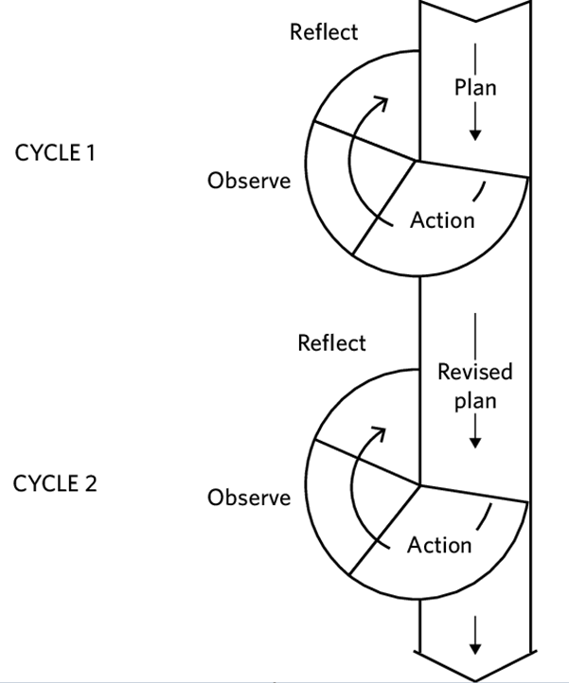
Figure 1: action research: spiral of cycles (Kemmis and McTaggart ,1988)

From the figure, it can be seen that action research is a spiral of cycles, each consisting of four phases: (1) planning; (2) acting; (3) observing; and (4) reflecting. Kemmis et. al. explaing the core meaning of it explicitly:
“a self-reflective spiral of cycles of planning, acting and observing, reflecting and then re-planning in successive cycles of improvement. We reaffirm that the purpose of critical participatory action research is to change social practices, including research practice itself, to make them more rational and reasonable, more productive and sustainable, and more just and inclusive.”
(Kemmis, McTaggart and Nixon, 2014, pp. 2-3)
In order to solve the three problems in ESP writing class, the planning part of the action research will firstly be a theoretical exploration for building up a blended learning model and then the theory-based model will be implemented in the teaching practice to test the effectiveness of it in solving the research questions. Reflections will be made based on the data collected before the modified model is finally put forward.

2.2 Concept and theories applied to build up the model in the planning phase of the action research
Building up a blended model is a very complicated process in which the following key concepts and theories are to be elaborated, namely, blended learning, constructivism, Garrison’s Communities of Inquiry and Merrill’s First Principles of Instruction, all of which play their roles either acting as thematic basis or specific operational guidelines. In this part more detailed explanation will be made.

2.2.1 Blended learning
The term “blended learning” is used for the first time at the beginnings of 2000. (Güzer & Caner, 2014). Although there are three definitions, namely, (1) a combination of conventional learning and online web-based learning, (2) a combination of media and devices used to build e-learning, and (3) a combination of a pedagogic approach (White Lock and Jelfs, 2013), most studies relate blended learning to the combination of face-to-face learning and online learning (Yulia, 2017). This article will focus on the third definition of blended learning.
Although most frequently cited articles defining blended learning are in the definition period between 2003 and 2006 (Güzer & Caner, 2014), the discussion on what is blended learning began in earlier time. According to Harvi Singh & Chris Reed (2001, p.2) blended learning is about “optimizing achievement of learning objectives by applying the “right” learning technologies to match the “right” personal learning style to transfer the “right” skills to the “right” person at the “right” time. In this definition, four principles concerning the learning objective, personal learning style, diverse knowledge from different participates and “just-what-I-need, just-in-time” learning strategy are embedded. Then based on five case studies Russel T. Osguthorpe and Charles R. Graham (2003)enrich the meaning of blended learning by defining it as“…combines face-to- face with distance delivery systems…to maximize the benefits of both face-to-face and online methods” and by explaining the aim of using blended learning approaches : to find a harmonious balance which will vary for every course owing to instructional goals, student characteristic, instructor background and online resources. Here goals are further illustrated into six types, namely, pedagogical richness, access to knowledge, social interaction, personal agency, cost effectiveness and ease of revision. Although Osguthorpe and Graham explain in detail what is blend learning and what factors should be taken into consideration when defining the best balance of the blend, the factors that contribute to clear definition are still limited. Later, the factors that need to be considered increase with more and more research carried out. So comes the most cited article on blended learning from Garrison & Kanuka (2004) who hold that blended learning is a thoughtful and effective integration of classroom face-to-face learning experiences with online learning experiences owing to its countless possibilities of design in varied context. It is strongly proved that online-learning attributes to flexibility, reflection, interpersonal and teamwork skill development, motivation and collaborative learning and it provides a platform for the participates who have expanded time to learn, to question and reflect and to record what they have learned. Compared to online learning which is asynchronous, face-to- face learning is spontaneous and contagious. Therefore, they are complementary. Like Osguthorpe and Graham, Garrison & Kanuka focus on how to design and deliver blended learning and put forward five categories of issues pertaining to blended learning: policies and operations required to support blended learning approaches; planning in which the identification of needs, goals and objectives; potential costs; available resources and assessment process; financial, human and technical resources; scheduling of courses and support services that facilitate access to blended learning. With further research on blended learning being carried out, learner and instructor related variables are taken into consideration such as learners’ satisfaction, motivation, achievement, attitude, cooperativeness, knowledge retention, critical thinking skills and drop-out rate for at risk students. (Deliağaoğlu & Yıldırım, 2008; El-Deghaidy & Nouby, 2009; Akyüz & Samsa, 2009; Hughes, 2007; Melton et. al., 2009; Woltering et. al., 2009) and perceptions of participations (Akkoyunlu & Soylu 2008; So & Brush 2008; Chandra & Fisher 2009). In fact, according to Taylor, M. et. al. (2018), although students still prefer the time flexibility and increased teacher-student interactions using a blended learning, there are some new challenges such as learner differences, the requirement for more support for course design and better professional development and training.
In addition, it is evident that the concept of blended learning at the beginnings of 2000 emphasize on the factors that contribute to the most appropriate blend in the most suitable context. But owing to the lack of theoretical basis, the early research is not systematic and those variables are studied in isolation in massive articles. In recent years, various theories are incorporated into the studies of blended learning. For example, Al-huneidi & Schreurs (2012) apply constructivism and conversation theories to propose a Constructivism Based Blended Learning model for his course in which all the factors are integrated together with the core meaning of constructing knowledge by learners themselves through problem solving, teachers’ guidance and interaction and collaboration with students in blended learning. The model consists of a variety of face-to-face classrooms and online learning activities such as collaboration, communication, and interactions between students themselves, the teacher, and the business people. The proposed learning process consists of 7 main phases during which the students are building up and constructing the knowledge through a variety of learning activities linked with a continuous evaluation process.

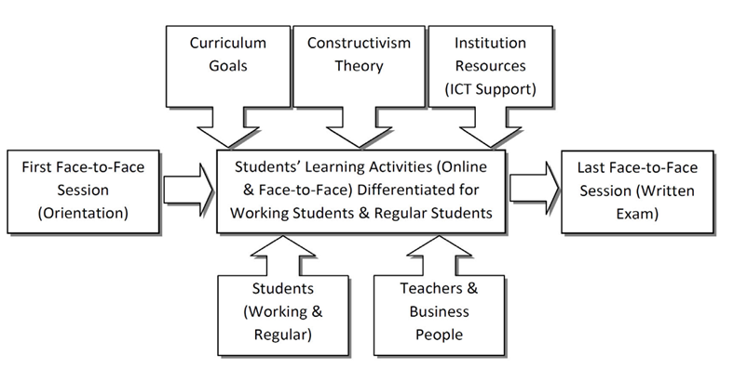
Figure 2 Constructivism Based Blended Learning Model (Ahmad M. Al-Huneidi & Jeanne Schreurs, 2012)

Although the model fails to elaborate specific factors that influence blended learning under the constructivism theory and also lacks evaluation, the design of the model shows the significance of theoretical foundation for class design, which provides very important implications to blended-learning design for ESP writing class - theoretically based.

2.2.2 Constructivism
Constructivism can be studied from two perspective: Cognitive and social-cultural. Cognitive constructivism is based on the work of Swiss developmental psychologist Jean Piaget. Piaget's theory includes two major parts, a “ages and stages" component that predicts what children can and cannot understand at different ages, and a “theory of development” that describes how children develop cognitive abilities. Piaget (1977) holds that learning does not occur passively; rather it occurs by active construction of meaning. When learners, encounter an experience or a situation that challenges what they think, a state of imbalance is created. In order to restore balance, they associate the new with the existing knowledge. Otherwise, they use accommodation by restructuring the present knowledge to a higher level of thinking, which finally promote learning. In contrast to Jean Piaget’s understanding of child development, Vygotsky (1978) states that the process of knowing is affected by other people and is mediated by community and culture. So cognitive growth first occurs on a social level and later on individual level. Thus, instructors who are facilitators in social constructivism first provide support and help for learners, then little by little this support is decreased and students learn independently. This is in fact a kind of scaffolding instructions done by teachers.
In my opinion, the two strands of constructivism analyze the cognitive process from different perspective and they are not contradicting with each other with one focusing on students’ learning process and the other on teachers’ instructions. And therefore, both of the key ideas can be applied to the design of the class in this research. Of course, only the theory of constructivism is not enough to build up the ESP writing model since it is too general for blended learning. However, it is the philosophical basis for all the stages of the class design, which means passive learning and teacher-centered class design is out of the consideration.

2.2.3 Randy Garrison’s Community of Inquiry Model (CoI)

For this blended learning design, the key theory will be one of the most influential frameworks for online learning research named Community of Inquiry Framework (CoI) by Randy Garrison, Terry Anderson and Walter Archer (2001) to operate originally in the context of "computer conferencing in higher education" aiming at online "asynchronous, text-based group discussions" (Garrison et.al., 2010, p.5). In other words, it is a model used to guide high education by virtue of online verbal communication media. The framework constitutes three core interactive elements: cognitive presence, social presence, and teaching presence, which can be clearly shown in the following figure.
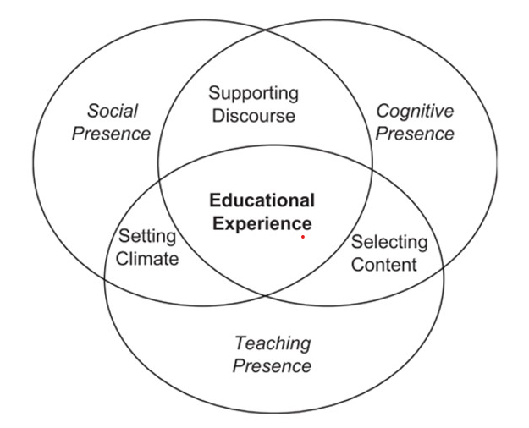
Figure 3: Randy Garrison’s Community of Inquiry Model (CoI)

According to Garrison et. al. (2010), the model aims to provide an understanding and methodology to describe and measure the elements of a collaborative and dynamic online learning experience with the three ‘presences’ interacting with each other. To briefly speaking, the core meaning of social presence is to encourage open communication and create trust; cognitive presence focuses on reflective inquiry based on four stages of "triggering event, exploration, integration and resolution" (Garrison et.al., 2010) which is closely related to critical thinking and teaching presence provides the design, facilitation, and direction for a worthwhile educational experience, establishes the curriculum, approaches, and methods and moderates, guides, and focuses discourse and tasks (Garrison & Kanuka, 2004). The striking part of the CoI model is its significance to guide design of the online learning part in the blended learning.
With the online learning guideline of CoI by Garrison et. al., a clearer framework for online learning is presented. However, how to make the three ‘presences’ of online learning well instructed and how to incorporate online learning with the face-to-face traditional way of teaching and learning under the effective instruction in order to build up a blended model so as to solve the problems in ESP writing class are the next stage of theoretical exploration. That is to say, how to operate instruction to make a problem-solving blended model into practice will be the focus of this stage, in the context of which Merrill's First Principles of Instruction are applied.

2.2.4 Merrill's First Principles of Instruction

According to Merrill (2013), instruction is a “goal-directed activity” that aims to “structure a learning environment” to “promote effective, efficient, and engaging learning”. (all three quotations, please see p.6). Instruction is very important even in the modern time when social networking and extensive multi-media are widely imbedded in the learning. No matter the instructions are instructor-directed or learners’ self-chosen, so long as the principles are taken into consideration when designing the blended model, they can promote learning. Briefly speaking, effective instructions are realized when learners are engaged in solving real-world problems, when existing knowledge is activated as a foundation for new knowledge, when new knowledge is demonstrated to the learner, applied by the learner and integrated into the learner’s world. In other words, effective instructions are problem-centered and are realized in four distinct phases: (a) activation of prior experience, (b) demonstration of skills, (c) application of skills, and (d) integration of these skills into real-world activities, which is clearly shown in figure 3.
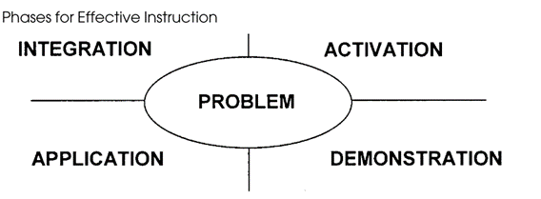
Figure 4: Merrill's First Principles of Instruction (2002)

To sum up, the above-mentioned theoretical exploration provides a framework from general to specific consideration of the model design: Constructivism lays a thematic foundation of the model – learner-centered active learning. Garrison’s CoI combines all the essential factors that influence the effectiveness of blended learning and therefore constitutes the basic structure of the model. Merrill’s First Principles of Instruction specifically guide the whole process of instruction in the three ‘presences.
After the model is built up, the testing of it will be implemented in the following three stages of action research --- acting, observing and reflecting the detailed explanation will be in the following parts since they are out of the theme of this part.

3. Research methodology
Briefly put, action research will be conducted in this research project through four phases, namely, planning, acting, observing and reflecting, during which data (evidence) will be collected and analyzed in mixed methods. In the planning phrase, the model is firstly built up and the data collection will be designed in accordance with the three research questions. In the acting phrase, the model is implemented during the middle term of the ESP course, before which the traditional way of face-to-face teaching method is used. The reason why the model is applied in mid-term is that a comparative study can be made with the same group of students acting as the subjects. In the third phase of observation, data will be collected based on the data collection design in the planning stage. In the fourth phase, reflections based on the analysis of the data will be made to evaluate the theory-based model on the effectiveness of solving the research questions.

3.1. The settings of data collection
This research is conducted in the whole teaching process of ESP writing. All the subjects are sophomores majored in arts and science except English majors, which means English is just one of their general foundation requisite and limited energy may be devoted to the study of English, especially in writing.

3.2 The methods of collect data and evidence collected
In this research data are mainly collected through the following ways: firstly, questionnaire at the end of the term; second, interview and focus group after the class of the whole term is over. thirdly, classroom and online observations of the students’ performance concerning the three research questions during the whole course before and after the blended learning model is applied and there are three kinds of evidence that will be collected in the research.
Firstly, responses to questionnaires that is based on the community of inquiry instrument developed by J.B. Arbaugh et. al. (2008) measuring social presence, cognitive presence and teaching presence. The results of the response can be used to find answers to the second research question concerning cooperative learning and can also indirectly answer the first question concerning the interest of the subjects.
Secondly, documents of students’ writing paper will be collected before the blended learning model is implemented in class in the mid-term and after the ESP writing class is over at the end of the term, which can be valuable to answer the third research question concerning writing proficiency.
Thirdly, responses to interview and focus group will be collected to find more information related to the three research questions in terms of the interest, collaboration and writing proficiency of the students. In addition, more valuable qualitative data from the interview and focus group will help to modify the model if content analysis of the data is employed.
3.3 The methods of analysing the evidence collected

Firstly, the data analysis for questionnaire will be made through SPSS to test whether the blended model can improve the interest of the learner on ESP writing and whether the model can promote the collaboration on line and in class so as to test the effectiveness of the model.
Secondly, a comparative study on the documents of students writing assignment will be made through marks based on the standard writing criterion in the standard examination.
Thirdly, content analysis will be used to the qualitative data from interview, focus group and observation of online and traditional classroom.
All the methods that are used in this research projects aim to test the blended learning model for ESP writing as well as modify it into a better one in blende learning.

4. The ethical issues in the research process

There are some ethical considerations for the research. First of all, in conducting questionnaire, a special notification will be listed at the beginning part of it, stating that replies of the questionnaire are never used to assess their course and names of the students are not required. Second, in order to ensure every student be treated fairly and their rights to be educated equally, the way of collecting data by control groups and experiment group is not used and comparison is made by dividing the term into two periods with the former period implementing the traditional one and the latter one the blended one. Thirdly, the students who are chosen as interviewee or the subjects of observation will be voluntarily based and all the detailed information in terms of protecting the students' confidentiality and the right to quit at any time will be put in the written agreement. Besides, all the data collected from students will be anonymous and all the data are collected after the assessment is finished for the sake of worries from students.

5 The timetable for the proposed project

The project will last about 2 years, which can be divided into three phases.
Phase one is the theoretical exploration aiming at building up the blended model and the design of the data collection including questionnaire and interview layout. It will last for 3 months.
Phase two is the real time teaching practice which last 16 weeks in the university, roughly about 6 months with 3 hours each week. In this period the first 6 weeks will be taught in a traditional face-to-face teaching and from week 7 blended learning will be implemented based on the theory model previously built up. In the whole 16 weeks quantitative and qualitative data will be collected.
Phase three is the data analysis and reflection, which lasts for 9 months including the writing of the research report.

Reference

Akkoyunlu, B., & Soylu, M.Y. (2008). A study of student’s perceptions in a blended learning environment based on different learning styles. Educational Technology & Society, 11(1), 183-193.
Akyüz, H.İ., & Samsa, S. (2009). The effects of blended learning environment on the critical thinking skills of students. Procedia Social and Behavioral Sciences, 1(1), 1744-1748.
Al-huneidi, A. M., & Schreurs, J. (2012). Constructivism Based Blended Learning in Higher Education. IJET, 7(1), 4–9.
Arbaugh, J.B et al., 2008. Developing a community of inquiry instrument: Testing a measure of the Community of Inquiry framework using a multi-institutional sample. The Internet and higher education, 11(3), pp.133–136.
British Educational Research Association [BERA]. 2018. Ethical Guidelines for Educational Research, fourth edition, London.
Chandra, V., & Fisher, D.L. (2009). Students’ perceptions of a blended web-based learning environment. Learning Environment Research, 12, 31-44.
Deliağaoğlu, Ö., & Yıldırım, Z. (2008). Design and development of a technology enhanced hybrid instruction based on MOLTA model: Its effectiveness in comparison to traditional instruction. Computers & Education, 51(1), 474-483.
El-Deghaidy, H., & Nouby, A. (2008). Effectiveness of a blended e-learning cooperative approach in an Egyptian teacher education programme. Computers & Education, 51(3), 988-1006.
Garrison, D. R., & Kanuka, H. (2004). Blended learning: Uncovering its transformative potential in higher education. Internet and Higher Education, 7(2), 95–105.
Garrison, D. Randy, Anderson, Terry & Archer, Walter, 2010. The first decade of the community of inquiry framework: A retrospective. The Internet and higher education, 13(1), pp.5–9.
Garrison, Vaughan & Vaughan, Norman D., 2008. Blended learning in higher education framework, principles, and guidelines 1st ed., San Francisco: Jossey-Bass.
Güzer, B., & Caner, H. (2014). The past, present and future of blended learning: an in depth analysis of literature. Procedia - Social and Behavioral Sciences 116, 116, 4596–4603.
Hanita Yulia, 2017. Readiness for Blended Learning viewed from the Students’ Attitude towards Learning Aspects. International Journal of Active Learning, 2(1), pp.15–26.
Hughes, G. (2007). Using blended learning to increase learner support and improve retention. Teaching in Higher Education, 12(3), 349-363.
Kemmis, S. and McTaggart, R. (Eds) (1988), The Action Research Planner 3rd ed., Deakin University Press, Geelong, Victoria.
Melton, B., Graf, J., & Chopak-Foss, J. (2009). Achievement and satisfaction in blended learning versus traditional general health course designs. International Journal for the Scholarship of Teaching and Learning, 3(1). Multidisciplinary Academic Conference, p165-171, 7p.
Merrill, M. D. 2002. First Principles of Instruction. Educational Technology Research and Development. 50(3), 43-59.
Merrill, M., 2013. First principles of instruction. San Francisco, CA: Pfeiffer.
Osguthorpe, R.E., Graham, C.R. (2003). Blended learning environments. Definitions and directions. The Quarterly Review of Distance Education, 4(3), 227-233.
Piaget J. 1977. The development of thought: Equilibration of cognitive structures. (A. Rosin, Trans). New York: The Viking Press.
Singh，Harvi, & Reed，Chris. (2001). A White Paper : Achieving Success with Blended Learning, (March), 1–11.
So, H J., & Brush, T.A. (2008). Students perceptions of collaborative learning, social presence and satisfaction in a blended learning environment: Relationships and critical factors. Computers & Education, 51(1), 318-336.
Vygotsky LS. 1978. Mind in society. Cambridge: Harvard University Press.
Wasoh, Faezah.( 2014). Exploring the Roles of Blended Learning as an Approach to Improve Teaching and Learning English. Proceedings of the Multidisciplinary Academic Conference. Feb2016, p165-171. 7p.
Whitelock, D. dan Jelfs, A. (2013). Editorial: Journal of Educational Media special Issue on Blended Learning. Journal of Educational Media, 28, 99 – 100.
Woltering, V., Herrler, A., Spitzer, K., Spreckelsen C. (2009). Blended learning positively affects students’ satisfaction and the role of the tutor in the problem-based learning process: Results of a mixed-method evaluation. Advances in Health Sciences Education, 14(5), 725-738.
Zuber-Skerritt, O. (2001), ``Action learning and action research: paradigm, praxis and programs'', in Sankaran, S., Dick, B., Passfield, R. and Swepson, P. (Eds), Effective Change Management Using Action Research and Action Learning: Concepts, Frameworks, Processes and Applications, Southern Cross University Press, Lismore, Australia, pp. 1-20.

