FESTO Cyber Physical production system – Goods dispatch process Automation Development
Manufacturing Design & Technology
Mark Watson
Student id: 2116466

Table of contents
Contents
Table of contents 1
Introduction and purpose 1
Technical specifications & Design Criteria 2
Gripper research 2
Gripper information 3
Detailed design documentation 4
Deign considerations 4
Angle and position to access of output stations (Left and Right) 4
Completed item strength and structure. 5
Design concept 1 5
Parallel grippers 5
Design concept 2 6
Design concept 3 8
Design choice 8
Design concept product analysis 9
FMEA 9
7 Point problem solving process 10
12
Lucas Design for Assembly method table 12
Solid works stress analysis and simulation 13
14
15
15
Results 16
Conclusions 16
References 17
Appendices 19

Introduction and purpose

Festo is a major supplier of Automation technology and provides technical education of its products globally (Festo, 2022) They are also heavily associated with uses of artificial intelligence and machines and supplies much of the world’s factories with pneumatic and electric drive solutions. Festo is a family-owned company that takes responsibility in sustainability solutions and centres its beliefs and services around quality and innovation.
Festo aim to integrate a collaborative robot within its cyber physical production system. A cyber and physical production system (CPPS) consist of autonomous and co-operative elements and subsystems. The entire process all levels of production are covered, from processing through machines, full production itself and finally logistics (Everything, 2022). Connected (2022) also state that there are three main characteristics used to describe the system:
- Intelligence: Information acquisition and gathering from surrounding environment and act autonomously towards goal.
- Connectedness: The connection to all elements within the system, from human operators for co operation and collaboration through to the knowledge and services available (internet and other)
- Responses: Its ability to respond accordingly to internal and external variations.
The intended use for the collaborative robot is to unload finished goods from its line output system lab and load onto an autonomous guided vehicle, it is then transported to inventory storage. The finished products are mobile phones, and the design brief is to research, design and evaluate a robot gripper for the above application of collection and transportation of the device.

Technical specifications & Design Criteria
The objectives and requirements from the Manufacture is as followed below.
- The finished product must be appropriate for use withing a high-volume production environment.
- The gripper must be mechanically actuated, therefore not pneumatically operated.
- The product must be able to withstand heavy prolonged use within a full production environment.
- The dimensions of the mobile phone are 60mm x 114mm x 20mm, although the material of the mobile phone is unknown therefore weight is unknown. However, any calculations used for mass will include potential material candidates. See Appendix 1.
- Workpiece output right / left slide dimensions: overall length 200mm X (118.48 – 118.00) width of side supports 16 pads 3.7mm high. See Appendix 2

Gripper research
It is important to fully understand what a gripper is and to what extend it is used within the automation and production industry. A gripper is a device used by a robot to collect and hold onto items and are often combined with a collaborative robot functioning arm. It is noted that the gripper not only picks items, but it can carry out key processes in automation that are inspection, picking and placing, assembling/building and machine vending (Robots, 2022). Appendix 3 shows many variations of grippers that range from vacuum grippers to soft hand grippers. Prior to selecting the type of gripper, we must consider what tasks will the gripper be required to execute.
Task overview | Customer requirement
Will the gripper handle multiple items? | No
What are the variety of items? | Mobile phone/Electrical
What is the shape of the item? | Flat, rectangular.
Will feedback be required from the gripper? | No
Will the gripper operate for long hours? | Yes
Will the gripper need to operate in confined spaces? | No
What type of gripper (Pneumatic, mechanical) | Mechanical function

Gripper information
Some of the most popular forms of grippers in the automation of parts are “angled, finger and parallel” (Right, 2022).
Angled grippers are types of grippers that approach the workpiece from various angles, and these angles are consequently adjusted to suit the workpiece and space. They are best suited to requirements where workpieces are larger and consist of unusual shapes (Guelker, 2011). They are also used in conditions where space is limited, where other grippers are unable to open far enough.
Finger (three) grippers are used when centring the workpiece is important, and the fingers are equally spaced at 120 degrees apart (Guelker, 2011). They are used when delicate objects are required picking and where items are not flat (ENNOMOTIVE, 2018)
Parallel grippers are constructed with two slides either side of the object and close parallel with the workpiece or open out where they would grip the inside walls of a workpiece. Parallel grippers are utilized in the pick and place application and where manufactured goods are repetitive in size and dimensions.
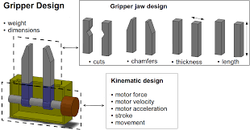
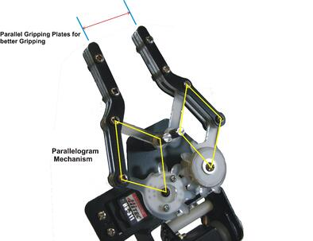

Above (left) and example of a parallel gripper (Belanger-Barrette, 2015) and the various jaws that contain different design difference to consider for the picking task required (Adam Wolniakowski, 2014).
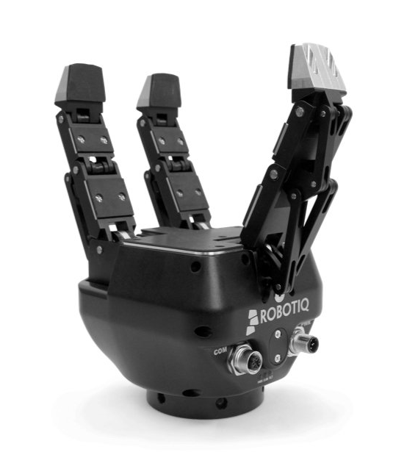
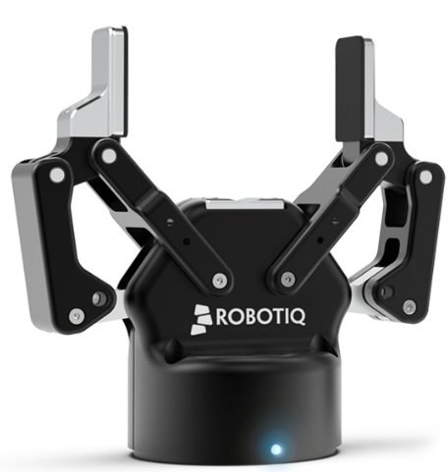

Parallel grippers Three finger grippers
(Robotik, 2022) (Robotik, 2022)

Whatever the gripper type they all perform the same sequence of operation Reach, grip, release, transport. Therefore, it is many of the variables in between (space, limitations, object shape, volume picking) that help to decide which gripper is suited for the job and process at hand, below is an example of a survey of use.
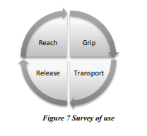

Above the survey of use in picking/collecting process (Mohammed, 2010).

Detailed design documentation

Deign considerations
Prior to considering designs there are a few considerations we must include that may or may not have affect on the process of collecting the mobile phones.

Angle and position to access of output stations (Left and Right)
In review the solid works models provided, it is noted that the output station is seen to be positioned at a slight angle, and it also has two end lips / sides to prevent mobile from falling off sideways from platform. The bottom of the output station there is also a small step, which prevents the mobile from falling downwards off the ramp. There are also raised pads/buttons on the output pads and thought must be given to their height and position for their effect on the gripping of the mobile phones, and that they allow the jaws / finger to perform their task. Therefore, in considering the above we must take these features into consideration during the picking of the phone, and that they do not prevent the gripper from functioning.

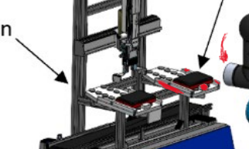
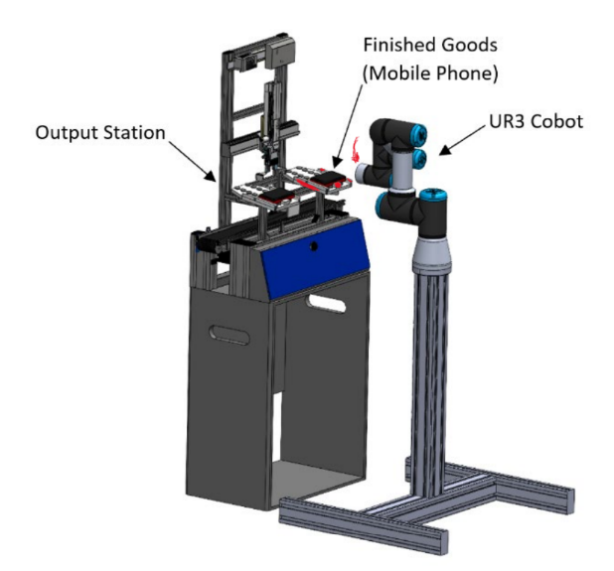

Above output station and cobot (left) and close image Right) of output station (Morgan, 2022)

Completed item strength and structure.
In reviewing the build up of the mobile phone, we can get an understanding of how potentially fragile the item can be. It consists of a front cover and a back cover and sandwiched between is the PCB board that house the fuses. As it isn’t clear how the item is fixed (screwed, glues, clipped with clasps) the end product should be treated as delicately as possible to prevent it from splitting and or damaging the case. The method of jaw selection is important and what material they are made from, and forces applied are just some of the considerations.
In briefly overviewing the various “popular” grippers used in automation I have decided to narrow the initial designs based loosely around parallel grippers, to which design three is a developed concept on parallel grippers.

Design concept 1

Parallel grippers
The initial concept in the figure (1 & 2) below follows a very simple design like standard grab style grippers. The gripper would approach the outfeed station and collect the mobile from above. There are a few limitations, the grippers are narrow in width and would not be able to grip the mobile evenly as seen in the figures below.
To answer this issue, I have included a variation of the jaws that can be adjusted to suit the various lengths of phone. There are short elbows at the bottom of each jaw, and they include chamfers to aid in preventing damage or collision with the raised pads on the workpiece output station. These would act like grabber in arcade machines where it would hover over above and collect the phone. However due to the angle of the workpiece station and the practicality of gripping the mobile this design and potentially colliding with the raised pads I feel isn’t quite up to standard for the task. See Appendix 4 for initial sketch ideas.

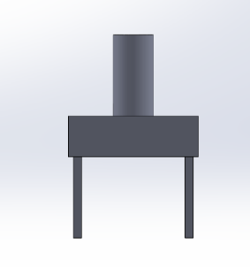
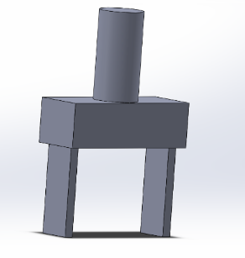

The first design will collect the mobile from above, however only having to jaws to grip would prove difficult to grip the mobile centrally.

In improving on the design flaw noted above, an adaptive hook end was created that would attach to the end of the jaws. A further advancement is included, where there would be four jaws and hooks allowing the device to be picked up securing all four corners.

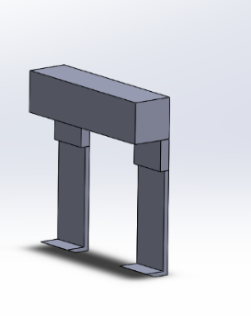

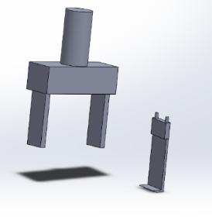

Design concept 2
Another concept variation of a parallel gripper includes wider jaws that would mimic the length of the mobile phone. There are four extended buttons/fingers that due to their shape would avoid collisions or interference from the raised pads. Included in the sketches (Appendix 5) from initial concept drawings it is noted that these fingers would have gripper pads that would add additional friction to help with gripping the mobile. This I feel is a strong contender for design, however positioning would still be crucial to grip the phone securely enough however I’m sure through programming this could be avoided and with use of fully articulating arms. The grippers pads would potentially wear over time depending on their material, and their material selection would be important. As the gripper will be required to run for prolonged periods and with the need to provide maximum output, I feel the opening and closing operation of the gripper may also cause wear and tear on mechanical internal parts however would happen over a long period of time and use.

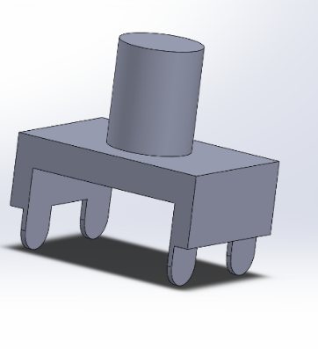
Highlighted are the “Button” style fingers attached on the jaws. These would be designed so they would pitch between the raised pads on the outfeed station. There is also an example designed with a rubber grip pad for maintain hold on mobile through friction. Therefore, reducing the amount of pressure needed to lift mobile.

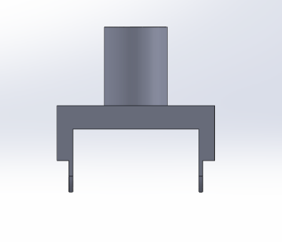
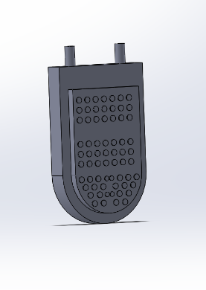
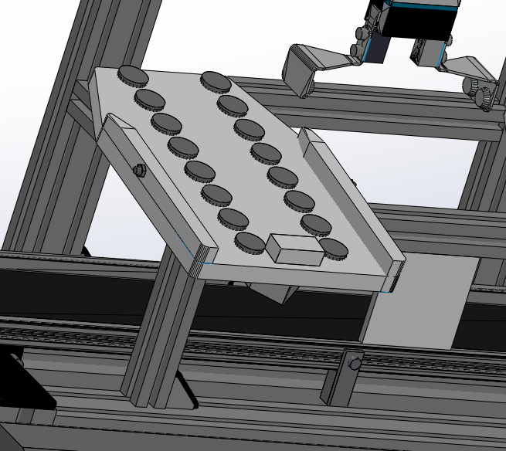

Further to the design above I have also designed another “hook” style jaw that can be slotted into positioned and fixes through the holes via a pin attachment. The fit of the diameters into their counterparts would need to be precise and tolerance accordingly. This to ensure good alignment, and no play laterally. This would prevent the bores from wearing and causing and distortion through prolonged use, therefore material selection of each component is important. I’ve included hollowed out sections in the bodies to limit the weight of each “hook” style jaw taking into consideration that there would be four jaws on this design and that could potentially increase the weight of the overall gripper. The thickness of each hook would need to be less than 3.7mm as this is the measured height of each raised pad on the out put station. This thickness would allow the hook to get under the mobile and lift it effectively.
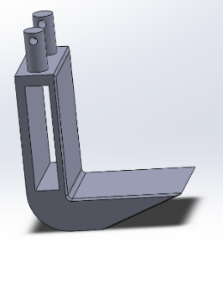
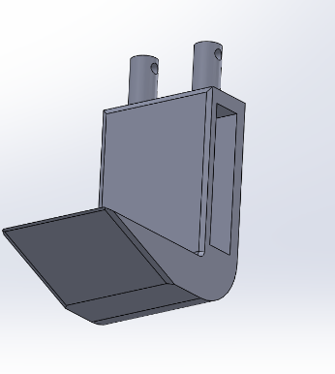

Design concept 3

The evolvement of this design took into consideration the out-feed station, where it has a slight degree of angle. This gripper would be on a fully articulating joint and capable of rotation and a degree of flexion like a human elbow joint. The lower jaw of the gripper would be a single piece and would act like a “scoop” to position under the mobile until the mobile is fully onto the jaw. The top jaw would have attached a soft gripper pad like that in Appendix 6. The gripper would be scooping the phone then just holding it in position until it is dispensed, buy changing the dynamics from gripping to holding there should be less wear and tear as we would rely on coaxing the mobile into position. Not only that we could improve productivity by increase the length of both sets of jaws to potentially scoop and hold up to two mobile devices rather than being limited to one.

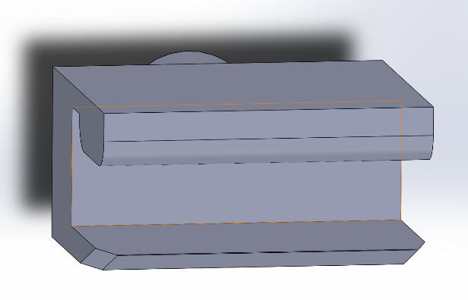
The initial model showing upper and lower jaws. Lower will act as a “scoop” and the top with the aid of soft gripper pad as a holding jaw preventing mobile from falling during transportation.

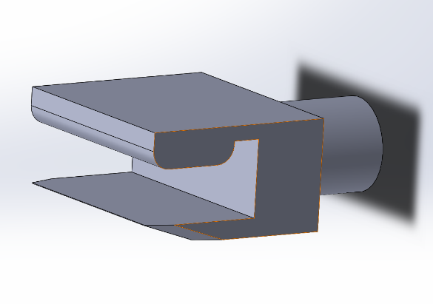
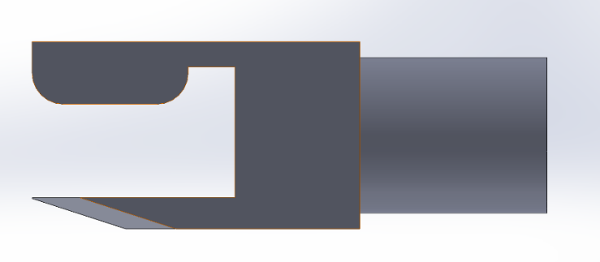

Design choice

The final design to be selected is design Concept 2, due to the ability to interchange jaws allowing for flexibility for future devices and sizes and its simplicity of design and function. Below are 6 reasons for final selection:
- Suitable for mechanical actuation, using an internal functioning mechanism similar as seen in Appendix 7.
- Suitable for high volume production environment due to its ability to replace jaws quickly and precisely through a pin locking system and selected material.
- Jaws can be adjusted (pitching) to accommodate larger or smaller devices providing flexibility to the customer.
- Design considers outfeed parameters (size and width of platform and height of raised pads). Also, the articulating arm would allow for gripper to retrieve mobile at most given angles.
- Due to the shape of the device being lifted, the ability to centre above the mobile device and due to four parallel jaws this would grip the mobile evenly dispersing the gripping forces.
- The textured gripper pads on fingers would decrease the gripping force required by increase friction forces applied to the mobile phone.

Design concept product analysis

FMEA

Failure Modes and Effect Analysis is a process used in highlighting failures or risks that may occur early in the design process or on an existing product (Smith, 2022). It will help in improving reliability and safety of product and improve customer satisfaction (Morgan, Failure Modes & Effects Analysis (FMEA), 2022). It is a tool that has been used for a long time and is heavily utilised in the aeronautical and automotive industries and consists of four divisions.
- Severity: Impact of the failure mode ranging from 1 being minimal concern to 10 being the greatest of concern.
- Occurrence: Chance of failure happening, 1 being least and 10 being highest.
- Detection: Chance of detecting failures, 1 being lowest and 10 being highest.
- RPN: Risk Priority Number = Severity X occurrence X detection. We will be required to design a number that if exceeded will require corrective action.

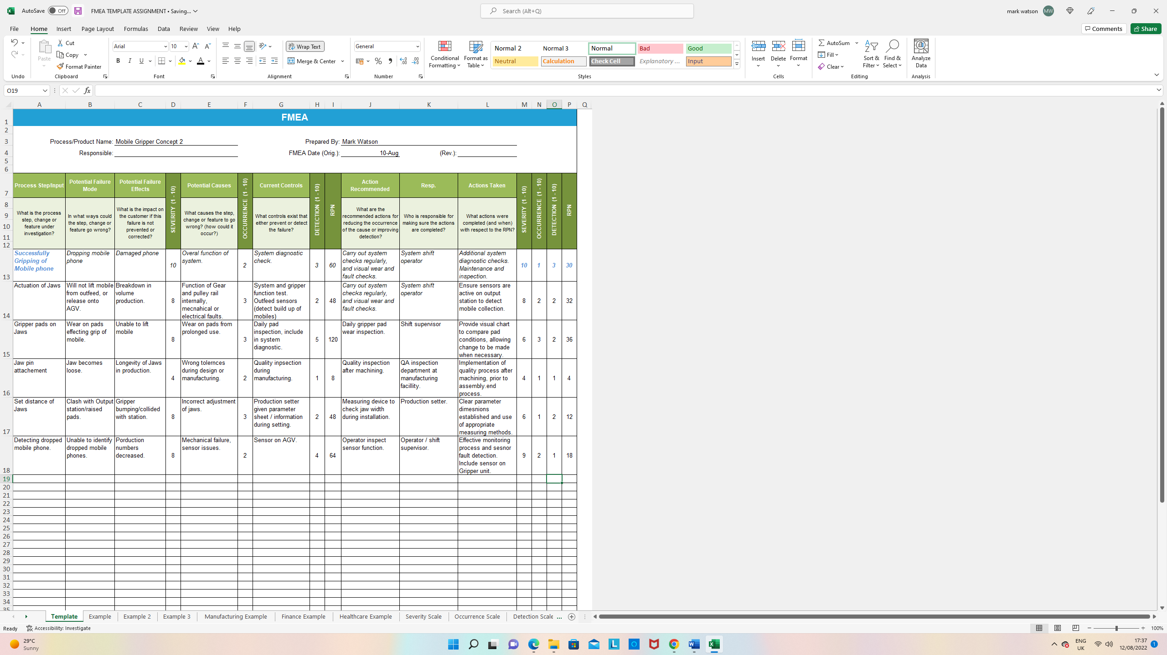
Above: Table of FMEA analysis.

7 Point problem solving process
Another tool that can be used is the 7-point problem solving process from whereas a designer we can use this workplace problem solving process for solving any of the high scoring processes from the FMEA table. The seven-step process consists of are included in the image below, and the process used in this example will be “The successful Gripping of the mobile phone” which had an initial FMEA RPN score of 60.
- Problem: Gripper not successfully gripping the mobile phone
- Analysing problem: This problem would be considered at the third stage (crisis stage) and requires immediate action, as this issue will damage the customers property and cause financial implications.
- Describe the problem (12 words or less): Dropping a mobile phone (Fragile) onto the floor causing severe damage.
- Look for root cause: Is there a failure in gripper actuation? Are the gripper pads worn and degraded? Are the fingers (attached to jaws) loose or incorrectly fixed? Are electronics functioning correctly? Are the internal gear teeth functioning/worn?
- Develop alternate solution: Through discussion and a problem eliminating process we can tackle the issue.
- Implement the solution: Replace any necessary parts (gear or gripper pads) or fix any process issues (actuation/electronics).
- Measure results: Record initial date of issue and number of faults, then implement changes and record results daily to review if changes are successful and likely to remain long term.

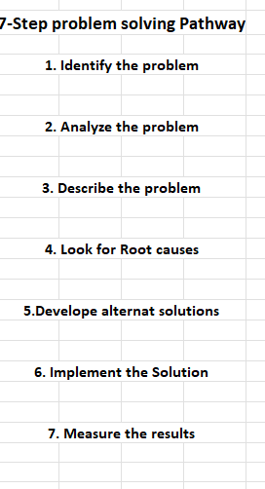

Above: 7-Step problem solving process used in industry as a leadership tool (CRESTCOM, 2016)

Boothroyd and Dewhurst Product Efficiency
The Boothroyd and Dewhurst product efficiency table was included to determine which parts of the gripper assembly are considered essential and those that are non-essential that will need to be designed out, and therefore product improved through redesign to make the final product more efficient and easier to maintain. Appendix 8 shows the efficiency chart used to decide which parts were essential and non-essential (Morgan, 2022). The design efficiency of the Boothroyd and Dewhurst table showed the design was 44.4% efficient in design and therefore would require further modification to improve the assembly and construction process.

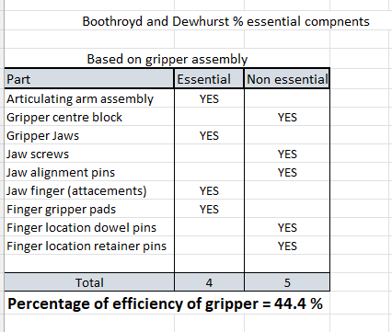

Lucas Design for Assembly method table
The Lucas DFA method is used to provide a handling index score for the Manual Handling Analysis of the gripper, and a similar method can be applied to the Manual Fitting analysis. The manual handling table produced a score of 14.6, which we can use to enter calculation below to give us feed handling ratio. This equation gave us a score of 3.65 and the ideal score is 2.5 or less (Ebrary, 2022).
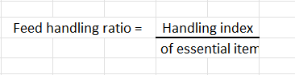

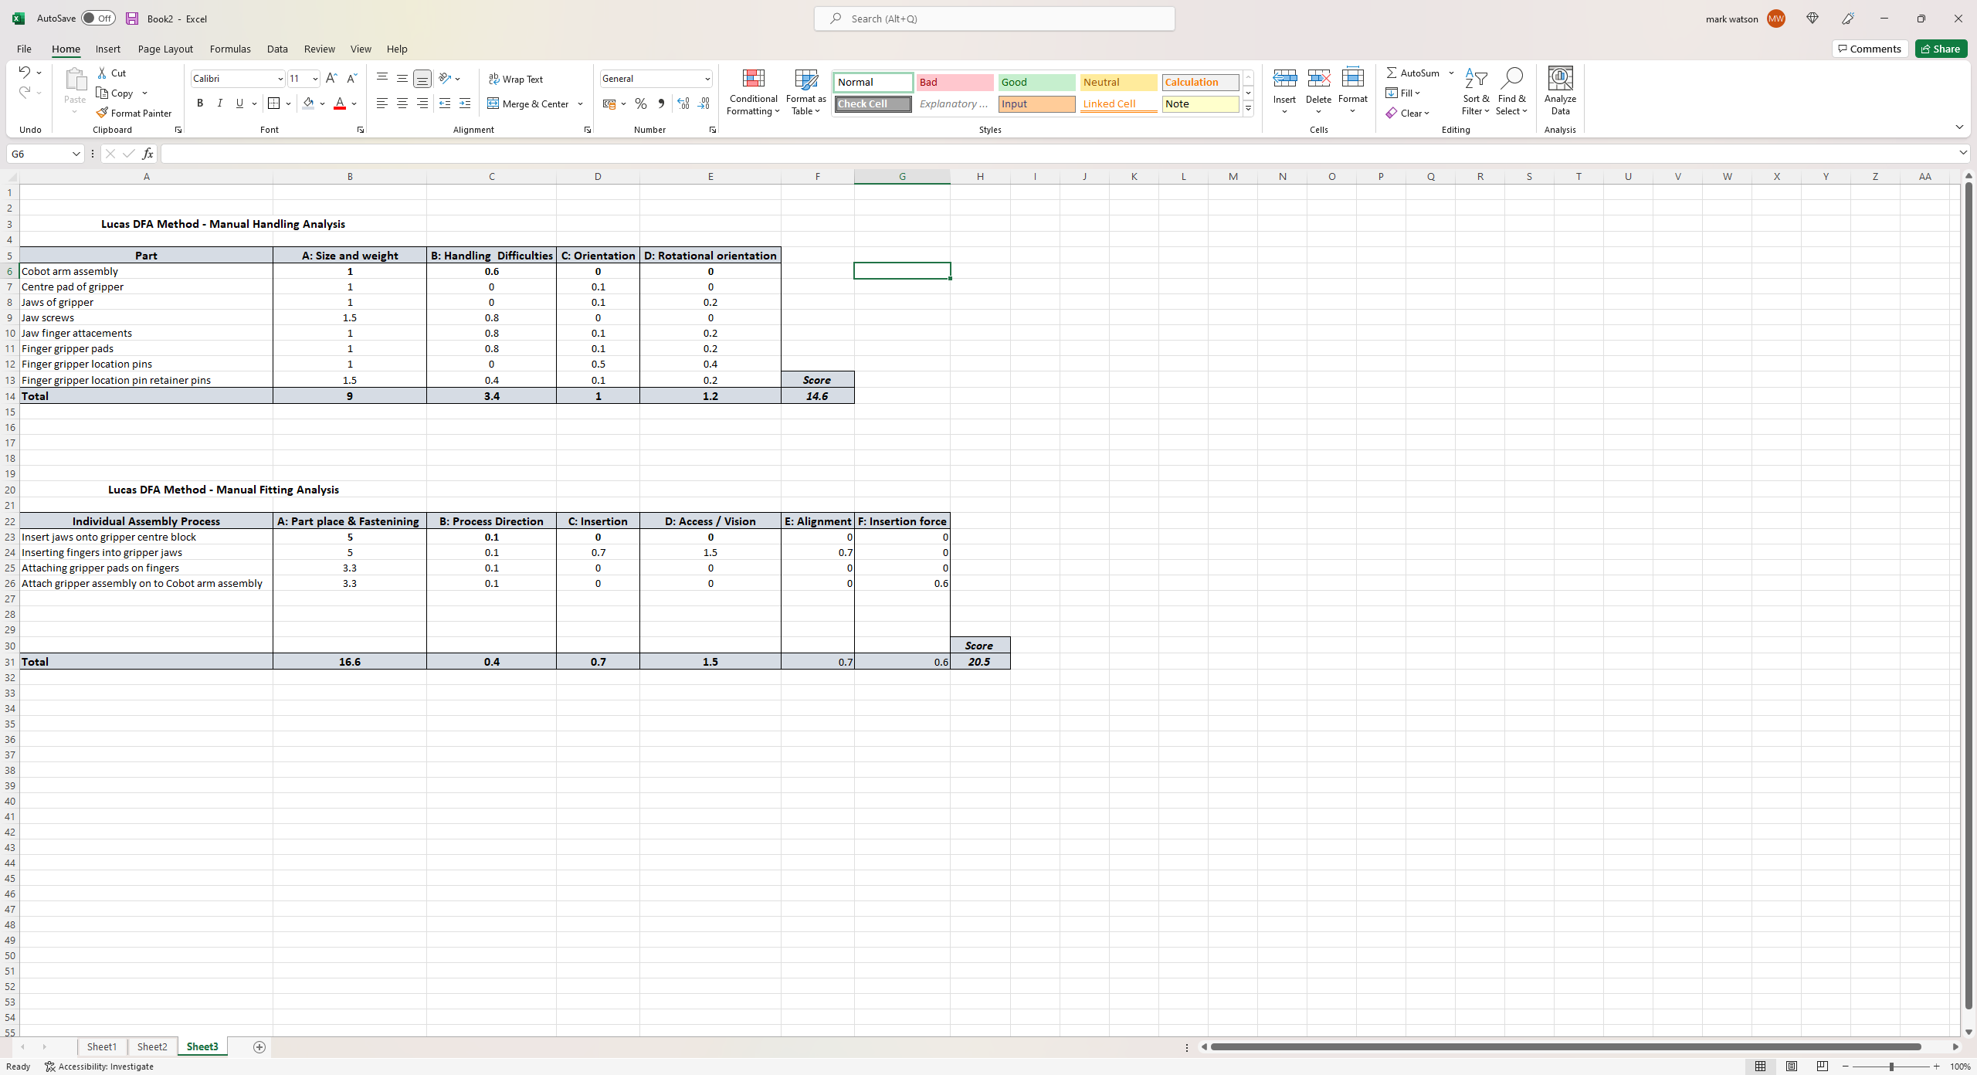
The manual fitting index provided a total score of 20.5 and in using the Fitting ratio equation included below we have a final score of 5.125, however the ideal range is 2.5 or less thus it suggests a design revision is required (Ebrary, 2022).

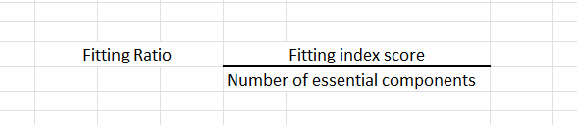

Solid works stress analysis and simulation

Using the Concept 2 Design, we will use Solidworks and run simulations on identified areas where stress and wear are most likely to occur. Using such software can allow us to calculate and visualize stresses at the design stage which will avoid us risking prototypes failing which will lead into reworks, and waste of cost time and resources (Solidsolutions, 2022) Due to this benefit we area be to alternate material to use and find which is the best for us to manufacture each component with.
Stress analysis will be carried out on the location pins of the finger which attach to the jaws of the gripper. This is because the pins will take majority of the stress applied when the fingers are under pressure. The simulation will include tests on the finger body being constructed from 2014 Aluminium alloy suited to structural applications in industry. The Pins will be based on a mod/high carbon content steel alloy due to the requirements to be hard like a dowel pin as they will distort/wear if softer.

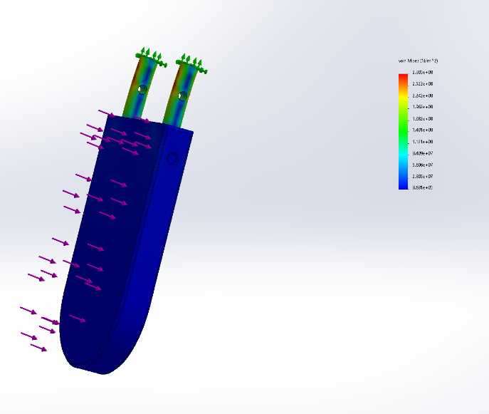
During the first simulation trial, the location pins were used as the fixed geometry to allow us to see how forces applied to the finger would distress the location pins. The images below highlight stresses on the bodies. Although higher than required forces were used (50N) it is enough to highlight the stress point of the pins.

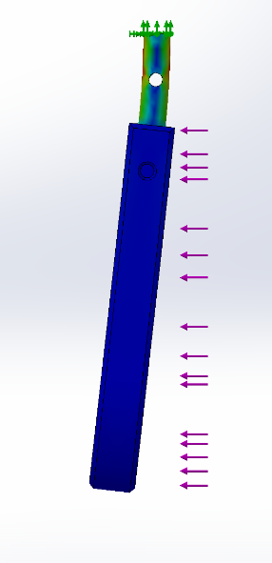

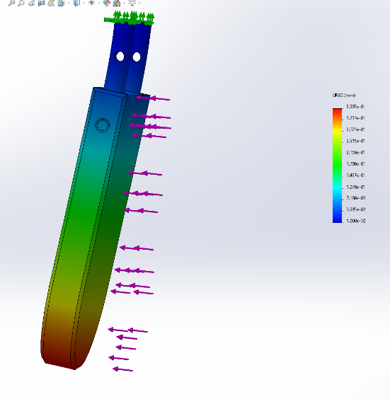
The image to the right highlights the displacement of the finger pad at this force from its starting point. It is seen that with 50N the very bottom of the finger shifts drastically.

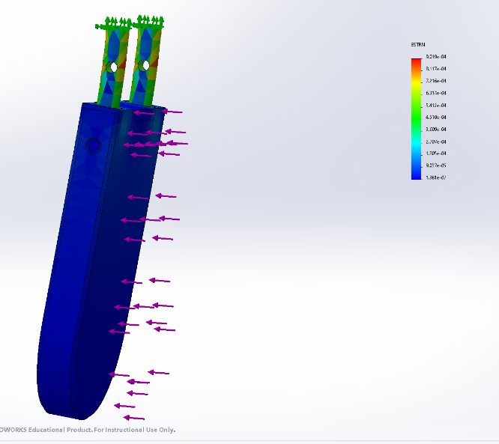
The image to the right shows the strain effect on the location pins. The image below up-close shows us the highest strain point where the through holes are on the pressure pins. This would require us to re evaluate the design of the pins and how they would be retained in the gripper jaws.

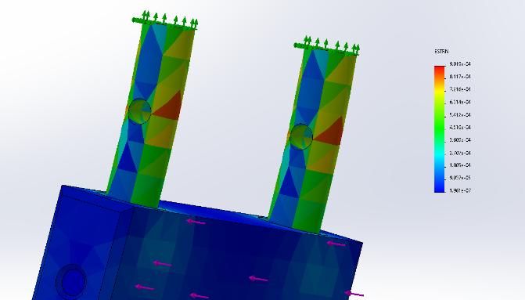

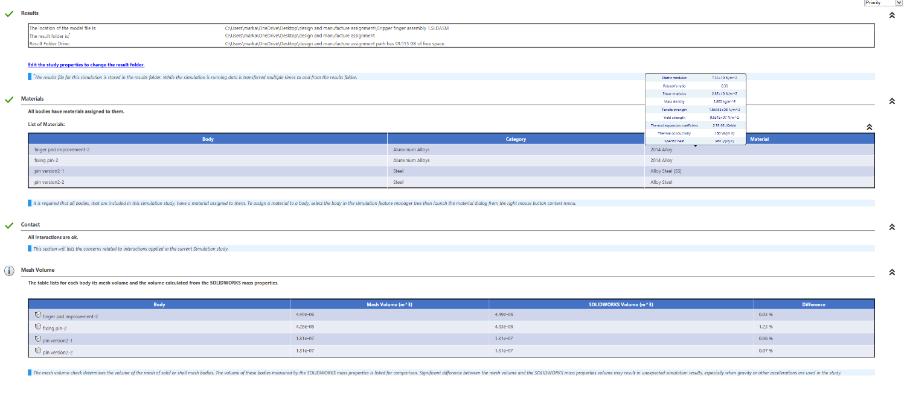

Results

The results and information gathered from the initial design highlighted many areas where work is required. In conducting the FMEA analysis this highlighted potential failures and areas for additional focus to improve the reliability and safety of the product with the customers consideration in mind. The areas scoring the highest were successful gripping of jaw pads 60, Gripper jaw pads wearing 120 and detection of dropped mobiles 64. These issues have varying effects to end process, from not meeting the high-volume demand, to damaging products causing cost issues.
The Boothroyd and Dewhurst efficiency table provided us with a design efficiency of 44.4%, and this percentage should and could be improved further to increase the design efficiency. The Lucas method for manual handling provided us with a handling ratio of 3.65, where the accepted standard score is 2.5. This highlighted room for improvement regarding handling efficiency and orientation requirements. The Lucas manual fitting process scored a final ratio of 5.125 where standard is 2.5, this helped us to identify parts placement and fastening as a concern, which required tooling alignment and considerations for orientation during the building process.
The Solidworks simulation provided us with visualisation of where the greatest stresses and displacement forces where experienced. The simulation highlighted flaws in the location pin retaining holes, due to material missing in the holes this created a focal point for stress and in time could possibly crack and fail causing the fingers to drop out of jaws or even fail to grip the mobile devices.

Conclusions

Following the development from initial design to final prototype results, further design alterations would provide us with improved scores and improved stress analysis results. The following improvements would be carried out.
- Reduction of screws and fixing required during the assemble and fitting process.
- Design the finger pads to incorporate the location pins as a part of the finger, machine as one single part eliminating the need to insert pins.
- Altering the shape of the location pins to a half round shape, which would allow for self-alignment and orientation.
- On the flat face of the orientation pin, a dog point grub screw could be used in the gripper jaw and aid in retaining the finger pad in position. This would give stability, ease of insertion and quick replacement of fingers with minimal tools required.
- Additional studies and research to be carried out on the internal mechanisms of the gripper function (gear, levers and mechanics).

References

Adam Wolniakowski, K. M. (2014). Automatic evaluation of task-focused parallel jaw gripper design. Automation and Robotics Deptartment, Bialystok University of Technology, Poland.
Arani, N. O. (2018). Quality Function Deployement : More than a design Tool. New Haven: Enginnering and applied science education facillity publications.
Babich, N. (2019, october 9th ). Product Design Guide Part 2: Research, Analysis, Ideation. Retrieved from xd.adobe.com: https://xd.adobe.com/ideas/guides/comprehensive-guide-product-design-research-user-analysis-ideation-part-2/#:~:text=Product%20research,before%20making%20any%20product%20decisions.
Belanger-Barrette, M. (2015, Feburary 24th). How does a Parallel Robot Gripper Work? Retrieved August 01, 2022, from blog.robotiq.com: https://blog.robotiq.com/how-does-a-parallel-robot-gripper-works
CRESTCOM. (2016, Septmeber 1st). 7 Steps to an effective Problem solving process. Retrieved August 14, 2022, from crestco.com: https://crestcom.com/blog/2016/09/01/7-steps-to-effective-problem-solving/
Ebrary. (2022). The Lucas DFA Evaluation Method. Retrieved August 14, 2022, from ebrary.net: https://ebrary.net/191720/business_finance/lucas_evaluation_method
ENNOMOTIVE. (2018). 7 Types of Robbot Grippers and their Industrial Applications. Retrieved 08 03, 2022, from ennonmotive: https://www.ennomotive.com/robot-grippers-industrial-applications/
Everything, C. (2022). Cyber-Physical Production Systems. Retrieved from Connected Everything: https://connectedeverything.ac.uk/cyber-physical-production-systems-2/#:~:text=Cyber%2Dphysical%20production%20systems%20(CPPS,to%20production%20and%20logistics%20networks.
Group, F. (2022, May 27th ). A responsible family owned company and global player in digitalisation. Unknown.
Guelker, M. (2011, September 1). The Difference between robotic grippers with parallel, three-finger,angled designs. (F. Richards, Ed.) Retrieved 08 03, 2022, from Machine design.com: https://www.machinedesign.com/markets/robotics/article/21833348/the-difference-between-robotic-grippers-with-parallel-threefinger-and-angled-designs
Mohammed, K. (2010, november 15th). Design of a Gripper tool for robotic picking and placing. p. 51.
Morgan, R. (2022). Design for X. Swansea. Retrieved August 14, 2022, from file:///C:/Users/marka/OneDrive/Desktop/design%20and%20manufacture%20assignment/Design_For_X%20lecture%20slides.pdf
Morgan, R. (2022). Failure Modes & Effects Analysis (FMEA). University Of Wales Trinity Saint David Swansea, Swansea. Retrieved August 12, 2022
Morgan, R. (2022, June 17th). FESTO Cyber Physical production system Goods dispatch Process Automation Development. Retrieved August 5th , 2022
Resources, G. (2022). Introduction to Robot Grippers. Retrieved from Gripshape.com: https://www.gripshape.com/introduction-to-robot-grippers/
Right, R. D. (2022). What is a Parallel Robot Gripper. Retrieved August 03, 2022, from Robots Done Right: https://robotsdoneright.com/Articles/what-is-a-parallel-robot-gripper.html#:~:text=Parallel%20grippers%20are%20commonly%20utilized,consistent%20during%20the%20manufacturing%20process.
Robotik, P. (2022). Pulsar.com.tr. Retrieved August 01, 2022, from Robotic: https://pulsar.com.tr/robotik/en/products/robotic-grippers/
Robots, U. (2022, Feburary 10th). Types Of Grippers Used In Manufacturing. Retrieved July 29th, 2022, from Universal-robots.com: https://www.universal-robots.com/blog/types-of-grippers-used-in-manufacturing/
Smith, K. (2022). Why should you do an FMEA? Retrieved Augfust 10, 2022, from Innoval Technology: https://www.innovaltec.com/fmea-blog/
Solidsolutions. (2022). Linear stress analysis. Retrieved August 14, 2022, from Solid solutions: https://www.solidsolutions.co.uk/solidworks/simulation/features/linear-stress-analysis.aspx

Appendices

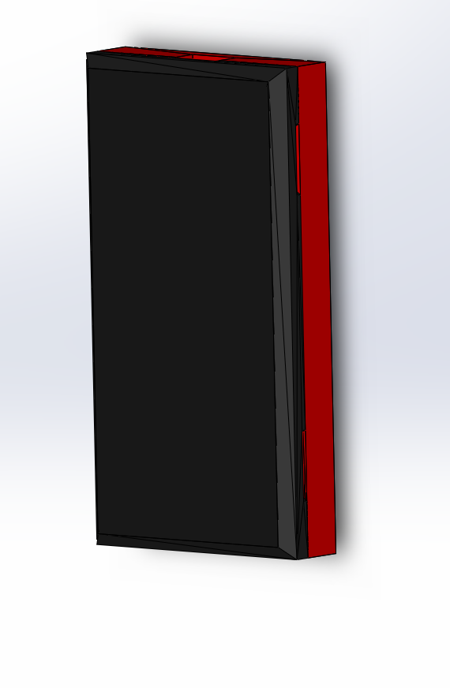

Appendix 1: Fully assembled mobile phone.

Appendix 2: Workpiece left / right slide station.

Appendix 3: Variations of Robot Grippers (ENNOMOTIVE, 2018)

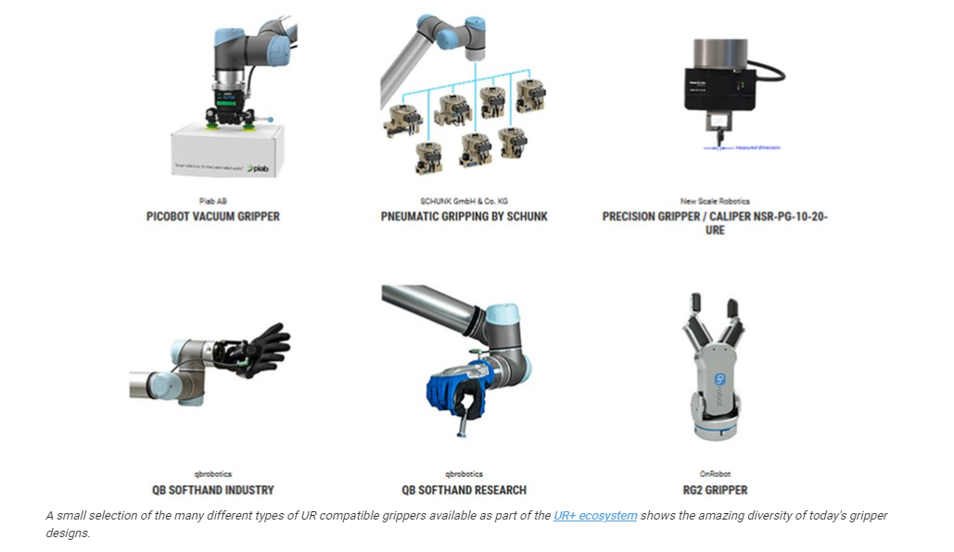

Appendix 4
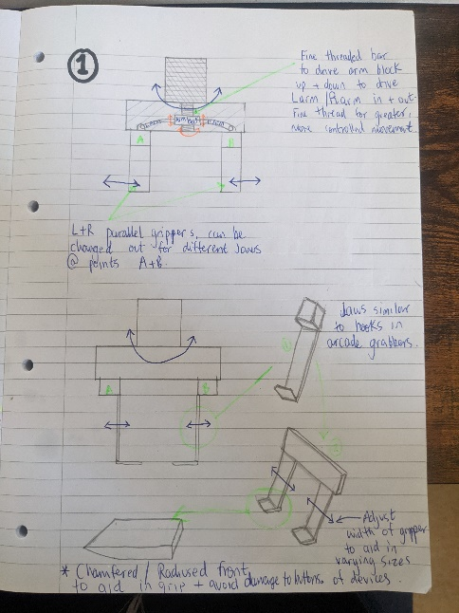

Appendix 5
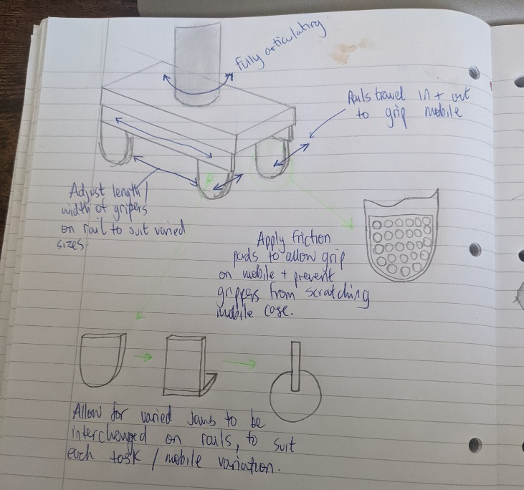

Appendix 6
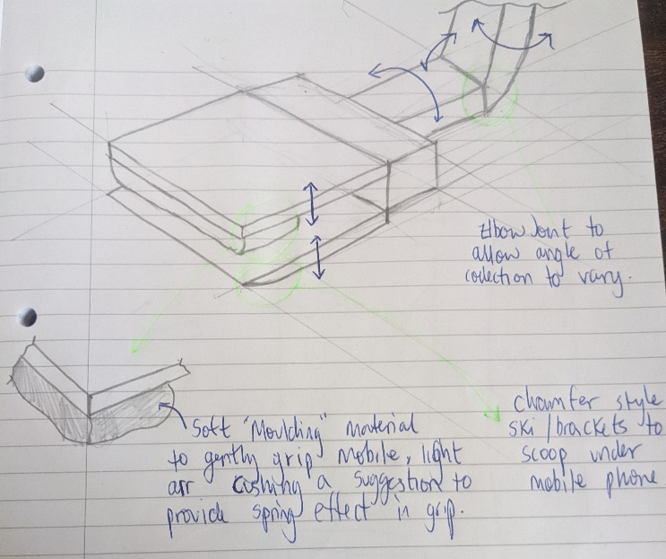

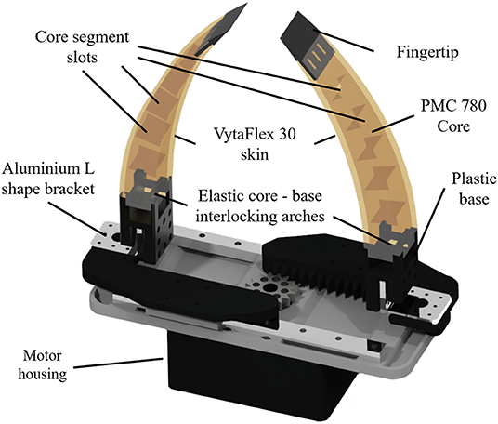
Appendix 7
https://www.frontiersin.org/articles/10.3389/fnbot.2019.00091/full 12/08/2022

Appendix 8 (Morgan, Design for X, 2022)


