Student Self-Evaluation

Module | World Building

This document helps facilitate the assessment of the module listed above.

Please evaluate your project or projects under each heading using the guidelines provided. Add visuals as necessary to support your evaluation. Consider each section in relation to your submitted website/social media outcomes, and your process and engagement with the timetabled sessions.

Name | Libby Turner

Website Link | www.libbyturner.com
Instagram Link: Libby Turner (@libby._photography) • Instagram photos and videos
Facebook Link: Libby Turner | Facebook

Part One: Engagement with Literature Skills (10%)

Artist, Website and Social Media Research

Include at least 3 artist websites. Discuss and evaluate in relation to how successfully they communicate the artists’ work and what you can take and learn from in relation to your own web presence.
Choose the same or different artists and discuss how they use social media to brand their work.
Consider structure (style, clarity, pattern etc.), content (image, text, multimedia etc.), navigation, responsiveness (across computer, phone, tablet etc.) and statement.

Use visuals and include links to the sites discussed.
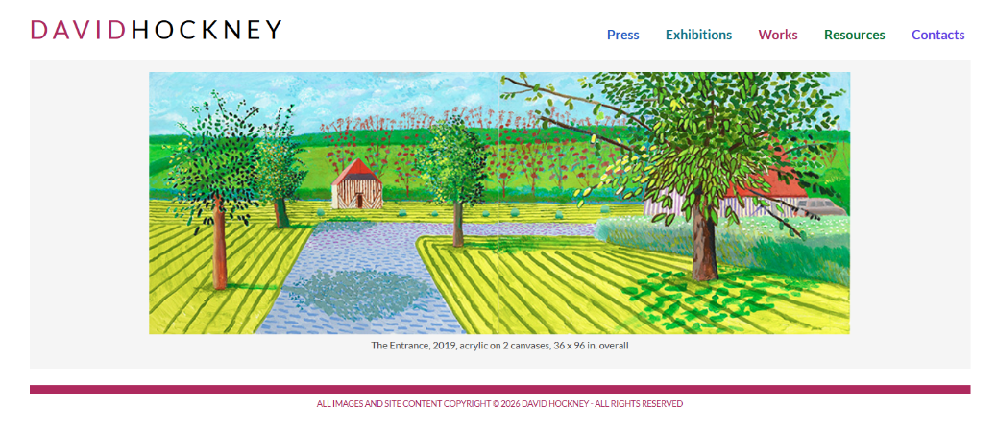
David Hockney

My first research artist was David Hockney who I used for a class seminar in one of the lessons we had in the semester. We were asked to pick an artist and talk about the strengths and weaknesses of the website. At first glance Hockney’s website is simple and easy to navigate using the top bar with the different pages. These then show a list of contained within the page helping viewers find what they are looking for easier and quicker. The front page has only one image meaning that viewers wouldn’t get lost on the front page and lose interest without seeing the rest of the site. Hockney has limited the number of words next to photos to allow people to focus on the imagery more with the meaning put simply next to it making it easier for the audience to understand what is going on. One thing that I did find was that there was no about page and so for anyone not knowing who Hockney is it would be hard for them to learn information about him other than the work he has produced. He is very well known so this might be due to that however I feel as though, it would still be useful in some way to viewers. After studying his website, I then proceeded to try find a social media page on Instagram however there were around 4 accounts which were not verified making me believe that he does not have an Instagram account for his work.

Welcome to The Arnold Newman Website | Arnold Newman

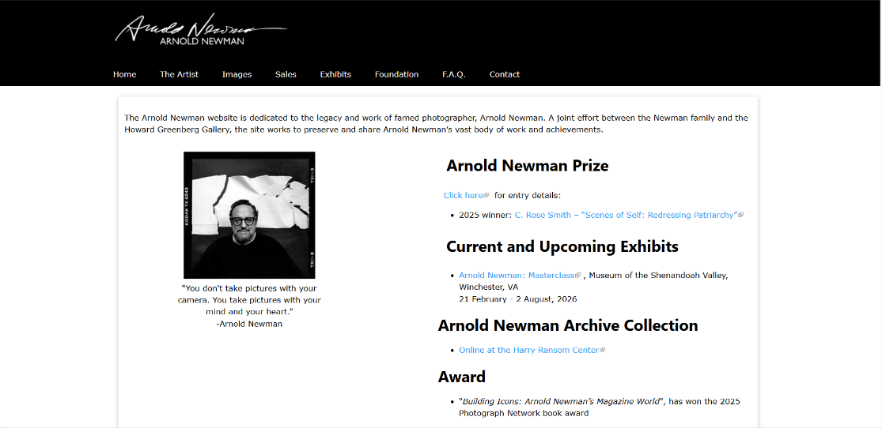
My second website I researched was Arnold Newman’s website. Unfortunately, he died in 2006 however a website about him was published. It shares his work, bibliography along with images. The images shown go from behind the scenes of shoots to portraits and his work through the years. What drew me to this site was the front page as it shows a big part of what was made after he died which was the Arnold Newman Prize allowing photographers to enter each year in hopes of getting in the top 3 to win money and a spot within an exclusive exhibit. It was started by the foundation in 2009 and is still going to this year. By doing this it shows the impact that Arnold Newman had on viewers of his work and the effort the foundation is showing to keep his legacy going of portraits.

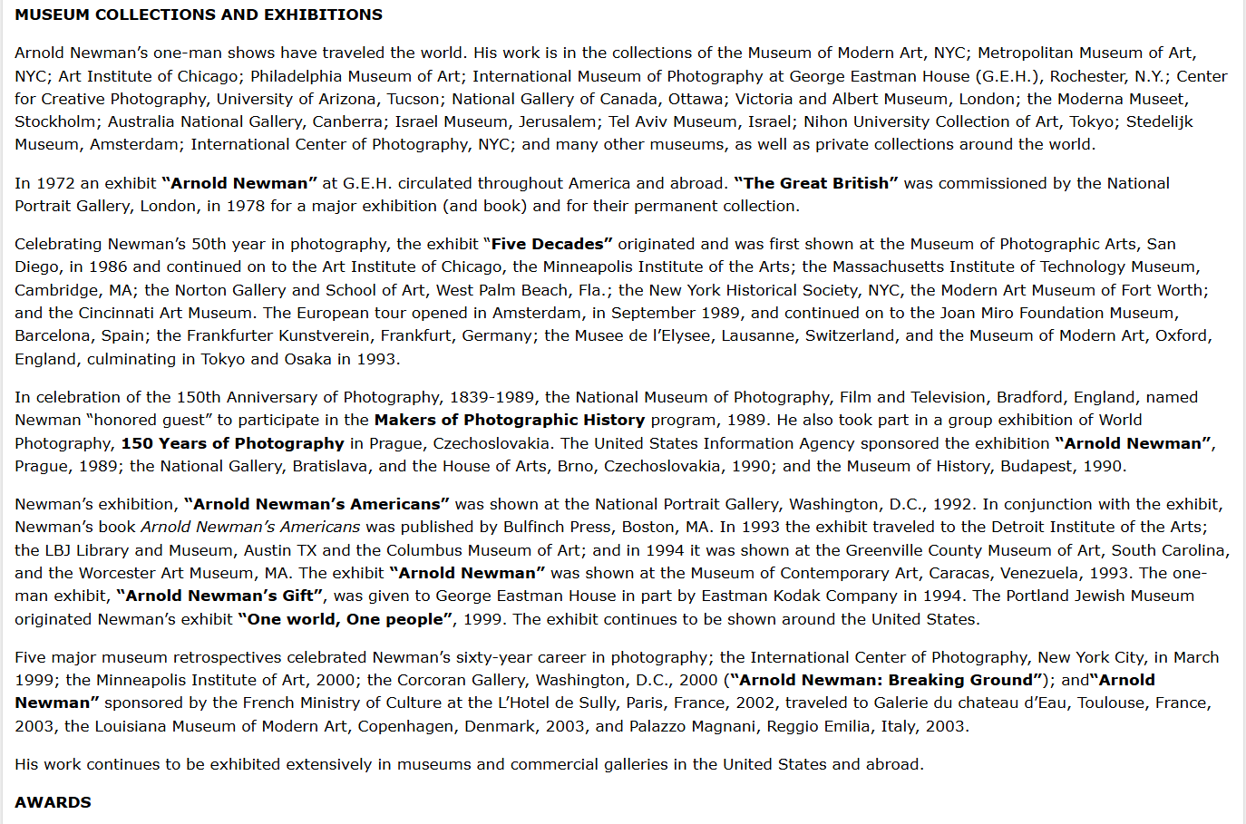
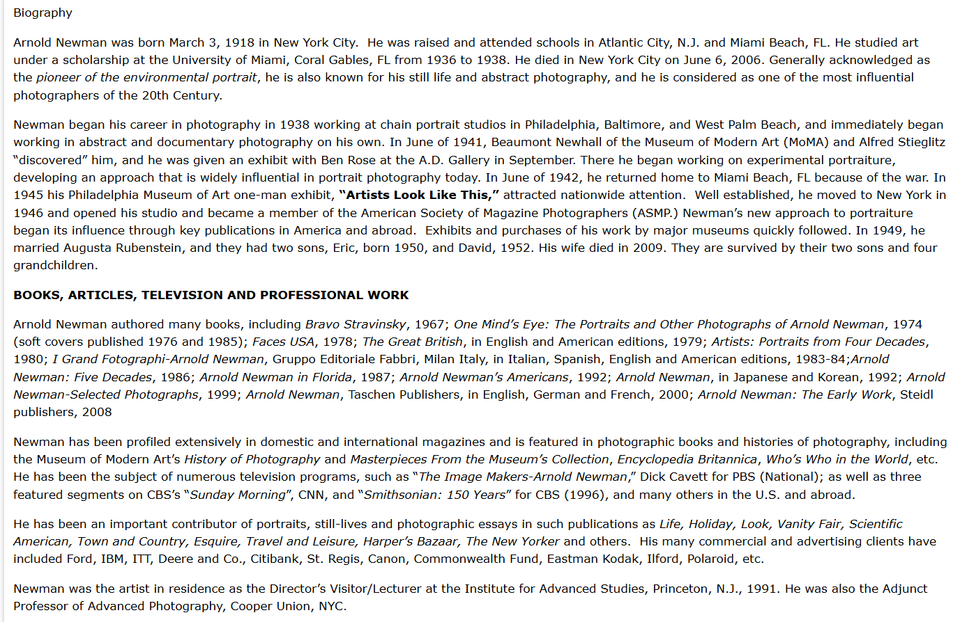
The simplistic look of the page being in black and white, tell me that it is professional and simple with the images and text being the main focus on the pages. The bar at the top of the page is very easy to navigate with everything being organised into sub-pages in the main subjects. One thing I love on the page is the signature and name at the top of the page being a link to the home page making it easy to flip back to it. One disadvantage of the website that I found is the amount of writing on the bio page. Although there is a lot of important content in the writing, some people find it hard reading that much including me and we tend to lose focus before reaching the end unfortunately however the information included is important and overall, a good personal statement about Newman.

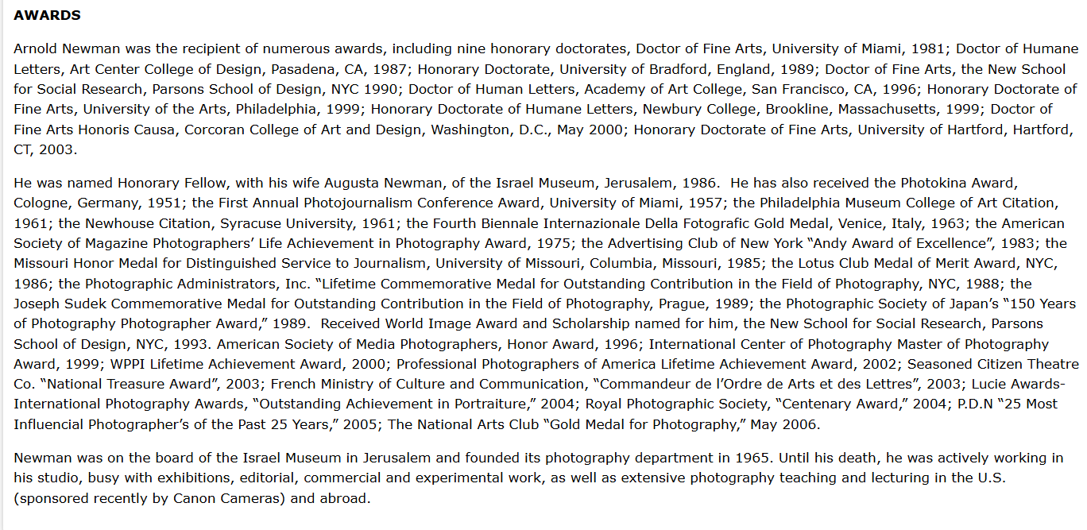

Home - Cindy Sherman - Photographer, Model, Director, Actor, Avant-Garde Images, Doll Parts and Prosthetics, Movies
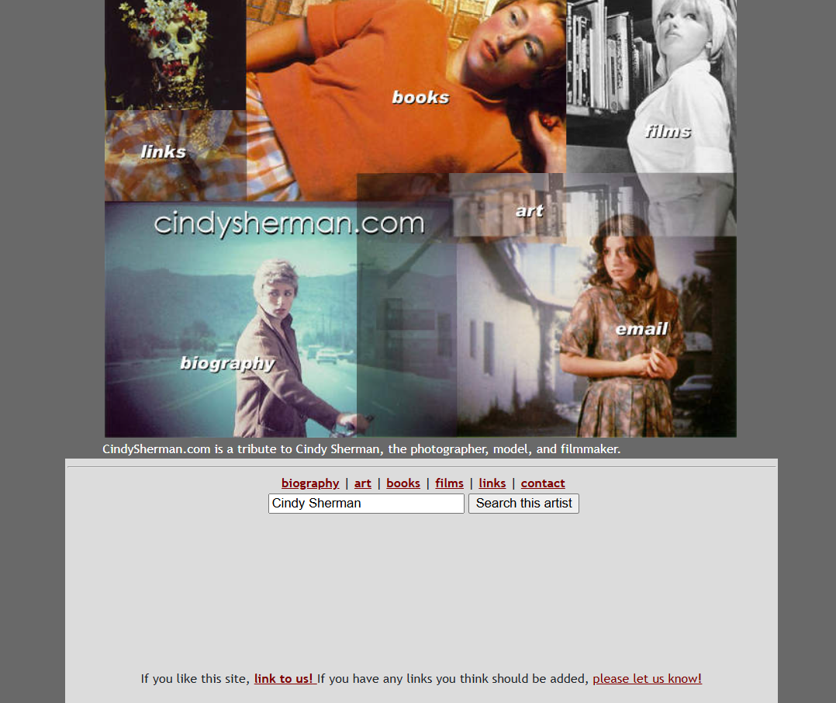
My third research website was Cindy Sherman. For my third website I wanted to discover a new photographer with a different website style to the others. Because of this I stubbled upon Cindy Sherman. One strength that this website holds is the creativity of the page bar, as instead of doing the traditional bar she instead chose to create a collage of images each being its own page to click onto. As well as the pictures she has also included the bar underneath for those who prefer that layout to navigate.

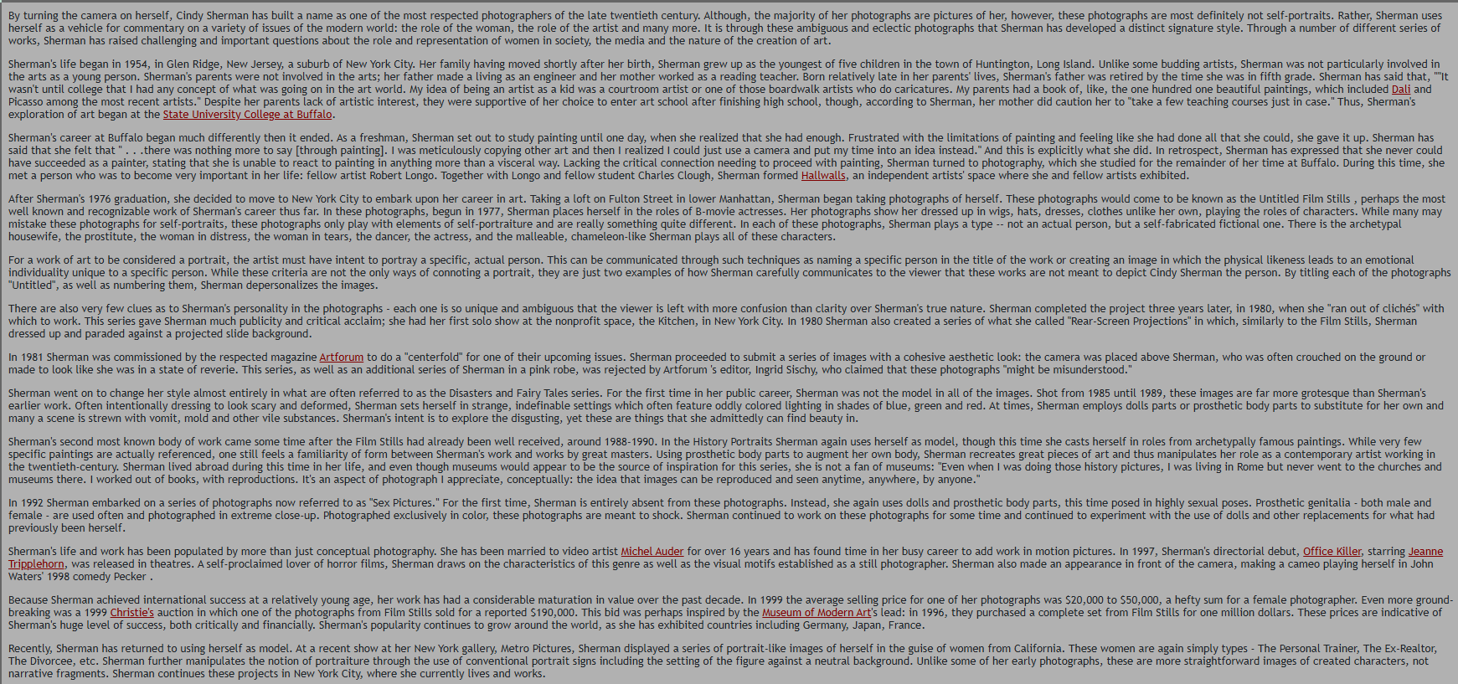
Like the Arnold Newman website, my one issue with the website is how long the biography artist statement is. The one difference in being that the Newman website had headings to split the sections up finding information better within the long page whereas Sherman hasn’t struggling to find the most important info in the page. The writing is very small as well making it harder for people who have bad eyesight to read the content which is one thing I will take into consideration when completing my website. When looking into her artwork, she has separated all work into sub-pages helping keep the work organised as well as putting the year next to each project to help create a timeline of her artwork. This helps show growth within her career and the experience that she has through the years.

Using the strengths and weaknesses of these websites I will take into consideration the things to include and not include as well as trying to keep my website simple and well organised.

Part Two: Knowledge and Understanding Skills (20%)
Applied Skills
In this section, students should discuss and evaluate the application of existing and newly acquired skills, and knowledge to their outcomes.
How have you ensured consistency of design on your site; how have you linked your social media exposure to your more personalised web ‘voice’?
Approx. 200-300 words.

When researching and viewing other artist’s sites, I liked the simplistic look and an organised website where you don’t have to scroll to read and view the images. Because of this I wanted to have a plain background which didn’t take the viewer’s attention away from the work along with sub-pages to organise my work into sections. I plan to have a variety of images on the home page and when clicked it will lead the viewer to that group of images making it easy to find the collection of photos.
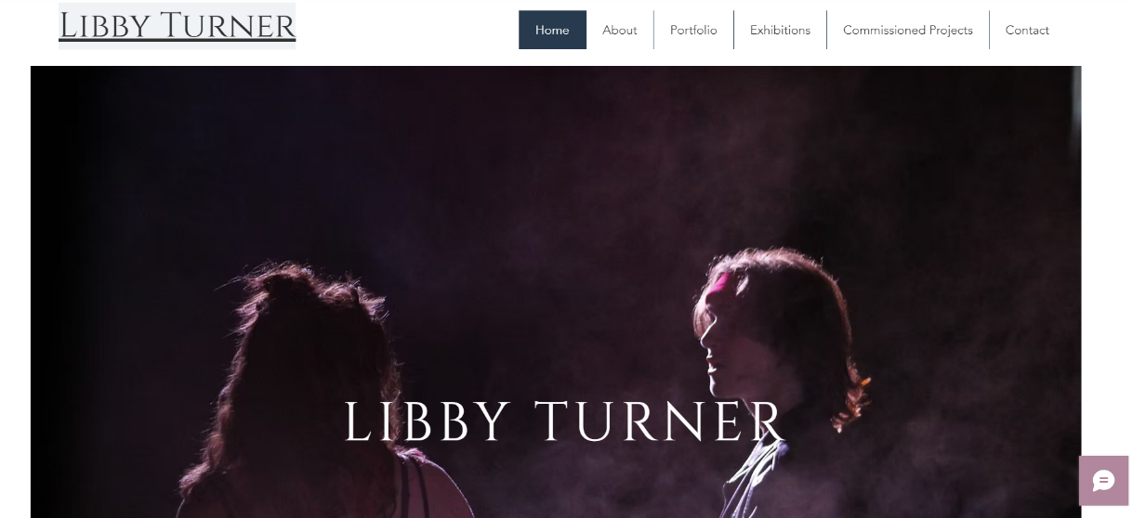

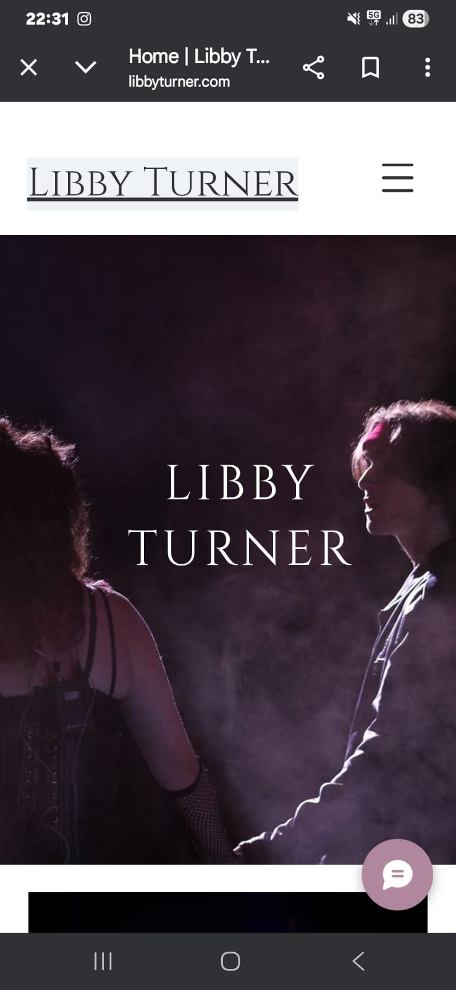
In the past I had to make a website for a portfolio in college and so I was already familiar with Wix as a site and the paths I could take with it. My original plan was to use the original template I used for that project however changed soon after starting due to the number of changes I was making. I figured it was better for myself to start fresh to help not take shortcuts and miss important sections of the website out. One thing that was new to me was creating the sub-pages for the content as at first it was very confusing on the different template pages however after finding one that worked I decided to keep the same template for all the different pages with my photos to help stay consistent throughout my website. I also took into consideration the look of the website on a phone so I planned to occasionally switch between the two to ensure my changes would work on both mobile and laptops.

Part Three: Cognitive and Intellectual Skills (20 %)

Editing and Audience Engagement

Discuss the process of editing your work for web use: selection, placement into specific galleries, different approaches to website and social media, sequencing, scale etc.
How are you presenting yourself to both a professional and a lay audience?

Use visuals as necessary.
Approx. 200-300 words
I started out by going through my existing photography account on Instagram and finding the posts that most represented my work. I tried to keep it within the last 2/3 years as I wanted to keep the website up to date as much as possible and show my most recent work. This will help get commissions for the right genre of photography that best suits me. As well as this, I also wanted to show some of the paid work I have done in the last year. When back at Uni, I will also update the website with other work done for clients which I couldn’t upload at home. By showing my commissioned work, it will give viewers the insight of the experience I have with the genre of photography, in this instance it was concerts and musicals for a local secondary school. For safety reasons I chose not to disclose the location or date of the commission due to it being a secondary school where some of the children are under 18. I did get most consent to post images of these people however for safety of others I thought it was best to keep this information hidden as well as following school guidelines about it.

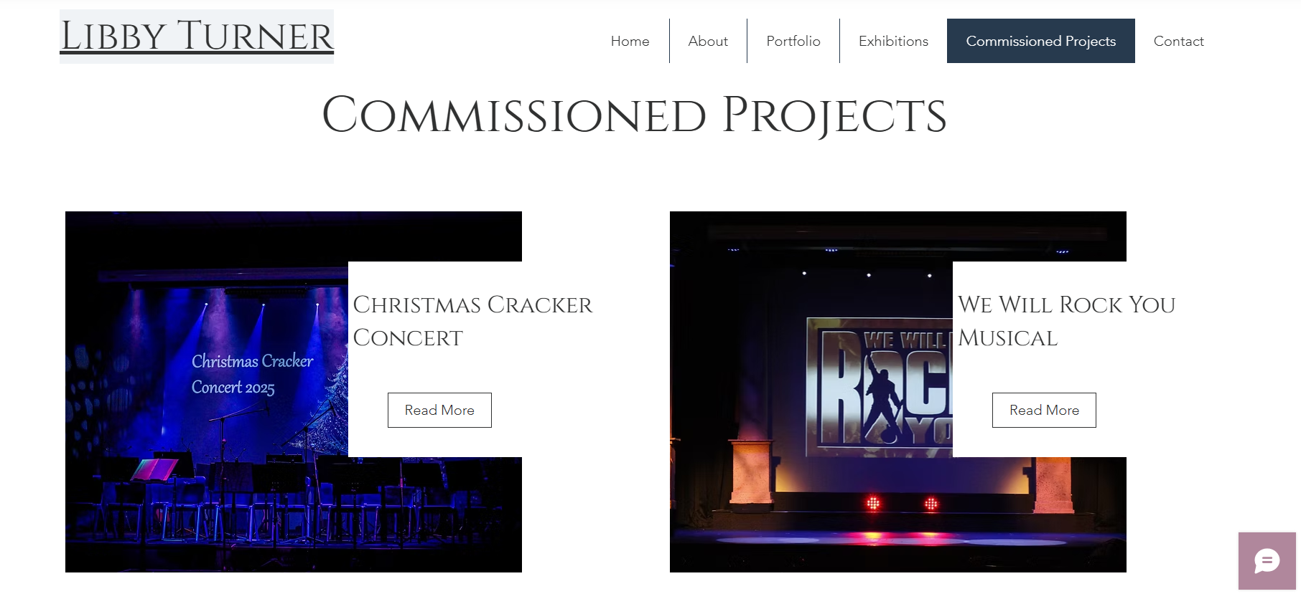

Part Four: Practical Skills (30%)
Practical Work Submission

Please provide a link to your website in the appropriate box.
Consider who you follow and engage with on social media; do you communicate with an art/photography audience and, if so, provide examples of career-related targeting?
Now that you have engaged with this process, discuss the strengths and weaknesses of your site and current social media.

This module is about setting up a process that builds on what you already have but should always evolve, with new refinements as you develop as an artist.

Approx. 400-500 words.

I first made my first social media for my photography in 2023 on Instagram. I did this to help separate my personal life to my work to stay more professional about my photography. By doing this it has allowed me to separate my following into personal and work based following. For example, on my photography Instagram I am not only following other photographers from other Uni’s, but I am also following photographers who are doing the real business that I plan to do later in life such as car and concert photography. Along with this I also follow editing profiles to allow me to expand my knowledge of post-production and different techniques to get different effects on images. There are a few people who follow the account that aren’t photographers however are people I have photographed in the past. I am glad they do because it gives me a sense of hope that later in life if they need a photographer then I may become an option for them due to our early connection in life.
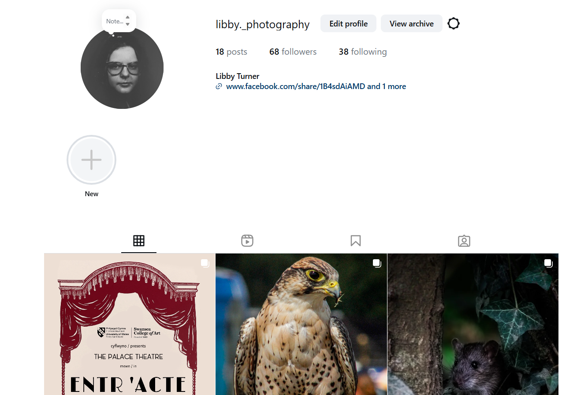
A strength that is also a weakness is the different types of photography I post as it gives the audience a wide view on what I am capable of. This will give me more options in the future to work with different clients. When making the website and my Facebook profile I chose to include the photos from my Instagram to help link them all together and allowing three different types of viewers giving me more chances of being found. I am also looking at setting up a LinkedIn profile to share my imagery more however for now I am happy with what I have created. I was originally going to have my Facebook and Instagram profile be named Libby Turner however unfortunately my name was already taken on Instagram and so chose a different username and added it to the bio instead. I have linked my Instagram and Facebook together allowing me to post on both at the same time as well as the profiles being linked on the pages.

One thing that has become a weakness to my website and social media is the people I work with. This is because, I work with a secondary school who pay me to take their photos however due to the children being under 18 it means that I can’t post majority of the images making it hard for me to share and get feedback on the work I produce. This also limits me getting more clients as they won’t be able to see the previous work I have accomplished. Another thing that has been a weakness is the number of different genres in photography that I do. I like to experiment and try new things which makes it hard to then get a client and not overload my website or social media. Due to this, I will focus more in the future on posting the main genres I do to allow myself to focus on what types of imagery means the most to me getting me more clients in the future hopefully.
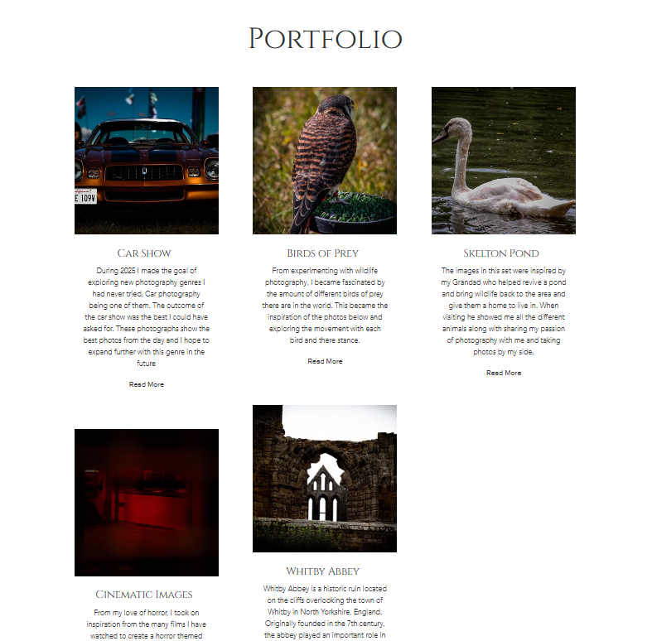

Part Five: Transferrable Skills for Life and Professional Practice. (20%)

Engagement with Taught and Studio (non-timetabled) Sessions; Professional Engagement

Have you participated in all tutorials and group seminars, and completed all the related tasks?
Present work to a professional standard with a view toward professional audiences and potential clients and collaborators.
Consider how your web and social media presence might help in your approach to external groups as you approach your final degree year.

How good has your time management been throughout the module?
Approx. 250-350 words.
I believe looking back over the semester I have tried my hardest to participate and arrive to lessons. However, I did not go to tutorials or participate in the personal statement group due to personal reasons that happened at my accommodation which affected my mental health. As well as this I wanted to take my own time with the website and social media and not rush it to show in a tutorial as I find when I do that it isn’t my best work. Compared to last year I have stayed on top of my work more allowing me to take more time in making things the best they can be. Looking back, I think it would have been nice to participate in the tutorials however it allowed me to spend more time working on my project and space out my timings more making the semester less stressful for myself. I did show my past website in a lecture seminar in which I did get feedback on what to improve and from that I gained a lot of confidence to carry on with what I was doing alone.

When looking at my work, I have shown the photographs and information needed to grow as a photographer. I have kept a simplistic look to my website making the site look professional to me along with it being easy to access and navigate. By growing my social media and web presence, it will give me more confidence to share my work with others as well as show myself more in my work. Whether that be the artwork being about myself or something that I love to gain that connection more.

